**BASICS**

**Of**

**ANTENNAS**

**Shubhendu Joardar**

*B.Tech.* (Electronics, NIT Calicut)

*M.S.* (Microwaves, IIT Madras)

*F.I.E.T.E.* (IETE, India)

*Ph.D.* (Physics, University of Kalyani)

License

This presentation is copyrighted to the author. All are free to use and distribute this presentation for non-commertial purposes like teaching, learning, science and education provided the contents are not modified. Figures and equations or any part of it may be copied for any similar usage provided the author is acknowledged. One should not aim to use this for destructive, non-scientific or non-educational purposes.

– AUTHOR –

# Introduction

Radio telescopes are based on the basic principle of optical telescopes. Radio telescopes use antennas as the viewing instrument. An offline image is constructed later from data using pseudo color which can be seen with the human eye. Thus the prime instrument of a radio telescope is the antenna.

In this chapter we shall explain the basic concepts of antenna theory from the engineering point of view which will be helpful in understanding the radio telescopes. In the subsequent chapters we shall enhance some of these definitions for radio astronomical usage.

# Antenna Radiation and Reception

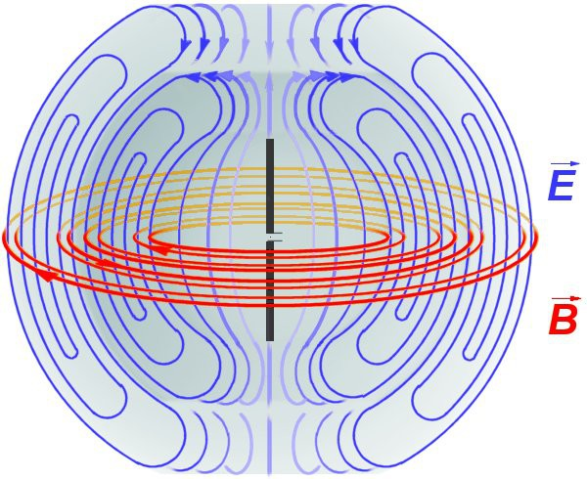

Dipole radiation fields: Electric field (blue) Magnetic field (red) (picture from wikipedia)

Due to absence of transmission line conductors, the field lines join together and an electromagnetic wave is generated with spherical wave front whose source is the signal generator connected at the input end.

# Antenna Radiation and Reception

#### Points to note

* The power fed to an antenna from a signal source is radiated into free space as electromagnetic waves.
* The reverse is also true, i.e. electromagnetic radiations falling on an antenna gets converted to power and is available at the antenna terminals which can be delivered to a load.
* Understanding the radiation properties of an antenna is equivalent to knowing its receiving properties.

The above properties of antennas are derived from the ***reciprocity principle*** of an antenna which may be stated as ***the properties of an antenna are unchanged when used as a radiator or a receiver***.

# Concept of Isotropic Radiator

The ***isotropic radiator*** or ***isotropic antenna*** is a fictitious radiator. It is defined as an antenna radiating equally in all directions. It is also known as ***isotropic source*** or simply ***unipole***.

The isotropic antenna or radiator is a conceptual lossless radiating antenna with which any practical radiating antenna is compared. Thus the isotropic antenna is a ***theoretical reference antenna***.

**Exceptions**

Though certain applications use a half wave dipole antenna as a reference antenna, but use of the concept of isotropic radiator is preferred in majority of the cases since it gives a better understanding of distribution of radiation in three dimensional space.

# Isotropic Radiator and Inverse Square Law

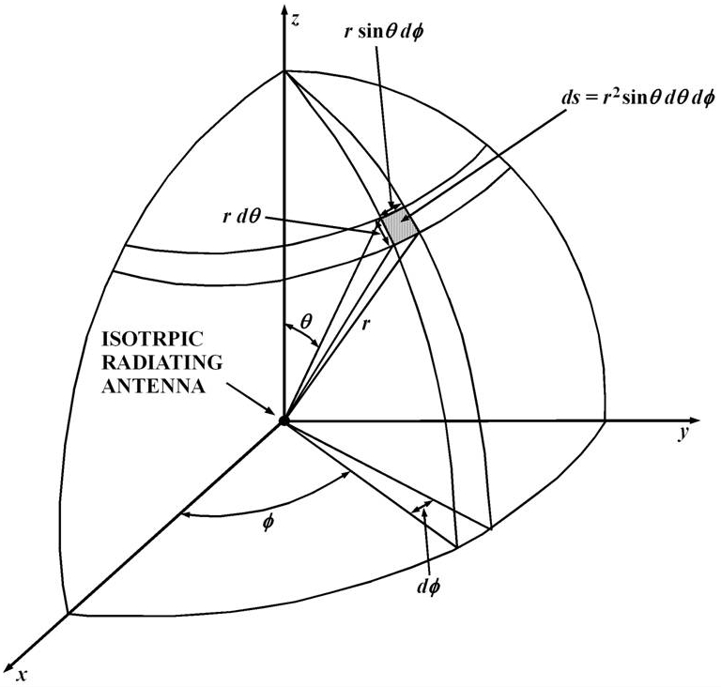

Power *W*t radiated from

center passes through the sphere’s surface

area

4 *r* 2.

Power density (power per unit area) at a radius *r* on the surface of the sphere is *Pr* given as:

*Pr* 

*Wt*

 *ds*

 2 

⇩  *r*2

0 0

*Wt*

sin

*d* *d*

 *Wt*

4 *r*2

Right hand side of the above equation is known

as ***inverse square law of radiation***.

© Shubhendu Joardar

# Radiating Near and Far Fields

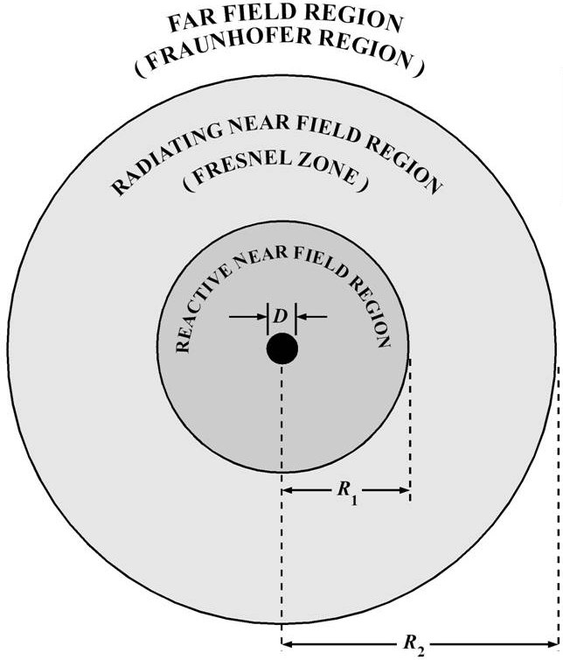The field patterns generated by a radiating antenna vary with distance and are associated with (*i*) radiating energy and (*ii*) reactive energy. The space surrounding an antenna can be divided into three regions (*i*) ***reactive field region***,

(*ii*) ***radiating near-field region*** and (*iii*) ***radiating far-field region***. The boundaries of these regions are not defined precisely but are only approximations.

2*D*2

*D*3

●

Reactive near field

*R*  *R*1

*R*1 

0.62

*R*2  

Radiating near field *R*

 *R*  *R*

Where *D* is the length of the largest element in the antenna.

1 2

© Shubhendu Joardar

# Radiation Patterns

Radiated power from a practical antenna is more in some particular direction and less or null in some other directions. The energy radiated in a particular direction is measured in terms of field strength or flux density at a point which is fixed radial distance from the center of the antenna. The measurement must be done in the Fraunhofer region.

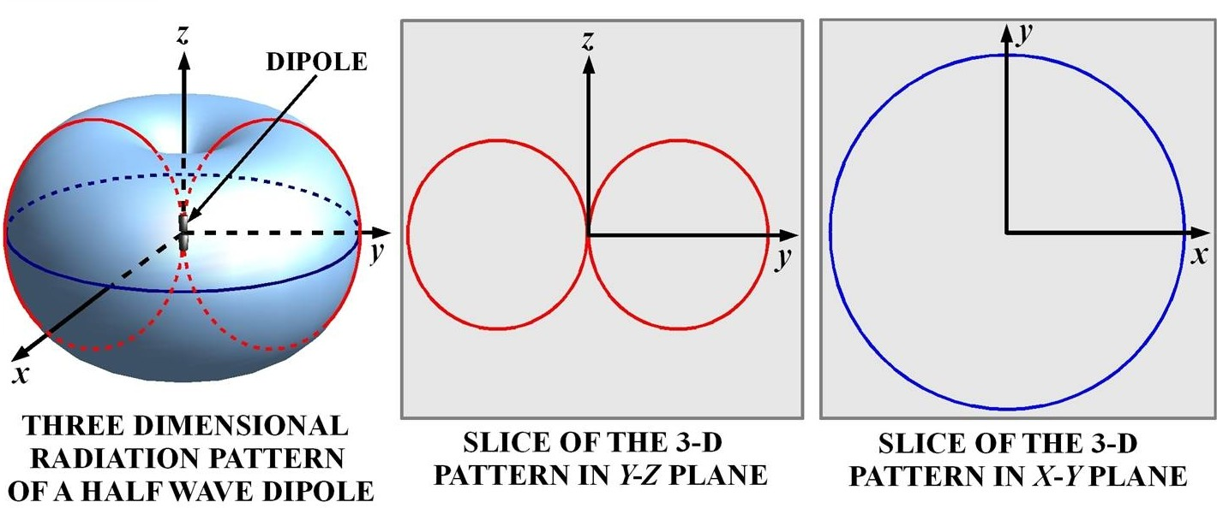

Radiation patterns of a dipole antenna.

© Shubhendu Joardar

# Principle Radiation Patterns

Generally, antennas are oriented in such a way that at least one of its principle plane patterns coincide with one geometrical plane.

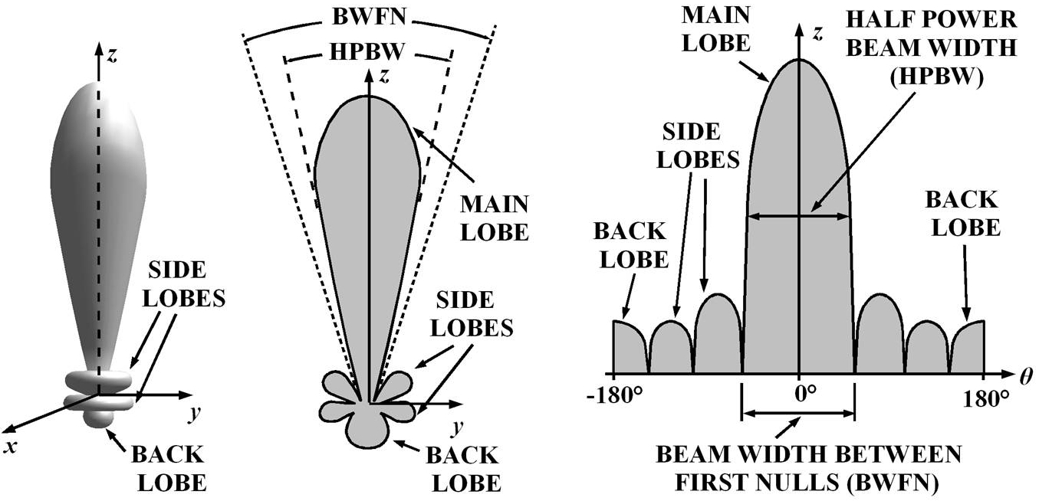

A three dimensional view of a radiation pattern.

A two dimensional view of the same radiation pattern.

The radiation pattern plotted as a function of angle in one plane.

Lobes of a radiation pattern with main lobe oriented along an axis.

# Lobes and Beam-widths

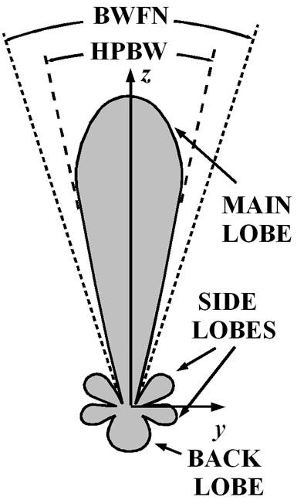Between two adjacent radiating regions, there exists a very low radiating region called ***null***. Region between two nulls is called a ***lobe***. The lobe associated with peak radiation is called the ***main lobe***. The others are called ***side lobes*** and a ***back lobe***.

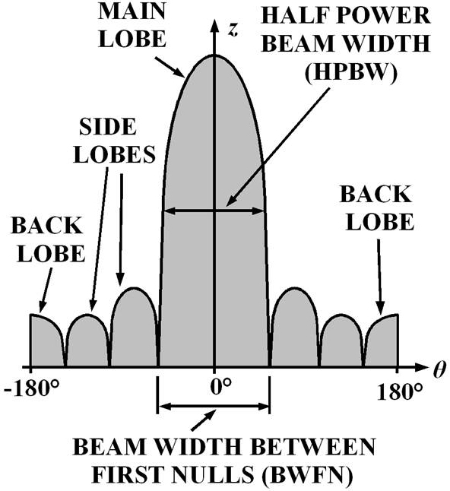The angle at which the peak radiating power of the main lobe falls by half on either sides is called ***half power beam width*** or ***HPBW***.

The angle subtended by the major lobe between two adjacent nulls is called ***beam width between first nulls*** or ***BWFN***.

The ***front to back ratio*** or ***FBR*** is given as:

*FBR* 

radiated flux density from the center of the major lobe

radiated flux density from the center of the back lobe

# Normalized Radiation Patterns

We place an antenna at the center. The electric field components are ***E***   and ***E***(, ). The radiated power will be in the direction of the Poynting vector ***P*** = ***E*** x ***H***. Power pattern is ***S*** (, ). The normalized power

pattern is ***Pn*** (, ).

Normalized electric field

*E* ( ,) 

*E* ( ,)

❑ *n* ( ,)

*E*

❑

max

Power pattern

*S* ( ,) 

*E* 2 ( ,) 

*E* 2 ( ,) / *Z*0

***Z***0 is characteristic impedance of free space.

Normalized power pattern

*Pn* (,)

  *S* (,)

*S* (,)

# Antenna Beam Solid-Angle

Sometimes it is easy to compare beam-widths using a common standard

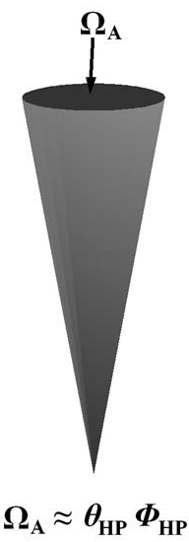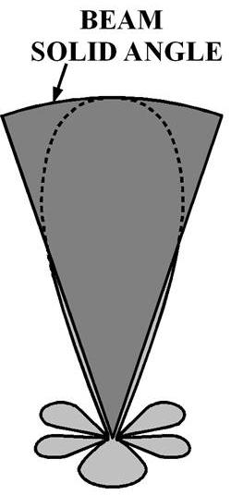namely, ***beam solid angle***.

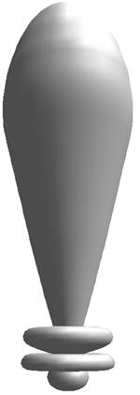Practical radiation patterns.

Fictitious beam pattern for calculating beam solid angle.

Comparison of the two patterns in a two dimensional plane.

If power radiated from both these patterns are same, the solid angle  is defined as ***beam solid angle***.

  *P*

( , )

*d*   

where,

*d*  sin *d* *d*

*A* 

4

*n HP HP*

Note: (*i*) side lobes are included for calculations, and (*ii*) the fictitious

pattern radiates at the peak intensity of the main lobe.

© Shubhendu Joardar

# Antenna Beam Solid-Angle

We now know that the beam solid angle is given as

*A* 

 *Pn* ( , )

4

*d*  *HP* *HP*

Some power is radiated by the side

lobes. Thus the solid angle *M* of the main lobe is less than the beam solid angle A (varies from <100% to 75% of A). Thus we introduce a factor *kB* in following equation:

 *M* 



main lobe

*Pn* ( , )

*d* 

*kB* *HP* *HP* ,

*d* = sin *d*

*d* , 0.8  *kB*

 1.0

# Antenna Beam-Efficiency, Stray-Factor

The distribution of radiation over the sphere is not uniform for any antenna. At certain points there seems to be no radiation at all. The shape of the antenna beam can give a rough estimation of what fraction of the power is radiated in required direction.

**Beam efficiency**: Ratio of solid angle of the main beam to the sum of solid angles subtended by all lobes (including main lobe).

*M* 

solid angle subtended by the main beam

sum of solid angles subtended by all the lobes

 *M*



*A*

**Stray factor**: Ratio of sum of solid angles subtended only by minor lobes to the sum of solid angles subtended by all lobes (including main

lobe).

*m*

 sum of solid angles subtended by the minor lobes  *m*

sum of solid angles subtended by all the lobes *A*

Thus the sum of these two factors is unity

*M*  *m*  1

# Radiation Power Density

Electromagnetic waves travel through free space. At a large distance from the source of radiation, the power available per unit area *P*av can be obtained from the average value of the Poynting vector as given below:

*P*=(*P*⃗*av*

)= *E*⃗ ×*H*⃗ = 1

2

*Real* ( *E* × *H* ) ***watt* / *m*2**

Here, ***P*** is the instantaneous Poynting vector, ***E*** and ***H*** are the instantaneous electric and magnetic fields, *E* and *H*\* are respectively the scalar values of time varying electric field and complex conjugate of magnetic field *H*.

If *E* and *H* are respectively expressed in volts/meter and ampere/meter, then the average value of the Poynting vector is in watts/m2.

# Radiation Intensity

Radiation intensity (*U*): It is the power emitted over a unit solid angle

from an antenna. It is independent of the distance and is expressed in watts/steradian.

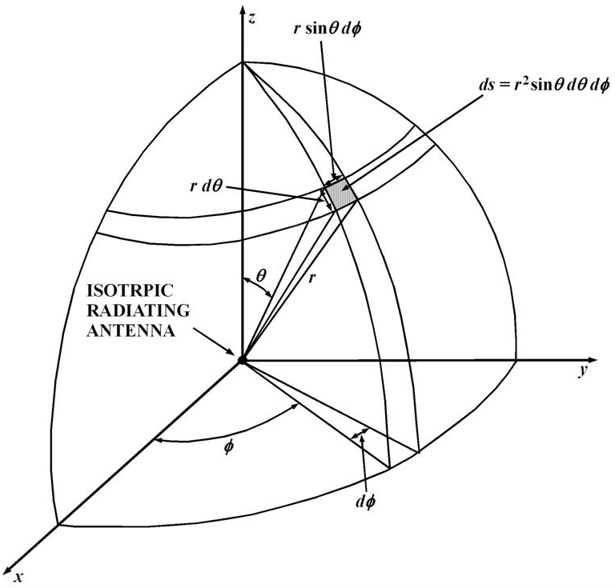An infinitesimal

*ds* 

*r* 2 sin *d* *d*

area on the sphere

Solid angle subtended

*d* 

sin *d* *d*

Total solid angle of a sphere is given as:

2 

   *d* 

⇩ sin *d* *d*

0 0

 4

Radiation intensity of isotropic radiator

*U*  *r*

4

*W*

*i*

Radiation intensity

*U*  infinitesimal power infinitesimal solid angle

 *dWr*

*d*

Normalized power pattern

*Pn* ( , )

  *U* ( ,)

*U* ( , )

max

© Shubhendu Joardar

# Antenna Impedance, Radiation Resistance

The antenna shows an impedance at its input terminals consisting of a resistive and a reactive part. The real part is responsible for radiation

and power loss.

*Z*  *R*  *jX*

The antenna dissipates the power fed to it. If the radiated power and the dissipated power are respectively represented by *Wr* and *Wl*, then the total power *Wt* consumed by the antenna can be expressed as:

*Wt* *Wr* *Wl*

If *I* is the current flowing through the antenna at its terminals then we may express the total power *Wt* consumed by the antenna is given as:

*W*  *I* 2  *R*  *R* 

*t r l*

Here, *Rr* is a fictitious resistance that would consume the amount of power lost as radiation. It is known as ***radiation resistance***. *Rl* is a resistance that would consume the amount of power lost as heat. It is

called the ***loss resistance***. For an ideal antenna, *Rl* = 0.

© Shubhendu Joardar

# Antenna Efficiency

The ***power efficiency*** of an antenna or ***antenna efficiency*** is the ratio of power radiated to total power input to the antenna and is denoted by a. Thus, if the radiation resistance *Rr* and the loss resistance *Rl* is known, the antenna efficiency can expressed as

## power radited by the antenna *I* 2*R R*

*a*  

*r*  *r*

## power input to the antenna

*I* 2  *R*  *R*  *R*  *R*

*r l r l*

Here, *I* is the current flowing through the antenna terminals. Multiplying *ηa* by 100, one may obtain the percentage antenna efficiency.

© Shubhendu Joardar

# Antenna Directivity

All practical antennas concentrate more power in one specific direction. It is of interest to see how much power is concentrated in a particular direction by the antenna. The ***antenna directivity*** may be visualized as to the extent which a lossless practical antenna (a = 1)

concentrates the radiated power relative to an isotropic radiator.

The directivity *D* is the ratio of (*i*) maximum radiated power density to its average value, or (*ii*) maximum radiation intensity to radiation intensity of an isotropic radiator. It is dimensionless and expressed as:

*D*  *P*( ,)max

*P*( ,)av

 *U* ( ,)max

*Ui*

 4

*M*

Here, *M* is the solid angle subtended by the main beam. *P*(*θ,Ф*)*max* max and and *P*(*θ,Ф*)*av* are are respectively the maximum (unity) and average (isotropic) normalized power pattern values. *U*(*θ,Ф*)*max* is the radiation intensity along any direction and *Ui* is the mean of radiation intensities over all directions. © Shubhendu Joardar

# Directivity and Half Power Beam Width

If the half power beam widths of the major lobe in the two principle planes are known, the directivity *D* may be approximately expressed as:

*D*  40000

*HP* *HP*

Here, *HP* and *HP* respectively represent the half power beam widths measured in the two principle planes in degrees.

# Directive Gain

Unlike directivity which is specific to the direction of maximum radiation, the directive gain *GD* is used for any direction. It is expressed as:

*G* (θ *,* ϕ)= *P* (θ *,* ϕ) = *U* (θ *,* ϕ)

*D*

*P* (θ *,* ϕ)*av U i*

Here, *P*(, ) is the radiated power density in the required direction, *P*(, )av is the average radiated power density over all directions, *U*(, ) is the radiation intensity in the required direction and *Ui* is the average radiation intensity over all directions.

# Gain or Power Gain

Another concept similar to the directive gain is the ***gain*** or ***power gain*** usually denoted either simply as *G* or *GP*. The directive gain *GD* and the power gain *GP* of an antenna are related by the antenna efficiency as expressed as:

*GP*  *a GD*

Here, a is the antenna efficiency (which is always less than unity for all practical antennas).

Also note that, the power gain is always less than the directive gain since all practical antennas produce some power loss.

# Effective Aperture Area of an Antenna

The concept of effective aperture area has been developed based on a receiving antenna. Let us assume we have a device which converts the electromagnetic energy into electrical power at its terminals. The ***amount of electromagnetic energy collected is proportional to the collecting area***. This arises from the fact that electromagnetic energy is measured as a *flow of energy per unit time* ***per unit area*** *across a frequency bandwidth*. In other words, it is flux density. Thus more the collecting area (more aperture area) the more is the received power.

The amount of power *Pant* received by an antenna is the product of a fictitious area called the ***effective aperture area*** *Ae* with the flux density of the electromagnetic waves falling perpendicular over this area. This is shown below:

*Pant*

 *S Ae*

# Aperture Efficiency of an Antenna

The effective aperture area is specific for different type of antennas. For example, the effective aperture area of a dish antenna could be equal to the physical cross sectional area of the dish if the antenna is lossless, whereas for a dipole antenna, this area is generally more than its physical area. The effective usage of the physical aperture depends on the aperture efficiency of the antenna which is the ratio of effective aperture area *Ae* to the physical aperture area *Ap* of the antenna and is expressed below:

Aperture efficiency

*ap* 

*p*

*Ae*

*A*

# Wavelength, Directivity and Aperture

The effective aperture area *Ae* is related to the wavelength *λ* and the solid angle *M* subtended by the main beam as shown below:

● 2  *A* 

*e M*

The directivity *D* may be obtained from the effective aperture area

*Ae* using the relationship shown below:

*D*  4 *Ae*

● 2

# Effective Height or Effective Length

The ***effective height*** or ***effective length*** *h* of an antenna is similar to the effective aperture except that it is used for calculating the potential developed across the terminals of a receiving antenna from an electromagnetic wave instead of power. The output voltage *V* in volts across the terminals of an antenna is a product of the electric field *E* in volts/m with the effective height *h* of the antenna in meters as expressed below:

*V*  *h E*

The above equation is useful when working with wire antennas whose physical aperture area is almost negligible.

# Antenna Reciprocity Theorem

***If an emf is applied to the terminals of an antenna 1 and the current is measured at the terminals of an antenna 2, then an equal current in both amplitude and phase will be obtained at the terminals of antenna 1 if the same emf is applied to the terminals of antenna 2***. The theorem is valid if the impedance of the signal generator and the load across the antenna 2 is zero.

Practically all signal generators have non-zero impedance. Thus it is necessary to have identical impedances of signal generator and load.

# Applications of Reciprocity Theorem

Most common applications of reciprocity theorem in radio telescopes are:

1. The radiation pattern of an antenna is unchanged whether used as a receiver or transmitter. Therefore, radiation patterns of the radio telescope antenna-feeds can be measured in the transmitting mode or in the receiving mode inside an anechoic chamber.
2. The impedance of an antenna does not change whether used in transmitting mode or in receiving mode. The impedance of the radio astronomical antenna-feeds can be measured inside anechoic chamber in the transmitting mode by measuring the voltage and current at its terminals.

The theorem fails when the propagation of the radio waves is highly effected by the presence of the Earth’s magnetic field and disturbances created in the ionosphere. © Shubhendu Joardar

# Antenna Bandwidth

The bandwidth of an antenna is difficult to define, since the antenna properties like radiation pattern, radiation resistance etc. changes with the frequency of operation. Therefore the bandwidth is defined in such a way that certain properties of the antenna meet certain specifications. Generally, the bandwidth is measured categorically:

Bandwidth over which the directivity of the antenna is higher than some acceptable value.

1. Bandwidth over which at least a specified front to back ratio is met.
2. Bandwidth over which the VSWR on the transmission line can be maintained over a specified value.

Antenna bandwidth

*f*  *fr*

*Q*

Antenna Q-factor

*Q*  Total energy stored by the antenna Energy dissipated or radiated per cycle

# Analysis of Half Wave Dipole Antenna

Equation of electric current variation across the dipole as a function of time

*I* (*t*, *l*)  *I*0 exp *j**t*  cos  *l* 

− *j I* cos( π cosθ)

Electric field

*E* θ=

0

2 π ϵ0 *c r*

2 *e*− *j* (ω *t*−β *r* )

### sin θ

π/2 cos ( π cos θ)

Radiation Resistance

*Rr* =120 ∫

0

2

### sin θ

*d* θ ≡73.13 ***ohm***

[π/ 2 cos (

−1

### π cos θ

)

2

2

Directivity

]

*D*= ∫

0

sin θ *d* θ

≡1.641, *i.e.* 2.15 ***dBi***

# Angular Spectrum

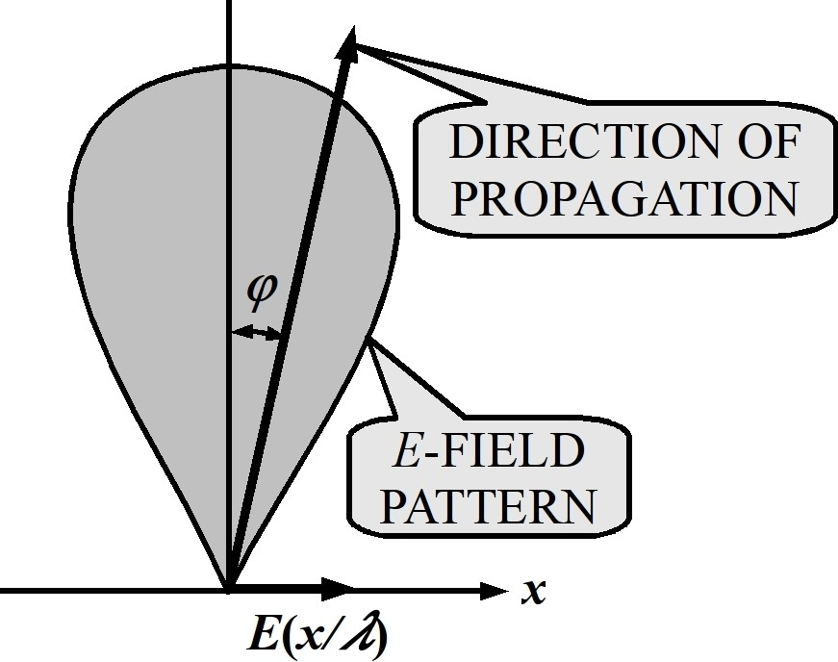The electric field *E*(*x*) at the aperture of an antenna may be thought to be composed of interference created by a continuum of plane evanescent waves propagating in various angular directions *φ*.

Let us represent a plane wave of fixed frequency ν as



where, *rφ* is the direction of propagation.

The electric field *E* may be represented as the sum of

continuum consisting of infinite spatial frequencies (Fourier transform of

*P*( *f*(*φ*) ) ). i.e.,



If we establish the above relationship only in the aperture plane of the antenna using direction cosines of the waves, what we obtain is called the ***angular spectrum of the antenna*** as shown next. © Shubhendu Joardar

Geometry for computing angular spectrum in one dimension.

# Angular Spectrum

#### One dimensional Angular Spectrum

Modified equations:







 

#### Two dimensional Angular Spectrum



Modified equations:



Geometry for angular spec. in two dimension.





    







# A few words on Antenna Polarization

The antenna is usually polarized. The electric and magnetic fields lie perpendicular to each other and to the direction of propagation. As the wave progresses in its travel through space, the electric field (and the magnetic field) may (*i*) continue to lie in the same plane, or (*ii*) change its orientation within each wavelength traveled. For the former case, the wave is said to ***linearly polarized*** while in the latter case, the wave could be ***circularly*** or ***elliptically polarized*** depending on the whether the amplitude of the electric field remain fixed or change with angle respectively.

The circular or elliptical polarizations can again be classified as left circular/elliptical or right circular/elliptical depending on the directions in which the plane of polarization rotates. The dipole type antennas are linearly polarized where as helical antennas are circularly polarized.

# Antenna Polarization for Astro-Sources

Astronomical radio sources have the possibility of all type of polarizations: (*i*) *linear*, (*ii*) *elliptical*, (*iii*) *circular*, (*iv*) *random*, or

(*v*) combination of *random* polarization with the remaining types. Complete information of the astronomical source can be obtained by using (*i*) two linearly polarized antennas with their planes of polarization perpendicular to each other, or (*ii*) two circularly polarized antennas having opposite polarizations (left and right circular).

If a single polarized antenna is used for receiving from an unpolarized source, only half of the flux density is received. An un-polarized source is like two incoherent noise sources of equal strength connected to two linearly polarized antennas positioned perpendicular to one another. Two circularly polarized antennas (one left and one right circular) may also be used instead.

# Assignment Problems-I

1. Explain the mechanism of radiation and reception using an antenna.
2. Explain the concept of an isotropic antenna.
3. Explain with a diagram the (*i*) reactive near-field region (*ii*) radiative near-field region and (*iii*) radiative far field region of an antenna. Please use equations to specify them.
4. What is the difference between Fresnel zone and Fraunhofer region?
5. What is meant by the radiation pattern of an antenna?
6. Explain the various lobes of an antenna using a diagram.
7. Using a diagram explain the concepts of half power beam width and beam width between first nulls.

# Assignment Problems-II

1. Explain the meaning of *front to back ratio*.
2. What is a normalized radiation pattern of an antenna?
3. What is the directivity of an isotropic antenna? [*D* = 1]
4. An antenna has a directivity of 900 at a frequency of 1 GHz. Calculate the effective aperture area of the antenna.

[Hint: Calculate the wavelength using the relation *c* = *f λ* , where *c* is the velocity of light, *f* is the frequency and *λ* is the wavelength.]

1. The physical cross section area of a paraboloid dish antenna is 100 m2. It has an effective aperture area of 60 m2. Calculate the aperture efficiency.

# Assignment Problems-III

1. An antenna has a radiation resistance of 73 ohms and dissipative resistance of 2 ohms. Calculate the antenna efficiency.
2. Using the same antenna efficiency calculate the gain of the antenna if the directivity is 10.
3. The flux density falling into an antenna of effective aperture area 10 m2 is 1 micro-watt/m2. Assuming the antenna to be 100% efficient, calculate the power delivered by the antenna to a matched load.
4. The electric field of an electromagnetic wave falling on an antenna of effective length 1 m is 1 milli-volt/m. Calculate the e.m.f. developed by antenna at its terminals.
5. What is the bandwith of a antenna with center frequency 5 MHz and *Q* of 100?

# Assignment Problems-IV

1. Explain the antenna reciprocity theorem and its implications towards radio astronomy.
2. Describe the half wave dipole. Why should the radiation resistance of an antenna be measured?
3. The directivity of an antenna is 10 with respect to an isotropic radiator. What is the value in dBi?
4. Why does a single linearly polarized antenna receive only half of the flux density available at its aperture produced from an un-polarized radio astronomical source?
5. Explain the concept of angular spectrum of an antenna.
6. What is meant by polarization of an antenna.

THANK YOU