**Bugs**

1. **Description:**  
**UI/UX -** Text box for integer accepts characters and special characters without any prior error.

Env: <https://qainterview.pythonanywhere.com/>  
**User:** N/A  
**Priority:** Low  
**Severity:** Minor  
**Steps to reproduce:**

* Navigate to <https://qainterview.pythonanywhere.com/>
* Enter Characters or special characters inside the textbox indicating “Enter an integer”.

**Expected result:** Text box should not accept anything other than Integers and error message should display under the textbox right after the input.  
**Actual result:** Text box is accepting characters and special characters and showing no error.

**Tester’s suggestion:** Error is being displayed upon Submit button click but ideally the text box should not accept anything other than integers and error message should display under the textbox right after entering any character or string or special characters.

2. **Description:** No error message is being displayed if a negative integer is entered and the “Calculate” button is clicked.

Env: <https://qainterview.pythonanywhere.com/>  
**User:** N/A  
**Priority:** Low  
**Severity:** Minor/Moderate  
**Steps to reproduce:**

* Navigate to <https://qainterview.pythonanywhere.com/>
* Enter a negative integer value(Eg: -10) inside the textbox indicating “Enter an integer”.
* Click on Calculate button

**Expected result:** Appropriate error message should be displayed for calculating negative integer  
**Actual result:** No error message is being displayed and no functional change is taking place once the user clicks on the calculate button.

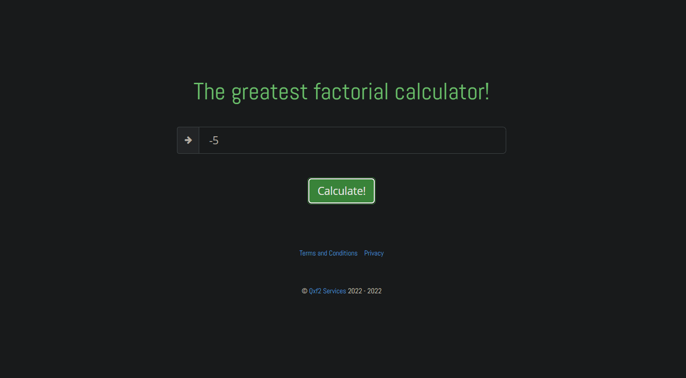

3. **Description:** 0 can be entered before a positive number and the factorial of the mentioned positive number is being calculated and displayed without the 0 being removed

Env: <https://qainterview.pythonanywhere.com/>  
**User:** N/A  
**Priority:** Low  
**Severity:** Minor  
**Steps to reproduce:**

* Navigate to <https://qainterview.pythonanywhere.com/>
* Enter a positive integer with 0 as a prefix inside the textbox indicating “Enter an integer”.
* Click on Calculate button

**Expected result:** 0 should be auto removed from textbox once Calculate button is being hit, and after calculation the result should be displayed for the positive integer and the description of the result should mention the same without 0.

**Actual result:** 0 is remaining in the text box and after calculation the result is being displayed for the positive integer and the description of the result is also containing 0.  
Please refer the screenshot below:  
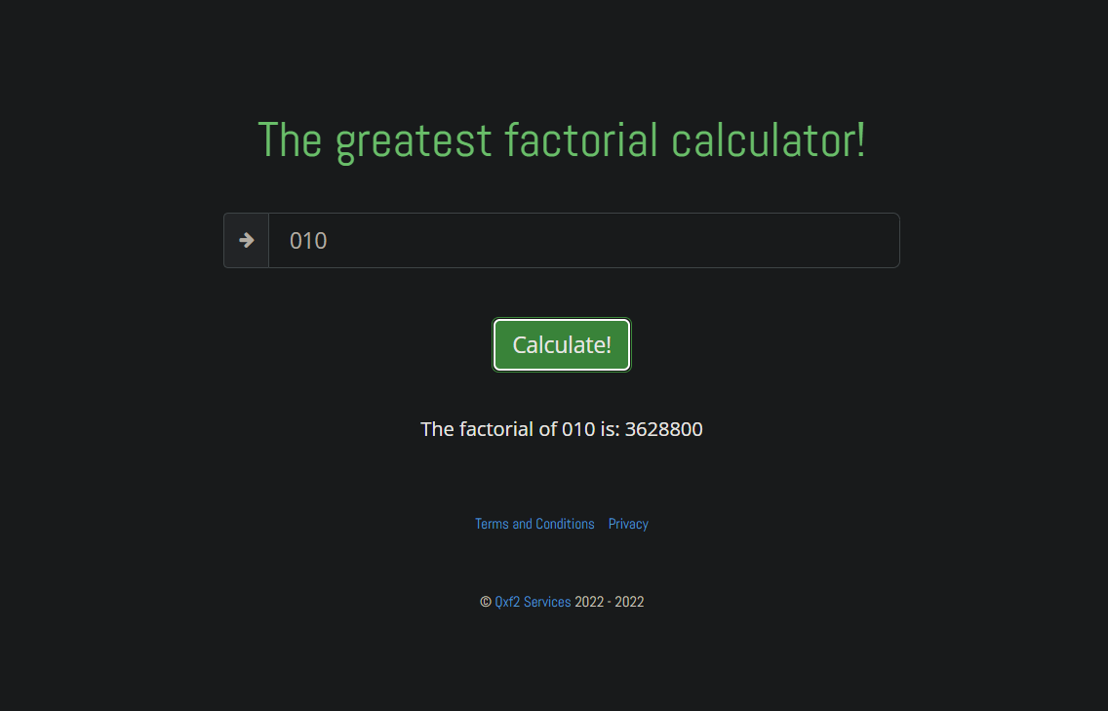

4.  **Description:** Incorrect result ie. “infinity” is being returned while calculating any number greater than 170 till 900.

Env: <https://qainterview.pythonanywhere.com/>  
**User:** N/A  
**Priority:** High  
**Severity:** Critical  
**Steps to reproduce:**

* Navigate to <https://qainterview.pythonanywhere.com/>
* Enter any positive integer between 171 and 900( >170<=900) inside the textbox indicating “Enter an integer”.
* Click on Calculate button

**Expected result:** Appropriate factorial should be calculated and the result should be displayed

**Actual result:** “Infinity” is being displayed as results for any number between the mentioned range.

Please refer the screenshots below:  
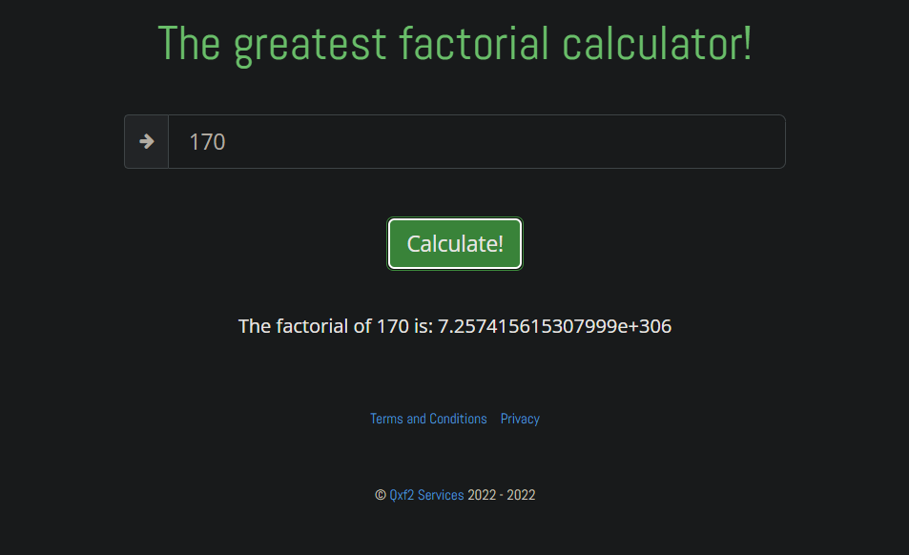  
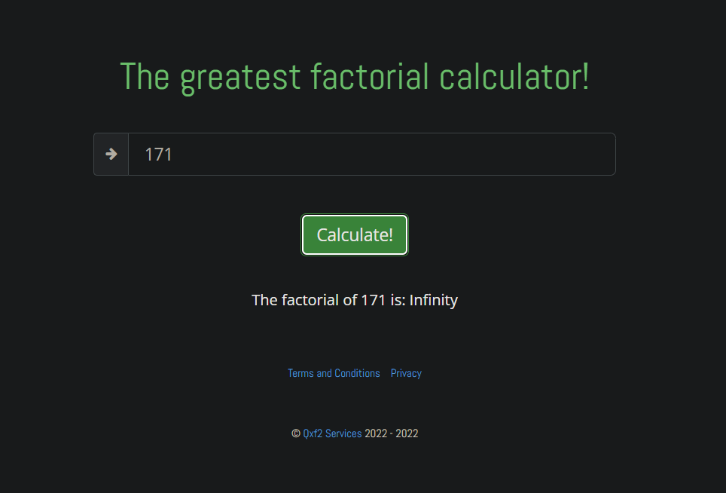  
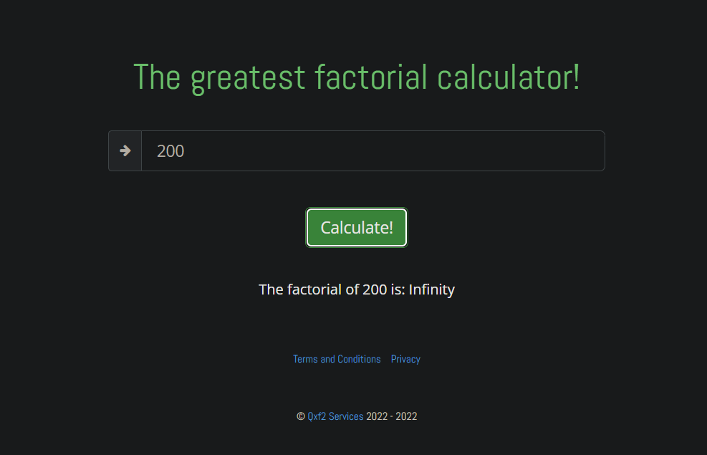  
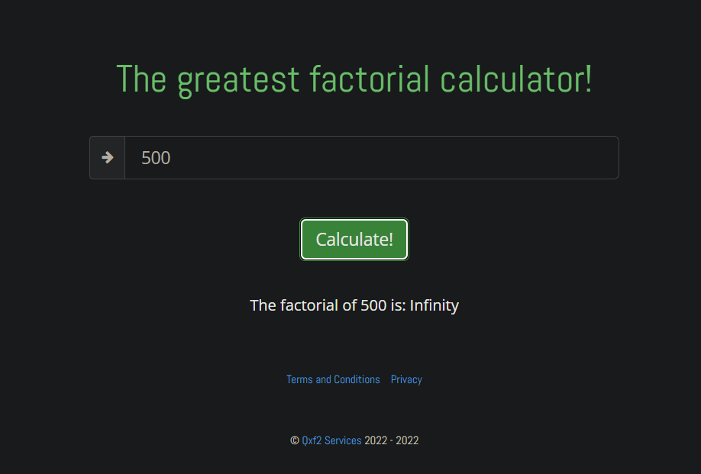  


5. **Description:** System is unable to calculate factorials of any number greater than 991. Internal server error is being occured:

Env: <https://qainterview.pythonanywhere.com/>  
**User:** N/A  
**Priority:** High  
**Severity:** Critical  
**Steps to reproduce:**

* Navigate to <https://qainterview.pythonanywhere.com/>
* Enter any positive integer greater than 991 inside the textbox indicating “Enter an integer”.
* Click on Calculate button

**Expected result:** Appropriate factorial should be calculated and the result should be displayed

**Actual result:** No calculation result is being returned.System is unable to calculate any number greater than 991. *Internal server error(500) in console.*  
  
Please refer the screenshots below: 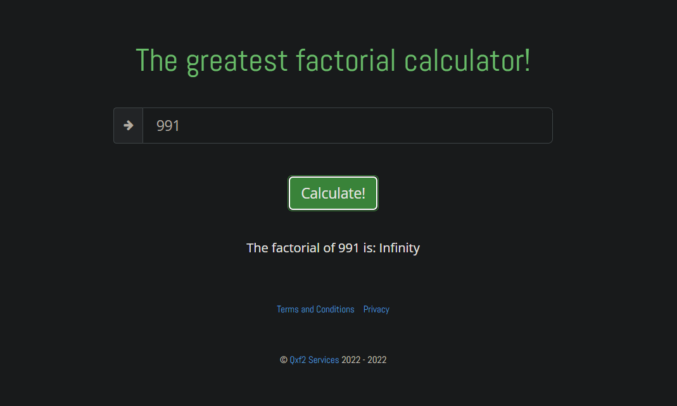  
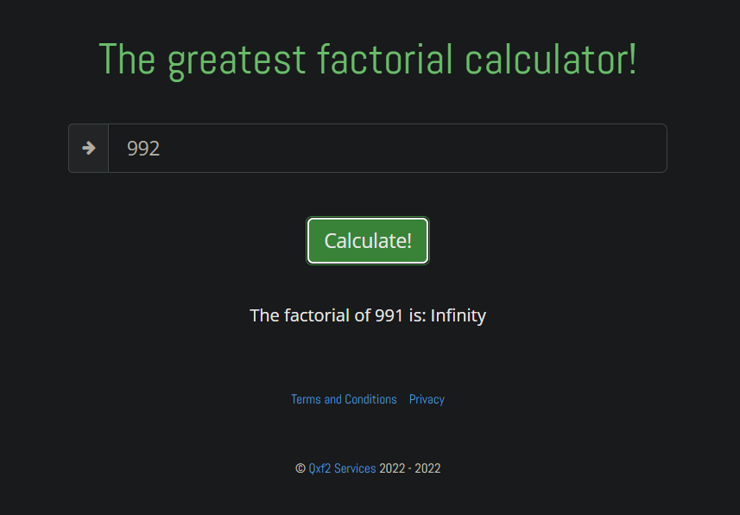  
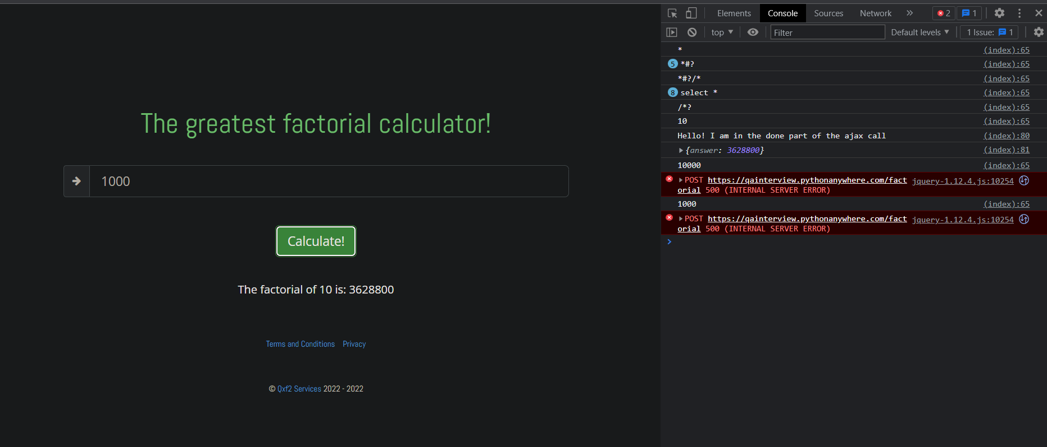

6. Description: Incorrect page(Privacy) upon clicking “Terms and Condition” link. Incorrect href mapping in xpath(href for privacy page is mapped with “terms and condition” UI hyperlink) .  
  
Env: <https://qainterview.pythonanywhere.com/>  
**User:** N/A  
**Priority:** High  
**Severity:** Critical  
**Steps to reproduce:**

* Navigate to <https://qainterview.pythonanywhere.com/>
* Click on “Terms and conditions” hyperlink

**Expected result:** Terms and conditions page should be opened with appropriate terms and conditions

**Actual result:** Privacy policy page is getting opened.  
If html codes of the very hyperlink is inspected then it is being confirmed that the href for Privacy page is mapped with terms and conditions link.  
*(Page is not ready yet)*  
  
Please refer the screenshots below:   
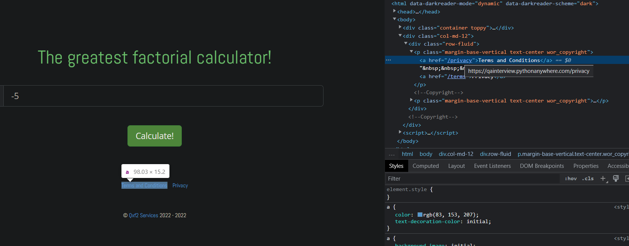

7. Description: Incorrect page(Terms and conditions) upon clicking “Privacy” link. Incorrect href mapping in xpath(href for terms and conditions page is mapped with “Privacy” UI hyperlink) .  
  
Env: <https://qainterview.pythonanywhere.com/>  
**User:** N/A  
**Priority:** High  
**Severity:** Critical  
**Steps to reproduce:**

* Navigate to <https://qainterview.pythonanywhere.com/>
* Click on “Privacy” hyperlink

**Expected result:** Privacy page should be opened with appropriate Privacy policy descriptions.

**Actual result:** Terms and conditions page is getting opened.  
If html codes of the very hyperlink is inspected then it is being confirmed that the href for Terms and conditions page is mapped with Privacy link.  
*(Page is not ready yet)*

Please refer the screenshots below:  
