**PROJECT-NAME: MED-CARE**

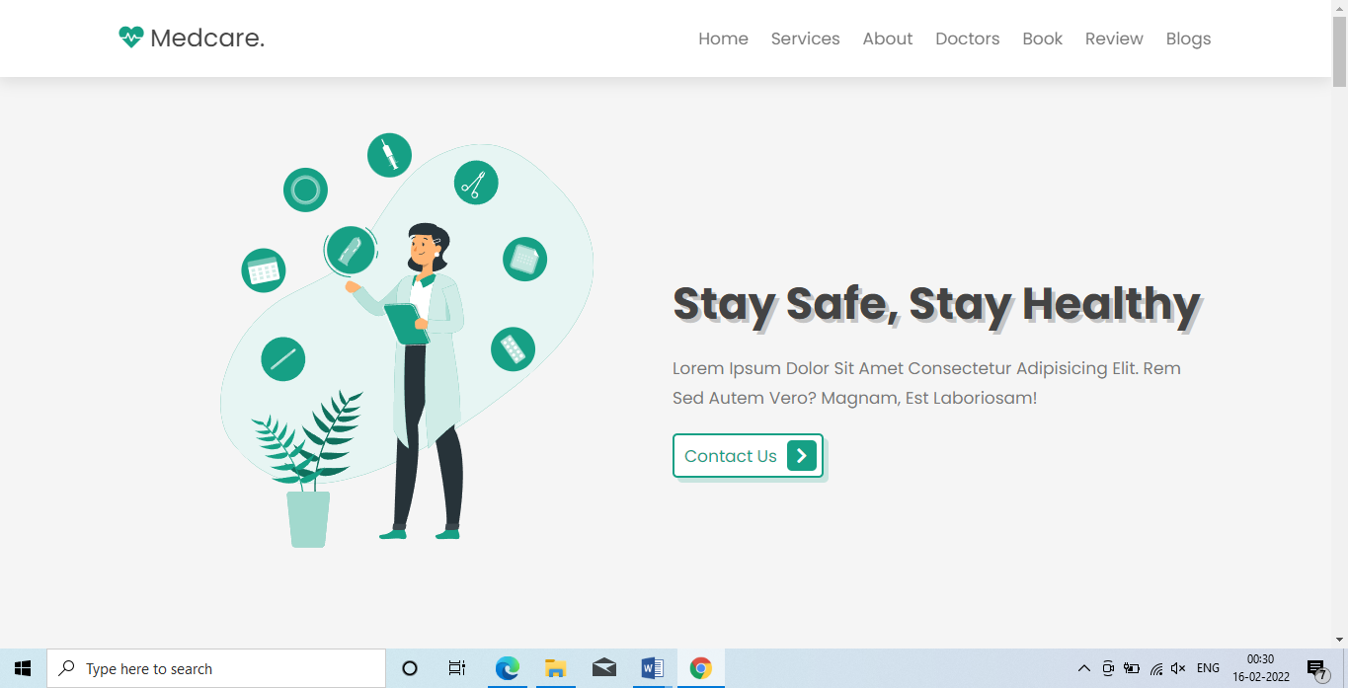

**\*OVERVIEW:** It’s an health-care website that deal into minimal invasive medical and surgical interventions.

**\*HOME-PAGE:**

#LOGO

#IMAGE

#CONTACT US

**\*APPOINMENT:**

#NAME

#EMAIL

#PHONE

#SELCET DOCTOR

#MESSAGE

#APPOINTMENT DATE

**\*ABOUT:**

**#**EMERGENCY

#SERVICES

#HEALTH IS WEALTH(LIKE)

**\*OUR BLOGS**

**\*REVIEW**