Stock Market Analysis Using Excel and Power BI

Introduction
This project focuses on analyzing stock market performance using historical data. The analysis was carried out using Microsoft Excel for data preparation and Power BI for individual visualizations. The project emphasizes trend analysis, return behavior, volatility, and trading volume .

Project Objectives
- Analyze closing price trends of selected stocks
- Evaluate cumulative returns and monthly performance
- Compare risk and return using volatility metrics
- Understand price distribution and trading activity

Dataset Description
The dataset includes daily stock market data for Apple (AAPL), Google (GOOG), Microsoft (MSFT), and Netflix (NFLX) from October to December 2025. Key fields include Date, Close Price, Volume, Daily Return, Cumulative Return Index, and Annual Volatility.

Tools Used
- Microsoft Excel – Data cleaning and calculation of returns and volatility
- Power BI – Creation of analytical visualizations

Exploratory Data Analysis (EDA)

1.Closing Price by Date and Ticker

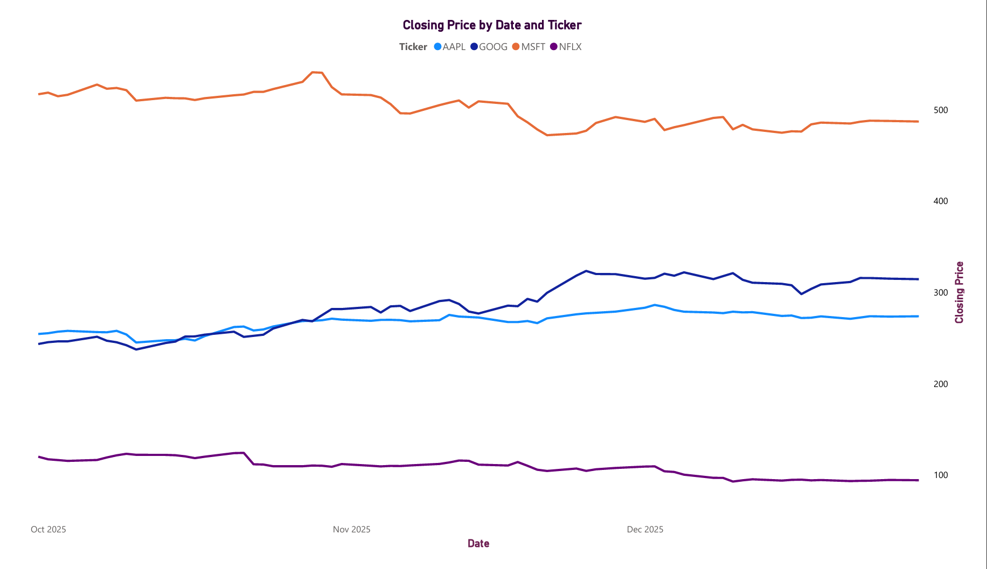
This graph illustrates the daily closing price movement of AAPL, GOOG, MSFT, and NFLX over the selected period. GOOG consistently maintains the highest price level, reflecting strong market value and stability. MSFT shows a clear upward trend, indicating positive growth momentum, while AAPL demonstrates steady but moderate price appreciation. In contrast, NFLX exhibits a declining trend, suggesting weaker performance during the period.

2. Cumulative Investment Growth Over Time

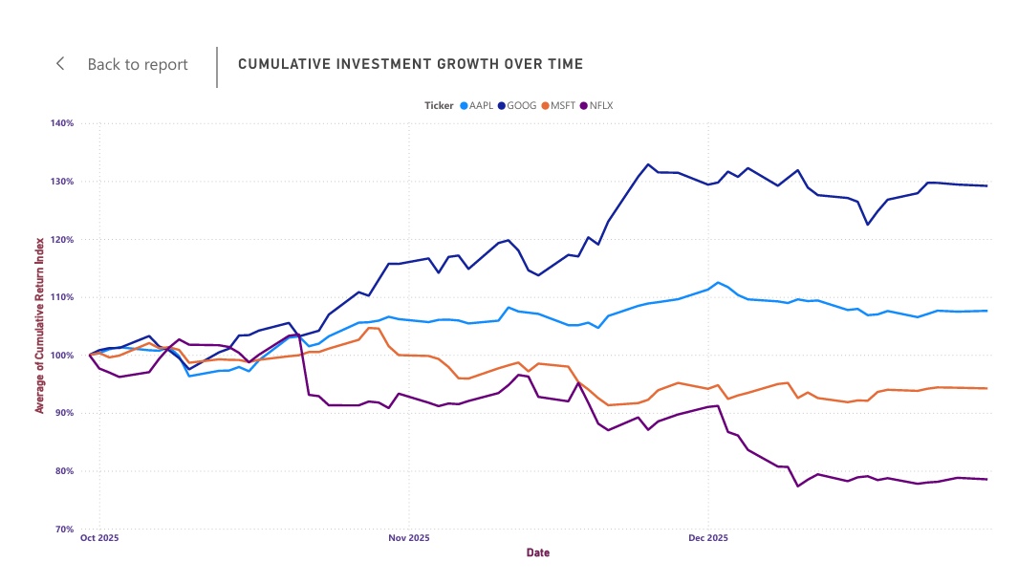
This chart represents cumulative investment growth over time, assuming an initial investment indexed at 100 for all stocks. GOOG shows the strongest performance, with cumulative returns rising above 130%, indicating consistent long-term growth and strong investor confidence. AAPL also demonstrates steady growth, ending above 105%, reflecting stable performance with moderate gains. MSFT remains relatively flat to slightly declining, suggesting limited growth during the period. In contrast, NFLX experiences a significant decline, falling below 80%, indicating negative cumulative returns and higher downside risk. This graph highlights how different stocks compound returns over time and clearly distinguishes strong performers from underperformers.
3. Monthly Average Return by Ticker
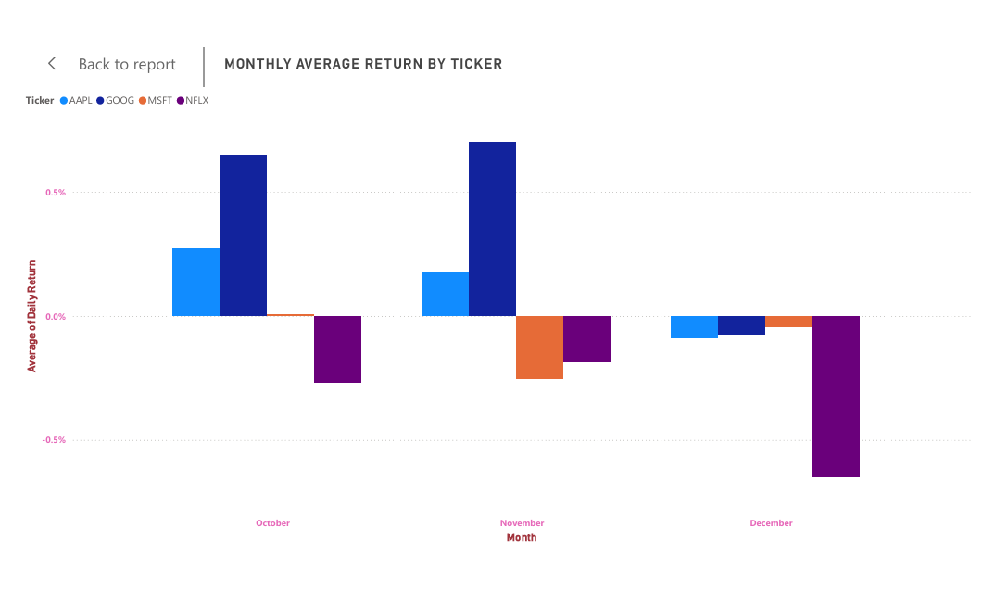
This chart compares the monthly average daily returns of the selected stocks across October, November, and December. GOOG delivers the strongest positive returns in October and November, indicating strong short-term performance during these months. AAPL also shows positive but relatively moderate returns in the same period. MSFT remains close to zero with slightly negative returns, suggesting stable but limited growth. NFLX consistently records negative returns, with a sharp decline in December, highlighting increased volatility and weaker performance. Overall, the chart shows clear differences in monthly performance, with GOOG outperforming and NFLX underperforming across the observed months.
4. Closing Price Distribution

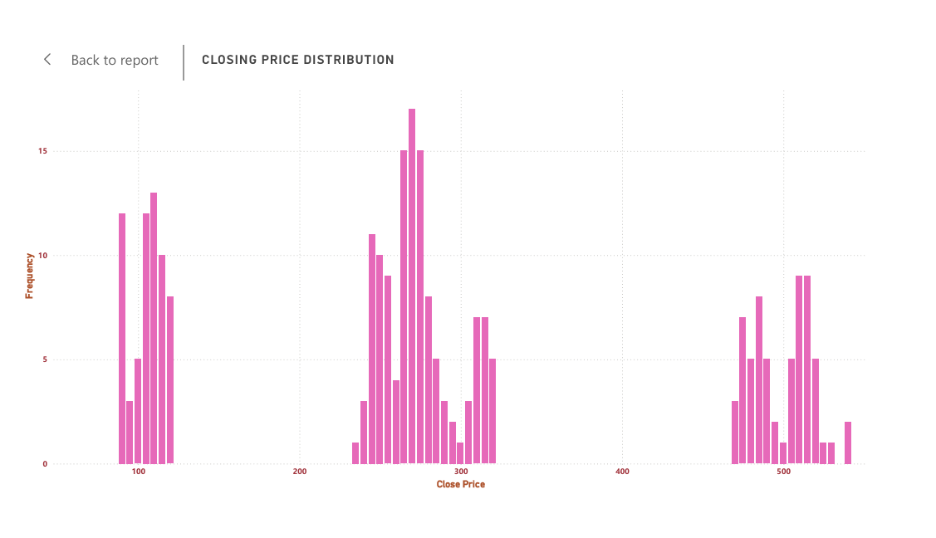
This histogram shows the distribution of closing prices for the selected stocks over the analysis period. The prices are grouped into distinct ranges, forming clear clusters that represent different stock price levels. Lower price ranges correspond to stocks like NFLX, mid-range values reflect AAPL and MSFT, while higher price ranges represent GOOG. The height of each bar indicates how frequently the closing prices occurred within that range. Overall, the distribution highlights that each stock trades within a relatively stable price band, with no extreme outliers, indicating consistent market behavior during the observed period.
5. Risk vs Return Analysis
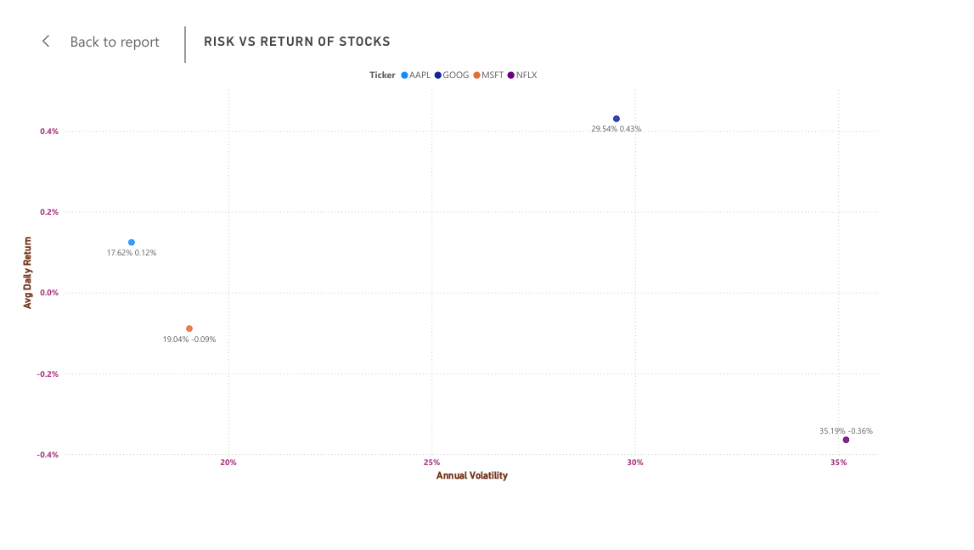

This scatter plot illustrates the relationship between risk (annual volatility) and return (average daily return) for the selected stocks. GOOG stands out by offering the highest average daily return with moderately high volatility, indicating a strong risk–return trade-off. AAPL shows relatively lower volatility with positive returns, making it a comparatively stable and balanced stock. MSFT has moderate risk but slightly negative returns during the period, suggesting underperformance despite controlled volatility. NFLX exhibits the highest volatility along with negative returns, indicating high risk without corresponding reward. Overall, the chart highlights how higher risk does not always guarantee higher returns and helps compare stock performance from a risk-adjusted perspective.

6. Trading Volume by Ticker
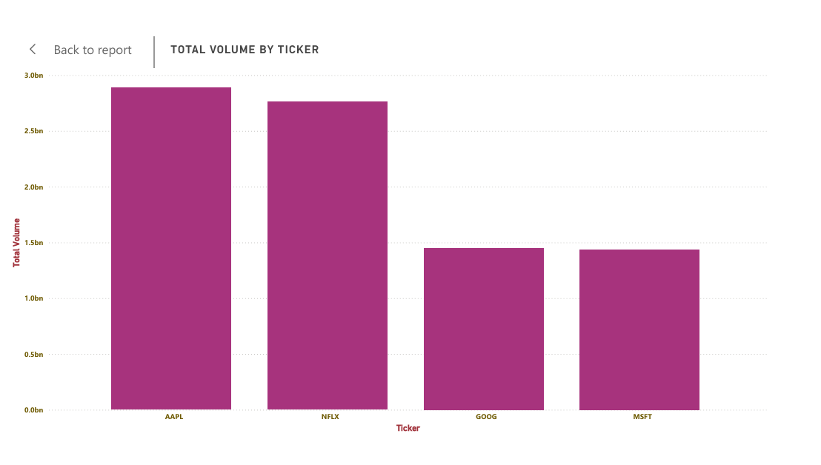 This bar chart compares the total trading volume of the selected stocks over the analysis period. AAPL shows the highest total volume, indicating strong investor interest and high liquidity in the market. NFLX also records a relatively high trading volume, suggesting active trading despite higher volatility. In contrast, GOOG and MSFT have comparatively lower volumes, indicating relatively fewer trades during the same period. Overall, the chart highlights differences in market participation and liquidity across stocks, which is an important factor when assessing ease of buying and selling shares.

Key Insights
- GOOG delivered the highest cumulative returns with a balanced level of risk, making it the best- performing stock during the analysis period.
- AAPL showed stable price movement and high trading volume, indicating strong market confidence and liquidity.
- -MSFT remained relatively low-risk with moderate and stable performance, suitable for conservative investment strategies.
- NFLX exhibited high volatility with negative returns, indicating higher risk without proportional reward.
- Monthly return analysis shows better performance in October and November, while December experienced weaker returns across most stocks.
- Closing price distribution highlights that each stock trades in a distinct price range, reflecting different market behaviours.
- Volume analysis confirms that higher trading volume does not always guarantee higher returns, as seen in NFLX.
Conclusion

The analysis shows clear differences in risk, return, and stability across stocks. GOOG and AAPL outperform in terms of returns and consistency, while NFLX carries higher risk. This project demonstrates effective market trend analysis using Excel and Power BI visualizations

