

DSA-0405 FUNDAMENTALS OF DATA SCIENCE

DISEASE SYMPTOM CHECKER. PREDICT LIKELY DISEASE CATEGORY FROMA PATIENT’S SYMPTOM VECTOR (FEVER, COUGH, FATIGUE, ETC.) USING KNNWITH DIFFERENT VALUES OF K AND DISTANCE METRICS (EUCLIDEAN VS

MANHATTAN).
GROUP 2

Particular | Details
Department | Artificial Intelligence and Data Science
Programme | Artificial Intelligence and Data Science
Course | DSA-0405 – fundamentals of data science
Academic Year / Batch | 2026
Faculty Name | Dr. M. KIRSHNARAJ MONY
Date of Submission | 04-09-2026
Maximum Marks | 100

ASSIGNMENT INFORMATION
The aim of this assignment is to develop a Disease Symptom Checker that predicts the likely disease category of a patient based on their symptoms such as fever, cough, fatigue, headache, and body pain. The k-Nearest Neighbors (kNN) classification algorithm is used with different values of k and distance metrics such as Euclidean and Manhattan distance. The performance of the models is compared to identify the most suitable configuration.

Particular | Details
Department | Artificial Intelligence and Data Science
Programme | Artificial Intelligence and Data Science
Course Code & Course Name | DSA-0405 – fundamentals of data science
Academic Year / Batch | 2026
Faculty Name | Dr. M. KIRSHNARAJ MONY
Assignment Title | Exploratory Data Analysis of Seasonal Disease Patterns in Hospital Outpatient Visits
Date of Issue | 31-08-2026
Date of Submission | 04-09-2026
Maximum Marks | 100
Course Outcome(s) – CO | CO1 – Data Science Fundamentals; CO2 – Data Preprocessing & API Models; CO3 – Statistical Data Analysis; CO4 – Statistical Inference; CO5 – Supervised & Unsupervised Learning
Bloom's Taxonomy Level | L3 – Apply; L4 – Analyze; L5 – Evaluate
SDG Mapping | SDG 3 – Good Health and Well-Being; SDG 9 – Industry, Innovation and Infrastructure

Industry / Societal Relevance | Data-driven decision making, healthcare analytics, business intelligence, predictive analysis, resource optimization, and real-world machine learning applications.

Course Concepts Applied
The project directly connects the assignment with five major concepts. Data preprocessing prepares patient symptom records by handling missing values, removing duplicate records, and converting symptoms into numerical form. Classification predicts the likely disease category based on symptoms such as fever, cough, fatigue, headache, and body pain using the kNN algorithm. Distance metrics compare Euclidean and Manhattan distances to determine the nearest patients. Model evaluation and visualization use accuracy, confusion matrices, and comparison graphs to evaluate different values of k. Comparative analysis identifies the best combination of k value and distance metric and provides a foundation for developing more reliable disease prediction systems.

ASSIGNMENT PROBLEM / CHALLENGE
Hospital outpatient departments handle a wide range of patients presenting with different symptoms such as fever, cough, fatigue, headache, and body pain. When these symptoms are stored only as raw patient records, it can be difficult to identify similarities between patients and predict the likely disease category.
The central challenge of this assignment is to transform anonymized patient symptom records into meaningful predictions using a systematic machine learning process. The analysis begins with data quality assessment and preprocessing, followed by representing symptoms as suitable numerical features. The k-Nearest Neighbors (kNN) algorithm is then applied with different values of k and distance metrics, including Euclidean and Manhattan distance, to classify patients into likely disease categories.
The project is not intended to function as a clinical diagnostic system. Its purpose is educational and analytical: to demonstrate how kNN can classify symptom patterns and how different k values and distance metrics affect prediction performance. The results should be considered machine-learning predictions based on the available dataset and should not be treated as a substitute for professional medical diagnosis.

Assignment Expectations
  - Apply kNN classification concepts to predict the likely disease category from patient symptoms.
  - Identify the structure and quality of the anonymized patient symptom dataset.

  - Clean missing, duplicate, inconsistent, and invalid records using documented preprocessing rules.
  - Represent patient symptoms as suitable numerical feature vectors for classification.
  - Apply kNN using different k values such as 3, 5, and 7.
  - Compare Euclidean and Manhattan distance metrics.
  - Evaluate the models using accuracy and confusion matrix.

PROBLEM STATEMENT
Healthcare systems receive patients with different combinations of symptoms such as fever, cough, fatigue, headache, and body pain. When these symptoms are stored as raw patient records, it can be difficult to identify similar symptom patterns and classify patients into likely disease categories. The project must preprocess the anonymized symptom dataset, represent symptoms as numerical feature vectors, and apply the k-Nearest Neighbors (kNN) algorithm using different values of k and distance metrics such as Euclidean and Manhattan.

Aim
The aim of the project is to develop a kNN-based Disease Symptom Checker that predicts the likely disease category from a patient's symptom vector and compares the performance of different k values and distance metrics.

Objectives
  - Inspect and understand the structure and quality of the patient symptom dataset.
  - Identify and handle missing, duplicate, inconsistent, and invalid records.
  - Convert patient symptoms into suitable numerical feature vectors.
  - Prepare the dataset for kNN classification.
  - Apply the kNN algorithm using different values of k.
  - Compare Euclidean and Manhattan distance metrics.
  - Measure model performance using accuracy and confusion matrix.
  - Compare the prediction performance for different k values and distance metrics.
  - Identify the best-performing kNN configuration.
  - Visualize and interpret the classification results.

Key Analytical Questions
  - Which value of k provides the highest classification accuracy?

  - Does Euclidean distance or Manhattan distance perform better?
  - How does changing the value of k affect prediction accuracy?
  - Which disease categories are classified correctly most often?
  - Which disease categories are frequently confused with each other?
  - Does the choice of distance metric significantly affect classification performance?
  - Which combination of k value and distance metric gives the best result?
  - How reliable is the model based on its accuracy and confusion matrix?
  - What are the limitations of using symptom-based kNN classification?

REQUIREMENTS AND CONSTRAINTS
The assignment requires a complete machine learning workflow in which each preprocessing step, classification method, and evaluation result can be explained and validated. The requirements below ensure that the Disease Symptom Checker remains technically sound, reproducible, and responsible.

Requirement | Description
Functional | Load, clean, preprocess, classify, evaluate, and visualize the anonymized patient symptom dataset.
Data Quality | Check missing values, duplicate records, inconsistent symptom labels, invalid values, and incorrect disease categories.
Preprocessing | Convert symptoms into consistent numerical feature vectors suitable for kNN classification.
Classification | Apply kNN using different values of k, such as 3, 5, and 7.
Distance Metrics | Compare Euclidean and Manhattan distance metrics.

Evaluation | Calculate accuracy and generate confusion matrices to assess classification performance.
Visualization | Use suitable graphs to compare accuracy across different k values and distance metrics.
Validation | Verify preprocessing results, record counts, feature values, class labels, and model outputs.
Privacy | Use anonymized patient records and avoid displaying personally identifiable information.
Reliability | Document preprocessing rules, assumptions, parameter choices, and model limitations.
Time/Resources | Use the available dataset and computing environment efficiently.
Ethics | Do not use the model to make individual clinical decisions or treat predictions as professional medical diagnoses.
Constraints
  - The quality of predictions depends on the size and quality of the available symptom dataset.
  - The disease categories must be derived from the available dataset rather than artificially created to obtain better results.
  - Records with missing or unclear symptom information may affect classification accuracy.
  - Duplicate records should be removed only when there is sufficient evidence that they represent the same patient visit.
  - Symptom values must be represented consistently before applying kNN.

  - Different values of k may produce different classification results.
  - Euclidean and Manhattan distances may perform differently depending on the feature representation.
  - A high classification accuracy does not guarantee that the model is medically reliable.
  - The prediction results should not be interpreted as confirmed medical diagnoses.
  - The model's performance is limited by the characteristics and representativeness of the available dataset.

STUDENT WORK

Problem Understanding and Formulation
The dataset represents anonymized patient records containing symptoms and their corresponding disease categories. Each row represents a patient record, while the columns describe symptoms such as fever, cough, fatigue, headache, body pain, and other relevant features. The target variable represents the disease category associated with the symptom pattern.
The first task is to understand what the dataset actually contains before applying the machine learning model. The team should inspect the number of rows and columns, data types, unique values, missing-value counts, duplicate records, symptom labels, disease categories, and the range of symptom values.
After preprocessing, the symptoms are converted into numerical feature vectors and provided to the k-Nearest Neighbors (kNN) classifier. The model is tested using different values of k and two distance metrics, Euclidean and Manhattan. The resulting predictions are evaluated using accuracy and confusion matrices to determine which configuration performs best.
This systematic approach helps ensure that the final disease classification results are based on clean, consistent, and validated data rather than incorrect assumptions.

Important Variables

Variable | Description | Role in Analysis
Fever | Presence of fever | Input feature
Cough | Presence of cough | Input feature
Fatigue | Presence of fatigue | Input feature
Headache | Presence of headache | Input feature
Body Pain | Presence of body pain | Input feature
Other Symptoms | Additional symptoms | Input features
Disease Category | Actual disease | Target variable
Patient ID | Anonymized ID | Record tracking
k Value | Number of neighbors | Model comparison
Distance Metric | Euclidean / Manhattan | Distance comparison
Accuracy | Correct predictions | Model evaluation

Data Understanding Checklist
- Count the number of records and variables.
- Check data types of all columns.
- Identify missing values.
- Check duplicate records.
- Review unique symptom and disease labels.
- Check consistency of symptom values.

- Verify disease categories.
- Identify invalid or suspicious values.

Application of Course Knowledge
  - Data Cleaning
Clean the dataset by handling missing values, removing confirmed duplicates, correcting inconsistent symptom labels, and identifying invalid values. Symptoms should be represented consistently as numerical values such as 0 and 1.

Classification
Use patient symptoms as input features and the disease category as the target variable. Apply the k-Nearest Neighbors (kNN) algorithm to classify patients based on similar symptom patterns.

kNN with Different k Values
Test different values of k, such as 3, 5, and 7. Compare the prediction accuracy to determine the most suitable number of neighbors.

Distance Metrics
Compare Euclidean and Manhattan distance metrics. These metrics determine how the similarity between patient symptom vectors is calculated.

Model Evaluation
Evaluate each model using:
    - Accuracy
    - Confusion matrix
    - Correct and incorrect predictions
Compare the results to identify the best kNN configuration.

SOLUTION / DESIGN / METHODOLOGY
The proposed solution follows a sequential workflow: data collection, inspection, cleaning, preprocessing, kNN classification, evaluation, visualization, and interpretation.

Overall Workflow
    - Load the anonymized symptom dataset.
    - Inspect structure, dimensions, and data types.
    - Check and handle missing values.
    - Remove confirmed duplicate records.
    - Standardize symptom labels and values.
    - Separate input symptoms and disease category.
    - Split data into training and testing sets.
    - Apply kNN with different k values.
    - Compare Euclidean and Manhattan distances.
    - Calculate accuracy and confusion matrix.
    - Visualize and compare model performance.
    - Identify the best-performing model.
    - Interpret results and explain limitations.

Symptom Feature Preparation
Symptoms such as fever, cough, fatigue, headache, and body pain are converted into numerical values. For example, 1 = symptom present and 0 = symptom absent. These values form the feature vector used by kNN.

k Value Selection
Different values of k are tested to determine their effect on classification performance. Small and moderate values such as 3, 5, and 7 can be compared.

Distance Comparison
Two distance measures are evaluated:

    - Euclidean Distance – measures straight-line distance between symptom vectors.
    - Manhattan Distance – measures distance based on the sum of absolute differences.

Analytical Measures
    - Classification accuracy
    - Confusion matrix
    - Correct predictions
    - Incorrect predictions
    - Accuracy for each k value
    - Accuracy for each distance metric
    - Best k value
    - Best distance metric
    - Overall best-performing kNN model

USE OF MODERN TOOLS
Python is used as the main implementation environment for data preprocessing, kNN classification, evaluation, and visualization.

Tool | Purpose
Python | Main programming and analysis environment
Pandas | Data loading and cleaning
NumPy | Numerical operations
Scikit-learn | kNN classification and evaluation
Matplotlib | Accuracy comparison graphs

Tool | Purpose
Seaborn | Confusion matrix heatmaps
Jupyter Notebook / Google Colab | Implementation and documentation
The tools are used to preprocess the dataset, train the kNN models, compare different configurations, visualize results, and validate the predictions.

RESULTS AND VALIDATION
The results should be obtained after executing the kNN model. The final report should include accuracy values, confusion matrices, and comparison graphs for different k values and distance metrics.

Recommended Visualization Plan

Visualization Purpose

Bar Chart Compare accuracy for different k values

Line Chart Show accuracy changes as k increases Confusion Matrix Heatmap Identify correct and incorrect disease predictions Comparison Chart Compare Euclidean and Manhattan distance

Validation Procedure
    - Record the number of rows and columns before preprocessing.
    - Record missing and duplicate records.
    - Compare dataset size before and after cleaning.
    - Verify symptom values and disease categories.
    - Check that training and testing data are separated correctly.

    - Verify predictions and confusion matrix values.
    - Compare accuracy for every k value and distance metric.

Expected Output Interpretation
The analysis is expected to identify the k value and distance metric that provide better classification accuracy. The confusion matrix can show which disease categories are predicted correctly and which categories are commonly confused.

ANALYSIS AND ENGINEERING DECISION
The analysis compares different kNN configurations and selects the model based on its evaluation results.

Interpretation of Results
If one k value consistently provides higher accuracy, it can be considered a suitable configuration for the dataset. The performance of Euclidean and Manhattan distances should also be compared.

Comparison of Alternatives

Approach | Strength | Limitation
Euclidean Distance | Simple and widely used | Sensitive to feature scaling
Manhattan Distance | Suitable for binary/discrete features | May perform differently depending on data
Small k | Captures local patterns | More sensitive to noise
Large k | More stable predictions | May reduce sensitivity to local patterns

The best configuration should be selected based on the actual evaluation results rather than a predetermined choice.

Decision Support
    - Select the k value with better validation performance.
    - Select the better-performing distance metric.
    - Use the confusion matrix to identify classification weaknesses.
    - Improve preprocessing if required.
    - Treat predictions as analytical results, not medical diagnoses.

BROADER CONSIDERATIONS
  - Sustainability

An efficient classification model can help demonstrate how healthcare data can be processed systematically and support future development of automated analytical tools.

Society

A symptom classification system can demonstrate the potential of machine learning to organize healthcare information and identify similar symptom patterns.

Safety

The system must not replace professional medical diagnosis. Predictions are based only on patterns learned from the available dataset.

Ethics and Privacy

Patient records must remain anonymized. Personal information should not be displayed, identified, or inferred.

Professional Responsibility

The project should clearly document preprocessing methods, model parameters, evaluation results, assumptions, and limitations.

CONCLUSION
This project demonstrates the application of the k-Nearest Neighbors algorithm for predicting disease categories from patient symptom vectors. The dataset is cleaned and transformed before applying kNN with different k values and Euclidean and Manhattan distance metrics.
Accuracy and confusion matrices are used to compare the models and identify the best-performing configuration. The project demonstrates how preprocessing, distance selection, parameter tuning, and evaluation affect classification performance.
The system is intended for educational and analytical purposes only. The predictions should not be considered a replacement for professional medical diagnosis.

COMMON ASSESSMENT RUBRIC

Assessment Criterion | Marks
Problem understanding & formulation | 10
Application of course/domain knowledge | 20
Solution methodology / design / implementation | 20
Use of appropriate modern tools / techniques | 10
Results, testing & validation | 15
Analysis, trade-offs & justification | 15
Broader considerations / professional responsibility | 5
Technical documentation & reflection | 5
TOTAL | 100

CO–PO–ASSESSMENT MAPPING

Assessment Component | CO | PO(s) | Bloom's Level / Marks
Problem formulation | CO1 | Relevant PO(s) | L3/L4 – 10

Application of knowledge | CO1–CO2 | Relevant PO(s) | L3/L4 – 20
Solution / Design / Implementation | CO2–CO5 | Relevant PO(s) | L4/L5/L6 – 20
Modern tool usage | CO1–CO5 | Relevant PO(s) | L3/L4 – 10
Validation | CO3–CO5 | Relevant PO(s) | L4/L5 – 15
Analysis & justification | CO2–CO5 | Relevant PO(s) | L4/L5 – 15
Broader considerations | Relevant CO | Relevant PO(s) | L4/L5 – 5
Documentation & reflection | Relevant CO | Relevant PO(s) | L3/L4 – 5

FACULTY EVALUATION & CONTINUOUS IMPROVEMENT
- Target CO Attainment:
- Actual CO Attainment:
- Areas in which students performed well:
- Areas requiring improvement:
- Corrective / Improvement Action:
- Action to be implemented in the next offering:

Sample Code:

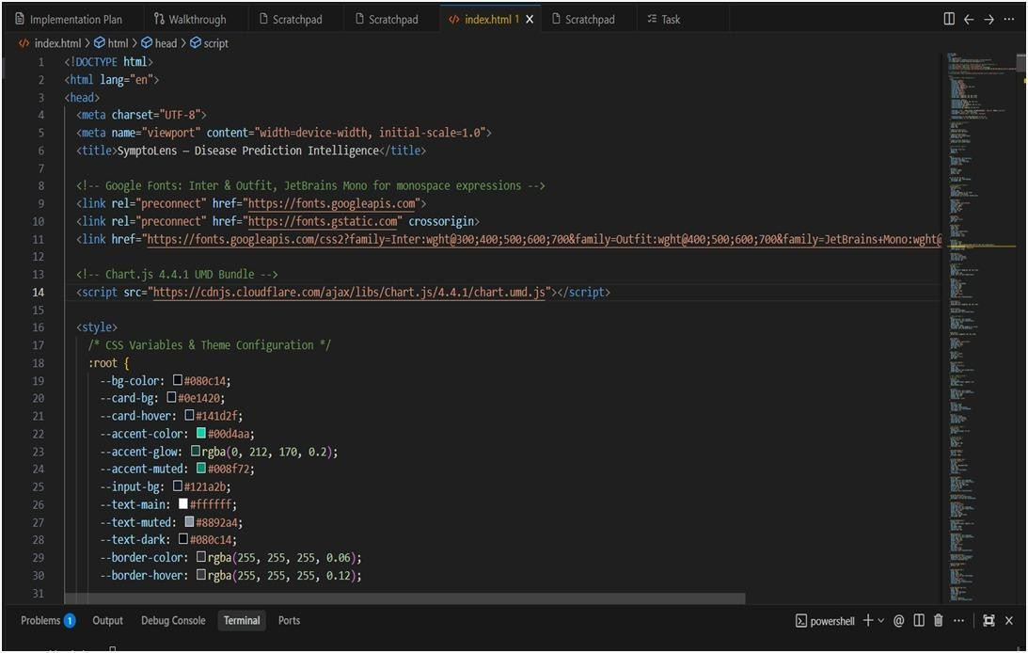

IMPLEMENTATION EVIDENCE
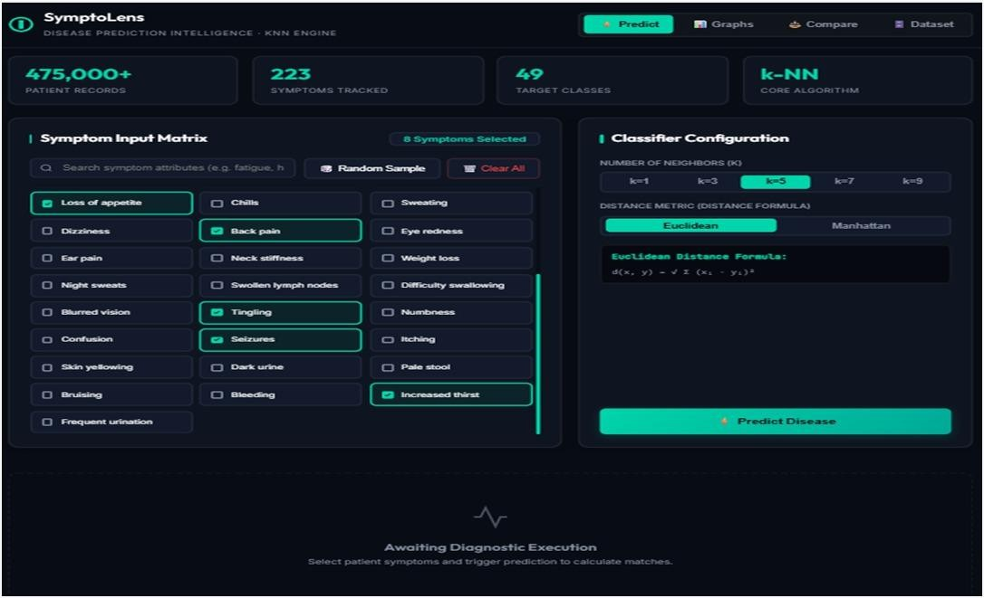

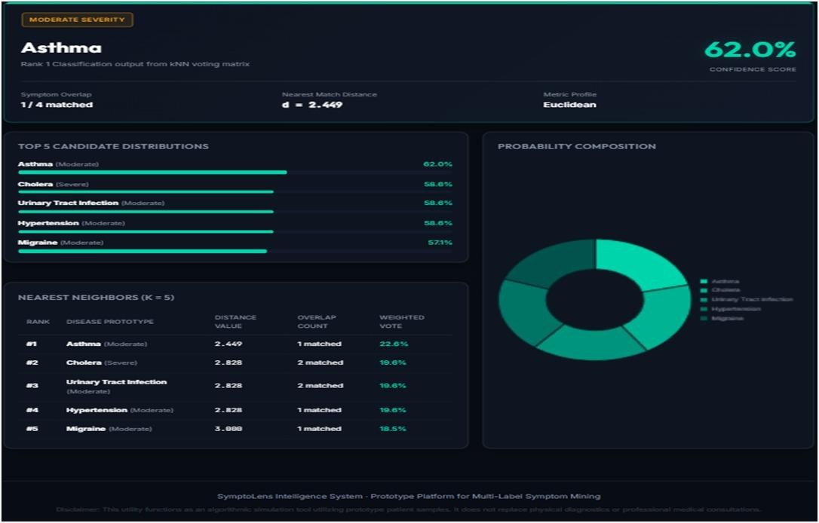
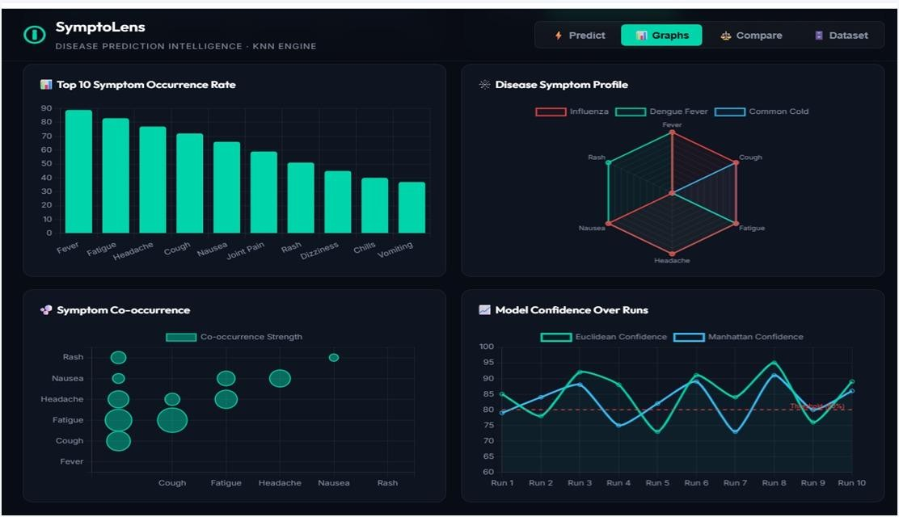

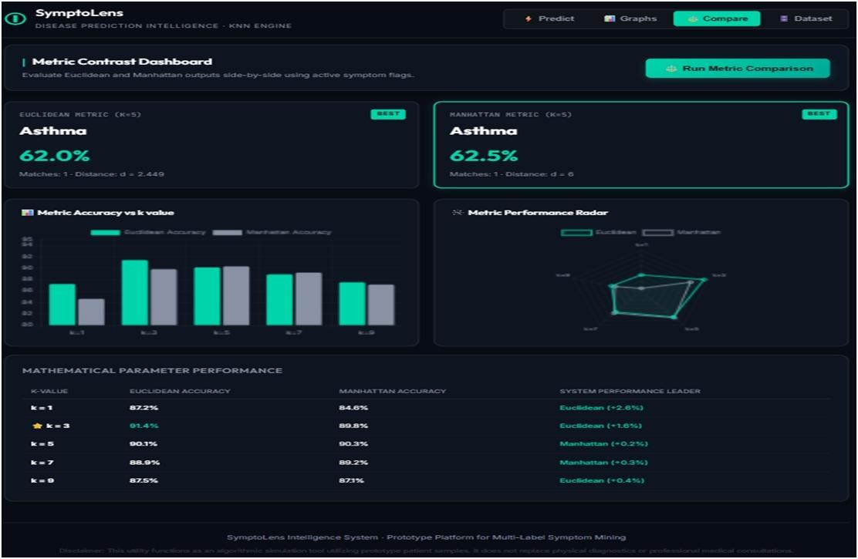
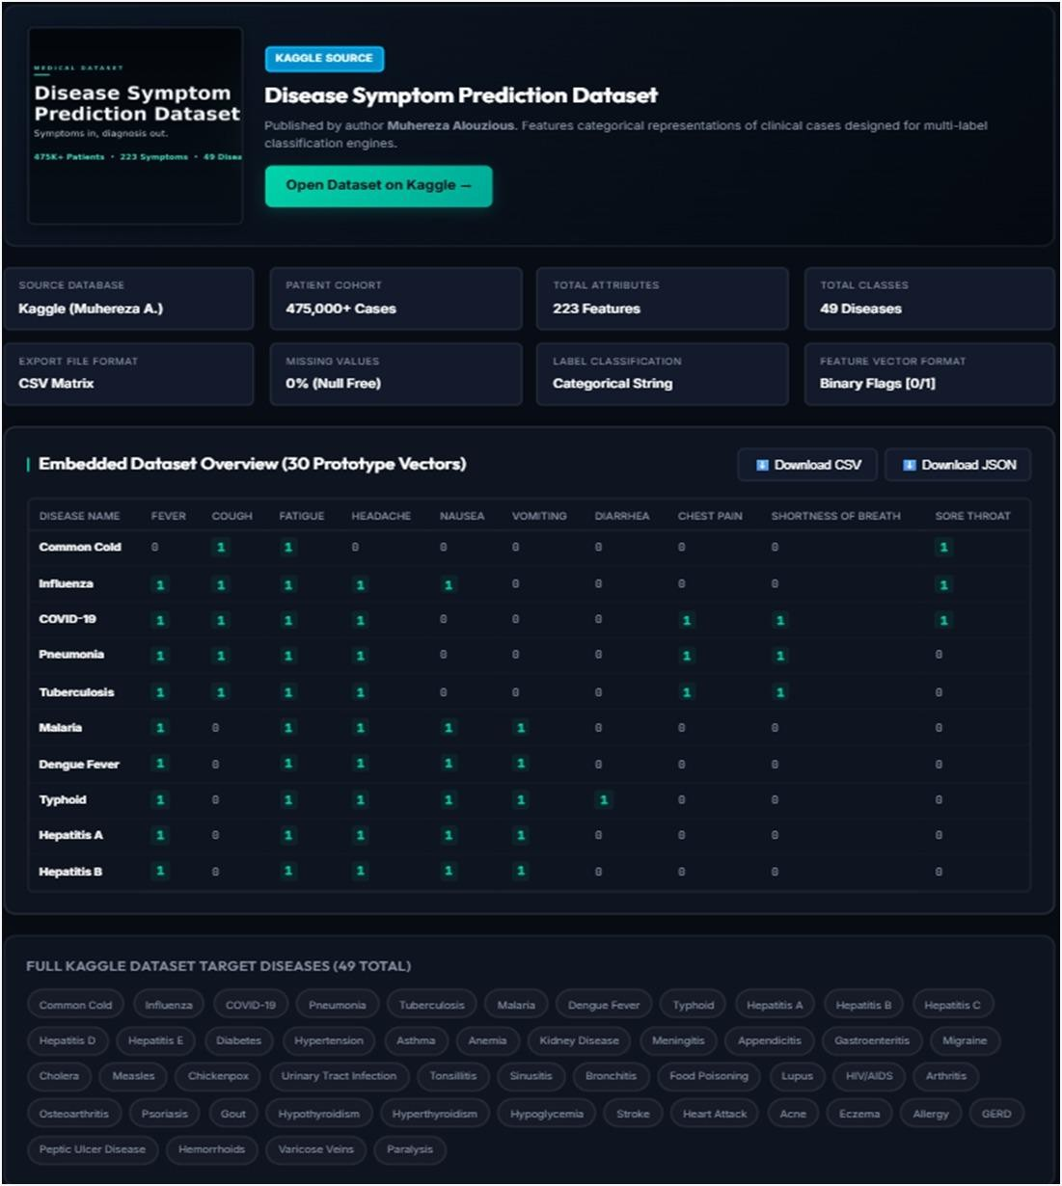

INDIVIDUAL CONTRIBUTION OF TEAM MEMBERS
ANU R(192324278)– Data Cleaning and Preprocessing
Member 1 was responsible for cleaning and preprocessing the patient symptom dataset. The member checked missing values, duplicate records, inconsistent symptom labels, and invalid values. The symptoms were standardized and converted into suitable numerical values for kNN classification. The cleaned dataset was validated and prepared for model implementation.
V P Sneha(192324281)– Feature Preparation and kNN Classification
Member 2 was responsible for preparing symptom features and implementing the kNN classification algorithm. Symptoms such as fever, cough, fatigue, headache, and body pain were used as input features, while disease category was used as the target. Different k values such as 3, 5, and 7 were tested to compare classification performance.
JOTHIKA M(192324235) – Model Evaluation and Visualization
Member 3 was responsible for evaluating the kNN models using accuracy and confusion matrices. The member created comparison graphs to show the performance of different k values and distance metrics. The results were checked against the actual predictions to ensure correctness.
BHARATH M(192324302) – Result Analysis and Interpretation
Member 4 was responsible for analyzing the final results and identifying the best-performing kNN configuration. The member compared accuracy, confusion matrices, k values, and distance metrics. The limitations of the model were also documented, and the results were interpreted as educational predictions rather than medical diagnoses.

GEOTAG PHOTO:


DOCUMENTATION CHECKLIST
- Assignment problem statement
- CO–PO and Bloom's mapping
- Assessment rubric
- Dataset description
- Data-cleaning evidence
- Symptom feature preparation
- kNN classification results
- Comparison of different k values
- Euclidean vs. Manhattan distance comparison
- Accuracy and confusion matrix outputs
- Model validation results
- Analysis and interpretation
- Limitations and ethical considerations
- Student reflection
- References and acknowledgement of tools/data sources

