SIMATS ENGINEERING
ASSESSMENT TOOL I – EXPERIMENTS
Course: Data Handling and  Visualization | Code: DSA0603 | CO: CO3
Duration: 120 min | Total Marks: 100 | Reg No :  Name:

COURSE OUTCOME COVERED
CO3: Analyze time-series data, trends, associations, and uncertainty through appropriate visualization methods. (BL4) Activity Tool : Experiments
Weightage: 20%
Code of Conduct:
I V.P Sneha(192324284) (Name / Reg No) certify that this submission is my original work and that I have adhered to the guidelines specified for this assessment. I understand that any violation of academic integrity rules will result in disciplinary action.
Signature of the student: v.p sneha
Criteria | Understanding of Concepts  25% | Experimental  Design  30% | Use of Tools  20% | Analysis of  Results  15% | Documents  10% | Total
Q1
Q2
Q3
Q4
Q5

DSA06 – Data Handling and Visualization | Assessment Tool: Experiment
DSA06 – DATA HANDLING AND VISUALIZATION
CO3_AT1_Assessment Tool: EXPERIMENT
Question 1 – Distribution Diagnosis using ECDF and Q-Q Plot
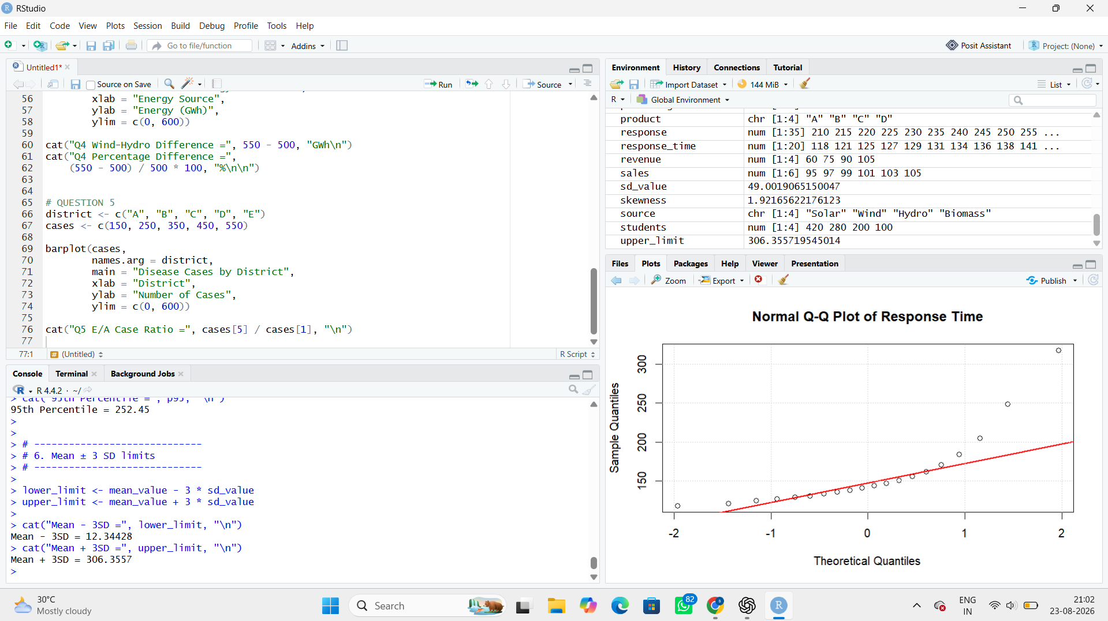

Interpretation
- The ECDF shows that most response times are concentrated below approximately 180 ms.
- The observations 205, 249 and 318 ms form a long upper tail.
- The Q-Q plot will show deviations from the straight reference line, especially at the upper end.
- Therefore, the data are right-skewed rather than approximately normal.
- The value 318 ms is an extreme observation.

Recommendation
For monitoring this dataset, percentile-based limits are preferable because the distribution is skewed and contains extreme high values.
For example:
5th percentile – 95th percentile
is more robust than relying only on:
Mean ± standard deviation
Question 2 – Comparing Many Distributions and Bean Plots
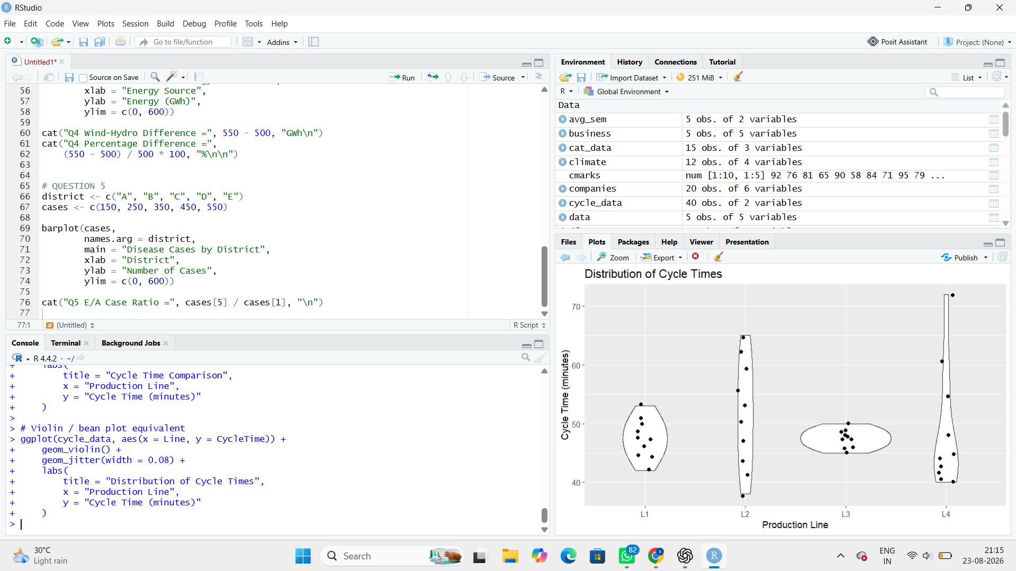

Three Largest Flows
The largest individual flows are:
- Residential → Bus → Central = 35
- Suburban → Train → Central = 30
- Residential → Train → Central = 25

Result
Flow | Commuters | Percentage
Residential → Bus → Central | 35 | 17.5%
Suburban → Train → Central | 30 | 15%
Residential → Train → Central | 25 | 12.5%
Together:
17.5 + 15 + 12.5 = 45%
So the three largest flows represent 45% of all commuters.
Question 3 – Proportion Visualization and Choice of Chart
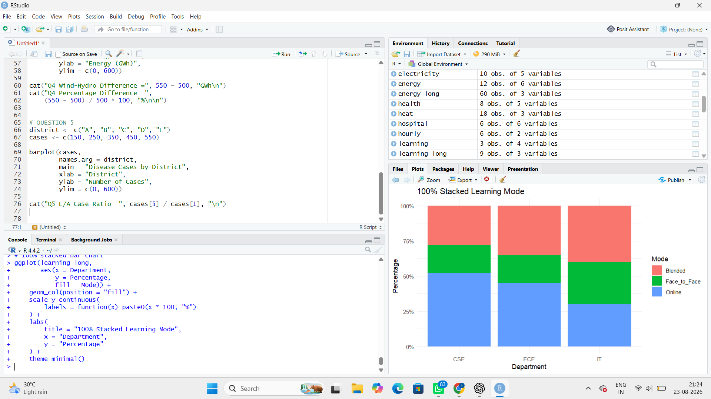

2. Which chart is better?
The side-by-side bar chart is better for comparing individual proportions.
For example, Online learning can be directly compared:
- CSE = 52%
- ECE = 45%
- IT = 30%
All bars have the same baseline, making small differences easier to compare accurately.
The 100% stacked bar chart is better for seeing the overall composition of each department, but comparing individual segments is more difficult.

3. Why are separate pie charts less effective?
Separate pie charts are less effective because:
- Each department has a separate circle.
- Slice angles are harder to compare than bar lengths.
- Small differences are difficult to identify.
- The starting position of slices can differ.
Therefore, a grouped bar chart provides a more accurate comparison.

4. Design choice that can exaggerate differences
A truncated Y-axis can make small differences appear much larger.
For example, showing an axis from 40% to 55% instead of 0% to 100% would make 52% and 45% appear dramatically different.

Question 4 – Nested Proportions using Treemap and Sunburst
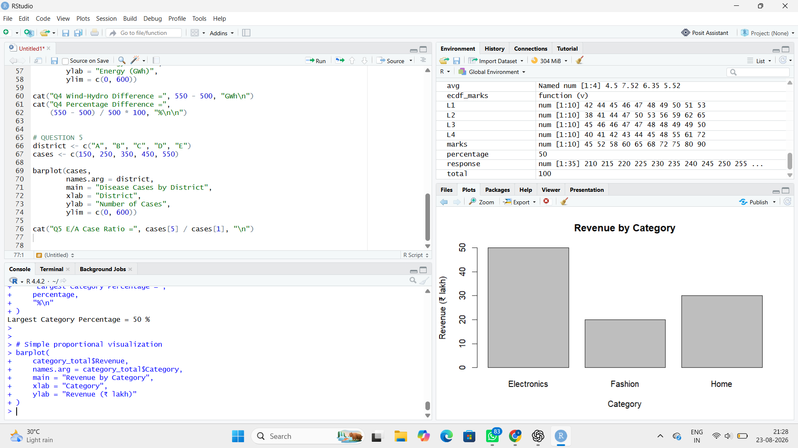

4. Treemap vs Sunburst
Treemap:
- Uses rectangular areas.
- Good for comparing revenue magnitude.
- Shows category and subcategory together.
- Large categories are easy to identify.
Sunburst:
- Uses concentric rings.
- Inner ring = categories.
- Outer ring = subcategories.
- Better for understanding the hierarchy.

5. How can area encoding mislead?
Area comparisons can be difficult when shapes have different dimensions. Two regions with similar areas may look different because one is long and narrow while another is compact.
Question 5 – Flow Proportions using Sankey Diagram / Parallel Sets Scenario:
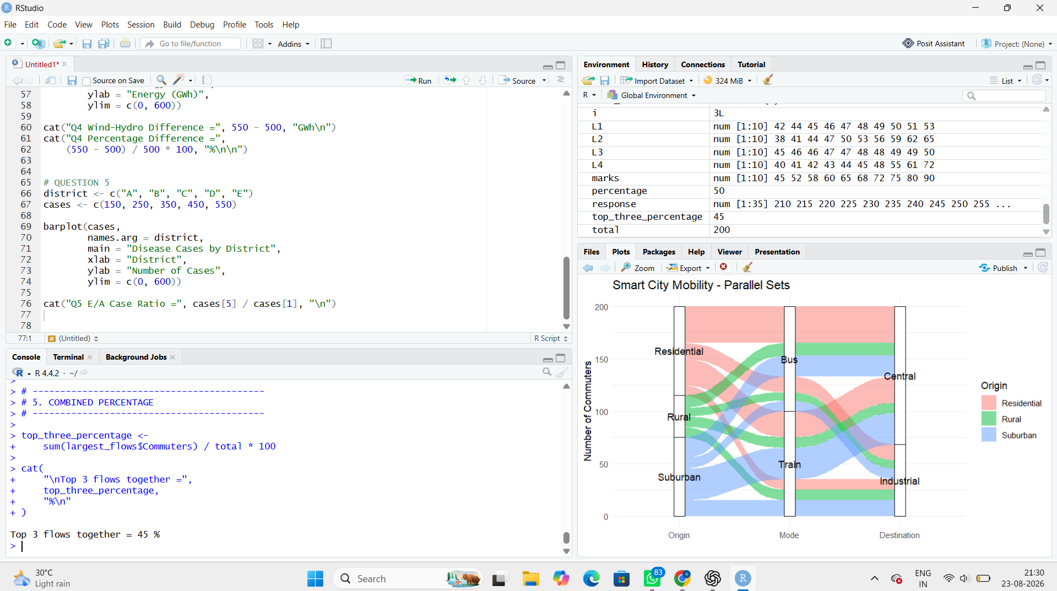

Sankey Diagram
A Sankey diagram is best for showing flow magnitude. The width of each connection represents the number of commuters.
For example, the flow of 35 commuters should visually be wider than the flow of 10 commuters.

Parallel Sets
Parallel sets are useful for showing relationships between categorical variables:
Origin → Mode → Destination
It helps identify patterns such as which transport modes are used by different residential zones and where commuters travel.

Task 5 – Misleading Design
A Sankey diagram can be misleading if the link width is not proportional to the actual number of commuters.
For example, if a 10-commuter flow is drawn almost as wide as a 35-commuter flow, viewers may incorrectly think both routes are equally important.

