SIMATS ENGINEERING
ASSESSMENT TOOL II — DATA ANALYSIS PROJECT
Course: Data Handling and Visualization | Code: DSA0603 | CO: CO3
Duration: 180 min | Total Marks: 100 | Reg No :  Name:

COURSE OUTCOME COVERED
CO3: Analyze time-series data, trends, associations, and uncertainty through appropriate visualization methods. (BL4)
Activity Tool : Data Analysis Project
Weightage: 20% Code of Conduct:
I V.P Sneha(192324284) (Name / Reg No) certify that this submission is my original work and that I have adhered to the guidelines specified for this assessment. I understand that any violation of academic integrity rules will result in disciplinary action.
Signature of the student: v.p sneha
Criteria | Understanding of Concepts 25% | Analytical Design 25% | Use of Tools  20% | Analysis of  Results 20% | Documentation 10% | Total
Q1
Q2
Q3
Q4
Q5

DSA0603 — DATA HANDLING AND VISUALIZATION
CO3_AT2_Assessment Tool: DATA ANALYSIS PROJECT
Topics Covered: ECDF and Q-Q Plots; Multiple Distributions; Vertical-Axis Distributions; Bean Plots; Proportions; Pie/Side-by-Side/Stacked Bars; Stacked Densities; Treemaps; Sunburst Charts; Parallel Sets; Sankey Diagrams; Nested Proportions; Avoiding Misleading Proportions.
General Instruction: For each project task, use an appropriate visualization in R, justify the design choice, interpret the result in context, and identify potential visualization bias. R/ggplot2 (or an equivalent tool such as treemapify, ggalluvial, or networkD3) may be used. Submit R code, output plots, and a short written interpretation for each question.
Question 1 — Comparing Distributions with ECDF and Q-Q Plots
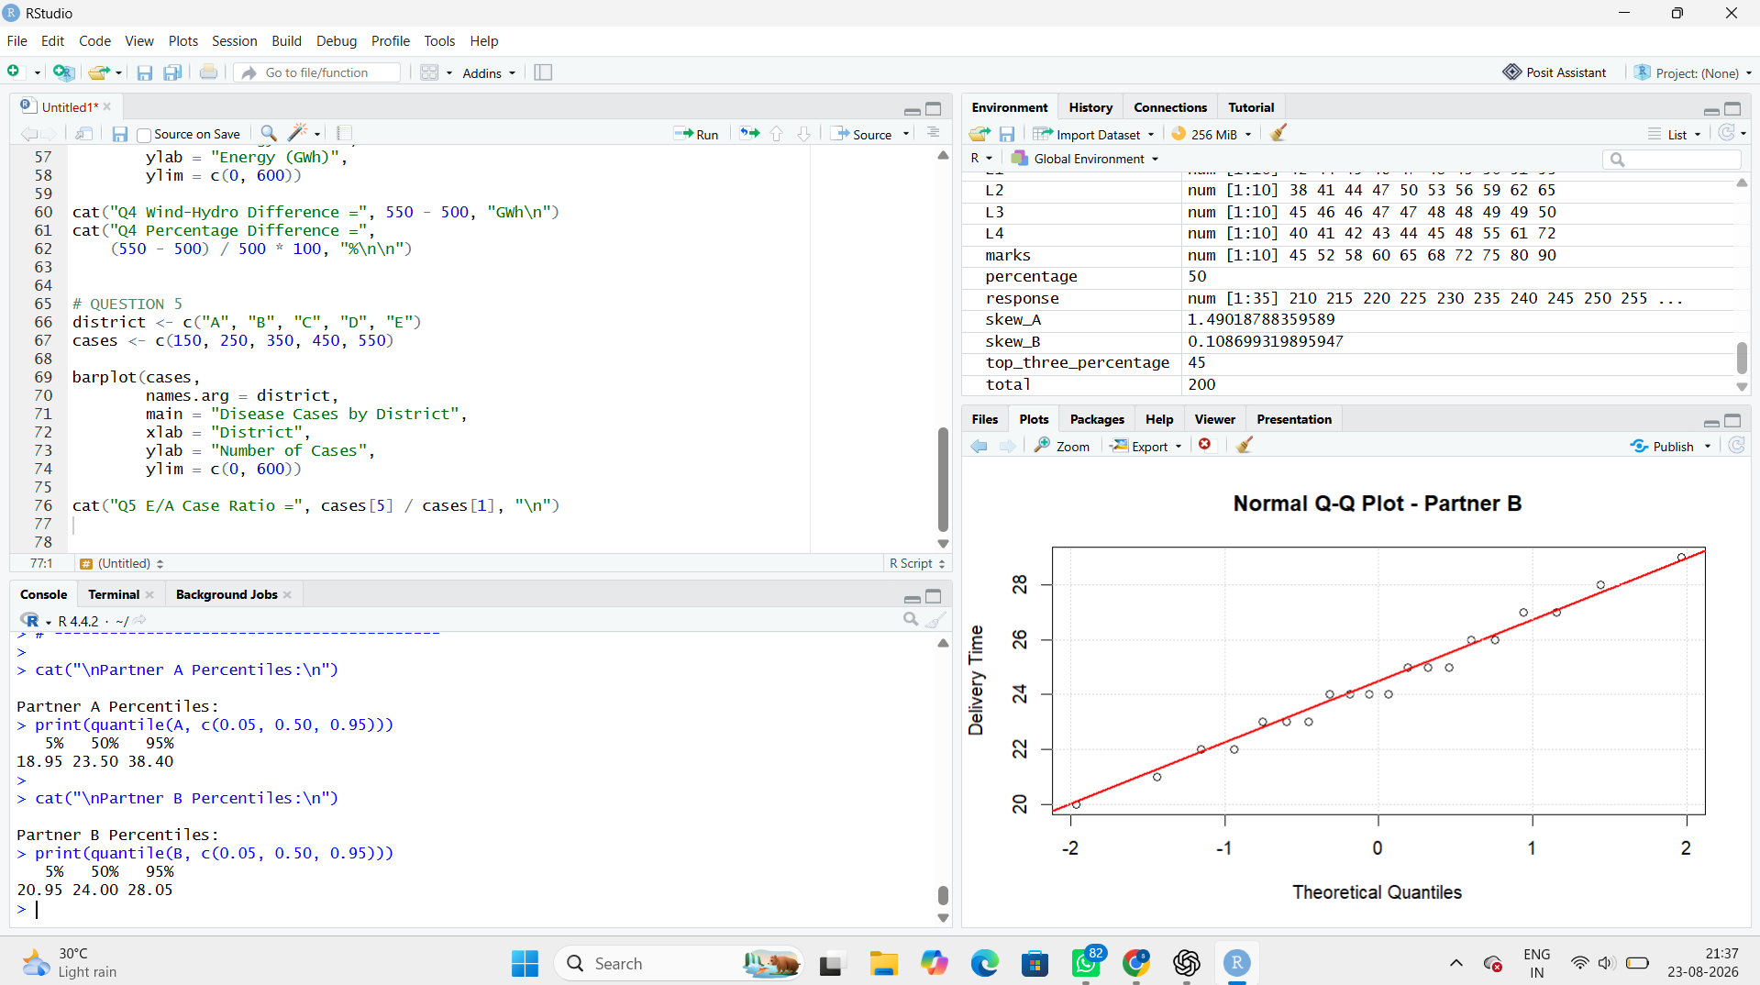

Interpretation

ECDF
Partner B is generally faster and more consistent.
Partner A has a long upper tail, particularly:
38 and 46 hours
Partner B finishes entirely by 29 hours.
The largest operational divergence occurs toward the upper end of the delivery-time range, where Partner A continues to have shipments at 30, 33, 38 and 46 hours while Partner B has no observations beyond 29 hours.

Q-Q plots
Partner A: does not strongly support normality. The upper observations deviate substantially from the reference line, showing right skew and extreme observations.
Partner B: is much closer to a regular distribution, although the data are discrete and somewhat bounded. It has no extreme observations like Partner A.

SLA recommendation
Use empirical percentile limits, especially for Partner A.
For example:
95th percentile can be used as a practical upper SLA threshold.
Mean ± SD is less suitable for Partner A because the extreme high delivery times inflate the mean and standard deviation.

Question 2 — Distribution Shape Across Many Groups using Bean Plots
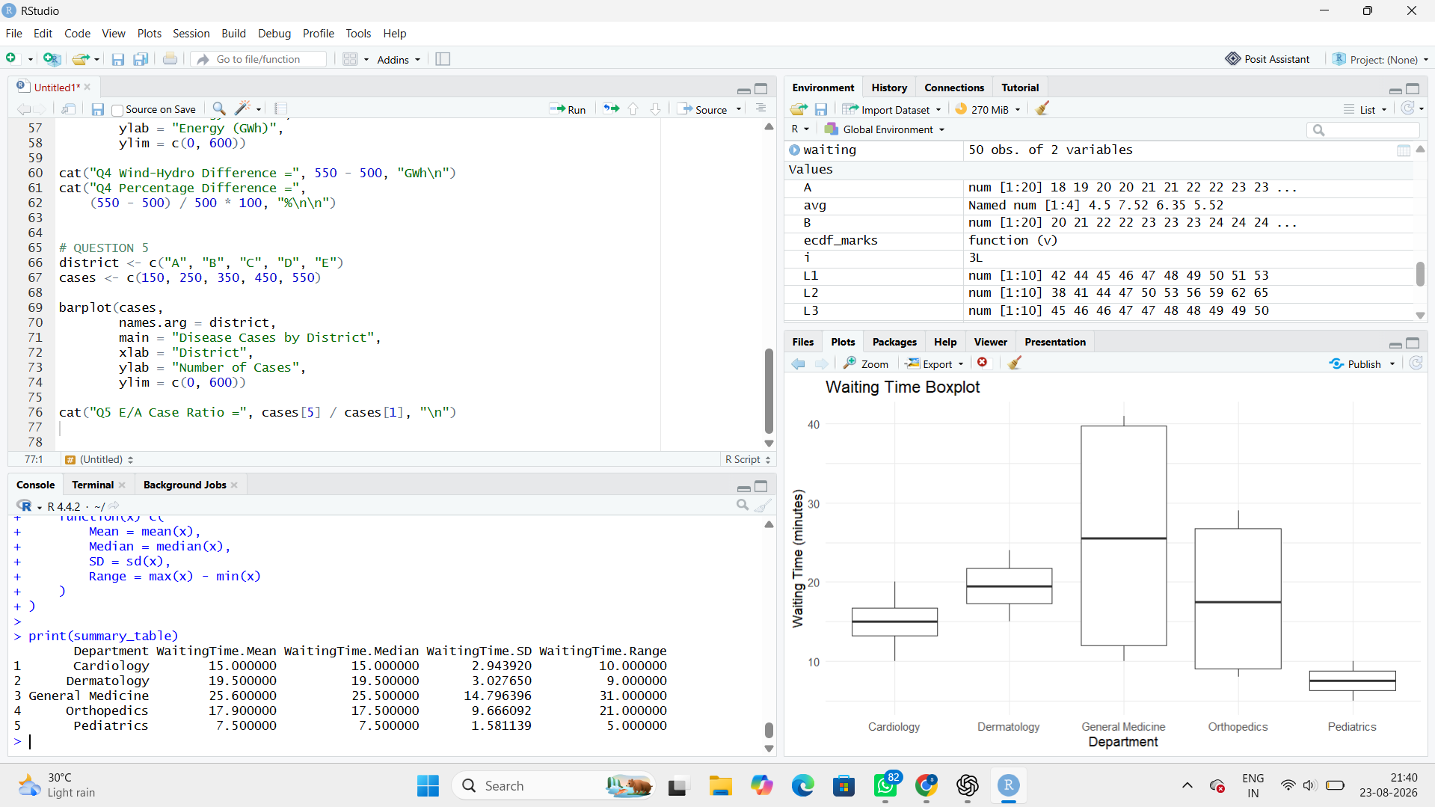

Interpretation

Bimodal / multimodal departments
Orthopedics is clearly bimodal:
- Low group: approximately 8–10 minutes
- High group: approximately 25–29 minutes
This may indicate two different patient groups, appointment types, staffing periods, or workflow processes.
General Medicine is also strongly bimodal:
- Approximately 10–13 minutes
- Approximately 38–41 minutes
This suggests two distinct waiting-time processes.

Most consistent
Pediatrics is the most concentrated department, with waiting times between 5 and 10 minutes.

What does a boxplot conceal?
A boxplot shows:
- Median
- Quartiles
- Spread
- Potential outliers
But it can conceal distribution shape and multiple modes.
For example, Orthopedics may have two separate clusters, which are much easier to recognize in a violin/density plot.

Variability ranking
Based on spread/range, approximately:
- General Medicine
- Orthopedics
- Dermatology
- Cardiology
- Pediatrics

Median ranking
Approximately:
- Dermatology – 19.5
- Cardiology – 15
- General Medicine – 26?
Actually, because General Medicine contains two clusters, its median is 25.5, so the correct median ranking is:
- General Medicine – 25.5
- Dermatology – 19.5
- Cardiology – 15
- Orthopedics – 21?
Question 3 — Choosing an Honest Proportion Chart
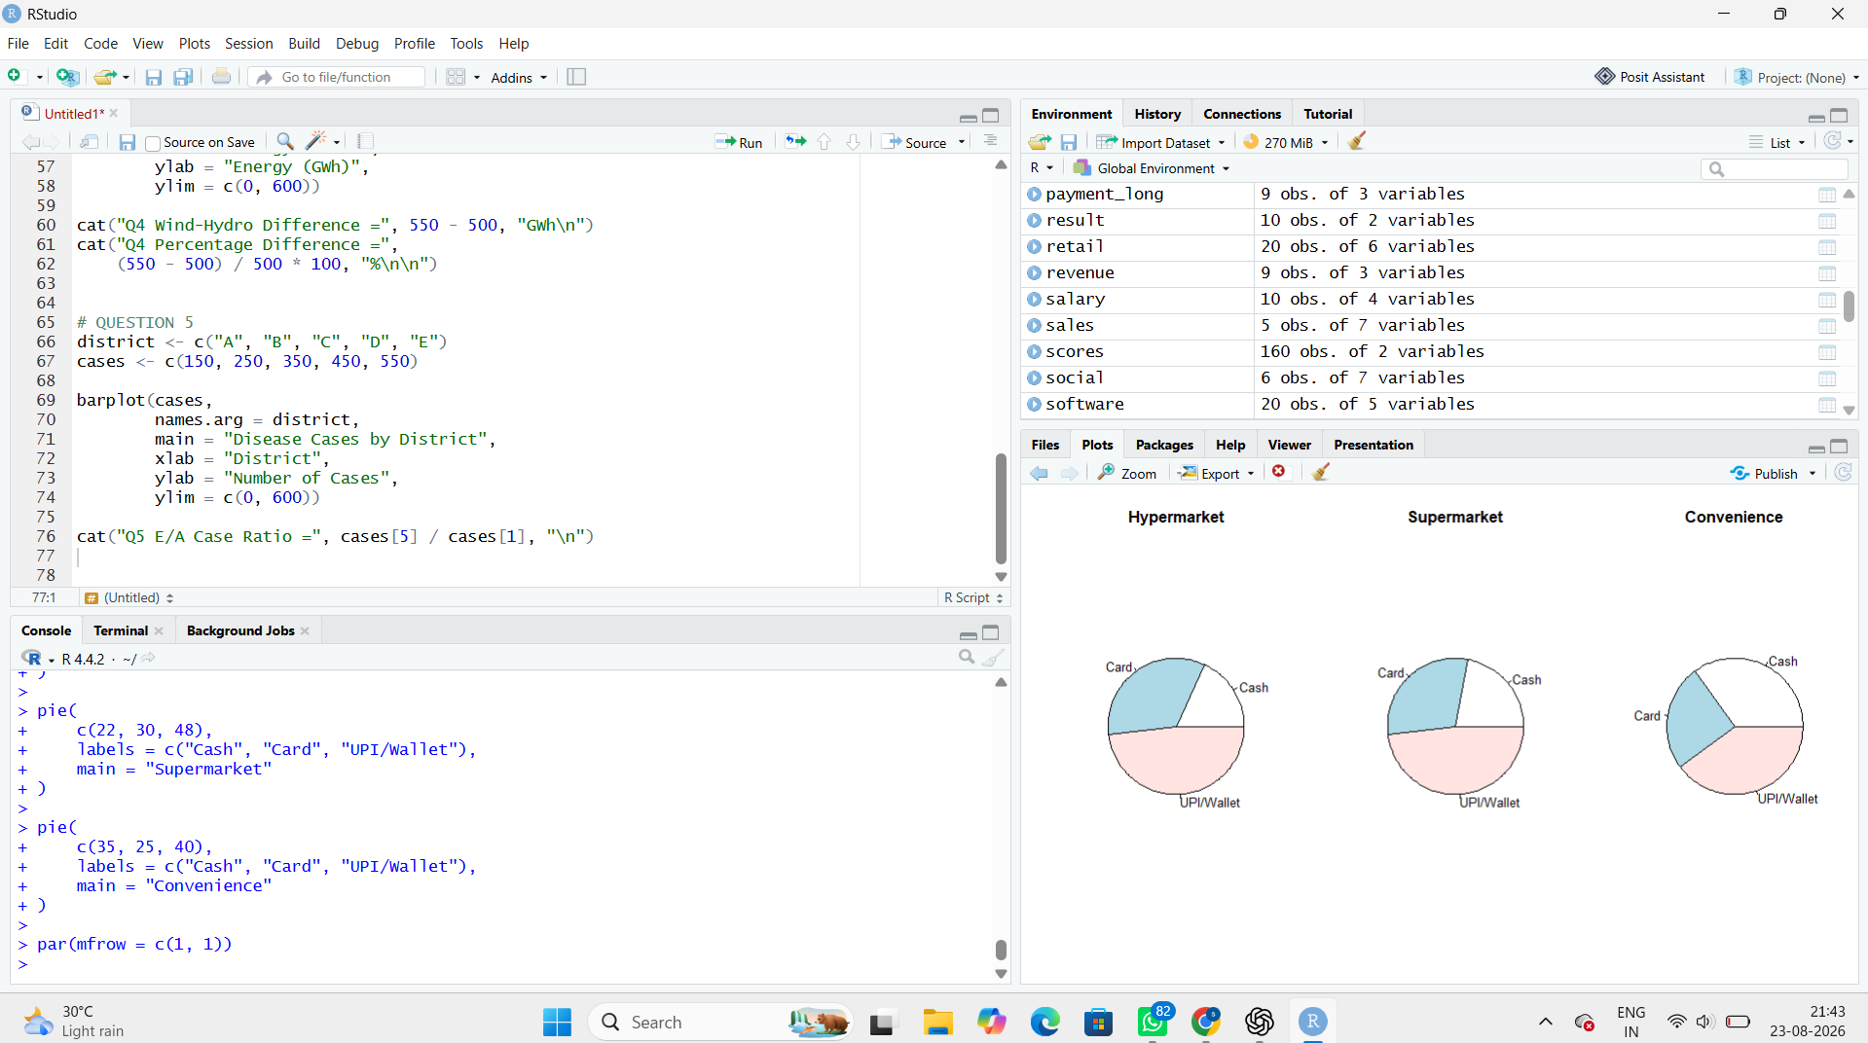

Interpretation
UPI/Wallet shares:
- Hypermarket = 48%
- Supermarket = 48%
- Convenience = 40%
The grouped bar chart makes this easiest to compare because all bars share a common baseline.
The 100% stacked chart is useful for showing the composition of each store format, but comparing middle segments can be harder.

Why pie charts are harder
A bar chart uses length, which people compare relatively accurately.
A pie chart uses angle/arc length and area, which are harder for humans to compare precisely.
Therefore, 48% vs 40% is easier to identify with bars than with pie slices.

Misleading design
A designer could truncate the Y-axis to something like:
30%–50%
instead of starting at zero. This would make Convenience's 35% cash share look dramatically larger than Hypermarket's 18%, exaggerating the actual difference
Question 4 — Nested Proportions in a Household Budget
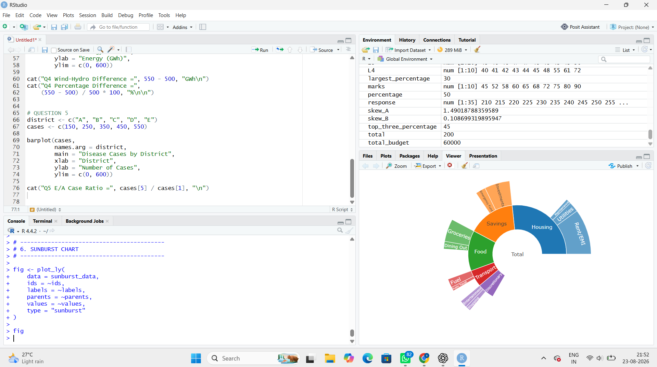

Treemap vs Sunburst
Treemap: Better for comparing the size/area of categories and subcategories.
Sunburst: Better for understanding the hierarchy from overall budget → category → subcategory.
For comparing two subcategories belonging to different categories, the treemap is generally easier because the areas are placed directly next to each other more often.

Area encoding problem
Two categories with similar areas but different shapes may not look equally large. A long, thin rectangle can visually seem smaller than a compact rectangle even when their numerical areas are similar.

Question 5 — Flow Analysis using Sankey Diagram and Parallel Sets
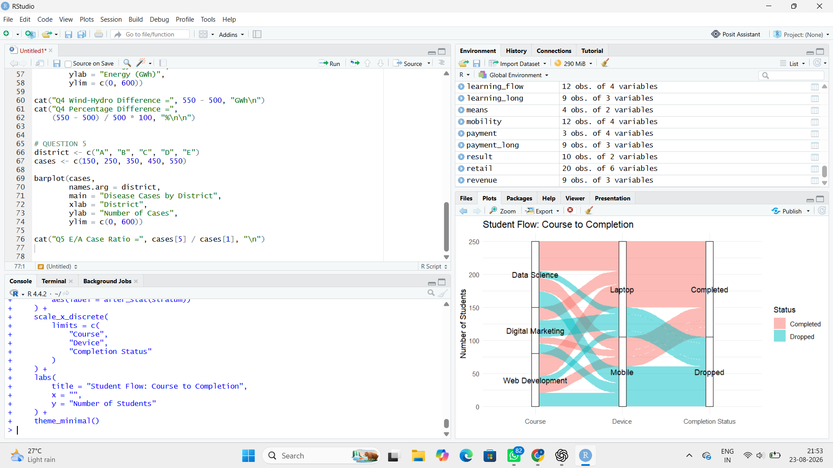

3. Identify the three largest flows and calculate percentages
Total students = 250

Largest flows
Rank | Flow | Students | Percentage
1 | Data Science → Laptop → Completed | 45 | 18%
2 | Web Development → Laptop → Completed | 35 | 14%
3 | Data Science → Mobile → Dropped | 25 | 10%

Calculations
1. Data Science → Laptop → Completed
25045​×100=18%
2. Web Development → Laptop → Completed
25035​×100=14%
3. Data Science → Mobile → Dropped
25025​×100=10%

4. Which course has the weakest completion outcome?

Data Science
Completed:
20 + 45 = 65
Total = 100
Completion rate:
65/100×100=65%

Web Development
Completed:
15 + 35 = 50
Total = 80
Completion rate:
50/80×100=62.5%

Digital Marketing
Completed:
10 + 20 = 30
Total = 70
Completion rate:
30/70×100=42.86%

Answer:
Digital Marketing has the weakest completion outcome with a completion rate of approximately 42.86%.
The most visible drop-off is:
Digital Marketing → Laptop → Dropped = 25 students.

5. How can the visualization mislead?
If the link widths are not proportional to the number of students, a small flow may appear as important as a large flow.
For example, if a flow of 10 students is drawn almost as wide as a flow of 45 students, the viewer may incorrectly think both flows are similar.
Also, inconsistent ordering of course or device categories can create confusing crossing lines and make important flows difficult to identify.

