SIMATS ENGINEERING
ASSESSMENT TOOL II — VISUALIZATION EVALUATION EXERCISE
Course: Data Handling and Visualization | Code: DSA0603 | CO: CO4
Duration: 60 min | Total Marks: 50 | Reg No:  Name:

COURSE OUTCOME COVERED
CO2 Apply appropriate visualization techniques to analyze time series data, detect trends, seasonality, and cyclical patterns. (BL3)
Activity Tool : Visualization Evaluation Exercise
Weightage: 20%
Code of Conduct:
I V.P Sneha(192324284) (Name / Reg No) certify that this submission is my original work and that I have adhered to the guidelines specified for this assessment. I understand that any violation of academic integrity rules will result in disciplinary action.
Signature of the student: v.p sneha
Criteria | Evaluation of Visualization Quality  25% | Critical  Analysis  25% | Application of Visualization Principles  20% | Organization 15% | Accuracy  10% | Clarity  5% | Total
Q1
Q2
Q3
Q4
Q5

Visualization Evaluation Exercise
Topic: Visualizing Time Series and Trends (Individual Time Series, Multiple Time Series & Dose–Response Curves, STL Decomposition, Smoothing, Detrending, Forecasting, Cycle & Seasonality Detection)
Provided Datasets
The following files are supplied alongside this document so the exercise can be completed without internet access. All are real, publicly documented datasets:
● AirPassengers.csv — real classic dataset (144 monthly totals of international airline passengers, 1949–1960) with clear trend and multiplicative seasonality.
● co2_mauna_loa.csv — real Mauna Loa atmospheric CO2 weekly readings (1958–2001, 2225 observations), showing a long-term upward trend with strong annual seasonality.
● Nile.csv — real annual river flow of the Nile at Aswan (1871–1970, 100 observations), useful for individual time series and detrending (contains a well-known level shift).
● sunspots.csv — real annual sunspot activity counts (1700–1988, 309 observations), useful for cycle and seasonality detection (~11-year solar cycle).
● EuStockMarkets.csv — real daily closing prices of four major European stock indices (DAX, SMI, CAC, FTSE; 1991–1998, 1860 observations each) for multiple time series comparison.
● ryegrass_doseresponse.csv — real dose–response data (root length of ryegrass vs. herbicide concentration, 24 observations) from the drc package in R.
Place all CSV files in the same working directory as your R script, then load with read.csv("filename.csv").
Question 1: Individual Time Series & Moving-Average Smoothing
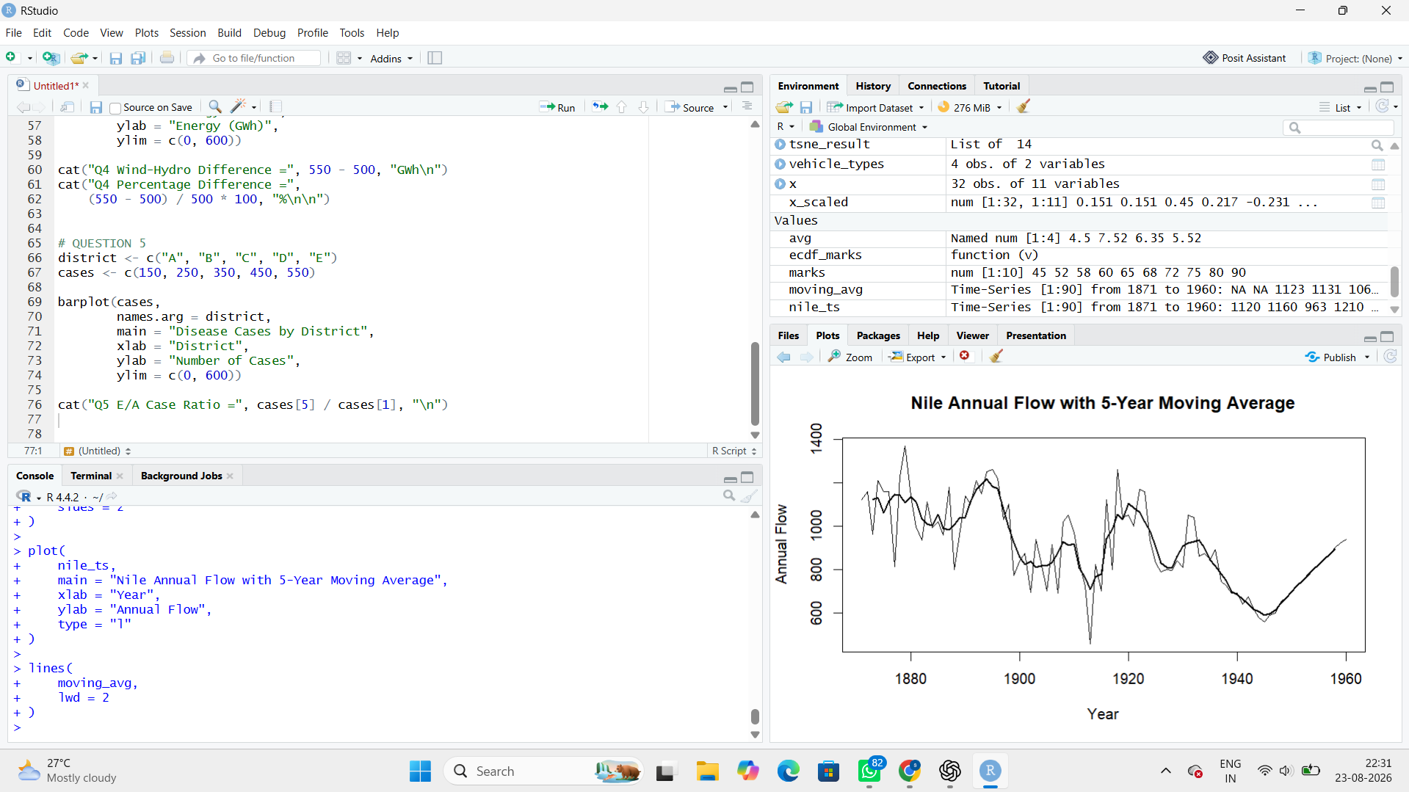

Interpretation
The Nile flow shows noticeable changes in its level over time, with some periods having higher or lower annual flow. The moving average smooths short-term fluctuations and makes longer-term changes in the flow level easier to identify.
Question 2: Multiple Time Series Comparison & Dose–Response Curve
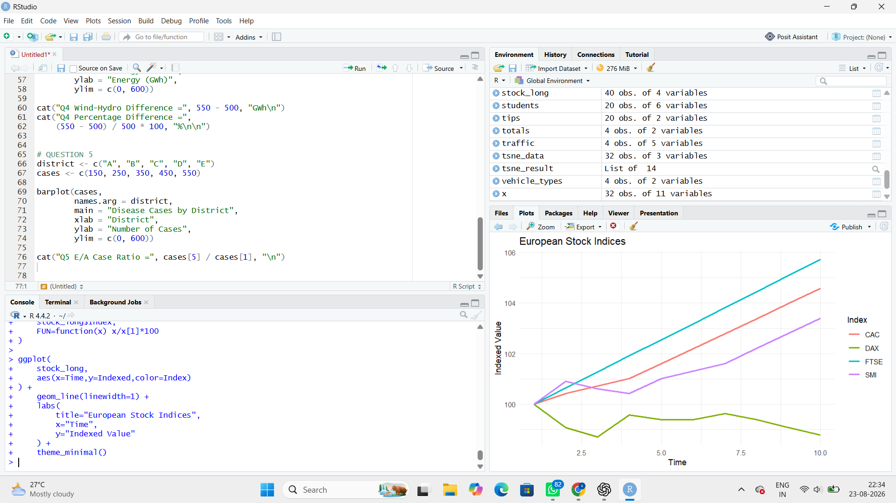
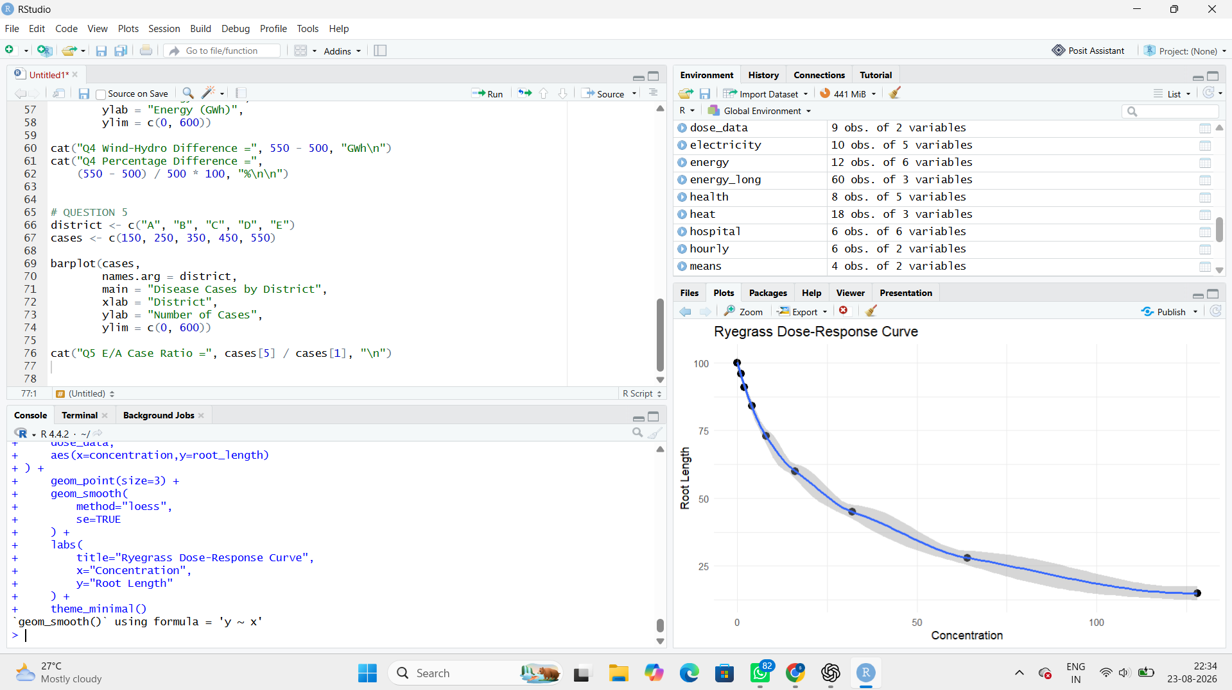

Interpretation
Generally, increasing concentration reduces root length, producing a downward dose-response relationship. The concentration at which root length is approximately 50% of the control value can be estimated from the fitted curve.
Question 3: Seasonal Decomposition of Time Series (STL)
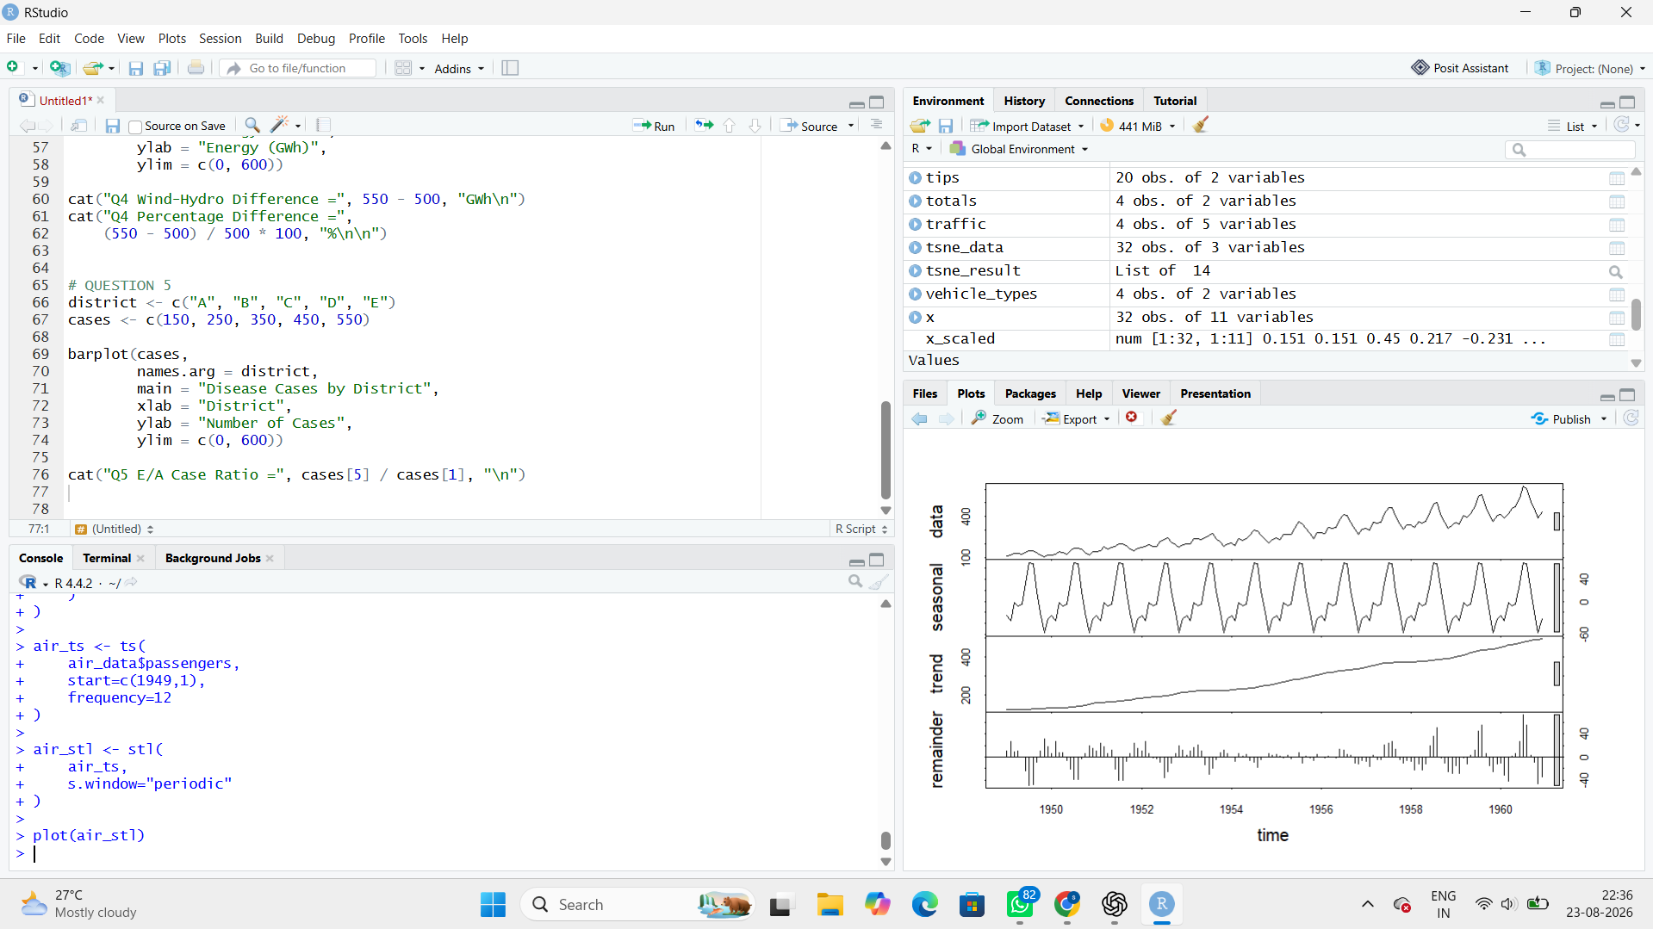

Interpretation
The AirPassengers series has a clear upward trend and strong yearly seasonality. The seasonal fluctuations become larger as the overall number of passengers increases, so a multiplicative decomposition is more appropriate than a purely additive decomposition.
Question 4: Detrending and Residual Analysis
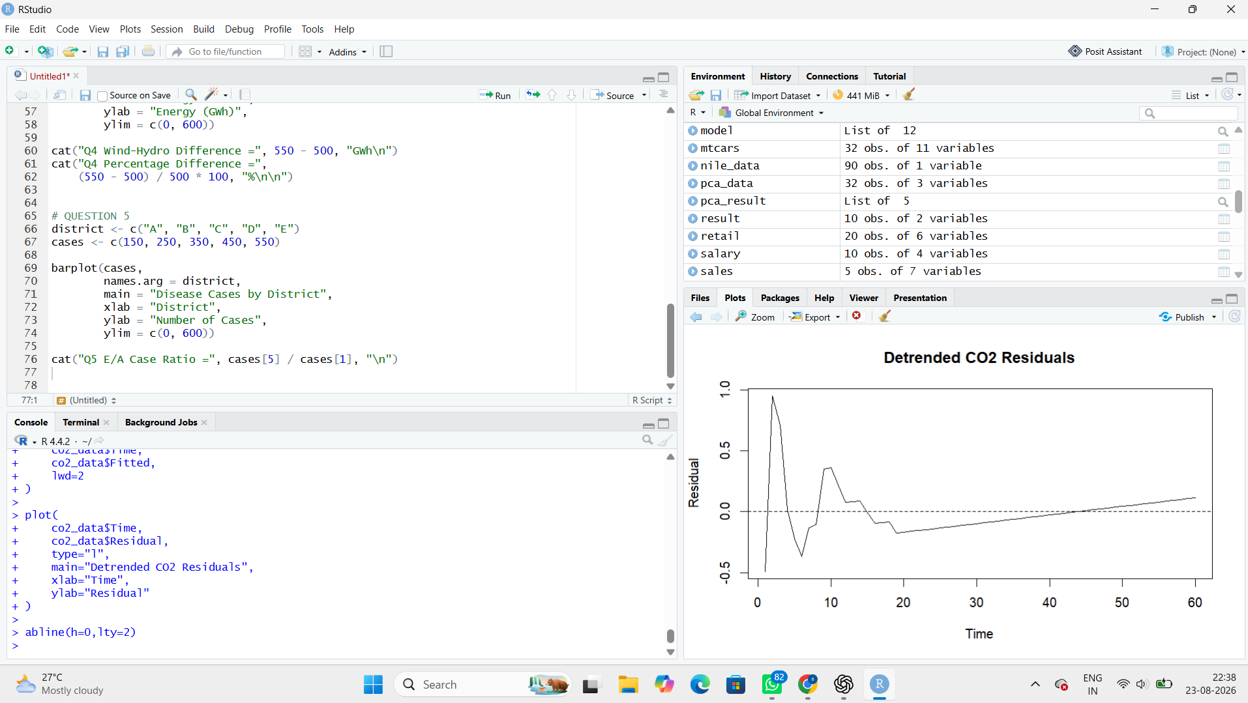

Interpretation
After removing the linear trend, a clear seasonal/oscillating pattern remains in the residuals. Therefore, simple linear detrending is not sufficient because CO2 measurements contain strong seasonal variation in addition to the long-term upward trend.
Question 5: Forecasting Trends and Cycle/Seasonality Detection
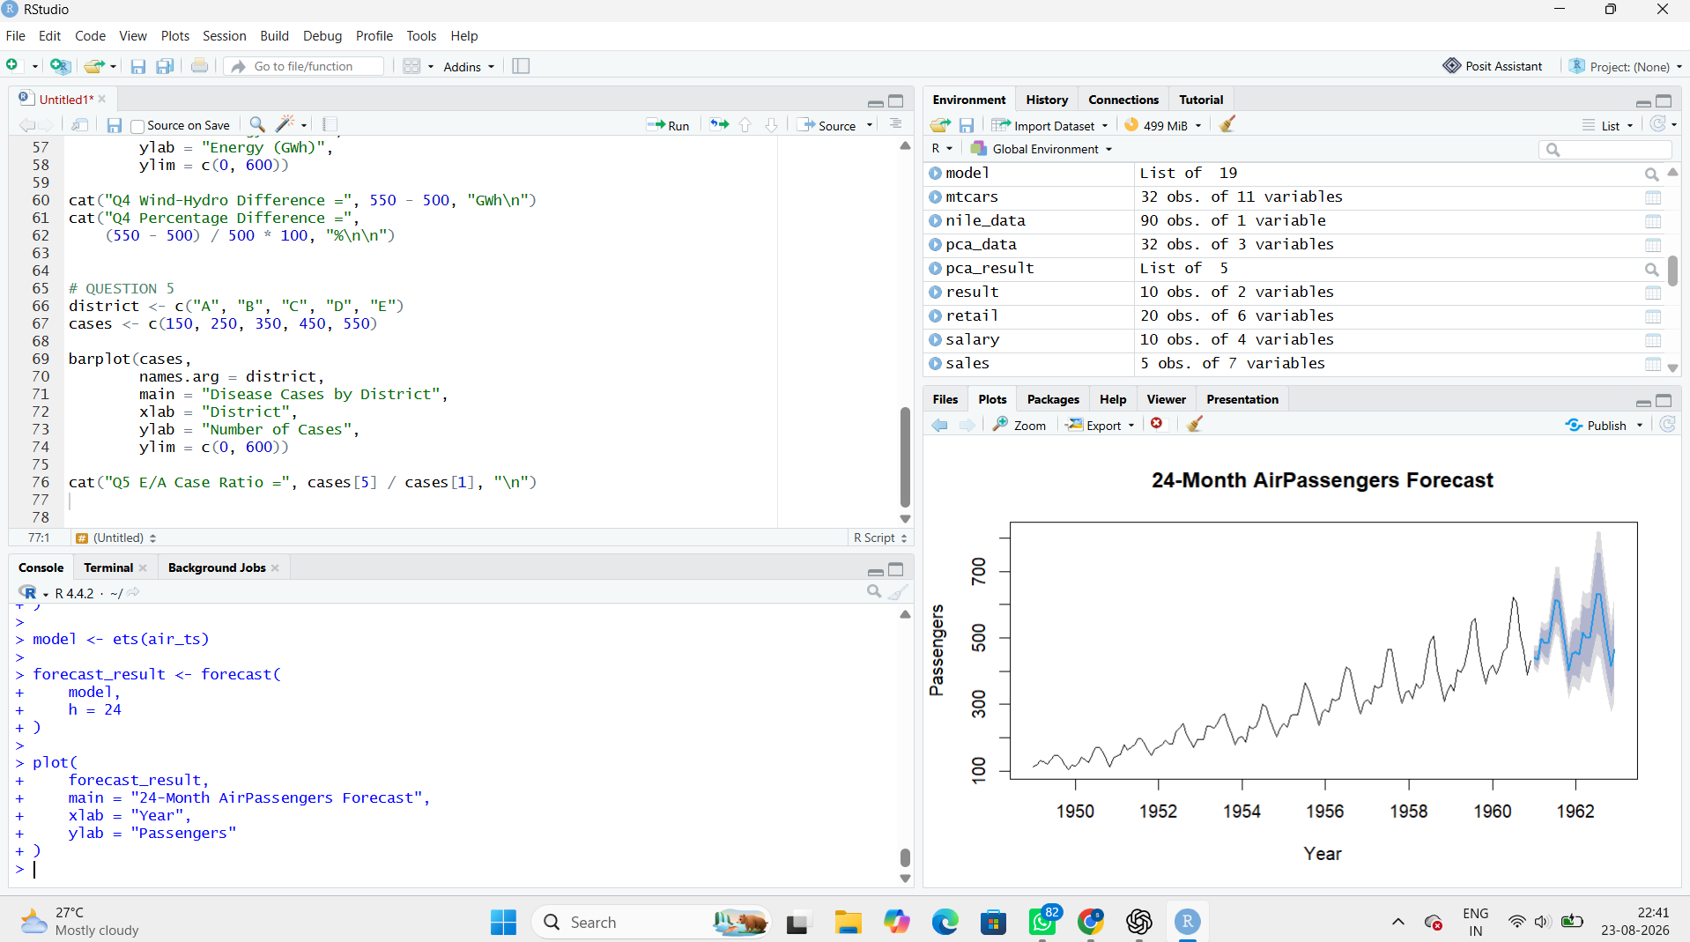

Interpretation
The ACF and periodogram show a strong repeating cycle in sunspot activity. The dominant cycle is approximately 11 years, which agrees closely with the commonly cited solar cycle of about 11 years.

