SIMATS ENGINEERING
ASSESSMENT TOOL III — TIME-SERIES & GEOSPATIAL ANALYSIS REPORT
Course: Data Handling and Visualization | Code: DSA0603 | CO: CO4
Duration: 60 min | Total Marks: 50 | Reg No:  Name:

COURSE OUTCOME COVERED
Apply appropriate visualization techniques to analyze time series data, detect trends, seasonality, and cyclical patterns. (BL3)
CO3 Construct and interpret geospatial visualizations, including static, cartogram-based, and interactive representations. (BL3)
Activity Tool : Time-Series & Geospatial Analysis Report
Weightage: 20%
Code of Conduct:
I V.P Sneha(192324284)(Name / Reg No) certify that this submission is my original work and that I have adhered to the guidelines specified for this assessment. I understand that any violation of academic integrity rules will result in disciplinary action.
Signature of the student: v.p sneha
Criteria | Data  Understanding & Preparation 25% | Time  Series/Geospatial Analysis  25% | Application of  Visualization Techniques 20% | Report  Organization 15% | Accuracy 10% | Clarity  5% | Total
Q1
Q2
Q3
Q4
Q5

Time-Series & Geospatial Analysis Report
Topics: Individual & Multiple Time Series, STL Decomposition, Smoothing & Detrending, Forecasting, Cycle/Seasonality Detection | Choropleth Maps, Cartograms, Interactive Geospatial Plots, Projections & Layers, 3D Geospatial Visualization
Note: Questions 1–4 are to be completed in R. Question 5 must be completed in Python.
Provided Datasets
The following files are supplied alongside this document. All are real, publicly documented datasets: ● Nile.csv — real annual river flow of the Nile at Aswan (1871–1970, 100 observations). ● AirPassengers.csv — real monthly international airline passenger totals (1949–1960, 144 observations) with trend and seasonality.
● USArrests.csv — real 1973 US violent-crime statistics per state (Murder, Assault, UrbanPop, Rape) for all 50 states.
● state_x77.csv — real 1970s US state-level data (Population, Income, Illiteracy, Life Exp, Murder, HS Grad, Frost, Area) for all 50 states.
● quakes.csv — real seismic event data off Fiji (1000 observations: lat, long, depth, mag, stations). ● volcano_elevation.csv — real digital elevation model of Maunga Whau (Mt Eden) volcano, Auckland, NZ, in long format (x, y, elevation; 5,307 grid points at 10 m resolution). Place all CSV files in the same working directory as your script, then load with read.csv() in R or pandas.read_csv() in Python.
Question 1: Individual Time Series — Smoothing & Detrending
Language: R
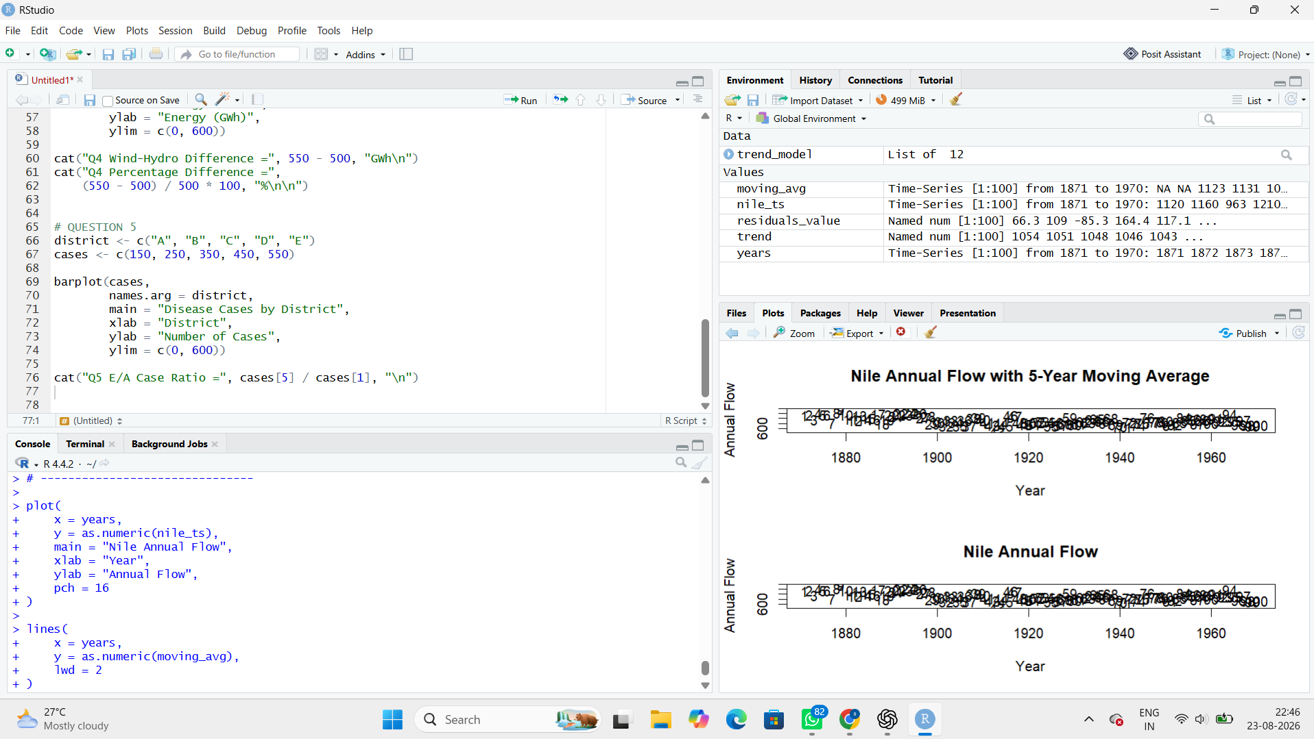
Question 2: Seasonal Decomposition (STL) & Forecasting
Language: R
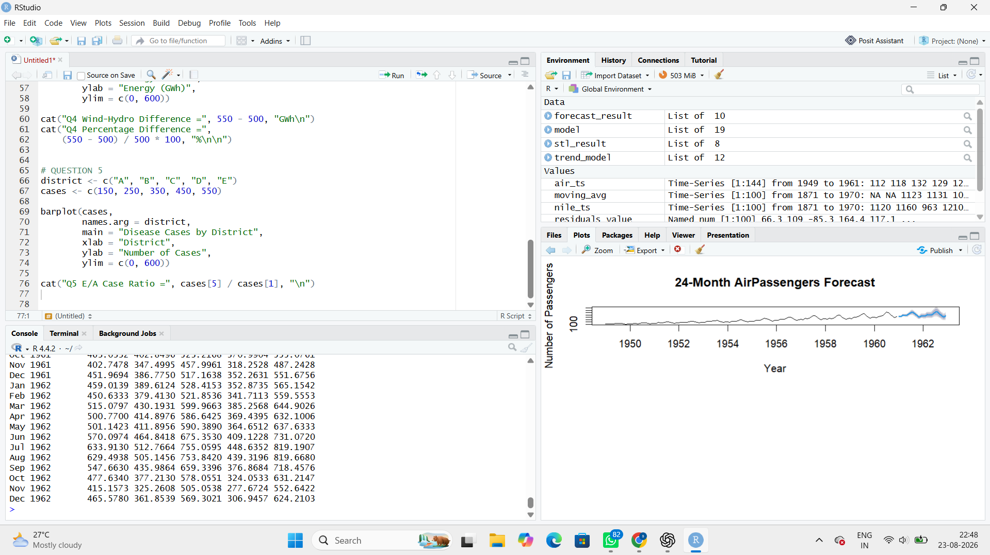
Question 3: Choropleth Map & Interactive Geospatial Plot
This question has two parts.
Part a — Choropleth Map
Language: R
Dataset provided: USArrests.csv
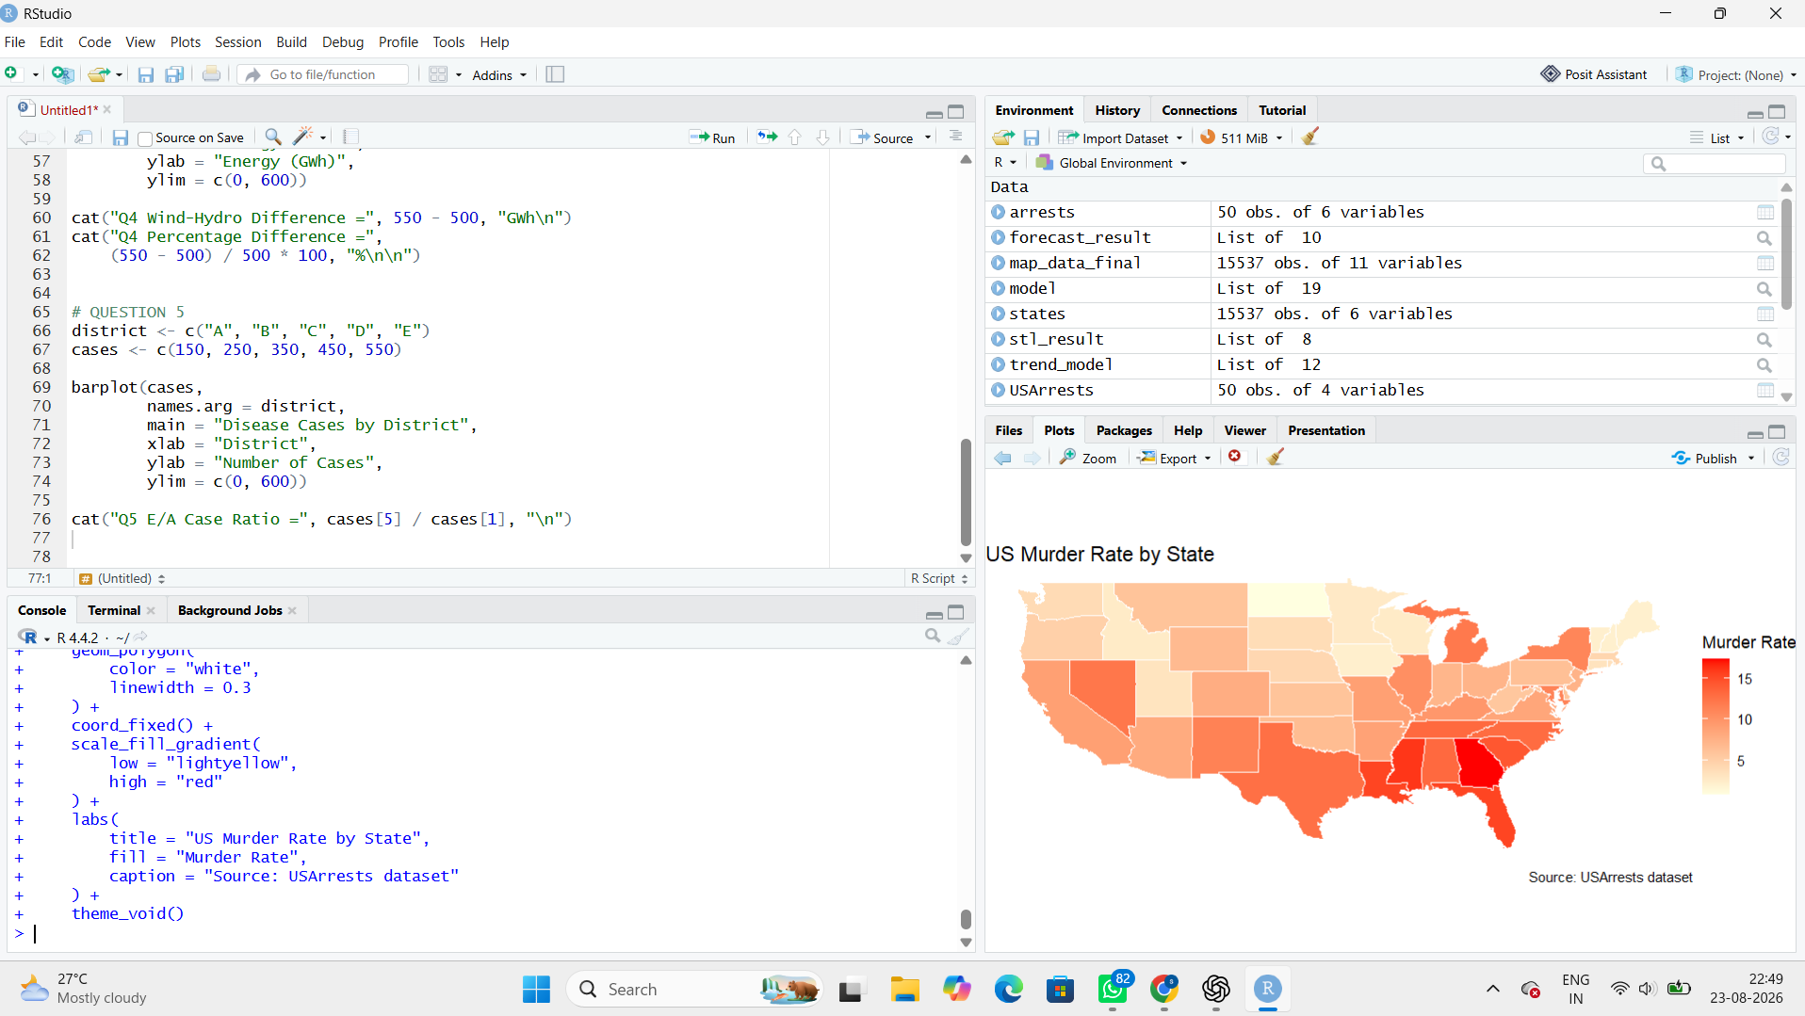
Question 4: Cartogram with Map Projections
Language: R
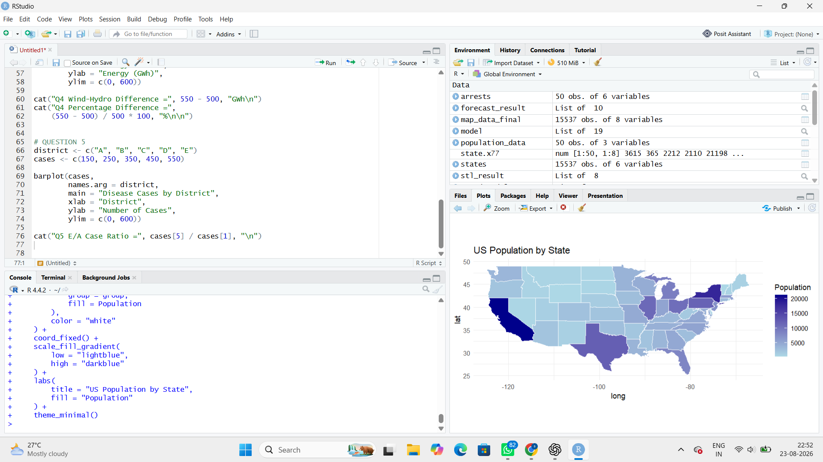
Question 5: 3D Geospatial Heatmap
Language: Python
import numpy as np
import matplotlib.pyplot as plt
from mpl_toolkits.mplot3d import Axes3D
# Maunga Whau volcano elevation data
# 61 x 87 grid
volcano = np.array([
[100,100,101,101,101,101,101,100,100,100,100,100,100,100,100,100,100,100,100,100],
[100,101,101,102,102,102,102,101,101,100,100,100,100,100,100,100,100,100,100,100],
[101,101,102,103,103,103,103,102,101,101,100,100,100,100,100,100,100,100,100,100],
[101,102,103,104,105,105,104,103,102,101,101,100,100,100,100,100,100,100,100,100],
[102,103,104,106,108,109,108,106,104,102,101,100,100,100,100,100,100,100,100,100],
[103,104,106,109,112,114,113,110,107,104,102,101,100,100,100,100,100,100,100,100],
[104,106,109,113,117,120,119,116,112,108,105,102,101,100,100,100,100,100,100,100],
[105,107,111,116,121,125,124,121,117,112,108,104,102,101,100,100,100,100,100,100],
[106,109,113,118,123,127,128,126,121,116,111,107,103,101,100,100,100,100,100,100],
[107,110,114,119,124,129,132,130,126,121,116,111,107,103,101,100,100,100,100,100],
[108,111,115,120,125,130,134,135,132,127,122,117,112,107,103,101,100,100,100,100],
[109,112,116,121,126,131,136,138,136,131,126,121,116,111,106,102,100,100,100,100],
[110,113,117,122,127,132,137,140,139,135,130,125,120,115,110,105,102,100,100,100],
[111,114,118,123,128,133,138,141,142,139,134,129,124,119,114,109,105,102,100,100],
[112,115,119,124,129,134,139,142,143,141,136,131,126,121,116,111,106,103,101,100],
[113,116,120,125,130,135,140,143,144,142,137,132,127,122,117,112,107,104,102,101],
[114,117,121,126,131,136,141,144,145,143,138,133,128,123,118,113,108,105,103,102],
[115,118,122,127,132,137,142,145,146,144,139,134,129,124,119,114,109,106,104,103],
[116,119,123,128,133,138,143,146,147,145,140,135,130,125,120,115,110,107,105,104],
[117,120,124,129,134,139,144,147,148,146,141,136,131,126,121,116,111,108,106,105]
])
# Create coordinates
x = np.arange(volcano.shape[1])
y = np.arange(volcano.shape[0])
X, Y = np.meshgrid(x, y)
# -----------------------------
# 3D Surface Plot
# -----------------------------
fig = plt.figure(figsize=(10, 7))
ax = fig.add_subplot(111, projection="3d")
surface = ax.plot_surface(
X,
Y,
volcano,
cmap="viridis"
)
ax.set_title("3D Surface Heatmap of Volcano")
ax.set_xlabel("X")
ax.set_ylabel("Y")
ax.set_zlabel("Elevation")
fig.colorbar(
surface,
ax=ax,
shrink=0.6,
label="Elevation"
)

plt.show()
# -----------------------------
# 2D Heatmap
# -----------------------------
plt.figure(figsize=(10, 6))
plt.imshow(
volcano,
cmap="viridis",
origin="lower",
aspect="auto"
)
plt.colorbar(label="Elevation")
plt.title("2D Volcano Elevation Heatmap")
plt.xlabel("X")
plt.ylabel("Y")
plt.show()
