
INDIAN INSTITUTE OF INFORMATION TECHNOLOGY, NAGPUR
Department of Computer Science and Engineering
2D 3D GAME DEVELOPMENT
COURSE CO-ORDINATOR: Dr. Ashish Kumar Patel
GROUP E
Name of the Student 1 | Vaishnav Eega (BT22CSH019)
Name of the Student 2 | Krishnasai Siddharth Madas (BT22CSH008)
Name of the Student 3 | Animesh Srivastava (BT22CSH016)
Name of the Student 4 | Snehartha Peddireddy (BT22CSH029)

TETRIS

Game Design Document

1. Project Description
Tetris is a 2D puzzle game where players must manipulate falling blocks called "Tetriminos" to form complete horizontal lines, which are then cleared to gain points. It is intended for casual and puzzle enthusiasts and will target short, engaging gameplay sessions. Genre: Puzzle Game.

2. Characters
Tetris does not feature traditional characters. The "Tetriminos" — geometric block shapes — are the primary elements the player interacts with. Each Tetrimino is a different shape (I, O, T, S, Z, J, L) and color-coded for easy identification.
Color | Number Representation
Empty (No Tile) | 0
Cyan (I Block) | 1
Blue (J Block) | 2
Orange (L Block) | 3
Yellow (O Block) | 4
Green (S Block) | 5
Purple (T Block) | 6
Red (Z Block) | 7
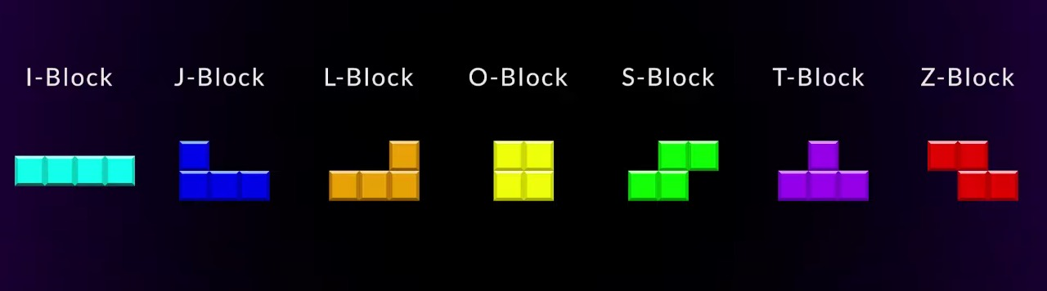

3. Storyline
Tetris is a mechanics-driven game, meaning it focuses entirely on how you play rather than telling a story or building characters. The challenge comes from the player's skill in placing and rotating falling blocks to clear lines and prevent the screen from filling up. There's no background plot or narrative — the experience is all about mastering the simple but addictive gameplay. Its appeal lies in quick thinking, precision, and improving your performance over time.

4. The Theme

Classic Arcade Puzzle.
Tetris has a simple and abstract style, with its clean shapes and bright colors creating a timeless and recognizable look. The main goal of the game is to fit falling blocks, called tetrominoes, together to form complete horizontal lines. This requires quick thinking, sharp spatial awareness, and the ability to recognize and predict patterns. Despite its minimal design and lack of storyline, Tetris captures players with its addictive, fast-paced gameplay that becomes more intense and rewarding the longer you survive.

5. Progression
The game begins slowly with Tetramines falling at a manageable speed. As the player clears more lines and gains points, the speed of the falling blocks increases, adding difficulty and excitement.
- Speed Increases: Blocks fall faster as the score rises.
- Scoring System: +1 point per cleared row.
- Game Over Conditions: When blocks reach the hidden spawning rows.
- Hold Feature: Players can hold a tetromino for strategic use.
- Ghost Piece: Shows where a tetromino would land.
- Hard Drop: Instantly places the tetromino at its lowest possible position.

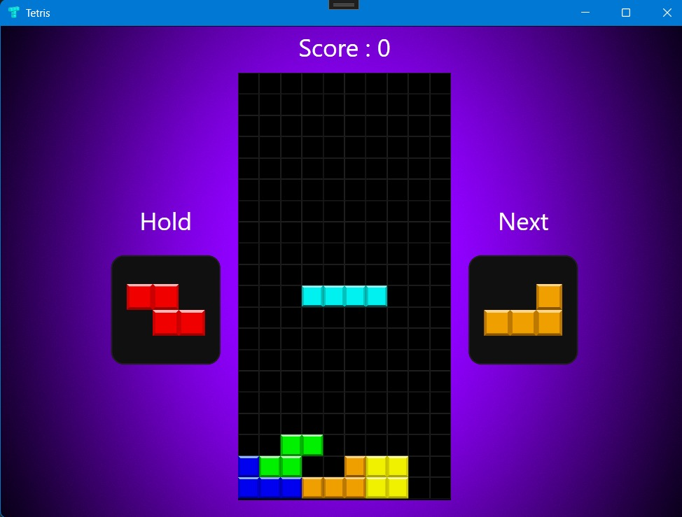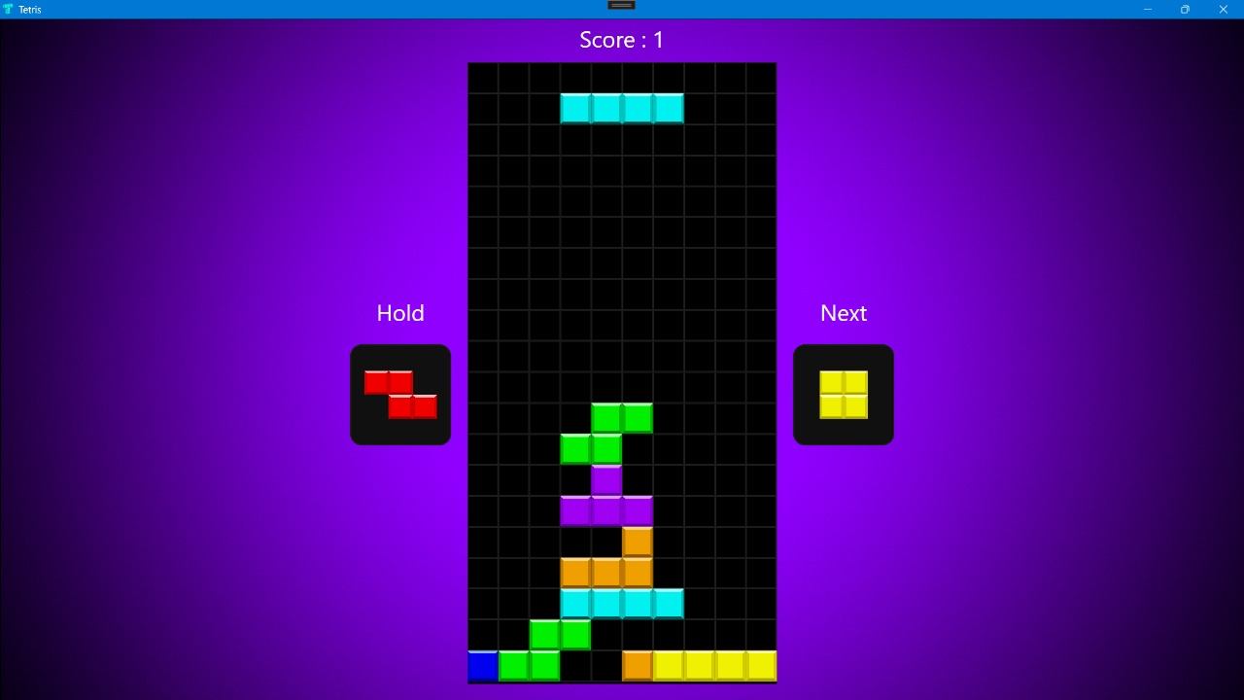

6. Levels and Environments
- Environment: A static playfield (a tall, narrow rectangular grid).
- Levels: Conceptually, the game has "levels" which increase difficulty (speed) after clearing a certain number of lines.
- Progression Mechanism: Line clear count determines level up.

7. Gameplay
- Goals:
- Clear as many lines as possible.
- Prevent the Tetriminos from reaching the top of the playfield.

- Game Mechanics:
- Objective: Create and clear complete rows.
- Mechanics:
- Piece Movement & Rotation
  - Move Left/Right (single step or hold)
  - Rotate Clockwise
- Gravity, Soft Drop & Hard Drop
- Gravity pulls piece down over time.
- Soft Drop: accelerate manually.
- Hard Drop: instantly place and lock piece.

- Next Queue & Hold Feature
- Preview next 3 shapes.
- Hold one shape for later use.

- Skills:
- Spatial reasoning
- Quick decision-making
- Pattern recognition
- Hand-eye coordination

- Difficulty Management and Progression:
- Increases: Gradual increase in Tetrimino fall speed per level.
- Score Multipliers: Clearing more lines at once yields higher rewards.
- Mistakes: As the board fills up, space becomes limited, adding strategic pressure.

- Losing Conditions:
- The game ends when Tetriminos stack up and reach the top of the playfield.

8. Graphic Style and Art
- Art Style: 2D pixel-art tiles.
- Visuals: Colorful, high-contrast tetrominoes against a dark gradient background.
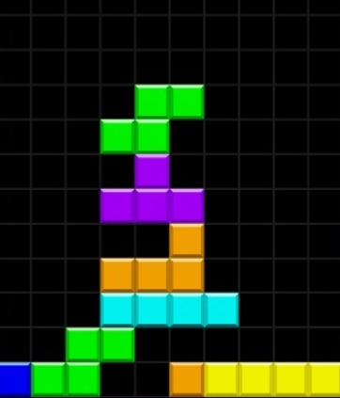
- Grid Size: 10 columns × 20 visible rows (plus 2 hidden rows).
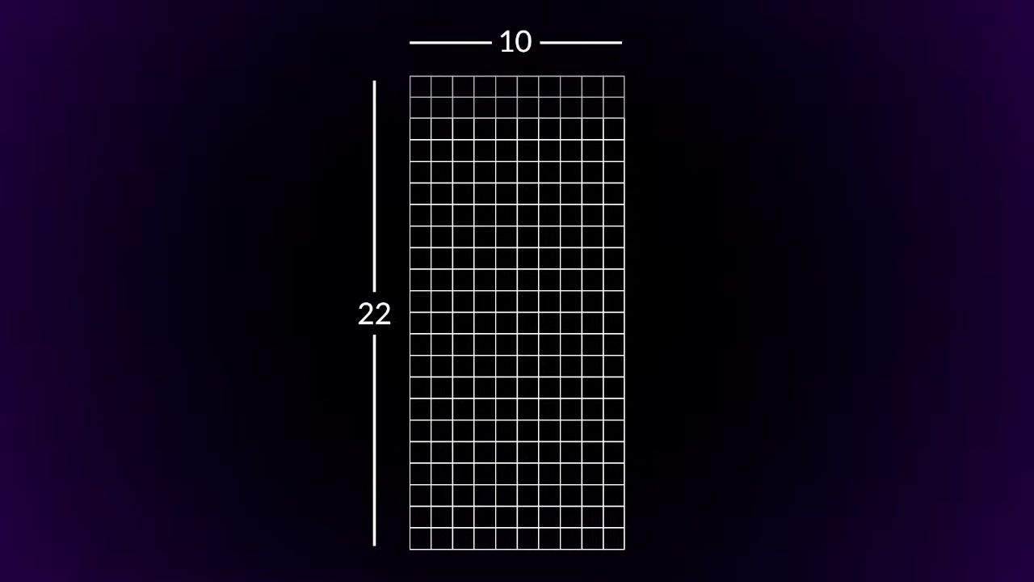

9. Sound and Music
- Music: Background music (optional) for a retro ambiance.
- Sound Effects:
- Block movement.
- Line clear.
- Level up.
- Game over.

10. User Interface
- Main Game Window: Canvas with scalable grid.
- HUD:
- Score display.
- Next block preview.
- Hold block preview.
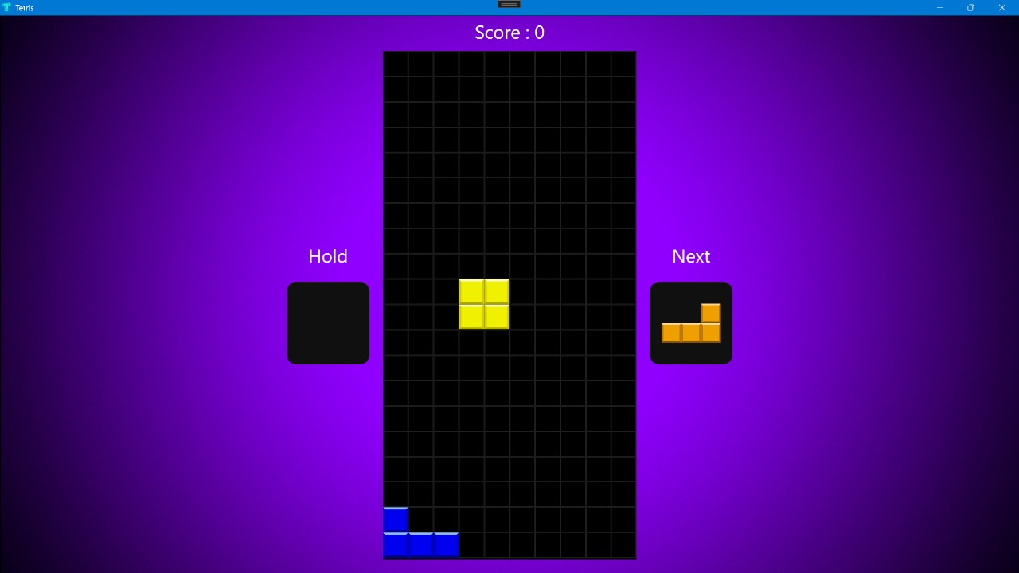
- Game Over Screen: Final score and restart button.
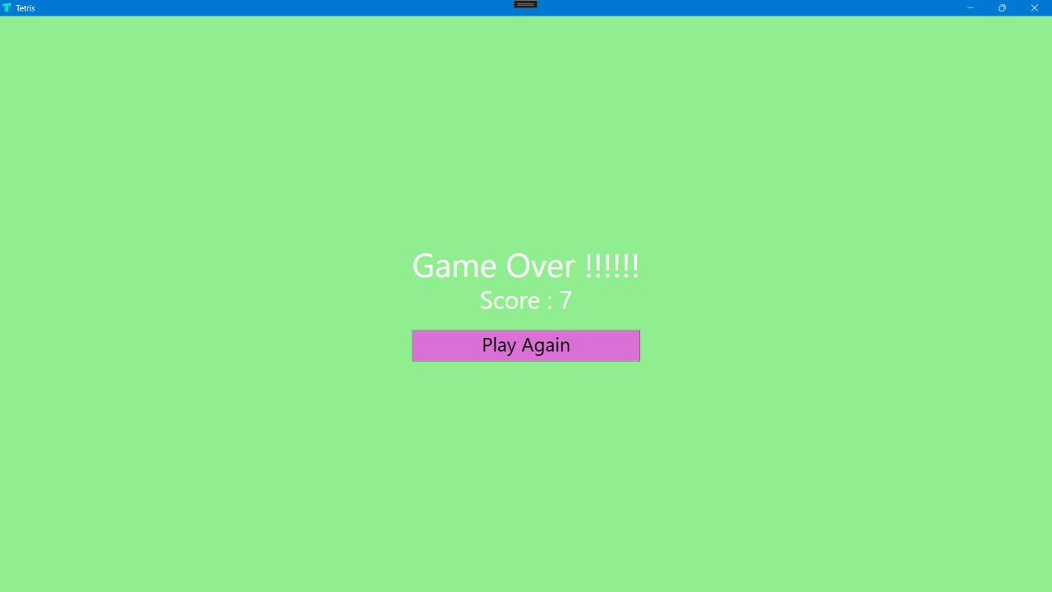
- Minimalistic Fonts: Segoe UI Light, easy on the eyes.

11. Game Controls
| Move Left: Left Arrow |
| Move Right: Right Arrow |
| Move Down: Down Arrow |
| Rotate Clockwise: Up Arrow |
| Rotate Counterclockwise: 'Z' Key |
| Hard Drop: Spacebar |
| Hold Block: 'C' Key |
| Restart Game: Mouse click on "Play Again" |

12. Accessibility Options
->Key Remapping: (Future feature) Allow users to customize controls.
->Visual Accessibility:
- High contrast colors for color-blind friendliness.
- Adjustable UI scaling.
->Gameplay Accessibility:
- Adjustable initial block fall speed (for easier or harder start).

13. Tools
-Language: C# (.NET 5.0)
-Framework: WPF
-IDE: Visual Studio
-Graphics: PNG assets for tiles, blocks, backgrounds.

14. Marketing
- Primary Target:
- Retro gaming enthusiasts.
- Programming learners (as an educational example).
- Puzzle and casual game players.
- Platforms:
- Windows desktop (WPF application).
- Selling Points:
- Authentic Tetris feels.
- Modern enhancements: Hold system, Ghost piece, Hard drop.
- Smooth scaling and clean, stylish design.

15. Conclusion
This project successfully recreates the classic Tetris experience using C# and WPF, combining timeless gameplay with modern features like Hold, Ghost Piece, and Hard Drop. It delivers a clean, engaging, and accessible puzzle game for casual players and retro enthusiasts, while also showcasing practical programming skills in a real-world application.

