**Experiment No: 5**

***Title :*** Implementation of different types of Joins

* Inner Join
* Outer Join • Natural Join..etc

***Objective :***

To implement different types of joins

***Theory :***

The SQL **Joins** clause is used to combine records from two or more tables in a

database. A JOIN is a means for combining fields from two tables by using values common to each.The join is actually performed by the ‘where’ clause which combines specified rows of tables.

Syntax:

SELECT column 1, column 2, column 3...

FROM table_name1, table_name2

WHERE table_name1.column name = table_name2.columnname;

**Types of Joins :**

1. Simple Join
2. Self Join
3. Outer Join

**Simple Join:**

It is the most common type of join. It retrieves the rows from 2 tables having a common column and is further classified into

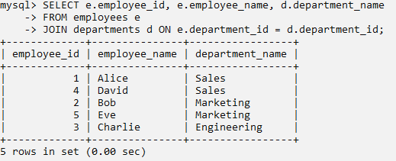

**Equi-join :**

A join, which is based on equalities, is called equi-join.

Example:

Select * from item, cust where item.id=cust.id;

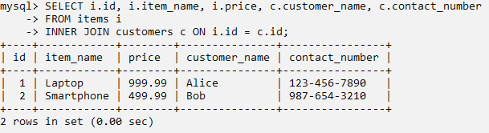

**Non Equi-join:**

It specifies the relationship between columns belonging to different tables by

making use of relational operators other than’=’.

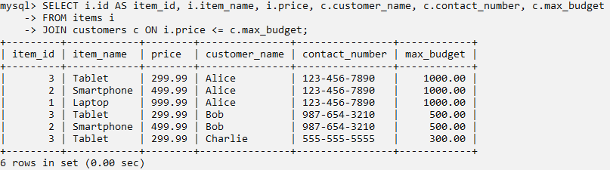

**Self join:**

Joining of a table to itself is known as self-join. It joins one row in a table to another. It can compare each row of the table to itself and also with other rows of the same table.

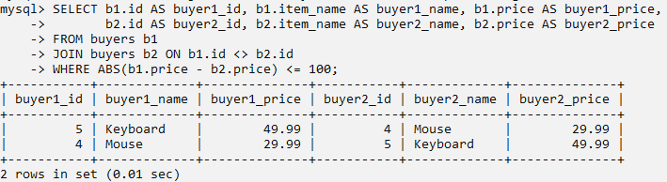

**Outer Join:**

It extends the result of a simple join. An outer join returns all the rows returned by simple join as well as those rows from one table that do not match any row from the table. The symbol(+) represents outer join.

* Left outer join

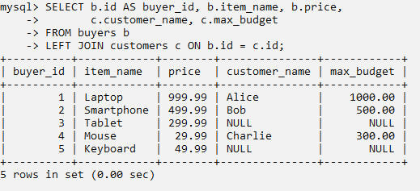

* Right outer join

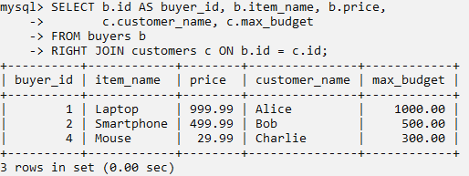

* Full outer join

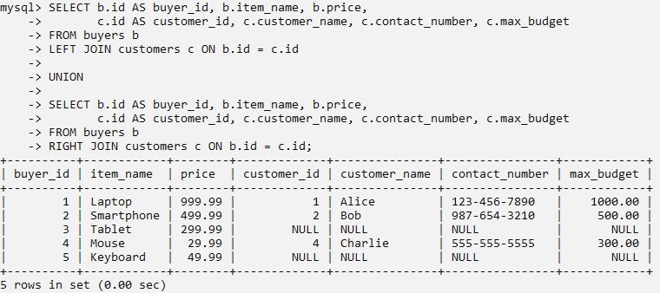

**LAB PRACTICE ASSIGNMENT:**

**Consider the following schema:**

**Sailors (sid, sname, rating, age)**

**Boats (bid, bname, color)**

**Reserves (sid, bid, day(date))**

1. Find all information of sailors who have reserved boat number 101.

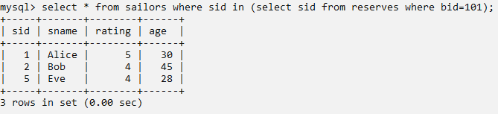

1. Find the name of boat reserved by Bob.

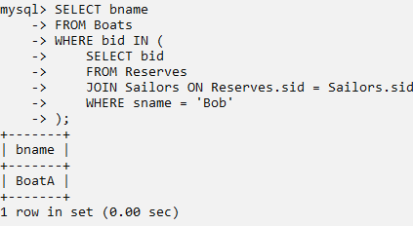

1. Find the names of sailors who have reserved a red boat, and list in the order of age.

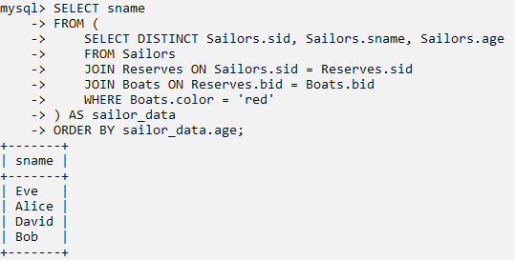

1. Find the names of sailors who have reserved at least one boat.

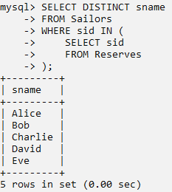

1. Find the ids and names of sailors who have reserved two different boats on the same day.

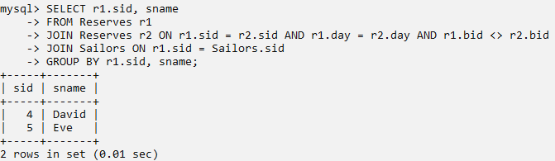

1. Find the ids of sailors who have reserved a red boat or a green boat.

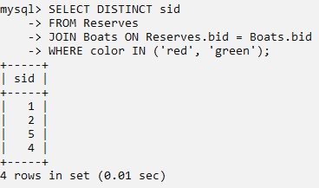

1. Find the name and the age of the youngest sailor.

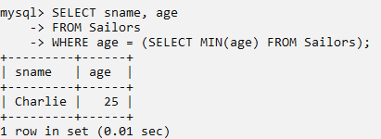

1. Count the number of different sailor names.

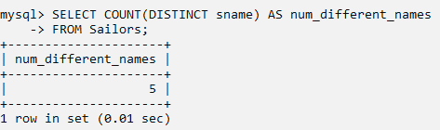

1. Find the average age of sailors for each rating level.

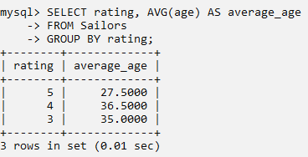

1. Find the average age of sailors for each rating level that has at least two sailors.

