**Consumer Electronics**

Camera Accessories

Weekly GMV generated from sales of Camera Accessories with Holiday/Event marks

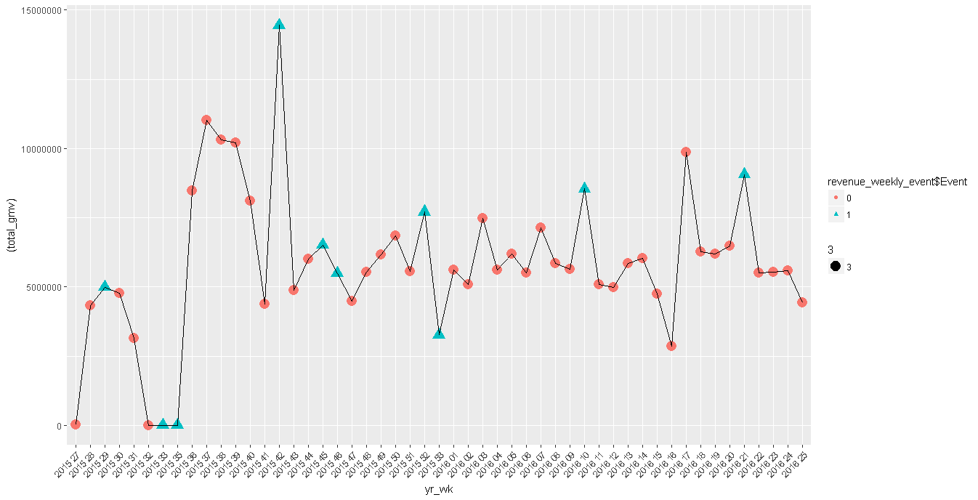

We can see the increase in overall sales in the last 1 year.

Investments made in commercials

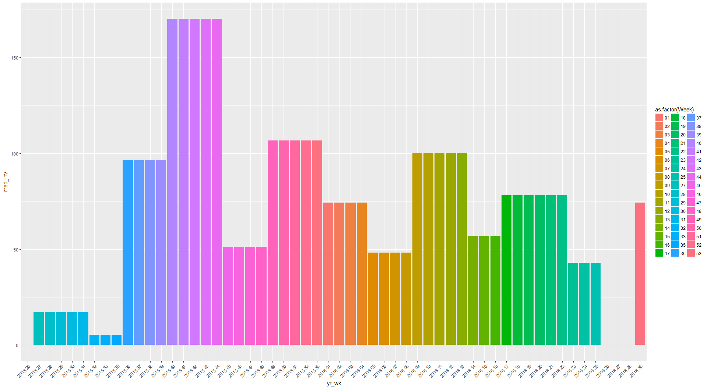

Comparison of discount Vs sales.

Discounts on various camera accessories given round the year

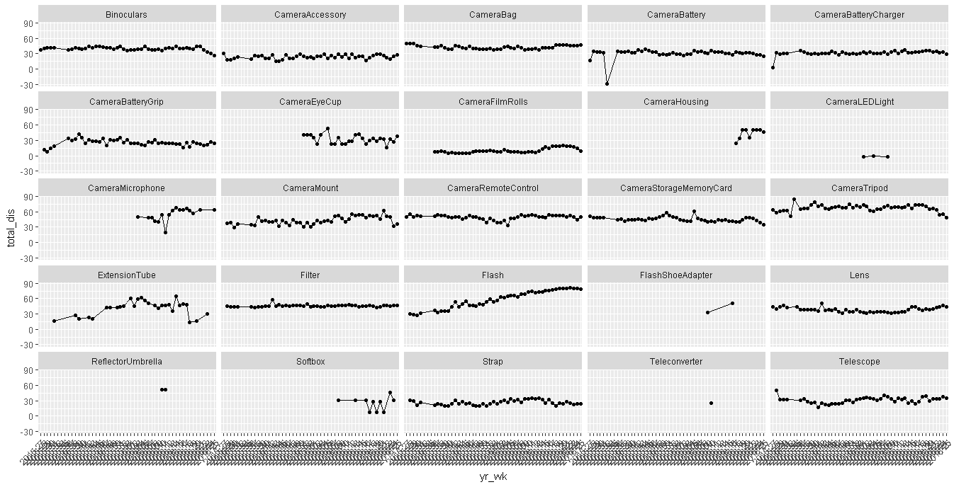

Revenue from the sale of various camera accessories, sale in log2 scale

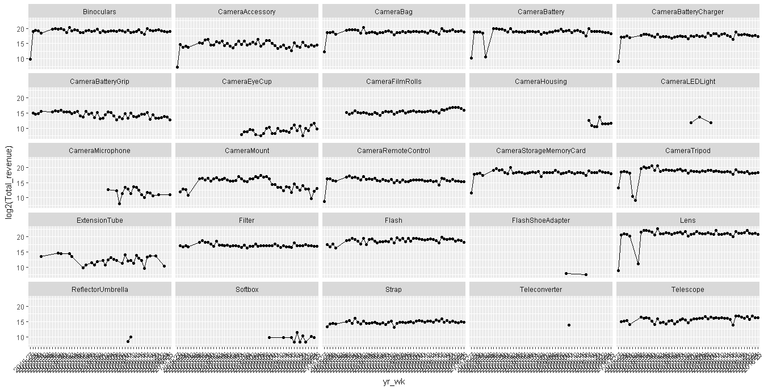

We can see that there is an increase in sale of few products and decline in few others.

**Media Investment and effects on GMV**

**Investment across the year**

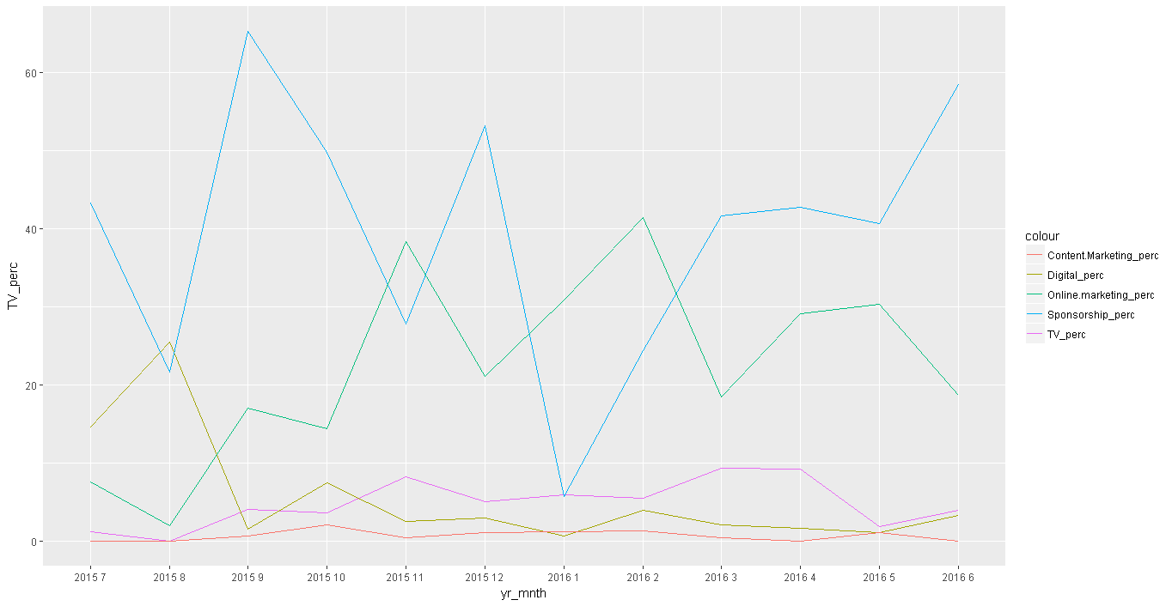

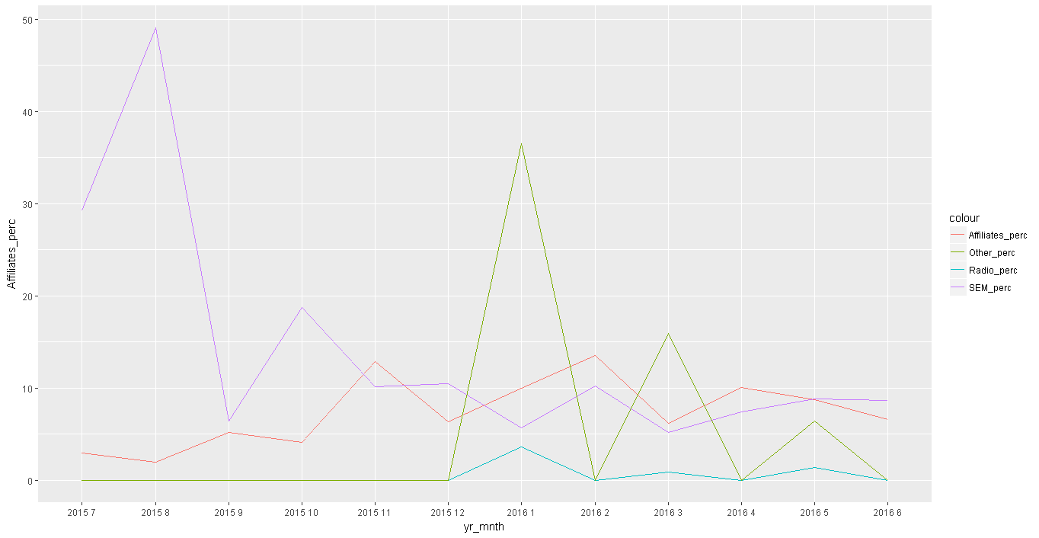

**Digital Marketing Vs Sales revenue**

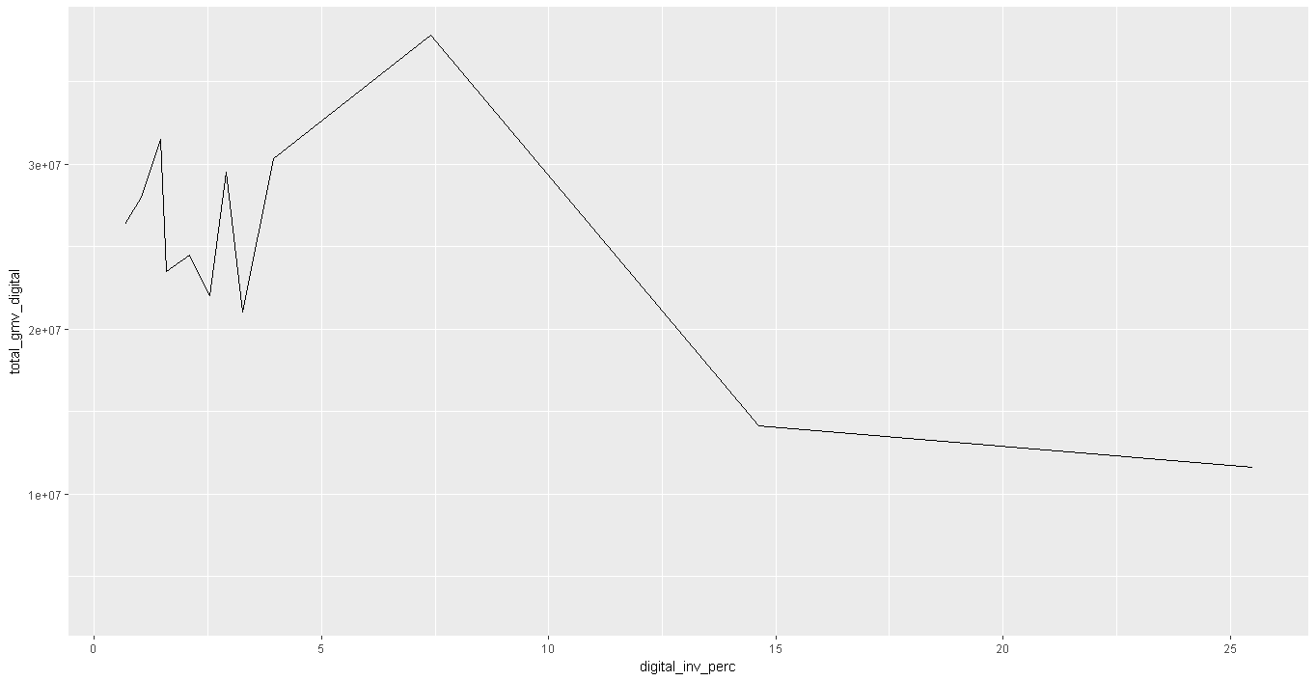

**Tv marketing Vs Sales revenue**

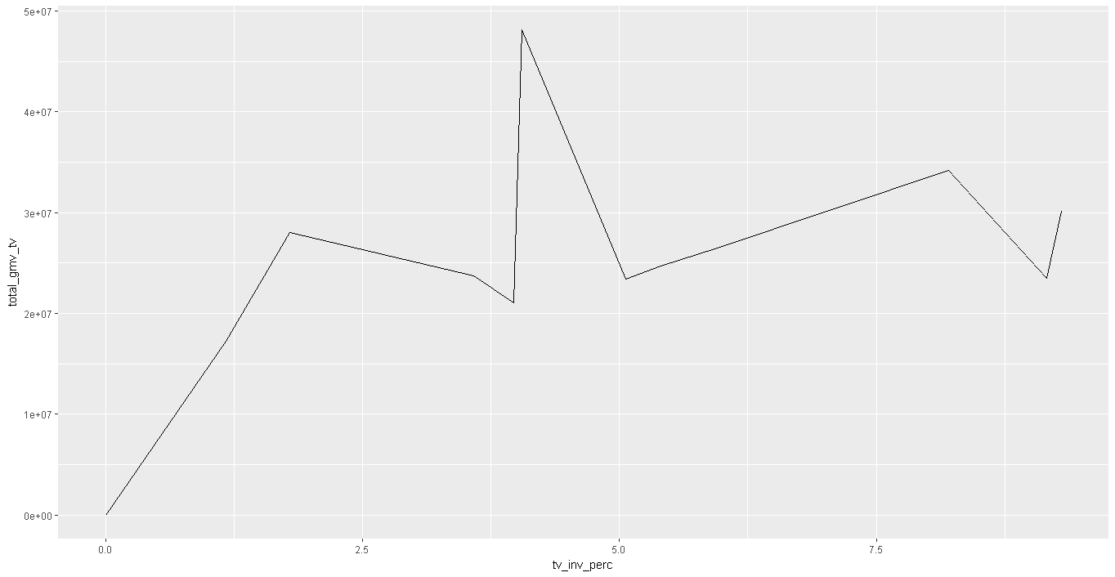

**Sponsorship Vs Sales revenue**

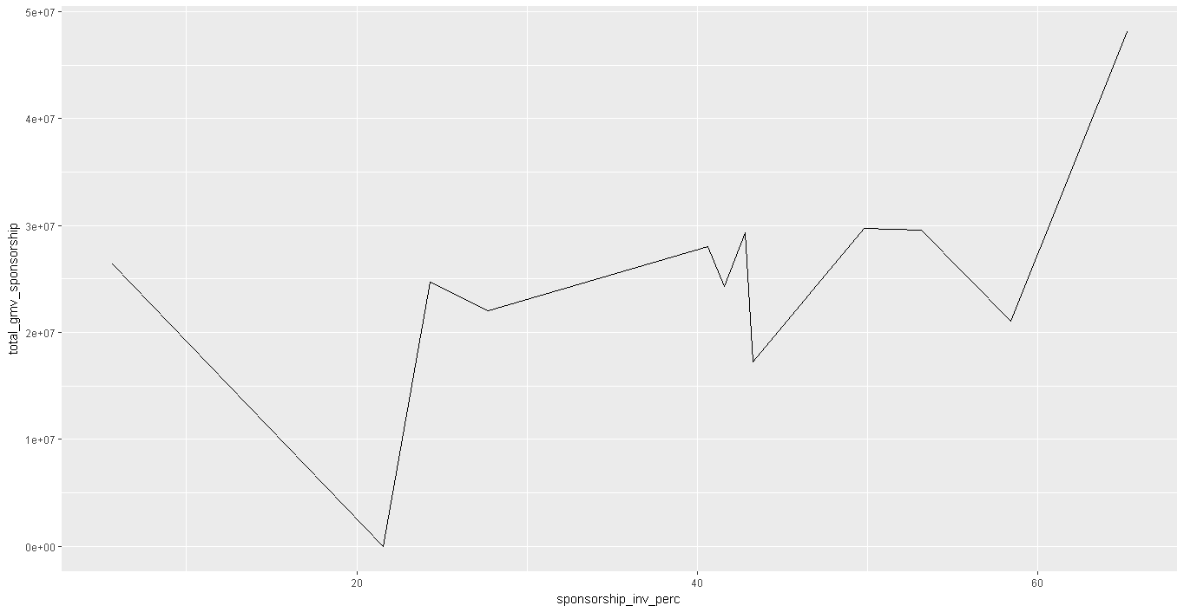

**Content Marketing Vs Sales Revenue**

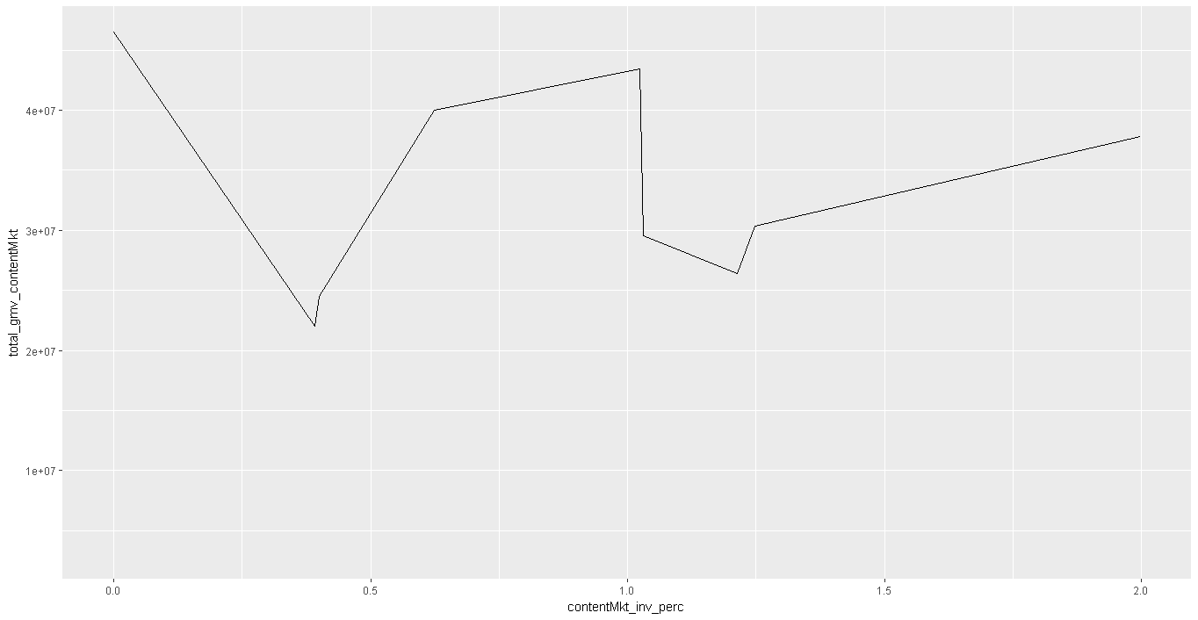

Online Marketing Vs Sales

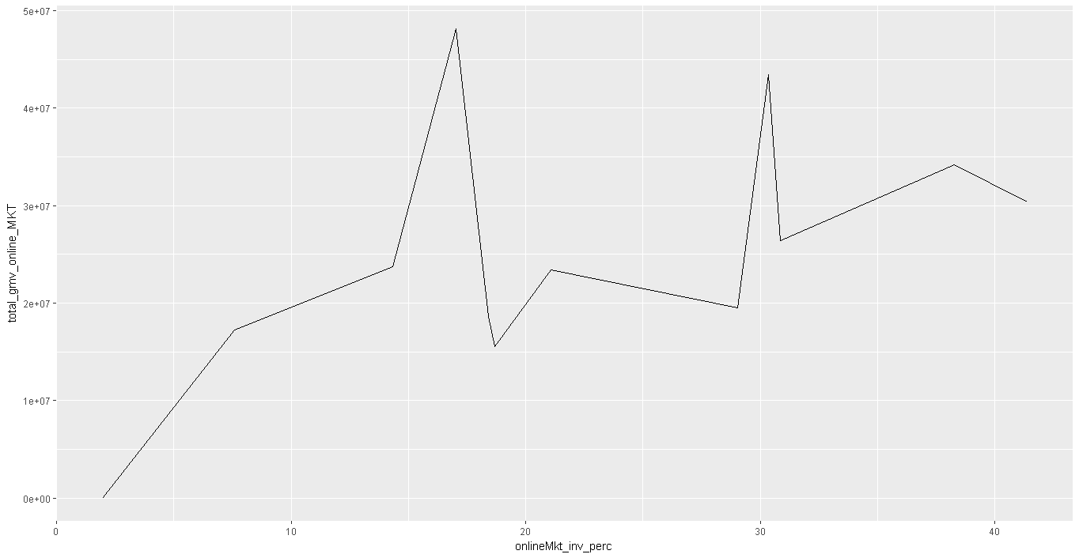

Affiliates Vs Sales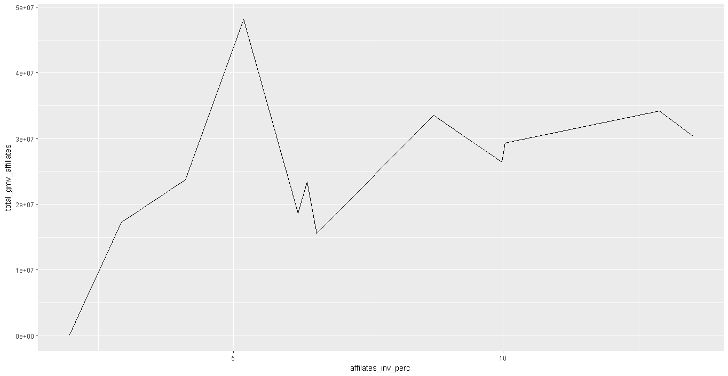

Radio Vs Sales

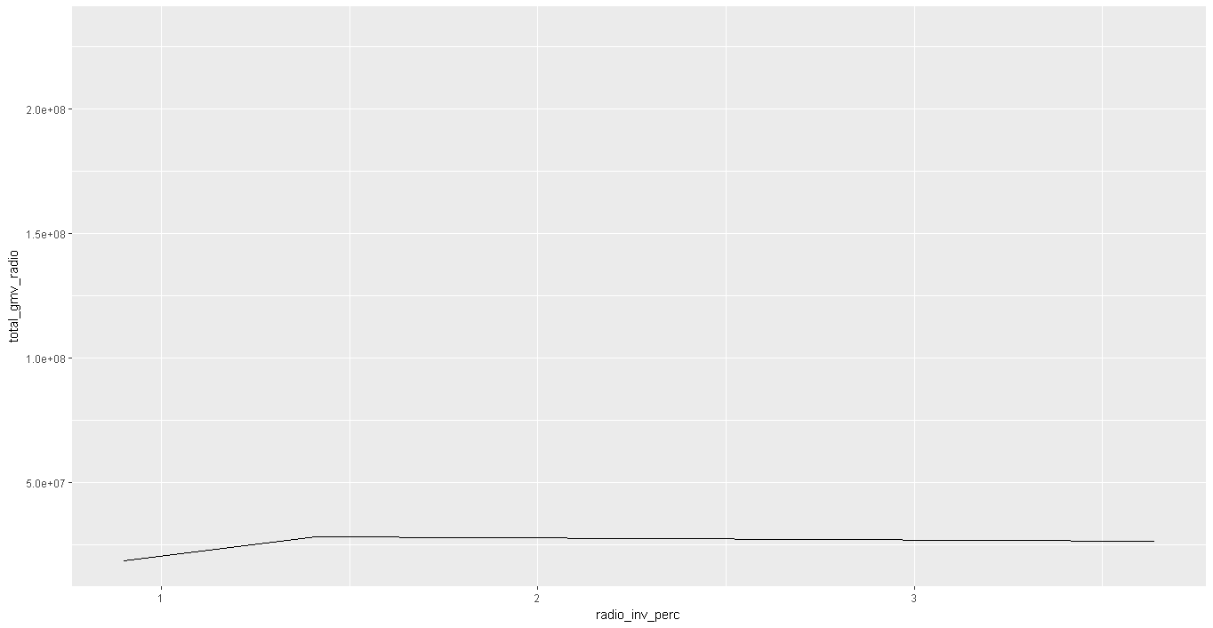

SEM Vs Sales

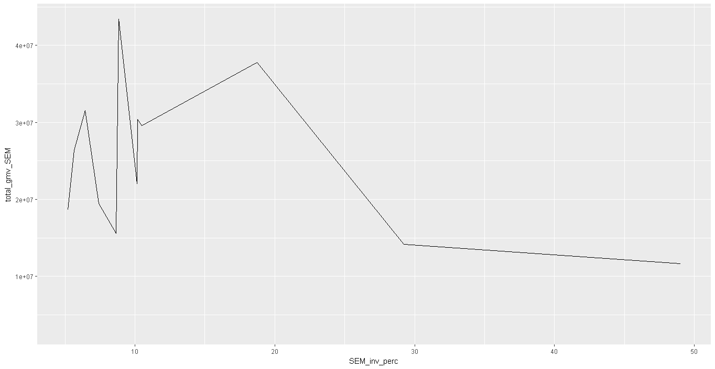

Others vs Sales

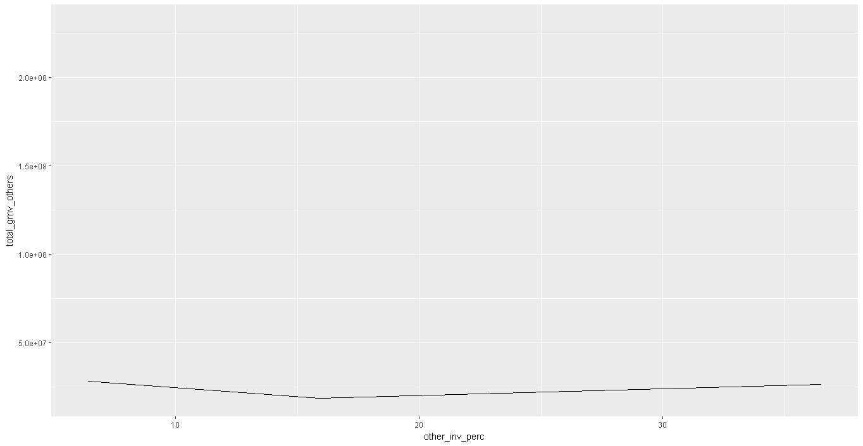

But here is the question.

Over the year we saw the proportion of investments on various channels were not uniform. What if when there was festival sale and the proportion of investment, let’s say on channel A was higher than on channel B (80:20)and during a normal week/month the proportion was reverse (20:80), we will end up concluding channel A is better. But we are not capturing the fact that it was a festival season and sale was supposed to go up anyways?

Plot attached shows digital marketing and SEM is not a better option to invest much. But the fact that heavy investment on these channels were made during non-event months

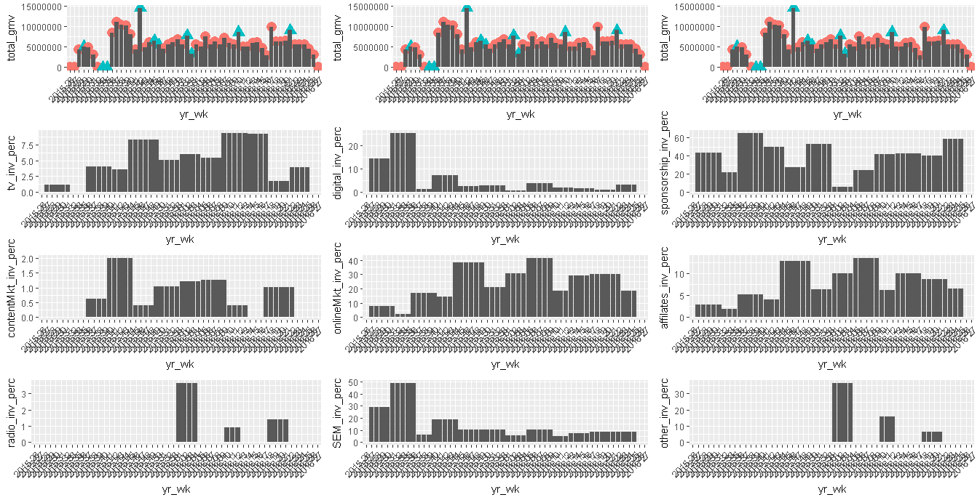

Discount Vs Sales on various camera accessories

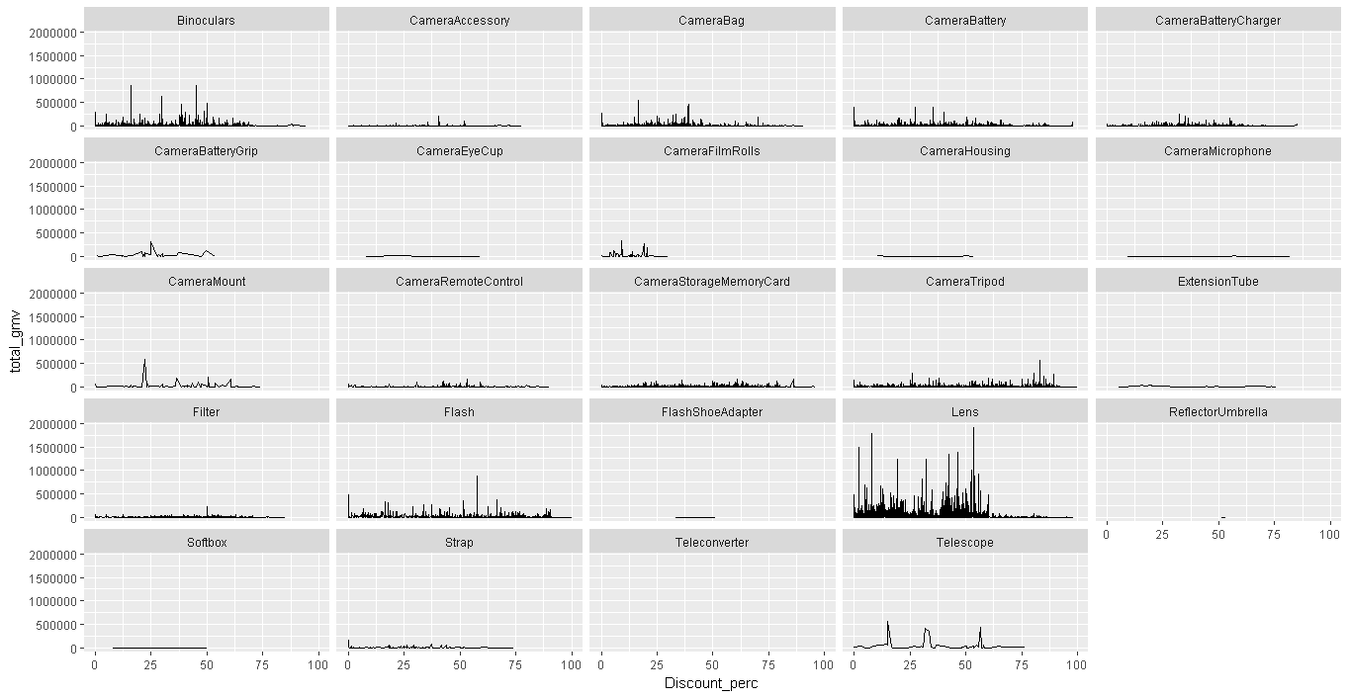

Sales in log2 scale

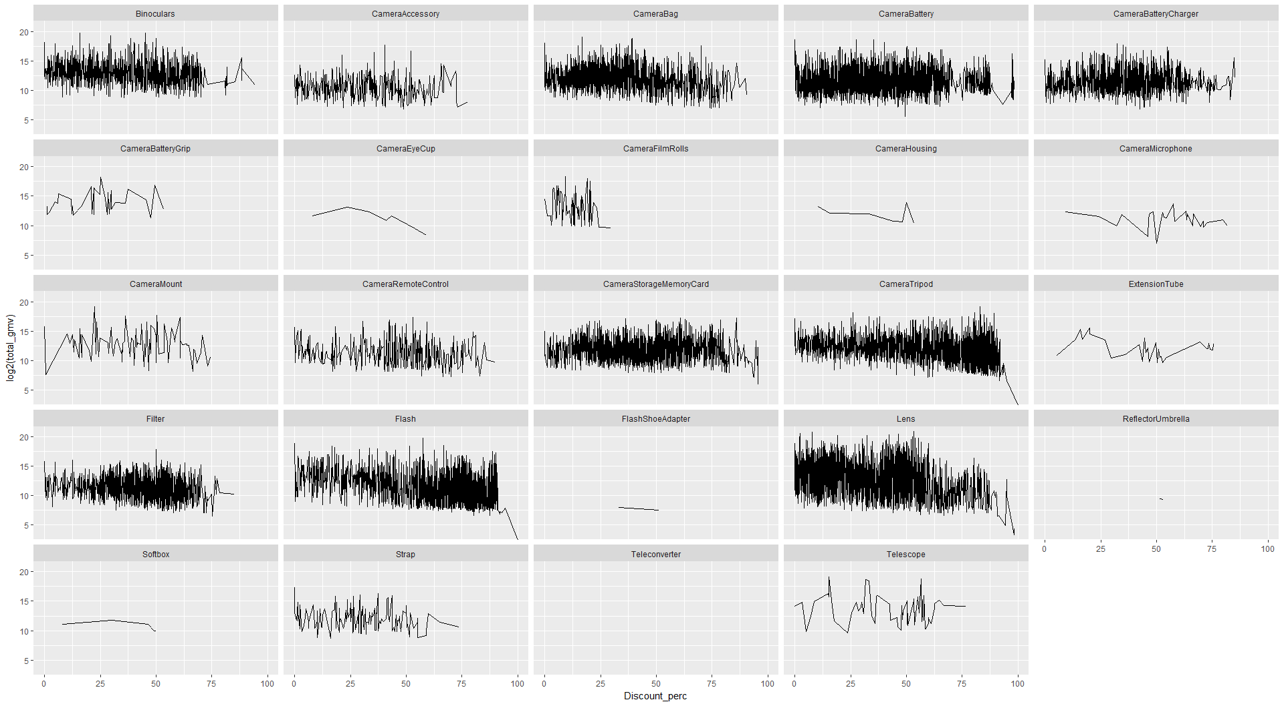

Discount Vs Sales effect in 3 product levels of same vertical (Camera Tripod)

Premium

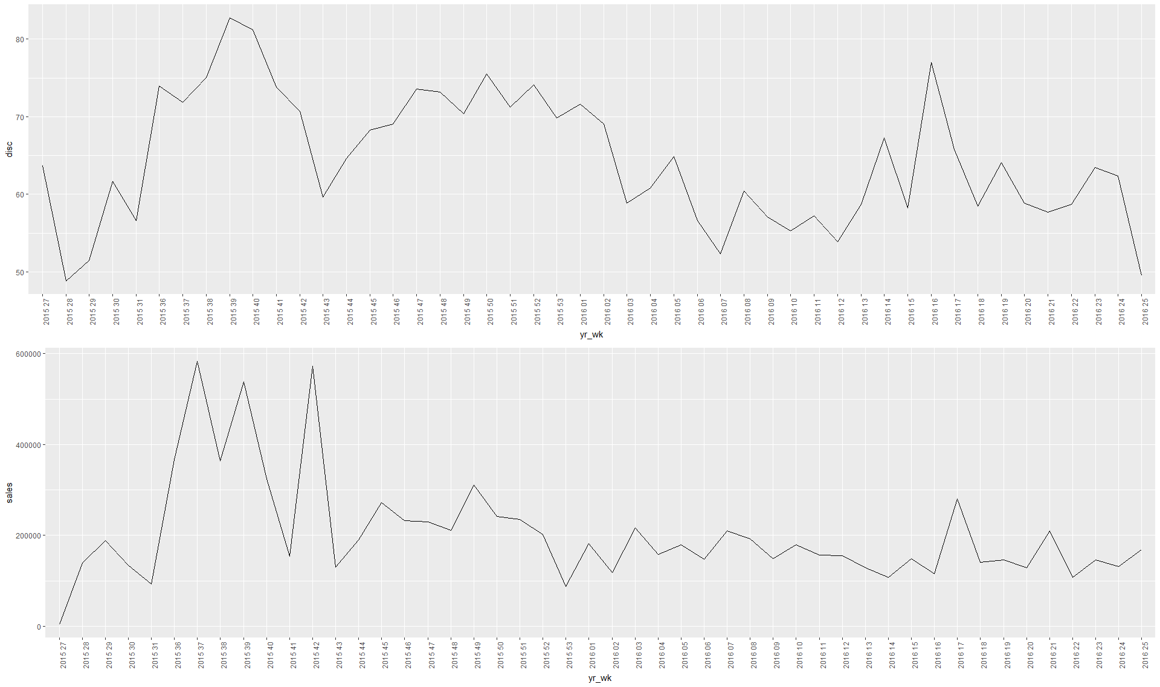

Budget

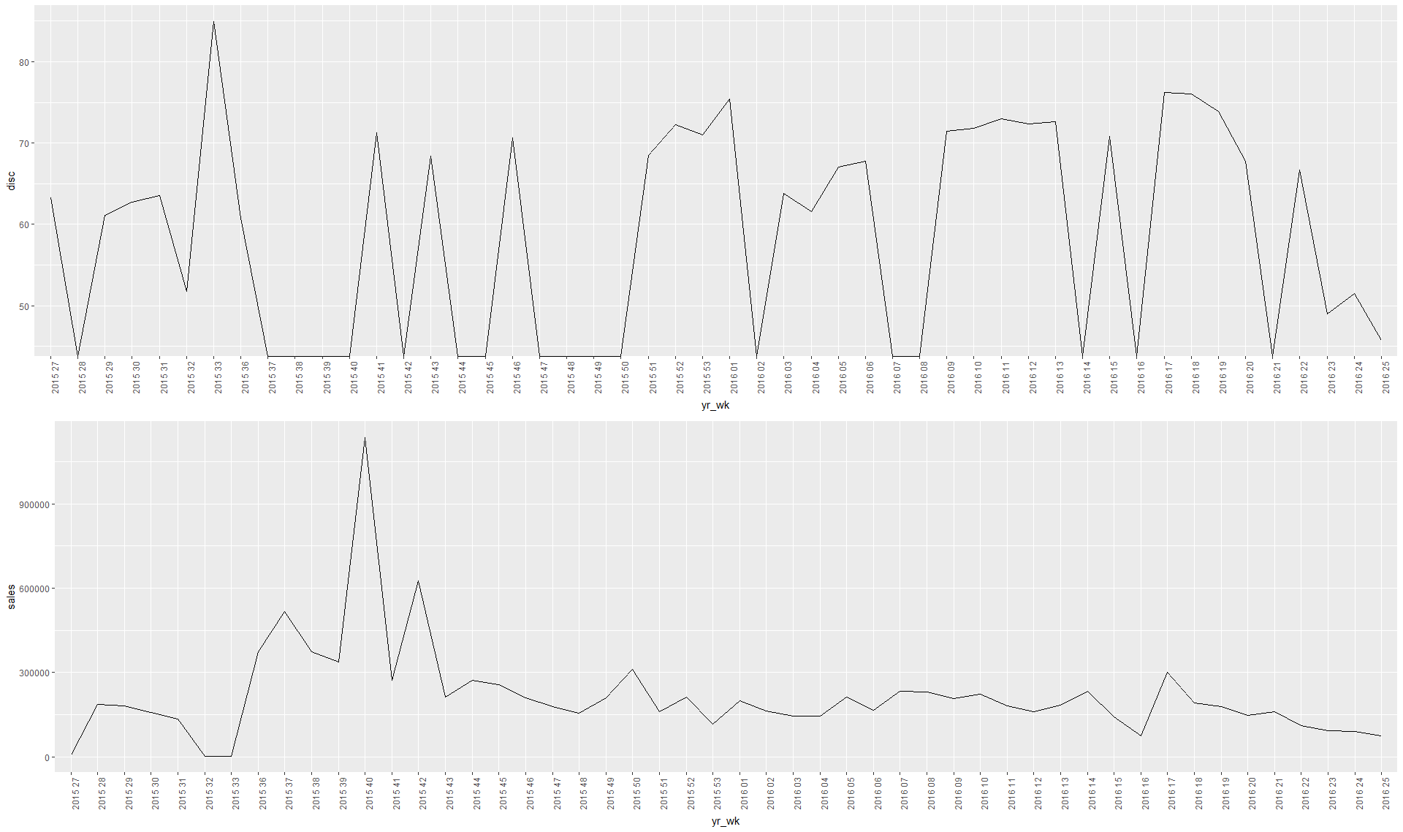

Economy

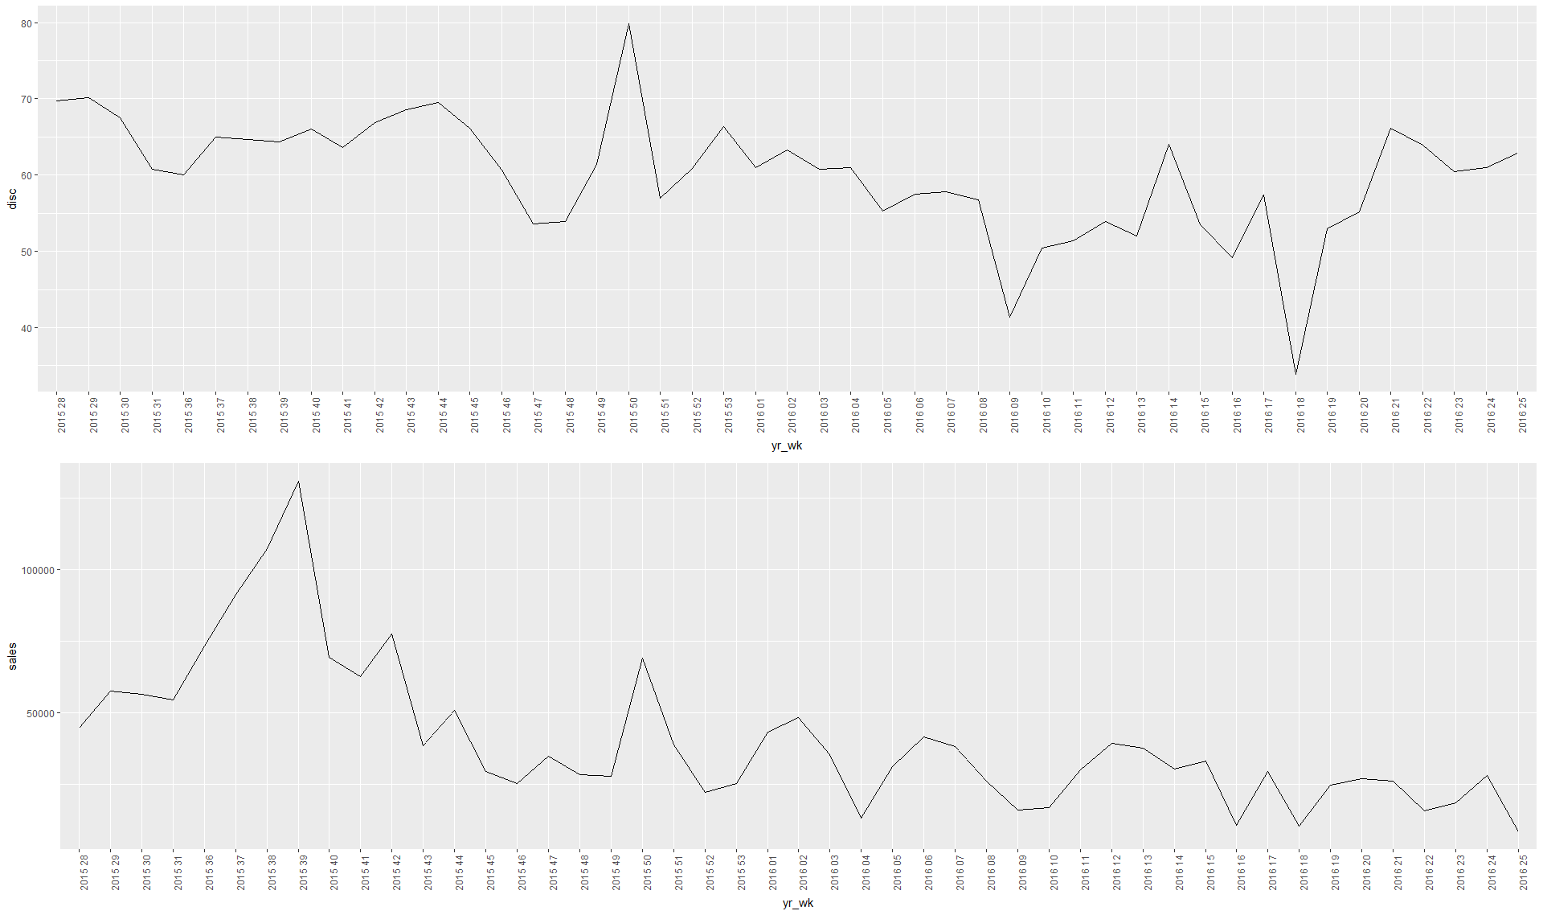

SLA vs Sales

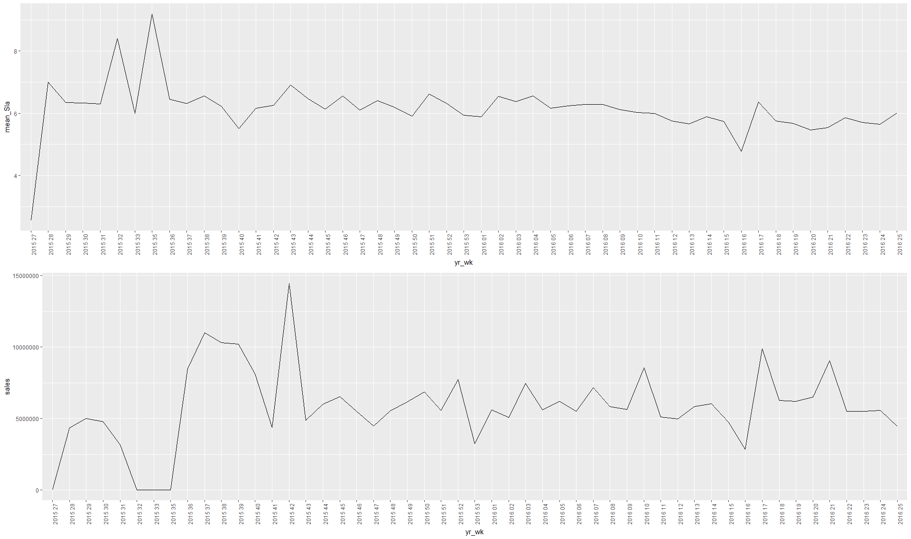

Price changes and change in sales unit

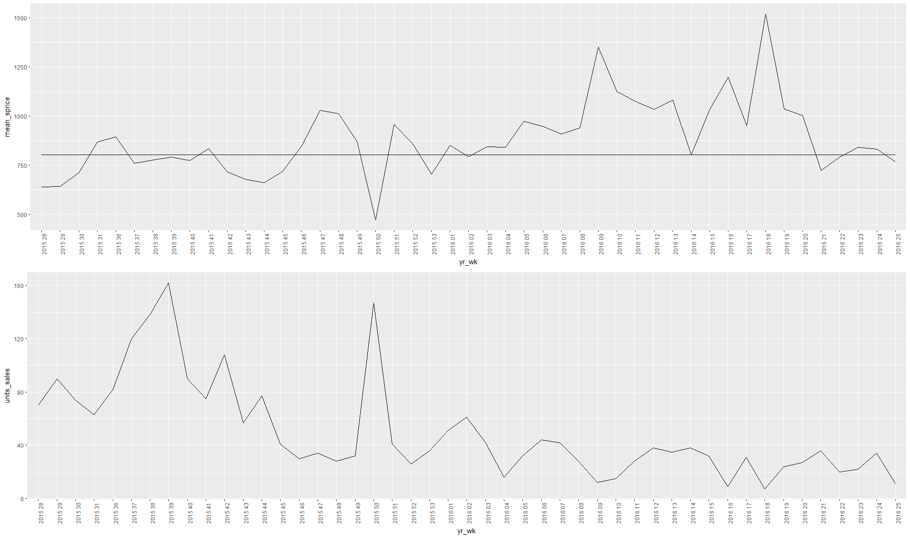

We are segmenting each type of products into 3 buckets:

Budget, Economic and Aspiring:

Violin plot for Camera Tripod

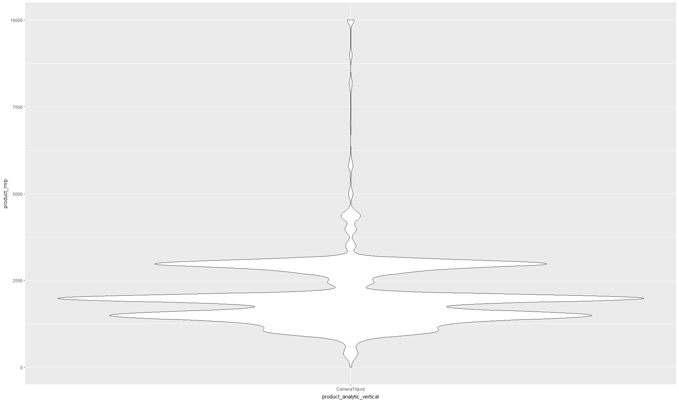

Question: How to choose the threshold values?

Can we run our analysis on all the SKUs based on these buckets?

**Before Regression final datasets and comparison plots**

**NO CLUSTER Cluster: MASS**

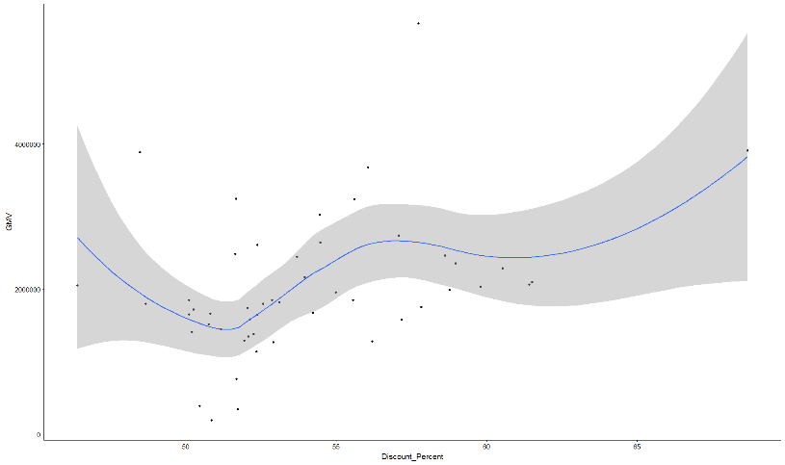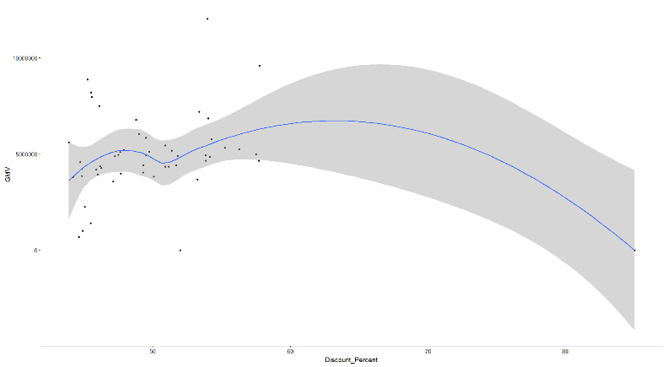**D**iscount Percent

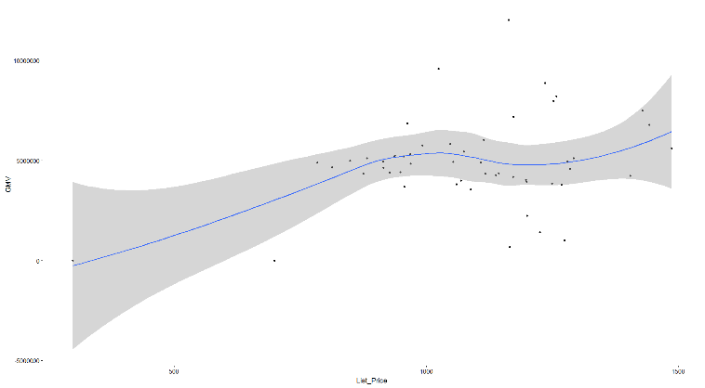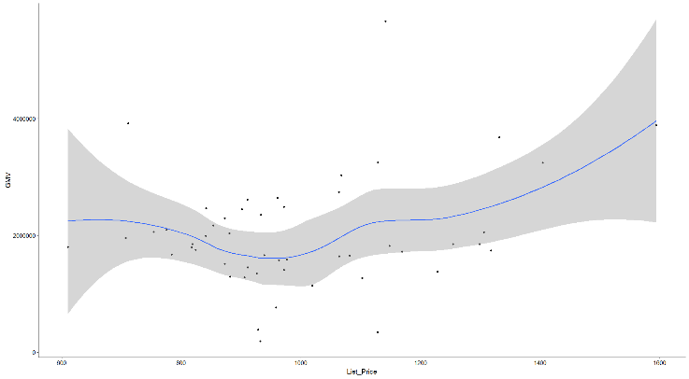List_price

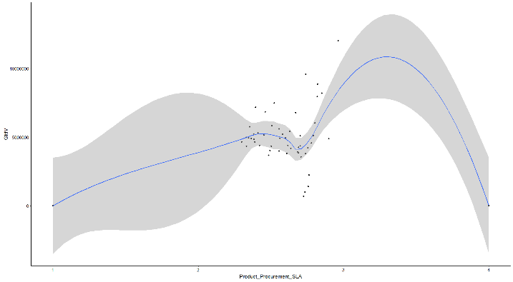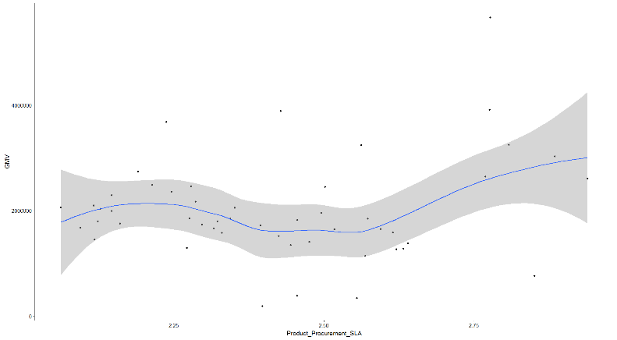Product_procurementSLA

NPS

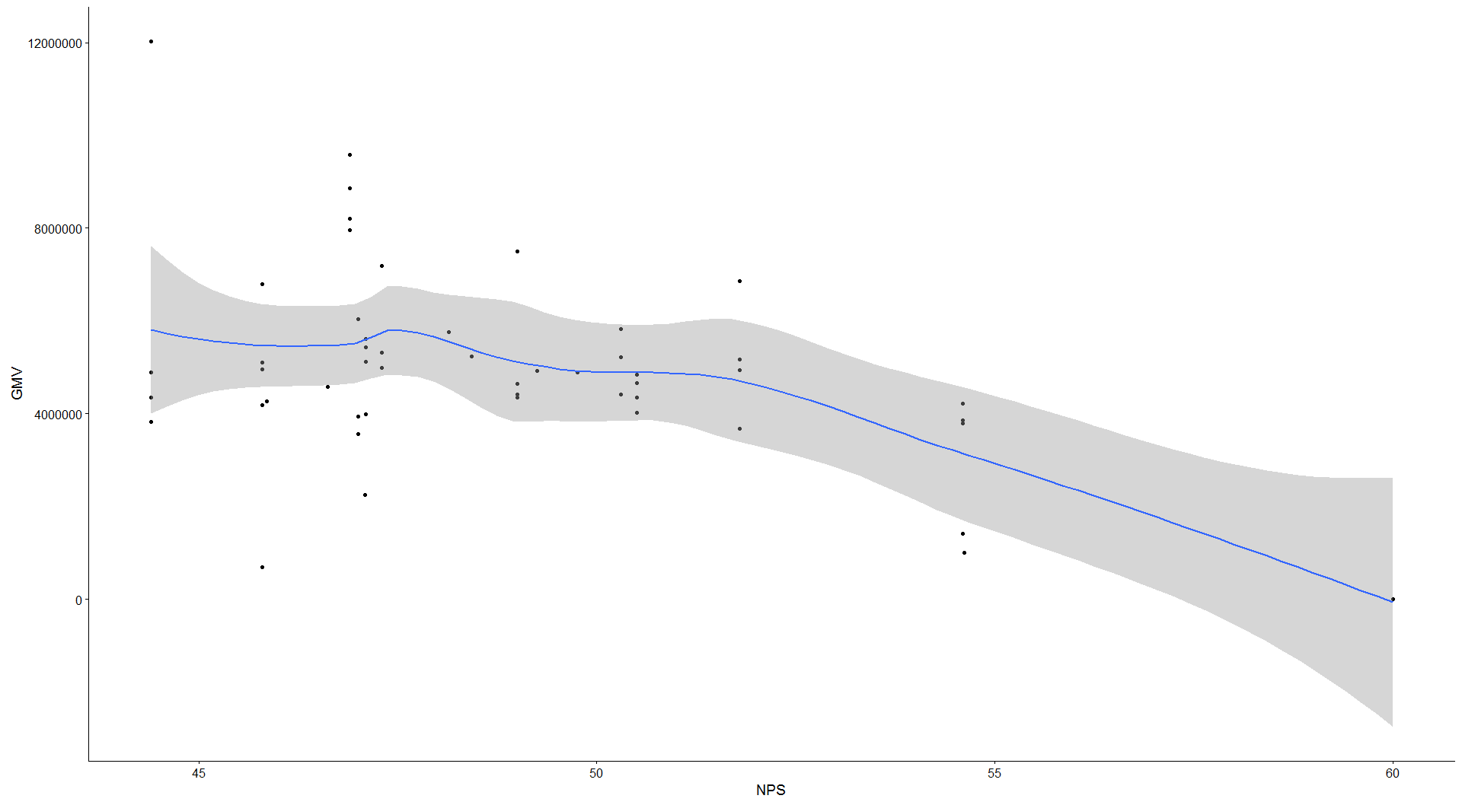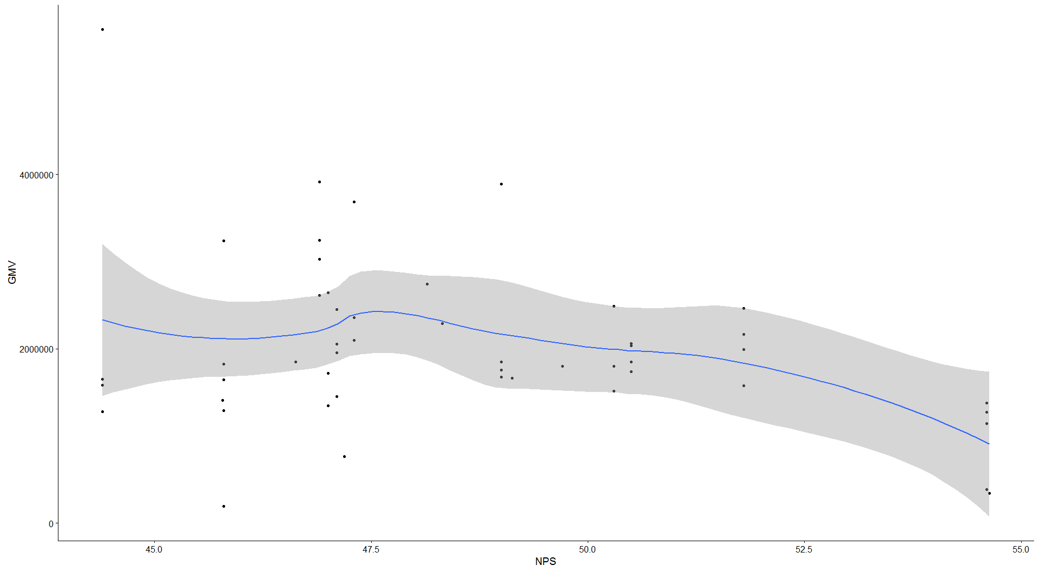

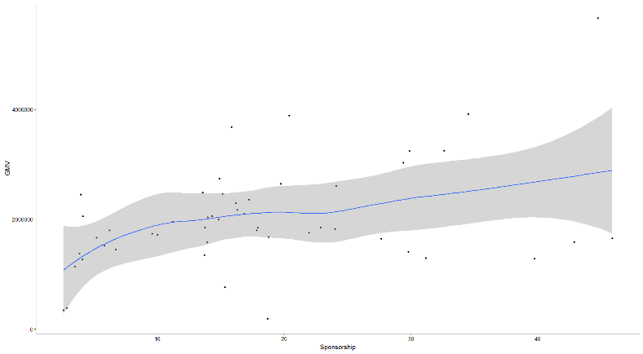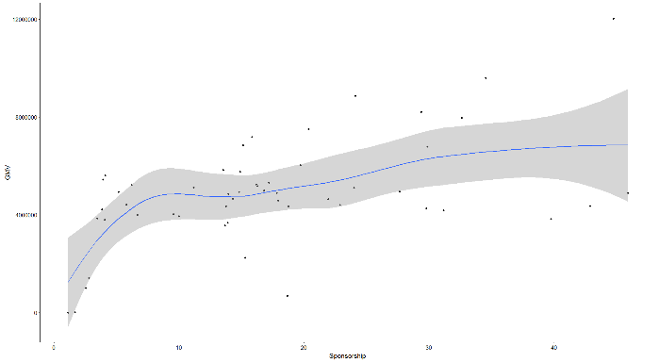Sponsorship

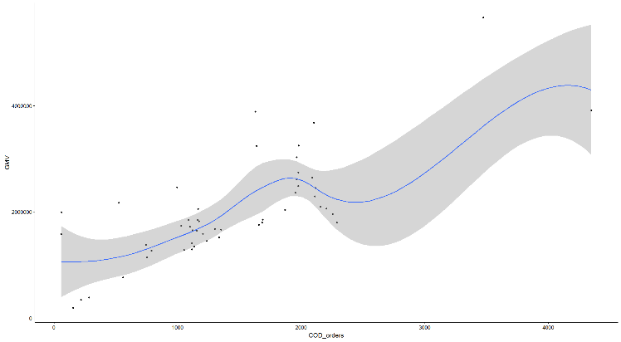COD orders

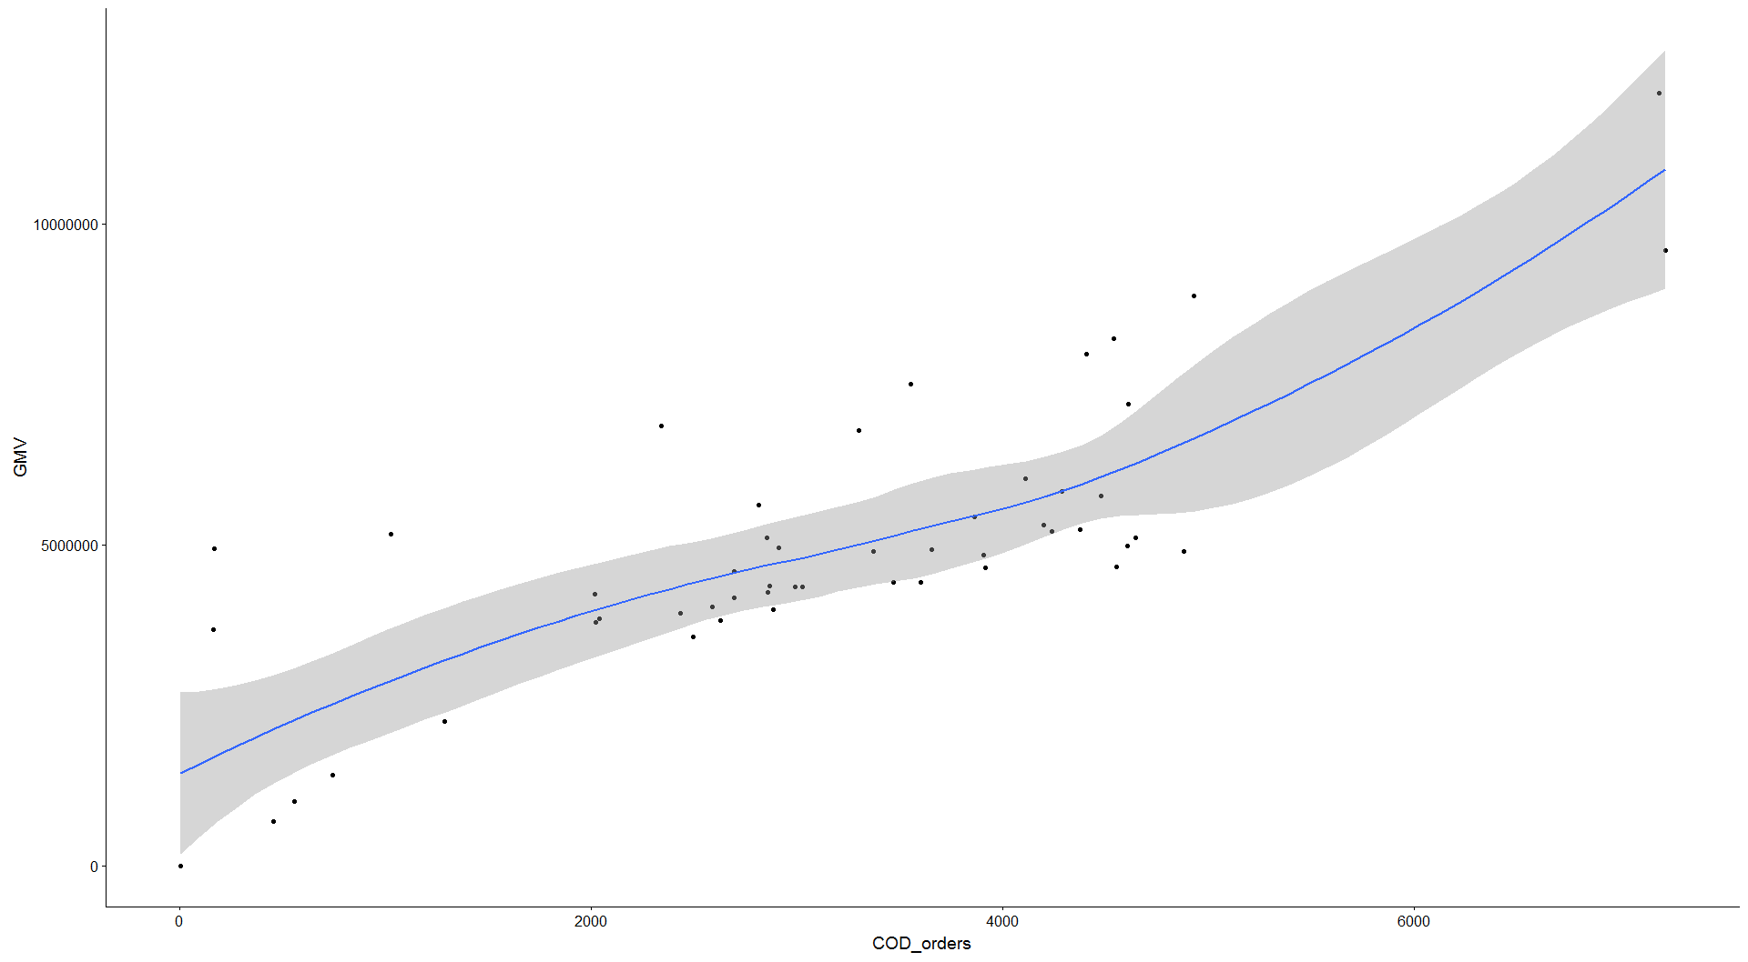

Affiliates

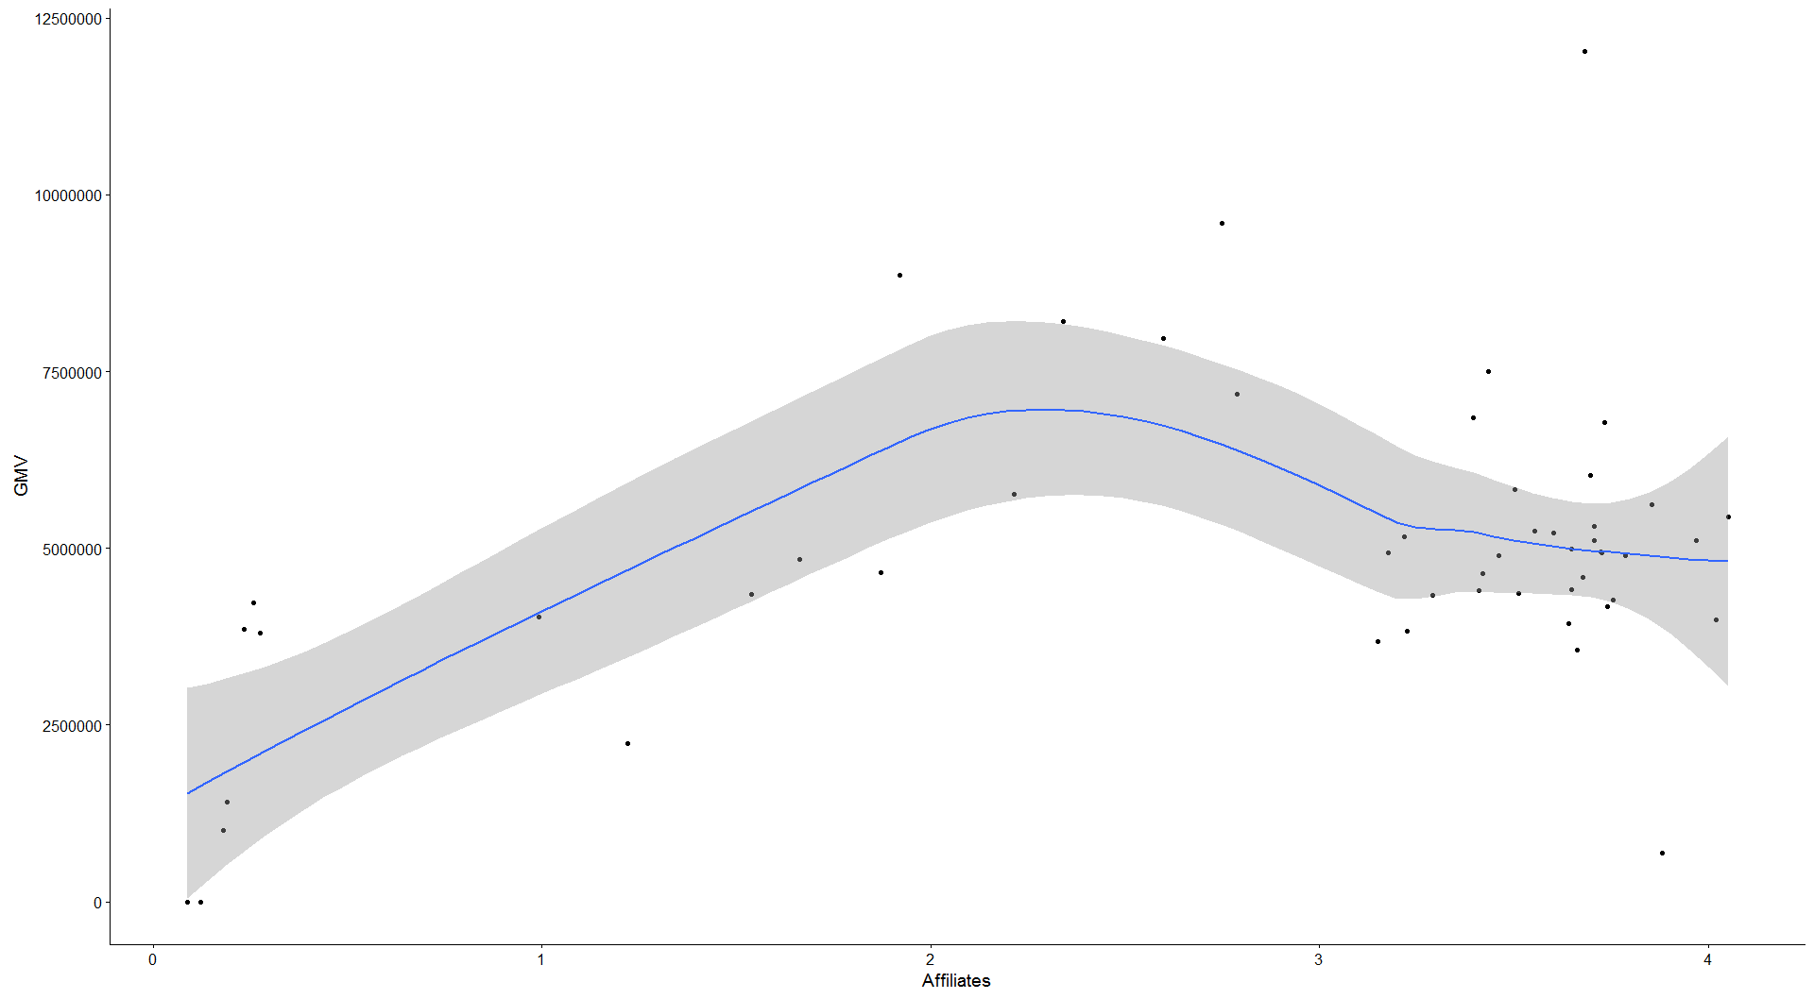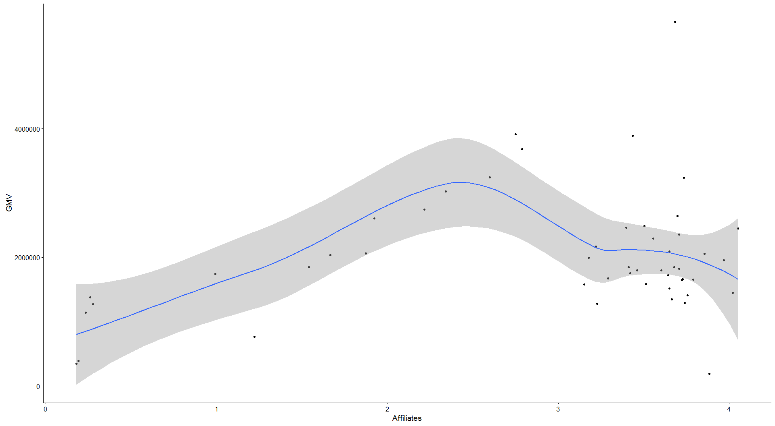

Online Marketing

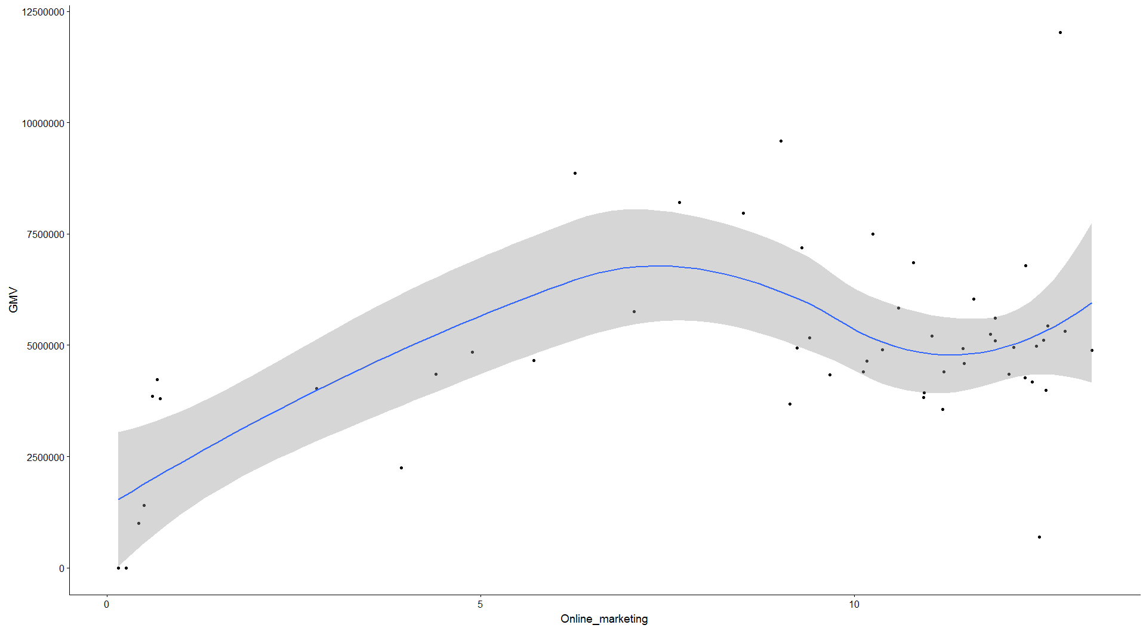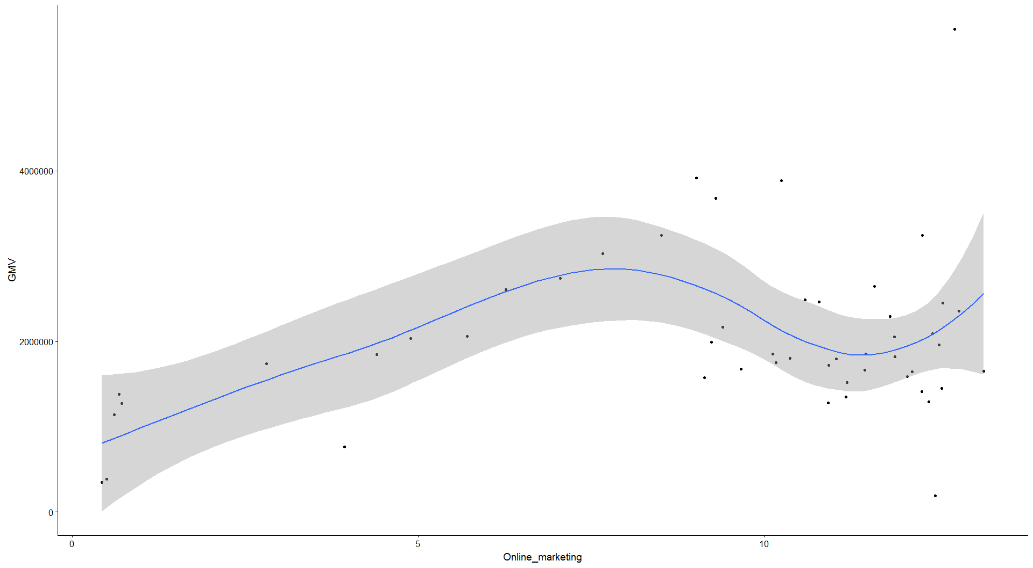

**QUESTIONS:**

Should we take the ListPrice, MRP, Discount all? It is multi-corelated. Isn’t it?