JAVA + DSA
COMPLETE INTERVIEW-READY STUDY NOTES
Premium Edition — Diagrams · Complexity Tables · Interview Traps · HR Insights
Curated & expanded from classroom (DSC) notes
Reviewed with 20 years of hands-on engineering + technical-hiring experience
“Data structures are the vocabulary. Algorithms are the grammar. Interviews test if you can write a sentence under pressure.”

How To Use These Notes
These notes are organised the way a senior engineer would revise before a bank / product-company interview: concept → diagram → complexity → code → trap questions. Colour-coded boxes appear throughout:
★ INTERVIEW TIP
Gold boxes = what interviewers actually probe, and how to answer confidently.
↻ REVISION BOX — RECALL IN 10 SECONDS
Blue boxes = the one-line fact you must recall instantly, even half-asleep.
⚠ EDGE CASES TO REMEMBER
Red boxes = the edge case that silently breaks 'working' code — interviewers love these.
💼 HR / CAREER NOTE
Green boxes = career / HR-side advice — how this topic is evaluated in real interview loops.

Suggested revision order: Java Fundamentals → Strings → Arrays → Collections → Hashing → Linked List → Recursion → Sorting → Trees → Trie → Graph → Final Cheat Sheet.

1. Java Fundamentals

1.1 Naming Conventions
Consistent naming is the first thing a reviewer notices in a pull request — get it automatic.
Convention | Used for | Example
PascalCase | Classes, Interfaces, Enums | StudentDetails, Runnable, DayOfWeek
camelCase | Variables & methods | studentName, calculateTotalMarks()
UPPER_SNAKE_CASE | Constants (static final) | MAX_MARKS, DB_TIMEOUT_MS
lowercase.dotted | Packages | com.bank.payments.core
public class StudentDetails { // PascalCase
static final int MAX_MARKS = 100; // UPPER_SNAKE_CASE
String studentName; // camelCase

void calculateTotalMarks() { // camelCase
System.out.println(studentName);
}
}
★ INTERVIEW TIP
Naming isn't cosmetic. In a banking codebase, reviewers reject PRs for bad naming as often as for bugs — it signals whether you'll be safe to let near production code.

1.2 Primitive Data Types
Type | Size | Range (approx.) | Default
byte | 1 byte (8 bits) | -128 to 127 | 0
short | 2 bytes | -32,768 to 32,767 | 0
int | 4 bytes | ≈ -2.1B to 2.1B | 0
long | 8 bytes | ≈ ±9.2 × 10¹⁸ | 0L
float | 4 bytes | ~6-7 decimal digits precision | 0.0f
double | 8 bytes | ~15 decimal digits precision | 0.0d
char | 2 bytes | 0 to 65,535 (Unicode) | '\u0000'
boolean | 1 bit (JVM-dependent) | true / false | false
⚠ EDGE CASES TO REMEMBER
int + int can silently overflow — no exception is thrown, it just wraps around. Interviewers ask this to catch people who assume Java is 'safe by default'.
Never compare float/double with == for equality — use a tolerance (Math.abs(a-b) < epsilon).

1.3 JDK vs JRE vs JVM
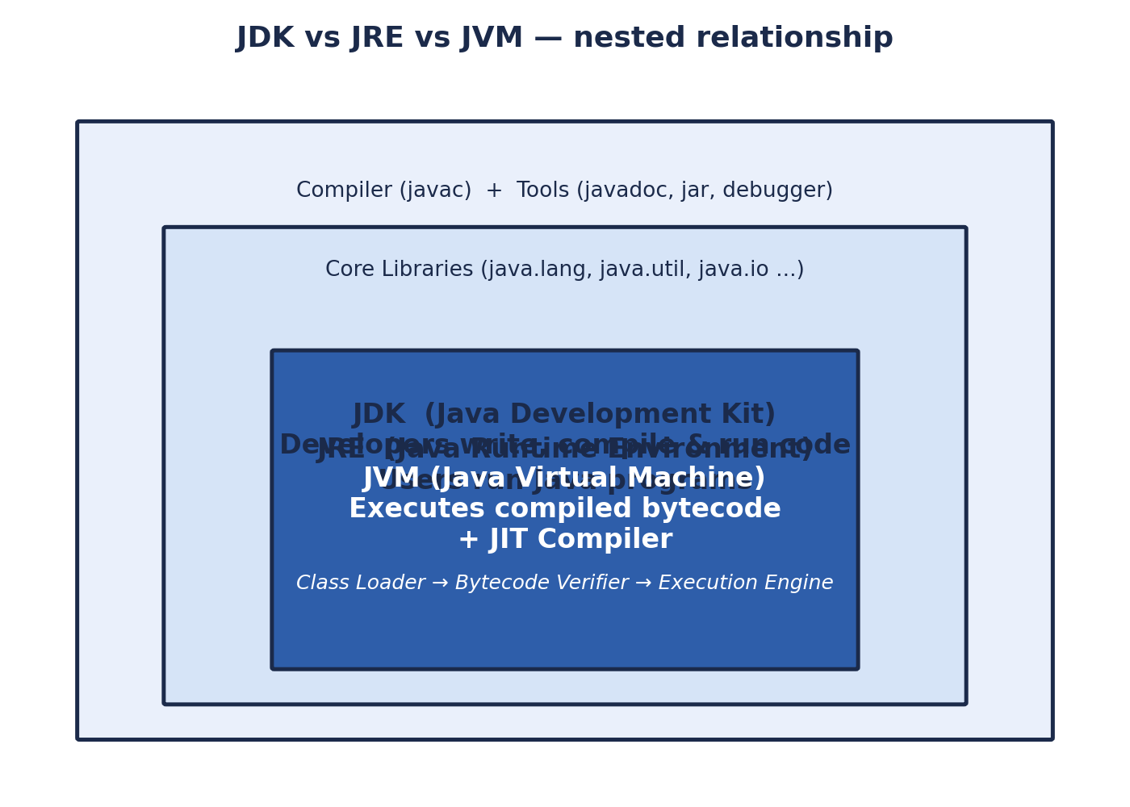
Figure 1 — JDK contains JRE, which contains the JVM
Term | Full form | Used by / for
JDK | Java Development Kit | Developers — write, compile, debug code (JRE + compiler + tools)
JRE | Java Runtime Environment | End users — run compiled Java programs (JVM + libraries)
JVM | Java Virtual Machine | Executes bytecode; makes Java 'write once, run anywhere'
JIT | Just-In-Time Compiler | Compiles hot bytecode paths to native machine code at runtime
JAR | Java ARchive | Packages classes + resources into a single deployable file
JDBC | Java Database Connectivity | Standard API to connect Java apps to relational databases
↻ REVISION BOX — RECALL IN 10 SECONDS
JDK = JRE + dev tools. JRE = JVM + libraries. JVM = executes bytecode. You need only the JRE to *run* a .jar; you need the JDK to *build* one.

1.4 Compiler vs Interpreter (Java is both!)
The notes describe an interpreter as something that executes code line-by-line rather than translating the whole program upfront. Java is a hybrid:
- javac (compiler) converts .java source → platform-independent .class bytecode ahead of time.
- The JVM then interprets that bytecode line-by-line at first run.
- The JIT compiler watches for 'hot' code (loops/methods run repeatedly) and compiles just that part to native machine code for speed.
★ INTERVIEW TIP
Classic interview question: 'Is Java compiled or interpreted?' Correct answer: both — compiled to bytecode, then interpreted/JIT-compiled by the JVM. Saying only one half is a common miss.

1.5 Memory Management — Stack vs Heap
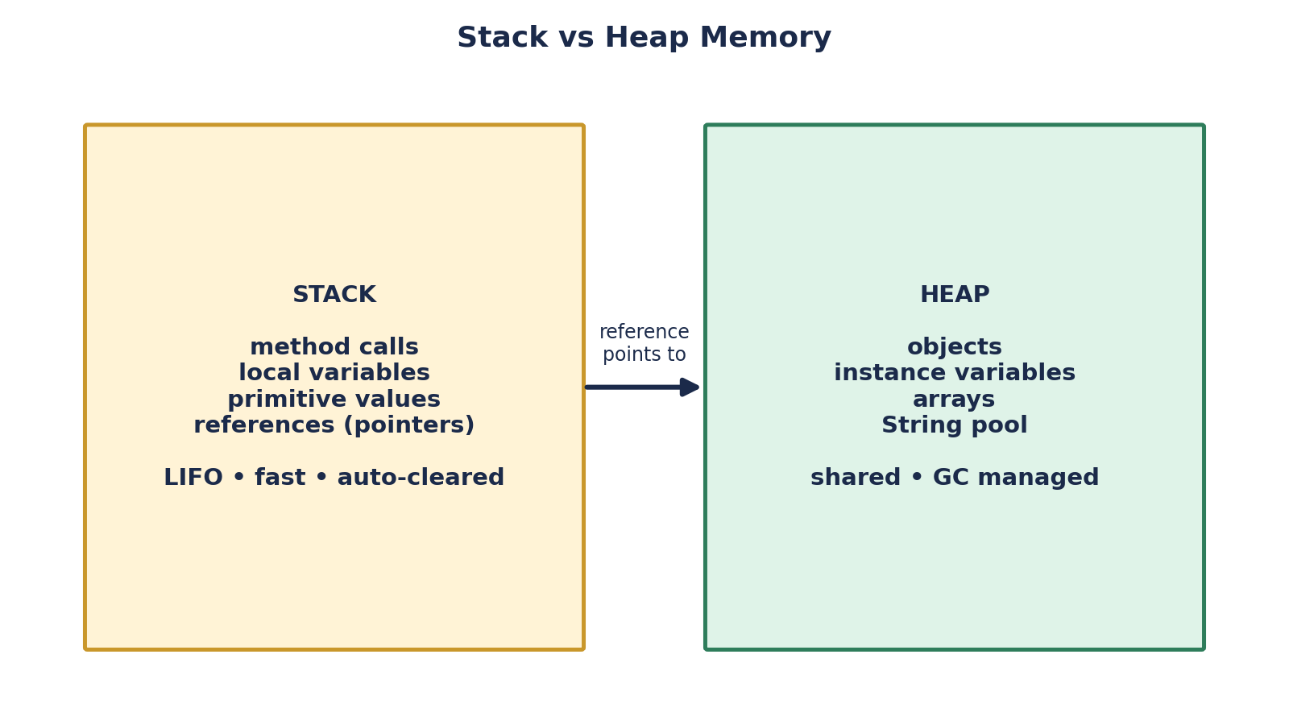
Figure 2 — Local variables & references live on the Stack; objects live on the Heap
Aspect | Stack | Heap
Stores | Method calls, local variables, primitives, references | Objects, instance variables, arrays
Lifetime | Cleared automatically when method returns | Lives until no references point to it (Garbage Collected)
Speed | Very fast (LIFO) | Slower — more bookkeeping
Error on overflow | StackOverflowError (deep/infinite recursion) | OutOfMemoryError (too many live objects)

1.6 OOP Pillars (missing from raw notes — core interview topic)
Every one of the syntax topics above exists to serve these four ideas. Almost every Java interview opens with 'explain OOP concepts with an example.'
Pillar | One-line definition | Java mechanism
Encapsulation | Hide internal state; expose behaviour via methods | private fields + public getters/setters
Inheritance | Reuse & extend behaviour from a parent class | extends keyword, super
Polymorphism | Same method call, different behaviour | Method overloading (compile-time) & overriding (runtime)
Abstraction | Expose 'what', hide 'how' | abstract classes & interfaces
abstract class Account { // Abstraction
protected double balance; // Encapsulation (protected, not public)
abstract double interestRate();

void printBalance() { // shared behaviour (Inheritance target)
System.out.println("Balance: " + balance);
}
}

class SavingsAccount extends Account { // Inheritance
double interestRate() { return 3.5; } // Overriding -> Polymorphism
}

class FixedDeposit extends Account {
double interestRate() { return 6.75; }// same call, different behaviour
}
★ INTERVIEW TIP
Give a real-world example tied to the company's domain (banking → Account/SavingsAccount/FixedDeposit) — it shows domain thinking, not memorised textbook answers.
Overloading = same method name, different parameter list, resolved at COMPILE time. Overriding = subclass redefines a parent method, resolved at RUNTIME. Interviewers routinely ask you to state which is compile-time vs runtime binding.

1.7 Constructors
- Special block that initialises an object; name must exactly match the class name.
- Has NO return type — not even void.
- Invoked automatically exactly once, at the moment of object creation (new keyword).
- Cannot be called again manually after the object exists.
Type | Description
Default constructor | No parameters; if you write no constructor at all, Java silently generates one.
Parameterized constructor | Accepts arguments to initialise fields at creation time.
Constructor overloading (missing concept) | Multiple constructors with different parameter lists in the same class.
Copy constructor (missing concept) | Not built into Java like C++ — commonly hand-written to clone an object's state.
class Employee {
String name;
double salary;

Employee() { // default
this("Unknown", 0.0); // constructor chaining via this()
}
Employee(String name, double salary) { // parameterized / overloaded
this.name = name;
this.salary = salary;
}
}
⚠ EDGE CASES TO REMEMBER
If you define ANY constructor yourself, Java stops auto-generating the no-arg default constructor — a very common source of 'constructor not found' compile errors when frameworks (like some ORMs) expect one.

1.8 Wrapper Classes, Autoboxing & Unboxing
A wrapper class converts a primitive into an object, so primitives can be used where objects are required (e.g., in Collections, which only store objects).
int num = 10;
Integer obj = num; // Autoboxing: primitive -> object
int value = obj; // Unboxing: object -> primitive
Primitive | byte | short | int | long | float | double | char | boolean
Wrapper | Byte | Short | Integer | Long | Float | Double | Character | Boolean
⚠ EDGE CASES TO REMEMBER
Integer caching: Integer a = 100, b = 100; a == b is true (cached, -128 to 127). But Integer a = 200, b = 200; a == b is FALSE — different objects outside the cache range. This is a classic trick question.
Unboxing a null wrapper (Integer x = null; int y = x;) throws NullPointerException at runtime.
💼 HR / CAREER NOTE
This exact Integer-caching question is a favourite at product-based and banking-tech interviews — it separates people who've only used Java from people who understand the JVM underneath it.

2. Strings in Java

2.1 Core Properties
- A String is a sequence of characters and is IMMUTABLE — once created, its contents can never change.
- Every 'modification' (concat, substring, replace) creates a brand-new String object.
- String literals are stored in a special memory region called the String Pool (part of the Heap) for reuse.
String s = new Scanner(System.in).nextLine();

String a = "hello"; // goes to String Pool
String b = "hello"; // reuses the same pooled object
String c = new String("hello"); // forces a NEW object on the heap, bypasses pool

2.2 == vs .equals()
Operator | Compares | Result for a==b above | Result for a==c above
== | Reference (memory address) | true | false
.equals() | Actual character content | true | true
★ INTERVIEW TIP
Always use .equals() for content comparison. == on Strings is a top-5 'gotcha' interview question precisely because it compiles and often 'seems' to work with literals — until a new String() or user input breaks the assumption.

2.3 StringBuilder vs StringBuffer (missing concept — frequently tested)
 | String | StringBuilder | StringBuffer
Mutability | Immutable | Mutable | Mutable
Thread-safe | N/A (immutable = inherently safe) | No | Yes (synchronized methods)
Performance | Slow for repeated concatenation | Fast | Slower than StringBuilder (sync overhead)
Use when | Value rarely changes | Single-threaded heavy string building | Multi-threaded heavy string building
⚠ EDGE CASES TO REMEMBER
Building a string with '+' inside a loop silently creates N throwaway String objects — O(N²) work overall. Always use StringBuilder in loops.
↻ REVISION BOX — RECALL IN 10 SECONDS
Immutable + shared pool → use == cautiously. Need to mutate a lot → StringBuilder (single thread) or StringBuffer (multi-thread).

3. Arrays
- Arrays are objects in Java — even arrays of primitives.
- Fixed size once declared — cannot grow or shrink.
- Homogeneous — every element must be the same type.
- Indexed — any element accessible in O(1) via its index.

2D Array / Matrix
int[][] matrix = {{1,2,3}, {4,5,6}, {7,8,9}};
long product = 1;
for (int[] row : matrix)
for (int val : row)
product *= val; // classic 'product in matrix' interview drill

Sieve of Eratosthenes — find all primes up to m (asked at Amazon)
boolean[] isComposite = new boolean[m + 1];
for (int i = 2; (long) i * i <= m; i++) {
if (!isComposite[i]) {
for (int j = i * i; j <= m; j += i)
isComposite[j] = true;
}
}
// any index i (i>=2) still false => i is prime. Time: O(N log log N)
↻ REVISION BOX — RECALL IN 10 SECONDS
Sieve beats trial division for RANGE queries (all primes up to m). For a single number's primality, trial division up to √n is enough.
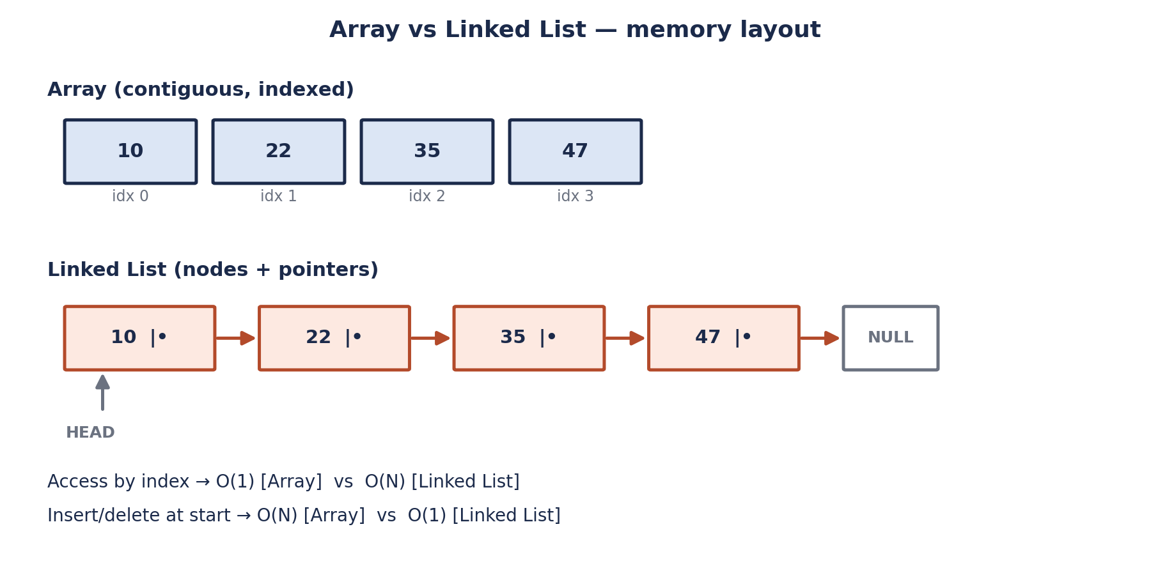
Figure 3 — Array (contiguous & indexed) vs Linked List (nodes & pointers)
⚠ EDGE CASES TO REMEMBER
ArrayIndexOutOfBoundsException is a RuntimeException — the compiler will not catch an off-by-one bug; always double-check loop bounds (< length, not <= length).

4. Collections Framework
A unified architecture to store, organise, and manipulate groups of objects efficiently — every non-trivial Java program uses this.

4.1 Generics
Generics let classes/interfaces/methods work with different types while keeping compile-time type safety — no manual casting, no ClassCastException surprises at runtime.
ArrayList<Integer> numbers = new ArrayList<>(); // only Integers allowed
numbers.add(10);
// numbers.add("ten"); <-- compile-time error, caught before runtime

4.2 ArrayList
Operation | Time Complexity | Why
Access by index | O(1) | Backed by a resizable array
Add at end | O(1) amortized | Occasional resize copies the array, but amortizes out
Add/remove at start or middle | O(N) | All following elements must shift
Search (contains/indexOf) | O(N) | No index by value — must scan

4.3 HashSet / LinkedHashSet / TreeSet
 | HashSet | LinkedHashSet (missing concept) | TreeSet (missing concept)
Ordering | No guaranteed order | Insertion order preserved | Sorted order (natural / Comparator)
Duplicates | Not allowed | Not allowed | Not allowed
Insert / Search | O(1) avg | O(1) avg | O(log N)
Backed by | HashMap | Hash table + linked list | Red-Black Tree

4.4 HashMap / LinkedHashMap / TreeMap
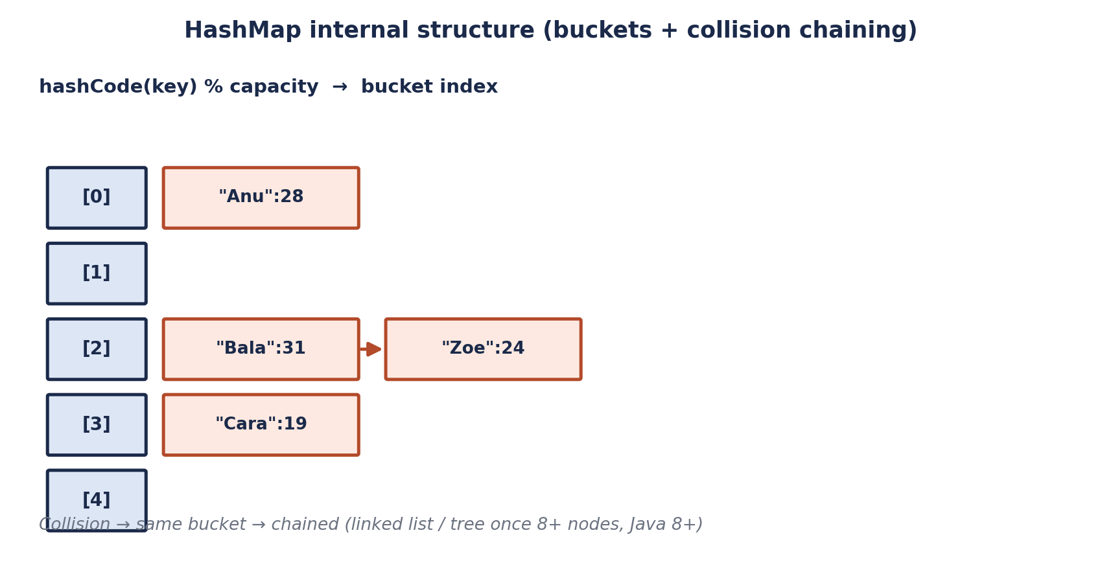
Figure 4 — HashMap buckets; collisions are chained
- Stores key-value pairs; keys must be unique and effectively immutable.
- Keys are hashed via hashCode() to pick a bucket, then equals() distinguishes keys within that bucket.
- Average O(1) for get/put; worst case O(N) if many keys collide into one bucket (Java 8+ converts long chains to a mini red-black tree, capping worst case at O(log N)).
for (Map.Entry<Integer, String> entry : map.entrySet()) { // no index in a Map, so iterate entrySet()
System.out.println(entry.getKey() + " : " + entry.getValue());
}
 | HashMap | LinkedHashMap | TreeMap
Ordering | No guarantee | Insertion order | Sorted by key
Get / Put | O(1) avg | O(1) avg | O(log N)
Null keys | One null key allowed | One null key allowed | No null keys (NPE on compare)

4.5 hashCode() & equals() contract (missing — critical for correctness)
⚠ EDGE CASES TO REMEMBER
If you override equals(), you MUST override hashCode() too. Two objects that are .equals() MUST return the same hashCode(), or they'll silently 'disappear' inside a HashMap/HashSet.
The reverse isn't required: equal hashCodes don't have to mean equal objects (that's exactly what a collision is).
★ INTERVIEW TIP
Draw this exact scenario on the whiteboard when asked: override equals() without hashCode() → put a custom key into a HashMap → get() with an 'equal' key returns null. It's the single most common Java hiring-round bug.

4.6 PriorityQueue (Heap)
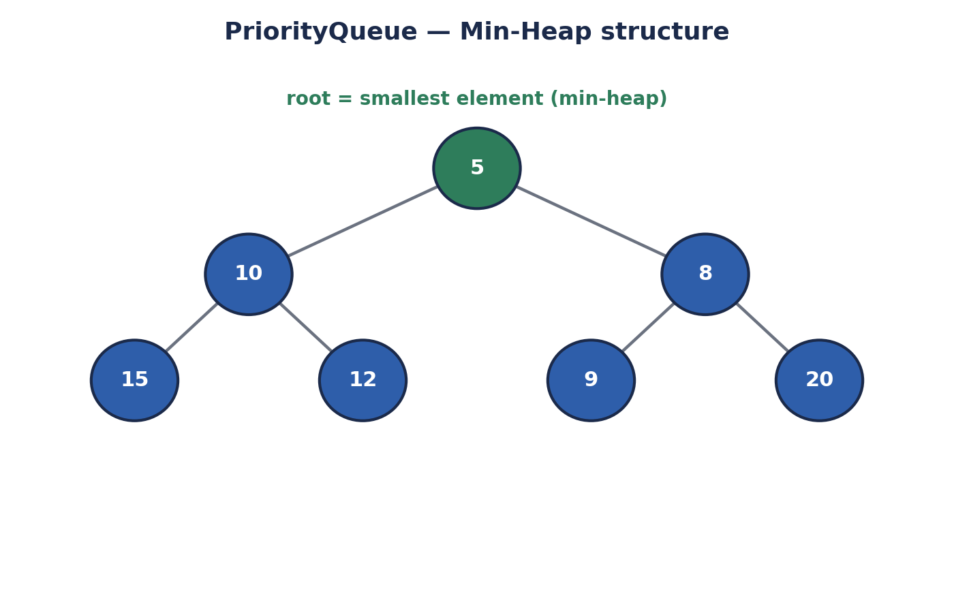
Figure 5 — Min-heap: smallest element always at the root
Type | Root holds | Java default
Min-Heap | Smallest element | Yes — new PriorityQueue<>()
Max-Heap | Largest element | new PriorityQueue<>(Collections.reverseOrder())
Operation | Complexity
peek() (see root) | O(1)
poll() / offer() (remove/insert) | O(log N)
Build heap from N elements | O(N)

4.7 ArrayDeque
- Resizable array implementation of the Deque (Double-Ended Queue) interface.
- Insertion & deletion from BOTH ends — usable as a Queue (FIFO) or a Stack (LIFO).
- Does not allow null elements.
- Faster than LinkedList and Stack for most use cases — the go-to choice today.

4.8 Master Complexity Table (revise this the night before)
Structure | Access | Search | Insert | Delete
ArrayList | O(1) | O(N) | O(1)* / O(N) middle | O(N)
LinkedList | O(N) | O(N) | O(1) at ends | O(1) at ends
HashSet / HashMap | — | O(1) avg | O(1) avg | O(1) avg
TreeSet / TreeMap | — | O(log N) | O(log N) | O(log N)
ArrayDeque | — | O(N) | O(1) at ends | O(1) at ends
PriorityQueue | O(1) peek | O(N) | O(log N) | O(log N)
↻ REVISION BOX — RECALL IN 10 SECONDS
*ArrayList add at end is amortized O(1); add at index 0 is O(N). HashMap worst case degrades to O(log N) in Java 8+ (treeified buckets), not O(N).

5. Linked List
- Linear data structure — a chain of Nodes, each holding Data + a pointer to the Next node.
- Head = first node, Tail = last node (points to NULL, except in a Circular Linked List).
- Dynamic size — memory allocated on demand, no wasted pre-allocation.
- Fast insertion/deletion at known positions; slow random access (no indexing, must walk from head).
Type | Description
Singly Linked List | Each node points only to the next node.
Doubly Linked List | Each node points to both next and previous — enables backward traversal.
Circular Linked List | Tail points back to Head instead of NULL — useful for round-robin scheduling.
Used internally in: Stack, Queue, Graph adjacency lists, and HashMap collision chaining.

Floyd's Cycle Detection (Fast & Slow Pointers)
boolean hasCycle(Node head) {
Node slow = head, fast = head;
while (fast != null && fast.next != null) {
slow = slow.next; // moves 1 step
fast = fast.next.next; // moves 2 steps
if (slow == fast) return true; // they meet -> cycle exists
}
return false;
}
↻ REVISION BOX — RECALL IN 10 SECONDS
Fast/slow pointers ('tortoise & hare') solve cycle detection in O(N) time, O(1) space — no extra HashSet needed. This pattern also solves 'find the middle node' in one pass.

Reverse a Singly Linked List (very common interview ask)
Node reverse(Node head) {
Node prev = null, curr = head;
while (curr != null) {
Node next = curr.next; // save next before overwriting
curr.next = prev; // reverse the pointer
prev = curr;
curr = next;
}
return prev; // new head
}
★ INTERVIEW TIP
Draw the pointers on a whiteboard step by step — interviewers weigh HOW you reason about pointer movement more than the final code.
⚠ EDGE CASES TO REMEMBER
Forgetting to save curr.next before reassigning curr.next = prev permanently loses the rest of the list — the #1 bug in this exact problem.

6. Recursion
- A function that calls itself to solve a smaller instance of the same problem.
- Every call is pushed onto the Call Stack; must have a Base Condition or it recurses forever → StackOverflowError.
- Naive recursion (e.g. plain Fibonacci) can cost O(2^N) — exponential — because of repeated overlapping work.
int factorial(int n) {
if (n <= 1) return 1; // base condition
return n * factorial(n - 1); // recursive call, smaller subproblem
}

int fib(int n) { // naive: O(2^N) time, recomputes same subproblems
if (n <= 1) return n;
return fib(n - 1) + fib(n - 2);
}
 | Recursion | Iteration
Readability | Often cleaner for tree/graph problems | Cleaner for simple linear loops
Memory | O(depth) extra call-stack space | O(1) extra space typically
Risk | StackOverflowError on deep/infinite recursion | Infinite loop if condition wrong (no crash by default)
Speed-up technique | Memoization (cache subproblem results) | N/A
★ INTERVIEW TIP
If asked to optimise naive recursion, say 'memoization' or 'convert to bottom-up DP' immediately — it's the expected next sentence after showing O(2^N) Fibonacci.

7. Sorting Algorithms
The notes mention 'Learn Merge Sort and Bubble Sort' — here is the full picture every interview expects you to compare.
Algorithm | Best | Average | Worst | Space | Stable?
Bubble Sort | O(N) | O(N²) | O(N²) | O(1) | Yes
Selection Sort | O(N²) | O(N²) | O(N²) | O(1) | No
Insertion Sort | O(N) | O(N²) | O(N²) | O(1) | Yes
Merge Sort | O(N log N) | O(N log N) | O(N log N) | O(N) | Yes
Quick Sort | O(N log N) | O(N log N) | O(N²) | O(log N) | No
Heap Sort | O(N log N) | O(N log N) | O(N log N) | O(1) | No
// Merge Sort — divide & conquer, O(N log N) guaranteed
void mergeSort(int[] a, int l, int r) {
if (l >= r) return;
int m = l + (r - l) / 2; // avoids overflow vs (l+r)/2
mergeSort(a, l, m);
mergeSort(a, m + 1, r);
merge(a, l, m, r); // combine two sorted halves, O(N)
}
⚠ EDGE CASES TO REMEMBER
Quick Sort's worst case O(N²) happens on already-sorted input with a naive pivot choice (first/last element) — mention randomised or median-of-three pivot selection to avoid it.
↻ REVISION BOX — RECALL IN 10 SECONDS
Need guaranteed O(N log N) and don't mind extra memory → Merge Sort. Need in-place and average-case speed → Quick Sort. Nearly-sorted small data → Insertion Sort.

8. Hashing
- A hash function converts data of any size into a fixed-size integer value (the 'hash' / 'digest').
- Deterministic & one-way: same input always gives the same hash, but you can't feasibly reverse a hash back to the original input.
- Enables O(1) average-time storage & retrieval — the backbone of HashMap / HashSet.
Use case | Typical tool
Fast lookup structures | hashCode() in HashMap / HashSet
Password storage / integrity checks | SHA-256 (cryptographic, collision-resistant)
Checking file/data tampering | Checksums (SHA-256, MD5 — MD5 now considered weak)
⚠ EDGE CASES TO REMEMBER
SHA-256 is one-way and NOT meant to encrypt/decrypt — never say 'decrypt the hash' in an interview; you verify by re-hashing and comparing, you don't reverse it.

9. Trees

9.1 Binary Tree Basics
- Root node = topmost node (no parent).
- Each node has at most 2 children (left, right).
- Leaf node = node with no children.
- Height/levels grow logarithmically only when the tree is balanced.
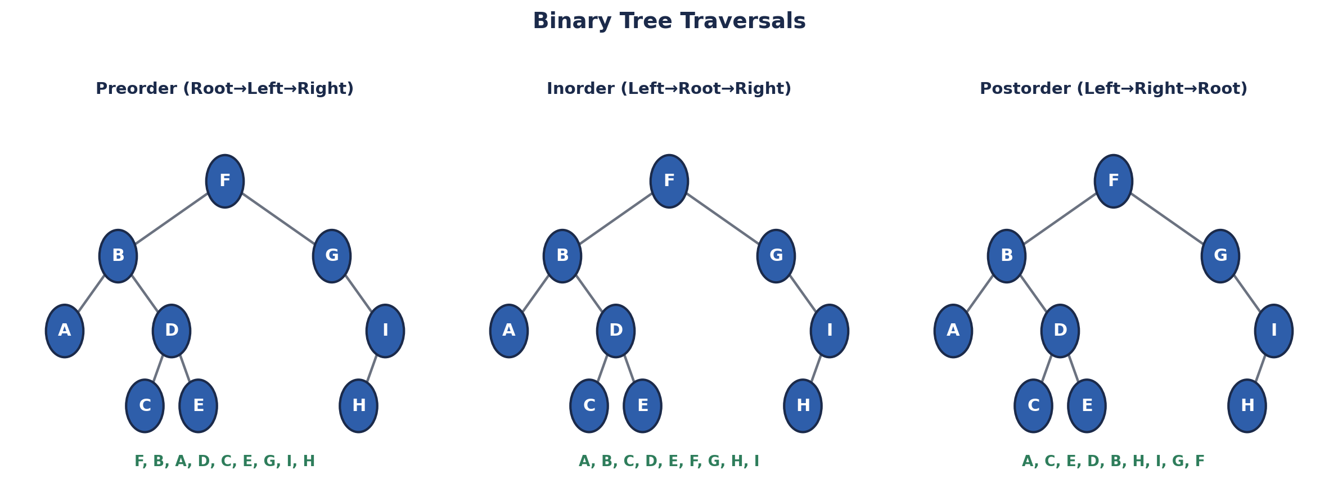
Figure 6 — Preorder, Inorder, Postorder traversals of the same tree
Traversal | Order | Typical use
Preorder | Root → Left → Right | Copy / serialize a tree
Inorder | Left → Root → Right | Gives sorted output for a BST
Postorder | Left → Right → Root | Safely delete/free a tree bottom-up

9.2 Binary Search Tree — BST (missing concept, foundational)
- Ordering rule: left subtree < node < right subtree, for every node.
- Inorder traversal of a BST always yields elements in sorted order.
- Search/insert/delete are O(log N) on a balanced tree, but degrade to O(N) if the tree becomes a skewed 'linked list' (e.g., inserting sorted data in order).
Structure | Search / Insert / Delete (balanced) | Worst case (skewed)
BST | O(log N) | O(N)
AVL / Red-Black Tree (self-balancing) | O(log N) guaranteed | O(log N) guaranteed
★ INTERVIEW TIP
If asked 'when does a BST become slow?', answer with the skewed-insert example (inserting 1,2,3,4,5 in order) and name AVL / Red-Black trees as the fix — TreeMap/TreeSet in Java use Red-Black trees internally.

10. Trie (Prefix Tree)
- A tree built specifically for fast prefix search — every path from root spells out a prefix.
- Each node commonly holds up to 26 children (for lowercase a-z) plus an 'end of word' flag.
- Insert / search a word of length L → O(L), independent of how many words are stored.
class TrieNode {
TrieNode[] children = new TrieNode[26];
boolean isEndOfWord;
}
// insert("cat"): root -> c -> a -> t (mark isEndOfWord=true)
// search("ca") returns false (not a full word) but startsWith("ca") returns true
💼 HR / CAREER NOTE
Autocomplete, spell-check, and IP routing tables all use Tries in production — a great real-world hook when asked 'where have you seen this used?'

11. Graphs
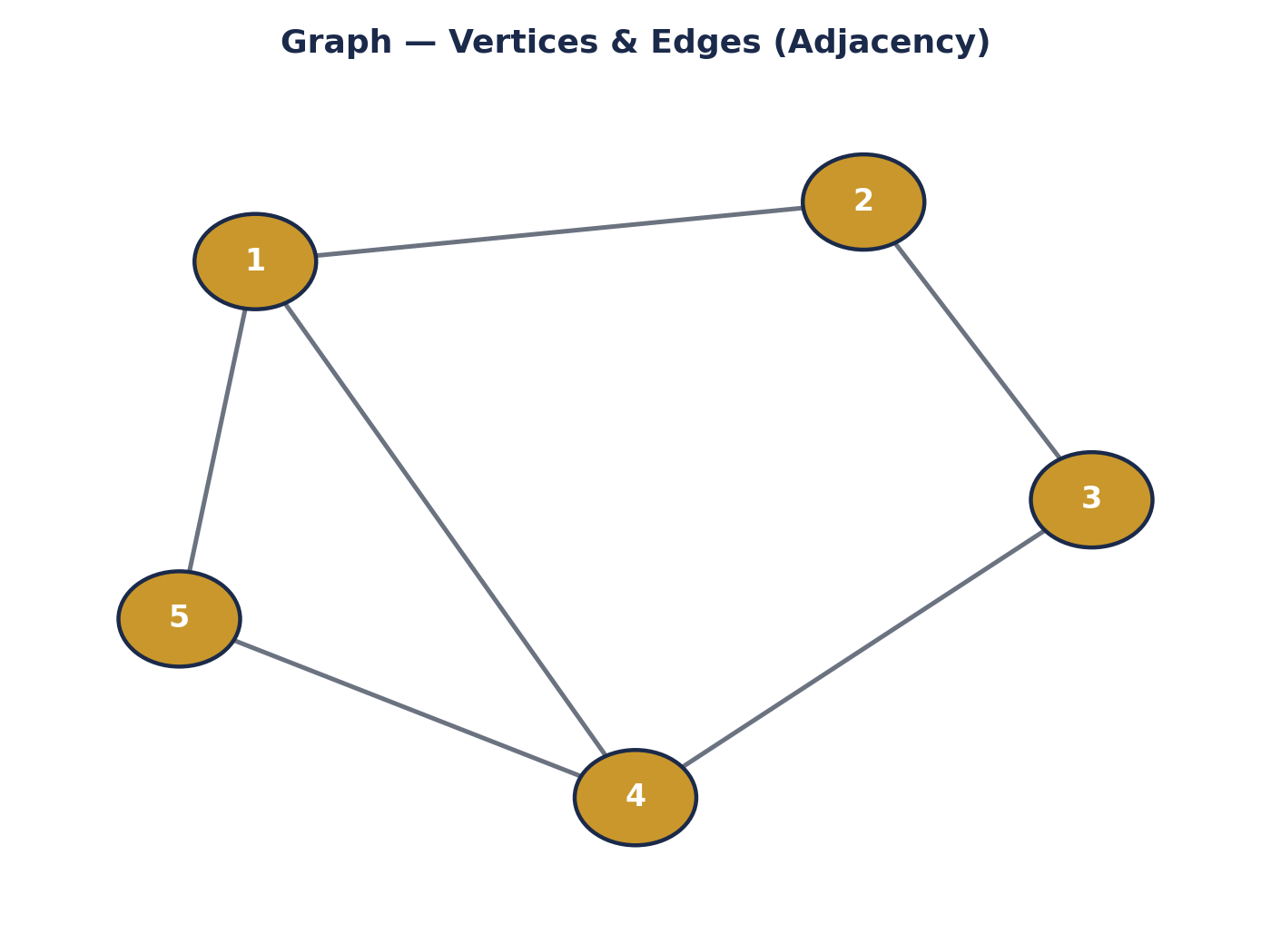
Figure 7 — A graph is nodes (vertices) connected by edges
- Nodes = 1,2,3,4,5. Edges connect pairs of nodes and can be directed or undirected, weighted or unweighted.
Representation | Space | Check if edge (u,v) exists | Best when
Adjacency Matrix | O(V²) | O(1) | Dense graphs, frequent edge lookups
Adjacency List | O(V + E) | O(degree of u) | Sparse graphs (most real-world graphs)

BFS vs DFS (missing concept — asked in nearly every graph question)
 | BFS (Breadth-First) | DFS (Depth-First)
Data structure | Queue | Stack (or recursion)
Explores | Level by level, outward from source | Goes deep down one path before backtracking
Shortest path (unweighted) | Yes — guarantees shortest path | No guarantee
Typical use | Shortest path, level-order problems | Cycle detection, topological sort, connected components
Time / Space | O(V + E) / O(V) | O(V + E) / O(V)
↻ REVISION BOX — RECALL IN 10 SECONDS
'Shortest path in an unweighted graph' → always BFS. 'Does a path/cycle exist, or explore everything deeply' → DFS.

12. Handy Formulas Used in Interviews
Formula | Use
average = x + (y - x) / 2 | Finds midpoint of x,y without overflow (used in binary search) — safer than (x+y)/2 which can overflow for large x,y.
sum of first N natural numbers = N × (N + 1) / 2 | O(1) sum instead of an O(N) loop — also used to spot a 'missing number' in an array.
Sieve of Eratosthenes | All primes up to m in O(N log log N) — see Section 3.
★ INTERVIEW TIP
The overflow-safe midpoint formula is a favourite 'do you actually understand why' follow-up after any binary-search question.

13. Final Interview Cheat Sheet
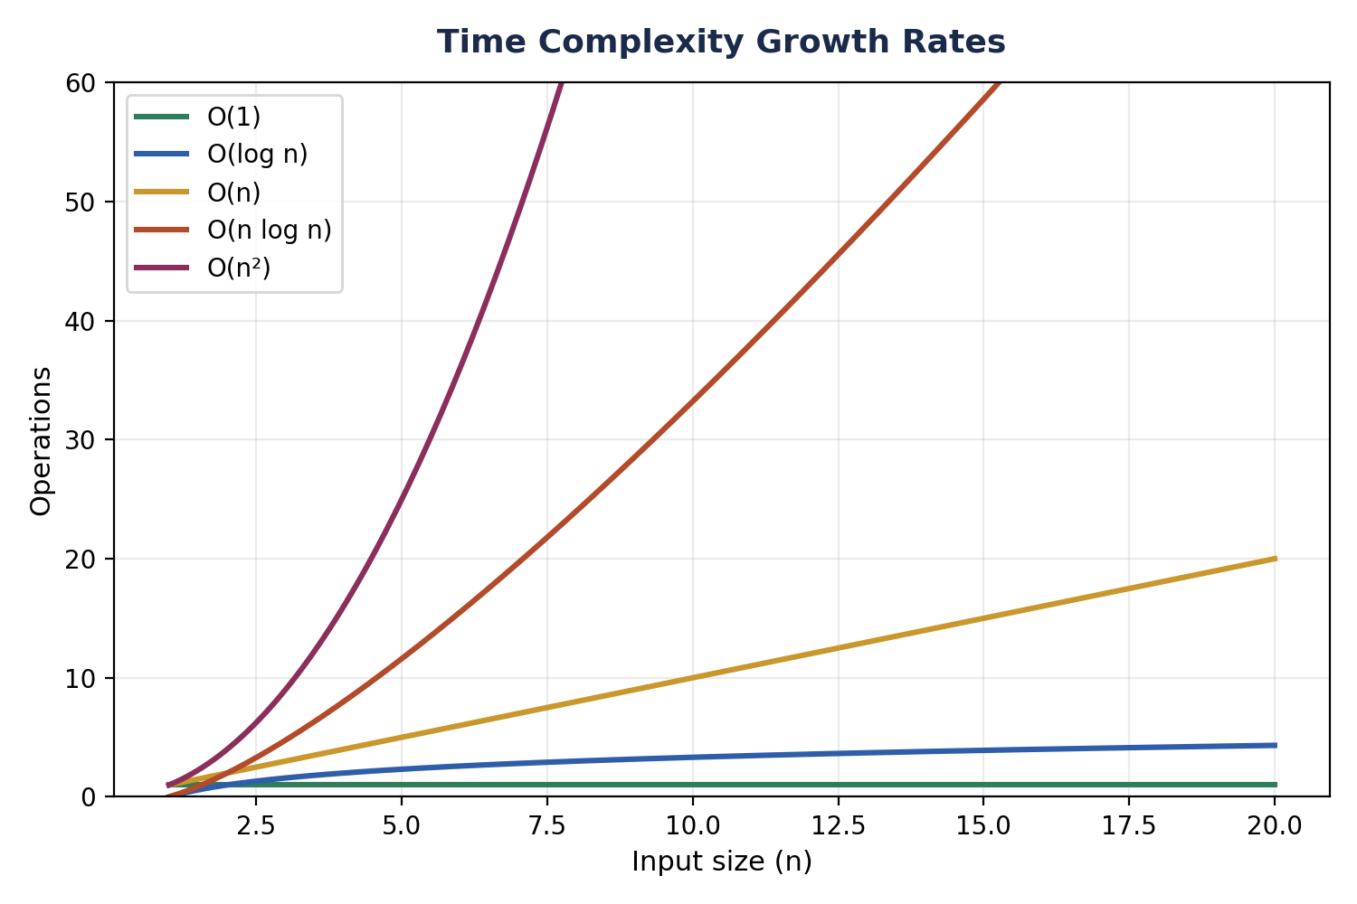
Figure 8 — Time complexity growth: O(1) < O(log n) < O(n) < O(n log n) < O(n²)
Rank (best → worst) | Complexity | Example
1 | O(1) | Array access, HashMap get/put (avg)
2 | O(log N) | Binary search, BST ops, heap insert
3 | O(N) | Linear scan, single loop
4 | O(N log N) | Merge sort, Quick sort (avg), Heap sort
5 | O(N²) | Bubble/Selection/Insertion sort, nested loops
6 | O(2^N) | Naive recursive Fibonacci, subsets/power set

13.1 Rapid-fire Q&A
Question | Model Answer
Why is String immutable in Java? | Security (safe to share across threads/network), caching via the String Pool, and safe use as a HashMap key (hashCode can be cached once).
Difference between ArrayList and LinkedList? | ArrayList: O(1) index access, O(N) insert at start. LinkedList: O(N) index access, O(1) insert/delete at the ends.
Why override hashCode() with equals()? | So equal objects land in the same HashMap bucket — otherwise lookups silently fail.
When would a HashMap degrade to O(N)? | Massive hashCode collisions (pre-Java 8); Java 8+ caps this at O(log N) by treeifying long chains.
BFS or DFS for shortest path? | BFS — guarantees shortest path in an unweighted graph.
What causes a StackOverflowError? | Recursion without a reachable base condition, or a call stack too deep for the JVM's thread stack size.

14. HR & Interview Strategy (from the other side of the table)
After sitting on both sides of hundreds of technical interviews at banks and large product companies, here is what actually moves the needle beyond 'knowing the syntax':

14.1 Before the Interview
- Re-derive complexity tables from memory, don't just read them — being asked 'why is it O(log N)?' is common, not just 'what is it.'
- Prepare ONE clean example per DSA topic you can explain end-to-end on a whiteboard without notes.
- For banking/finance interviews specifically, expect a heavier emphasis on correctness, edge cases, and concurrency safety over cleverness — favour boring, provably-correct code.

14.2 During the Interview
- Say your approach out loud before coding — interviewers score reasoning as much as the final answer.
- State time & space complexity unprompted once you finish — it shows the habit is internalised, not memorised for this one answer.
- If stuck, narrate what you know and what you're unsure of — silence is scored worse than a wrong-but-reasoned guess.
- Always test your own code against at least one edge case (empty input, single element, duplicates, nulls) before saying 'done.'

14.3 Common Rejection Reasons (from an interviewer's notes)
⚠ EDGE CASES TO REMEMBER
Jumping to code before clarifying constraints (input size? duplicates allowed? sorted?).
Correct brute force but no attempt to discuss optimisation when asked 'can we do better?'
Ignoring edge cases even when explicitly warned ('what if the list is empty?').
Overconfidence on topics not actually understood — 'I know Collections' but can't explain HashMap collision handling.
💼 HR / CAREER NOTE
Confidence paired with precise language ('this is O(1) amortized, not strictly O(1)') reads as senior. Vague confidence ('it's basically instant') reads as junior — regardless of the actual code quality.

15. Practice Problem Tracker
Compiled from the homework references in the original notes — track these as your baseline revision set, then move to the broader lists below.
LeetCode # | Topic | Why it matters
34 | Find First & Last Position (Binary Search) | Binary search on boundaries, not just exact match
33 | Search in Rotated Sorted Array | Modified binary search — very common
2812 | Find the Safest Path in a Grid | BFS/DFS + binary search combo
162 | Find Peak Element | Binary search on an unsorted-looking array
1985 | Find the Kth Largest Integer | Heap / PriorityQueue application
19 | Remove Nth Node From End of List | Two-pointer technique on Linked List
2 | Add Two Numbers (Linked List) | Linked list traversal + carry logic
515 | Find Largest Value in Each Tree Row | Level-order (BFS) traversal on a tree
637 | Average of Levels in Binary Tree | Level-order traversal, aggregation
208 | Implement Trie (Prefix Tree) | Core Trie implementation
11 | Container With Most Water | Two-pointer greedy — very common
1288 | Remove Covered Intervals | Interval sorting & scanning
56 | Merge Intervals | Interval sorting & merging — extremely common
- Custom build (recommended): implement your own Queue using an array, then your own Stack using an array — forces you to internalise pointer/index management before relying on library classes.
- After this list: move to the 'Top 75' and 'Top 150' curated LeetCode lists, then HackerRank, then Codeforces for competitive-programming depth.

16. Quick-Reference Glossary
Term | Meaning
Heap (memory) | Region storing objects & instance variables; not the same as the Heap data structure (PriorityQueue).
Hash | One-way conversion of data into a fixed-size integer (e.g., SHA-256).
Instance | An object created from a class via new.
Catalog | An organised list/collection of information — general term, not Java-specific.
Maven | Build automation & dependency management tool for Java; dependencies declared in pom.xml.
Short-circuit evaluation | && and || skip evaluating the right side once the result is already determined — avoids unnecessary work and null-check failures.
Interface | Contract of abstract methods (plus default/static methods since Java 8); a class 'implements' it.
Amortized O(1) | Occasionally expensive (e.g., array resize) but cheap on average across many operations.
↻ REVISION BOX — RECALL IN 10 SECONDS
Keep this page bookmarked — it's the fastest 90-second refresh before walking into a live round.

