1.Create the following tables :
Tablename: EMPLOYEE
Structure :
EMP_CODE char(16)
EMP_NAME char(20)
DEPT_CODE char(16)
DESIG_CODE char(16)
SEX char(1)
ADDRESS char (25)
CITY char (20)
STATE char (20)
PIN char (6)
BASIC Number
JN_DT Date
Primary key is EMP_CODE
Tablename : DESIGNATION
Structure :
DESIG_CODE char(16)
DESIG_DESC char(20)
Primary key is DESIG_CODE
Tablename : DEPARTMENT
Structure :
DEPT_CODE char(16)
DEPT_NAME char(20)
Primary key is DEPT_CODE.

Query :
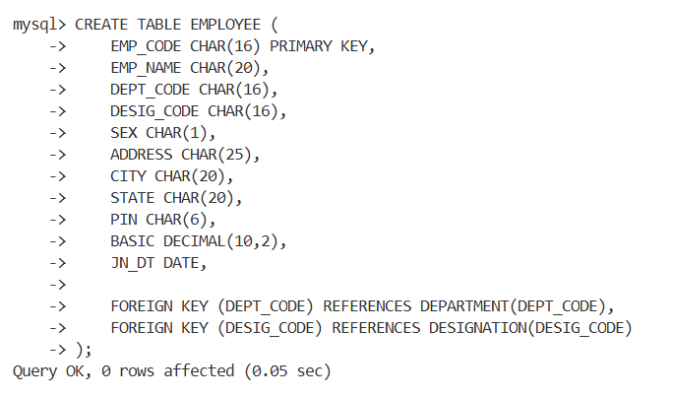

- Display the structure of each table .

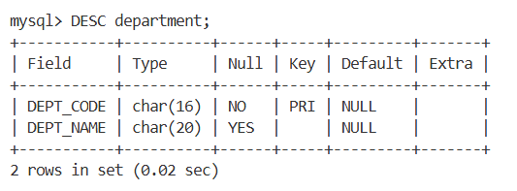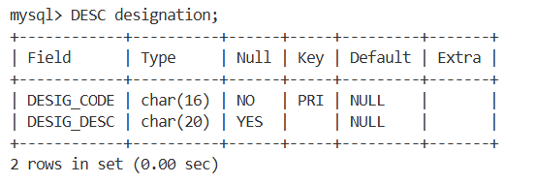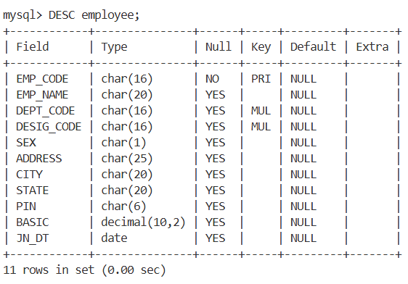

- Insert few rows in each table .
[While entering data in EMP table use DESIG_CODE which exists in
DESIGNATION table and DEPT_CODE which is exists in DEPARTMENT table. In
DESIGNATION table, assign code for Manager, Executive, officer, clerk and helper. In
DEPARTMENT table, assign code for Personnel, Production, Purchase, Finance,
Research departments]

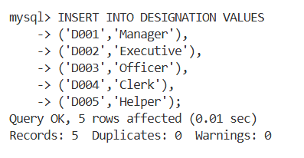
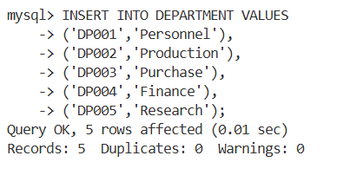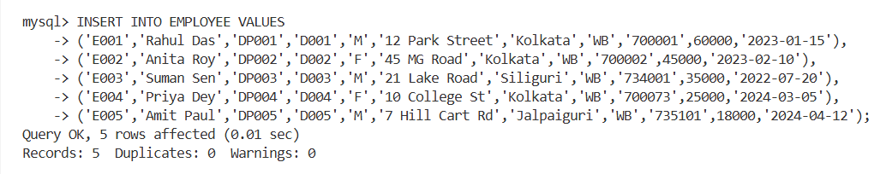

- In EMP table insert few rows without DEPT_CODE and BASIC.
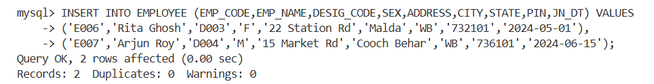

- Find the rows with unassigned DEPT_CODE

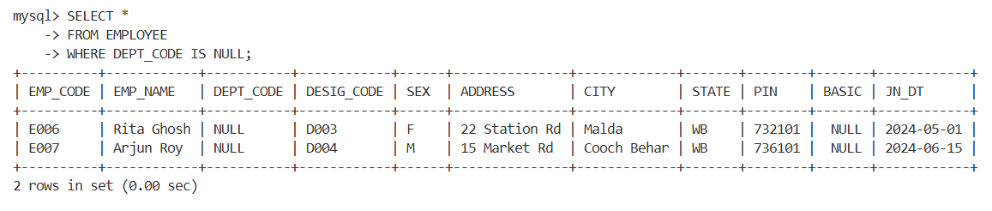

- Find the rows with BASIC equal to zero
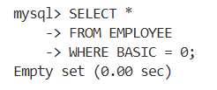

- Find the rows with unassigned Basic [note down the difference between the results obtained in Q.6 and Q.7]

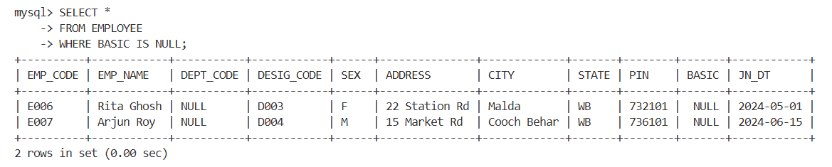

- Find the average basic of the employees.
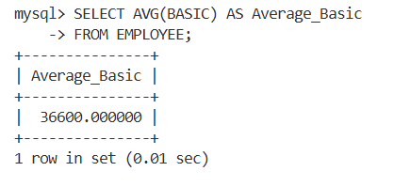
- Replace the BASIC with 0 for the rows with unassigned Basic.
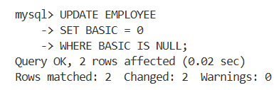

- Again, find the average Basic. (Note the difference of result obtained in Q.8 & Q.10.)
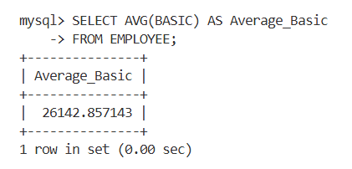
- Delete the rows with unassigned DEPT_CODE.
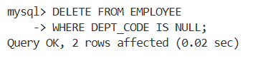
- Say, Net pay of an employee= Basic+HRA+DA where HRA is 50% of the Basic & DA is 40% of Basic. Show the employee name & Net pay for all employees.
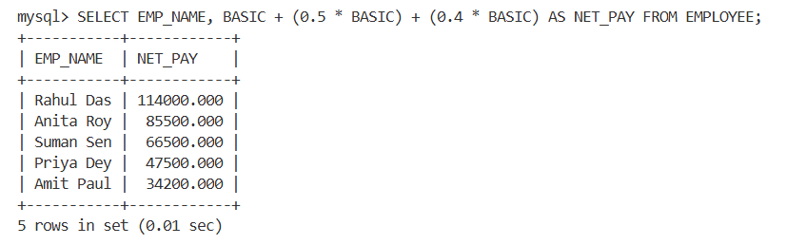
13. Show the EMP_NAME & BASIC in the ascending order of DEPT_CODE. The
employee name must appear in uppercase.
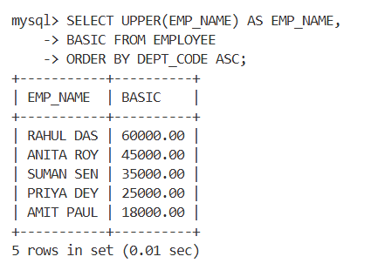
- Find the employees who have joined after 1st January 2010.
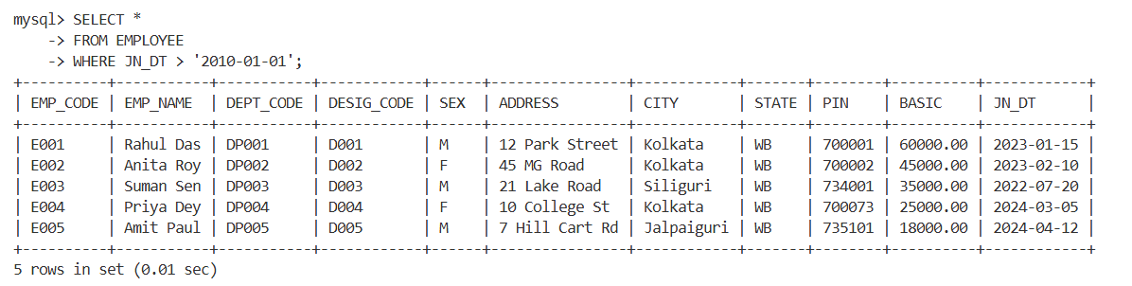
- Find, how many employees have joined in the month of January?
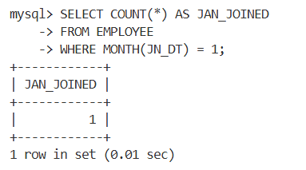

- Find the maximum & minimum Basic.
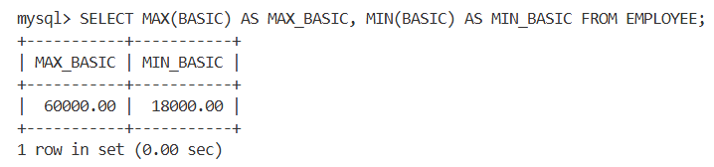

- Find how many Female employees are there?
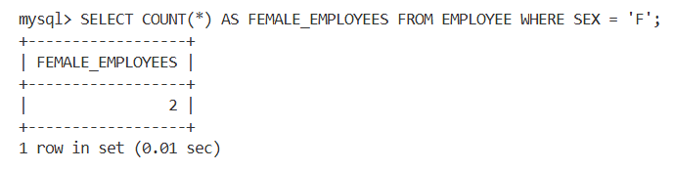
- Replace CITY with existing value converted into uppercase for all rows.
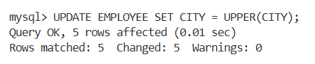
- Find in how many different cities various employees are residing?
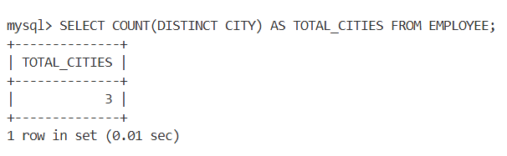
20. Display the employee information in the ascending order of DEPT_CODE and with in a Department, it should be in the descending order of BASIC
