Question 1. String Processing Server: Implement a TCP client server application where the client sends a string to the server. The server determines the length of the string, number of vowels, number of consonants, and number of digits, and sends the results back to the client.
Code :
server.py
import socket

def total_vowels_const(data: str) -> list[int]:
count = 0
data = "".join(c for c in data if c.isalpha() and c.isascii())
vowels = ('a', 'e', 'i', 'o', 'u')
for ch in data:
if ch.lower() in vowels:
count += 1

return [count, len(data) - count]

def count_digit(data: str) -> int:
count = 0
for c in data:
if c.isdigit() and c.isascii():
count += 1
return count

def data_process(data: str) -> dict:
res = dict()
count = total_vowels_const(data)
res.update({'len' : len(data), 'vowels' : count[0], 'consonants' : count[1], 'digit' : count_digit(data)})

return res

def main():
TCP_PORT = 5000
IP_ADDRESS = '127.0.0.1'
BUFFER_SIZE = 1024

k = socket.socket(family=socket.AF_INET, type=socket.SOCK_STREAM)
print("Server has created socket.")

k.bind((IP_ADDRESS, TCP_PORT))
print("Server has bounded successfully.")

k.listen(1)

while True:
print("\n\nServer is waiting for client connection ...")
conn, addr = k.accept()

print("Connection Address is : ", addr)

data = conn.recv(BUFFER_SIZE)
res = data_process(data.decode())

res = str(res).encode()

conn.sendall(res)
conn.close()

if __name__ == '__main__':
main()

client.py
import socket

IP_ADDRESS = '127.0.0.1'
TCP_PORT = 5000
BUFFER_SIZE = 1024

flag = True
while flag:
k = socket.socket(family=socket.AF_INET, type=socket.SOCK_STREAM)
k.connect((IP_ADDRESS, TCP_PORT))
print("\n\nClient has sent connection request.")

msg = input("MESSAGE : ")
k.sendall(msg.encode())
print("Message sent successfully.")

data = k.recv(BUFFER_SIZE)
print("RECEIVED : ", data.decode())

k.close()

flag = False if input("Enter x for exit : ").lower() == 'x' else True

Output :
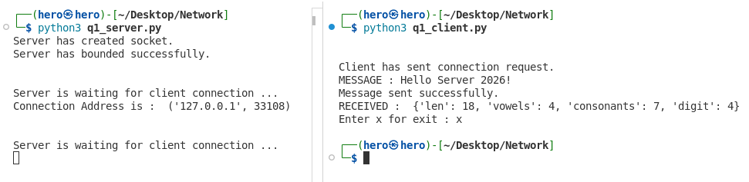

Question 2. Simple File Transfer: Implement a TCP client server application in which the client requests a file by specifying its filename. If the file exists, the server sends its contents to the client, which stores them in a new file. If the requested file does not exist, the server sends an appropriate error response.
Code :
server.py
import socket
from pathlib import Path

def main():
IP_ADDR = '127.0.0.1'
TCP_PORT = 7001
BUFFER_SIZE = 1024

k = socket.socket(family=socket.AF_INET, type=socket.SOCK_STREAM)
k.bind((IP_ADDR, TCP_PORT))
print("Server is Bounded successfully.")

k.listen(1)
print("Server is listening ... ")
conn, addr = k.accept()
print("Connection address : ", addr)

req = conn.recv(BUFFER_SIZE)

path = Path(f"./send/{req.decode()}")
if path.is_file():
with open(path, "rb") as file:
while True:
data = file.read(BUFFER_SIZE)
if not data:
break

conn.sendall(data)

print("File sent successfully")
else:
conn.sendall(b"404 FILE NOT FOUND.")
print("FILE NOT FOUND")

conn.close()
k.close()

if __name__ == "__main__":
main()

client.py
import socket

def main():
TCP_PORT = 7001
IP_ADDR = '127.0.0.1'
BUFFER_SIZE = 1024

k = socket.socket(family=socket.AF_INET, type=socket.SOCK_STREAM)
k.connect((IP_ADDR, TCP_PORT))

req = input("Enter file name : ")
k.sendall(req.encode())

response = k.recv(BUFFER_SIZE)

if response == b"404 FILE NOT FOUND.":
print(response.decode())
k.close()
return

path = f"./recv/{req}"
with open(path, "wb") as file:
file.write(response)

while True:
data = k.recv(BUFFER_SIZE)

if not data:
break

file.write(data)

print("File received successfully.")
k.close()

if __name__ == "__main__":
main()

Output :
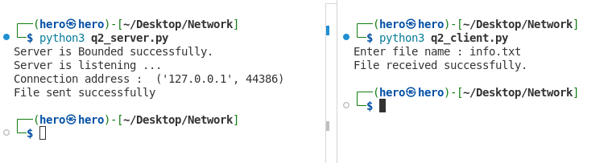

Question 3. Command Based TCP Service: Design a TCP server supporting the following requests from a client: TIME ⇒ return server time; DATE ⇒ return server date; HOSTNAME ⇒ return server hostname; ECHO <message> ⇒ return the supplied message; and QUIT ⇒ terminate the connection. Define a simple application layer protocol for the requests and responses. Implement the server so that it can serve multiple clients sequentially. After one client disconnects, the server should return to accept() and wait for another client. Record and display the IP address and port number of every connected client.
Code :
server.py
import socket
from datetime import datetime
def main():
IP_ADDR = '127.0.0.1'
TCP_PORT = 30000
BUFF_SIZE = 1024
k = socket.socket(family=socket.AF_INET, type=socket.SOCK_STREAM)
k.bind((IP_ADDR, TCP_PORT))
print("Server is bounded successfully.")
k.listen(1)
while True:
print("Server is waiting ...")
conn, addr = k.accept()
print(f"Connected to IP : {addr[0]}, Port : {addr[1]}.")

while True:
command = conn.recv(BUFF_SIZE)
if not command:
break
command = command.decode()
match command:
case 'time':
res = datetime.now().strftime("%H:%M:%S")
case 'date':
res = datetime.now().strftime("%Y-%m-%d")
case 'hostname':
res = socket.gethostname()
case 'quit':
conn.sendall(b"Connection terminated.")
break
case _ if command.startswith('echo '):
res = command[5:]
case _:
res = "Invalid command."
print("Command executed successfully.")
conn.sendall(res.encode())
print("Output sent successfully.")

conn.close()

if __name__ == "__main__":
main()

client.py
import socket

def main():
TCP_PORT = 30000
IP_ADDR = '127.0.0.1'
BUF_SIZE = 1024

client = socket.socket(family=socket.AF_INET, type=socket.SOCK_STREAM)
client.connect((IP_ADDR, TCP_PORT))
print("Client has sent connection request.")

flag = True
while flag:
command = input("Enter :\n1. time\n2. date\n3. hostname\n4. echo <message>\n5. quit\n >>> ")
command = command.lower()

client.sendall(command.encode())
print("Command sent successfully.")

res = client.recv(BUF_SIZE)
print(res.decode())

if command == 'quit':
flag = False
client.close()
print("Client closed.")

if __name__ == "__main__":
main()

Output :
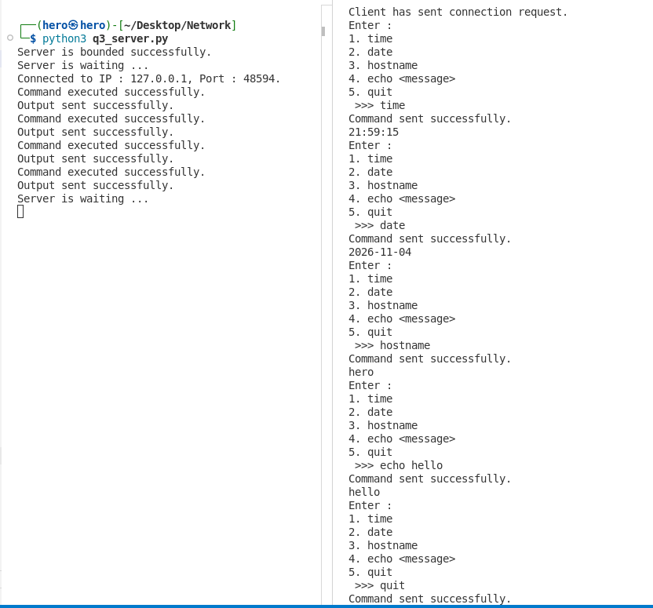

Question 4. Concurrent TCP Server: Extend the above problem statement, so that multiple clients can be served concurrently. Implement the server using either fork() or POSIX threads. Test the server by simultaneously running at least three client processes.
Code :
server.py
import socket
from datetime import datetime
import multiprocessing as mp

def client_handler(conn, BUFF_SIZE):

while True:

command = conn.recv(BUFF_SIZE).decode().strip().lower()

if not command:
break

match command:

case 'time':
res = datetime.now().strftime("%H:%M:%S")

case 'date':
res = datetime.now().strftime("%Y-%m-%d")

case 'hostname':
res = socket.gethostname()

case 'quit':
conn.sendall(b"Connection terminated.")
break

case _ if command.startswith('echo '):
res = command[5:]

case _:
conn.sendall(b"Invalid command")
continue

conn.sendall(res.encode())

print("Command executed successfully.")
print("Output sent successfully.")

conn.close()
print("Connection closed.")

def main():

IP_ADDR = '127.0.0.1'
TCP_PORT = 30000
BUFF_SIZE = 1024

server = socket.socket(
family=socket.AF_INET,
type=socket.SOCK_STREAM
)

server.bind((IP_ADDR, TCP_PORT))

print("Server is bound successfully.")

server.listen(10)

while True:

print("Server is waiting ...")

conn, addr = server.accept()

print(
f"Connected to IP : {addr[0]}, "
f"Port : {addr[1]}."
)

process = mp.Process(
target=client_handler,
args=(conn, BUFF_SIZE)
)

process.start()

conn.close()

if __name__ == "__main__":
main()

client.py
import socket

def main():

TCP_PORT = 30000
IP_ADDR = '127.0.0.1'
BUF_SIZE = 1024

client = socket.socket(
family=socket.AF_INET,
type=socket.SOCK_STREAM
)

client.connect((IP_ADDR, TCP_PORT))

print("Client has sent connection request.")

while True:

command = input(
"Enter:\n"
"1. time\n"
"2. date\n"
"3. hostname\n"
"4. echo <message>\n"
"5. quit\n"
">>> "
).lower().strip()

client.sendall(command.encode())

print("Command sent successfully.")

res = client.recv(BUF_SIZE)

print("Server:", res.decode())

if command == 'quit':
break

client.close()

print("Client closed.")

if __name__ == "__main__":
main()

Output :
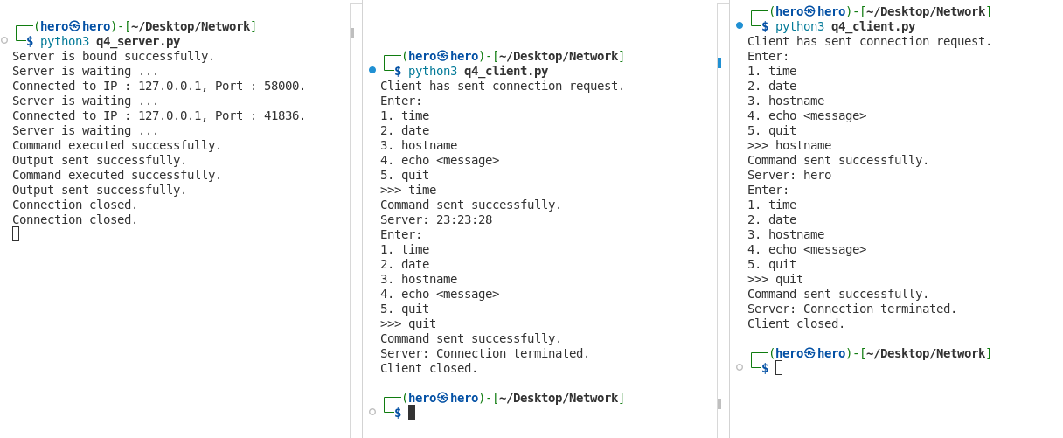

Question 5. Date and Time Server: Implement a UDP server that responds to client requests such as DATE, TIME, and DATETIME. The server sends the corresponding information back to the requesting client.
Code :
server.py
import socket
from datetime import datetime

BUF_SIZE = 1024
IP_ADDR = '127.0.0.1'
PORT = 20000
server = socket.socket(family=socket.AF_INET, type=socket.SOCK_DGRAM)
server.bind((IP_ADDR, PORT))

while True:
print('UDP server is listening ... ')
bytesAddressPair = server.recvfrom(BUF_SIZE)

print(F'Client IP : {bytesAddressPair[1]}')
print(F'Client msg : {bytesAddressPair[0].decode()}')

command = bytesAddressPair[0].decode().upper()

if command == 'DATE':
data = datetime.now().strftime("%Y-%m-%d")

elif command == 'TIME':
data = datetime.now().strftime("%H:%M:%S")

elif command == 'DATETIME':
data = datetime.now().strftime("%Y-%m-%d %H:%M:%S")

else:
data = "Invalid request. Use DATE, TIME or DATETIME."

server.sendto(data.encode(), bytesAddressPair[1])
print('Message sent successfully')

client.py
import socket
SERVER_IP = '127.0.0.1'
SERVER_PORT = 20000
BUFF_SIZE = 1024

client = socket.socket(family=socket.AF_INET, type=socket.SOCK_DGRAM)
msg = input("Enter DATE, TIME or DATETIME : ").upper()
client.sendto(msg.encode(), (SERVER_IP, SERVER_PORT))

res = client.recvfrom(BUFF_SIZE)
print(f"Response : {res[0].decode()}")

client.close()

Output :
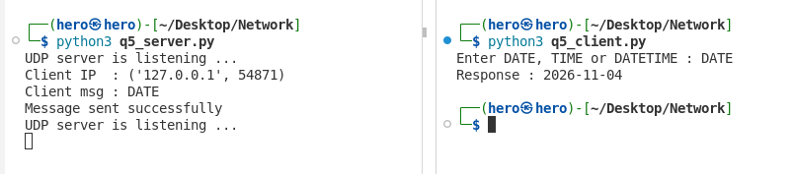

Question 6. File Content Request Using UDP: Write a UDP client that sends a filename to the server. If the file exists, the server sends its contents to the client. For simplicity, initially restrict the file size so that the entire content can fit within a single datagram. The server should return an error message if the file is unavailable.

Code :
server.py
import socket
import os

BUF_SIZE = 1024
IP_ADDR = '127.0.0.1'
PORT = 20000

server = socket.socket(family=socket.AF_INET, type=socket.SOCK_DGRAM)
server.bind((IP_ADDR, PORT))

while True:
print('UDP server is listening ... ')

bytesAddressPair = server.recvfrom(BUF_SIZE)

filename = bytesAddressPair[0].decode()
client_addr = bytesAddressPair[1]

print(f'Client IP : {client_addr}')
print(f'Client file : {filename}')

filepath = os.path.join('send', filename)

if os.path.isfile(filepath):
if os.path.getsize(filepath) > BUF_SIZE:
server.sendto(
"ERROR : FILE SIZE IS GREATER THAN BUFFER SIZE".encode(),
client_addr
)
print('File size is greater than buffer size')

else:
with open(filepath, 'rb') as file:
data = file.read(BUF_SIZE)

server.sendto(data, client_addr)
print('File sent successfully')

else:
server.sendto(
"ERROR : FILE NOT FOUND".encode(),
client_addr
)
print('File Not Found')

client.py
import socket

SERVER_IP = '127.0.0.1'
SERVER_PORT = 20000
BUFF_SIZE = 1024

client = socket.socket(family=socket.AF_INET, type=socket.SOCK_DGRAM)

filename = input('Enter filename: ')

client.sendto(filename.encode(), (SERVER_IP, SERVER_PORT))

res = client.recvfrom(BUFF_SIZE)

data = res[0]

if data.startswith(b'ERROR'):
print(f'Response : {data.decode()}')
else:
print('File content:')
print(data.decode(errors='replace'))

client.close()

Output :
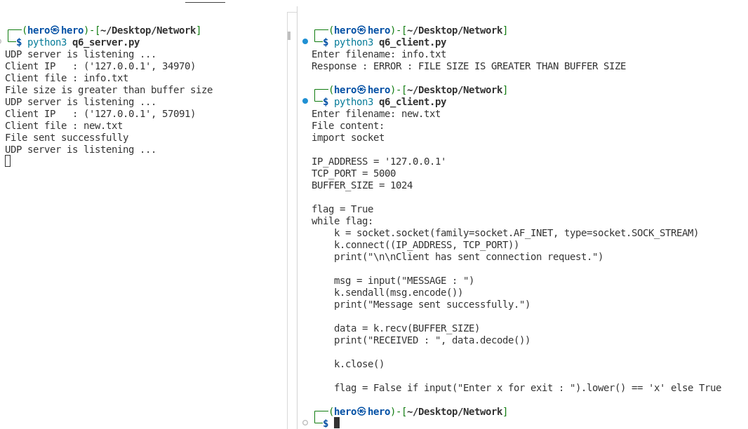

Question 7. Chunk Based UDP File Transfer: Extend the previous assignment to transfer files larger than a single datagram. Divide the file into fixed-size blocks and attach a sequence number to every block. The client should reconstruct the file in the correct order.
Code :
server.py
import socket
import os

BUF_SIZE = 1024
IP_ADDR = '127.0.0.1'
PORT = 20000

server = socket.socket(family=socket.AF_INET, type=socket.SOCK_DGRAM)
server.bind((IP_ADDR, PORT))

while True:
print('UDP server is listening ... ')

bytesAddressPair = server.recvfrom(BUF_SIZE)

filename = bytesAddressPair[0].decode()
client_addr = bytesAddressPair[1]

print(f'Client IP : {client_addr}')
print(f'Client file : {filename}')

filepath = os.path.join('send', filename)

if os.path.isfile(filepath):
with open(filepath, 'rb') as file:
seq = 0

while True:
data = file.read(BUF_SIZE - 20)

if not data:
break

packet = str(seq).encode() + b':' + data
server.sendto(packet, client_addr)

seq += 1

server.sendto(b'END', client_addr)
print('File sent successfully')

else:
server.sendto(
b"ERROR : FILE NOT FOUND",
client_addr
)
print('File Not Found')

client.py
import socket
import os

SERVER_IP = '127.0.0.1'
SERVER_PORT = 20000
BUFF_SIZE = 1024

client = socket.socket(family=socket.AF_INET, type=socket.SOCK_DGRAM)

filename = input('Enter filename: ')

client.sendto(filename.encode(), (SERVER_IP, SERVER_PORT))

filename = os.path.join('recv', filename)

chunks = {}

while True:
res = client.recvfrom(BUFF_SIZE)

data = res[0]

if data == b'END':
break

if data.startswith(b'ERROR'):
print(data.decode())
client.close()
exit()

seq, data = data.split(b':', 1)
seq = int(seq.decode())

chunks[seq] = data

with open(filename, 'wb') as file:
for seq in sorted(chunks):
file.write(chunks[seq])

print('File Recieved.')
client.close()

Output :
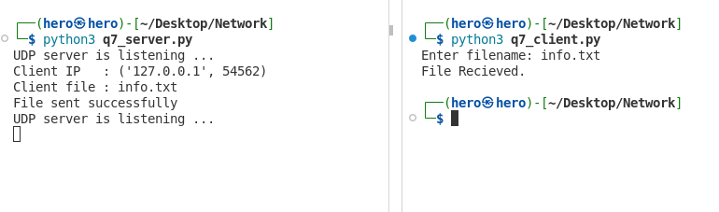

Question 8. Simple UDP Name Service: Create a small server side table containing mappings such as:
server1 → 192.168.1.10
server2 → 192.168.1.20
...
The client sends a host name, and the UDP server returns the corresponding IP address. Return “NOT FOUND” when no matching entry exists.
Code :
server.py
import socket

BUF_SIZE = 1024
IP_ADDR = '127.0.0.1'
PORT = 20000

server_table = {
'server1': '192.168.1.10',
'server2': '192.168.1.20',
'server3': '192.168.1.30',
'server4': '192.168.1.40'
}

server = socket.socket(family=socket.AF_INET, type=socket.SOCK_DGRAM)
server.bind((IP_ADDR, PORT))

while True:
print('UDP Name Server is listening ... ')

bytesAddressPair = server.recvfrom(BUF_SIZE)

hostname = bytesAddressPair[0].decode().strip().lower()
client_addr = bytesAddressPair[1]

print(f'Client IP : {client_addr}')
print(f'Hostname : {hostname}')

if hostname in server_table:
ip_address = server_table[hostname]

server.sendto(
ip_address.encode(),
client_addr
)

print(f'IP Address sent : {ip_address}')

else:
server.sendto(
'NOT FOUND'.encode(),
client_addr
)

print('Host not found')

client.py
import socket

SERVER_IP = '127.0.0.1'
SERVER_PORT = 20000
BUFF_SIZE = 1024

client = socket.socket(
family=socket.AF_INET,
type=socket.SOCK_DGRAM
)

hostname = input('Enter hostname: ').strip().lower()

client.sendto(
hostname.encode(),
(SERVER_IP, SERVER_PORT)
)

res = client.recvfrom(BUFF_SIZE)

print(f'IP Address : {res[0].decode()}')

client.close()

Output :
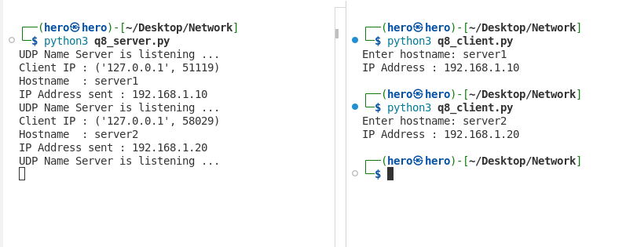
Assignment 2
EXPERIMENT 1: Analysis of TCP Data Transfer, Segmentation and Flow Control

Response ACK | Packet | Acknowledgment Number | Bytes Acknowledged | Single vs. Multisegment | Advertised Receive Window
ACK 1 | Pkt 5 | 4095078107 (Rel: 9) | Bytes 1 to 8 | Single Segment | 512
ACK 2 | Pkt 7 | 3371343477 (Rel: 1025) | Bytes 1 to 1024 | Single Segment | 537
ACK 3 | Pkt 9 | 3371344501 (Rel: 2049) | Bytes 1025 to 2048 | Single Segment | 532
ACK 4 | Pkt 11 | 3371345324 (Rel: 2872) | Bytes 2049 to 2871 | Single Segment | 529
ACK 5 | Pkt 13 | 3371345327 (Rel: 2875) | Bytes 2872 to 2874 | Single Segment | 529

Segment | Packet | Sequence Number | Ack Number | TCP Payload (Bytes) | TCP Flags | Advertised Window
Segment 1 | Pkt 4 | 4095078099  (Rel: 1) | 3371342453  (Rel: 1) | 8 | [ACK, PSH] | 512
Segment 2 | Pkt 6 | 3371342453  (Rel: 1) | 4095078107  (Rel: 9) | 1024 | [ACK, PSH] | 512
Segment 3 | Pkt 8 | 3371343477  (Rel: 1025) | 4095078107  (Rel: 9) | 1024 | [ACK, PSH] | 512
Segment 4 | Pkt 10 | 3371344501  (Rel: 2049) | 4095078107  (Rel: 9) | 823 | [ACK, PSH] | 512
Segment 5 | Pkt 12 | 3371345324  (Rel: 2872) | 4095078107  (Rel: 9) | 3 | [ACK, PSH] | 512

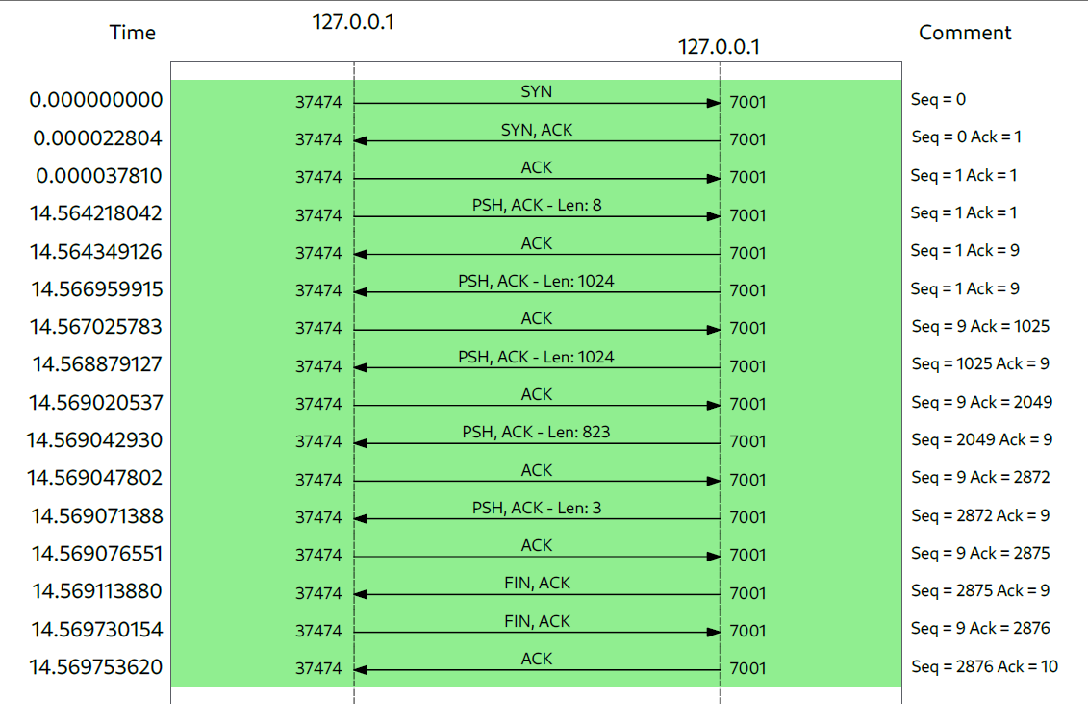

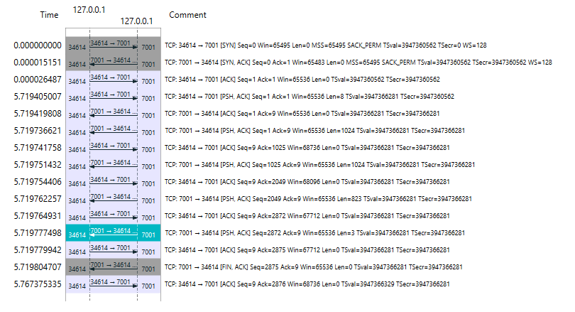

1. Does the advertised receive window remain constant?
No, it doesn't stay completely static. While default socket buffers can start large, our Wireshark trace showed that the advertised window dynamically fluctuates (e.g., shifting between 512, 537, 532, and 529 bytes) as data packets are actively transferred and processed.

2. If it changes, what could be the reason?
It changes based on the state of the receiver's socket buffer. When incoming data arrives faster than the application layer can read it out using `recv()` calls, the buffer fills up, causing the receiver to shrink its advertised window. Once the application processes the data, the window expands again.

3. What is the purpose of the TCP receive window?
Its main purpose is buffer management and congestion/overflow prevention. It lets the sender know precisely how much empty space is currently available in the receiver's buffer so it never sends more data than the receiver can handle.

4. How does the receive window contribute to TCP flow control?
It drives TCP's sliding window flow control mechanism. It places a strict hardware/software limit on unacknowledged data in transit:

Bytes in Flight = Bytes Sent - Bytes Acknowledged ≤ Advertised Window

This ensures a fast sender doesn't overwhelm a slower receiver.

Conclusion

Through this laboratory experiment, we successfully analyzed the core operational mechanisms of TCP using Wireshark packet captures. We observed the complete lifecycle of a TCP connection—starting from the 3way handshake (`SYN`, `SYNACK`, `ACK`), moving through reliable data segmentation using sequence and cumulative acknowledgment numbers, and ending with connection teardown. Furthermore, tracking the window size field demonstrated how TCP's flow control dynamically throttles transmission rates to protect the receiver's buffer space.

Experiment 2 : UDP Request–Response and Datagram Analysis
Packet No. | Time (s) | Source IP | Destination IP | Protocol | Frame Length (Bytes) | Source Port | Destination Port | UDP Length (Bytes) | Application Data Length (Bytes)
1 | 0.000000 | 127.0.0.1 | 127.0.0.1 | UDP | 50 | 41373 | 20000 | 16 | 8
2 | 0.000360 | 127.0.0.1 | 127.0.0.1 | UDP | 1048 | 20000 | 41373 | 1014 | 1006
3 | 0.000424 | 127.0.0.1 | 127.0.0.1 | UDP | 1048 | 20000 | 41373 | 1014 | 1006
4 | 0.000436 | 127.0.0.1 | 127.0.0.1 | UDP | 907 | 20000 | 41373 | 873 | 865
5 | 0.000457 | 127.0.0.1 | 127.0.0.1 | UDP | 45 | 20000 | 41373 | 11 | 3

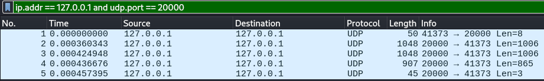

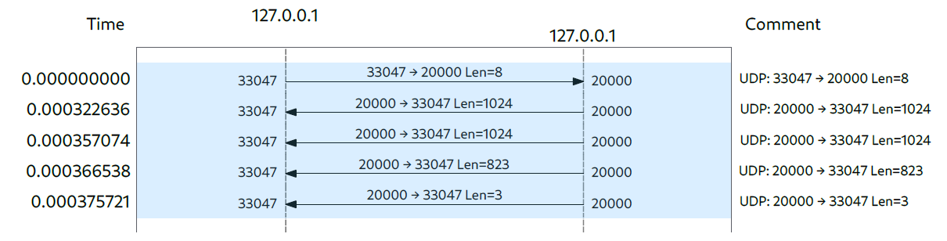
Verification of UDP Length Calculation
Formula:
UDP Length = UDP Header Length (8 Bytes) + Application Data Length (Len)

Verification for Packets from Trace:
- Packet 1 (Request):
UDP Length = 8 Bytes + 8 Bytes = 16 Bytes
Total Frame Length = 14 (Ethernet) + 20 (IP) + 16 (UDP) = 50 Bytes

- Packet 2 & 3 (Large Response Segments):
UDP Length = 8 Bytes + 1006 Bytes = 1014 Bytes
Total Frame Length = 14 + 20 + 1014 = 1048 Bytes

- Packet 4 (Medium Response Segment):
UDP Length = 8 Bytes + 865 Bytes = 873 Bytes
Total Frame Length = 14 + 20 + 873 = 907 Bytes

- Packet 5 (Short Response Segment):
UDP Length = 8 Bytes + 3 Bytes = 11 Bytes
Total Frame Length = 14 + 20 + 11 = 45 Bytes

- Can the client still send the datagram?
Yes. Because UDP is connectionless, the client socket sends the packet immediately via sendto() without checking if a listener is active.
- Is any UDP acknowledgment received?
No. There is no handshake or transport-layer ACK in UDP.
- Is an ICMP message generated?
Yes, depending on OS configuration and loopback routing, an ICMP Destination Unreachable packet may be triggered when the kernel tries to deliver to a closed port.
ICMP Type and Code: Type 3 (Destination Unreachable), Code 3 (Port Unreachable). This indicates that the host was reached, but the specified UDP port has no active process listening on it.

Comparison of TCP and UDP (Experiments 1 & 2)
Feature | TCP Observation (Experiment 1) | UDP Observation (Experiment 2)
Connection State | Connection-oriented (Requires 3-way handshake) | Connectionless (Immediate transmission)
Data Transfer Type | Continuous byte stream | Discrete datagrams (Preserves boundaries)
Reliability & ACKs | Uses sequence & cumulative ACK numbers | No ACKs or delivery guarantees
Flow Control | Dynamic Advertised Receive Window | None
Header Overhead | Variable (20–60 Bytes) | Fixed small header (8 Bytes)
Server Offline Error | Client gets RST flag during handshake | Operating system returns ICMP Type 3, Code 3

Assignment 3
Experiment 1: TCP Flag Behaviour Analysis
Source Code :
from scapy.all import IP, TCP, ICMP, sr1, conf
import sys

conf.verb = 0

def analyze_tcp_flags(dst_ip, dst_port):
test_cases = [
{"name": "1. SYN", "flags": "S"},
{"name": "2. ACK", "flags": "A"},
{"name": "3. FIN+ACK", "flags": "FA"},
{"name": "4. RST", "flags": "R"},
{"name": "5. SYN+FIN", "flags": "SF"}
]

print(f"\n[*] Starting TCP Flag Analysis on target {dst_ip}:{dst_port}\n")
print("-" * 65)
print(f"{'Test Case':<15} | {'Transmitted Flags':<18} | {'Response / Result'}")
print("-" * 65)

for test in test_cases:
case_name = test["name"]
flags = test["flags"]

pkt = IP(dst=dst_ip) / TCP(dport=dst_port, sport=45000, flags=flags, seq=1000)

reply = sr1(pkt, timeout=2, verbose=0)

result_str = ""

if reply is None:
result_str = "Filtered / No Response (Timeout)"
elif reply.haslayer(ICMP):
icmp_layer = reply.getlayer(ICMP)
result_str = f"ICMP Response -> Type: {icmp_layer.type}, Code: {icmp_layer.code}"
elif reply.haslayer(TCP):
tcp_reply = reply.getlayer(TCP)
resp_flags = tcp_reply.sprintf("%TCP.flags%")
result_str = f"TCP Response Flags: {resp_flags}"
else:
result_str = f"Received packet with layer: {reply.summary()}"

print(f"{case_name:<15} | {flags:<18} | {result_str}")

print("-" * 65)

if __name__ == "__main__":
if len(sys.argv) == 3:
target_ip = sys.argv[1]
target_port = int(sys.argv[2])
else:
target_ip = input("Enter Destination IP Address: ").strip()
target_port = int(input("Enter Destination TCP Port: ").strip())

analyze_tcp_flags(target_ip, target_port)

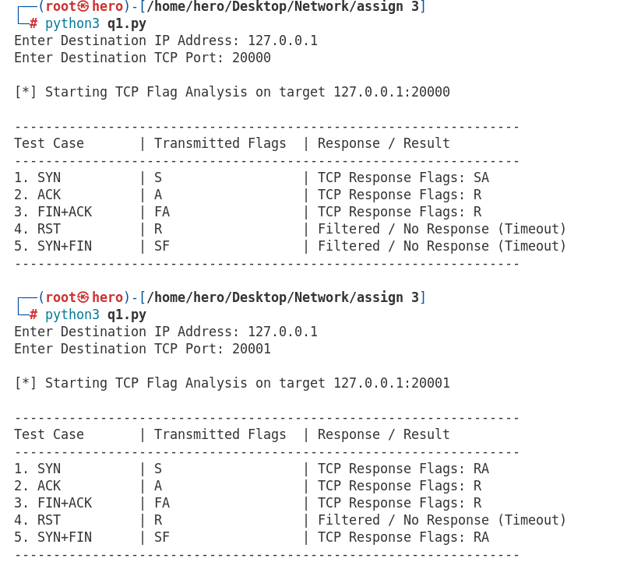

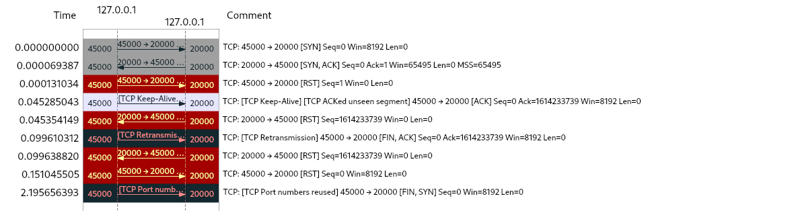

Explanation of TCP Response Behavior to Different Flag Combinations
The TCP state machine dictates that the receiving host must process incoming segments based on its current connection state and the combination of flags set in the TCP header. Because each flag combination represents a different phase or control command in a connection’s lifecycle, the receiving TCP stack reacts uniquely:
- SYN (Synchronization):
- Open Port: The kernel recognizes that an application is actively listening on this port. It accepts the connection request and responds with a SYN-ACK (SA) packet to initiate the 3-way handshake.
- Closed Port: Since no process is listening, the operating system rejects the attempt by replying with a RST (R or RA) packet, indicating that the connection was refused.
- ACK (Acknowledgment): Open/Closed Port: When a host receives an unexpected bare ACK packet for which no transmission control block (TCB) or active connection exists, it treats the segment as anomalous. According to standard TCP behavior (RFC 793), it responds with a RST (R) packet to tear down or reject the phantom connection state.

- FIN+ACK (Finish + Acknowledgment): Open/Closed Port: Similar to a stray ACK, receiving a FIN+ACK out of the blue on a port without an established connection violates the standard TCP state sequence. The receiving TCP stack drops its state expectations and responds with a RST (R) packet to clear the invalid connection attempt.

- RST (Reset): Open/Closed Port: A RST packet is meant to abort a connection abruptly. To prevent broadcast storms and infinite loops of error messages, the TCP specification strictly mandates that hosts must never reply to a received RST packet with another RST. Consequently, the receiving stack silently drops the packet, resulting in a timeout (no response).

- SYN+FIN (Malformed Combination): Open Port (Local Loopback / Linux Stack): In your local test results, a SYN+FIN combination sent to an open port resulted in a timeout, whereas on a closed port, it triggered a RST-ACK (RA) response.

Why it varies: SYN+FIN is a classic anomalous/malformed flag combination (often used in fingerprinting tools like Nmap). While RFC standards specify handling, modern operating system kernels implement custom security measures, SYN-cookies, or strict state validation checks. Depending on how the kernel parses conflicting flags (trying to start a connection via SYN while simultaneously trying to close it via FIN), the stack may either silently drop the malformed packet or immediately reject it with a RST.

Experiment 2: TCP Sequence and Acknowledgment Number Experiment
Source Code :
from scapy.all import IP, TCP, sr1, send, conf
import random
import sys

conf.verb = 0

def tcp_sequence_experiment(dst_ip, dst_port):
print(f"\n[*] Starting TCP Sequence & Acknowledgment Experiment on target {dst_ip}:{dst_port}\n")

client_isn = random.randint(1000, 50000)
src_port = random.randint(40000, 60000)

syn_pkt = IP(dst=dst_ip) / TCP(dport=dst_port, sport=src_port, flags="S", seq=client_isn)

print(f"[*] Transmitting SYN packet with Seq = {client_isn}...")

syn_ack_reply = sr1(syn_pkt, timeout=2)

if syn_ack_reply is None:
print("[-] Error: No response received (Timeout). Is the server running?")
return

if not syn_ack_reply.haslayer(TCP) or syn_ack_reply.getlayer(TCP).flags != "SA":
print("[-] Error: Received packet is not a valid SYN-ACK segment.")
return

tcp_layer = syn_ack_reply.getlayer(TCP)

server_isn = tcp_layer.seq
syn_ack_ack = tcp_layer.ack

expected_client_ack = server_isn + 1
next_seq = client_isn + 1

ack_pkt = IP(dst=dst_ip) / TCP(
dport=dst_port,
sport=src_port,
flags="A",
seq=next_seq,
ack=expected_client_ack
)

print("[*] Transmitting final ACK segment to complete handshake...")
send(ack_pkt)

print("\n" + "="*50)
print(" EXPERIMENT 2 SUMMARY")
print("="*50)
print(f"Client ISN = {client_isn}")
print(f"Server ISN = {server_isn}")
print(f"SYN+ACK acknowledgment = {syn_ack_ack}")
print(f"Expected client acknowledgment = {expected_client_ack}")
print("="*50 + "\n")

if __name__ == "__main__":
if len(sys.argv) == 3:
target_ip = sys.argv[1]
target_port = int(sys.argv[2])
else:
target_ip = input("Enter Destination IP Address (e.g., 127.0.0.1): ").strip()
target_port = int(input("Enter Destination TCP Port (e.g., 20000): ").strip())

tcp_sequence_experiment(target_ip, target_port)

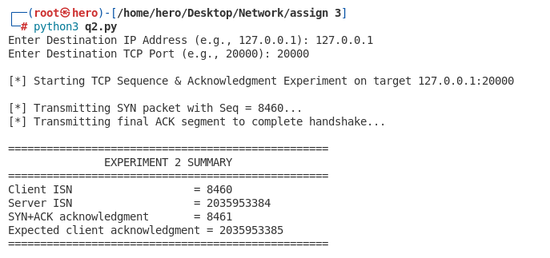

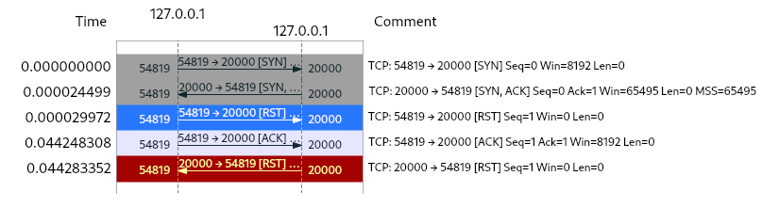

Explanation of the Relationship Among These Values
The TCP protocol uses sequence and acknowledgment numbers to guarantee reliable, ordered delivery of data. During the connection establishment phase (the 3-way handshake):

- Client to Server (SYN): The client initiates the connection by sending a segment with a random Initial Sequence Number (e.g., Seq = 8460). This establishes the starting point of the client's byte stream.

- Server to Client (SYN+ACK): The server responds with its own random Initial Sequence Number (Seq = 2035953384). Simultaneously, the server sets its acknowledgment number to 8461 (Client ISN + 1). This explicitly tells the client: "I have received all bytes up to sequence number 8460, and my next expected byte from you is 8461."

- Client to Server (ACK): To finalize the handshake, the client must acknowledge the server's SYN segment. It sets its acknowledgment number to 2035953385 (Server ISN + 1), confirming receipt of the server's sequence stream up to that point.

Why a SYN Consumes One TCP Sequence Number
In the TCP protocol specification (RFC 793), control flags like SYN and FIN are treated as occupying one sequence number in the virtual byte stream, even though they carry no actual application payload data. Because the SYN packet itself occupies sequence number 8460, the sequence space advances by 1. Therefore, the next logical sequence number for the client to use when sending its next packet (the final ACK) must be incremented to 8461 (Client ISN + 1). If the client sent the final ACK with Seq = 8460, the receiving stack would misinterpret it as a retransmission of the original SYN packet rather than a separate acknowledgment segment.

Experiment 3: ICMP TTL and Hop-Limit Investigation
Source Code :
from scapy.all import IP, ICMP, sr1, conf
import sys

conf.verb = 0

def icmp_ttl_investigation(dst_ip, max_ttl=30):
print(f"\n[*] Starting ICMP TTL & Hop-Limit Investigation on target: {dst_ip}\n")
print("-" * 50)
print(f"{'TTL':<5} | {'Responding IP':<18} | {'ICMP Type':<10} | {'ICMP Code'}")
print("-" * 50)

for ttl in range(1, max_ttl + 1):
pkt = IP(dst=dst_ip, ttl=ttl) / ICMP()

reply = sr1(pkt, timeout=2, verbose=0)

if reply is None:
print(f"{ttl:<5} | {'* (Timeout / No Response)':<18} | {'-':<10} | {'-'}")
continue

responding_ip = reply.src
icmp_type = reply.getlayer(ICMP).type
icmp_code = reply.getlayer(ICMP).code

print(f"{ttl:<5} | {responding_ip:<18} | {icmp_type:<10} | {icmp_code}")

if icmp_type == 0:
print("-" * 50)
print(f"[+] Reached destination {dst_ip} at TTL = {ttl}")
break
else:
print("-" * 50)
print("[-] Reached maximum TTL limit without hitting destination.")

if __name__ == "__main__":
if len(sys.argv) == 2:
target_ip = sys.argv[1]
else:
target_ip = input("Enter Destination IP Address (e.g., 8.8.8.8 or 127.0.0.1): ").strip()

icmp_ttl_investigation(target_ip)

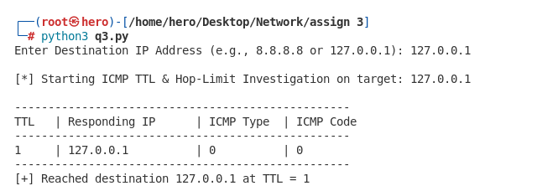

How This Mechanism Determines the Sequence of Routers?
Based on network packet analysis and the Internet Protocol (IP) specification, the TTL mechanism maps the exact sequence of routers between a source and destination through the following sequential steps:

- Role of the IP TTL (Time To Live) Field: Every IP packet contains a TTL field designed to prevent packets from looping indefinitely in a network. Each intermediate router that handles and forwards the packet decrements the TTL value by 1.

- Triggering ICMP Time Exceeded (Type 11, Code 0): If a router receives a packet with TTL = 1 and must forward it to the next hop, the TTL decrements to 0. When this happens, the router drops the packet and generates an ICMP Time Exceeded message (Type 11, Code 0), sending it back to the source IP address. By capturing this response, the source records the responding router's IP address, revealing the device located exactly that many hops away.

- Reaching the Destination (ICMP Echo Reply, Type 0, Code 0): By successively incrementing the TTL value (1, 2, 3...) in subsequent transmissions, the packet is allowed to travel deeper into the network, surviving one additional router hop per increment. Eventually, the TTL becomes high enough for the packet to bypass all intermediate routers and arrive at the intended destination host. Upon receipt, the destination host processes the ICMP Echo Request and returns an ICMP Echo Reply (Type 0, Code 0), signaling that the final destination has been successfully reached.

- Mapping the Complete Path: By assembling the sequence of responding router IPs gathered at each incremental TTL stage before receiving the final Echo Reply, network tools successfully map out the complete, ordered path (sequence of routers) connecting the source to the destination.

Experiment 4: UDP Response and ICMP Port-Unreachable Analysis
Source Code :
from scapy.all import IP, UDP, ICMP, sr1, conf
import sys

conf.verb = 0

def udp_port_analysis(dst_ip, start_port, end_port):
print(f"\n[*] Starting UDP Response & ICMP Port-Unreachable Analysis on {dst_ip}")
print(f"[*] Scanning UDP ports from {start_port} to {end_port}\n")
print("-" * 75)
print(f"{'Port':<8} | {'Status / Response Type':<35} | {'ICMP Details'}")
print("-" * 75)

for port in range(start_port, end_port + 1):
pkt = IP(dst=dst_ip) / UDP(dport=port, sport=55555) / b"HelloUDP"

reply = sr1(pkt, timeout=1.5, verbose=0)

status_str = ""
icmp_details = "-"

if reply is None:
status_str = "No Response (Open / Filtered / Dropped)"
elif reply.haslayer(ICMP):
icmp_layer = reply.getlayer(ICMP)
icmp_type = icmp_layer.type
icmp_code = icmp_layer.code

if icmp_type == 3 and icmp_code == 3:
status_str = "ICMP Port Unreachable (Closed)"
else:
status_str = f"ICMP Error Received"
icmp_details = f"Type: {icmp_type}, Code: {icmp_code} (Port {port})"
elif reply.haslayer(UDP):
status_str = "UDP Response Received (Open)"
icmp_details = f"Responding Source Port: {reply.getlayer(UDP).sport}"
else:
status_str = f"Other Packet Layer Received"

print(f"{port:<8} | {status_str:<35} | {icmp_details}")

print("-" * 75)

if __name__ == "__main__":
if len(sys.argv) == 4:
target_ip = sys.argv[1]
start_p = int(sys.argv[2])
end_p = int(sys.argv[3])
else:
target_ip = input("Enter Destination IP Address (e.g., 127.0.0.1): ").strip()
start_p = int(input("Enter Start UDP Port: ").strip())
end_p = int(input("Enter End UDP Port: ").strip())

udp_port_analysis(target_ip, start_p, end_p)

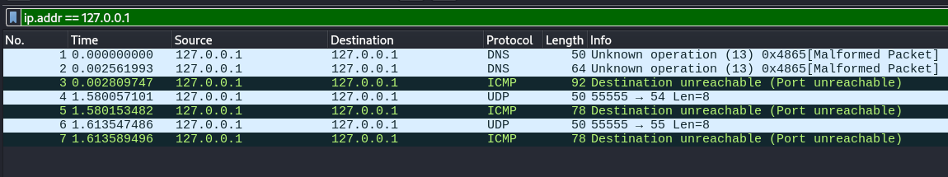

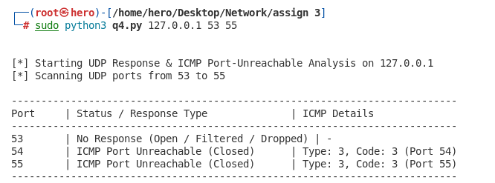

Why UDP Port Analysis is Less Straightforward than TCP SYN Scanning?
Based on the packet captures and protocol design, determining the state of a UDP port is significantly more complex and ambiguous than checking a TCP port with a SYN request due to the following factors:
- Stateless vs. State-Driven Handshake:
- TCP relies on a strict connection-oriented state machine. A single SYN packet yields deterministic, explicit responses: a SYN-ACK packet if the port is open, or a RST packet if the port is closed.
- UDP is entirely connectionless and stateless. It does not perform handshakes or maintain session states, meaning there are no built-in connection control flags to instantly verify port availability.

- Ambiguity of Timeouts (Open vs. Filtered vs. Silent Service):
- If a UDP packet reaches an open port running a service (like your listener on port 53), the application may process the data silently or only reply if valid application-layer input matching its protocol is provided.
- If no response comes back, the scanner experiences a timeout. A timeout is fundamentally ambiguous—it could mean the port is open (but silent), filtered (dropped by a firewall), or closed (and the ICMP error was blocked).

- Reliance on Unreliable ICMP Error Generation:
- Determining that a UDP port is closed depends entirely on the remote host's operating system generating an ICMP Port Unreachable message.
- In real-world networks, security firewalls, routers, and operating systems frequently rate-limit or completely block ICMP error messages to prevent network reconnaissance and denial-of-service (DoS) attacks. Because these error packets can be silently dropped by intermediate security layers, a scanner can never entirely trust a timeout, making UDP port scanning far less straightforward than TCP.

Assignment 4 : Network Flow
Objective: To generate network flow information.
Source Code :
from scapy.all import sniff, IP, TCP, UDP
from collections import defaultdict
from datetime import datetime
import time

CAPTURE_DURATION = 15 * 60

flows = defaultdict(lambda: {
"packets": 0,
"bytes": 0,
"first_time": None,
"last_time": None
})

ip_stats = defaultdict(lambda: {
"packets": 0,
"bytes": 0
})

def packet_analysis(pkt):

if not pkt.haslayer(IP):
return

ip = pkt[IP]

if pkt.haslayer(TCP):
protocol = "TCP"
sport = pkt[TCP].sport
dport = pkt[TCP].dport

elif pkt.haslayer(UDP):
protocol = "UDP"
sport = pkt[UDP].sport
dport = pkt[UDP].dport

else:
return

src_ip = ip.src
dst_ip = ip.dst

flow_key = (
src_ip,
sport,
dst_ip,
dport,
protocol
)

packet_size = len(pkt)
timestamp = float(pkt.time)

flow = flows[flow_key]

flow["packets"] += 1
flow["bytes"] += packet_size

if flow["first_time"] is None:
flow["first_time"] = timestamp

flow["last_time"] = timestamp

ip_stats[src_ip]["packets"] += 1
ip_stats[src_ip]["bytes"] += packet_size

print("Starting network capture...")
print("Duration: 15 minutes")

start = time.time()

sniff(
filter="tcp or udp",
prn=packet_analysis,
store=False,
timeout=CAPTURE_DURATION
)

end = time.time()

print("\nCapture completed!")
print("Actual capture time:", round(end - start, 2), "seconds")

print("\n========== NETWORK FLOWS ==========")

for key, data in flows.items():

duration = data["last_time"] - data["first_time"]

print("\nFlow:", key)
print("Packets:", data["packets"])
print("Bytes:", data["bytes"])
print("Duration:", round(duration, 6), "seconds")

print("\n========== TOP 10 FLOWS BY BYTES ==========")

top_bytes = sorted(
flows.items(),
key=lambda x: x[1]["bytes"],
reverse=True
)[:10]

for key, data in top_bytes:
print(key, "Bytes:", data["bytes"])

print("\n========== TOP 10 FLOWS BY PACKETS ==========")

top_packets = sorted(
flows.items(),
key=lambda x: x[1]["packets"],
reverse=True
)[:10]
for key, data in top_packets:
print(key, "Packets:", data["packets"])
print("\n========== TOP IPs BY PACKETS ==========")

top_ip_packets = sorted(
ip_stats.items(),
key=lambda x: x[1]["packets"],
reverse=True
)
for ip, data in top_ip_packets[:10]:
print(ip, "Packets:", data["packets"])
print("\n========== TOP IPs BY BYTES ==========")

top_ip_bytes = sorted(
ip_stats.items(),
key=lambda x: x[1]["bytes"],
reverse=True
)
for ip, data in top_ip_bytes[:10]:
print(ip, "Bytes:", data["bytes"])
print("\n========== SUMMARY ==========")
print("Total flows:", len(flows))
print(
"Total packets:",
sum(data["packets"] for data in flows.values())
)
print(
"Total bytes:",
sum(data["bytes"] for data in flows.values())
)

Output :
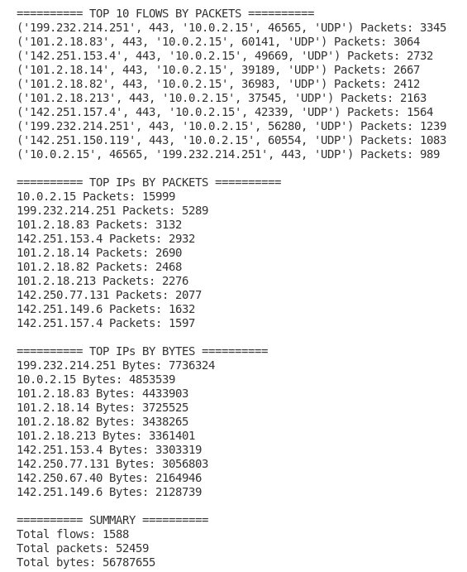
Assignment 6
Experiment 1: ICMP Ping Analysis
Problem Statement
The objective of this experiment is to verify host reachability and study network diagnostics using the ping utility. By capturing ICMP Echo Request and Echo Reply packets using Wireshark, we analyze the structural composition of Ethernet II Frames, IP Headers, and ICMP Headers.

Concept of ICMP and IP Fragmentation
The Internet Control Message Protocol (ICMP) is a core network-layer protocol used by network devices to communicate error messages, operational feedback, and IP-processing information. Unlike TCP or UDP, ICMP does not carry application-layer data nor does it rely on transport-layer port numbers.

The ping command sends ICMP Echo Request (Type 8) packets to a target host; if the destination is operational, it responds with ICMP Echo Reply (Type 0) packets. When an IP datagram exceeds the Maximum Transmission Unit (MTU) of the underlying link layer (typically 1500 bytes), the IP layer divides the datagram into multiple smaller fragments to be reassembled at the destination host.

Descriptions of ICMP and IP Header Fields
Ethernet II Frame Header
- Destination MAC Address (6 bytes): 48-bit physical address of the destination interface or next-hop gateway.
- Source MAC Address (6 bytes): 48-bit physical address of the sending host's network interface.
- EtherType (2 bytes): Specifies the encapsulated upper network-layer protocol (e.g., 0x0800 for IPv4).
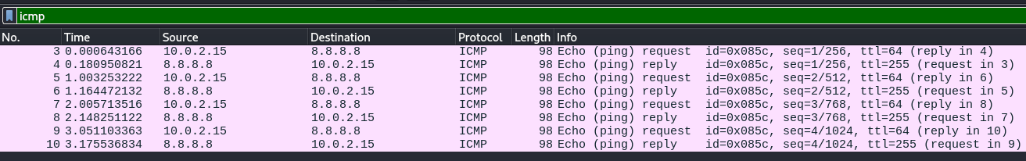
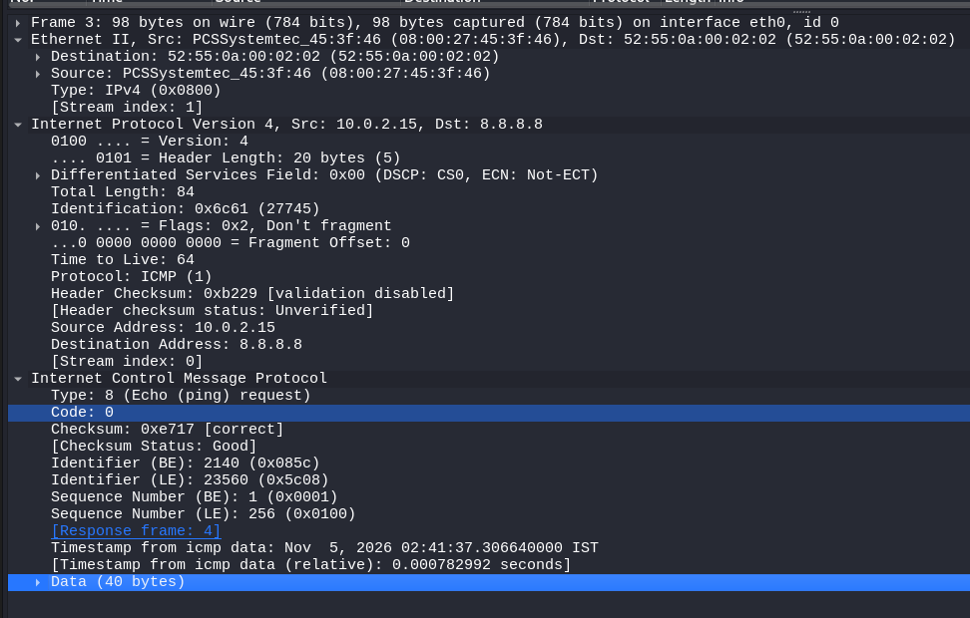

IPv4 Header
- Version (4 bits): Indicates the IP version (IPv4 = 4).
- Header Length / IHL (4 bits): Length of the IP header in 32-bit words (default is 5 words = 20 bytes).
- Total Length (16 bits): Entire length of the IP datagram (header plus payload) in bytes.
- Identification (16 bits): Unique value identifying fragments belonging to the same original datagram.
- Flags (3 bits): Controls fragmentation (Control Bits: Reserved, Don't Fragment (DF), More Fragments (MF)).
- Fragment Offset (13 bits): Indicates the relative position of the fragment's payload in 8-byte blocks.
- Time to Live / TTL (8 bits): Prevents packets from circulating indefinitely by decrementing at each router hop.
- Protocol (8 bits): Indicates the next-level protocol (e.g., 1 for ICMP).

ICMP Header
- Type (1 byte): Defines the specific ICMP message type (e.g., 8 for Echo Request, 0 for Echo Reply).
- Code (1 byte): Sub-category parameter for the given ICMP type (e.g., 0 for standard Echo).
- Checksum (2 bytes): Error-checking code covering the ICMP header and data.
- Identifier (2 bytes): Session tag used to associate requests with corresponding replies.
- Sequence Number (2 bytes): Monotonically increasing number for each request packet sent.

(a) What is the 48-bit Ethernet address of your computer?
Source MAC Address: 08:00:27:45:3f:46

(b) What is the 48-bit destination address in the Ethernet frame?
Destination MAC Address: 52:55:0a:00:02:02

(c) Give the hexadecimal value for the two-byte Frame type field.
EtherType: 0x0800 (IPv4)

(d) What is the hexadecimal value of the CRC field in this Ethernet frame?
CRC / FCS: Hardware-level Frame Check Sequence (FCS) fields are automatically stripped by the Ethernet Network Interface Card (NIC) driver prior to packet logging; hence, it is omitted in the Wireshark trace.

(e) What is the IP address of your host? What is the IP address of the destination host?
Source Host IP (Your Host): 10.0.2.15
Destination Host IP: 8.8.8.8

(f) Why is it that an ICMP packet does not have source and destination port numbers?
ICMP operates directly at the Network Layer (Layer 3) as an architectural control protocol. Transport-layer port numbers (such as TCP or UDP ports) are designed to route traffic to specific application processes on an operating system. Since ICMP handles host-to-host network testing and control rather than application-layer communication, port numbers are unnecessary.

(g) Examine one of the ping request packets sent by your host (Frame 3).
ICMP Type Number: 8 (Echo Request)
ICMP Code Number: 0
Other Fields Present: Checksum, Identifier (Big-Endian & Little-Endian), Sequence Number (Big-Endian & Little-Endian), Timestamp, and Data Payload.
Field Sizes:
Checksum: 2 bytes (0xe717)
Identifier: 2 bytes (0x085c / 2140)
Sequence Number: 2 bytes (0x0001 / 1)

(h) Examine the corresponding ping reply packet (Frame 4).
ICMP Type Number: 0 (Echo Reply)
ICMP Code Number: 0
Other Fields Present: Checksum, Identifier (Big-Endian & Little-Endian), Sequence Number (Big-Endian & Little-Endian), and Data Payload.
Field Sizes:
Checksum: 2 bytes
Identifier: 2 bytes (0x085c / 2140)
Sequence Number: 2 bytes (0x0001 / 1)

Experiment 2: IP Fragmentation Analysis
Problem Statement
The objective of this experiment is to study how the Internet Protocol (IP) handles datagrams that exceed the Maximum Transmission Unit (MTU) of the underlying link layer (typically 1500 bytes on standard Ethernet). By generating ICMP Echo Requests with larger custom payload sizes (2000 bytes and 5000 bytes) using the ping command, we capture and analyze the resulting IP fragments and their respective header fields.

Concept of IP Fragmentation
When an IP datagram exceeds the link layer MTU, the network layer divides the datagram into smaller fragments so that each piece can fit within an individual frame. Each fragment travels as an independent IP packet across the network.

Reassembly of the datagram is handled exclusively at the destination host (not by intermediate routers) using three primary fields in the IPv4 header:
  - Identification (16 bits): A unique identifier shared by all fragments belonging to the same original datagram.
  - Flags (3 bits): Contains control bits, specifically the More Fragments (MF) flag (1 indicates more fragments follow; 0 indicates the final fragment).
  - Fragment Offset (13 bits): Specifies the offset of a particular fragment relative to the beginning of the original unfragmented payload, measured in units of 8 bytes.

Descriptions of IP Header Fields
- Version (4 bits): Indicates the IP protocol version being used (e.g., IPv4 = 4).
- Header Length / IHL (4 bits): Specifies the length of the IP header in 32-bit words (standard length is 5 words = 20 bytes).
- Total Length (16 bits): Specifies the entire length of the IP datagram (header plus payload) in bytes.
- Identification (16 bits): A unique tracking number assigned to identify fragments of the same datagram.
- Flags (3 bits): Control flags including Reserved, Don't Fragment (DF), and More Fragments (MF).
- Fragment Offset (13 bits): Indicates the position of the fragment data block within the original payload (in 8-byte blocks).
- Time to Live / TTL (8 bits): Hop counter decremented by each router to prevent infinite loops.
- Protocol (8 bits): Identifies the upper-layer protocol encapsulated within the IP datagram (e.g., 1 for ICMP).

Part A: Ping with 2000 Bytes Payload (ping -s 2000 8.8.8.8)
1. First Fragment Analysis
What information in the IP header indicates that the datagram has been fragmented?
The Total Length field is 1500 bytes (20 bytes IP header + 1480 bytes payload), which matches the maximum Ethernet MTU limit, and the More Fragments (MF) flag is set to 1 (Flags: 0x1, More fragments).

What information indicates whether this is the first fragment versus a latter fragment?
The Fragment Offset field is set to 0 (Fragment Offset: 0), verifying that this packet contains the starting portion of the original payload.

How long is this IP datagram?
The Total Length of the IP datagram is 1500 bytes (encapsulated within a 1514-byte Ethernet frame).

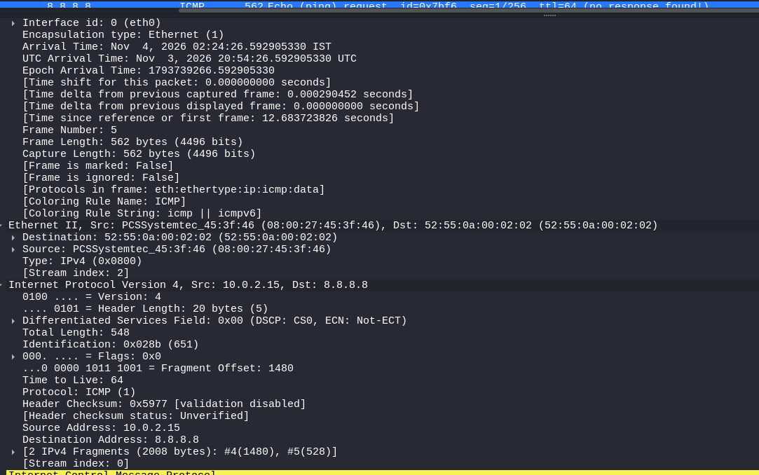
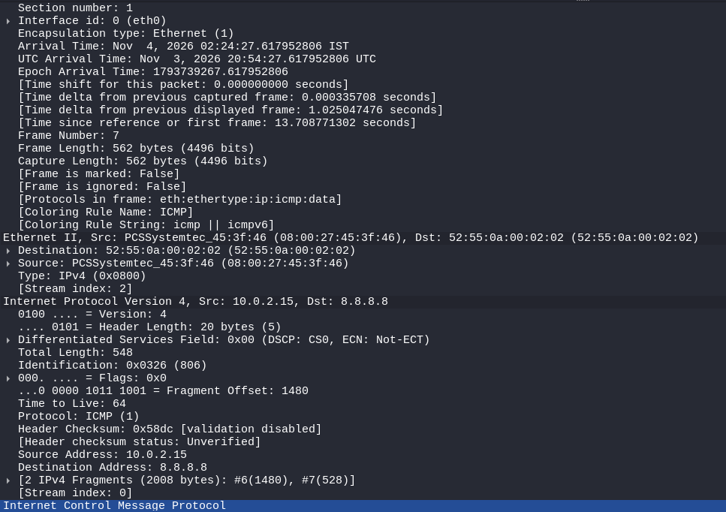

2. Second Fragment Analysis
What information in the IP header indicates that this is not the first datagram fragment?
The Fragment Offset field is non-zero (Fragment Offset: 1480), meaning it starts at byte offset 1480 of the original payload.

Are there more fragments? How can you tell?
No, there are no more fragments.
This is confirmed because the More Fragments (MF) flag is set to 0 (Flags: 0x0), and Wireshark reassembles the complete packet structure as [2 IPv4 Fragments (2008 bytes): #4(1480), #5(528)].

3. What fields change in the IP header between the first and second fragment?
- Total Length: Decreases from 1500 bytes in the first fragment to 548 bytes in the second fragment.
- Flags (More Fragments): Changes from 1 (indicating more fragments follow) in the first fragment to 0 in the second fragment.
- Fragment Offset: Changes from 0 in the first fragment to 1480 in the second fragment.
- Header Checksum: Recalculated for each header to account for changes in the Total Length, Flags, and Offset fields (e.g., changes from 0x5977 in one fragment to 0x58dc in the next).

Part B: Ping with 5000 Bytes Payload (ping -l 5000 8.8.8.8)
How many fragments were created from the original datagram?
Calculation:
- Total payload size = 5000 bytes (data) + 8 bytes (ICMP header) = 5008 bytes.
- Maximum payload capacity per full fragment = 1500 - 20 = 1480 bytes.
- Number of full fragments = 5008 / 1480 = 3 fragments of 1480 bytes.
- Remaining fragment payload = 5008 - (3 * 1480) = 568 bytes.

Total Fragments Created: 4 fragments
- Fragment 1: Total Length = 1500 bytes, Offset = 0, MF = 1
- Fragment 2: Total Length = 1500 bytes, Offset = 1480, MF = 1
- Fragment 3: Total Length = 1500 bytes, Offset = 2960, MF = 1
- Fragment 4: Total Length = 588 bytes, Offset = 4440, MF = 0

What fields change in the IP header among the fragments?
- Total Length: Maintains 1500 bytes for the first three fragments, but drops to 588 bytes for the final (fourth) fragment.
- Fragment Offset: Increments systematically by 1480 bytes for each successive fragment (0, 1480, 2960, 4440).
- More Fragments (MF) Flag: Stays set to 1 across the first three fragments, and changes to 0 on the final fragment to mark the end of the chain.
- Header Checksum: Recalculated individually for each fragment header to ensure data integrity under changing field values.

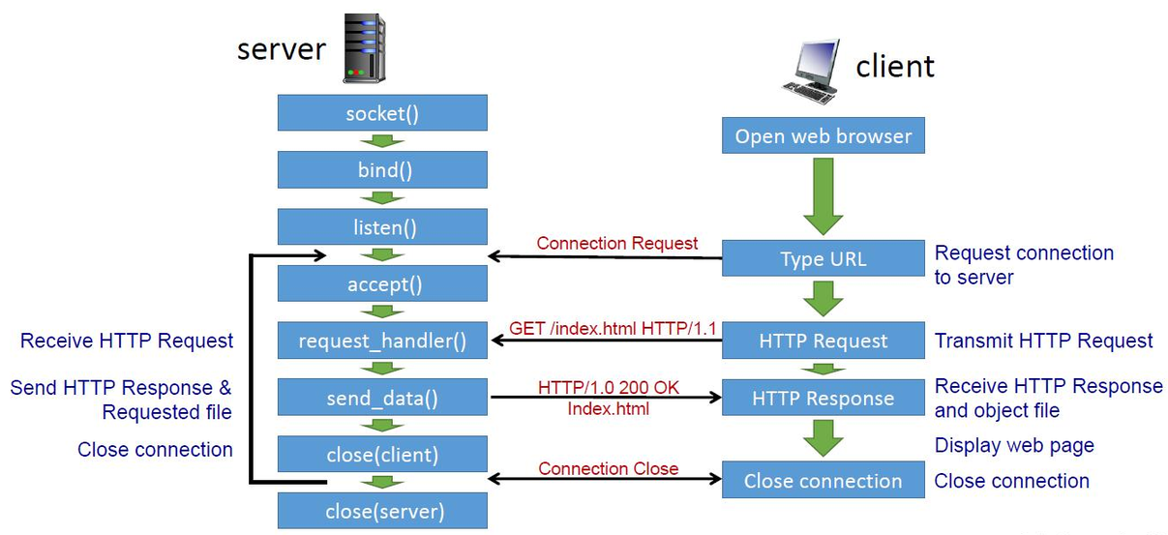

Assignment 7 : IMPLEMENTATION OF HTTP CLIENT AND SERVER USING TCP SOCKET PROGRAMMING
Objective
To implement an HTTP client and server using TCP socket programming, supporting the HTTP GET and PUT methods for retrieving and uploading files.

HTTP Server Program
File Name: server.py
import socket
import sys
import os
import mimetypes
from pathlib import Path

HOST = "0.0.0.0"
BUFFER_SIZE = 4096
SERVER_DIR = Path("server_files").resolve()

def send_response(client, status, body=b"", content_type="text/plain"):
"""Construct and send an HTTP response."""

reason = {
200: "OK",
201: "Created",
400: "Bad Request",
403: "Forbidden",
404: "Not Found",
405: "Method Not Allowed",
411: "Length Required",
413: "Content Too Large",
500: "Internal Server Error"
}

response = (
f"HTTP/1.0 {status} {reason[status]}\r\n"
f"Content-Type: {content_type}\r\n"
f"Content-Length: {len(body)}\r\n"
"Connection: close\r\n"
"\r\n"
).encode("ascii")

client.sendall(response + body)

def receive_request(client):
"""Read HTTP headers and exactly Content-Length bytes."""

request = b""

while b"\r\n\r\n" not in request:
chunk = client.recv(BUFFER_SIZE)

if not chunk:
raise ValueError("Incomplete HTTP headers")

request += chunk

if len(request) > 65536:
raise ValueError("HTTP headers too large")

header_data, body = request.split(b"\r\n\r\n", 1)

lines = header_data.decode("iso-8859-1").split("\r\n")

request_line = lines[0].split()

if len(request_line) != 3:
raise ValueError("Invalid request line")

method, path, version = request_line

headers = {}

for line in lines[1:]:
if ":" not in line:
raise ValueError("Invalid HTTP header")

key, value = line.split(":", 1)
headers[key.strip().lower()] = value.strip()

if version not in ("HTTP/1.0", "HTTP/1.1"):
raise ValueError("Unsupported HTTP version")

if method == "PUT":
if "content-length" not in headers:
raise ValueError("Content-Length required")

try:
length = int(headers["content-length"])
except ValueError:
raise ValueError("Invalid Content-Length")

if length < 0:
raise ValueError("Invalid Content-Length")

if length > 100 * 1024 * 1024:
raise OverflowError("File too large")

while len(body) < length:
chunk = client.recv(min(BUFFER_SIZE, length - len(body)))

if not chunk:
raise ValueError("Incomplete request body")

body += chunk

body = body[:length]

return method, path, body

def get_file(client, path):
"""Handle HTTP GET."""

# Remove query parameters
path = path.split("?", 1)[0]

# Convert URL path into a safe filesystem path
relative_path = path.lstrip("/")

if not relative_path:
relative_path = "index.html"

file_path = (SERVER_DIR / relative_path).resolve()

# Prevent access outside server_files
if not file_path.is_relative_to(SERVER_DIR):
send_response(client, 403, b"Forbidden")
return

if not file_path.is_file():
send_response(client, 404, b"File Not Found")
print("GET: File not found:", path)
return

try:
with open(file_path, "rb") as file:
content = file.read()

content_type, _ = mimetypes.guess_type(str(file_path))

send_response(
client,
200,
content,
content_type or "application/octet-stream"
)

print("GET: Successfully sent", file_path.name)

except OSError:
send_response(client, 500, b"Internal Server Error")

def put_file(client, path, body):
"""Handle HTTP PUT."""

# Accept only filenames, not directory paths
filename = path.split("?", 1)[0].lstrip("/")

if not filename or filename in (".", "..") or "/" in filename or "\\" in filename:
send_response(client, 400, b"Invalid filename")
return

file_path = SERVER_DIR / filename

try:
file_path.parent.mkdir(parents=True, exist_ok=True)

with open(file_path, "wb") as file:
file.write(body)

send_response(client, 200, b"File Created")

print("PUT: Successfully created", filename)

except OSError:
send_response(client, 500, b"Internal Server Error")

def handle_client(client, address):
"""Process one client connection."""

print("\nClient connected:", address)

try:
method, path, body = receive_request(client)

print("Method:", method)
print("Path:", path)

if method == "GET":
get_file(client, path)

elif method == "PUT":
put_file(client, path, body)

else:
send_response(client, 405, b"Method Not Allowed")

except ValueError as error:
send_response(client, 400, str(error).encode())

except OverflowError:
send_response(client, 413, b"File too large")

except OSError as error:
print("Socket error:", error)

finally:
client.close()
print("Client disconnected")

def main():
if len(sys.argv) != 2:
print("Usage: python server.py <port>")
return

port = int(sys.argv[1])

SERVER_DIR.mkdir(parents=True, exist_ok=True)

server = socket.socket(socket.AF_INET, socket.SOCK_STREAM)

server.setsockopt(socket.SOL_SOCKET, socket.SO_REUSEADDR, 1)

server.bind((HOST, port))
server.listen(5)

print("HTTP Server started")
print("Listening on port:", port)
print("Server directory:", SERVER_DIR)

try:
while True:
client, address = server.accept()
handle_client(client, address)

except KeyboardInterrupt:
print("\nServer shutting down")

finally:
server.close()

if __name__ == "__main__":
main()

HTTP Client Program
File Name: client.py
import socket
import sys
from pathlib import Path

BUFFER_SIZE = 4096

def receive_response(client):
"""Receive the complete HTTP response."""

response = b""

while True:
data = client.recv(BUFFER_SIZE)

if not data:
break

response += data

return response

def display_response(response):
"""Display HTTP response headers and body."""

if b"\r\n\r\n" not in response:
print("Invalid HTTP response")
return

headers, body = response.split(b"\r\n\r\n", 1)

print("\n========== HTTP RESPONSE ==========")

print(headers.decode("iso-8859-1"))

print("\n========== RESPONSE BODY ==========")

content_type = ""

for line in headers.decode("iso-8859-1").split("\r\n"):
if line.lower().startswith("content-type:"):
content_type = line.split(":", 1)[1].strip().lower()

if content_type.startswith("text/") or "json" in content_type or "xml" in content_type:
print(body.decode("utf-8", errors="replace"))
else:
print(f"Binary data received: {len(body)} bytes")

print("\n===================================")

def main():

if len(sys.argv) not in (5, 6):
print("Usage:")
print("GET: python client.py <server> <port> GET <path>")
print("PUT: python client.py <server> <port> PUT <path> <local_file>")
return

server = sys.argv[1]
port = int(sys.argv[2])
method = sys.argv[3].upper()
path = sys.argv[4]

if method not in ("GET", "PUT"):
print("Only GET and PUT methods are supported")
return

if not path.startswith("/"):
path = "/" + path

# Establish TCP connection
try:
client = socket.create_connection((server, port), timeout=15)

print(f"Connected to {server}:{port}")

# Construct HTTP request
if method == "GET":

request = (
f"GET {path} HTTP/1.0\r\n"
f"Host: {server}\r\n"
"\r\n"
).encode()

print("Sending GET request...")

client.sendall(request)

elif method == "PUT":

if len(sys.argv) != 6:
print("PUT requires a local filename")
client.close()
return

local_file = Path(sys.argv[5])

if not local_file.is_file():
print("Local file does not exist:", local_file)
client.close()
return

with open(local_file, "rb") as file:
file_content = file.read()

request_headers = (
f"PUT {path} HTTP/1.0\r\n"
f"Host: {server}\r\n"
f"Content-Length: {len(file_content)}\r\n"
"Content-Type: application/octet-stream\r\n"
"\r\n"
).encode()

print("Sending PUT request...")
print("File size:", len(file_content), "bytes")

client.sendall(request_headers + file_content)

# Receive server response
response = receive_response(client)

display_response(response)

client.close()

except socket.timeout:
print("Connection timed out")

except ConnectionRefusedError:
print("Connection refused. Is the server running?")

except OSError as error:
print("Network error:", error)

if __name__ == "__main__":
main()

Experimental Results and Outputs
Test Case 1: Starting the HTTP Server
Command: python server.py 8080
Output:
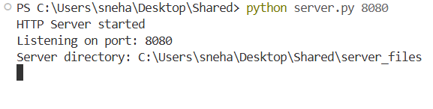
Test Case 2: Accessing an HTML File Using a Web Browser
URL: http://localhost:8080/
Output:
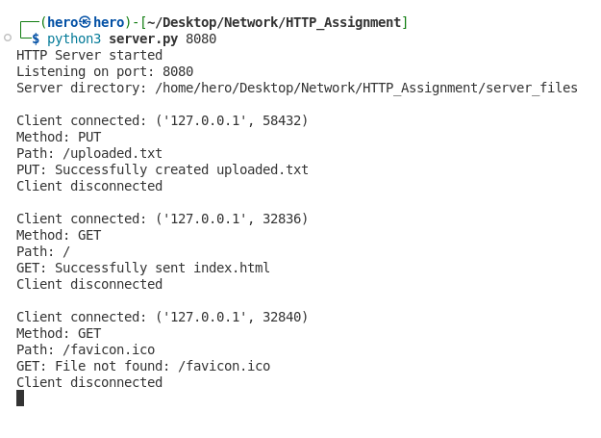
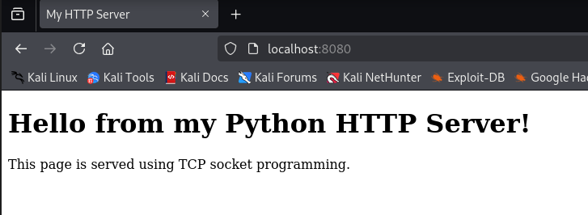
Test Case 3: Retrieving a File Using the HTTP Client (GET)
Command: python client.py localhost 8080 GET /index.html
Output:
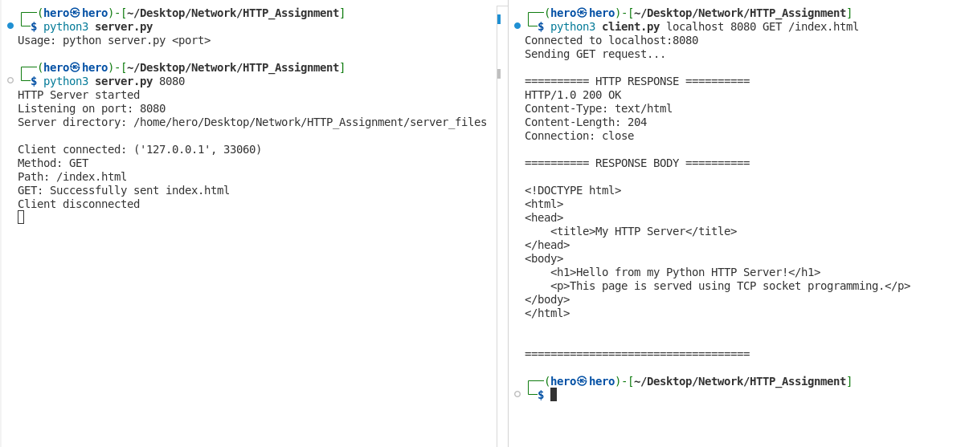

Test Case 4: Requesting a Nonexistent File (404 Not Found)
Command: python client.py localhost 8080 GET /unknown.html
Output:
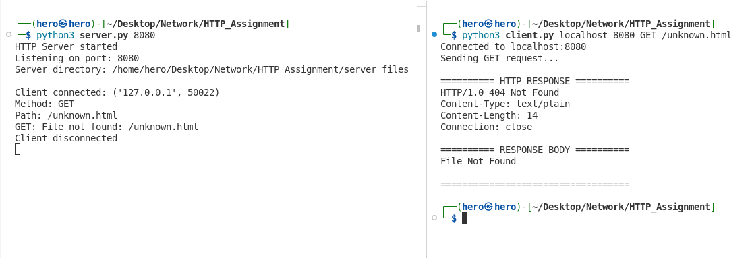

Test Case 5: Uploading a File Using the HTTP Client (PUT)
Command: python client.py localhost 8080 PUT /uploaded.txt client_files/upload.txt
Output:
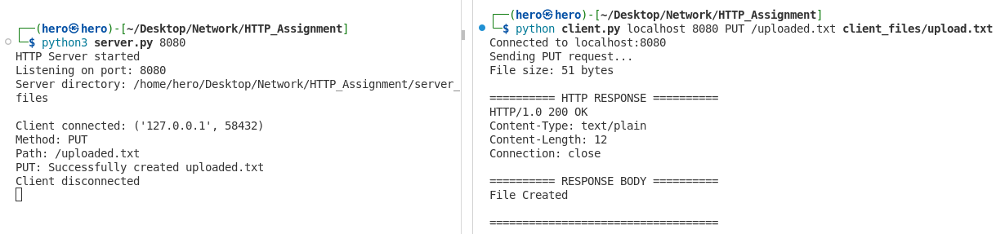

Test Case 6: Retrieving a File from a Real Web Server on the Internet
Command:
python client.py neverssl.com 80 GET /
Output:
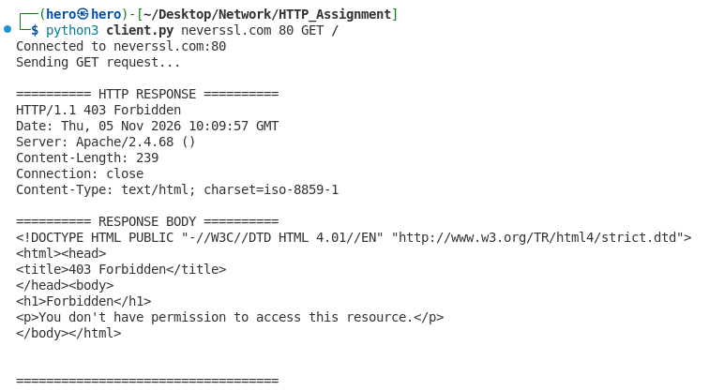
5. Result
The HTTP client and server were successfully implemented using Python TCP socket programming. The GET and PUT operations were tested successfully, including file retrieval, file uploading, handling nonexistent files, accessing the server through a web browser, and communicating with a real web server on the internet.

