JADAVPUR UNIVERSITY
188, Raja S.C. Mallick Road, Kolkata – 700032

Department of Computer Science and Engineering, FET.

MASTER OF COMPUTER APPLICATION
1st Year 2nd Semester

DATABASE MANAGEMENT SYSTEM ASSIGNMENT

Name: Snehasish Sarkar
Roll No.: 002510503033

Question 1. Create the following tables : Tablename: EMPLOYEE Structure :
EMP_CODE char(16) EMP_NAME char(20) DEPT_CODE char(16) DESIG_CODE char(16)
SEX char(1) ADDRESS char (25)
CITY char (20)
STATE char (20)
PIN char (6) BASIC Number JN_DT Date
Primary key is EMP_CODE

Tablename : DESIGNATION Structure :
DESIG_CODE char(16) DESIG_DESC char(20)
Primary key is DESIG_CODE

Tablename : DEPARTMENT Structure :
DEPT_CODE char(16) DEPT_NAME char(20)
Primary key is DEPT_CODE. Query :
CREATE TABLE IF NOT EXISTS DEPARTMENT ( DEPT_CODE CHAR(16) PRIMARY KEY, DEPT_NAME CHAR(20)
);

CREATE TABLE IF NOT EXISTS DESIGNATION ( DESIG_CODE CHAR(16) PRIMARY KEY, DESIG_DESC CHAR(20)
);

CREATE TABLE IF NOT EXISTS EMPLOYEE ( EMP_CODE CHAR(16) PRIMARY KEY, EMP_NAME CHAR(20),
DEPT_CODE CHAR(16), DESIG_CODE CHAR(16), SEX CHAR(1),
ADDRESS CHAR(25), CITY CHAR(20), STATE CHAR(20), PIN CHAR(6),
BASIC DECIMAL(10,2), JN_DT DATE,

FOREIGN KEY (DEPT_CODE) REFERENCES DEPARTMENT(DEPT_CODE), FOREIGN KEY (DESIG_CODE) REFERENCES DESIGNATION(DESIG_CODE)
);

Output :

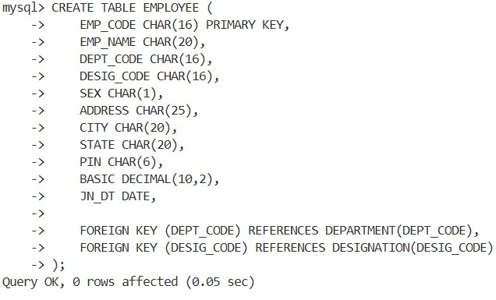

Question 2 : Display the structure of each table . Query :
DESC department; DESC designation; DESC employee;

Output :
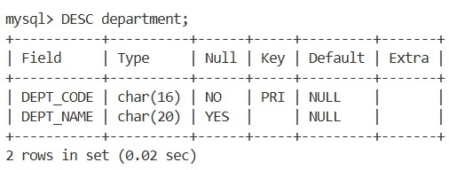

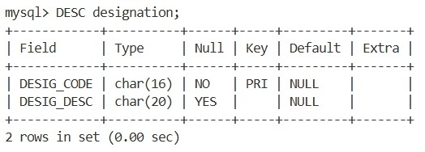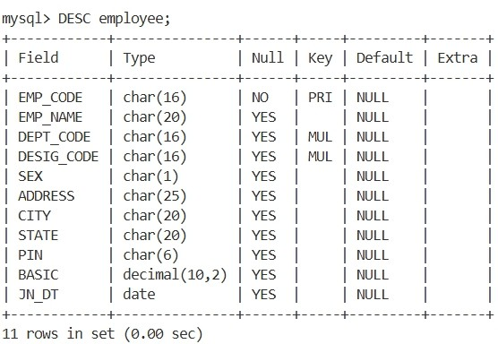

Question 3: Insert few rows in each table .
[While entering data in EMP table use DESIG_CODE which exists in DESIGNATION table and DEPT_CODE which is exists in DEPARTMENT table. In
DESIGNATION table, assign code for Manager, Executive, officer, clerk and helper. In DEPARTMENT table, assign code for Personnel, Production, Purchase, Finance, Research departments]

Query :
INSERT INTO DESIGNATION VALUES
('D001','Manager'),
('D002','Executive'),
('D003','Officer'),
('D004','Clerk'),
('D005','Helper');

INSERT INTO DEPARTMENT VALUES
('DP001','Personnel'),
('DP002','Production'),
('DP003','Purchase'),
('DP004','Finance'),
('DP005','Research');

INSERT INTO EMPLOYEE VALUES
('E001','Rahul Das','DP001','D001','M','12 Park
Street','Kolkata','WB','700001',60000,'2023-01-15'),
('E002','Anita Roy','DP002','D002','F','45 MG
Road','Kolkata','WB','700002',45000,'2023-02-10'),
('E003','Suman Sen','DP003','D003','M','21 Lake
Road','Siliguri','WB','734001',35000,'2022-07-20'),
('E004','Priya Dey','DP004','D004','F','10 College
St','Kolkata','WB','700073',25000,'2024-03-05'),
('E005','Amit Paul','DP005','D005','M','7 Hill Cart
Rd','Jalpaiguri','WB','735101',18000,'2024-04-12');

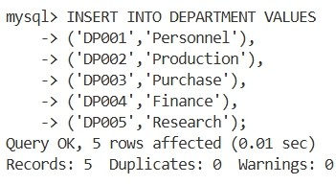
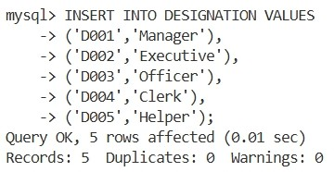
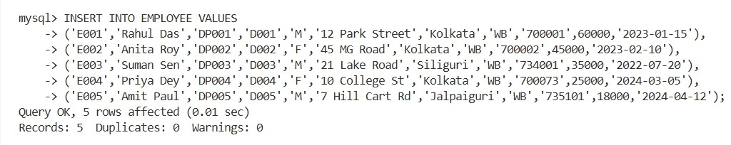
Output :

Question 4: In EMP table insert few rows without DEPT_CODE and BASIC. Query :
INSERT INTO EMPLOYEE (EMP_CODE,EMP_NAME,DESIG_CODE,SEX,ADDRESS,CITY,STATE,PIN,JN_DT) VALUES ('E006','Rita Ghosh','D003','F','22 Station Rd','Malda','WB','732101','2024-05- 01'),
('E007','Arjun Roy','D004','M','15 Market Rd','Cooch
Behar','WB','736101','2024-06-15');

Ouput :
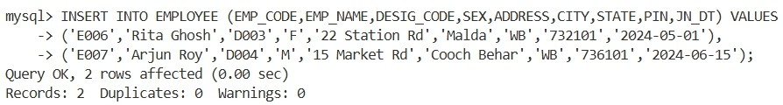

Question 5: Find the rows with unassigned DEPT_CODE Query :
SELECT * FROM EMPLOYEE WHERE DEPT_CODE IS NULL;

Output :
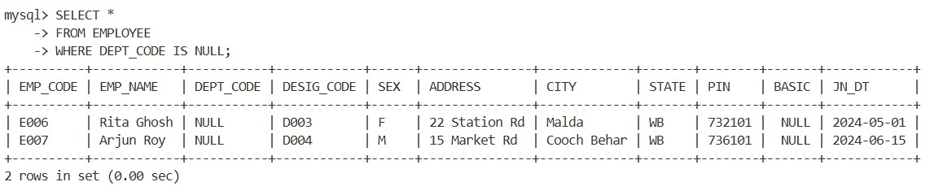

Question 6 : Find the rows with BASIC equal to zero Query :
SELECT * FROM EMPLOYEE WHERE BASIC = 0;

Ouput :
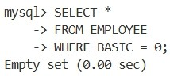

Question 7 : Find the rows with unassigned Basic [note down the difference between the results obtained in Q.6 and Q.7]
Query :
SELECT * FROM EMPLOYEE WHERE BASIC IS NULL;

Output :
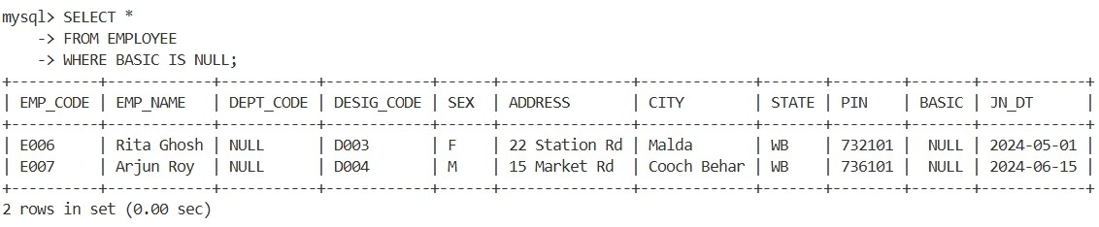

Question 8: Find the average basic of the employees. Query :
SELECT AVG(BASIC) AS Average_Basic FROM EMPLOYEE;

Output :
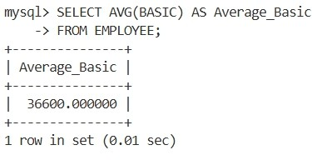
Question 9: Replace the BASIC with 0 for the rows with unassigned Basic. Query :
UPDATE EMPLOYEE SET BASIC = 0 WHERE BASIC IS NULL;

Ouput :
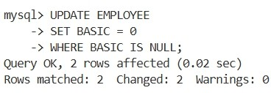

Question 10 : Again, find the average Basic. (Note the difference of result obtained in Q.8 & Q.10.) Query :
SELECT AVG(BASIC) AS Average_Basic FROM EMPLOYEE;

Output :
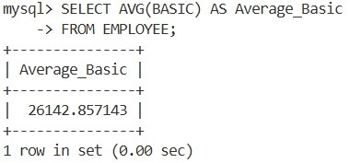

Question 11 : Delete the rows with unassigned DEPT_CODE. Query :
DELETE FROM EMPLOYEE WHERE DEPT_CODE IS NULL;

Output :
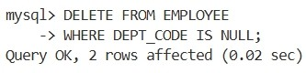

Question 12 : Say, Net pay of an employee= Basic+HRA+DA where HRA is 50% of the Basic & DA is 40% of Basic. Show the employee name & Net pay for all employees.
Query :
SELECT EMP_NAME, BASIC + (0.5 * BASIC) + (0.4 * BASIC) AS NET_PAY FROM EMPLOYEE;

Output :
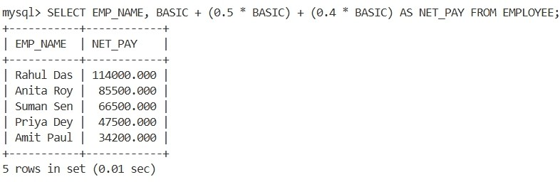
Question 13 : Show the EMP_NAME & BASIC in the ascending order of DEPT_CODE. The employee name must appear in uppercase.
Query :
SELECT UPPER(EMP_NAME) AS EMP_NAME, BASIC FROM EMPLOYEE ORDER BY DEPT_CODE ASC;

Output :
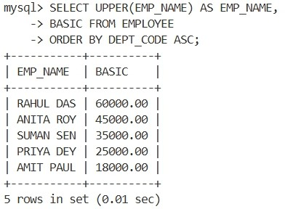

Question 14 : Find the employees who have joined after 1st January 2010. Query :
SELECT * FROM EMPLOYEE WHERE JN_DT > '2010-01-01';

Output :
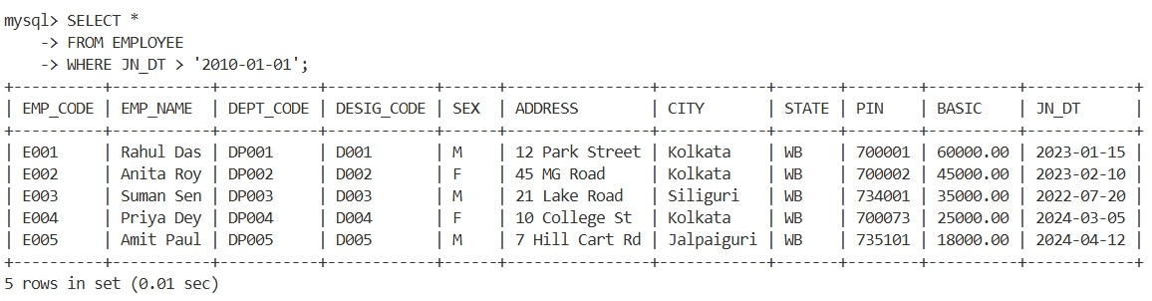

Question 15: Find, how many employees have joined in the month of January? Query :
SELECT COUNT(*) AS JAN_JOINED FROM EMPLOYEE WHERE MONTH(JN_DT) = 1;

Output :
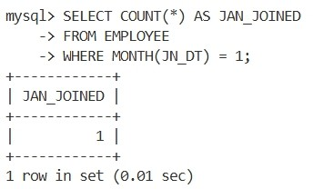

Question 16 : Find the maximum & minimum Basic. Query :
SELECT MAX(BASIC) AS MAX_BASIC, MIN(BASIC) AS MIN_BASIC FROM EMPLOYEE;

Output :
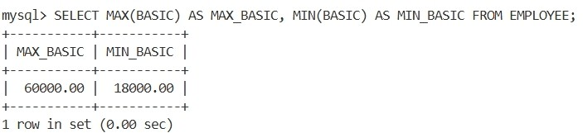

Question 17 : Find how many Female employees are there? Query :
SELECT COUNT(*) AS FEMALE_EMPLOYEES FROM EMPLOYEE WHERE SEX = 'F';

Output :
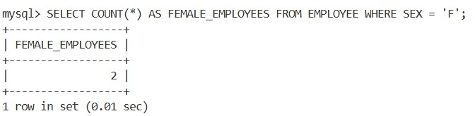
Question 18: Replace CITY with existing value converted into uppercase for all rows. Query :
UPDATE EMPLOYEE SET CITY = UPPER(CITY);

Output :
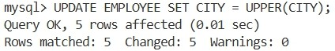

Question 19: Find in how many different cities various employees are residing? Query :
SELECT COUNT(DISTINCT CITY) AS TOTAL_CITIES FROM EMPLOYEE;

Output :
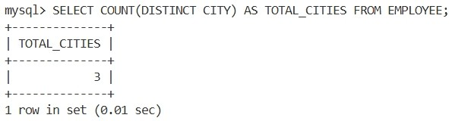
Question 20 : Display the employee information in the ascending order of DEPT_CODE and with in a Department, it should be in the descending order of BASIC
Query :
SELECT * FROM EMPLOYEE ORDER BY DEPT_CODE ASC, BASIC DESC;

Output :
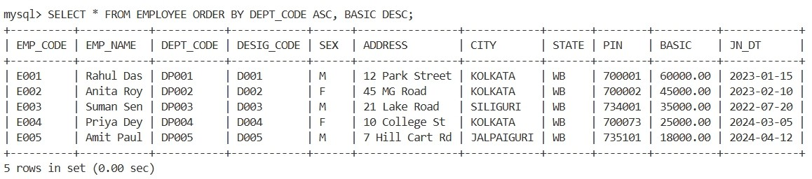

Question 21. From the EMP table show the minimum, maximum and average basic for each department (show dept. Code).
Query :
SELECT
DEPT_CODE,
MIN(BASIC) AS MIN_BASIC, MAX(BASIC) AS MAX_BASIC, AVG(BASIC) AS AVG_BASIC
FROM EMPLOYEE
GROUP BY DEPT_CODE;
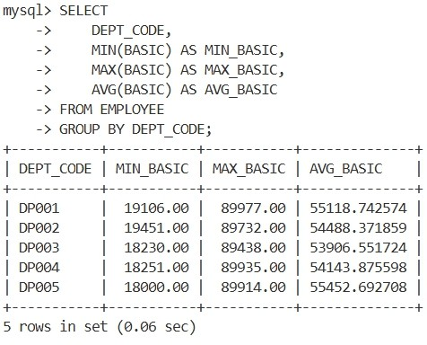

Question 22. Find the number of female employees in each department (show dept. Code). Query :
SELECT
DEPT_CODE,
COUNT(*) AS FEMALE_EMPLOYEES FROM EMPLOYEE
WHERE SEX='F'
GROUP BY DEPT_CODE;
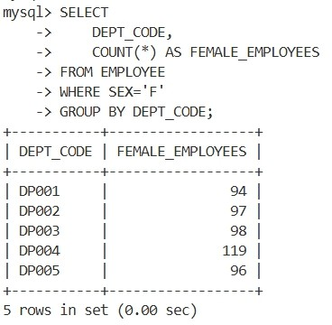

Question 23: Find the city wise no. of employees for each department (show dept. Code). Query :
SELECT
DEPT_CODE, CITY,
COUNT(*) AS TOTAL_EMPLOYEES FROM EMPLOYEE
GROUP BY DEPT_CODE, CITY;
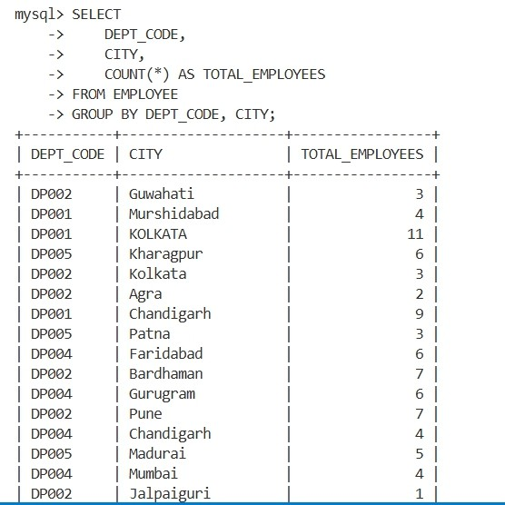

Question 24 : Show the designation wise no of employees who have joined in the year 2000 in each department. The listing should appear in the ascending order of no. of employees.
Query :
SELECT
  - EPT_CODE, D.DESIG_DESC, COUNT(*) AS EMP_COUNT
FROM EMPLOYEE E JOIN DESIGNATION D
ON E.DESIG_CODE=D.DESIG_CODE WHERE YEAR(E.JN_DT)=2000
GROUP BY E.DEPT_CODE,D.DESIG_DESC ORDER BY EMP_COUNT ASC;

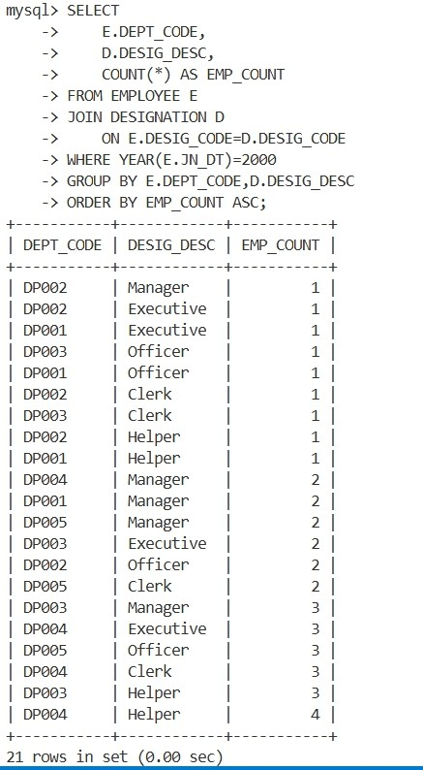

Question 25: Find the department code wise total basic of male employees only for the departments for which such total is more than 50,000 and the listing should appear in the descending order of total basic.
Query :
SELECT
DEPT_CODE,
SUM(BASIC) AS TOTAL_BASIC FROM EMPLOYEE
WHERE SEX='M' GROUP BY DEPT_CODE
HAVING SUM(BASIC) > 50000 ORDER BY TOTAL_BASIC DESC;
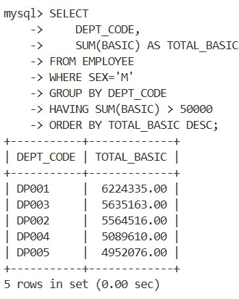

Question 26: Show the employee name, Designation description and basic for all employees. Query :
SELECT
  - MP_NAME, D.DESIG_DESC, E.BASIC
FROM EMPLOYEE E JOIN DESIGNATION D
ON E.DESIG_CODE=D.DESIG_CODE;
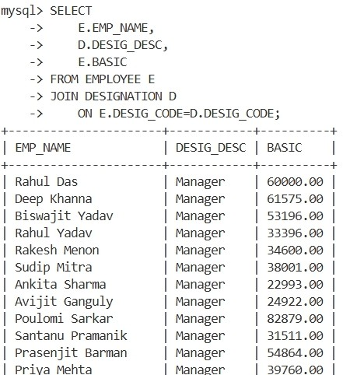

Question 27 : Show the employee name, Designation description, Department Name & Basic for all employees.
Query :
SELECT
E.EMP_NAME, DG.DESIG_DESC, DP.DEPT_NAME, E.BASIC
FROM EMPLOYEE E JOIN DESIGNATION DG
ON E.DESIG_CODE=DG.DESIG_CODE JOIN DEPARTMENT DP
ON E.DEPT_CODE=DP.DEPT_CODE;
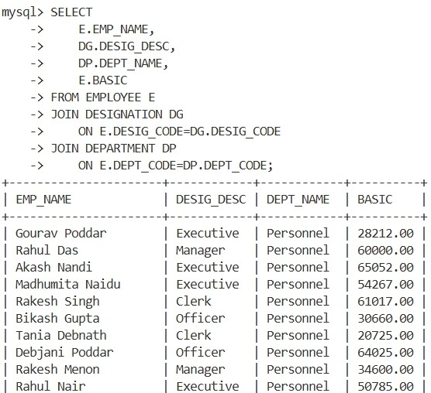

Question 28 : Find the department Codes in which no employee works. Query :
SELECT DEPT_CODE FROM DEPARTMENT
WHERE DEPT_CODE NOT IN ( SELECT DISTINCT DEPT_CODE FROM EMPLOYEE
WHERE DEPT_CODE IS NOT NULL
);
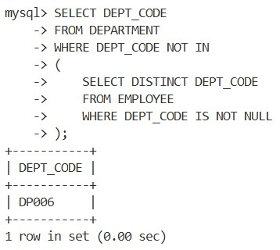

Question 29 : Find the department names where at least one employee works. Query :
SELECT DISTINCT D.DEPT_NAME
FROM DEPARTMENT D JOIN EMPLOYEE E ON D.DEPT_CODE=E.DEPT_CODE;
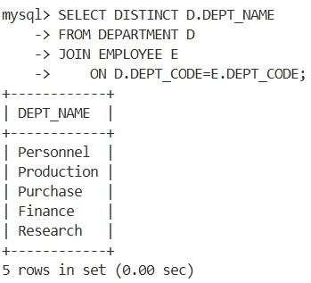

Question 30: Find the department names where at least 10 employees work. Query :
SELECT D.DEPT_NAME
FROM DEPARTMENT D JOIN EMPLOYEE E ON D.DEPT_CODE=E.DEPT_CODE GROUP BY D.DEPT_CODE,D.DEPT_NAME HAVING COUNT(*) >= 10;
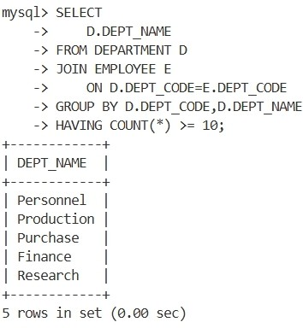

Question 31: Find the department code in which employee with highest Basic works. Query :
SELECT DEPT_CODE FROM EMPLOYEE WHERE BASIC = ( SELECT MAX(BASIC)
FROM EMPLOYEE
);
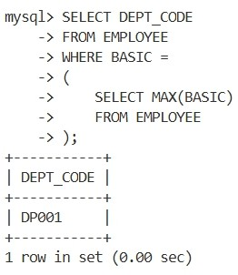

Question 32: Find the Designation description of the employee with highest basic. Query :
SELECT D.DESIG_DESC FROM EMPLOYEE E JOIN DESIGNATION D
ON E.DESIG_CODE=D.DESIG_CODE WHERE E.BASIC =
(
SELECT MAX(BASIC) FROM EMPLOYEE
);
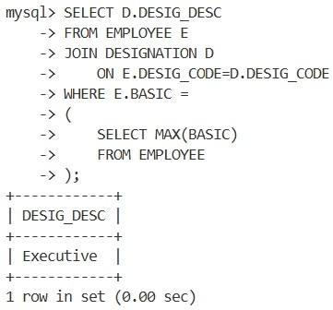

Question 33: Find the no. of managers in each department. Query :
SELECT
  - EPT_CODE,
COUNT(*) AS TOTAL_MANAGERS FROM EMPLOYEE E
JOIN DESIGNATION D
ON E.DESIG_CODE=D.DESIG_CODE WHERE D.DESIG_DESC='Manager' GROUP BY E.DEPT_CODE;
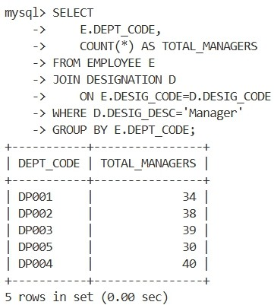

Question 34: Find the maximum basic from EMP table without using MAX(). Query :
SELECT BASIC AS MAX_BASIC FROM EMPLOYEE
ORDER BY BASIC DESC LIMIT 1;
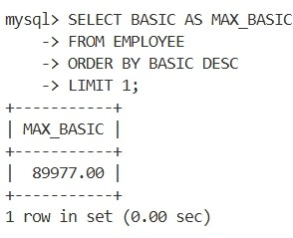

Question 35: Find the minimum basic from EMP table without using MIN(). Query :
SELECT BASIC AS MIN_BASIC FROM EMPLOYEE
ORDER BY BASIC ASC LIMIT 1;
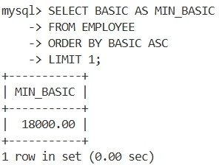

Question 36: Find the name of the department with highest total basic. Do the same for highest average basic and maximum no. of employee.
Query :
SELECT D.DEPT_NAME
FROM DEPARTMENT D JOIN EMPLOYEE E ON D.DEPT_CODE=E.DEPT_CODE GROUP BY D.DEPT_CODE,D.DEPT_NAME
ORDER BY SUM(E.BASIC) DESC LIMIT 1;

SELECT D.DEPT_NAME
FROM DEPARTMENT D JOIN EMPLOYEE E ON D.DEPT_CODE=E.DEPT_CODE GROUP BY D.DEPT_CODE,D.DEPT_NAME
ORDER BY AVG(E.BASIC) DESC LIMIT 1;

SELECT D.DEPT_NAME
FROM DEPARTMENT D JOIN EMPLOYEE E ON D.DEPT_CODE=E.DEPT_CODE GROUP BY D.DEPT_CODE,D.DEPT_NAME
ORDER BY COUNT(*) DESC LIMIT 1;

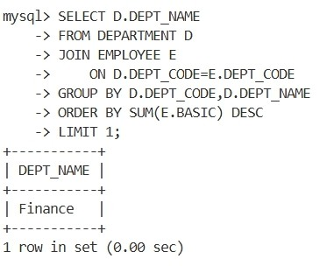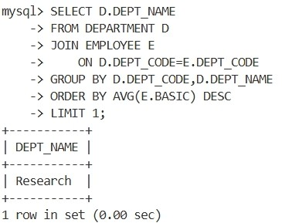

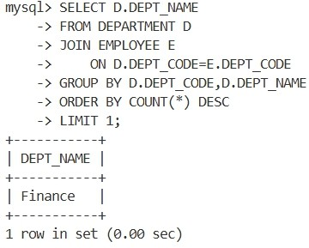

Question 37: Insert same rows into EMP table with designation code not existing in DESIGNATION table.
Query :
INSERT INTO EMPLOYEE VALUES
('E100','Test User','DP001','D999','M',
'ABC Road','Kolkata','WB','700001', 30000,'2024-01-01');

After droping the foreign key :
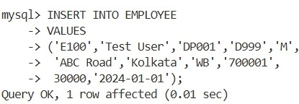

Question 38: Delete the rows from EMP table with invalid DESIG_CODE. Query :
DELETE FROM EMPLOYEE WHERE DESIG_CODE NOT IN ( SELECT DESIG_CODE
FROM DESIGNATION
);
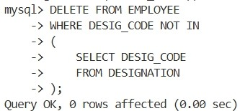

Question 39: Find the name of the female employees with basic greater than the average basic of their respective department.
Query :
SELECT E1.EMP_NAME FROM EMPLOYEE E1 WHERE E1.SEX='F' AND E1.BASIC > ( SELECT AVG(E2.BASIC)
FROM EMPLOYEE E2
WHERE E2.DEPT_CODE=E1.DEPT_CODE
);
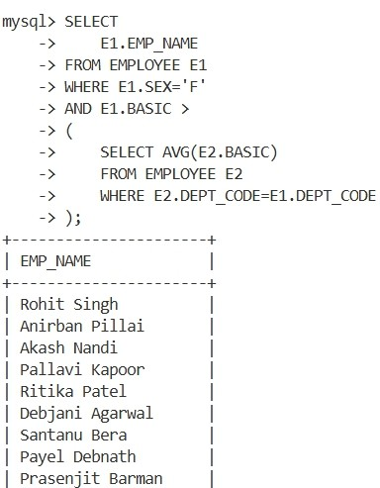

Question 40: Find the number of female managers. Query :
SELECT COUNT(*) AS FEMALE_MANAGERS FROM EMPLOYEE E JOIN DESIGNATION D ON E.DESIG_CODE=D.DESIG_CODE WHERE E.SEX='F' AND D.DESIG_DESC='Manager';
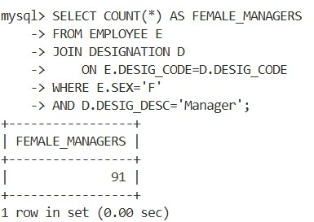

Question 41: In an organization, number of departments exists. Each department has a name &amp; unique code. Number of employees work in each department. Each employee has unique employee code. Detailed information like name, address, city, basic, date of join are also stored. In a leave register for each employee leave records are kept showing leave type (CL/EL/ML etc.), from-date and to-date. When an employee retires or resigns then all the leave information pertaining to him are also deleted. Basic salary must be within Rs.5000 to Rs.9000. A department can not be deleted if any employee record refers to it. Valid grades are A/B/C. Employee name must be in uppercase only. Default value for joining date is system date. Design &amp; implement the tables with necessary constraints to support the scenario depicted above.
Query :
CREATE TABLE Department(
dcode VARCHAR(10) PRIMARY KEY, dname VARCHAR(50) NOT NULL UNIQUE,
no_of_employee INT DEFAULT 0
);

CREATE TABLE Employee( empcode INT PRIMARY KEY,
ename VARCHAR(50) NOT NULL,
address VARCHAR(100), city VARCHAR(50), basic DECIMAL(8,2),
doj DATE DEFAULT (CURRENT_DATE),
grade CHAR(1), dcode VARCHAR(10),

CONSTRAINT chk_basic CHECK (basic BETWEEN 5000 AND 9000), CONSTRAINT chk_grade CHECK (grade IN ('A','B','C')),
CONSTRAINT chk_uppercase CHECK (ename = UPPER(ename)),
CONSTRAINT fk_emp_dept FOREIGN KEY (dcode) REFERENCES Department(dcode) ON DELETE RESTRICT
);

CREATE TABLE LeaveRegister(
leave_id INT AUTO_INCREMENT PRIMARY KEY,
empcode INT NOT NULL, leave_type VARCHAR(10) NOT NULL, from_date DATE NOT NULL,
to_date DATE NOT NULL,

CONSTRAINT fk_leave_emp FOREIGN KEY(empcode) REFERENCES Employee(empcode) ON DELETE CASCADE
);

Output :
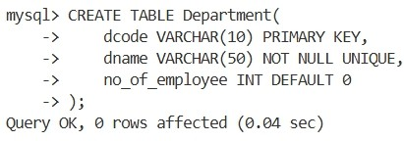

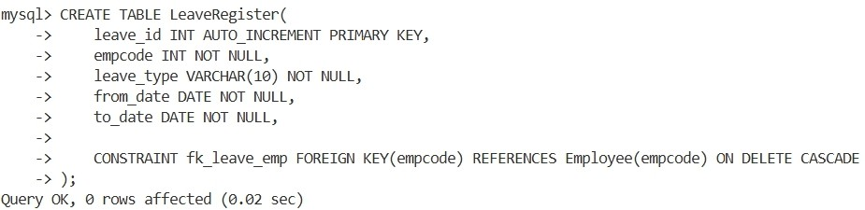
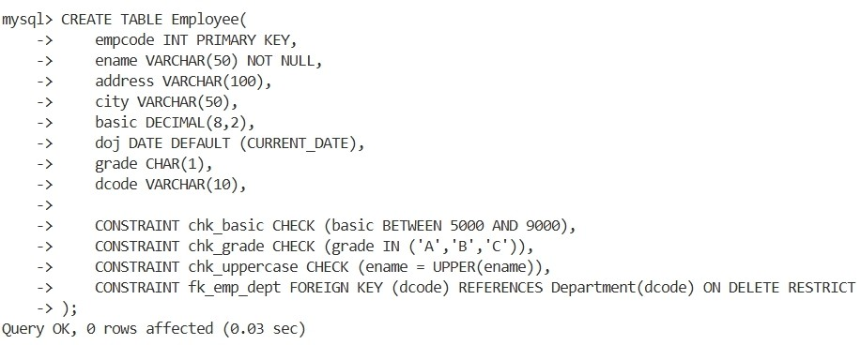

Question 42: Try to violate the constraints that you have implemented in the table &amp; note, what happens. [Try with suitable INSERT/UPDATE/DELETE instruction]
Query :
INSERT INTO Employee(empcode,ename,address,city,basic,grade,dcode) VALUES (104,'RAKESH','ABC','KOLKATA',10000,'A','D1');

INSERT INTO Employee (empcode,ename,address,city,basic,grade,dcode) VALUES (105,'RAMESH','ABC','KOLKATA',7000,'D','D1');

INSERT INTO Employee(empcode,ename,address,city,basic,grade,dcode) VALUES (107,'SOUMEN','ABC','KOLKATA',7000,'A','D10');

DELETE FROM Department WHERE dcode='D1';

DELETE FROM Employee WHERE empcode=101;

Output :
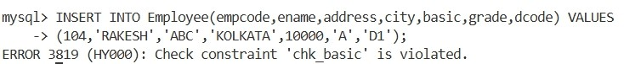

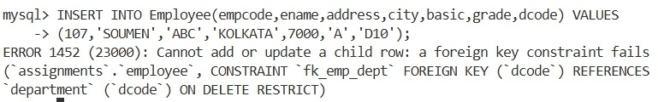
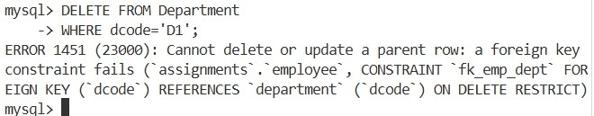

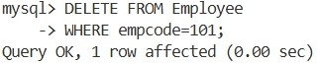

Question 43:
- create a view showing employee code, name, dcode &amp; Basic For a particular department. Query :
CREATE VIEW D1_EMP_VIEW AS
SELECT empcode, ename, dcode, basic FROM Employee WHERE dcode='D1';

Output :
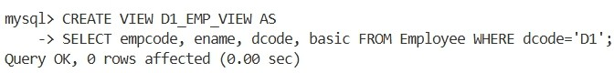
- Try to ensure a row into the view with valid department &amp; also with invalid ones. Query :
INSERT INTO D1_EMP_VIEW VALUES(201,'ANIK','D1',7500);

INSERT INTO D1_EMP_VIEW VALUES(202,'ROHIT','D5',7000);

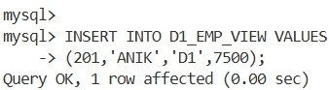
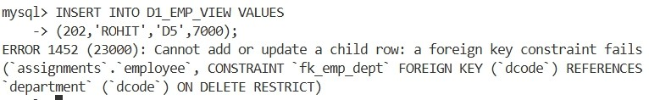
Output :
- Find the newly inserted row in the table From which view was created . Query :
SELECT * FROM Employee WHERE empcode=201;

Output :
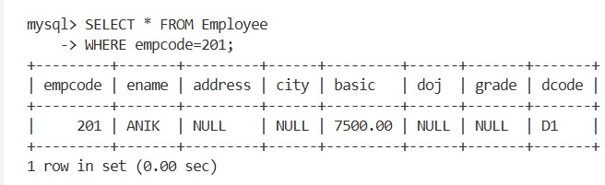
- Try to increment basic by Rs.100/- Query :
UPDATE D1_EMP_VIEW SET basic = basic + 100;

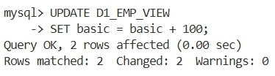
Output :
- Check it in the original table. Query :
SELECT empcode, ename, basic FROM Employee;

Output :
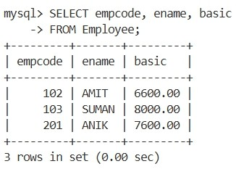
- Delete the view. Query :
DROP VIEW D1_EMP_VIEW;

Output :
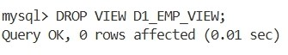

Question 44:
- create a view Showing empcode, name, deptname, basic, leave type, From date &amp; to date. Query :

CREATE VIEW EMP_LEAVE_VIEW AS
SELECT E.empcode, E.ename, D.dname, E.basic, L.leave_type, L.from_date, L.to_date
FROM Employee E JOIN Department D ON E.dcode = D.dcode JOIN LeaveRegister L ON E.empcode = L.empcode;

Output :
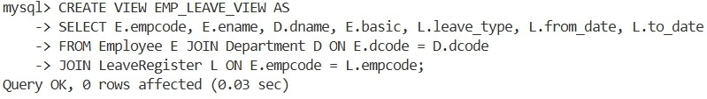

- Try to insert a row in the view. Check what happens? Query :
INSERT INTO EMP_LEAVE_VIEW VALUES
(500,'JOY','COMPUTER SCIENCE',7000,'CL','2026-04-01','2026-04-03');

Output :

- Try to increment basic by Rs.100. Query :
UPDATE EMP_LEAVE_VIEW
SET basic = basic + 100;

Output :
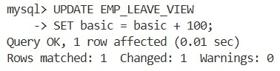
- Delete the view. Query :
DROP VIEW EMP_LEAVE_VIEW;

Output :
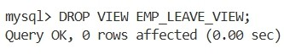

Question 45:
- Create a table having empcode , Name, deptname, &amp; basic From the existing tables along with the records of the employee who are in a particular department (say, d1) and with a basic Rs. 7000/- Query :
CREATE TABLE D1_EMPLOYEE AS
SELECT E.empcode, E.ename, D.dname, E.basic
FROM Employee E JOIN Department D ON E.dcode = D.dcode WHERE E.dcode='D1' AND E.basic=7000;

Output :
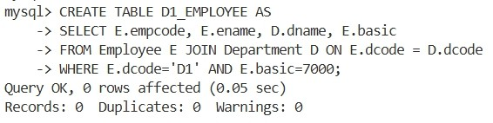
- From the existing table, add the employees with the basic salary greater than or equal to 7000/- Query :
INSERT INTO D1_EMPLOYEE
SELECT E.empcode, E.ename, D.dname, E.basic
FROM Employee E JOIN Department D ON E.dcode = D.dcode WHERE E.basic >= 7000;

Output :
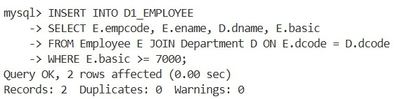
- Alter the table to add a net pay column. Query :
ALTER TABLE D1_EMPLOYEE ADD netpay DECIMAL(10,2);

Output :
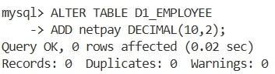
- Replace net pay with 1.5* Basic. Query :
UPDATE D1_EMPLOYEE
SET netpay = basic * 1.5;

Output :
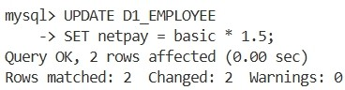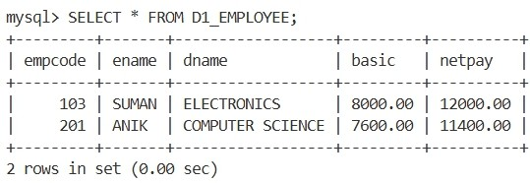

Try to remove the net net pay column. [ It may require no. of steps] Query :
ALTER TABLE D1_EMPLOYEE
DROP COLUMN netpay;

Output :
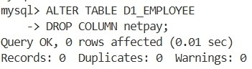

Question 46: Drop all the tables that you have created . Query :
DROP TABLE LeaveRegister; DROP TABLE Employee;
DROP TABLE Department; DROP TABLE D1_EMPLOYEE;

Output :
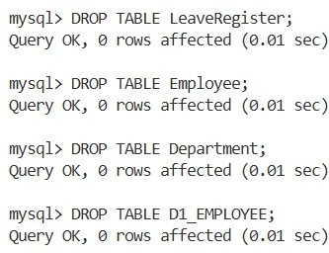

Question 47:
- Create EMP table with ECODE(primary key), ENAME, DCODE, GRADE, BASIC & JN-DT as the columns.[except BASIC & JN-DT,all columns are of char type and site of Grade is 1.]
- Insert number of rows.

Query :
CREATE TABLE EMP(
ECODE CHAR(5) PRIMARY KEY, ENAME CHAR(20),
DCODE CHAR(5), GRADE CHAR(1), BASIC NUMBER(8,2), JN_DT DATE
);

INSERT ALL
INTO EMP VALUES ('E001','RAHUL','D01','A',25000,TO_DATE('10-JAN-2020','DD- MON-YYYY'))
INTO EMP VALUES ('E002','AMIT','D01','A',28000,TO_DATE('15-FEB-2021','DD- MON-YYYY'))
INTO EMP VALUES ('E003','SUMAN','D01','B',22000,TO_DATE('20-MAR-2022','DD- MON-YYYY'))
INTO EMP VALUES ('E004','RINA','D02','A',30000,TO_DATE('12-APR-2020','DD- MON-YYYY'))
INTO EMP VALUES ('E005','ANITA','D02','B',24000,TO_DATE('22-MAY-2021','DD- MON-YYYY'))
INTO EMP VALUES ('E006','ARUN','D02','B',26000,TO_DATE('11-JUN-2022','DD- MON-YYYY'))
INTO EMP VALUES ('E007','JOY','D03','A',35000,TO_DATE('05-JUL-2019','DD- MON-YYYY'))
INTO EMP VALUES ('E008','PRIYA','D03','C',20000,TO_DATE('16-AUG-2020','DD- MON-YYYY'))
INTO EMP VALUES ('E009','SOURAV','D03','C',21000,TO_DATE('25-SEP-2021','DD- MON-YYYY'))
SELECT * FROM DUAL;

Output :
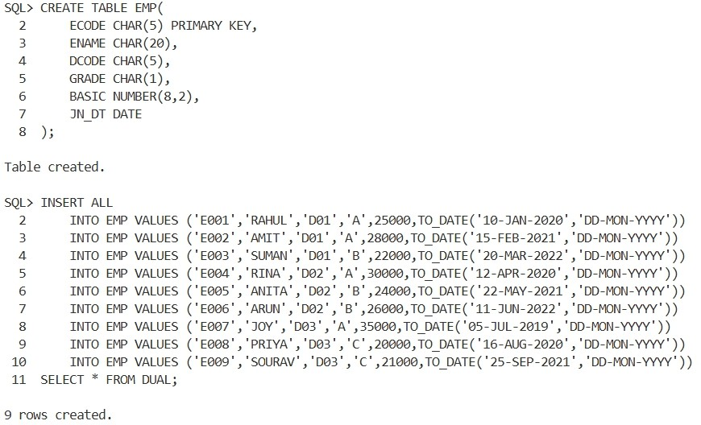

Question 48 : change the column heading as shown below, So that in subsequent SELECT statement newly set heading will be shown:
ECODE EMPLOYEE CODE ENAME NAME
DCODE DEPT.CODE JN-DT JONING DATE
Query :
COLUMN ECODE HEADING 'EMPLOYEE CODE'; COLUMN ENAME HEADING 'NAME';
COLUMN DCODE HEADING 'DEPT.CODE'; COLUMN JN_DT HEADING 'JOINING DATE'; COLUMN

Output :
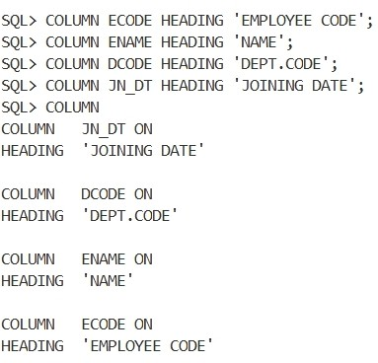

Question 49: Set the format of columns as mentioned below, So that in subsequent SELECT statement ,values appear in the specified format:
*format of BASIC is such that a value of 7000 will be shown as7,000
*Format of GRADE will be such that full column name appears in the display.
*For JN-DT format is such that 01-JAN-00 will be shown as JANURY 01,2000 Query :
COLUMN BASIC FORMAT 999,999.99; COLUMN GRADE HEADING 'GRADE'; COLUMN JN_DT FORMAT A20;

SELECT ECODE,
ENAME, DCODE, GRADE, BASIC,
TO_CHAR(JN_DT,'MONTH DD,YYYY') JN_DT FROM EMP;

Output :
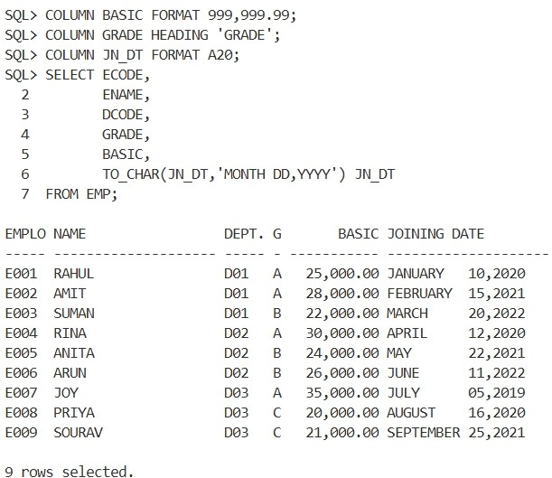

Question 50:
- Show the display attributes of all the columns. Query :
COLUMN;

Output :
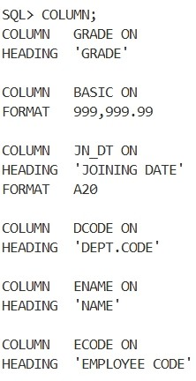
- Show the display attributes of particular column. Query :
COLUMN JN_DT;

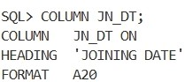
Output :

- Suppress the newly set attributes of JN-DT .Try a select statement. Query :
COLUMN JN_DT OFF; SELECT * FROM EMP;

Output :
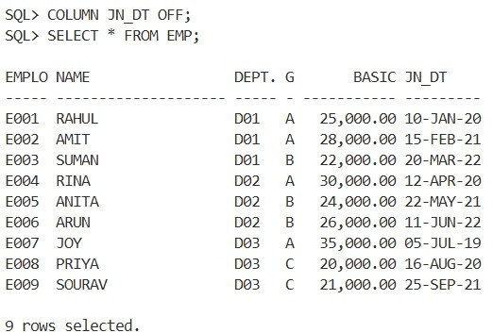

- Reset the newly set attributes of JN-DT Query :
COLUMN JN_DT CLEAR COLUMN JN_DT

Output :
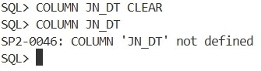

- Reset the newly set attributes of all columns. Query :
CLEAR COLUMNS;

Output :
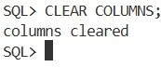
- Shown the display attributes of all columns. Query :
COLUMN;

Output :
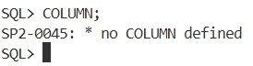

Question 51:
- Show the records from EMP table in the ascending order of DCODE . DCODE value will be shown only for the first record of that department (same of DCODE is not repeated)
Query :
BREAK ON DCODE;

SELECT ECODE, ENAME, DCODE, GRADE, BASIC FROM EMP ORDER BY DCODE;

Output :
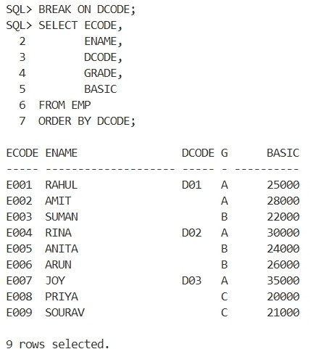

- Further take measures so that ,after displaying the records of a department it skips one line . Query :
BREAK ON DCODE SKIP 1;

SELECT ECODE, ENAME, DCODE, GRADE, BASIC FROM EMP ORDER BY DCODE;

Output :
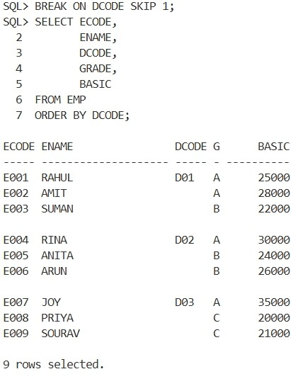

- Further take measures so that records one also ordered on the basic of GRADE with in a department & same GRADE value is not repeated.
Query :
BREAK ON DCODE SKIP 1 ON GRADE; SELECT ECODE,
ENAME, DCODE, GRADE, BASIC
FROM EMP
ORDER BY DCODE, GRADE;

Output :
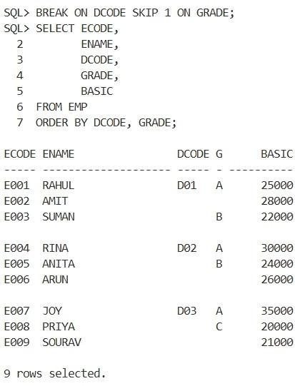
- Take measure so that at the end of each GRADE in a department it will show average Basic for that grade in that department. At the end of each department, it will show the average & total Basic for the department. At the end of all departments it will show the overall total basic & average basic. Query :
BREAK ON DCODE SKIP 1 ON GRADE SKIP 1; COMPUTE AVG OF BASIC ON GRADE;
COMPUTE AVG OF BASIC ON DCODE; COMPUTE SUM OF BASIC ON DCODE;

COMPUTE AVG OF BASIC ON REPORT; COMPUTE SUM OF BASIC ON REPORT;

SELECT ECODE,
ENAME, DCODE,

GRADE, BASIC
FROM EMP
ORDER BY DCODE, GRADE;

Output :
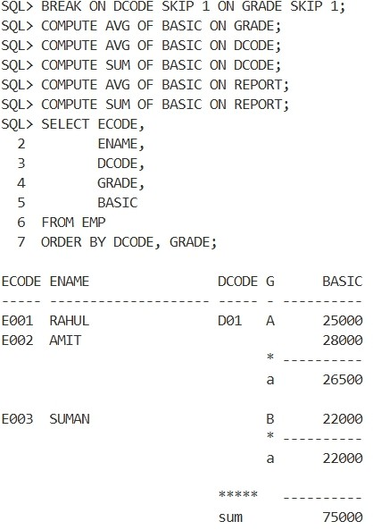
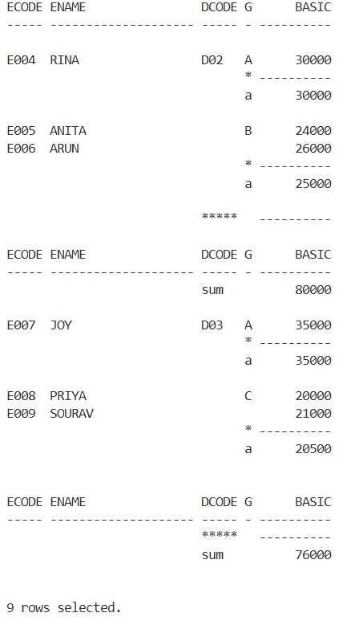

Question 52: Accept an employee code from user . Find the name of the employee from EMP table. If the employee is not existing then indicate it through a suitable message.
Query :
SET SERVEROUTPUT ON; SET VERIFY OFF;
ACCEPT S_ECODE CHAR PROMPT 'Enter Employee Code : ' DECLARE
V_ENAME EMP.ENAME%TYPE; BEGIN
SELECT ENAME INTO V_ENAME FROM EMP WHERE ECODE='&S_ECODE';
DBMS_OUTPUT.PUT_LINE('Employee Name : '||V_ENAME); EXCEPTION
WHEN NO_DATA_FOUND THEN
DBMS_OUTPUT.PUT_LINE('NO EMPLOYEE WITH ID : &S_ECODE.'); WHEN OTHERS THEN
DBMS_OUTPUT.PUT_LINE(SQLERRM);
END;
/

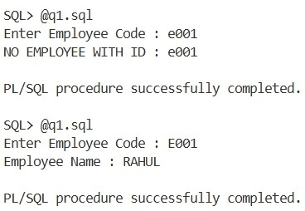
Code :

Question 53: Write a PL / SQL block to add row in EMP table . If employee code is duplicate/dept code is not present in DEPT table then message is to be shown &amp; row can not be added.
Query :
SET SERVEROUTPUT ON; SET VERIFY OFF;
ACCEPT T_ECODE CHAR PROMPT 'Employee Code : ' ACCEPT T_ENAME CHAR PROMPT 'Employee Name : '
ACCEPT T_DCODE CHAR PROMPT 'Department Code : ' ACCEPT T_GRADE CHAR PROMPT 'Grade : '
ACCEPT T_BASIC NUMBER PROMPT 'Basic Salary : '
ACCEPT T_JNDT CHAR PROMPT 'Joining Date (DD-MON-YYYY) : ' DECLARE
VAR_COUNT NUMBER; DUPLICATE_EMP EXCEPTION; DEPT_NOT_EXISTS EXCEPTION;
BEGIN
SELECT COUNT(*) INTO VAR_COUNT FROM EMP WHERE ECODE='&T_ECODE'; IF VAR_COUNT>0 THEN
RAISE DUPLICATE_EMP;

ELSE

SELECT COUNT(*) INTO VAR_COUNT FROM DEPT WHERE DCODE='&T_DCODE'; IF VAR_COUNT=0 THEN
RAISE DEPT_NOT_EXISTS;

ELSE
INSERT INTO EMP
VALUES('&T_ECODE','&T_ENAME','&T_DCODE','&T_GRADE',&T_BASIC,TO_DATE('&T_JNDT',' DD-MON-YYYY'));
COMMIT;
DBMS_OUTPUT.PUT_LINE('RECORD INSERTED.'); END IF;
END IF; EXCEPTION
WHEN DUPLICATE_EMP THEN
DBMS_OUTPUT.PUT_LINE('EMPLOYEE EXISTS WITH ECODE : &T_ECODE.'); WHEN DEPT_NOT_EXISTS THEN
DBMS_OUTPUT.PUT_LINE('DEPATMENT DOES NOT EXISTS WITH DCODE : &T_DCODE.');
WHEN OTHERS THEN DBMS_OUTPUT.PUT_LINE(SQLERRM);
END;
/

Code :

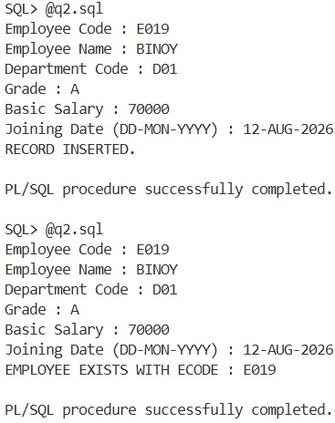

Question 54: From the EMP table find the name of top 5 (according to basic salary) employees. Query :
SET SERVEROUTPUT ON; SET VERIFY OFF; DECLARE
VAR_COUNT NUMBER; BEGIN
SELECT COUNT(*) INTO VAR_COUNT FROM EMP; IF VAR_COUNT<5 THEN
FOR R IN (SELECT * FROM EMP) LOOP DBMS_OUTPUT.PUT_LINE(RPAD(R.ENAME,20)||' '||R.BASIC);
END LOOP;
DBMS_OUTPUT.PUT_LINE('TABLE HAVE '||VAR_COUNT||' ROWS.');

ELSE

DBMS_OUTPUT.PUT_LINE('TOP 5 EMPLOYEES');
FOR R IN ( SELECT * FROM ( SELECT ENAME, BASIC FROM EMP ORDER BY BASIC

DESC ) WHERE ROWNUM<=5) LOOP
DBMS_OUTPUT.PUT_LINE(RPAD(R.ENAME,20)||' '||R.BASIC); END LOOP;
END IF; EXCEPTION
WHEN OTHERS THEN DBMS_OUTPUT.PUT_LINE(SQLERRM);
END;
/

Code :
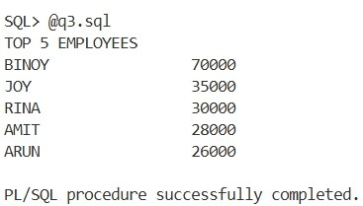

Question 55: Accept a department code from the user . Delete all the employee rows with that department code. Show how many rows have been deleted.
Query :
SET SERVEROUTPUT ON; SET VERIFY OFF;
ACCEPT T_DCODE CHAR PROMPT 'Enter Department Code : ' DECLARE
VAR_COUNT NUMBER; NO_EMP_FOUND EXCEPTION;
BEGIN
DELETE FROM EMP WHERE DCODE='&T_DCODE'; VAR_COUNT := SQL%ROWCOUNT;
IF VAR_COUNT = 0 THEN RAISE NO_EMP_FOUND;
END IF; COMMIT;
DBMS_OUTPUT.PUT_LINE(VAR_COUNT || ' row(s) deleted.'); EXCEPTION
WHEN NO_EMP_FOUND THEN
DBMS_OUTPUT.PUT_LINE('NO EMPLOYEE FOUND IN DEPARTMENT &T_DCODE.'); WHEN OTHERS THEN
DBMS_OUTPUT.PUT_LINE(SQLERRM);
END;
/

Code :
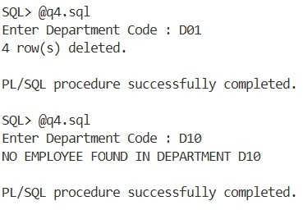

Question 56: Consider the following tables:

Table: ORDERMAST
Structure:
ORDER_NO CHAR(5) primary key ORDER_DT DATE

Table: ORDERDETAILS
Structure: ORDER_NO CHAR(5) ITEM_NO CHAR(5) QTY NUMBER
ORDER_NO + ITEM_NO is primary key

Table: DELIVERYMAST
Structure:
DELV_NO CHAR(5) primary key ORDER_NO CHAR(5) DELV_DT DATE

Table: DELIVERY_DETAILS
Structure: DELV_NO CHAR(5) ITEM_NO CHAR(5) QTY NUMBER
DELV_NO+ITEM_NO is primary key

Write a PL/SQL block which accepts two dates &amp; find the information of the pending delivery for the orders placed between the two dates supplied by the user. Note, an order can have request for multiple items. Against an order, multiple delivery with partial shipment is possible.
Query :
SET SERVEROUTPUT ON; SET VERIFY OFF;
SET LINESIZE 200;

ACCEPT T_FROM CHAR PROMPT 'Enter From Date (DD-MON-YYYY): ' ACCEPT T_TO CHAR PROMPT 'Enter To Date (DD-MON-YYYY): '

DECLARE BEGIN
DBMS_OUTPUT.PUT_LINE('PENDING DELIVERY REPORT'); DBMS_OUTPUT.PUT_LINE('-----------------------'); FOR R IN
(
SELECT
OD.ORDER_NO, OD.ITEM_NO,
OD.QTY AS ORDER_QTY, NVL(SUM(DD.QTY),0) AS DELIVERED_QTY,
OD.QTY - NVL(SUM(DD.QTY),0) AS PENDING_QTY FROM ORDERMAST OM JOIN ORDERDETAILS OD
ON OM.ORDER_NO = OD.ORDER_NO LEFT JOIN DELIVERYMAST DM
ON OM.ORDER_NO = DM.ORDER_NO LEFT JOIN DELIVERY_DETAILS DD

) LOOP
ON DM.DELV_NO = DD.DELV_NO AND OD.ITEM_NO = DD.ITEM_NO WHERE OM.ORDER_DT BETWEEN
TO_DATE('&T_FROM','DD-MON-YYYY') AND TO_DATE('&T_TO','DD-MON-YYYY') GROUP BY
OD.ORDER_NO, OD.ITEM_NO, OD.QTY
ORDER BY
OD.ORDER_NO, OD.ITEM_NO

DBMS_OUTPUT.PUT_LINE(
'ORDER NO : ' || R.ORDER_NO || ' ITEM NO : ' || R.ITEM_NO ||
- ORDERED QTY : ' || R.ORDER_QTY ||
- DELIVERED QTY : ' || R.DELIVERED_QTY || ' PENDING : ' || R.PENDING_QTY

END;
/
); END LOOP;

Code :
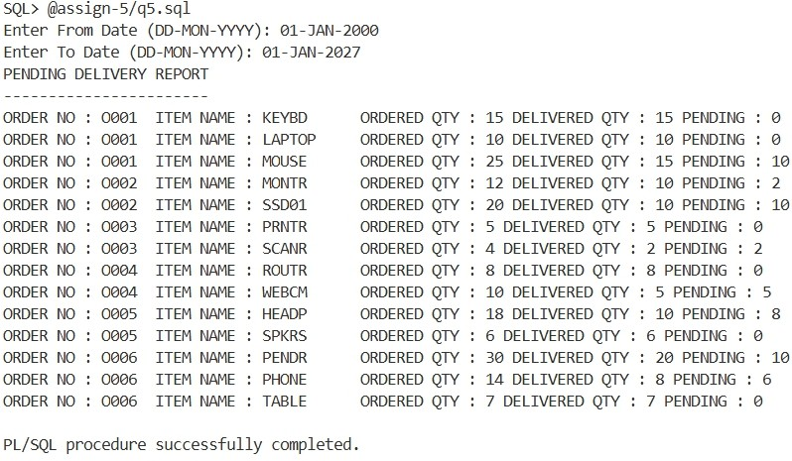

Question 57: Assume a LEAVE table with emp_no,month,no._of_days.
For each employee find the effective basic for the current month as per the formula given below: BASIC - (BASIC * no. of leave days in the month)/no. of days in that month.
Query :
SET SERVEROUTPUT ON; SET VERIFY OFF;

DECLARE
VAR_DAYS NUMBER; BEGIN
VAR_DAYS := TO_NUMBER(TO_CHAR(LAST_DAY(SYSDATE),'DD')); DBMS_OUTPUT.PUT_LINE('EFFECTIVE BASIC REPORT'); DBMS_OUTPUT.PUT_LINE('----------------------');
FOR R IN (

) LOOP
SELECT
  - CODE, E.ENAME, E.BASIC,
NVL(L.NO_OF_DAYS,0) LEAVE_DAYS,
E.BASIC -(E.BASIC * NVL(L.NO_OF_DAYS,0) / VAR_DAYS) EFFECTIVE_BASIC FROM EMP E LEFT JOIN LEAVE_TAB L ON E.ECODE = L.EMP_NO
AND L.MONTH_NAME = TO_CHAR(SYSDATE, 'MON') ORDER BY E.ECODE

DBMS_OUTPUT.PUT_LINE(
R.ECODE||' '|| RPAD(R.ENAME,20)||' '|| 'EFFECTIVE BASIC = '|| ROUND(R.EFFECTIVE_BASIC,2)

END;
/
); END LOOP;

Code :
