Question 41: In an organization, number of departments exists. Each department has a name &amp; unique code. Number of employees work in each department. Each employee has unique employee code. Detailed information like name, address, city, basic, date of join are also stored. In a leave register for each employee leave records are kept showing leave type (CL/EL/ML etc.), from-date and to-date. When an employee retires or resigns then all the leave information pertaining to him are also deleted. Basic salary must be within Rs.5000 to Rs.9000. A department can not be deleted if any employee record refers to it. Valid grades are A/B/C. Employee name must be in uppercase only. Default value for joining date is system date. Design &amp; implement the tables with necessary constraints to support the scenario depicted above.
Query :
CREATE TABLE Department(
dcode VARCHAR(10) PRIMARY KEY,
dname VARCHAR(50) NOT NULL UNIQUE,
no_of_employee INT DEFAULT 0
);

CREATE TABLE Employee(
empcode INT PRIMARY KEY,
ename VARCHAR(50) NOT NULL,
address VARCHAR(100),
city VARCHAR(50),
basic DECIMAL(8,2),
doj DATE DEFAULT (CURRENT_DATE),
grade CHAR(1),
dcode VARCHAR(10),

CONSTRAINT chk_basic CHECK (basic BETWEEN 5000 AND 9000),
CONSTRAINT chk_grade CHECK (grade IN ('A','B','C')),
CONSTRAINT chk_uppercase CHECK (ename = UPPER(ename)),
CONSTRAINT fk_emp_dept FOREIGN KEY (dcode) REFERENCES Department(dcode) ON DELETE RESTRICT
);

CREATE TABLE LeaveRegister(
leave_id INT AUTO_INCREMENT PRIMARY KEY,
empcode INT NOT NULL,
leave_type VARCHAR(10) NOT NULL,
from_date DATE NOT NULL,
to_date DATE NOT NULL,

CONSTRAINT fk_leave_emp FOREIGN KEY(empcode) REFERENCES Employee(empcode) ON DELETE CASCADE
);
Output :

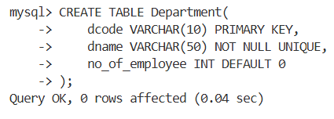
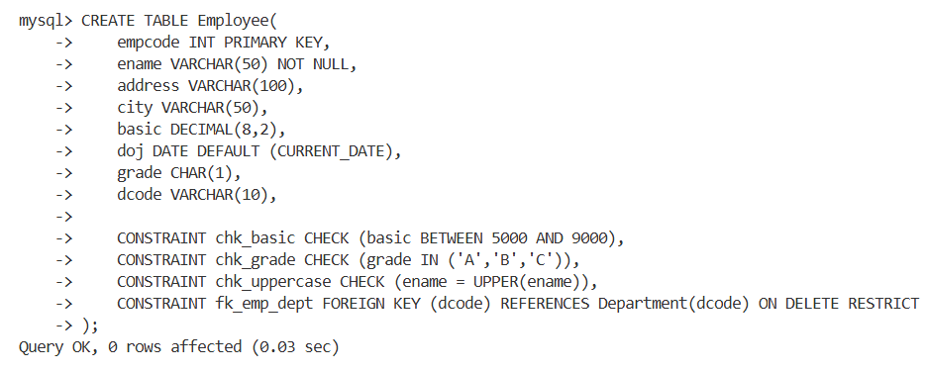
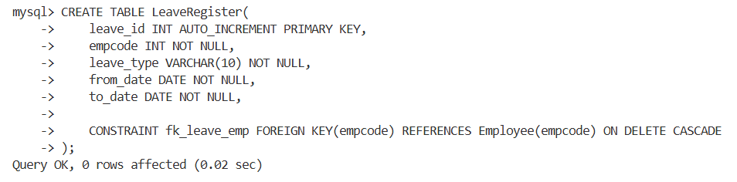

Question 42: Try to violate the constraints that you have implemented in the table &amp; note, what happens. [Try with suitable INSERT/UPDATE/DELETE instruction]
Query :
INSERT INTO Employee(empcode,ename,address,city,basic,grade,dcode) VALUES
(104,'RAKESH','ABC','KOLKATA',10000,'A','D1');

INSERT INTO Employee (empcode,ename,address,city,basic,grade,dcode) VALUES
(105,'RAMESH','ABC','KOLKATA',7000,'D','D1');

INSERT INTO Employee(empcode,ename,address,city,basic,grade,dcode) VALUES
(107,'SOUMEN','ABC','KOLKATA',7000,'A','D10');

DELETE FROM Department
WHERE dcode='D1';

DELETE FROM Employee
WHERE empcode=101;

Output :

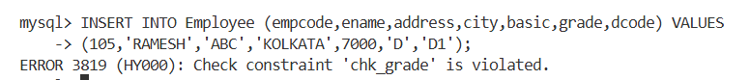

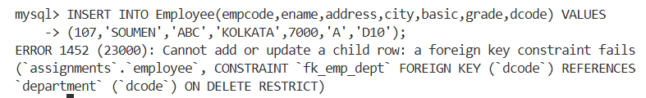

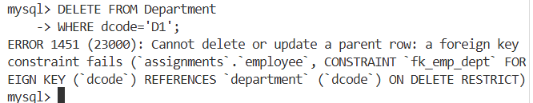

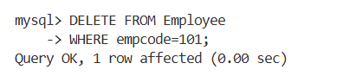
Question 43:
- create a view showing employee code, name, dcode &amp; Basic For a particular department.
Query :
CREATE VIEW D1_EMP_VIEW AS
SELECT empcode, ename, dcode, basic FROM Employee WHERE dcode='D1';
Output :
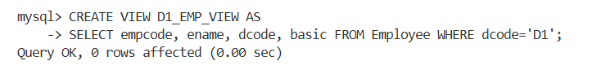
- Try to ensure a row into the view with valid department &amp; also with invalid ones.
Query :
INSERT INTO D1_EMP_VIEW VALUES(201,'ANIK','D1',7500);

INSERT INTO D1_EMP_VIEW VALUES(202,'ROHIT','D5',7000);
Output :
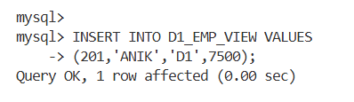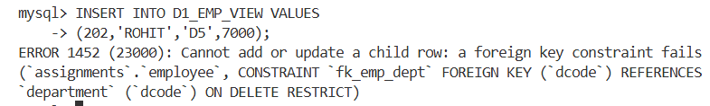
- Find the newly inserted row in the table From which view was created .
Query :
SELECT * FROM Employee WHERE empcode=201;
Output :
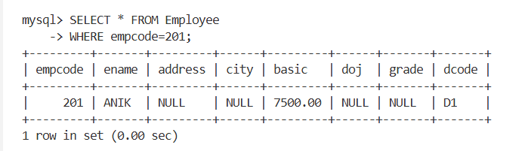
- Try to increment basic by Rs.100/-
Query :
UPDATE D1_EMP_VIEW SET basic = basic + 100;
Output :
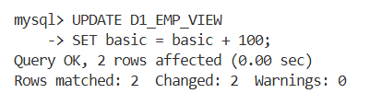
- Check it in the original table.
Query :
SELECT empcode, ename, basic FROM Employee;
Output :
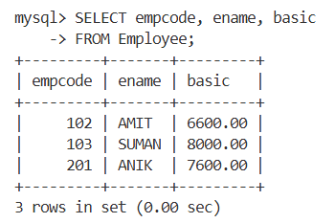
- Delete the view.
Query :
DROP VIEW D1_EMP_VIEW;
Output :
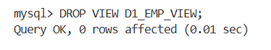
Question 44:
- create a view Showing empcode, name, deptname, basic, leave type, From date &amp; to date.
Query :

CREATE VIEW EMP_LEAVE_VIEW AS
SELECT E.empcode, E.ename, D.dname, E.basic, L.leave_type, L.from_date, L.to_date
FROM Employee E JOIN Department D ON E.dcode = D.dcode
JOIN LeaveRegister L ON E.empcode = L.empcode;

Output :
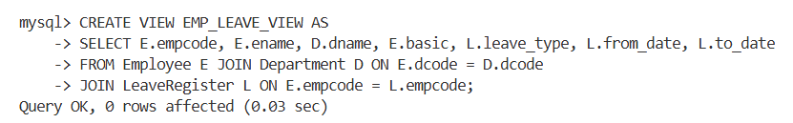

- Try to insert a row in the view. Check what happens?
Query :
INSERT INTO EMP_LEAVE_VIEW VALUES
(500,'JOY','COMPUTER SCIENCE',7000,'CL','2026-04-01','2026-04-03');

Output :
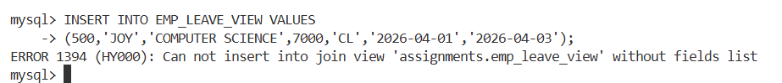

- Try to increment basic by Rs.100.
Query :
UPDATE EMP_LEAVE_VIEW
SET basic = basic + 100;

Output :
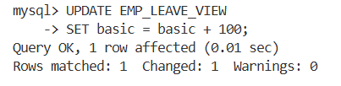
d) Delete the view.
Query :
DROP VIEW EMP_LEAVE_VIEW;

Output :
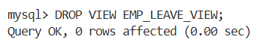
Question 45:
- Create a table having empcode , Name, deptname, &amp; basic From the existing tables along with the records of the employee who are in a particular department (say, d1) and with a basic Rs. 7000/-
Query :
CREATE TABLE D1_EMPLOYEE AS
SELECT E.empcode, E.ename, D.dname, E.basic
FROM Employee E JOIN Department D ON E.dcode = D.dcode
WHERE E.dcode='D1' AND E.basic=7000;
Output :
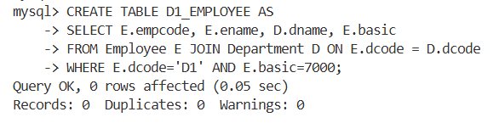
- From the existing table, add the employees with the basic salary greater than or equal to 7000/-
Query :
INSERT INTO D1_EMPLOYEE
SELECT E.empcode, E.ename, D.dname, E.basic
FROM Employee E JOIN Department D ON E.dcode = D.dcode
WHERE E.basic >= 7000;
Output :
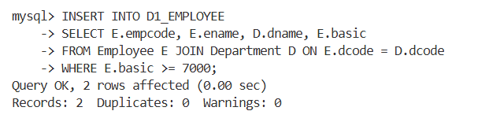
- Alter the table to add a net pay column.
Query :
ALTER TABLE D1_EMPLOYEE
ADD netpay DECIMAL(10,2);
Output :
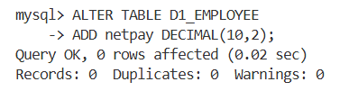
- Replace net pay with 1.5* Basic.
Query :
UPDATE D1_EMPLOYEE
SET netpay = basic * 1.5;
Output :
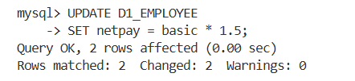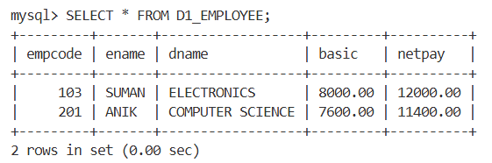
- Try to remove the net net pay column. [ It may require no. of steps]
Query :
ALTER TABLE D1_EMPLOYEE
DROP COLUMN netpay;
Output :
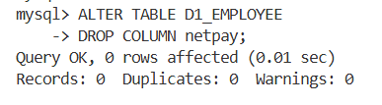
Question 46: Drop all the tables that you have created .
Query :
DROP TABLE LeaveRegister;

DROP TABLE Employee;

DROP TABLE Department;

DROP TABLE D1_EMPLOYEE;

Output :
