JADAVPUR UNIVERSITY
188, Raja S.C. Mallick Road, Kolkata – 700032

Department of Computer Science and Engineering, FET.

MASTER OF COMPUTER APPLICATION
1st Year 2nd Semester

JAVA ASSIGNMENT

Name: Snehasish Sarkar
Roll No.: 002510503033
Assignment 1: Write a java program with a special class
- To store name and dob
- To calculate age
- To specify age category as follows:
  - “Under Age”, if Age < 18
  - “Young Adult” if 18<age<30
  - “Matured Adult”, if 30<age<45
  - “Middle Aged” if 45<age<60 & so on.

Source Code:
import java.time.LocalDate;
import java.time.Period;
import java.util.Scanner;

class Person {
private String name;
private LocalDate dob;
private int age;

Person(String name, LocalDate dob) {
this.name = name;
this.dob = dob;
this.age = calculateAge();
}

private int calculateAge() {
LocalDate today = LocalDate.now();
return Period.between(dob, today).getYears();
}

public String getAgeCategory() {
if (age < 18)
return "Under Age";
else if (age >= 18 && age < 30)
return "Young Adult";
else if (age >= 30 && age < 45)
return "Matured Adult";
else if (age >= 45 && age < 60)
return "Middle Aged";
else
return "Senior Citizen";
}

public String toString() {
return "\nName : "+name+"\nDOB : "+dob+"\nAge : "+age+"\nCategory : "+getAgeCategory();
}
}

public class AgeCategory {
public static void main(String[] args) {
Scanner sc = new Scanner(System.in);

System.out.print("Enter Name: ");
String name = sc.nextLine();

System.out.print("Enter Birth Year (yyyy): ");
int year = sc.nextInt();

System.out.print("Enter Birth Month (mm): ");
int month = sc.nextInt();

System.out.print("Enter Birth Day (dd): ");
int day = sc.nextInt();

LocalDate dob = LocalDate.of(year, month, day);

Person p = new Person(name, dob);
System.out.println(p);

sc.close();
}
}

Output :
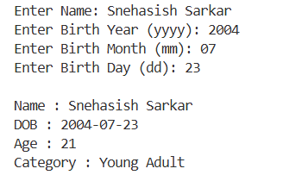

Assignment 2: Design you own Stack such that the stack class objects need to be :
- Initialized by a constructor
- Provided proper push() and pop() methods
- Checked for tos content using peek()
- Overload with display() for several tasks
  - Display content of the whole stack
  - Give a parameter for the depth of a particular element, display just that element.

Source Code :
import java.util.Scanner;

class MyStack {
private int[] stack;
private int top;
private int size;
public MyStack(int size) {
this.size = size;
stack = new int[size];
top = -1;
}
public void push(int value) {
if (top == size - 1) {
System.out.println("Stack Overflow!");
return;
}
stack[++top] = value;
System.out.println(value + " pushed into stack.");
}
public void pop() {
if (top == -1) {
System.out.println("Stack Underflow!");
return;
}

System.out.println("Popped Element: " + stack[top--]);
}

public void peek() {
if (top == -1) {
System.out.println("Stack is Empty!");
return;
}

System.out.println("Top Element: " + stack[top]);
}
public void display() {
if (top == -1) {
System.out.println("Stack is Empty!");
return;
}

System.out.println("\nStack Contents (Top to Bottom):");
for (int i = top; i >= 0; i--) {
System.out.println(stack[i]);
}
}
public void display(int depth) {
if (top == -1) {
System.out.println("Stack is Empty!");
return;
}
if (depth < 0 || depth > top) {
System.out.println("Invalid Depth!");
return;
}
System.out.println("Element at Depth " + depth +
" : " + stack[top - depth]);
}
}

public class Stack{
public static void main(String[] args) {
Scanner sc = new Scanner(System.in);
System.out.print("Enter Stack Size: ");
int size = sc.nextInt();
MyStack stack = new MyStack(size);

int choice;
do {
System.out.println("\n===== STACK MENU =====");
System.out.println("1. Push");
System.out.println("2. Pop");
System.out.println("3. Peek");
System.out.println("4. Display Entire Stack");
System.out.println("5. Display Element at Given Depth");
System.out.println("6. Exit");
System.out.print("Enter Choice: ");
choice = sc.nextInt();

switch (choice) {
case 1:
System.out.print("Enter Element: ");
int value = sc.nextInt();
stack.push(value);
break;

case 2:
stack.pop();
break;

case 3:
stack.peek();
break;

case 4:
stack.display();
break;

case 5:
System.out.print("Enter Depth: ");
int depth = sc.nextInt();
stack.display(depth);
break;

case 6:
System.out.println("Exiting...");
break;

default:
System.out.println("Invalid Choice!");
}

} while (choice != 6);

sc.close();
}
}

Output :
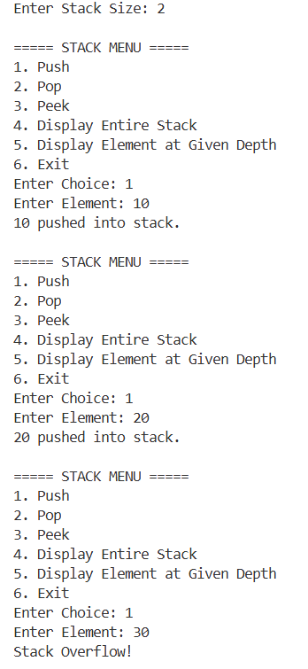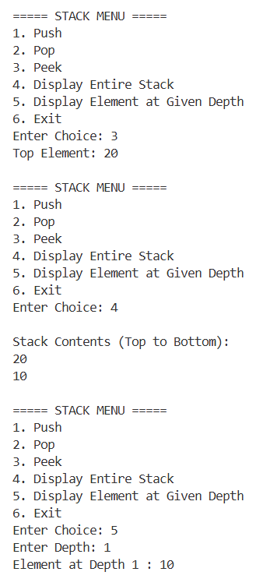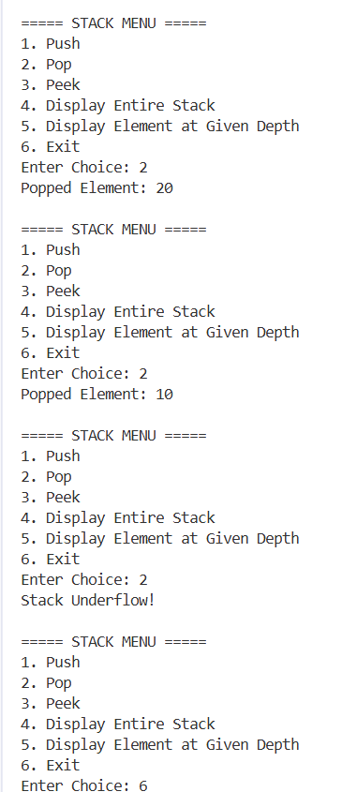

Assignment 3:
- Implement merge operations on two stacks presorted in ascending order. Check for stack overflow conditions all along.
- Inherit a special Stack
  - The inherited class should allow : A number to be pushed in if and only if it is less than the one currently at the top.
  - With the help of such STACK objects, solve the Tower of Hanoi problem most economically, by arranging a sequence of haphazard numbers in the original base type Stack in ascending order in a final STACK.

Source Code :
import java.util.Scanner;

class StackException extends Exception {
public StackException(String msg) {
super(msg);
}
}

class Stack {
protected int[] stk;
protected int top;
protected int size;

public Stack(int size) {
this.size = size;
stk = new int[size];
top = -1;
}

public boolean isEmpty() {
return top == -1;
}

public boolean isFull() {
return top == size - 1;
}

public void push(int item) throws StackException {
if (isFull())
throw new StackException("Stack Overflow");

stk[++top] = item;
}

public int pop() throws StackException {
if (isEmpty())
throw new StackException("Stack Underflow");

return stk[top--];
}

public int peek() throws StackException {
if (isEmpty())
throw new StackException("Stack Empty");

return stk[top];
}

public void display() {
if (isEmpty()) {
System.out.println("Stack Empty");
return;
}

System.out.println("Top -> Bottom");

for (int i = top; i >= 0; i--)
System.out.println(stk[i]);
}
}

class SpecialStack extends Stack {

public SpecialStack(int size) {
super(size);
}

@Override
public void push(int item) throws StackException {

if (isFull())
throw new StackException("Stack Overflow");

if (!isEmpty() && item >= stk[top])
throw new StackException(
"Cannot place larger disk on smaller disk");

stk[++top] = item;
}
}

public class Tower {

static SpecialStack t1;
static SpecialStack t2;
static SpecialStack t3;
static int moves = 0;

static Stack merge(Stack s1, Stack s2) throws StackException {
Stack temp = new Stack(s1.size + s2.size);
Stack result = new Stack(s1.size + s2.size);

while (!s1.isEmpty() && !s2.isEmpty()) {

if (s1.peek() > s2.peek())
temp.push(s1.pop());
else
temp.push(s2.pop());
}

while (!s1.isEmpty())
temp.push(s1.pop());

while (!s2.isEmpty())
temp.push(s2.pop());

while (!temp.isEmpty())
result.push(temp.pop());

return result;
}
static int valueAt(SpecialStack s, int index) {
if (index <= s.top) return s.stk[index];
return 0;
}

static void displayTowers() {
int start = Math.max(t1.top, Math.max(t2.top, t3.top));

System.out.println();
for (int i = start; i >= 0; i--) {
System.out.printf( "| %2d | | %2d | | %2d |\n", valueAt(t1, i),
valueAt(t2, i), valueAt(t3, i));

System.out.println("--------------------------");
}

System.out.println(" A B C");
System.out.println();
}
static void hanoi(int disk, SpecialStack source, SpecialStack auxiliary,
SpecialStack destination, char s, char a, char d) throws StackException {
if (disk == 1) {
int item = source.pop();
destination.push(item);
moves++;
System.out.println("Move Disk " + item + " from " + s + " to " + d);

displayTowers();
return;
}
hanoi(disk - 1, source, destination, auxiliary, s, d, a);

int item = source.pop();
destination.push(item);
moves++;
System.out.println("Move Disk " + item + " from " + s + " to " + d);
displayTowers();
hanoi(disk - 1, auxiliary, source, destination, a, s, d);
}

public static void main(String[] args) {
Scanner sc = new Scanner(System.in);
int choice;

do {
System.out.println("\n===== ASSIGNMENT 3 =====");
System.out.println("1. Merge Two Sorted Stacks");
System.out.println("2. Tower Of Hanoi");
System.out.println("3. Exit");
System.out.print("Enter Choice : ");
choice = sc.nextInt();

switch (choice) {
case 1:
try {
System.out.print("Size of Stack 1 : ");
int n1 = sc.nextInt();
Stack s1 = new Stack(n1);
System.out.println("Enter elements in ascending order:");

for (int i = 0; i < n1; i++)
s1.push(sc.nextInt());

System.out.print("Size of Stack 2 : ");
int n2 = sc.nextInt();
Stack s2 = new Stack(n2);
System.out.println("Enter elements in ascending order:");

for (int i = 0; i < n2; i++)
s2.push(sc.nextInt());

Stack merged = merge(s1, s2);
System.out.println("\nMerged Stack:");
merged.display();

} catch (StackException e) {
System.out.println(e.getMessage());
}

break;
case 2:

try {
System.out.print("Enter number of disks : ");
int disk = sc.nextInt();
t1 = new SpecialStack(disk);
t2 = new SpecialStack(disk);
t3 = new SpecialStack(disk);
for (int i = disk; i >= 1; i--)
t1.push(i);

moves = 0;
System.out.println("\nInitial Towers:");
displayTowers();
hanoi(disk, t1, t2, t3,'A', 'B', 'C');
System.out.println("Total Moves = " + moves);
System.out.println("Calculated Moves = "+ ((int)Math.pow(2, disk) - 1));

} catch (StackException e) {
System.out.println(e.getMessage());
}

break;

case 3:
System.out.println("Program Ended.");
break;

default:
System.out.println("Invalid Choice");
}

} while (choice != 3);
sc.close();
}
}

Output :
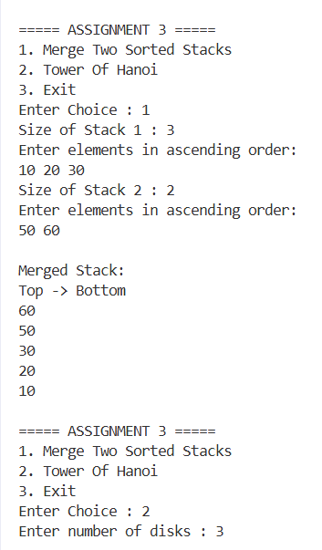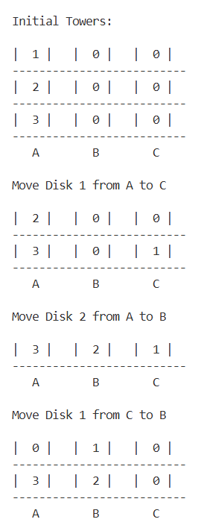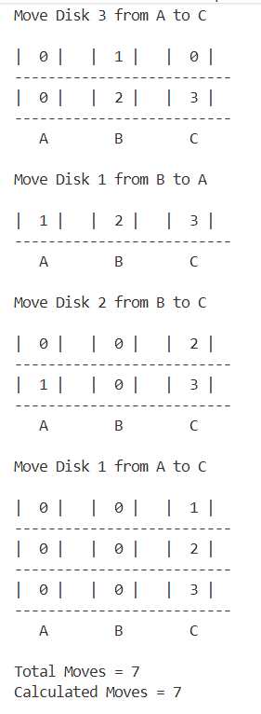

Assignment 4:
- Create a new class Graded_Emp from an existing class EMP, where class Emp got two fields ID and dep_code[0-5], whereas the derived class has an additional field Grade[A-E].
- Use the super keyword judiciously to
- Populate objects of both the base and derived classes above with minimum repetition of code; &
- Change Dep_code 0 to 10 while populating derived objects.
- Create your own exception class to trap accepting invalid data above.
- How would you restructure your code if the Grade field is dependent on average marks obtained in several skill-tests recorded separately?

Source Code :
import java.util.Scanner;

class InvalidDataException extends Exception {
public InvalidDataException(String msg) {
super(msg);
}
}

class EMP {
protected int id;
protected int depCode;

public EMP(int id, int depCode)
throws InvalidDataException {

if (id <= 0)
throw new InvalidDataException(
"Employee ID must be positive");

if (depCode < 0 || depCode > 5)
throw new InvalidDataException(
"Department Code must be between 0 and 5");

this.id = id;
this.depCode = depCode;
}

public void display() {
System.out.println("Employee ID : " + id);
System.out.println("Department Code : " + depCode);
}
}

class GradedEmp extends EMP {

private char grade;

public GradedEmp(int id, int depCode, char grade) throws InvalidDataException {

super(id, depCode == 0 ? 10 : depCode);
grade = Character.toUpperCase(grade);
if (grade < 'A' || grade > 'E') throw new InvalidDataException( "Grade must be between A and E");
this.grade = grade;
}

@Override
public void display() {
super.display();
System.out.println("Grade : " + grade);
}
}
public class Assignment4 {
public static void main(String[] args) {
Scanner sc = new Scanner(System.in);
try {

System.out.print("Enter Employee ID : ");
int id = sc.nextInt();
System.out.print( "Enter Department Code (0-5) : ");
int dep = sc.nextInt();

System.out.print( "Enter Grade (A-E) : ");
char grade = sc.next().charAt(0);

GradedEmp emp = new GradedEmp(id, dep, grade);

System.out.println("\nEmployee Details");
System.out.println("----------------");

emp.display();

} catch (InvalidDataException e) {
System.out.println( "Exception : " + e.getMessage());
} catch (Exception e) {
System.out.println( "Invalid Input");
}

sc.close();
}
}

Output :
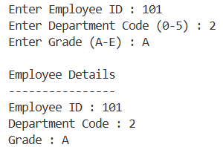

Assignment 5:
- Create an interface Shape with the getArea() method. Create three classes Rectangle, Circle, and Triangle that implement the Shape interface. Implement the getArea() method for each of the classes.
- Create a Animal Interface with a method called sound() that takes no arguments and returns void. Create a few specific animal classes that implement Animal and overrides sound() differently for each species.

Source Code :
package shapes;

public interface Shape{
float getArea();
}

import shapes.Shape;

public class Circle implements Shape{
float r;
static float PI = 3.14f;
Circle(float r) {
this.r = r;
}

public float getArea() {
return PI * 2 * r;
}
}

import shapes.Shape;
public class Rectangle implements Shape{
float l, b;
Rectangle(float l, float b) {
this.l = l;
this.b = b;
}

public float getArea() {
return this.l * this.b;
}
}

import shapes.Shape;

public class Triangle implements Shape{
float b, h;
Triangle(float b, float h) {
this.b = b;
this.h = h;
}

public float getArea() {
return 0.5f * this.b * this.h;
}
}

public class Main {
public static void main(String[] args) {
Triangle t = new Triangle(10.0f, 20.0f);
Circle c = new Circle(5f);
Rectangle r = new Rectangle(12.0f, 13.0f);

System.out.println("Area triangle : "+t.getArea());
System.out.println("Area circle : "+c.getArea());
System.out.println("Area rectangle : "+r.getArea());
}
}

public interface Animals {
void sound();
}

public class Dog implements Animals{
@Override
public void sound() {
System.out.println("Barks");
}

public static void main(String[] args) {
Animals d = new Dog();
d.sound();
}
}

Output :

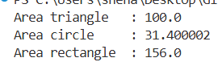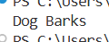

Assignment 6: Create an interface Sortable with a method sort() that sorts an array of integers in ascending order. Create a class BubbleSort that implements the Sortable interface and provide its own version of the sort method.

Source Code :
public interface Sortable {
void sort(int[] arr);
}

public class BubbleSort implements Sortable {
public void sort(int[] arr) {
for (int i = 0; i < arr.length; i++) {
for (int j = 0; j < arr.length - i - 1; j++) {
if (arr[j] > arr[j + 1]) {
int temp = arr[j];
arr[j] = arr[j + 1];
arr[j + 1] = temp;
}
}
}
}

void display(int[] arr) {
System.out.print("\nSorted Array : | ");
for (int i = 0; i < arr.length; i++) {
System.out.print(arr[i]+" | ");
}
}

public static void main(String[] args) {
BubbleSort b = new BubbleSort();
int[] arr = {10, 5, 20, 32, 1, 23, 42, 2, 1, 3, 4, 6};

System.out.print("Unsorted Array : | ");
for (int i = 0; i < arr.length; i++) {
System.out.print(arr[i]+" | ");
}

b.sort(arr);

b.display(arr);
}
}

Output :

Assignment 7:
- Create an interface ResizableTray with methods W(int width) and L(int length) that help trays to be resized. Create a class Tray that implements the interface to carry a number of fixed size plates.
- Inherit an interface ResizableBox from ResizableTray with a new method D(int depth). Create a class NewBox that implements ResizableBox to house a given number of balls of fixed size using the overridden resizing methods.

Source Code :
interface ResizableTray {

void W(int width);

void L(int length);
}

class Tray implements ResizableTray {

protected int width;
protected int length;
protected int plateCount;

public Tray(int width, int length, int plateCount) {
this.width = width;
this.length = length;
this.plateCount = plateCount;
}

@Override
public void W(int width) {
this.width = width;
}

@Override
public void L(int length) {
this.length = length;
}

public void displayTray() {
System.out.println("\nTray Details");
System.out.println("Width = " + width);
System.out.println("Length = " + length);
System.out.println("Number of Plates = " + plateCount);
}
}

interface ResizableBox extends ResizableTray {

void D(int depth);
}

public class NewBox implements ResizableBox {

private int width;
private int length;
private int depth;
private int ballCount;

public NewBox(int width,
int length,
int depth,
int ballCount) {

this.width = width;
this.length = length;
this.depth = depth;
this.ballCount = ballCount;
}

@Override
public void W(int width) {
this.width = width;
}

@Override
public void L(int length) {
this.length = length;
}

@Override
public void D(int depth) {
this.depth = depth;
}

public void displayBox() {
System.out.println("\nBox Details");
System.out.println("Width = " + width);
System.out.println("Length = " + length);
System.out.println("Depth = " + depth);
System.out.println("Number of Balls = " + ballCount);
}

public static void main(String[] args) {

Tray tray = new Tray(20, 30, 12);

tray.displayTray();

tray.W(25);
tray.L(35);

System.out.println("\nAfter Resizing Tray:");
tray.displayTray();

NewBox box = new NewBox(10, 15, 20, 50);

box.displayBox();

box.W(12);
box.L(18);
box.D(25);

System.out.println("\nAfter Resizing Box:");
box.displayBox();
}
}

Output :
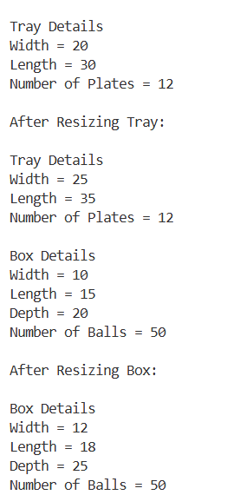

Assignment 8:
- Write the first 10 Fibonacci numbers to a text file "Fibo.txt".
- Read "Fibo.txt" and append next numbers (<250).
- Generate a binary file "Fibo.bin" from "Fibo.txt".

Source Code :
import java.io.*;
import java.util.*;

public class FibonacciFile {

public static void main(String[] args) {

try {

FileWriter fw = new FileWriter("Fibo.txt");

int a = 0, b = 1;

for (int i = 1; i <= 10; i++) {
fw.write(a + " ");
int c = a + b;
a = b;
b = c;
}

fw.close();

System.out.println("First 10 Fibonacci numbers written to Fibo.txt");

Scanner sc = new Scanner(new FileReader("Fibo.txt"));

ArrayList<Integer> fibo = new ArrayList<>();

while (sc.hasNextInt()) {
fibo.add(sc.nextInt());
}

sc.close();

System.out.println("\nContents of Fibo.txt: "+fibo);

FileWriter appendWriter = new FileWriter("Fibo.txt", true);

int n1 = fibo.get(fibo.size() - 2);
int n2 = fibo.get(fibo.size() - 1);

int next = n1 + n2;
while (next < 250) {
appendWriter.write(next + " ");
n1 = n2;
n2 = next;
next = n1 + n2;
}

appendWriter.close();

System.out.println("\nNumbers appended successfully.");

Scanner sc2 = new Scanner(new FileReader("Fibo.txt"));

FileOutputStream fos = new FileOutputStream("Fibo.bin");

while (sc2.hasNextInt()) {
int num = sc2.nextInt();
fos.write(num);
}

sc2.close();
fos.close();

System.out.println("Binary file Fibo.bin created.");
}

catch (IOException e) {
System.out.println(e);
}
}
}

Output ;
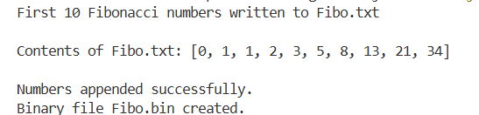

Assignment 9:
- Create a class Profile to store Name, Age, Average Marks. Allow creation of objects and store information for #n persons, with provision for storing content in "Profile.bin".
- Read "Profile.bin" and display the record for the highest scorer.

Source Code :
import java.io.*;
import java.util.ArrayList;
import java.util.Random;

public class Profile implements Serializable {

private String name;
private int age;
private float avgMarks;

public Profile() {
name = "";
age = 0;
avgMarks = 0;
}

public Profile(String name, int age, float avgMarks) {
this.name = name;
this.age = age;

this.avgMarks = Math.round(avgMarks * 100) / 100.0f;
}

public float getAvgMarks() {
return avgMarks;
}

@Override
public String toString() {
return String.format(
"Name : %-20s Age : %2d Average Marks : %.2f",
name, age, avgMarks
);
}

public static void main(String[] args) {

String[] names = {
"Ram", "Laxman", "Krishna",
"Radha", "Sita", "Arjun",
"Nakul", "Bhim", "Ajoy"
};

String[] titles = {
"Sarkar", "Roy", "Chatterjee",
"Ghosh", "Barman", "Mondal",
"Banerjee"
};

ArrayList<Profile> profiles = new ArrayList<>();
Random r = new Random();

int n = r.nextInt(5, 15);

System.out.println("Number of Profiles = " + n);

for (int i = 0; i < n; i++) {

String fullName = names[r.nextInt(names.length)]+ " "+ titles[r.nextInt(titles.length)];
int age = r.nextInt(18, 26);
float marks = r.nextFloat() * 100;

profiles.add(new Profile(fullName, age, marks));
}

try {

ObjectOutputStream oos = new ObjectOutputStream(new FileOutputStream("Profile.bin"));

for (Profile p : profiles) {
oos.writeObject(p);
}

oos.close();

System.out.println("\nProfiles successfully stored in Profile.bin");

ObjectInputStream ois = new ObjectInputStream( new FileInputStream("Profile.bin"));

Profile highestScorer = null;

System.out.println("\nAll Profiles");
System.out.println("----------------------------------------------------------");

try {
while (true) {
Profile p = (Profile) ois.readObject();
System.out.println(p);
if (highestScorer == null || p.getAvgMarks() > highestScorer.getAvgMarks()) {
highestScorer = p;
}
}

} catch (EOFException e) {

}

ois.close();

System.out.println("\nHighest Scorer");
System.out.println("----------------------------------------------------------");
System.out.println(highestScorer);

} catch (IOException | ClassNotFoundException e) {

System.out.println("Error : " + e.getMessage());
}
}
}

Output :
