JADAVPUR UNIVERSITY
188, Raja S.C. Mallick Road, Kolkata – 700032

Department of Computer Science and Engineering, FET.

MASTER OF COMPUTER APPLICATION
1st Year 2nd Semester

OPERATING SYSTEM ASSIGNMENT

Name: Snehasish Sarkar
Roll No.: 002510503033
QUESTION 1: Write a shell script that asks for the values of 2 variables: userv1 and userv2, from the user and takes in any type (real/integer/character). Try to perform the following operations on the variables: (a) add, (b) multiply (c) subtract (d) division. Print appropriate error message/s if the operation cannot be performed, otherwise print the result: “the sum of ‘userv1’ and ‘userv2’ is ....”. Execute the shell script as many number of times the user wants. Show all possible combinations of the types of variables and result/s of the corresponding operation/s.

SOURCE CODE :
#!/bin/bash

while true
do
echo "Enter first value:"
read userv1

echo "Enter second value:"
read userv2

# Check if both are integers or real numbers
if [[ $userv1 =~ ^-?[0-9]+([.][0-9]+)?$ && $userv2 =~ ^-?[0-9]+([.][0-9]+)?$ ]]
then
sum=$(echo "$userv1 + $userv2" | bc)
sub=$(echo "$userv1 - $userv2" | bc)
mul=$(echo "$userv1 * $userv2" | bc)

if [ "$(echo "$userv2 == 0" | bc)" -eq 1 ]
then
div="Undefined (Division by Zero)"
else
div=$(echo "scale=2; $userv1 / $userv2" | bc)
fi

echo "Sum = $sum"
echo "Difference = $sub"
echo "Product = $mul"
echo "Division = $div"

else
echo "Error: Arithmetic operations cannot be performed on non-numeric values."
fi

echo
echo "Do you want to continue? (y/n)"
read ch

if [ "$ch" != "y" ]
then
break
fi
done

OUTPUT :
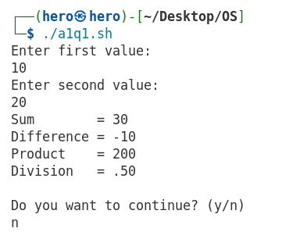

QUESTION 2: Write a shell script which accepts basic salary, House Rent allowance and Dearness Allowance of an employee and calculates net salary and displays the salary slip containing the Name of the Employee and the net salary.

SOURCE CODE :
#!/bin/bash

echo "Enter Employee Name:"
read name

echo "Enter Basic Salary:"
read basic

echo "Enter House Rent Allowance (HRA):"
read hra

echo "Enter Dearness Allowance (DA):"
read da

net=$(echo "$basic + $hra + $da" | bc)

echo
echo "========== Salary Slip =========="
echo "Employee Name : $name"
echo "Basic Salary : $basic"
echo "HRA : $hra"
echo "DA : $da"
echo "Net Salary : $net"
echo "================================="

OUTPUT :
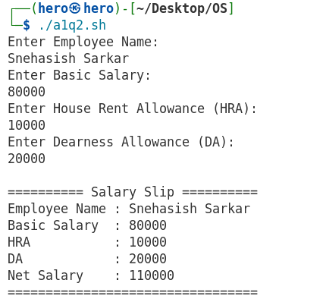
QUESTION 3: Write a shell script which accepts a four digit number (integer) and a) displays the sum
of its digits, b) displays the integer in reverse [that is, if you enter 7890, the program
output will be 0987].

SOURCE CODE :

#!/bin/bash

echo "Enter a 4-digit number:"
read num

if [[ ! $num =~ ^[0-9]{4}$ ]]
then
echo "Error: Please enter a valid 4-digit number."
exit
fi

d1=$((num / 1000))
d2=$(((num / 100) % 10))
d3=$(((num / 10) % 10))
d4=$((num % 10))

sum=$((d1 + d2 + d3 + d4))

echo "Sum of digits = $sum"
echo "Reverse = $d4$d3$d2$d1"

OUTPUT :
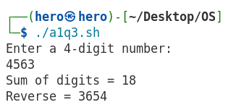

QUESTION 4: Write a shell script a) to find out the total count of files and directories in the current
/any other directory. b) Also list the file and directory names separately with the
respective counts. c) b) The script should also print out the total size of the files created in
the past week.
SOURCE CODE :
#!/bin/bash

echo "Enter directory path (Press Enter for current directory):"
read dir

if [ -z "$dir" ]
then
dir="."
fi

if [ ! -d "$dir" ]
then
echo "Directory does not exist!"
exit
fi

echo
echo "===== Files ====="
find "$dir" -maxdepth 1 -type f -printf "%f\n"
fileCount=$(find "$dir" -maxdepth 1 -type f | wc -l)
echo "Total Files: $fileCount"

echo
echo "===== Directories ====="
find "$dir" -maxdepth 1 -type d -printf "%f\n"
dirCount=$(find "$dir" -maxdepth 1 -type d | wc -l)
echo "Total Directories: $dirCount"

echo
echo "Total Files + Directories: $((fileCount + dirCount))"

echo
echo "Total size of files created/modified in the last 7 days:"
find "$dir" -maxdepth 1 -type f -mtime -7 -printf "%s\n" | \
awk '{sum += $1} END {print sum, "bytes"}'

OUTPUT :
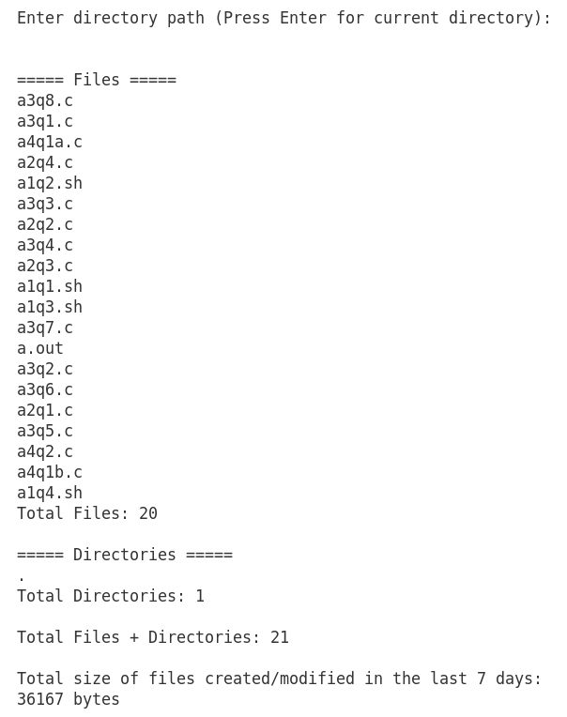

QUESTION 5: Write a script that adds up the sizes reported by the ls command for the files in the
current / any other directory. a) The script should print out only the total number of bytes
used. b) The script should also print out the total size of the files created in the day that
you are using this script.

SOURCE CODE :
#!/bin/bash

echo "Enter directory path (Press Enter for current directory):"
read dir

if [ -z "$dir" ]
then
dir="."
fi

if [ ! -d "$dir" ]
then
echo "Directory does not exist!"
exit
fi

# (a) Total size of all files
total=$(find "$dir" -maxdepth 1 -type f -printf "%s\n" | \
awk '{sum += $1} END {print sum}')

echo "Total bytes used by all files: $total bytes"

# (b) Total size of today's files (modified today)
today=$(find "$dir" -maxdepth 1 -type f -daystart -mtime 0 -printf "%s\n" | \
awk '{sum += $1} END {print sum}')

echo "Total size of files modified today: $today bytes"

OUTPUT :
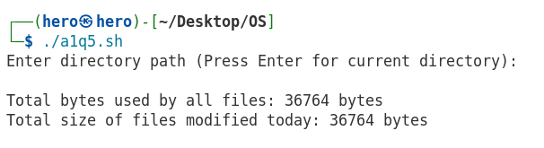
QUESTION 6: The PATH variable is an environment variable that contains an ordered list of paths that
Linux will search for executables when running a command. Write a shell script to
display all the directories in the PATH variable in a simple way, i.e., one line per
directory. In addition, display information about each directory, such as the permissions
and the modification times.

SOURCE CODE :
#!/bin/bash

echo "Directories in PATH:"
echo "------------------------------"

echo $PATH | tr ":" "\n" | while read dir
do
echo
echo "Directory: $dir"

if [ -d "$dir" ]
then
ls -ld "$dir"
else
echo "Directory does not exist."
fi
done

OUTPUT :
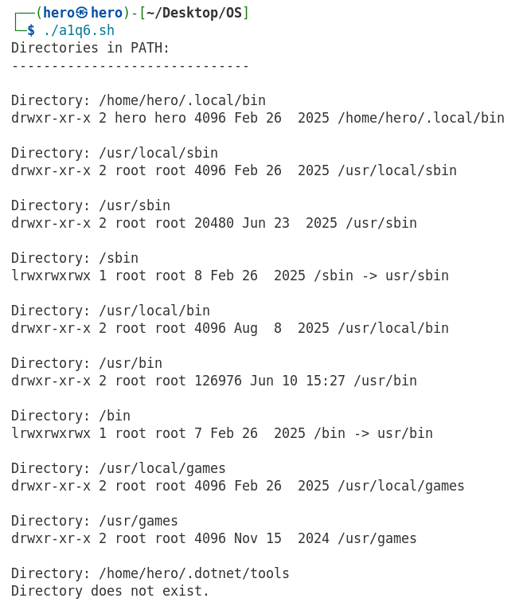
QUESTION 7: Write a shell script which displays vendor id, model name, cpu MHz, cache size
information about the processor present in your computer. [Hint: most of this information
can be obtained by reading the file /proc/cpuinfo.]

SOURCE CODE :
#!/bin/bash

echo "===== CPU Information ====="

echo "Vendor ID :"
grep "vendor_id" /proc/cpuinfo | head -1

echo

echo "Model Name :"
grep "model name" /proc/cpuinfo | head -1

echo

echo "CPU MHz :"
grep "cpu MHz" /proc/cpuinfo | head -1

echo

echo "Cache Size :"
grep "cache size" /proc/cpuinfo | head -1

OUTPUT :
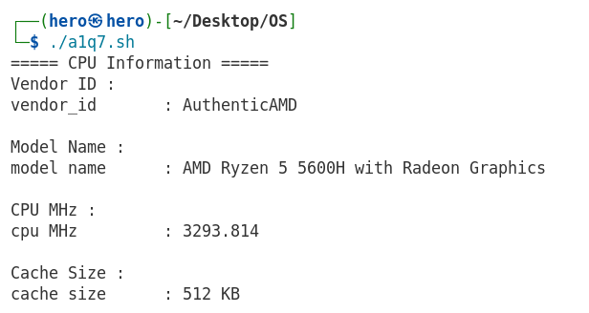

QUESTION 8: Write a shell script multiplication_table that will generate a multiplication table for a
number given on the command line.

SOURCE CODE :
#!/bin/bash

if [ $# -ne 1 ]
then
echo "Usage: ./multiplication_table.sh <number>"
exit 1
fi

num=$1

echo "Multiplication Table of $num"

for i in {1..10}
do
echo "$num x $i = $((num * i))"
done

OUTPUT :
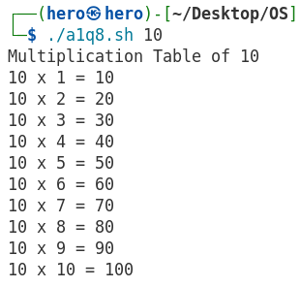

QUESTION 9: Write a shell script to count the number of lines in a file.

SOURCE CODE :
#!/bin/bash

if [ $# -ne 1 ]
then
echo "Usage: ./count_lines.txt <filename>"
exit 1
fi

if [ ! -f "$1" ]
then
echo "File does not exist!"
exit 1
fi

lines=$(wc -l < "$1")

echo "Number of lines in $1 = $lines"

OUTPUT :
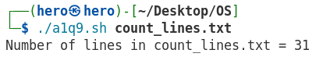

QUESTION 10: Design a CPU scheduler (choose any programming language of your preference) for jobs whose execution profiles will be in a file that is to be read and appropriate scheduling algorithm to be chosen by the scheduler.
Format of the profile:
<Job id> <priority> <arrival time> <CPU burst(1) I/O burst(1) CPU burst(2) ....... >-1 (Each information is separated by blank space and each job profile ends with -1.
Lesser priority number denotes higher priority process with priority number 1 being the process with highest priority.) Example: 2 3 4 100 2 200 3 25 -1 7 1 8 60 10 ..... -1 etc.
Testing:
- Create job profiles for 30 jobs and use three different scheduling algorithms (FCFS, Priority and Round Robin (?me slice: 15)). You may also test with other scheduling algorithms that you have done in class.

- Compare the average waiting ?me, turnaround ?me of each process for the different scheduling algorithms.

SOURCE CODE :
#include <stdio.h>
#include <stdlib.h>
#include <time.h>

#define N 5
#define TQ 15

typedef struct
{
int id;
int priority;
int arrival;
int burst;

int remaining;
int waiting;
int turnaround;
int completed;
} Process;

void generate(Process p[])
{
srand(time(NULL));

printf("Generated Processes\n");
printf("---------------------------------------------\n");
printf("ID\tPri\tAT\tBT\n");

for(int i=0;i<N;i++)
{
p[i].id=i+1;
p[i].priority=1+rand()%5;
p[i].arrival=rand()%20;
p[i].burst=10+rand()%91;

p[i].remaining=p[i].burst;
p[i].completed=0;

printf("%d\t%d\t%d\t%d\n",
p[i].id,
p[i].priority,
p[i].arrival,
p[i].burst);
}

printf("\n");
}

void reset(Process a[],Process b[])
{
for(int i=0;i<N;i++)
{
b[i]=a[i];
b[i].remaining=b[i].burst;
b[i].completed=0;
}
}

void FCFS(Process p[])
{
int time=0;

for(int i=0;i<N-1;i++)
for(int j=i+1;j<N;j++)
if(p[i].arrival>p[j].arrival)
{
Process t=p[i];
p[i]=p[j];
p[j]=t;
}

double aw=0,at=0;

printf("\n========== FCFS ==========\n");

printf("ID\tWT\tTAT\n");

for(int i=0;i<N;i++)
{
if(time<p[i].arrival)
time=p[i].arrival;

p[i].waiting=time-p[i].arrival;

time+=p[i].burst;

p[i].turnaround=time-p[i].arrival;

aw+=p[i].waiting;
at+=p[i].turnaround;

printf("%d\t%d\t%d\n",
p[i].id,
p[i].waiting,
p[i].turnaround);
}

printf("Average Waiting Time = %.2lf\n",aw/N);
printf("Average Turnaround Time = %.2lf\n",at/N);
}

void Priority(Process p[])
{
int done=0,time=0;

double aw=0,at=0;

printf("\n========== PRIORITY ==========\n");
printf("ID\tWT\tTAT\n");

while(done<N)
{
int idx=-1;

for(int i=0;i<N;i++)
{
if(!p[i].completed && p[i].arrival<=time)
{
if(idx==-1 || p[i].priority<p[idx].priority)
idx=i;
}
}

if(idx==-1)
{
time++;
continue;
}

p[idx].waiting=time-p[idx].arrival;

time+=p[idx].burst;

p[idx].turnaround=time-p[idx].arrival;

p[idx].completed=1;

done++;

aw+=p[idx].waiting;
at+=p[idx].turnaround;

printf("%d\t%d\t%d\n",
p[idx].id,
p[idx].waiting,
p[idx].turnaround);
}

printf("Average Waiting Time = %.2lf\n",aw/N);
printf("Average Turnaround Time = %.2lf\n",at/N);
}

void RoundRobin(Process p[])
{
int queue[500];
int front=0,rear=0;

int visited[N]={0};

int completed=0;
int time=0;

double aw=0,at=0;

printf("\n========== ROUND ROBIN (TQ=15) ==========\n");

while(completed<N)
{
for(int i=0;i<N;i++)
{
if(!visited[i] && p[i].arrival<=time)
{
queue[rear++]=i;
visited[i]=1;
}
}

if(front==rear)
{
time++;
continue;
}

int i=queue[front++];

if(p[i].remaining>TQ)
{
p[i].remaining-=TQ;
time+=TQ;

for(int j=0;j<N;j++)
{
if(!visited[j] && p[j].arrival<=time)
{
queue[rear++]=j;
visited[j]=1;
}
}

queue[rear++]=i;
}
else
{
time+=p[i].remaining;
p[i].remaining=0;

p[i].turnaround=time-p[i].arrival;
p[i].waiting=p[i].turnaround-p[i].burst;

completed++;

aw+=p[i].waiting;
at+=p[i].turnaround;
}
}

printf("ID\tWT\tTAT\n");

for(int i=0;i<N;i++)
{
printf("%d\t%d\t%d\n",
p[i].id,
p[i].waiting,
p[i].turnaround);
}

printf("Average Waiting Time = %.2lf\n",aw/N);
printf("Average Turnaround Time = %.2lf\n",at/N);
}

int main()
{
Process original[N],temp[N];

generate(original);

reset(original,temp);
FCFS(temp);

reset(original,temp);
Priority(temp);

reset(original,temp);
RoundRobin(temp);

return 0;
}

OUTPUT :
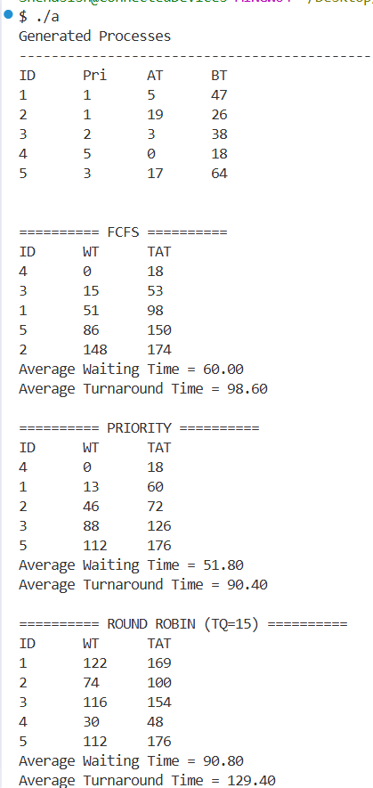

QUESTION 11 : Write a C program to create a child process. The parent process must wait until the child finishes. Both the processes must print their own pid and parent pid. Additionally the parent process should print the exit status of the child.

SOURCE CODE :
#include <stdio.h>
#include <windows.h>

int main(int argc, char *argv[])
{
// Child process
if (argc > 1)
{
printf("----- Child Process -----\n");
printf("Child PID : %lu\n", GetCurrentProcessId());
printf("Parent PID : Not directly available in Windows\n");

return 10; // Exit status
}

// Parent process
STARTUPINFO si;
PROCESS_INFORMATION pi;

ZeroMemory(&si, sizeof(si));
si.cb = sizeof(si);
ZeroMemory(&pi, sizeof(pi));

char cmd[] = "child.exe child";

if (!CreateProcess(
NULL,
cmd,
NULL,
NULL,
FALSE,
0,
NULL,
NULL,
&si,
&pi))
{
printf("CreateProcess failed (%lu)\n", GetLastError());
return 1;
}

// Wait for child
WaitForSingleObject(pi.hProcess, INFINITE);

DWORD exitCode;
GetExitCodeProcess(pi.hProcess, &exitCode);

printf("\n----- Parent Process -----\n");
printf("Parent PID : %lu\n", GetCurrentProcessId());
printf("Child Exit Status : %lu\n", exitCode);

CloseHandle(pi.hProcess);
CloseHandle(pi.hThread);

return 0;
}

OUTPUT :
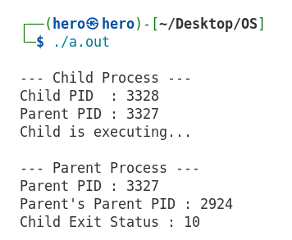

QUESTION 12: Write a C program which prints prime numbers between the range 1 to 10,00,000 by creating ten child processes and subdividing the task equally among all child processes, i.e., the first child should print prime numbers in the range 1 to 1,00,000, the second child in the range 1,00,001 to 2,00,000, ... The child processes must run in parallel and the parent process must wait until all the child processes finish.

SOURCE CODE :
#include <stdio.h>
#include <stdlib.h>
#include <unistd.h>
#include <sys/wait.h>

#define LIMIT 1000000
#define CHILDREN 10

int isPrime(int n)
{
if (n < 2)
return 0;

for (int i = 2; i * i <= n; i++)
if (n % i == 0)
return 0;

return 1;
}

int main()
{
int range = LIMIT / CHILDREN;

for (int i = 0; i < CHILDREN; i++)
{
pid_t pid = fork();

if (pid == 0)
{
int start = i * range + 1;
int end = (i + 1) * range;
int count = 0;

for (int j = start; j <= end; j++)
if (isPrime(j))
count++;

printf("Child %2d | PID: %5d | Range: %6d - %7d | Primes: %d\n",
i + 1, getpid(), start, end, count);

exit(0);
}
}

// Parent waits for all children
for (int i = 0; i < CHILDREN; i++)
wait(NULL);

printf("\nParent: All child processes have finished.\n");

return 0;
}

OUTPUT :
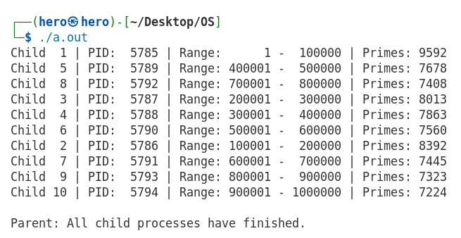

QUESTION 13 : Write a C program which creates a child process. The parent process sends a string (input by user) which the child process inspects and sends ”YES” back to the parent if the string is a palindrome, otherwise it sends ”NO”. The IPC to be used is pipe. Both the processes terminate when the input string is “quit”.

SOURCE CODE :
#include <stdio.h>
#include <string.h>
#include <unistd.h>
#include <sys/wait.h>

int isPalindrome(char str[])
{
int i = 0;
int j = strlen(str) - 1;

while (i < j)
{
if (str[i] != str[j])
return 0;
i++;
j--;
}
return 1;
}

int main()
{
int p1[2], p2[2];
pipe(p1); // Parent -> Child
pipe(p2); // Child -> Parent

pid_t pid = fork();

if (pid == 0)
{
// Child
char str[100], result[10];

while (1)
{
read(p1[0], str, sizeof(str));

if (strcmp(str, "quit") == 0)
break;

if (isPalindrome(str))
strcpy(result, "YES");
else
strcpy(result, "NO");

write(p2[1], result, sizeof(result));
}
}
else
{
// Parent
char str[100], result[10];

while (1)
{
printf("Enter string: ");
scanf("%s", str);

write(p1[1], str, sizeof(str));

if (strcmp(str, "quit") == 0)
break;

read(p2[0], result, sizeof(result));
printf("Child says: %s\n\n", result);
}

wait(NULL);
}

return 0;
}

OUTPUT :
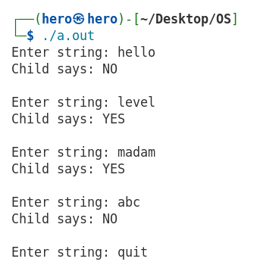
QUESTION 14: Write a program for the Reader-Writer process for the following situation:
- Multiple readers and one writer: writer gets to write whenever it is ready (reader/s wait)

SOURCE CODE:
#include <stdio.h>
#include <pthread.h>
#include <semaphore.h>
#include <unistd.h>

int readCount = 0;
int data = 0;

sem_t mutex; // Protects readCount
sem_t wrt; // Controls database access
sem_t readTry; // Blocks readers when writer is waiting

void *reader(void *arg)
{
int id = *(int *)arg;

sem_wait(&readTry);
sem_wait(&mutex);

readCount++;
if (readCount == 1)
sem_wait(&wrt);

sem_post(&mutex);
sem_post(&readTry);

printf("Reader %d is reading: %d\n", id, data);
sleep(1);

sem_wait(&mutex);

readCount--;
if (readCount == 0)
sem_post(&wrt);

sem_post(&mutex);

return NULL;
}

void *writer(void *arg)
{
int id = *(int *)arg;

sem_wait(&readTry); // Stop new readers
sem_wait(&wrt);

data++;
printf("Writer %d is writing: %d\n", id, data);
sleep(2);

sem_post(&wrt);
sem_post(&readTry);

return NULL;
}

int main()
{
pthread_t r[3], w;
int rid[3] = {1, 2, 3};
int wid = 1;

sem_init(&mutex, 0, 1);
sem_init(&wrt, 0, 1);
sem_init(&readTry, 0, 1);
pthread_create(&r[0], NULL, reader, &rid[0]);
pthread_create(&r[1], NULL, reader, &rid[1]);
sleep(1);
pthread_create(&w, NULL, writer, &wid);
sleep(1);
pthread_create(&r[2], NULL, reader, &rid[2]);
for (int i = 0; i < 3; i++)
pthread_join(r[i], NULL);

pthread_join(w, NULL);
sem_destroy(&mutex);
sem_destroy(&wrt);
sem_destroy(&readTry);
return 0;
}
OUTPUT :
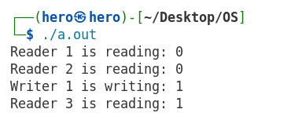
QUESTION 15: Write a C program to simulate Bankers Algorithm for Deadlock Avoidance.
SOURCE CODE:
#include <stdio.h>

#define P 5
#define R 3

int main()
{
int alloc[P][R] = {
{0,1,0},
{2,0,0},
{3,0,2},
{2,1,1},
{0,0,2}
};

int max[P][R] = {
{7,5,3},
{3,2,2},
{9,0,2},
{2,2,2},
{4,3,3}
};

int avail[R] = {3,3,2};

int need[P][R];
int finish[P] = {0};
int safe[P];

// Calculate Need Matrix
for(int i=0;i<P;i++)
for(int j=0;j<R;j++)
need[i][j] = max[i][j] - alloc[i][j];

int count = 0;

while(count < P)
{
int found = 0;

for(int i=0;i<P;i++)
{
if(!finish[i])
{
int j;

for(j=0;j<R;j++)
if(need[i][j] > avail[j])
break;

if(j==R)
{
for(int k=0;k<R;k++)
avail[k] += alloc[i][k];

finish[i] = 1;
safe[count++] = i;
found = 1;
}
}
}

if(!found)
break;
}

if(count == P)
{
printf("System is in SAFE state.\n");
printf("Safe Sequence: ");

for(int i=0;i<P;i++)
printf("P%d ", safe[i]);

printf("\n");
}
else
{
printf("System is NOT in SAFE state.\n");
}

return 0;
}

OUTPUT :
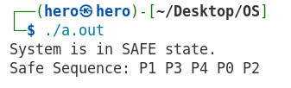
QUESTION 16: Write a C program to simulate Worst-Fit memory allocation technique.
SOURCE CODE:
#include <stdio.h>

#define BLOCKS 5
#define PROCESSES 4

int main()
{
// Static Input
int blockSize[BLOCKS] = {100, 500, 200, 300, 600};
int processSize[PROCESSES] = {212, 417, 112, 426};

int allocation[PROCESSES];

for (int i = 0; i < PROCESSES; i++)
allocation[i] = -1;

// Worst-Fit Allocation
for (int i = 0; i < PROCESSES; i++)
{
int worst = -1;

for (int j = 0; j < BLOCKS; j++)
{
if (blockSize[j] >= processSize[i])
{
if (worst == -1 || blockSize[j] > blockSize[worst])
worst = j;
}
}

if (worst != -1)
{
allocation[i] = worst;
blockSize[worst] -= processSize[i];
}
}

// Output
printf("Process\tSize\tBlock\n");

for (int i = 0; i < PROCESSES; i++)
{
printf("P%d\t%d\t", i + 1, processSize[i]);

if (allocation[i] != -1)
printf("%d\n", allocation[i] + 1);
else
printf("Not Allocated\n");
}

return 0;
}

OUTPUT :
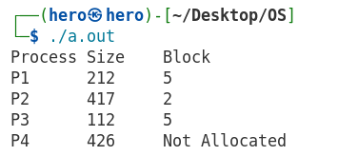

QUESTION 17: Write a C program to simulate First-Fit memory allocation technique.
SOURCE CODE:
#include <stdio.h>

#define BLOCKS 5
#define PROCESSES 4

int main()
{
int blockSize[BLOCKS] = {100, 500, 200, 300, 600};
int processSize[PROCESSES] = {212, 417, 112, 426};
int allocation[PROCESSES];

for (int i = 0; i < PROCESSES; i++)
allocation[i] = -1;
for (int i = 0; i < PROCESSES; i++)
{
for (int j = 0; j < BLOCKS; j++)
{
if (blockSize[j] >= processSize[i])
{
allocation[i] = j;
blockSize[j] -= processSize[i];
break;
}
}
}
printf("Process\tSize\tBlock\n");
for (int i = 0; i < PROCESSES; i++)
{
printf("P%d\t%d\t", i + 1, processSize[i]);
if (allocation[i] != -1)
printf("%d\n", allocation[i] + 1);
else
printf("Not Allocated\n");
}

return 0;
}

OUTPUT :
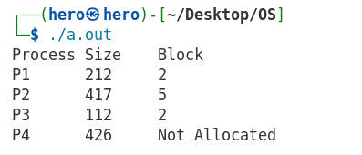
QUESTION 18: Write a C program for simulating the Indexed File Allocation algorithm.
SOURCE CODE:
#include <stdio.h>

#define TOTAL_BLOCKS 20

int main()
{
// 0 = Free, 1 = Allocated
int memory[TOTAL_BLOCKS] = {0};

// Static Input
int indexBlock = 5;
int fileBlocks[] = {2, 7, 10, 15};
int n = 4;

// Check if index block is free
if (memory[indexBlock] == 1)
{
printf("Index Block %d is already allocated.\n", indexBlock);
return 0;
}

memory[indexBlock] = 1;

// Allocate data blocks
for (int i = 0; i < n; i++)
{
if (memory[fileBlocks[i]] == 0)
memory[fileBlocks[i]] = 1;
else
{
printf("Block %d is already allocated.\n", fileBlocks[i]);
return 0;
}
}

// Display Allocation
printf("Indexed File Allocation\n");
printf("-----------------------\n");
printf("Index Block : %d\n", indexBlock);

printf("Data Blocks : ");
for (int i = 0; i < n; i++)
printf("%d ", fileBlocks[i]);

printf("\n");

return 0;
}

OUTPUT :
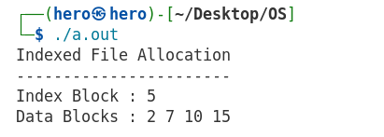

QUESTION 19: Write a C program to simulate FCFS (First Come First Serve) Disk scheduling algorithm.
SOURCE CODE:
#include <stdio.h>
#include <stdlib.h>

int main()
{
// Static Input
int request[] = {98, 183, 37, 122, 14, 124, 65, 67};
int n = 8;
int head = 53;

int totalSeek = 0;

printf("FCFS Disk Scheduling\n");
printf("--------------------\n");
printf("Initial Head Position = %d\n\n", head);

printf("Head Movement:\n");
printf("%d", head);

for(int i = 0; i < n; i++)
{
totalSeek += abs(request[i] - head);
head = request[i];
printf(" -> %d", head);
}

printf("\n\nTotal Seek Time = %d\n", totalSeek);
printf("Average Seek Time = %.2f\n", (float)totalSeek / n);

return 0;
}

OUTPUT :
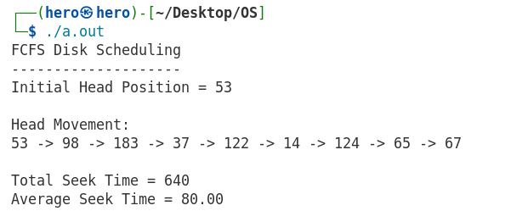
QUESTION 20: Write a program to simulate Least Recently Used (LRU) page replacement algorithm for the following page reference string: 9, 8, 11, 7, 12, 8, 7, 6, 8, 12, 5, 4, 12, 3, 10, 11, 12, 4, 9, 4. Consider (i) 4 frames and (ii) 5 frames. Compare the results.
SOURCE CODE:
#include <stdio.h>

#define N 20

int pages[N] = {
9, 8, 11, 7, 12, 8, 7, 6, 8, 12,
5, 4, 12, 3, 10, 11, 12, 4, 9, 4
};

void LRU(int frames)
{
int frame[10];
int lastUsed[10];
int faults = 0;

for (int i = 0; i < frames; i++)
{
frame[i] = -1;
lastUsed[i] = -1;
}

for (int i = 0; i < N; i++)
{
int found = 0;

// Check if page is already present
for (int j = 0; j < frames; j++)
{
if (frame[j] == pages[i])
{
found = 1;
lastUsed[j] = i;
break;
}
}

// Page Fault
if (!found)
{
int pos = 0;

// Find empty frame
for (int j = 0; j < frames; j++)
{
if (frame[j] == -1)
{
pos = j;
goto allocate;
}
}

pos = 0;
for (int j = 1; j < frames; j++)
{
if (lastUsed[j] < lastUsed[pos])
pos = j;
}

allocate:
frame[pos] = pages[i];
lastUsed[pos] = i;
faults++;
}
}

printf("Frames = %d\n", frames);
printf("Total Page Faults = %d\n\n", faults);
}

int main()
{
printf("LRU Page Replacement\n");
printf("--------------------\n\n");

LRU(4);
LRU(5);

return 0;
}

OUTPUT :
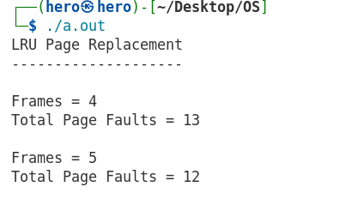
QUESTION 21: Write a program to simulate First In First Out (FIFO) page replacement algorithm for the following page reference string: 9, 10, 7, 12, 7, 6, 12, 6, 5, 4, 3, 10, 11, 12, 4, 5, 6, 9, 4, 5. Consider (i) 3 frames and (ii) 4 frames. Compare the results.
SOURCE CODE:
#include <stdio.h>

#define N 20

int pages[N] = {
9, 10, 7, 12, 7, 6, 12, 6, 5, 4,
3, 10, 11, 12, 4, 5, 6, 9, 4, 5
};

void FIFO(int frames)
{
int frame[10];
int faults = 0;
int index = 0;

for (int i = 0; i < frames; i++)
frame[i] = -1;

for (int i = 0; i < N; i++)
{
int found = 0;

// Check if page already exists
for (int j = 0; j < frames; j++)
{
if (frame[j] == pages[i])
{
found = 1;
break;
}
}

// Page Fault
if (!found)
{
frame[index] = pages[i];
index = (index + 1) % frames;
faults++;
}
}

printf("Frames = %d\n", frames);
printf("Total Page Faults = %d\n\n", faults);
}

int main()
{
printf("FIFO Page Replacement\n");
printf("---------------------\n\n");

FIFO(3);
FIFO(4);

return 0;
}

OUTPUT :

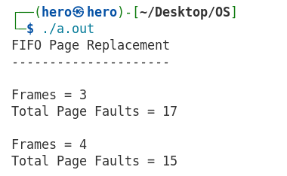

QUESTION 22 : Write a program for the Reader-Writer process for the following situation:
- Multiple readers and multiple writers: writers have priority

#include <stdio.h>
#include <pthread.h>
#include <semaphore.h>
#include <unistd.h>

int data = 0, readCount = 0;

sem_t mutex, wrt, readTry;

void *reader(void *arg)
{
int id = *(int *)arg;

sem_wait(&readTry);
sem_wait(&mutex);

readCount++;
if(readCount == 1)
sem_wait(&wrt);

sem_post(&mutex);
sem_post(&readTry);

printf("Reader %d reads %d\n", id, data);
sleep(1);

sem_wait(&mutex);
readCount--;

if(readCount == 0)
sem_post(&wrt);

sem_post(&mutex);

return NULL;
}

void *writer(void *arg)
{
int id = *(int *)arg;

sem_wait(&readTry);
sem_wait(&wrt);

data++;
printf("Writer %d writes %d\n", id, data);
sleep(1);

sem_post(&wrt);
sem_post(&readTry);

return NULL;
}

int main()
{
pthread_t r[3], w[2];

int rid[3]={1,2,3};
int wid[2]={1,2};

sem_init(&mutex,0,1);
sem_init(&wrt,0,1);
sem_init(&readTry,0,1);

pthread_create(&r[0],NULL,reader,&rid[0]);
pthread_create(&r[1],NULL,reader,&rid[1]);

pthread_create(&w[0],NULL,writer,&wid[0]);

pthread_create(&r[2],NULL,reader,&rid[2]);

pthread_create(&w[1],NULL,writer,&wid[1]);

for(int i=0;i<3;i++)
pthread_join(r[i],NULL);

for(int i=0;i<2;i++)
pthread_join(w[i],NULL);

return 0;
}

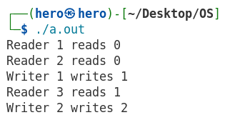

b) Multiple readers and multiple writers: readers have priority

#include <stdio.h>
#include <pthread.h>
#include <semaphore.h>
#include <unistd.h>

int data = 0, readCount = 0;

sem_t mutex, wrt;

void *reader(void *arg)
{
int id = *(int *)arg;

sem_wait(&mutex);

readCount++;
if(readCount == 1)
sem_wait(&wrt);

sem_post(&mutex);

printf("Reader %d reads %d\n", id, data);
sleep(1);

sem_wait(&mutex);

readCount--;
if(readCount == 0)
sem_post(&wrt);

sem_post(&mutex);

return NULL;
}

void *writer(void *arg)
{
int id = *(int *)arg;

sem_wait(&wrt);

data++;
printf("Writer %d writes %d\n", id, data);
sleep(1);

sem_post(&wrt);

return NULL;
}

int main()
{
pthread_t r[3], w[2];

int rid[3]={1,2,3};
int wid[2]={1,2};

sem_init(&mutex,0,1);
sem_init(&wrt,0,1);

pthread_create(&r[0],NULL,reader,&rid[0]);
pthread_create(&r[1],NULL,reader,&rid[1]);

pthread_create(&w[0],NULL,writer,&wid[0]);

pthread_create(&r[2],NULL,reader,&rid[2]);

pthread_create(&w[1],NULL,writer,&wid[1]);

for(int i=0;i<3;i++)
pthread_join(r[i],NULL);

for(int i=0;i<2;i++)
pthread_join(w[i],NULL);

return 0;
}

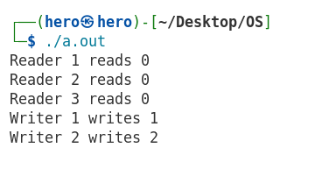

QUESTION 23: Write a C program to simulate SCAN and CSCAN Disk scheduling algorithm.
- Use 3 randomly generated lists of disk requests spanning from cylinders 0 (outermost) to 199 (innermost)
b) Test each list with each disk scheduling algorithm and compare the results
c) Generate a list of requests in which the requests are concentrated at one end of the disk
d) Generate a list of request in which the requests are concentrated at the centre of the disk
Repeat step (b) for both (c) and (d).

SOURCE CODE :
#include <stdio.h>
#include <stdlib.h>
#include <time.h>

#define N 10
#define MAX 199

void sort(int a[], int n)
{
for(int i=0;i<n-1;i++)
for(int j=0;j<n-i-1;j++)
if(a[j]>a[j+1])
{
int t=a[j];
a[j]=a[j+1];
a[j+1]=t;
}
}

void SCAN(int req[], int n, int head)
{
int a[20];

for(int i=0;i<n;i++)
a[i]=req[i];

sort(a,n);

int pos=0;

while(pos<n && a[pos]<head)
pos++;

int seek=0,temp=head;

// Move towards higher cylinders
for(int i=pos;i<n;i++)
{
seek+=abs(a[i]-temp);
temp=a[i];
}

if(temp!=MAX)
{
seek+=abs(MAX-temp);
temp=MAX;
}

// Reverse direction
for(int i=pos-1;i>=0;i--)
{
seek+=abs(temp-a[i]);
temp=a[i];
}

printf("SCAN : Total Seek=%d Avg=%.2f\n",
seek,(float)seek/n);
}

void CSCAN(int req[], int n, int head)
{
int a[20];

for(int i=0;i<n;i++)
a[i]=req[i];

sort(a,n);

int pos=0;

while(pos<n && a[pos]<head)
pos++;

int seek=0,temp=head;

for(int i=pos;i<n;i++)
{
seek+=abs(a[i]-temp);
temp=a[i];
}

if(temp!=MAX)
{
seek+=MAX-temp;
temp=MAX;
}

seek+=MAX;
temp=0;

for(int i=0;i<pos;i++)
{
seek+=abs(a[i]-temp);
temp=a[i];
}

printf("CSCAN : Total Seek=%d Avg=%.2f\n",
seek,(float)seek/n);
}

void randomList(int a[])
{
for(int i=0;i<N;i++)
a[i]=rand()%200;
}

void endList(int a[])
{
for(int i=0;i<N;i++)
a[i]=rand()%40;
}

void centerList(int a[])
{
for(int i=0;i<N;i++)
a[i]=80+rand()%41;
}

void printList(int a[])
{
for(int i=0;i<N;i++)
printf("%d ",a[i]);
printf("\n");
}

int main()
{
srand(time(NULL));

int req[N];
int head=100;

printf("Initial Head = %d\n\n",head);

// Three Random Lists
for(int i=1;i<=3;i++)
{
printf("Random List %d:\n",i);

randomList(req);

printList(req);

SCAN(req,N,head);
CSCAN(req,N,head);

printf("\n");
}

// One End
printf("Requests Near One End:\n");

endList(req);

printList(req);

SCAN(req,N,head);
CSCAN(req,N,head);

printf("\n");

// Centre
printf("Requests Near Centre:\n");

centerList(req);

printList(req);

SCAN(req,N,head);
CSCAN(req,N,head);

return 0;
}

OUTPUT :

