Question 21. From the EMP table show the minimum, maximum and average basic for each department (show dept. Code).
Query :
SELECT
DEPT_CODE,
MIN(BASIC) AS MIN_BASIC,
MAX(BASIC) AS MAX_BASIC,
AVG(BASIC) AS AVG_BASIC
FROM EMPLOYEE
GROUP BY DEPT_CODE;
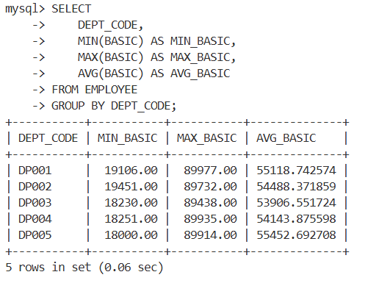

Question 22. Find the number of female employees in each department (show dept. Code).
Query :
SELECT
DEPT_CODE,
COUNT(*) AS FEMALE_EMPLOYEES
FROM EMPLOYEE
WHERE SEX='F'
GROUP BY DEPT_CODE;

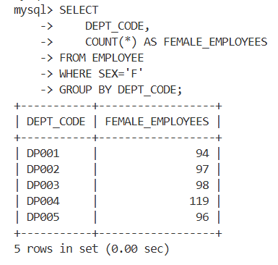
Question 23: Find the city wise no. of employees for each department (show dept. Code).
Query :
SELECT
DEPT_CODE,
CITY,
COUNT(*) AS TOTAL_EMPLOYEES
FROM EMPLOYEE
GROUP BY DEPT_CODE, CITY;
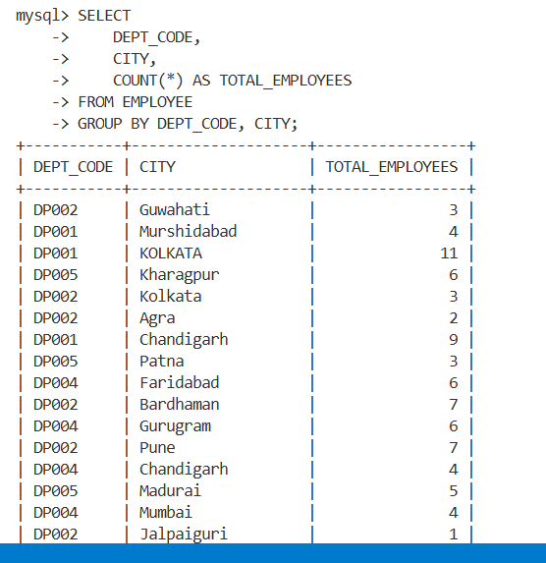

Question 24 : Show the designation wise no of employees who have joined in the year 2000 in each department. The listing should appear in the ascending order of no. of employees.
Query :
SELECT
E.DEPT_CODE,
D.DESIG_DESC,
COUNT(*) AS EMP_COUNT
FROM EMPLOYEE E
JOIN DESIGNATION D
ON E.DESIG_CODE=D.DESIG_CODE
WHERE YEAR(E.JN_DT)=2000
GROUP BY E.DEPT_CODE,D.DESIG_DESC
ORDER BY EMP_COUNT ASC;
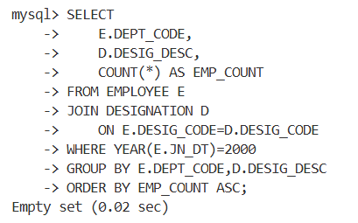
Question 25: Find the department code wise total basic of male employees only for the departments for which such total is more than 50,000 and the listing should appear in the descending order of total basic.
Query :
SELECT
DEPT_CODE,
SUM(BASIC) AS TOTAL_BASIC
FROM EMPLOYEE
WHERE SEX='M'
GROUP BY DEPT_CODE
HAVING SUM(BASIC) > 50000
ORDER BY TOTAL_BASIC DESC;
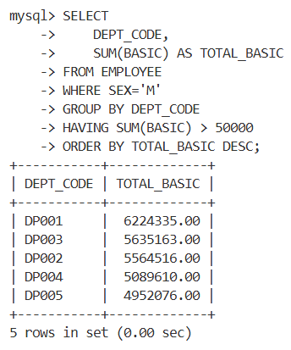

Question 26: Show the employee name, Designation description and basic for all employees.
Query :
SELECT
E.EMP_NAME,
D.DESIG_DESC,
E.BASIC
FROM EMPLOYEE E
JOIN DESIGNATION D
ON E.DESIG_CODE=D.DESIG_CODE;
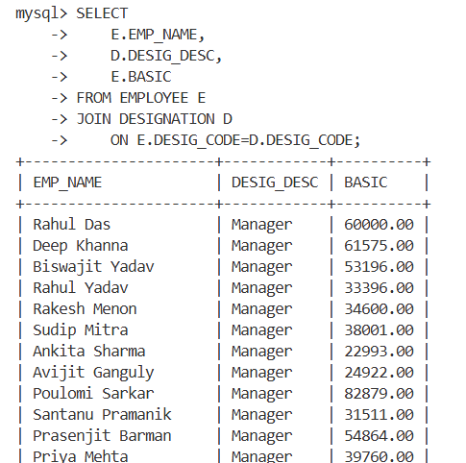
Question 27 : Show the employee name, Designation description, Department Name & Basic for all employees.
Query :
SELECT
E.EMP_NAME,
DG.DESIG_DESC,
DP.DEPT_NAME,
E.BASIC
FROM EMPLOYEE E
JOIN DESIGNATION DG
ON E.DESIG_CODE=DG.DESIG_CODE
JOIN DEPARTMENT DP
ON E.DEPT_CODE=DP.DEPT_CODE;
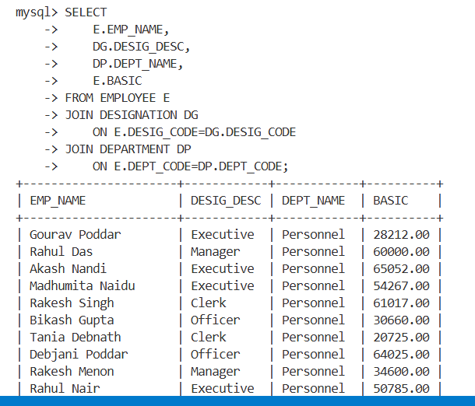

Question 28 : Find the department Codes in which no employee works.
Query :
SELECT DEPT_CODE
FROM DEPARTMENT
WHERE DEPT_CODE NOT IN
(
SELECT DISTINCT DEPT_CODE
FROM EMPLOYEE
WHERE DEPT_CODE IS NOT NULL
);

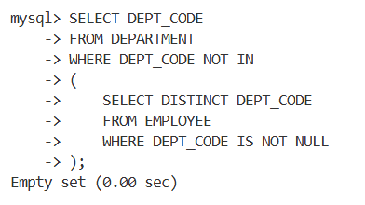
Question 29 : Find the department names where at least one employee works.
Query :
SELECT DISTINCT D.DEPT_NAME
FROM DEPARTMENT D JOIN EMPLOYEE E ON D.DEPT_CODE=E.DEPT_CODE;
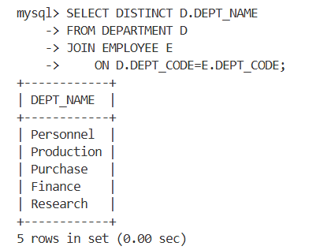

Question 30: Find the department names where at least 10 employees work.
Query :
SELECT D.DEPT_NAME
FROM DEPARTMENT D JOIN EMPLOYEE E ON D.DEPT_CODE=E.DEPT_CODE
GROUP BY D.DEPT_CODE,D.DEPT_NAME HAVING COUNT(*) >= 10;
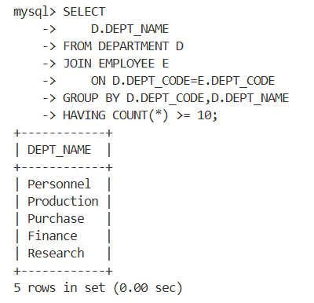
Question 31: Find the department code in which employee with highest Basic works.
Query :
SELECT DEPT_CODE FROM EMPLOYEE WHERE BASIC = (
SELECT MAX(BASIC)
FROM EMPLOYEE
);

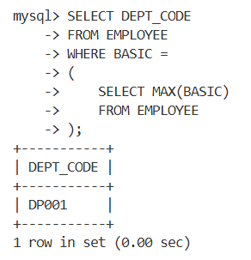
Question 32: Find the Designation description of the employee with highest basic.
Query :
SELECT D.DESIG_DESC
FROM EMPLOYEE E
JOIN DESIGNATION D
ON E.DESIG_CODE=D.DESIG_CODE
WHERE E.BASIC =
(
SELECT MAX(BASIC)
FROM EMPLOYEE
);
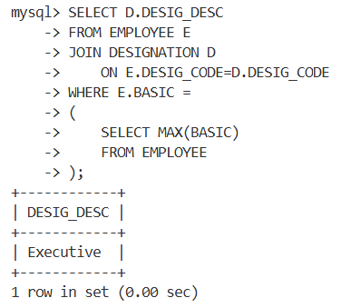

Question 33: Find the no. of managers in each department.
Query :
SELECT
E.DEPT_CODE,
COUNT(*) AS TOTAL_MANAGERS
FROM EMPLOYEE E
JOIN DESIGNATION D
ON E.DESIG_CODE=D.DESIG_CODE
WHERE D.DESIG_DESC='Manager'
GROUP BY E.DEPT_CODE;
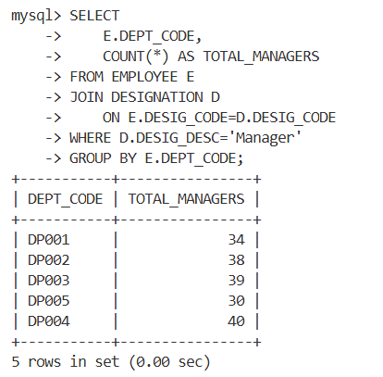
Question 34: Find the maximum basic from EMP table without using MAX().
Query :
SELECT BASIC AS MAX_BASIC
FROM EMPLOYEE
ORDER BY BASIC DESC
LIMIT 1;
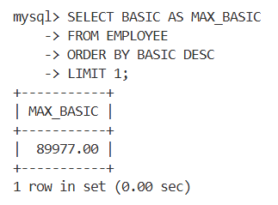
Question 35: Find the minimum basic from EMP table without using MIN().
Query :
SELECT BASIC AS MIN_BASIC
FROM EMPLOYEE
ORDER BY BASIC ASC
LIMIT 1;

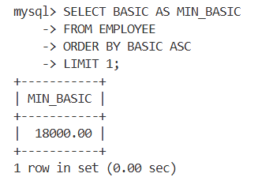
Question 36: Find the name of the department with highest total basic. Do the same for highest average basic and maximum no. of employee.
Query :
SELECT D.DEPT_NAME
FROM DEPARTMENT D JOIN EMPLOYEE E ON D.DEPT_CODE=E.DEPT_CODE
GROUP BY D.DEPT_CODE,D.DEPT_NAME
ORDER BY SUM(E.BASIC) DESC LIMIT 1;

SELECT D.DEPT_NAME
FROM DEPARTMENT D JOIN EMPLOYEE E ON D.DEPT_CODE=E.DEPT_CODE
GROUP BY D.DEPT_CODE,D.DEPT_NAME
ORDER BY AVG(E.BASIC) DESC LIMIT 1;

SELECT D.DEPT_NAME
FROM DEPARTMENT D JOIN EMPLOYEE E ON D.DEPT_CODE=E.DEPT_CODE
GROUP BY D.DEPT_CODE,D.DEPT_NAME
ORDER BY COUNT(*) DESC LIMIT 1;

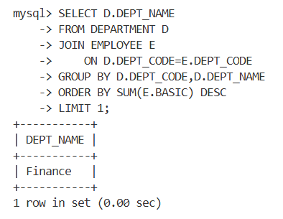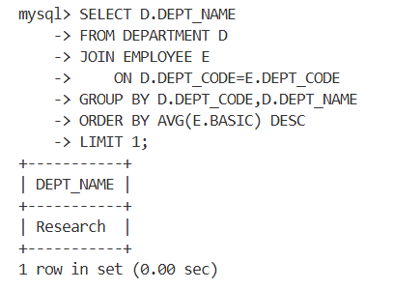

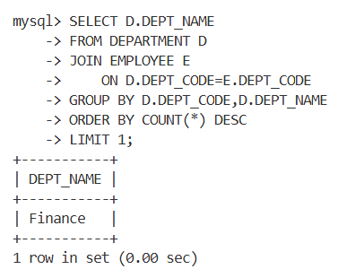

Question 37: Insert same rows into EMP table with designation code not existing in DESIGNATION table.
Query :
INSERT INTO EMPLOYEE
VALUES
('E100','Test User','DP001','D999','M',
'ABC Road','Kolkata','WB','700001',
30000,'2024-01-01');

After droping the foreign key :
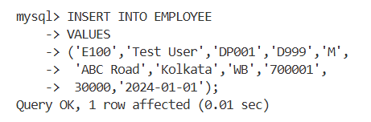

Question 38: Delete the rows from EMP table with invalid DESIG_CODE.
Query :
DELETE FROM EMPLOYEE WHERE DESIG_CODE NOT IN (
SELECT DESIG_CODE
FROM DESIGNATION
);
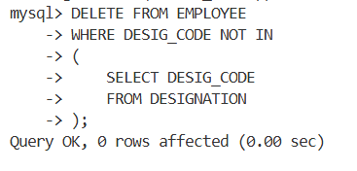

Question 39: Find the name of the female employees with basic greater than the average basic of their respective department.
Query :
SELECT E1.EMP_NAME FROM EMPLOYEE E1 WHERE E1.SEX='F' AND E1.BASIC > (
SELECT AVG(E2.BASIC)
FROM EMPLOYEE E2
WHERE E2.DEPT_CODE=E1.DEPT_CODE
);
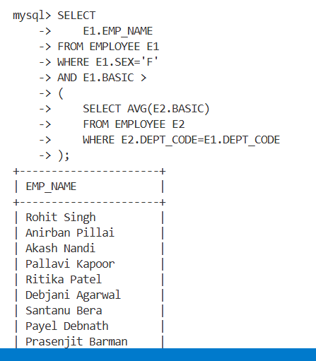

Question 40: Find the number of female managers.
Query :
SELECT COUNT(*) AS FEMALE_MANAGERS FROM EMPLOYEE E JOIN DESIGNATION D ON E.DESIG_CODE=D.DESIG_CODE WHERE E.SEX='F' AND D.DESIG_DESC='Manager';
