Question 52: Accept an employee code from user . Find the name of the employee from EMP table. If the employee is not existing then indicate it through a suitable message.
Query :
SET SERVEROUTPUT ON;
SET VERIFY OFF;
ACCEPT S_ECODE CHAR PROMPT 'Enter Employee Code : '
DECLARE
V_ENAME EMP.ENAME%TYPE;
BEGIN
SELECT ENAME INTO V_ENAME FROM EMP WHERE ECODE='&S_ECODE';
DBMS_OUTPUT.PUT_LINE('Employee Name : '||V_ENAME);
EXCEPTION
WHEN NO_DATA_FOUND THEN
DBMS_OUTPUT.PUT_LINE('NO EMPLOYEE WITH ID : &S_ECODE.');
WHEN OTHERS THEN
DBMS_OUTPUT.PUT_LINE(SQLERRM);
END;
/

Code :
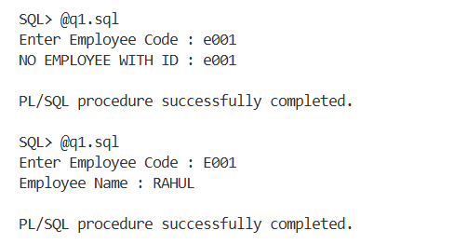

Question 53: Write a PL / SQL block to add row in EMP table . If employee code is duplicate/dept code is not present in DEPT table then message is to be shown &amp; row can not be added.
Query :
SET SERVEROUTPUT ON;
SET VERIFY OFF;
ACCEPT T_ECODE CHAR PROMPT 'Employee Code : '
ACCEPT T_ENAME CHAR PROMPT 'Employee Name : '
ACCEPT T_DCODE CHAR PROMPT 'Department Code : '
ACCEPT T_GRADE CHAR PROMPT 'Grade : '
ACCEPT T_BASIC NUMBER PROMPT 'Basic Salary : '
ACCEPT T_JNDT CHAR PROMPT 'Joining Date (DD-MON-YYYY) : '
DECLARE
VAR_COUNT NUMBER;
DUPLICATE_EMP EXCEPTION;
DEPT_NOT_EXISTS EXCEPTION;
BEGIN
SELECT COUNT(*) INTO VAR_COUNT FROM EMP WHERE ECODE='&T_ECODE';
IF VAR_COUNT>0 THEN
RAISE DUPLICATE_EMP;
ELSE
SELECT COUNT(*) INTO VAR_COUNT FROM DEPT WHERE DCODE='&T_DCODE';
IF VAR_COUNT=0 THEN
RAISE DEPT_NOT_EXISTS;
ELSE
INSERT INTO EMP VALUES('&T_ECODE','&T_ENAME','&T_DCODE','&T_GRADE',&T_BASIC,TO_DATE('&T_JNDT','DD-MON-YYYY'));
COMMIT;
DBMS_OUTPUT.PUT_LINE('RECORD INSERTED.');
END IF;
END IF;
EXCEPTION
WHEN DUPLICATE_EMP THEN
DBMS_OUTPUT.PUT_LINE('EMPLOYEE EXISTS WITH ECODE : &T_ECODE.');
WHEN DEPT_NOT_EXISTS THEN
DBMS_OUTPUT.PUT_LINE('DEPATMENT DOES NOT EXISTS WITH DCODE : &T_DCODE.');
WHEN OTHERS THEN
DBMS_OUTPUT.PUT_LINE(SQLERRM);
END;
/

Code :
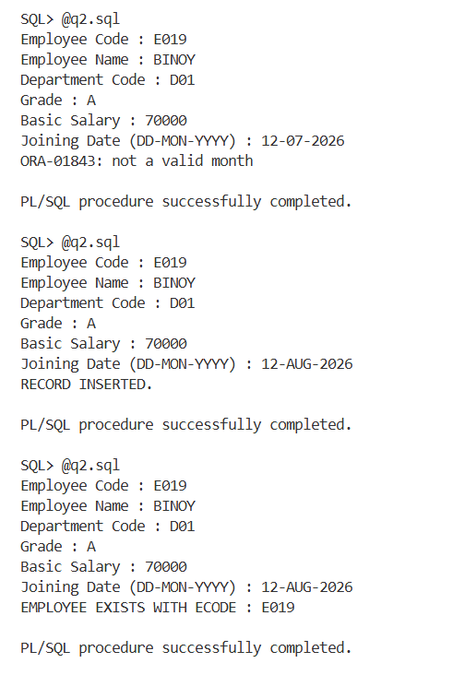

Question 54: From the EMP table find the name of top 5 (according to basic salary) employees.
Query :
SET SERVEROUTPUT ON;
SET VERIFY OFF;
DECLARE
VAR_COUNT NUMBER;
BEGIN
SELECT COUNT(*) INTO VAR_COUNT FROM EMP;
IF VAR_COUNT<5 THEN
FOR R IN (SELECT * FROM EMP) LOOP
DBMS_OUTPUT.PUT_LINE(RPAD(R.ENAME,20)||' '||R.BASIC);
END LOOP;
DBMS_OUTPUT.PUT_LINE('TABLE HAVE '||VAR_COUNT||' ROWS.');
ELSE
DBMS_OUTPUT.PUT_LINE('TOP 5 EMPLOYEES');
FOR R IN ( SELECT * FROM ( SELECT ENAME, BASIC FROM EMP ORDER BY BASIC DESC ) WHERE ROWNUM<=5) LOOP
DBMS_OUTPUT.PUT_LINE(RPAD(R.ENAME,20)||' '||R.BASIC);
END LOOP;
END IF;
EXCEPTION
WHEN OTHERS THEN
DBMS_OUTPUT.PUT_LINE(SQLERRM);
END;
/

Code :
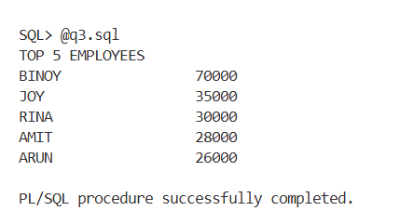

Question 55: Accept a department code from the user . Delete all the employee rows with that department code. Show how many rows have been deleted.
Query :
SET SERVEROUTPUT ON;
SET VERIFY OFF;
ACCEPT T_DCODE CHAR PROMPT 'Enter Department Code : '
DECLARE
VAR_COUNT NUMBER;
NO_EMP_FOUND EXCEPTION;
BEGIN
DELETE FROM EMP WHERE DCODE='&T_DCODE';
VAR_COUNT := SQL%ROWCOUNT;
IF VAR_COUNT = 0 THEN
RAISE NO_EMP_FOUND;
END IF;
COMMIT;
DBMS_OUTPUT.PUT_LINE(VAR_COUNT || ' row(s) deleted.');
EXCEPTION
WHEN NO_EMP_FOUND THEN
DBMS_OUTPUT.PUT_LINE('NO EMPLOYEE FOUND IN DEPARTMENT &T_DCODE.');
WHEN OTHERS THEN
DBMS_OUTPUT.PUT_LINE(SQLERRM);
END;
/

Code :
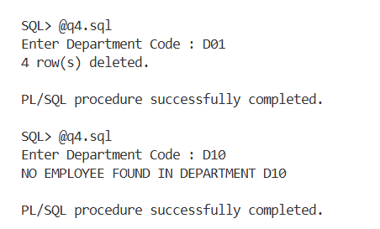

Question 56: Consider the following tables:

Table: ORDERMAST
Structure:
ORDER_NO CHAR(5) primary key
ORDER_DT DATE

Table: ORDERDETAILS
Structure:
ORDER_NO CHAR(5)
ITEM_NO CHAR(5)
QTY NUMBER
ORDER_NO + ITEM_NO is primary key

Table: DELIVERYMAST
Structure:
DELV_NO CHAR(5) primary key
ORDER_NO CHAR(5)
DELV_DT DATE

Table: DELIVERY_DETAILS
Structure:
DELV_NO CHAR(5)
ITEM_NO CHAR(5)
QTY NUMBER
DELV_NO+ITEM_NO is primary key

Write a PL/SQL block which accepts two dates &amp; find the information of the pending delivery for the orders placed between the two dates supplied by the user. Note, an order can have request for multiple items. Against an order, multiple delivery with partial
shipment is possible.
Query :
SET SERVEROUTPUT ON;
SET VERIFY OFF;
SET LINESIZE 200;

ACCEPT T_FROM CHAR PROMPT 'Enter From Date (DD-MON-YYYY): '
ACCEPT T_TO CHAR PROMPT 'Enter To Date (DD-MON-YYYY): '

DECLARE
BEGIN
DBMS_OUTPUT.PUT_LINE('PENDING DELIVERY REPORT');
DBMS_OUTPUT.PUT_LINE('-----------------------');
FOR R IN
(
SELECT
OD.ORDER_NO,
OD.ITEM_NO,
OD.QTY AS ORDER_QTY,
NVL(SUM(DD.QTY),0) AS DELIVERED_QTY,
OD.QTY - NVL(SUM(DD.QTY),0) AS PENDING_QTY
FROM ORDERMAST OM JOIN ORDERDETAILS OD
ON OM.ORDER_NO = OD.ORDER_NO
LEFT JOIN DELIVERYMAST DM
ON OM.ORDER_NO = DM.ORDER_NO
LEFT JOIN DELIVERY_DETAILS DD
ON DM.DELV_NO = DD.DELV_NO AND OD.ITEM_NO = DD.ITEM_NO
WHERE OM.ORDER_DT BETWEEN
TO_DATE('&T_FROM','DD-MON-YYYY')
AND TO_DATE('&T_TO','DD-MON-YYYY')
GROUP BY
OD.ORDER_NO,
OD.ITEM_NO,
OD.QTY
HAVING
OD.QTY - NVL(SUM(DD.QTY),0) > 0
ORDER BY
OD.ORDER_NO,
OD.ITEM_NO
)
LOOP
DBMS_OUTPUT.PUT_LINE(
'ORDER NO : ' || R.ORDER_NO ||
' ITEM NO : ' || R.ITEM_NO ||
' ORDERED QTY : ' || R.ORDER_QTY ||
' DELIVERED QTY : ' || R.DELIVERED_QTY ||
' PENDING : ' || R.PENDING_QTY
);
END LOOP;
END;
/

Code :
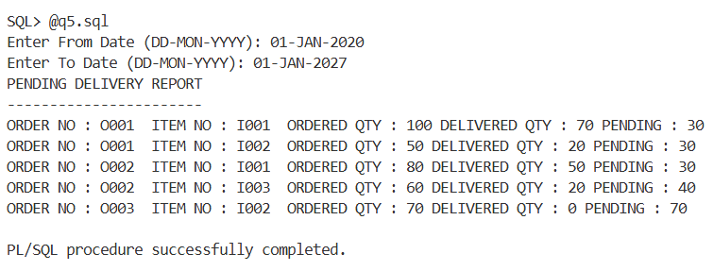

Question 57: Assume a LEAVE table with emp_no,month,no._of_days.
For each employee find the effective basic for the current month as per the formula given below:
BASIC - (BASIC * no. of leave days in the month)/no. of days in that month.
Query :
SET SERVEROUTPUT ON;
SET VERIFY OFF;

DECLARE
VAR_DAYS NUMBER;
BEGIN
VAR_DAYS := TO_NUMBER(TO_CHAR(LAST_DAY(SYSDATE),'DD'));
DBMS_OUTPUT.PUT_LINE('EFFECTIVE BASIC REPORT');
DBMS_OUTPUT.PUT_LINE('----------------------');
FOR R IN
(
SELECT
E.ECODE,
E.ENAME,
E.BASIC,
NVL(L.NO_OF_DAYS,0) LEAVE_DAYS,
E.BASIC -(E.BASIC * NVL(L.NO_OF_DAYS,0) / VAR_DAYS) EFFECTIVE_BASIC
FROM EMP E LEFT JOIN LEAVE_TAB L ON E.ECODE = L.EMP_NO
AND L.MONTH_NAME = TO_CHAR(SYSDATE, 'MON') ORDER BY E.ECODE
)
LOOP
DBMS_OUTPUT.PUT_LINE(
R.ECODE||' '||
RPAD(R.ENAME,20)||' '||
'EFFECTIVE BASIC = '||
ROUND(R.EFFECTIVE_BASIC,2)
);
END LOOP;
END;
/

Code :
