Question 47:
- Create EMP table with ECODE(primary key), ENAME, DCODE, GRADE, BASIC & JN-DT as the columns.[except BASIC & JN-DT,all columns are of char type and site of Grade is 1.]
Query :
create table emp( ecode char(4) primary key, ename varchar(40), dcode char(4), grade char(1), basic decimal(9,2), jn_dt date);
Output :
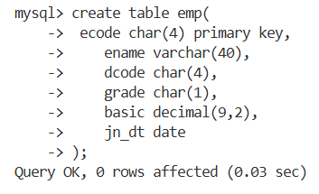
b)Insert number of rows.
Query :
INSERT INTO EMP (ECODE, ENAME, DCODE, GRADE, BASIC, JN_DT) VALUES
('E001','RAHUL','D001','A',50000.00,'2022-01-15'),
('E002','AMIT','D002','B',45000.00,'2021-06-20'),
('E003','PRIYA','D001','A',55000.00,'2020-03-10'),
('E004','SNEHA','D003','C',35000.00,'2023-02-05'),
('E005','ROHAN','D002','B',48000.00,'2021-11-18'),
('E006','ANITA','D004','A',62000.00,'2019-08-12'),
('E007','VIKAS','D003','B',42000.00,'2020-12-01'),
('E008','POOJA','D001','A',58000.00,'2022-07-25'),
('E009','ARJUN','D005','C',33000.00,'2023-04-11'),
('E010','NEHA','D002','B',47000.00,'2021-09-14'),
('E011','KARAN','D004','A',61000.00,'2018-11-30'),
('E012','RITU','D005','C',36000.00,'2024-01-20'),
('E013','MOHAN','D003','B',44000.00,'2020-05-08'),
('E014','NISHA','D001','A',59000.00,'2022-03-19'),
('E015','DEEPAK','D002','B',49000.00,'2021-10-27'),
('E016','SONALI','D004','A',65000.00,'2019-02-16'),
('E017','MANOJ','D005','C',34000.00,'2023-08-09'),
('E018','KAVITA','D003','B',43000.00,'2020-06-22'),
('E019','AJAY','D001','A',57000.00,'2022-12-05'),
('E020','MEENA','D002','B',46000.00,'2021-04-17');

Output :
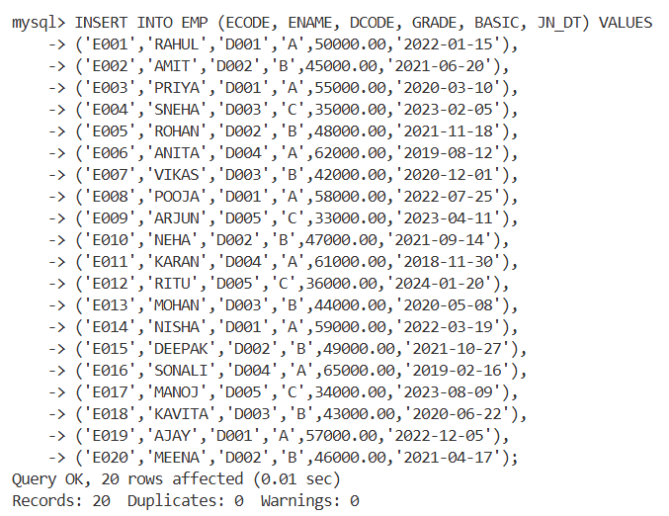
Question 48 : change the column heading as shown below, So that in subsequent SELECT statement newly set heading will be shown:
ECODE EMPLOYEE CODE
ENAME NAME
DCODE DEPT.CODE
JN-DT JONING DATE
Query :
SELECT
ECODE AS 'EMPLOYEE CODE',
ENAME AS 'NAME',
DCODE AS 'DEPT.CODE',
JN_DT AS 'JOINING DATE'
FROM EMP;

Output :
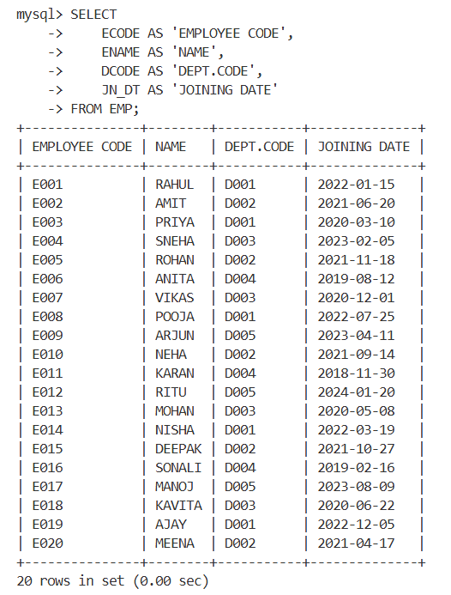

Question 49: Set the format of columns as mentioned below, So that in subsequent SELECT statement ,values appear in the specified format:
*format of BASIC is such that a value of 7000 will be shown as7,000
*Format of GRADE will be such that full column name appears in the display.
*For JN-DT format is such that 01-JAN-00 will be shown as JANURY 01,2000
Query :
SELECT
ECODE AS 'EMPLOYEE CODE',
ENAME AS 'NAME',
DCODE AS 'DEPT.CODE',
GRADE AS 'GRADE',
FORMAT(BASIC,0) AS 'BASIC',
DATE_FORMAT(JN_DT,'%M %d,%Y') AS 'JOINING DATE'
FROM EMP;

Output :
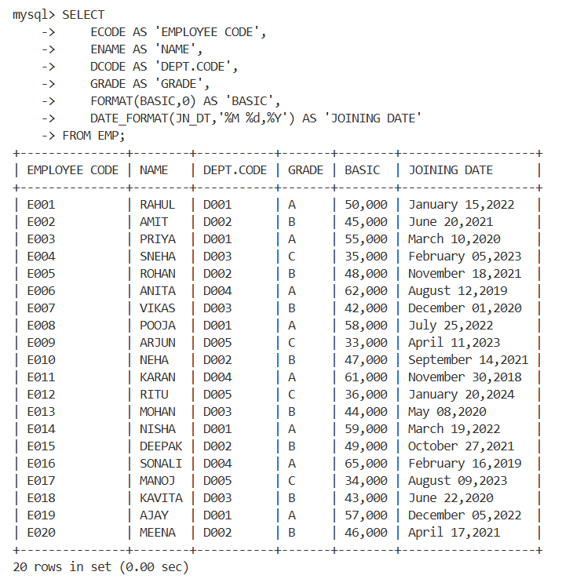

Question 50:
a) Show the display attributes of all the columns.
b) Show the display attributes of particular column.
c) Suppress the newly set attributes of JN-DT .Try a select statement.
d) Reset the newly set attributes of JN-DT
e) Reset the newly set attributes of all columns.
f) Shown the display attributes of all columns.
Query :
DESCRIBE EMP;

Output :
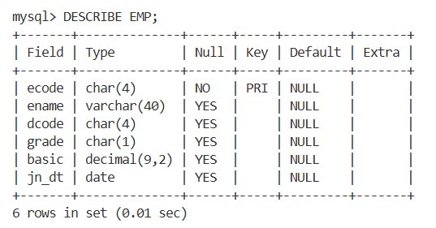

Question 51:
- Show the records from EMP table in the ascending order of DCODE . DCODE value will be shown only for the first record of that department (same of DCODE is not repeated)
Query :
SELECT * FROM EMP ORDER BY DCODE;

Output :
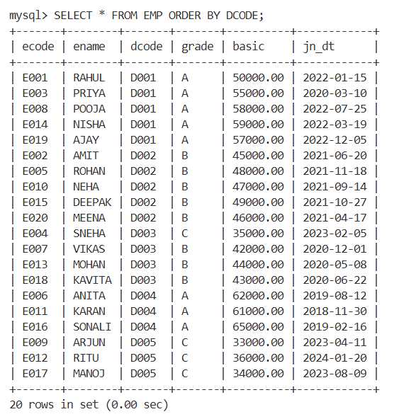

b) Further take measures so that ,after displaying the records of a department it skips one line .
c)Further take measures so that records one also ordered on the basic of GRADE with in a department & same GRADE value is not repeated.
Query :
SELECT * FROM EMP ORDER BY DCODE, GRADE;

Output :
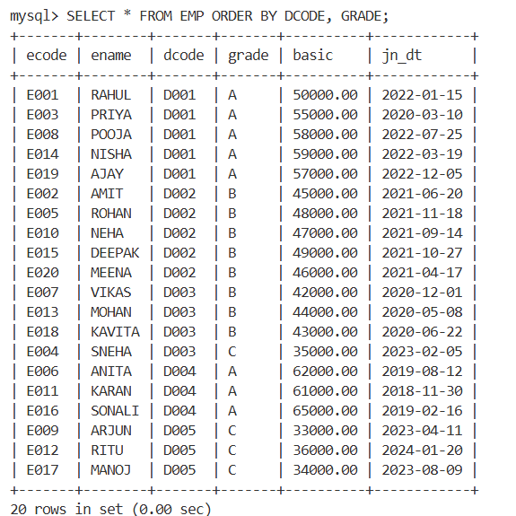
d) Take measure so that at the end of each GRADE in a department it will show average Basic for that grade in that department. At the end of each department, it will show the average & total Basic for the department. At the end of all departments it will show the overall total basic & average basic.
Query :
SELECT
DCODE,
GRADE,
AVG(BASIC) AS AVG_BASIC
FROM EMP
GROUP BY DCODE, GRADE
ORDER BY DCODE, GRADE;

Output :
