Mortality Project — Analysis Pictures
Visual outputs from the data science analysis

Objective 2: Distribution of Infant Mortality Rate
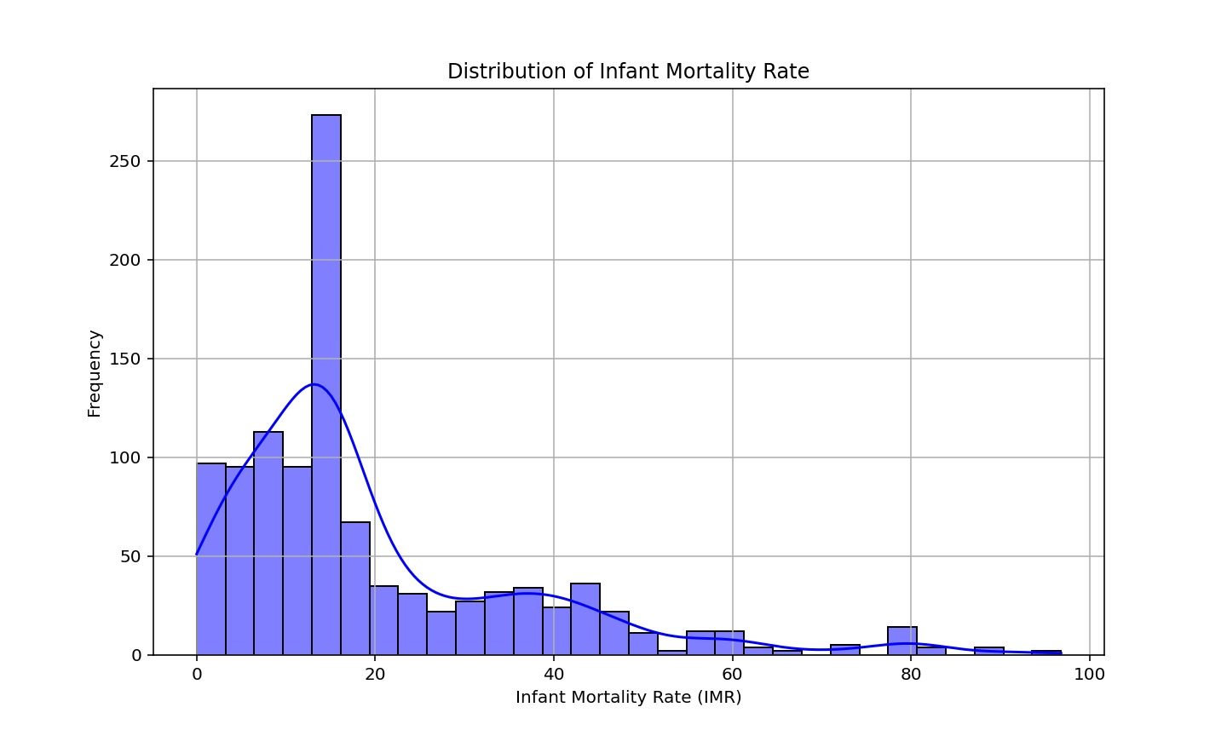
Figure 1: Objective 2: Distribution of Infant Mortality Rate

Objective 3: Correlation Matrix of Socio-Economic and Health Factors
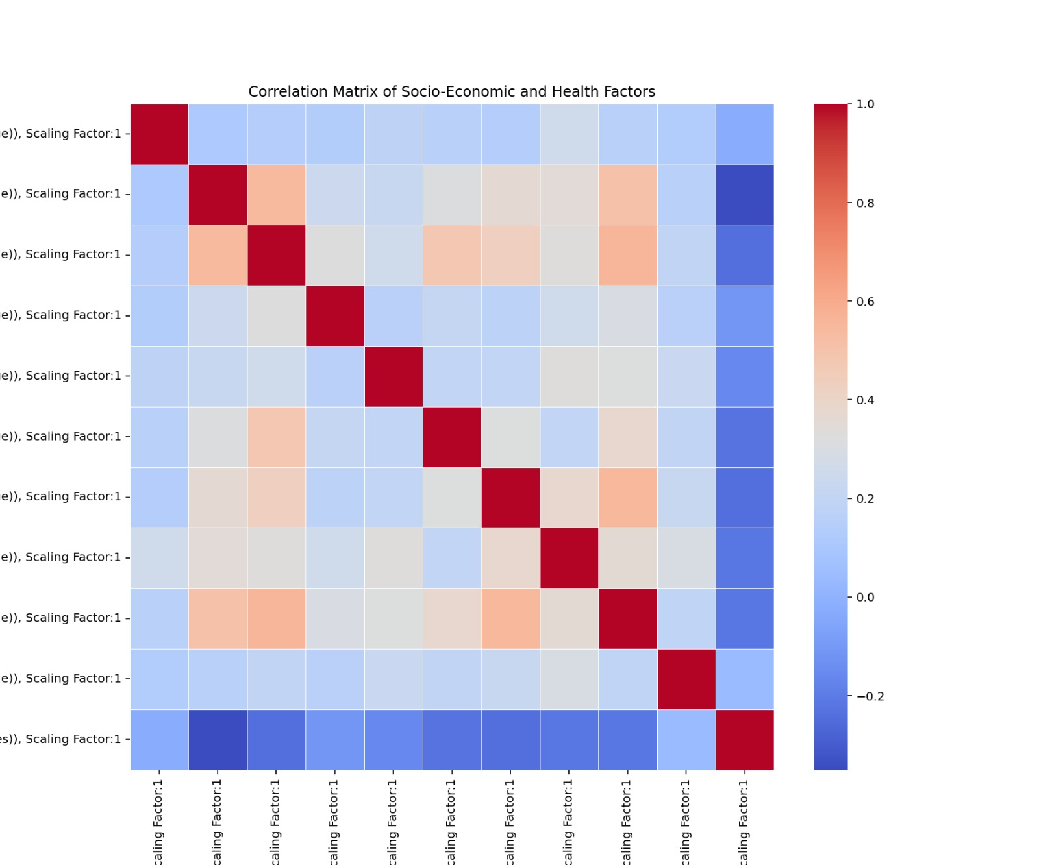
Figure 2: Objective 3: Correlation Matrix of Socio-Economic and Health Factors

Objective 4: Impact of Maternal Anemia on Infant Mortality
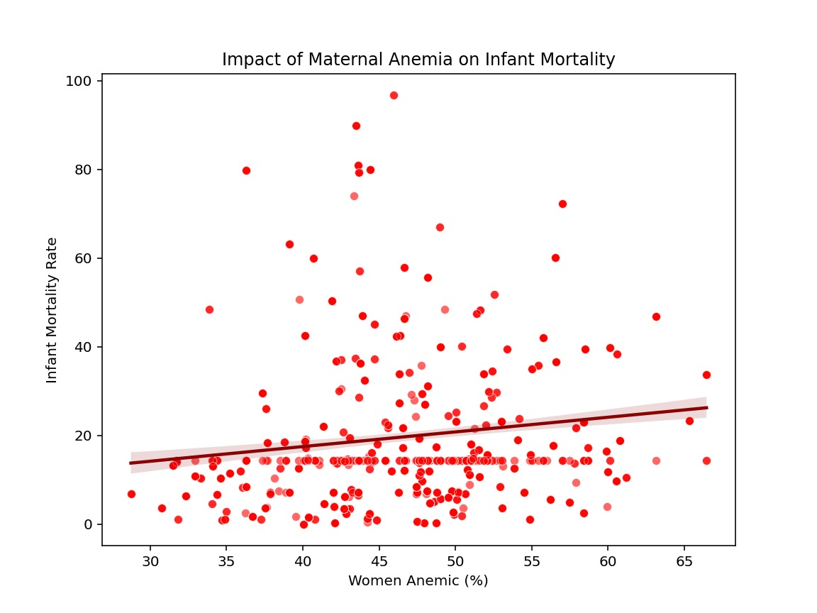
Figure 3: Objective 4: Impact of Maternal Anemia on Infant Mortality

Objective 5: Average Per Capita Income by District
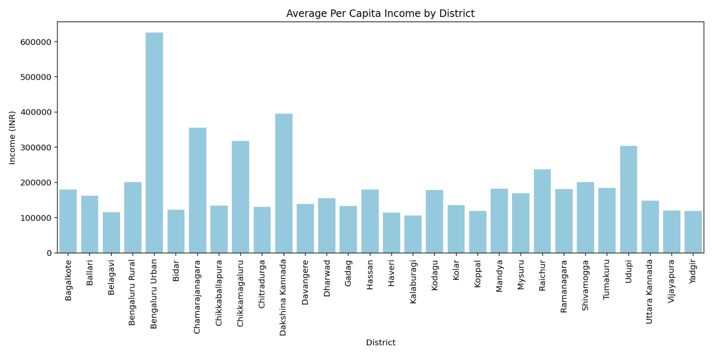
Figure 4: Objective 5: Average Per Capita Income by District

Objective 7: Top 10 Feature Importances for Predicting IMR
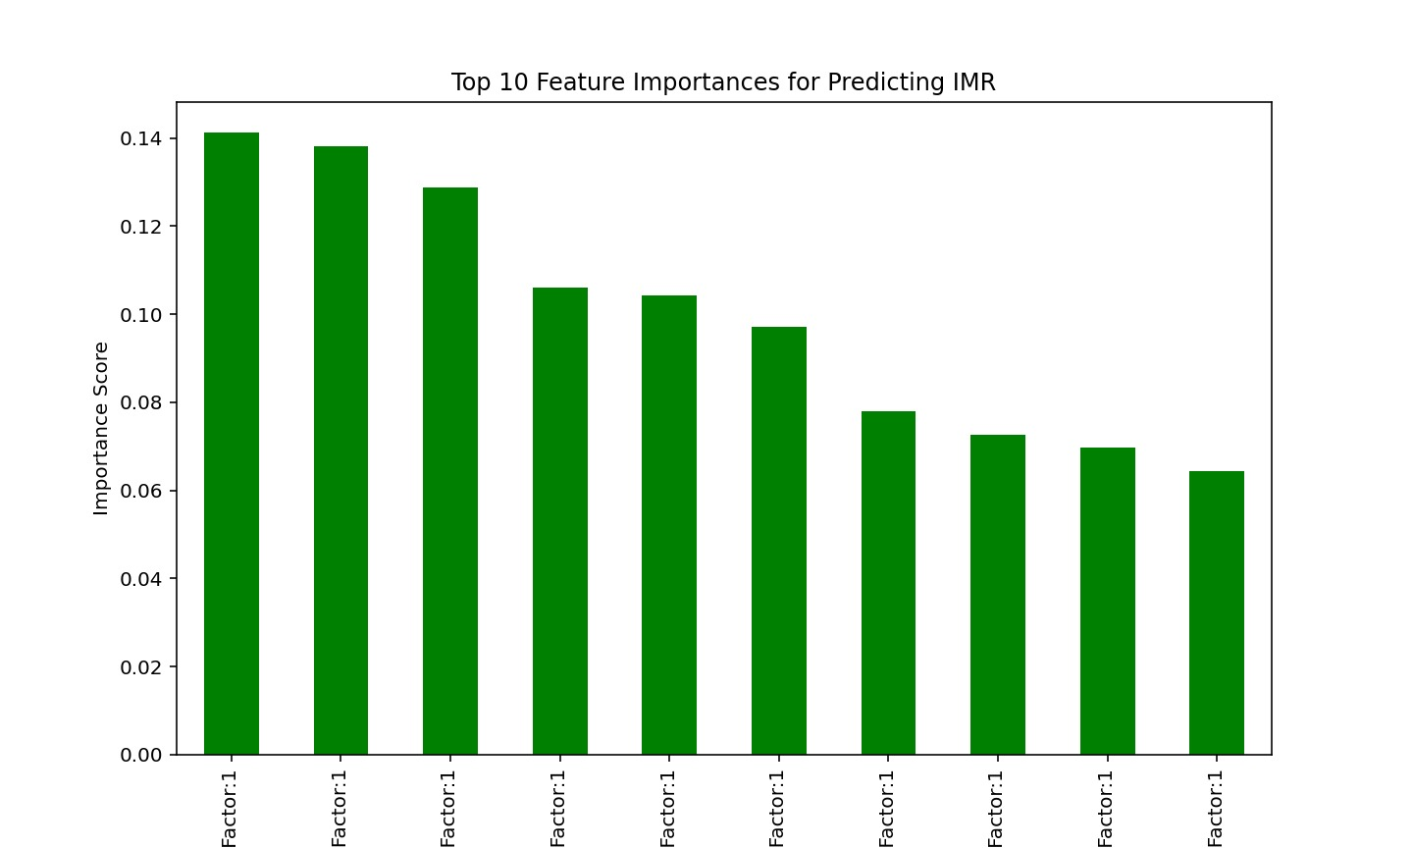
Figure 5: Objective 7: Top 10 Feature Importances for Predicting IMR

