**IDOR in Password Reset Form**

**dont-use-client-side**

Vulnerability Description:

The details are stored in the client side, so the information stored on the client side will get us to the flag.

Summary:

I the hint itself gives that we should not trust the client side. So, we get it by checking the source code of the webpage, where the flag is hidden, and the flag is shattered We should join the flag with the given hints.

Given below is the shattered flag. So we need to join and find it.

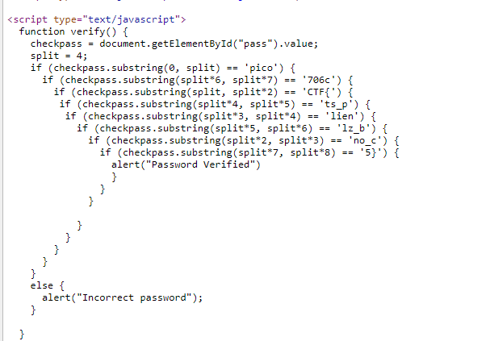

So the flag is: picoCTF{no_clients_plz_ee2f24}