**🌤️ Get Daily Weather & Send by Email**

This project automates fetching daily weather data for a city and sends it to your email every morning at **7:00 AM**.  
It uses OpenWeatherMap API for weather data and a simple SMTP email setup to deliver the report.

**📌 Features**

✅ **Daily Automation** – Runs automatically at 7:00 AM  
✅ **Live Weather Data** – Fetches temperature, humidity, and conditions  
✅ **Customizable City** – Change to any city you want  
✅ **Email Delivery** – Sends a nicely formatted daily report

**🛠️ Prerequisites**

Before using this workflow, make sure you have:

* **n8n (or a similar automation tool)** installed and running
* A **Gmail account** (or SMTP server credentials)
* A **free API key** from OpenWeatherMap

**⚙️ Setup Instructions**

**1️⃣ Step 1 – ScheduleTrigger (Cron Node)**

1. Add a **Cron Node** in your workflow.
2. Configure it as:
   * **Mode:** Every Day
   * **Hour:** 7
   * **Minute:** 0

This ensures the workflow runs daily at **7:00 AM**.

💡 **Tip:** You can test it by clicking **Execute Node** to run immediately.

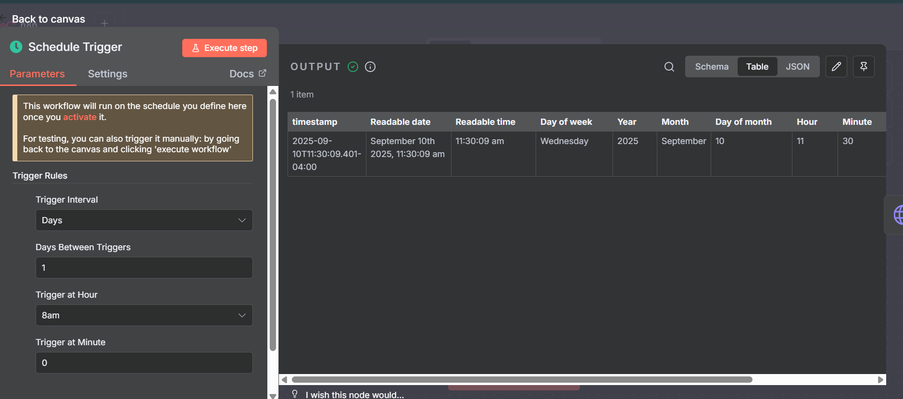

**2️⃣ Step 2 – Fetch Weather (HTTP Request Node)**

1. Add an **HTTP Request Node**.
2. Configure it as:
   * **Method:** GET
   * **URL:**
   * https://api.openweathermap.org/data/2.5/weather?q=YOUR_CITY&appid=YOUR_API_KEY&units=metric
3. Replace:
   * YOUR_CITY → e.g. Hyderabad
   * YOUR_API_KEY → Your OpenWeatherMap API key
4. Keep **Response Format: JSON** (default).

✅ **Test Node:** Click **Execute Node** – You should see JSON output with name, main.temp, main.humidity, etc.

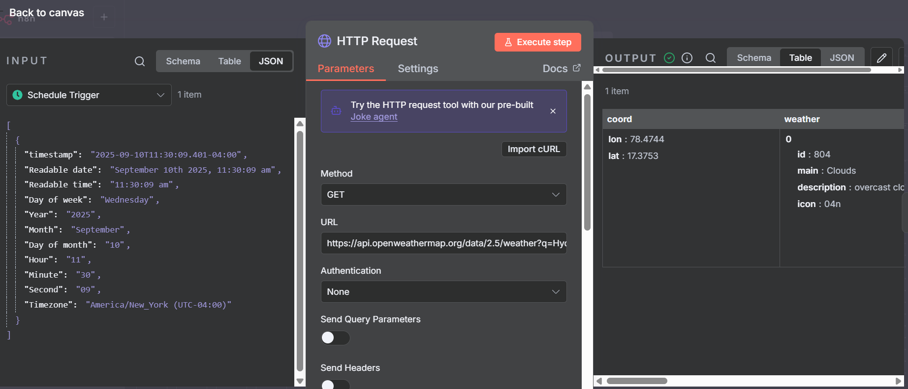

**3️⃣ Step 3 – Format Weather Data (Set Node)**

1. Add a **Set Node/Edit Fields**.
2. Configure a field:
   * **Name:** message
   * **Value (Expression):**
   * 🌤️ Today's weather in {{$json["name"]}}:<br>
   * {{$json["weather"][0]["description"]}}<br>
   * 🌡️ Temp: {{$json["main"]["temp"]}}°C<br>
   * 💧 Humidity: {{$json["main"]["humidity"]}}%

This extracts relevant fields and formats them for email.

✅ **Test Node:** Execute – you should see a message field with a clean weather summary.

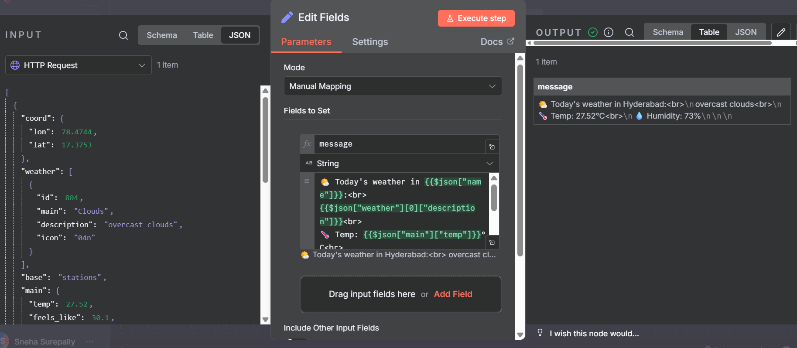

**4️⃣ Step 4 – Send Email (Gmail Node)**

1. Add a Gmail Node (not SMTP)
2. Under Credential to connect with, choose:
   * Gmail account (or click Create new credential to authorize n8n to access your Gmail using OAuth2)
3. Configure:
   * Resource: Message
   * Operation: Send
   * To: Your Gmail address (or any recipient)
   * Subject: Daily Weather Report
   * Message:
   * {{$json["message"]}}

✅ Test Node → You should receive the weather report in your inbox.

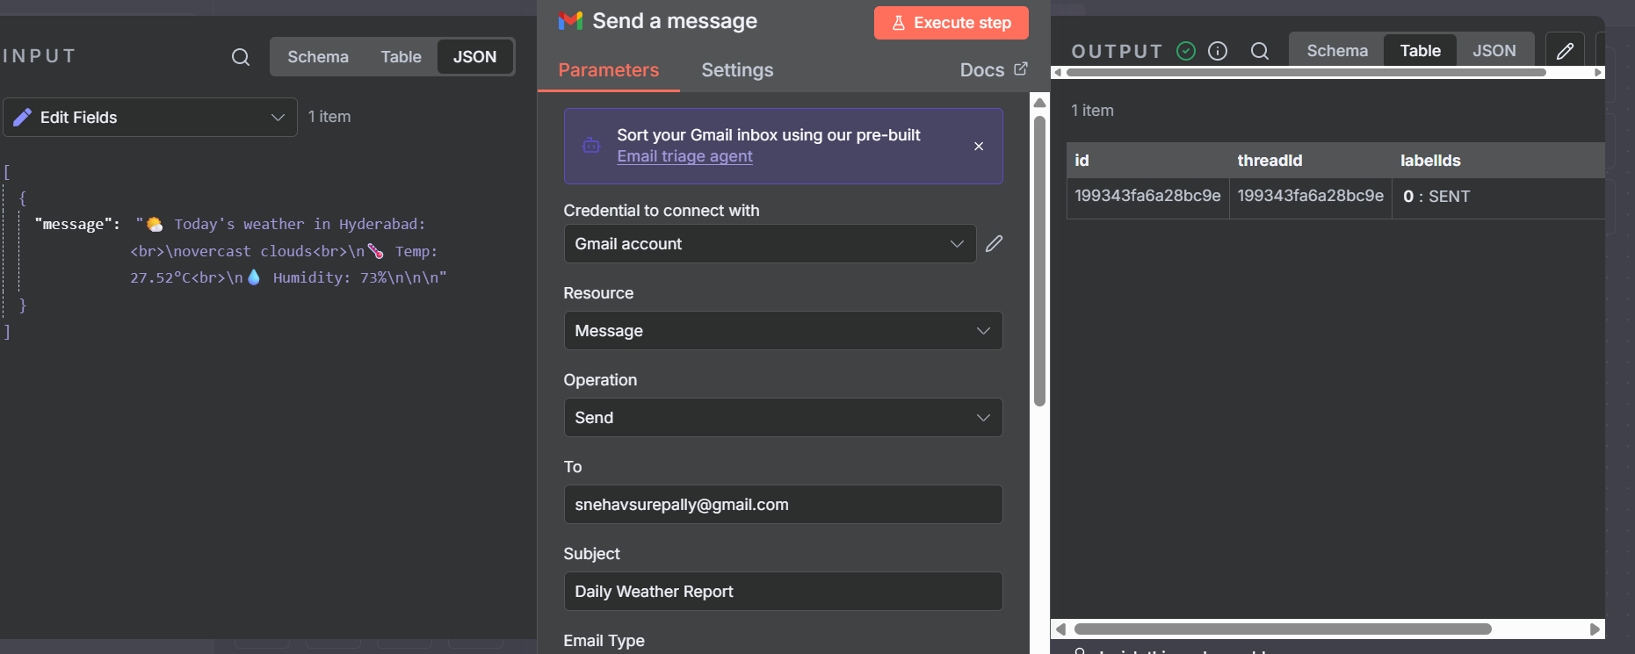

**5️⃣ Step 5 – Connect & Activate**

* Connect nodes in order:(drag the circle of first node to start of next node)  
  **Cron → HTTP Request → Set → Email**
* **Save** your workflow
* **Activate** it using the toggle (top right corner)

Your weather report will now be delivered **automatically every day at 7:00 AM! 🎉**

