ML Lab Week 10 SVM

SNEHA VERMA

PES1UG23AM309

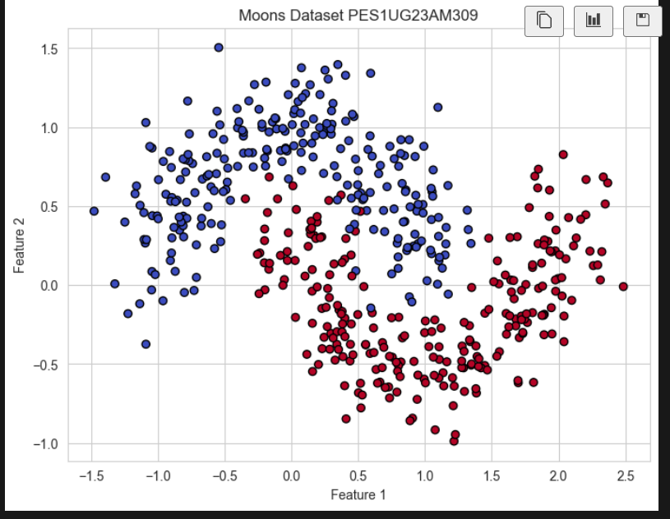

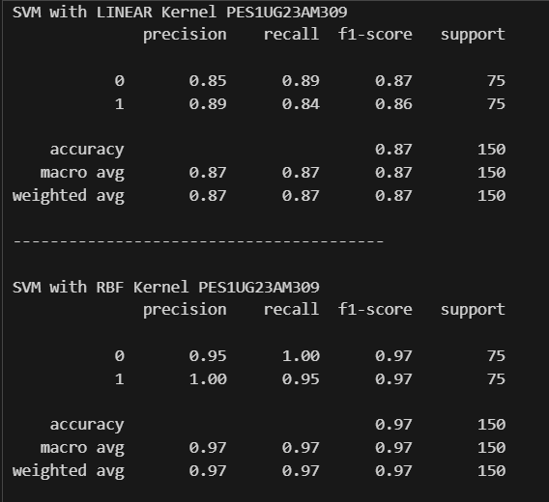

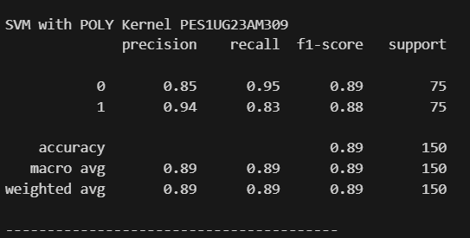

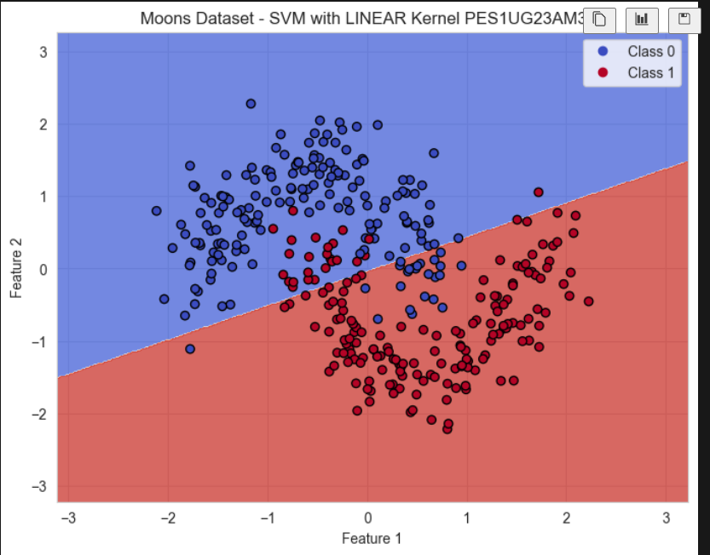

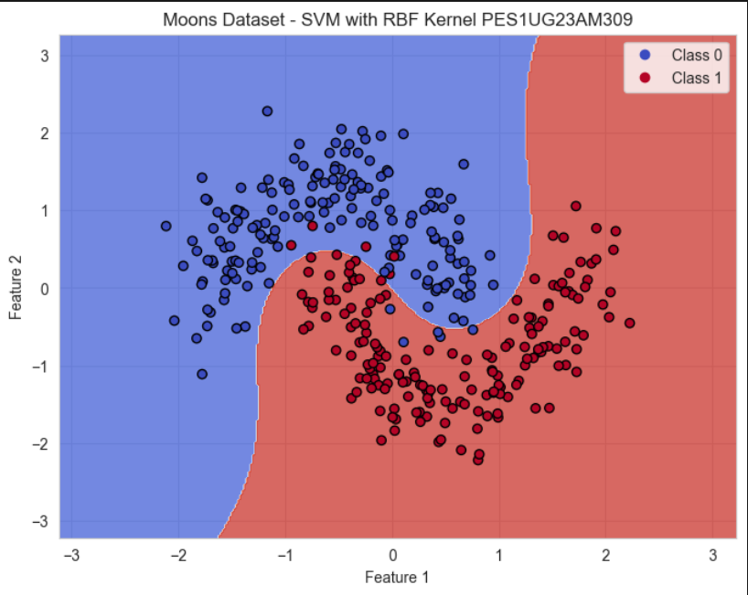

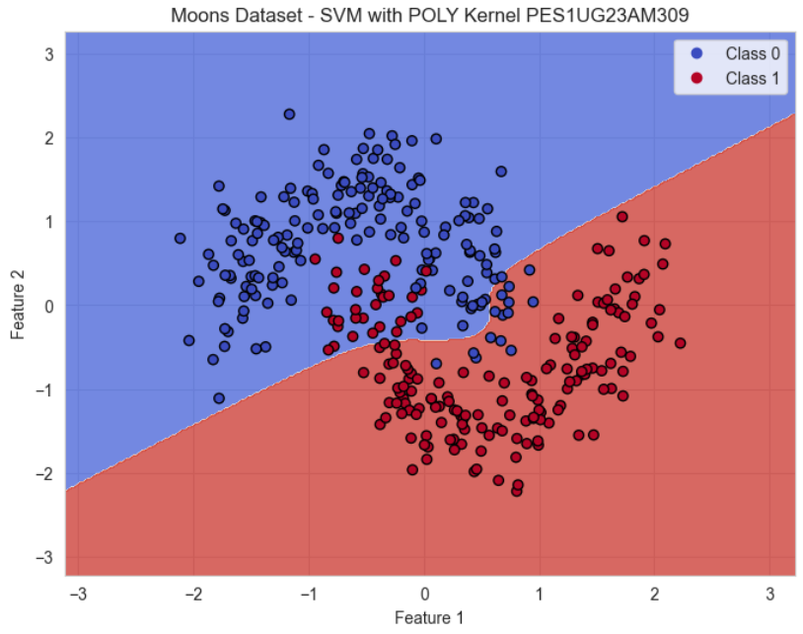

Analysis Questions for Moons:

1. Based on the metrics and the visualizations, what inferences about the performance of the Linear Kernel can you draw?

• The Linear Kernel achieves 87% accuracy but fails to separate the crescent-shaped clusters effectively.

• Its decision boundary is a straight line, which cannot capture the non-linear distribution of the Moons dataset, resulting in frequent misclassifications along the curved boundaries.

1. Compare the decision boundaries of the RBF and Polynomial kernels. Which one seems to capture the shape of the data more naturally?

Both the RBF and Polynomial kernels can handle non-linear decision boundaries, but the RBF kernel captures the moon-shaped data much more effectively. The RBF kernel is highly flexible and adapts smoothly to the curved clusters, giving a high accuracy of about 97%. In contrast, the Polynomial kernel only introduces limited curvature, which is not sufficient to fully separate the complex shapes, resulting in a lower accuracy of around 89%. Hence, the RBF kernel is better suited for this dataset as it naturally matches the underlying structure.

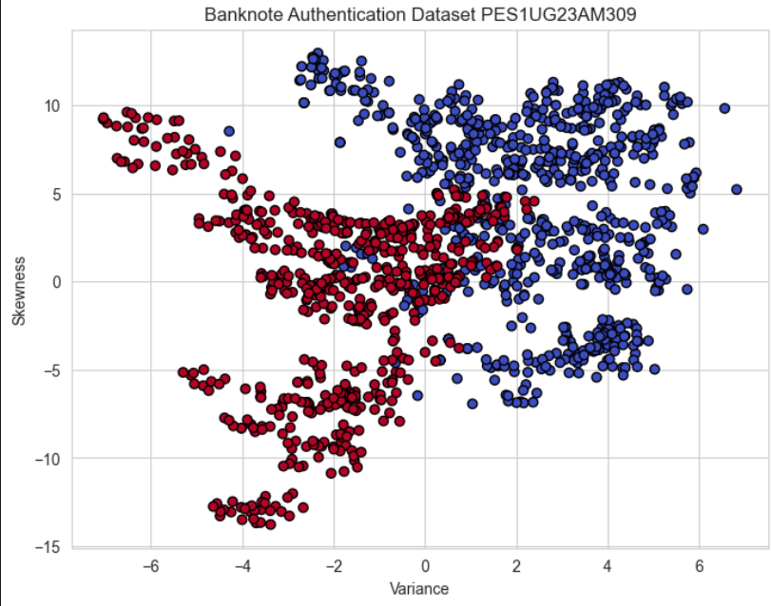

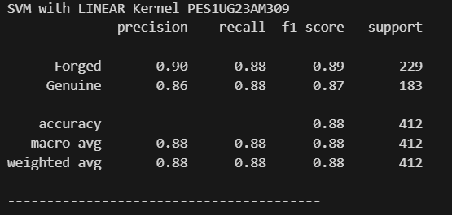

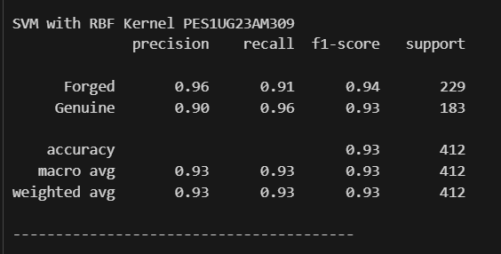

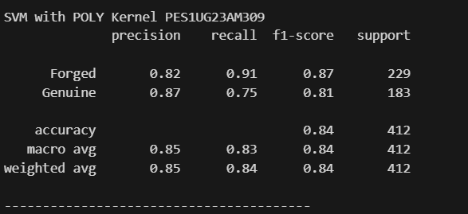

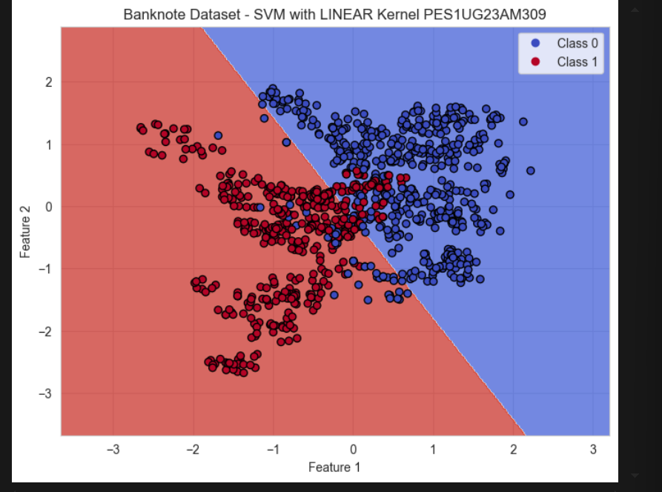

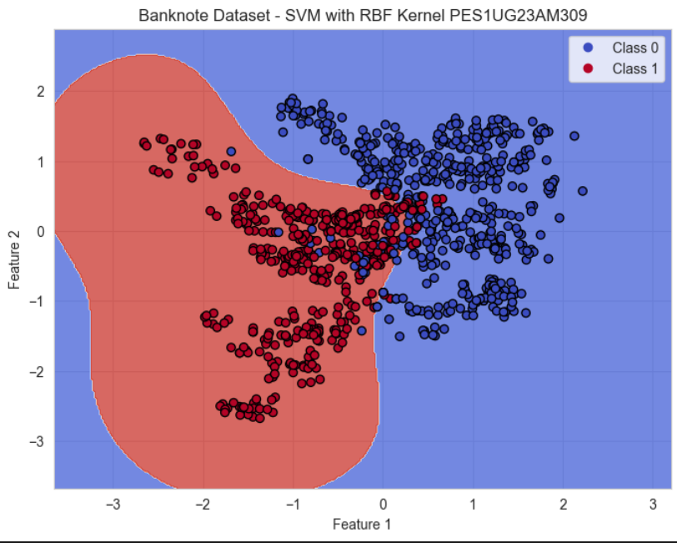

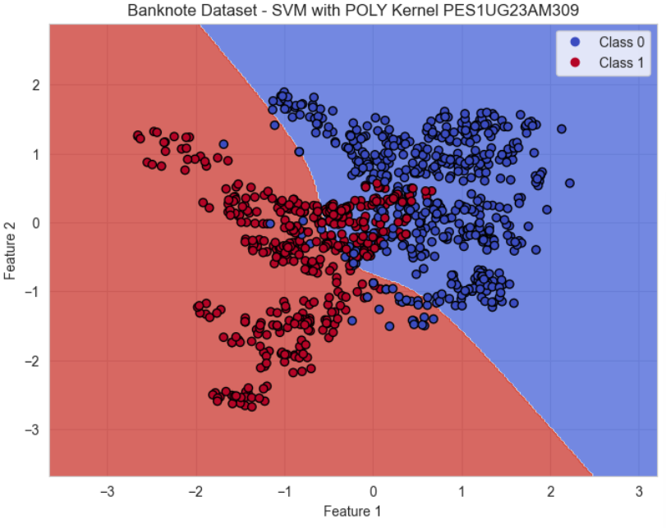

Analysis Questions for Banknote:

1. In this case, which kernel appears to be the most effective?

• The **RBF Kernel** is the most effective, achieving 93% accuracy.

• It outperforms the Linear (88%) and Polynomial (84%) kernels.

1. The Polynomial kernel shows lower performance here compared to the Moons dataset. What might be the reason for this?

•The Banknote dataset is largely **linearly separable.**

•The Polynomial kernel imposes curvature on the decision boundary, which leads to poorer generalization.

•This explains its performance drop (84%) compared to both Linear (88%) and RBF (93%).

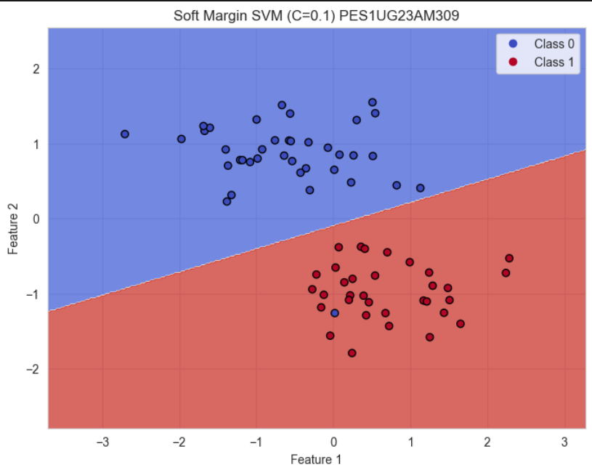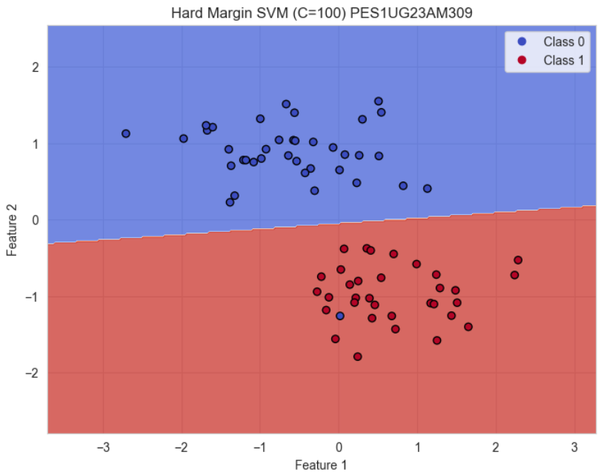

Analysis Questions

1. Compare the two plots. Which model, the "Soft Margin" (C=0.1) or the "Hard Margin" (C=100), produces a wider margin?

• The **Soft Margin (C=0.1)** produces a wider margin than the Hard Margin (C=100).

• The Hard Margin’s boundary is narrow and tightly fit to the data.

1. Look closely at the "Soft Margin" (C=0.1) plot. You'll notice some points are either inside the margin or on the wrong side of the decision boundary. Why does the SVM allow these "mistakes"? What is the primary goal of this model?

• The Soft Margin SVM permits some points inside the margin or on the wrong side of the decision boundary.

• Its objective is to **maximize margin width** and improve generalization, even at the cost of a few misclassifications.

• This makes it less sensitive to noise and outliers.

1. Which of these two models do you think is more likely to be overfitting to the training data? Explain your reasoning.

• The **Hard Margin (C=100)** is more prone to overfitting.

• It penalizes misclassification heavily, forcing the model to perfectly classify training points (including noisy data), reducing generalization ability.

1. Imagine you receive a new, unseen data point. Which model do you trust more to classify it correctly? Why? In a real-world scenario where data is often noisy, which value of C (low or high) would you generally prefer to start with?

• The Soft Margin (C=0.1) is more reliable for unseen data due to its broader, more general boundary.

• In real-world noisy datasets, a low C value is preferred initially, as it balances accuracy and robustness.