Expense Tracker – Python Mini Project
Project Title : Expense Tracker (Menu-Driven Python Application)
Description :
This project is a simple menu-driven Python console application designed to track daily expenses. It allows users to add new expenses, view all expenses, search expenses by category, and save expense data to a file .The project is developed using basic Python concepts taught in class.
Features :
- Add a new expense
- View all recorded expenses
- Search expenses by category
- Save expense records to a file
- Pre-filled expense data for easy testing
- Menu-driven and user-friendly interface
Concepts Used :
- Lists
- Dictionaries
- Functions
- While loop
- Conditional statements (if / elif / else)
- String methods (lower(), strip())
- List methods (append(), len())
- Dictionary methods (get(), keys(), values())
- Exception handling (try / except)
- File handling
- Importing standard Python modules

How to Run the Program :
- Ensure that Python is installed on your computer.
- Save the program file with the name.
- Open the file using any Python-supported editor such as IDLE, PyCharm, VS Code, or Thonny.
- Run the program by clicking the Run button in the editor or pressing the run option provided by the software.
- The menu will appear on the screen.
- Enter the required option number to perform actions like adding, viewing, or searching expenses.
Input Guidelines :
- Expense ID should be an integer
- Amount should be a numeric value
- Category should be entered as text (e.g., Food, Travel, Shopping)
- Enter menu options only from the given list
File Handling Details :
- Expense data is saved to a file named expenses.json
- The file is created automatically if it does not exist
- Data is stored in JSON format for easy readability and reuse
Testing and Screenshots :
Useful test Scenarios
- Viewing all Expenses
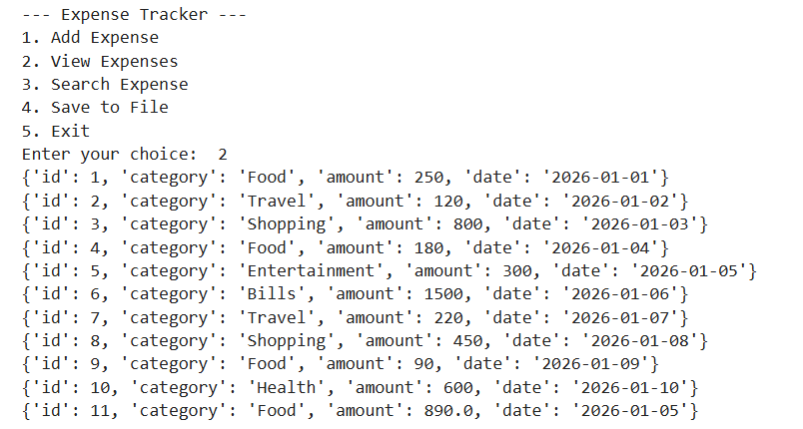

- Adding Expense
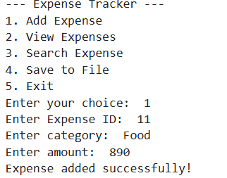

- Searching Expense
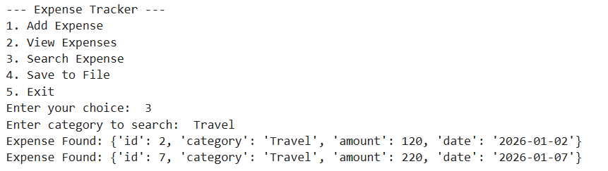

- Save to file
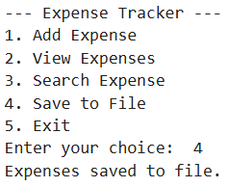

Author Information :
Name: Sneha V Prabhu
Course: AI & ML for Financial Services (MBA)
Assignment: Python Mini Project

