Creating a Lumped Model of the Myogenic Response to Increased Intraluminal Pressure

Sneh Talwar

1. **Introduction**

The myogenic mechanism, or myogenic response, is a standard regulatory response of the body which controls the diameter of blood vessels in response to changes in intraluminal pressure, or the pressure in blood vessels. The response of the system works to regulate blood flow by dilating or constricting the arteries for these surrounding changes. This mechanism has been thoroughly researched and studied, and many mathematical models have come from the abundance of research around this topic. Though physiological lumped models have been made, this paper attempts to create a simplistic computational and lumped model of the myogenic mechanism’s response to changes in pressure in the renal arteries. This will build off the work done in [1], where there are mathematical models, but no lumped models.

The myogenic response is commonly seen in the renal system [2], also called the urinary system. One area it is observed in is the kidney, where it takes part as one of the body’s autoregulation mechanisms [3], to counter the effects of blood pressure changes; it is present wherever there is smooth muscle tissue. This is a response to the development of myogenic tone, and tone “…is defined as a sustained state of contraction in a muscle. The word says nothing about the exact cellular events except that it is an active process in the contractile proteins,” [4]. Before the myogenic response is triggered, the myogenic tone reaches a certain threshold for activity, and then the myogenic regulation response starts. In the cerebral artery, the myogenic related responses can be broken down into three distinct phases: *Phase 1,*“The first, development of tone (myogenic tone; 40–60 mmHg), is characterized by substantial membrane depolarization, elevation of cytosolic calcium, constriction, accompanied by a reduction in wall tension. *Phase 2*, myogenic reactivity…” and phase 3 after vessels have become unstable because the pressure exceeds 140 mmHg, when the vessels undergo forced dilation – this leads to a loss of myogenic tone. [5].

The myogenic response is from the parasympathetic nervous system, because it reacts to changes in blood pressure, whose function is controlled by the sympathetic nervous system [6]. Both the parasympathetic and sympathetic nervous systems make up the autonomic nervous system, which controls and takes care of the involuntary actions and reactions of the body. The sympathetic nervous system, “controls the body's responses to a perceived threat and is responsible for the "fight or flight" response,” [6]. In other words, when talking about blood pressure and baroreceptors, baroreceptors regulate blood pressure when it fluctuates. As a result of the blood pressure changing, the blood vessels contract or dilate around the body, and the parasympathetic nervous system regulates this as a reaction. All these factors influence the role and reactive response of the myogenic mechanism and are important for understanding it.

Most of the research done on the myogenic effect is about measuring the diameter when there is increased intraluminal pressure in different arteries [7] with other varying parameters, and in some different species (i.e. rats, rabbits, etc.) [8]. Some lumped models about the myogenic response have been created, such as for cerebral blood flow [9]. A closely related study about the renal system also has been done but is more complex because it considers multiple nephrons separately, instead of lumping them [10]. In another previous study, calcium and chloride ions were involved, where they were studied to see if they may be related to triggering the myogenic response [11]. The research explained the ion channels and the role they play in varying artery diameter, showing that there are many possible triggers of the myogenic response, including transient receptor channels (TRPs) [12].

The goal of this research is to create a simplistic computational lumped model of the myogenic response in the renal system and to analyze the data on changes to a microvessel in the steady state and compare it to the previous study on the renal myogenic response in steady-state conditions. The data of mesenteric arterioles of rats from physiome.org on, “Vessel_Mechanics” [13] includes equations related to the vessel response, as well as many graphs constructed from the data, such as diameter versus pressure. The data from [1] includes transfer functions for modeling the response, which will be used to create the computational model to be put into Simulink.

1. **Methods and Materials**

*2.1 Schematic of the feedback system of the myogenic response*

There are two feedback mechanisms for autoregulation in the kidney: the tubuloglomerular feedback system and the myogenic mechanism. This paper focuses on the myogenic mechanism, for which a very simple feedback schematic has been made for understanding of the system, and as a preliminary step of making a simplistic lumped model. The reference for making this schematic was seen in a class at George Mason University: *Bioengineering 330: Computational Methods and Models* [] [14].

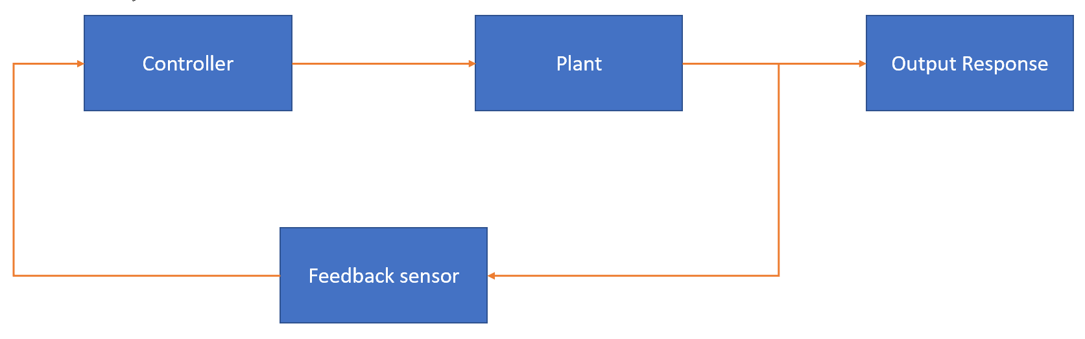

*Figure 1: Reference schematic feedback system diagram from BENG 330*

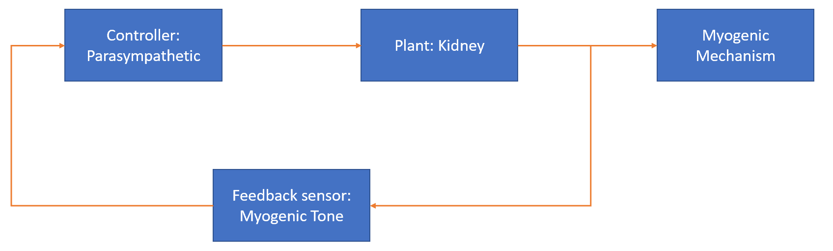

*Figure 2: Simplistic schematic of myogenic feedback response system*

In this model, the ‘Plant’ represents where the feedback system is taking place in the body. The ‘Feedback sensor’ is what triggers the response. This is a bit tricky for the myogenic response because it is a response in the smooth muscle tissue, and there isn’t a clear receptor like the baroreceptor in response to changes in blood pressure. When smooth muscle of the blood vessels stretch and open ion channels like transient receptor potential channels (TRPs) [12] the muscle depolarizes and contracts. This coincides with the myogenic tone in *Phase 1*, as defined earlier. The response to stretch is called the Bayliss effect [15]. For the purposes of this model and research, I have determined the feedback sensor to be myogenic tone which triggers the myogenic response. The ‘Controller’ is the parasympathetic nervous system, which is the controller of the reactions of the myogenic response.

*2.2 Setup and background for computational modeling in Simulink*

The data and JSIM model for ‘Vessel Mechanics’ describes, “how a microvessel responds to changes in intraluminal pressure in the steady state,” [13]. The set of data describes the equations and graphs they used in their model. The graphs include graphs for ‘Diameter-Pressure Response,’ ‘Stress-Strain Response,’ and ‘Tension-Length’. The data used in the Vessel Mechanics model uses data from the mesenteric arterioles of a rat [18], and the same set will be used in this model for simplicity and ease of use. With this data, the equations provided with the data, and other data which include mathematical representations of the myogenic response in the renal vasculature [16] [17], a computational model can be made in Simulink and MATLAB.

*2.3 Simulink computational model of myogenic response*

The transfer function for the model is as follows:

$$SigTot=\frac{P*D}{2*tWall}$$

*Equation 1: Transfer function for myogenic vessel mechanics model [13]*

To model the transfer function, a simulink model will be implemented:

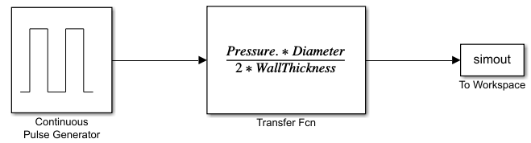

*Figure 3: Simulink model – components from left to right: a) continuous pulse generator block, b) SigTot; transfer function, c) to MATLAB workspace variable*

*2.4 Equations*

The transfer function is defined two ways: one as shown in equation 1, and the second way shows all the full underlying components and mechanisms.

SigTot = SigPass + (Act.*SigActMax)

*Equation 2: Transfer function with underlying components [13]*

SigPass is defined as the passive parts of the total signal being measured.

SigPass =(Cp1./WallThickness).*exp(Cp2*((Diameter./Dp100)-1))

*Equation 3: SigPass, a major component of the total signal [13]*

The parameters in this equation are defined as,

* “Cp1 is the passive tension at an intraluminal pressure of 100 mmHg,
* Cp2 describes the steepness of the exponential and
* Dp100 is the diameter of the vessel in a passive state at 100 mmHg,”

and where the WallThickness is an array of values at each Pressure, given by the dataset, as well the Diameter as each Pressure that was measured.

The next component of the full SigTot is the vascular smooth muscle cells (VSM) activation function, a value between [0 1]:

Act = 1 ./ (1 + exp(-Cmyo.*SigTot .* WallThickness + Ctone))

*Equation 4: The VSM activation function, which returns a value between 0-1, approximated as a sigmoidal function [13]*

In this function, the parameters are defined as:

* Cmyo – “determines the sensitivity of the VSM activation function to circumferential tension”
* Ctone – “base level of VSM tone that is in a vessel without these stimuli”
* SigTot – the original transfer function defined with pressure and diameter, defined in equation 1

Finally, the last component of the newly defined SigTot function in equation 2, is SigActMax. This is defined as, “the active stress generated by the VSM in a maximally activated state.”

SigActMax = (Ca1./WallThickness) .* exp(-1*(((Diameter./Dp100) - Ca2)./Ca3).^2)

*Equation 5: The active stress in the measured signal [13]*

1. **Results**

3.1 The results of the previous study

From the paper this data is used from, the researchers used values for Rat mesenteric arteries [18]. First, these results were replicated in MATLAB, with the same values. The following graphs are the reproduction:

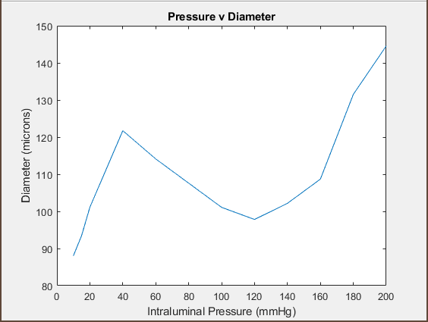

*Figure 4: Pressure vs Diameter response in Rat mesenteric arterioles*

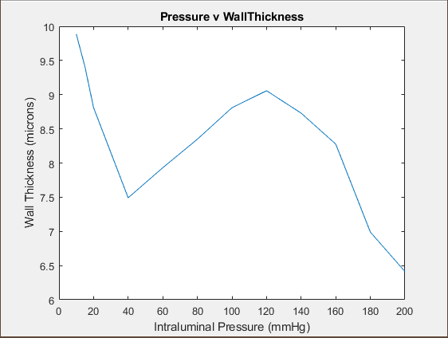

*Figure 5: Pressure vs Wall Thickness of Rat mesenteric arterioles*

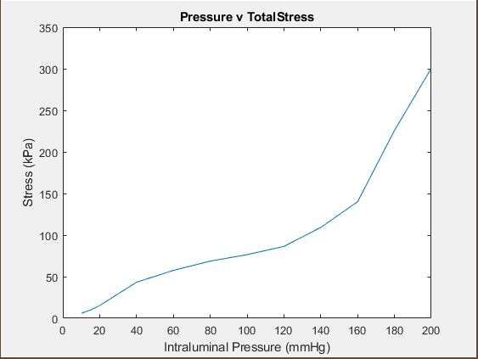

*Figure 6: Pressure vs Total Stress of Rat mesenteric arterioles*

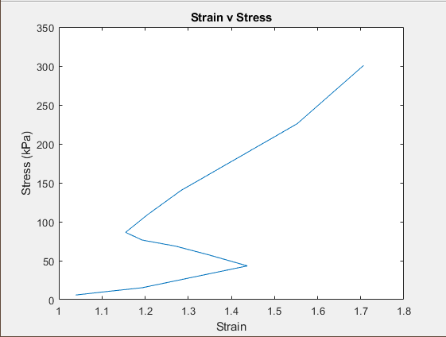

*Figure 7: Stress vs strain of Rat mesenteric arterioles*

*3.2 Modeling SigTot for Rat femoral artery*

Since the previous paper used the Rat mesenteric arteriole data, here I have modeled the SigTot transfer function for the Rat femoral artery. The data is also from Table 3 of the paper this data comes from [18]. This figure comes from the Simulink model that was implemented from the SigTot full transfer function with underlying components, shown in figure 3.

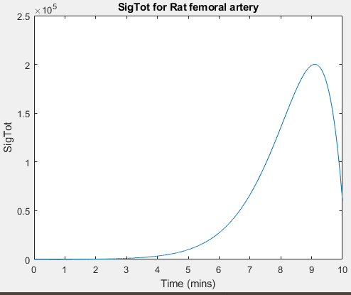

*Figure 8: SigTot for Rat femoral artery data*

1. **Discussion**

The plots in figures 4-7 show that when more pressure, stress, or strain is applied to the system, the diameter of the arteries increase.

The most important graph, showing pressure vs diameter, is shown in figure 4. In figure 4, the plot is pressure vs diameter, and the response as pressure increases is the diameter increasing. Figure 5 is plotting the pressure vs wall thickness. This plot is interesting because the image is the reflected plot of pressure vs diameter, upside down. Figure 6 plots the pressure vs the total stress in the mesenteric arterioles. This response is clearer and has a steady increase of pressure as stress increases. Finally, figure 6 is the stress vs strain plot, and shows that as stress increases, strain also increases. [this plot looks weird]

Figures 4-7 are plots from the primary data used in the previous study, showing the different responses in the mesenteric arterioles of rats. Figure 8, for the purposes of this paper, uses data from the femoral artery of rats.

Modeling the transfer function of the myogenic response shows response of the system when a pulse is given.

1. **Conclusion**

This is good. Now, I want you interpret these results and say what this tells you about the physiological system. What does the behaviour you see in Figures 4-7 ﻿﻿﻿﻿﻿﻿﻿﻿﻿﻿﻿﻿﻿﻿﻿﻿﻿﻿﻿﻿﻿﻿﻿﻿﻿﻿tell you about myogenic response? Why does it behave this way? Is there evidence from the literature to support this?

References

[1] R. Loutzenhiser, A. Bidani and L. Chilton, "Renal Myogenic Response", *Circulation Research*, vol. 90, no. 12, pp. 1316-1324, 2002. Available: 10.1161/01.res.0000024262.11534.18.

[2] K. Yip et al., "Intraluminal pressure triggers myogenic response via activation of calcium spark and calcium-activated chloride channel in rat renal afferent arteriole", *American Journal of Physiology-Renal Physiology*, vol. 315, no. 6, pp. F1592-F1600, 2018. Available: <https://www.ncbi.nlm.nih.gov/pubmed/30089032>.

[3] K. Aukland, “Myogenic Mechanisms in the Kidney,” *Journal of Hypertension. Supplement: Official Journal of the International Society of Hypertension* vol. 7,4 (1989): S71-6; discussion S77.

[4] Johansson B., “Myogenic tone and reactivity: definitions based on muscle physiology,” *Journal of Hypertenion. Supplement*. 1989; vol. 7 no. 4: S5–S8; discussion S9.

[5] G. Osol, J. Brekke, K. McElroy-Yaggy and N. Gokina, "Myogenic tone, reactivity, and forced dilatation: a three-phase model of in vitro arterial myogenic behavior", *American Journal of Physiology-Heart and Circulatory Physiology*, vol. 283, no. 6, pp. H2260-H2267, 2002. Available: 10.1152/ajpheart.00634.2002

[6] Parasympathetic vs Sympathetic Nervous System - Difference and Comparison | Diffen", Diffen.com. [Online]. Available: <https://www.diffen.com/difference/Parasympathetic_nervous_system_vs_Sympathetic_nervous_system>.

[7] M. B. W, “On the local reactions of the arterial wall to changes of internal pressure,” The Journal of Physiology, vol. 28, no. 3, pp. 220–231, 1902, doi: 10.1113/jphysiol.1902.sp000911.

[8] T. Takenaka, H. Forster, A. De Micheli and M. Epstein, "Impaired myogenic responsiveness of renal microvessels in Dahl salt-sensitive rats.", Circulation Research, vol. 71, no. 2, pp. 471-480, 1992. Available: <https://www.ahajournals.org/doi/pdf/10.1161/01.RES.71.2.471>.

[9] B. Spronck, E. Martens, E. Gommer and F. van de Vosse, "A lumped parameter model of cerebral blood flow control combining cerebral autoregulation and neurovascular coupling", American Journal of Physiology-Heart and Circulatory Physiology, vol. 303, no. 9, pp. H1143-H1153, 2012. Available: <https://doi.org/10.1152/ajpheart.00303.2012>.

[10] A. Øien and K. Aukland, "A multinephron model of renal blood flow autoregulation by tubuloglomerular feedback and myogenic response", Acta Physiologica Scandinavica, vol. 143, no. 1, pp. 71-92, 1991. Available: 10.1111/j.1748-1716.1991.tb09203.x.

[11] S. Lee and G. Schmid-Scho¨nbein, "Biomechanical Model for the Myogenic Response in the Microcirculation: Part I—Formulation and Initial Testing", Journal of Biomechanical Engineering, vol. 118, no. 2, pp. 145-151, 1996. Available: <https://doi.org/10.1115/1.2795952>.

[12] T. Voets and B. Nilius, "TRPCs, GPCRs and the Bayliss effect", The EMBO Journal, vol. 28, no. 1, pp. 4-5, 2009. Available: 10.1038/emboj.2008.261.

[13] "Vessel_Mechanics", Physiome.org, 2020. [Online]. Available: <https://www.physiome.org/jsim/models/webmodel/NSR/Vessel_Mechanics/>.

[14] Chapter 7.4 - Control Paradigms: Model Following", Engineering 360. [Online]. Available: <https://www.globalspec.com/reference/13560/179909/chapter-7-4-control-paradigms-model-following>.

[15] Myogenic mechanism explained", Everything.explained.today. [Online]. Available: <https://everything.explained.today/Myogenic_mechanism/>.

[16] J. Arciero and T. Secomb, "Spontaneous oscillations in a model for active control of microvessel diameters", Mathematical Medicine and Biology, vol. 29, no. 2, pp. 163-180, 2011. Available: 10.1093/imammb/dqr005.

[17] B. Hald, "A generative modeling approach to connectivity—Electrical conduction in vascular networks", Journal of Theoretical Biology, vol. 399, pp. 1-12, 2016. Available: 10.1016/j.jtbi.2016.03.032

[18] <https://onlinelibrary.wiley.com/doi/full/10.1080/10739680590934745>