**Synopsis**

**On**

**Interact Upon – An Interactive Classroom**

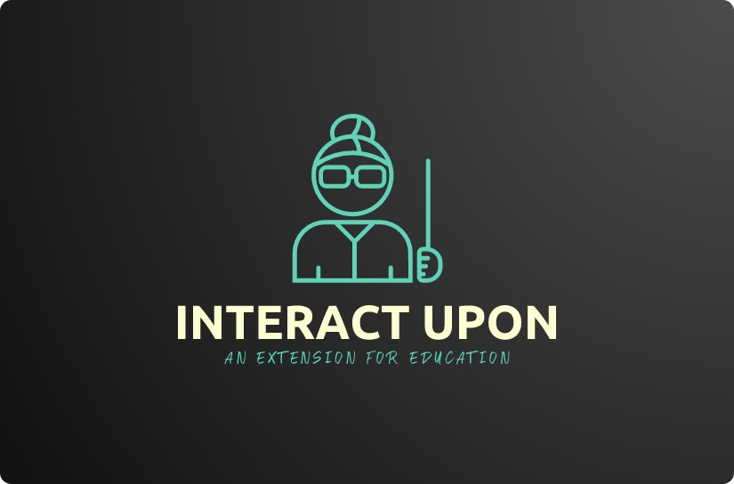

***Submitted To***:

Er. Shivani Sharma(Project Incharge)

***Submitted By:***

Vanshika (1900295)

Er. Vinod Kumar Sharma(HOD)



**DEPARTMENT OF COMPUTER SCIENCE & ENGINEERING**

**Amritsar College of Engineering & Technology, Amritsar**

**(Autonomous college under UGC Act – 1956[2(f) and 12(B)])**

**TABLE OF CONTENTS:**

|  |  |  |
| --- | --- | --- |
| **Serial No.** | **Topic** | **Page** |
| **1** | Organization Profile | 3-4 |
| **2** | Introduction | 5 |
| **3** | Front End - JAVA | 6-10 |
| **4** | Back End – ORACLE | 11-14 |
| **5** | Hardware & Software Requirements | 15 |
| **6** | Tools to be used | 16-17 |
|  |  |  |

**ORGANIZATION PROFILE**

VMM Education’s journey started in January 2005 with a vision of bringing computer education of global standard to the holy city of Amritsar. To turn this dream into reality we create a talent pool of bright young minds who would power the engines of growth of the global economy. Today seven years later VMM Education or VMM, as it is popularly known, is the largest and the most trusted computer centre of the region, with annual turn out of more than 1000 students. The reason for the success of VMM is simply the “Hard work” that our team has put in these seven years.

**VMM Education:**

VMM Education provides world class training in global technologies such as .Net and Linux, while keeping our syllabus up to date with the current industry standard. We have managed to successfully train more than 7000 engineers who are currently working in Global Multinationals like TCS, Tech Mahindra, Infosys, and CSC etc.

VMM is today the favourite choice of students of various engineering college for pursuing their six months or six weeks industrial training .A unique “industry-endorsed curriculum,” crafted by professionals of VMM which enhances the job-readiness and employability of learners and equips them for the IT Industry.

To provide IT education which can match with the global IT standards, VMM also undertakes industrial projects from UK & USA under the banner of Venus Software Solutions like im4schools.co.uk and many more. This allows our students to work on the live projects and make projects for the industry. Some of our products include Point of sale software for Super Markets with barcode reader support, Finger print attendance Management System that works for schools, colleges and other institutes, Remote LAN Controller which is used to view remote desktops on LAN or WAN.

VMM has the world class computer labs that are equipped with the latest Hardware and software so that the students can do practical without any hindrance. We continuously upgrade our hardware and software’s every 6 months.

Attendance of students is one of the major features of VMM, students are required to record their day to day attendance using Biometric Finger-print Recognition device. This allows us to provide accurate attendance of students to their parents and college during their training time.

**Some Key learning solutions for Individuals include the following:**

* **Foundation course**

This course includes two languages C and C++ that allows us to build a strong foundation of programming for the beginner and First year & Second year engineering graduates.

* **Six Weeks Industrial training**

This training program which is of 42 working days allows the 3rd year engineering graduates to get hands on experience on either of the following technologies VB.Net ,C#.Net & SQL. This training is pretty intensive as the students are required to spend 4-8 hours at the institute learning any one of the above languages along with developing a project by working in team. This allows students to learn how to work as team member and also gets hands on training on the latest technology.

* **Six Months Industrial Training**

Doing your six months industrial training at VMM is a very special experience for any engineering graduate as it allows the students to nurture his / her of knowledge by working on Technologies like ASP.Net, Silverlight, and AJAX etc. The candidate is required to spend almost whole day at institute doing their Lab practical or attending their tutorial lecture and developing a project which they can submit in their college as a part of dissertation.

* **7 Months Project Training**

This program is for the final year BCA students who can learn latest technologies like VB.Net, C#.Net, ASP.Net and make their project.

* **Individual Skill enhancement programs**

Apart from above training program VMM provides a bouquet of courses in windows application development using VB.Net/C#.Net, Web Development using ASP.Net.

**INTRODUCTION TO THE PROJECT:**

INTERACT UPON – AN INTERACTIVE CLASSROOM is a system whose approach is based on Teacher - Student Interaction. Interact Upon intends to contribute to a better communication between a Teacher and Student. In particular, it intends to provide a platform which will act as an E-Classroom. The Teachers will be able to schedule lectures, assign homework, give assignments and post notifications which will be accessible by the students creating an environment of E-Classroom. In the time of pandemic when majority of the education system has shifted to online mode Interact Upon will turn up as an advantage as it will provide the experience of an E-classroom with a better management environment.

This project will be developed by using JAVA as a Front-end and MySQL as Back-end. The system will be divided into three interfaces: Admin, Teacher and Student and will have features as such per interface requirements. The system will require a successful login to start.

* **Admin Interface:** The Admin interface will be mainly linked with management having primitive features such as Add, Update and Delete.
* **Teacher’s Interface:** This interface will be directly linked with its role and features as such which will create the impression of a teacher being in a physical classroom. Some of its proposed features are as follows:

1. Schedule Lectures
2. Give Homework and Assignments
3. Post Notifications

* **Student’s Interface:** Very much like teacher’s interface, this interface will also directly link to its role and will radiate the impression of a student being in physical classroom. Exactly like in real life learning institutions students will be able to take up a course and perform tasks related to it. Some of its proposed features are:

1. View Lectures scheduled by the teachers
2. View and submit given homework and assignments
3. Receive and view Notifications posted by teachers

**Note: More Features may be added to the said system and some might differ than the ones mentioned above.**

**FRONT END - JAVA**

Java is a general purpose and the most popular object-oriented programming language. Java was developed by James Gosling and his colleagues at Sun Microsystems in the early 1990’s.

Due to its simplicity and easy to learn and advanced features, we opted this language for our six months industrial training. This language supports many interesting features that make it an ideal language for software development. In addition to the object oriented features, it also provides features such as platform independence, security, multithreading, portability; etc which makes it well suited for the web and networked services, applications, platform-independent desktops, robotics and any other embedded devices*.*

**Features of Java:**

Dynamic & Extensible

Architectural Neutral

Secure

Simple

Robust

Distributed

Compiled and Interpreted

Portable

Object-oriented

Multi Threaded

High Performance

* **Simple**: Java is a compact and simple language. Programs are easy to write and debug as it omits many clumsy, poorly understood and confusing features of other programming languages such as C++.
* **Object-oriented:** Java is purely object-oriented language because programming in java is centered on creating objects; manipulating objects and making objects work together.
* **Distributed:** Java is a distributed language which means that the programs can be designed to run on computer networks. Java provides an extensive library of classes for communicating using TCP/IP protocols such as HTTP and FTP. This makes creating network connections much easier.
* **Robust:** Java is designed for writing programs that are highly robust. By robust, we mean reliable.
* **Secure:** As java is intended to be used in networked/distributed environments so it implements several security mechanisms to protect you against malicious code that might try to invade your file system.
* **Architectural Neutral:** This means that the programs written on one platform can run on any other platform without having to rewrite or recompile them. It follows ‘Write-once-run-anywhere’ approach.
* **Portable:** In Java, the size of the primitive data types is machine independent. These consistencies make java program portable among different platforms such as Windows, UNIX and Mac.
* **Interpreted:** Java is such a language that is both compiled and interpreted. The two steps of compilation and interpretation allow extensive code checking and improved security.
* **High performance:** Java programs are complied with portable intermediate form known as byte codes, rather than to native machine level instructions and JVM executes java byte codes on any machine on which it is installed. This architecture means that java programs are faster.
* **Multithreaded:** Java is also a multithreaded programming language. It allows you to write a program that can do many tasks simultaneously.
* **Dynamic:** Java is designed to be dynamic. Classes are stored in separate files and are loaded into the Java Interpreter only when they are needed.

**JAVA DEVELOPMENT KIT (JDK)**

The Java Development Kit (JDK) is a software package that sun has made available to public. It includes all the basic components that makeup the java environment. These include the Java compiler, Java Interpreter, an applet viewer that lets you see applets without opening a Java-compatible web browser.

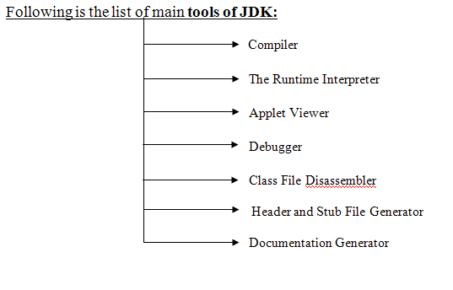

**APPLICATIONS OF JAVA**

Java has evolved from a simple language providing interactive dynamic content for webpage’s to a predominant enterprise-enables programming language suitable for developing significant and critical applications.

Today, Java is used for many applications like:

* Web based applications
* Financial applications
* Gaming applications
* Embedded applications
* Distributed enterprise applications
* Mobile applications
* Image applications
* E-business applications
* Desktop applications and many more.

**JSP (Java Server Pages)**

JSP technology is used to create dynamic web applications. JSP pages are easier to maintain then a Servlet. JSP pages are opposite of Servlets as a servlet adds HTML code inside Java code, while JSP adds Java code inside HTML using JSP tags. Everything a Servlet can do, a JSP page can also do it.

JSP enables us to write HTML pages containing tags, inside which we can include powerful Java programs. Using JSP, one can easily separate Presentation and Business logic as a web designer can design and update JSP pages creating the presentation layer and java developer can write server side complex computational code without concerning the web design. And both the layers can easily interact over HTTP requests.

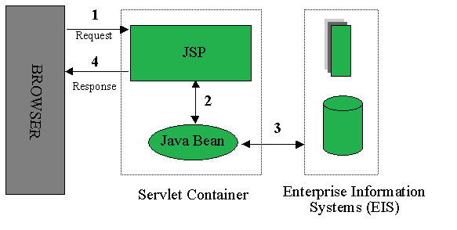

**Advantages of JSP:**

1. Easy to maintain and code.
2. High Performance and Scalability.
3. JSP is built on Java technology, so it is platform independent.

**BACK END - ORACLE**

An Oracle database is a collection of data treated as a unit. The purpose of a database is to store and retrieve related information. A database server is the key to solving the problems of information management. In general, a server reliably manages a large amount of data in a multiuser environment so that many users can concurrently access the same data. All this is accomplished while delivering high performance. A database server also prevents unauthorized access and provides efficient solutions for failure recovery.

Oracle Database is the first database designed for enterprise grid computing, the most flexible and cost effective way to manage information and applications. Enterprise grid computing creates large pools of industry-standard, modular storage and servers. With this architecture, each new system can be rapidly provisioned from the pool of components. There is no need for peak workloads, because capacity can be easily added or reallocated from the resource pools as needed.

The database has logical structures and physical structures. Because the physical and logical structures are separate, the physical storage of data can be managed without affecting the access to logical storage structures.

Oracle Database allows you to quickly and safely store and retrieve data. Here are the integration benefits of the Oracle Database:

* Oracle Database is cross-platform. It can run on various hardware’s across operating systems including Windows Server, UNIX, and various distributions of GNU/Linux.
* Oracle Database has its networking stack that allows application from a different platform to communicate with the Oracle Database smoothly. For example, applications running on Windows can connect to the Oracle Database running on UNIX.
* ACID-compliant – Oracle is ACID-compliant Database that helps maintain data integrity and reliability.
* Commitment to open technologies – Oracle is one of the first Database that supported GNU/Linux in the late 1990s before GNU/Linux become a commerce product. It has been supporting this open platform since then.

**Features:**

The following list describes some of the important **Features of Oracle** Database Software.

* **Column Types:**
* Many column types are supported. Such as NUMBER, CHAR, VARCHAR, FLOAT, INT, LONG, VARCHAR2 TEXT, BLOB, DATE, TIME, DATETIME, TIMESTAMP, INTERVAL YEAR, INTERVAL DAY etc.
* Fixed-length and variable-length records.
* **Statements and Functions:**
* Full operator and function support in the SELECT and WHERE clauses of queries. For example:

It provides Full support for SQL GROUP BY and ORDER BY clauses. Support for group functions (COUNT(), COUNT(DISTINCT ...), AVG(), STD(), SUM(), MAX(), MIN(), and VAR()) etc.

* + - Support for LEFT OUTER JOIN and RIGHT OUTER JOIN with both standard SQL and ODBC syntax.
    - Support for aliases on tables and columns as required by standard SQL.
* DELETE, INSERT, REPLACE, and UPDATE return the number of rows that were changed (affected). It is possible to return the number of rows matched instead by setting a flag when connecting to the server.
* **Scalability and Limits:**
* Handles large databases. We use **Oracle** Server with databases that contain 50 million records. We also know of users who use **Oracle** Server with 60,000 tables and about 5,000,000,000 rows.
* Up to 64 indexes per table are allowed. Each index may consist of 1 to 16 columns or parts of columns. The maximum index width is 1000 bytes. An index may use a prefix of a column for CHAR, VARCHAR, BLOB, or TEXT column types.
* **Connectivity:**
* The Connector/ODBC (MyODBC) interface provides **Oracle** support for client programs that use ODBC (Open Database Connectivity) connections.
* The Connector/J interface provides **Oracle** support for Java client programs that use JDBC connections. Clients can be run on Windows or UNIX. Connector/J source is available.
* **Localization:**
* The server can provide error messages to clients in many languages.
* Full support for several different character sets, including latin1 (ISO-8859-1), German, big5 and more. For example, the Scandinavian characters 'â', 'ä' and 'ö' are allowed in table and column names.
* All data is saved in the chosen character set. All comparisons for normal string columns are case-insensitive.
* **Logical data structure:**
* Oracle uses the logical data structure to store data so that you can interact with the database without knowing where the data is stored physically.
* **Partitioning:**
* It is a high-performance feature that allows you to divide a large table into different pieces and store each piece across storage devices.
* **Memory caching:**
* The memory caching architecture allows you to scale up a very large database that still can perform at a high speed.
* **Data Dictionary:**
* It is a set of internal tables and views that support administers Oracle Database more effectively.
* **Backup and recovery:**
* It ensures the integrity of the data in case of system failure. Oracle includes a powerful tool called Recovery Manager (RMAN) – allows DBA to perform cold, hot, and incremental database backups and point-in-time recoveries.
* **Clustering:**
* Oracle Real Application Clusters (RAC) – Oracle enables high availability that enables the system is up and running without interruption of services in case one or more server in a cluster fails.
* **Scalability and Performance:**
  + Features like Real Application Clustering and Portability make an Oracle database scalable according to the usage. In a multiuser database, it is required to control data consistency and concurrency which are contemplated by Oracle.
* **Availability:**
* Real-time applications require high data availability. High performing computing environments are configured to provide all-time data availability. Data is available during the time of planned or unplanned downtimes and failures.
* **Backup and Recovery:**
* Its layout complete recovery features to recover data from almost all kinds of failures. In case of failure, the database needs to be recovered within no time for high availability. Unaffected parts of data are available while the affected ones are getting recovered.
* **Security:**
* Securing the data is always the top priority. Oracle provides mechanisms to control data access and usage. Implementing authorization and editing user actions can prevent unauthorized access and allow distinct access to the users.

**HARDWARE REQUIREMENTS:**

Hardware requirements include that hardware which is required for its working. It includes:

* Pentium 4 Computer
* 512 MB RAM
* High Speed Internet Connection(DSL/Cable)

**SOFTWARE REQUIREMENTS**

The technical specifications of requirements for the software are as follows:

* Any Operating System (Windows, Linux, MAC)
* Java run time environment
* Netbeans (Java IDE)
* Java SDK (Software Development Kit)
* Any web browser(Chrome , Firefox , etc)

**TOOLS TO BE USED:**

1. **JAVA DEVELOPMENT KIT (JDK)**

The Java Development Kit (JDK) is a software package that sun has made available to public. It includes all the basic components that makeup the java environment. These include the Java compiler, Java Interpreter, an applet viewer that lets you see applets without opening a Java-compatible web browser.



1. **NETBEANS - INTEGRATED DEVELOPMENT ENVIRONMENT**

**Net Beans** IDE is a free, open source, popular integrated development environment used by many developers. Out of the box, it provides built-in support for developing in Java, C, C++, XML, and HTML. And this author especially likes the support for editing JSPs, including syntax highlighting, HTML tag completion, JSP tag completion, and Java code completion.

The basic steps for making a new project in java are as follows.

* Create a new project
* Mount a directory - specify a location to save project files
* Add a new class to the project
* Compile and run a Java program

