A Survey of Container Scheduling in Cloud and Study of its Behaviour in Real Time Dataset
Prof Jalpa Ramavat, Prof Kajal Patel, Vishwa Patel, Dhwani Desai, Himali Luhar, Snehee Patel
Vishwakarma Government Engineering College, Chandkheda, Ahmedabad
Abstract: The rapid development of cloud services has helped in the invention of technologies like containerization for coherent results. Orchestration tools were built to handle the massive numbers of containers. The reason that orchestrators make managing containers effortless lies in the underlying scheduling algorithm. There have been many improvements in the scheduling based on load balancing, energy efficiency, etc. Moreover, cloud services bring forth their computing logs in public for analysis of containers. In this paper, we have discussed some of the load balancing techniques as well as container scheduling algorithms. Along with this, a brief study of Google trace is given with a deep analysis of the Alibaba cluster trace dataset v2017. Resource management is a complicated task that includes diverse parameters of the device like CPU usage, memory, and space. The study includes data visualization on the carefully selected fields of the dataset. Data visualization clearly shows that online and offline tasks do not run equally on the servers, which leads to a resource management gap.
Keywords: Cloud Computing, orchestration tools, Docker, Alibaba Trace, Container, Visualization, Resource management.
I. INTRODUCTION
According to [1], as of 2021, roughly 92% of organizations are already using cloud resources and services in some way. In the future, it is only going to get a big business [2]. These staggering numbers indicate that cloud development will be involved in every software. A good cloud environment is often a server-side app, faster and more reliable. The cloud ecosystem has diverse independent components such as containers, virtual machines, orchestrations, load balancers, applications, and security that function concurrently to provide the services [3][4].
VM vs Container
Massively popular technology virtualization is possible due to virtual machines. The VMs are Infrastructure as a service (IaaS) that share the physical device with the host OS [5]. It requires its own physical memory and space. The fact that VMs work with the help of virtualization technology is not new. They use the VM specific software applications to recreate the virtual hardware. Hence, this way a hypervisor manages the resources like storage and memory.
Containers are defined to be lightweight, as a result, they deliver higher efficiency. Unlike VMs, containers are Platform as a service (PaaS) components that work on the host OS. Recently there has been a staggering peak in the development of containerized software. As per [6], nearly 79% of applications had implemented internal containerization in 2020. Since containers are capable of delivering real-time and real-world benefits, they are preferred over VMs. Under the hood, containers use a Linux utility called cgroups for resource sharing and namespace for isolation [7].
Table 1: The difference between VMs and Containers [8]
Factor | Virtual Machine | Container
Technology | Iaas | Paas
Boot time | High | Low
OS | Use the system hardware | Share the host OS
Migration | Difficult as it is not portable | Easy as it is portable and lightweight
Security | Provides complete isolation from other OS | Provides isolation using namespace utility
Memory | Needs more RAM | Needs very less RAM compared to VM
Performance | High | High

Docker
Docker is open-source software for creating and running container applications. Docker mainly enforces client and server architecture. Hence, it has three central pieces - daemon, client, and REST API, which simultaneously are known as Docker Engine [9]. The client works as user-end software that allows users to connect to the daemon. The daemon is responsible for all the back-end handling of container creation, execution, and deployment. Moreover, the client and daemon communicate via the REST API interface.
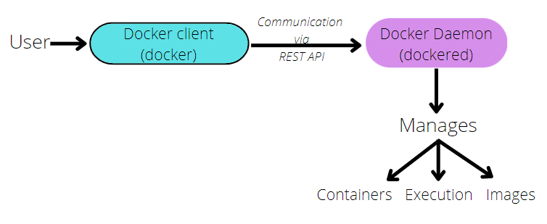
Figure 1: Docker client-server architecture design shows that user connects with Docker client via command line or GUI, then the client communicates the requests to the Docker daemon by using the API

Figure 1 presents the architectural design of the Docker system [10]. The Docker daemon includes containers, images, configuration files, networking settings, and storage. While the daemon listens for Docker API, the docker client sends the request for the daemon. A Docker image is a layered read-only file that has the application software. Similarly, a container is an instance of the image.
The original concept of container was implemented by the Linux kernel with a utility called namespaces. Docker uses this highly reliable technology for creating the small isolated runnable containers. Docker tops off the layer of container with a Linux based control group tool called cgroups. For the most part, cgroups are helpful in achieving resource allocation amongst the containers and the host OS. These all are easily managed by Docker software.
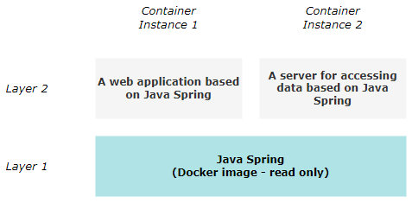
Figure 2: Different containers running the same base image do not need two replicas of the same image. As here, two different applications can share same image

Other three significant components that work simultaneously are Docker images, Docker containers and Union File System (UFS). Docker images are the read-only files that have the actual code of the application. It can be created and initialized in the dockerfile, as a result, the dockerfile will build and package the application. On the other hand, the container is the executable instance of the Docker image. Container is created on top of the Docker image layer, following the design of the UFS. The UFS is a special type of operating system also known as copy-on-write system. In such a system, everything is based on the layers. Essentially it means that, if there is a repeating component used by two different tasks, then both of them will share the repeating component and they will execute on the layer above it. The same operation is performed by Docker containers with Docker images. As shown in figure 2, if there are two or more containers that can use the same Docker image, they will share the image and run on a layer above it.
Container orchestration
As more and more applications involve containers, it becomes essential to scale them rapidly. There was a demand for software that automatically regulates container scaling and management. Container orchestration is such a tool designed to drive thousands of distributed containers [6]. Few popular container orchestrators are Docker Swarm, Kubernetes, Apache Mesos, OpenShift, and Nomad.
A. Docker Swarm
To meet the demands, Docker programmed Docker Swarm to govern a cluster of Docker nodes. Now, Docker Swarm comes integrated with Docker software [11][12]. Docker Swarm is the implementation of the Docker project called SwarmKit, which provides the core orchestration layer for Docker. The Swarm has all the features that are expected in an orchestration tool. Additionally, it is highly customizable in terms of scalability and multi-host networking. The Swarm architecture is a simple design consisting of two key hosts - manager and worker. In a cluster of hosts, one host runs the Swarm manager, while others run the Swarm worker. The worker node is responsible for handling and assigning the tasks when scaling occurs. The other feature of the worker node is to continuously survey the state of the cluster. These include scanning for any failure, scanning that the tasks are up and running, etc. Meanwhile, the worker nodes accept the task allotted by the manager and execute them. To balance the load, it utilizes ingress load balancing and exposes the service ports. The manager node implements the Raft Consensus Algorithm to balance the cluster state. It has to use the Consensus algorithm to ensure that all other manager nodes are in the identical state.
B. Kubernetes
Kubernetes or K8s is an open-source PaaS orchestration software that offers scaling, deployment, and load balancing. It was presented by Google in the year 2014. It is built on the master and slave model for operating containerized applications [13]. The elementary functions of Kubernetes are similar to Swarm; the only difference is how it implements them. It provides services like load balancing, storage management, rollouts, rollbacks, and self-healing. Kubernetes[14] is meant to be deployed on a cluster. Each Kubernetes cluster has at least one node. Unlike Docker Swarm, in Kubernetes, a runnable environment is called a pod. In a nutshell, a cluster is made of one or more nodes, a node consists of one or more pods, and a pod has one or more executable containers. This design results in increased availability and reasonable fault tolerance[15]. The control panel manages the pods and nodes in the cluster. The control panel has the responsibility of making global decisions related to the cluster. It maintains the scheduling and networking amongst the clusters. It also keeps track of the replicas of the current containers as a part of fault tolerance. The Kube-apiserver is the Kubernetes API that functions as the front side of the control panel. This API is used to scale the resources horizontally. Kube-scheduler looks for new pods and schedules the task according to the requirements. In the process of scheduling, the leader is selected using the Raft protocol. Then there are two steps involved in assigning the pods to a node by scheduling. One is to filter the available nodes, and two is to prioritize the nodes based on the requirements[16][17]. The third important part of the control panel is the kube-controller-manager - it operates to manage the nodes, jobs, and tokens. Like a control panel, a node also has three fundamental parts. A kubelet keeps the container running in the pod, a kube-proxy implements the networking services, and a container runtime executes the containers.
C. Hasicorp Nomad and Apache Mesos
Next tools in line are Hasicorp Nomad and Mesos. Nomad platform supports the container and non-container orchestration. Furthermore, it also comes plugged in with other Hashicorp tools. In some terms, Nomad works identical to that of Kubernetes. However, it is claimed that Nomad is much simpler than Kubernetes. Apache Mesos is built on the principles of the Linux system. In this the scheduling is done in two parts. The two level scheduling becomes helpful in executing the native cloud and the legacy applications in the identical cluster[18].
Table 2: Comparison between different orchestration tools
Factor | Docker Swarm | Kubernetes | Hashicorp Nomas | Apache Mesos
Architecture | Very simple | A little complex | Simple | Simple
Single runnable unit | Container | Pod | Task | Executor
Installation | No installation needed | Complicated | Very easy | Easy
Cluster scale support | 1000 nodes | 5000 nodes | 10,000 nodes | 10,000 nodes
Automatic scaling | Not possible | Possible and highly efficient | Possible | Possible
Maintained by | Docker | Google | Cloud Native Computing Foundation | UC Berkely

Container scheduling
Load balancing plays an important role in managing the resources on the servers. For this many algorithms have been developed. To manage the load in containers container scheduling techniques are used. Container schedulers behaves so much like the general purpose scheduler. Container scheduling algorithms mainly try to schedule the containers on specific machines for better performance. It also tries to assign the containers on the appropriate node based on the variety of parameters. The load balancing and container scheduling algorithms are further discussed in the paper.
Real world container application
To understand the real world working of the containers, we also studied the cloud logs made available to the public. Google Trace and Alibaba Cluster Trace are the cloud computing logs provided by Google Cloud and Alibaba Cloud respectively, describing the CPU, memory and disk utilization of the servers. They roll out different versions of log data yearly for analysis and research purposes. Detailed analysis on Alibaba Cloud trace is discussed further in the paper.

II. LITERATURE REVIEW
Resource management
Cloud architecture provides high end computation which can be useful for scalability, flexibility and providing mobility to the data. Cloud resources consist of the servers, memory, storage, network, CPU, application servers, and cybernetic systems. Thus effective utilization of such resources can provide the best use of cloud computing [19].
In virtual machines, such resources are native so the conventional methods can be used for management whereas in containerized architecture there is need for effective resource management techniques as the case is not the same [20]. Along with this, different types of management techniques are required to perform the resource management tasks and optimize the result [21].
Performance metrics
1. Energy efficiency:
Energy is used in deploying the containers on worker nodes. Reducing the energy consumption also decreases the cost of execution, carbon footprint (amount of CO₂ released during energy consumption of fuels) and also improves sustainability.
2. Cost:
Overall cost includes the cost of operations such as computation, storage and communication cost. Computational cost includes time spent on running the clusters on the available cores and the communication cost refers to the cost of network providers for telecommunication services.
3. Resource utilization:
Resource utilization refers to the efficiency in utilizing the available resources on a node. This implies that higher utilization of resources of a node, the more energy efficient the node is.
4. Makespan and throughput:
Makespan metric refers to the time required to run the application. It is advisable to reduce the makespan to make the scheduler efficient. Throughput is calculated by division of the total number of tasks to the time taken for task execution. It is an overall view for the system, but it does not guarantee lower cost.
5. Network Bandwidth:
Network bandwidth refers to the number of bits transferred in one second on the network. This helps in calculating the network delay in communication of containers and also in handling congestion [22].
Load Balancing
Load balancing in the cloud refers to how the workload and resources are distributed on the cloud platform servers. This ensures the performance of the cloud services. Load balancing includes CPU load, network load, website traffic, and server storage capacity. It is a critical element in scalability of the cloud as it distributes the traffic across the new virtual servers which are formed by “scaling-up” the cloud. The load balancing algorithms are divided into:
- Static load balancing:
In static load balancing the load balancing algorithms ignore the current state of the system i.e. they do not consider the current state of the machine rather they distribute the load based on the assumptions of resources and arrival times for the entire system. Static load balancing algorithms include round robin, min-min, max-min algorithm etc.
- Dynamic load balancing:
Dynamic load balancing algorithms consider the current load of each computer system unlike static algorithms. The tasks can be transferred from overloaded systems to under-loaded systems which leads to faster processing. These systems are harder to build but they yield great results when the execution time of each request varies substantially. Some of the dynamic load balancing algorithms are honey bee foraging behavior, active clustering and ACCLB (Ant colony and complex network theory)[23].

Container Scheduling Techniques
1. Heuristic algorithms:
a. ABP scheduler:
Availability-assured Buffer-layer Prioritized scheduler was developed by Wu and Chen (2017) to reduce the network traffic in Docker Swarm. ABP uses less start-up time and does faster task distribution. The drawbacks of this algorithm are that it does not work for heterogeneous containers and is not energy efficient[24].
b. DRAP scheduler:
Dynamic and Resource Aware Placement Scheme algorithm was implemented by Mao et al (2017) for heterogeneous nodes in Docker Swarm. This algorithm deploys the container on the basis of resource availability and demand for that node from other services. Performance and resource utilization of this scheme is efficient compared to others however, it uses a higher amount of network[25].
c. Gaia scheduler:
Gaia is a topology based GPU scheduling algorithm which was proposed by Song et al (2018) for Kubernetes. The main aim of the algorithm is to enhance resource utilization and computational efficiency by using access cost tree for dynamic scheduling. The efficiency increased by 10% in resource utilization and decreased network overhead but the algorithm only works for GPU based systems[26].

2. Meta heuristic Algorithms
a. Whale optimization algorithm:
Proves the CaaS (Container as a Service) Environment and maximizes the power consumption and resource utilization[27]. Whale optimization is used to address the two major problems combined as one optimization problem. These include minimizing the migration time and minimizing the SLA violation of the migrated VMs in addition to the considered objective, minimizing the power consumption. The main agenda of WOA is to reduce the search space between the Virtual machines and Physical machines and this way the power consumption and resource utilization is optimized.
b. Whale Random update assisted Lion Algorithm:
This paper[28] introduces Whale Random update assisted Lion Algorithm (WR-LA), which is the hybrid form of Lion Algorithm (LA) and Whale Optimization Algorithm (WOA). With use of this algorithm we can get advantages of both the algorithms by incorporating the WOA in LA in place of the fertilization function.
c. Multi-Objective Accelerated Particle Swarm Optimization:
[29]This research focuses on Energy Efficient Container(EECT) based Technology for IOT and Non IOT devices with use of Accelerated swarm optimization technique. It has three main components, selection of executing components and optimal server selection and complete the algorithm. We can also optimize the CO2 emission and thus we can improve energy consumption with use of this algorithm.
d. Neighborhood Division in Micro Service:
This method focuses on Load balancing and Response time in order to improve the system performance[30]. This algorithm divides the containers into neighborhoods and improves the particle swarm algorithm in terms of results. It improves the efficiency at a rate of 20 to 25 percent than commonly used swarm algorithms.
e. A Genetic Algorithm-Based Energy-Efficient Container Placement Strategy:
This algorithm uses the Improved Genetic algorithm in which mutation operation and control parameter is changed. It is proved more efficient than Particle swarm algorithm, Conventional GA and first fit algorithm when Virtual machine resource utilization is high. It is also more efficient than binpack and spread in terms of energy efficiency. This algorithm has two mutation functions and also the control parameter to choose the Mutation operation to be performed on the data. But it is only working on the energy efficiency of the algorithm[31].

Real World Application Analysis
After studying containers, their orchestration tools and load balancing algorithms, we studied different real world container behaviors made available such as Google Trace dataset and Alibaba Trace dataset.
- Google Trace Dataset
Google made its cloud log activity public for analysis purposes. The logs are collected over a span of multiple days containing information on CPU, memory and disk utilization of hundreds of servers executing and serving the users’ job requests. The overview of referenced papers for Google trace are below as mentioned:
- This paper made analysis on resource utilization and characteristics of servers in Google Cloud using the 2nd version of Google trace dataset. This dataset contains 12,000 heterogeneous servers and logs made over a span of 29 days capturing CPU, memory and disk utilizations for every 5 mins being a total of 250GB in size. Big data environment such as Hadoop MapReduce 1.0.2 was used to extrapolate the desired data from the dataset for analysis and implemented queries in Apache Hive 0.90. The dataset contains 25,375,377 total tasks, 12,532 total machines and 930 total users.
After analysis, heterogeneity was observed in task submission, task length and number of users each day. However, the machines showed homogeneity as 93% had similar CPU capacity. Along with this, CPU and memory utilization was measured at day 2, 13, 14, 18 resulting in average utilization between 40-60% and there was 4.54 – 14.22% CPU wastage and 1.26-7.61% memory wastage due to task failure.
Therefore results of this paper show the server resource utilization and wastage due to task failures and resubmissions and tried to gain insights into the dynamicity of the real environments on the Cloud[32].
- Another paper which was studied, worked on predicting the workload for the cloud cluster. Their main motive was to have a high accuracy workload prediction which optimized the running of the cloud computing environment. As a solution, they used RNN technique for workload prediction. So for the same they used Google Trace dataset released in 2011 for training the model and making the prediction. Initially they used CPU and ram as parameters but further ahead, conducted an orthogonal experimental design (OED) to obtain an optimized and most influential parameter set.
The dataset contained 672,075 jobs, around 48 million tasks and 7000 heterogeneous machine server clusters collected over 29 days. They divided the dataset with 80-20 ratio for train and test set for RNN. They successfully predicted the workload but can only solve short term time sequences[33].
- Alibaba Trace Dataset
Similar to Google Trace, Alibaba Cloud also made their cloud logs available for analysis and research purposes. They rolled our various different versions for the same year by year. The dataset mainly contained machine resource utilization records as per online and offline jobs such as CPU, memory and disk usage. The overview of certain papers referenced is as follows:
- This paper analyzed 11089 online service jobs and 12951 batch jobs co-locating on 1300 machines over a 12 hour period. And by observing, they found imbalance in workload distribution, resource access and memory utilization. By the analysis, it was also observed that there was no uniformity among 1300 machines. They provided heat maps describing increase in CPU and memory utilization with increase in time. And finally they provided a solution for the imbalance – designing an intelligent scheduler for the cloud to improve resource efficiency[34].
We also performed our analysis on Alibaba cluster trace dataset v2017 to gain further insights on working of containers in a real world application.

Alibaba Dataset Explanation
The dataset of Alibaba cluster-trace-v2017 is log data generated by real time online and offline jobs recorded in a 12 hour period for over 1300 machines [35]. The dataset consists of 2 different types of workloads:
- online container services and
- offline batch services
Running on all the included machines making the size of the dataset of about 1.5GB. Furthermore the dataset is categorized into 3 subtopics:
- Machines - server_event.csv, server_usage.csv
- Batch workload - batch_task.csv, batch_instance.csv
- Online services - container_event.csv, container_usage.csv
Making a total of 6 csv data files.
These files contain data regarding timestamp, machine id, instance id, task id, CPU usage (%), memory usage (%), disk usage (%), plan cpu, plan normalized memory, plan normalized disk, average load after 1/5/15 min, and so on. Along with this, the relationship among the online and offline jobs, tasks and instances is as represented in the diagram below.
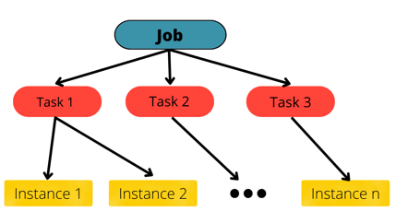
Figure 3: A Job from the user is divided into multiple Tasks and further tasks are divided into child instances which are then executed

Moreover all 6 data files are further explained in detail.
1. SERVER_EVENT.CSV:
This file contains the hardware information about each of 1300 servers. The data fields here are:
- Timestamp - describes the time at which the machines are added to the cluster. Majority of the data here is ‘0’ as those machines were in running state when the log period began. Certain rows have different values showing that machines were unavailable at that moment due some software or hardware error.
- Machine id - All the machines are provided a unique id ranging from 1 to 1313.
- Event type - There are 2 types of event here: ‘ADD’ representing where the machines were before the trace period (consists of timestamp ‘0’) and ‘SOFT_ERROR’ stating that machines were unavailable at a particular moment due to some software error.
- Event detail - This field provides the description of the error (reason why the error occurred).
- Number of CPUs - The machines have ‘64’ cores each.
- Normalized memory - This field shows the plan/total memory available in a machine. But this is a normalized value in the range of 0 to 1.
- Normalized disk space - Similarly this field shows the plan/total disk space available in a machine. This is also a normalized value in the range of 0 to 1.
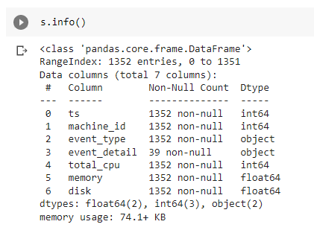
Figure 4: A detailed info of server_event.csv
2. SERVER_USAGE.CSV:
Logs describing the machine resource utilization are shown here. Along with this the data is recorded after every 5 min (12 * 60 = 720 min; 720/5 = 144), making 144 entries for each 1313 machines. Furthermore, apart from timestamp and machine id, other major fields are as follows:
- Used CPU, used memory and used disk space - All these fields are recorded in % format. These fields show the resource utilization of each machine.
- CPU load in 1/5/15 min - This shows the average load on the CPU in the interval of 1 min, 5 min and 15 min ranging from 39600 s to 82500 s.

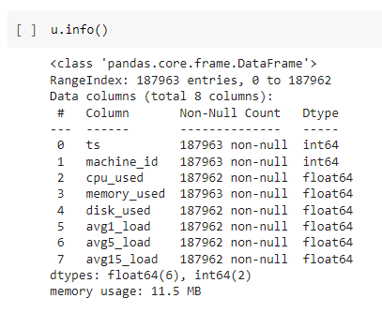
Figure 5: A detailed info of server_usage.csv
3. CONTAINER_EVENT.CSV:
This file contains the data describing the incoming container requests and the fields are as follows:
- Event type - Two types of records are present here: ‘CREATE’ maintaining the online instance creation record whereas ‘FINISH’ maintaining the online instance finish record.
- Instance id - This is a unique id provided to the online jobs. And there are a total of 11102 instances recorded.
- Plan CPU - This value shows the number of requested CPU by the online job.
- Plan memory and plan disk space - These are the normalized memory and normalized disk space requested by the online job.
- CPU set - They are the CPU s assigned by the online scheduler and are separated by ‘|’ delimiter.
- Along with these, timestamp and machine id are also available in this file.
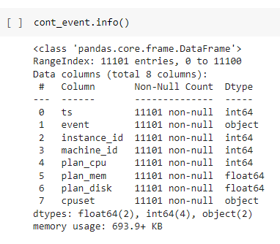
Figure 6: A detailed info of container_event.csv
4. CONTAINER_USAGE.CSV:
All the resource utilization for the container instances are recorded here. Data fields along with start time of the instance execution and instance id are described below:
- CPU, memory and disk util - These 3 fields hold the percentage values of utilized CPU, memory and disk out of total requested by the job.
- Average CPU load after 1/5/15 min - Shows the CPU load recorded after every 1/5/15 min by the system.
- Furthermore, average and maximum cycles per instruction are also recorded along with average and maximum cache misses per 1000 instructions.

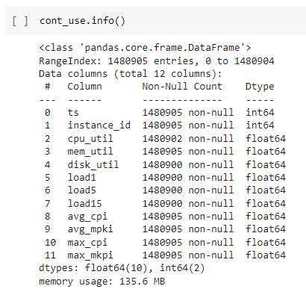
Figure 7: A detailed info of co.csv
5. BATCH_TASK.CSV:
Both batch_task.csv and batch_instance.csv describe the data of the offline batch jobs running on the server machines. Batch_task.csv contains the data fields such as:
- Create timestamp - This is the time of the creation of the batch task.
- End timestamp - Whereas this is the end time of the batch task.
- Job id and Task id - These are the unique id values assigned to the offline jobs and tasks. Job id runs from 0 to 12950 and task id runs from 0 to 67988.
- Number of instances - These show the total number of instances for the particular task.
- Status - Status shows the current state of the task such as: READY, WAITING, RUNNING, TERMINATED, FAILED, CANCELED.
- Plan CPU and plan memory - These fields show the requested CPUs for each instance as well as normalized requested memory for all instances.

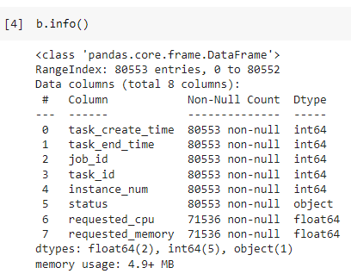
Figure 8: Info of batch_task.csv
6. BATCH_INSTANCE.CSV:
Apart from start time, end time, job id, task id, machine id, status like fields; there are many other data fields that describe the executional data of the offline batch tasks like:
- Sequence number - It shows the trial number for running the task which starts from 1 and increases by 1 for each retry.
- Total sequence number - This shows the total number of retrials.
- Real CPU max and average - Shows the max and average CPU numbers for actual instance running.
- Real memory max and average - Similarly this shows the max and average memory usage when the actual instance is running.
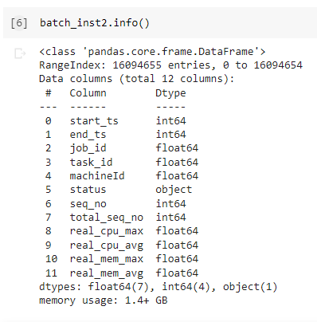
Figure 9: Info of batch_instance.csv

Visualization
On visualizing the data of machines (servers) from server_usage.csv for 12 hours it was clear that the resources are not utilized to their maximum. The heat map below is plotted for the CPU utilization of all the 1313 machines over the given period of time. It is evident from the graph that the CPU is used up to 50% in the initial hours and the usage further decreases with time. Along with this, the machines 390 to 570 are not utilized properly.
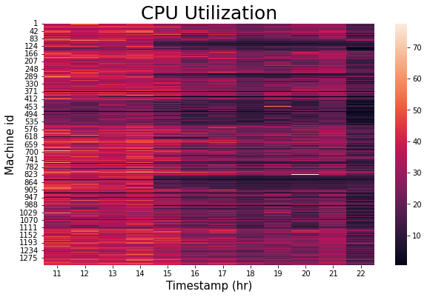
Figure 10: CPU utilization for server
The scatterplot below shows the clear indication of maximum 50% usage of CPU for all machines.
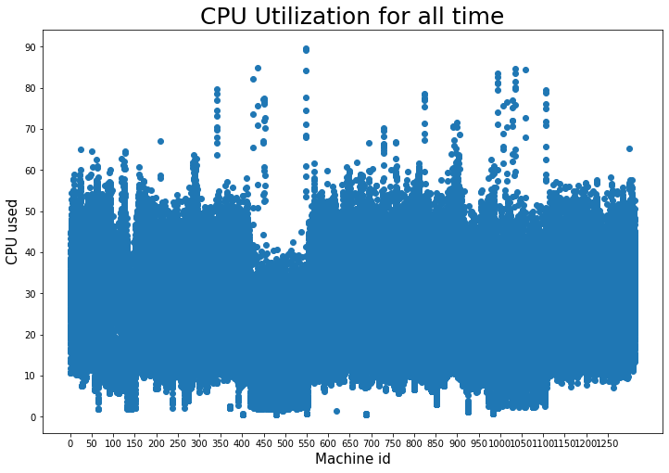
Figure 11: Max 50% CPU usage in servers for the whole time frame

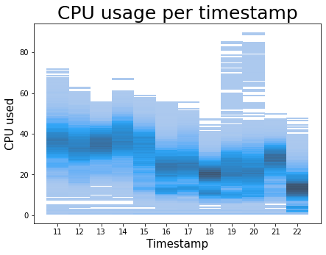
Figure 12: General decreasing trend in CPU usage with time

The below given heat map shows the memory usage in the servers in the given time period. The memory is also not utilized for machine_id 380 to 570. Similar to CPU utilization, memory usage also decreases with time for each machine. Majorly 50% of the memory is used for maximum servers.
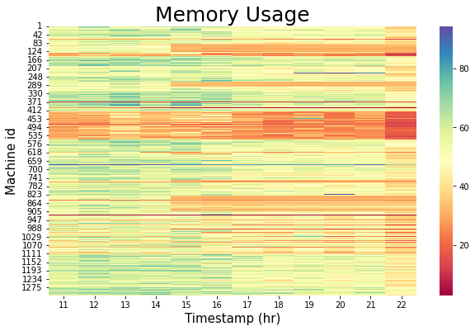
Figure 13: Memory utilization for server
Therefore from all the above graphs it can be inferred that distribution of resources among the machines for the time frame is not balanced.
Furthermore, the line graph below shows the utilized CPU and the remaining CPU resources calculated by subtracting the used CPU value from initial CPU resource
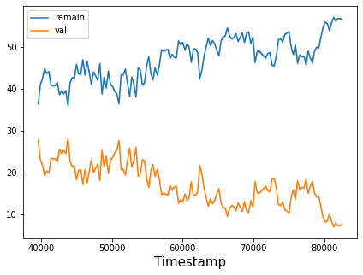
Figure 14: CPU remaining vs initial value for server
III. CONCLUSION
To conclude, this paper is a survey of various technologies related to cloud computing. It started with the differences between virtual machines and containers, and how containers are getting more admired than VMs. Secondly, there was the description of the Docker software and the way it worked internally using Linux utilities and UFS. It also explains the basic concepts of Docker architecture containers, images, and Docker API. With more usage of containers, there arrives the need to develop orchestration tools to manage and scale them. The thorough difference between various orchestrators such as Docker Swarm, Kubernetes, Nomad, and Mesos demonstrated there are different kinds of orchestrators for every type of architecture. Moreover, the paper portrayed in-depth research on resource management. Resource management can be applied to parameters like energy efficiency, cost of computation, resource utilization, makespan, throughput, and network bandwidth. The fact that there is much research on load balancing of cloud computing, shows that it is a crucial part of resource management. Specifically, there are two types of load balancing - static and dynamic. Furthermore, various load balancing techniques have been studied and analyzed in depth. Finally, in the last section, the real-world application of containers was analyzed. This includes the publicly available cloud dataset logs. There is a total of six main files that constitute the Alibaba dataset, and there have been analyses with the help of heat maps on various parameters such as CPU, memory, etc. The other dataset noted in the paper is the Google trace dataset.

Reference
[1] Roy Ikink, “25 cloud trends for 2021 and beyond,” Mar. 04, 2021. https://www.accenture.com/nl-en/blogs/insights/cloud-trends (accessed Apr. 15, 2022).
[2] Vladimir Sumina, “26 Cloud Computing Statistics, Facts & Trends for 2022,” Mar. 18, 2022. https://www.cloudwards.net/cloud-computing-statistics/ (accessed Apr. 15, 2022).
[3] IncludeHelp, “Cloud Ecosystem,” Jan. 07, 2021. https://www.includehelp.com/cloud-computing/cloud-ecosystem.aspx (accessed Apr. 15, 2022).
[4] W.-T. Tsai, X. Sun, and J. Balasooriya, “Service-Oriented Cloud Computing Architecture,” in 2010 Seventh International Conference on Information Technology: New Generations, 2010, pp. 684–689, doi: 10.1109/ITNG.2010.214.
[5] R. K. Barik, R. K. Lenka, K. R. Rao, and D. Ghose, “Performance analysis of virtual machines and containers in cloud computing,” in 2016 International Conference on Computing, Communication and Automation (ICCCA), Apr. 2016, pp. 1204–1210, doi: 10.1109/CCAA.2016.7813925.
[6] IBM Market Development & Insights, “Containers in the enterprise Rapid enterprise adoption continues ,” 2020. Accessed: Apr. 15, 2022. [Online]. Available: https://www.ibm.com/downloads/cas/VG8KRPRM.
[7] Nitin AGARWAL, “Understanding the Docker Internals,” Jan. 05, 2017. https://medium.com/@BeNitinAgarwal/understanding-the-docker-internals-7ccb052ce9fe (accessed Apr. 15, 2022).
[8] A. K. Yadav, M. L. Garg, and Ritika, “Docker Containers Versus Virtual Machine-Based Virtualization,” 2019, pp. 141–150.
[9] Docker Docs, “Docker overview.” https://docs.docker.com/get-started/overview/ (accessed Apr. 15, 2022).
[10] Docker Docs, “Docker architecture.” https://docs.docker.com/get-started/overview/#docker-architecture (accessed Apr. 15, 2022).
[11] Docker Docs, “Swarm mode key concepts.” https://docs.docker.com/engine/swarm/key-concepts/ (accessed Apr. 15, 2022).
[12] Fabrizio Soppelsa and Chanwit Kaewkasi, Native Docker Clustering with Swarm. Packt Publishing Ltd, 2016.
[13] Kubernetes Documentation, “Overview | Kubernetes,” 2021. https://kubernetes.io/docs/concepts/overview/ (accessed Apr. 15, 2022).
[14] Kubernetes Docs, “Concepts | Kubernetes,” 2020. https://kubernetes.io/docs/concepts/ (accessed May 04, 2022).
[15] Tom Gallacher, “Kubernetes: Core Concepts,” 2019. https://www.cncf.io/blog/2019/05/10/kubernetes-core-concepts/ (accessed May 04, 2022).
[16] Raft Consensus Algorithm, “The Raft Consensus Algorithm.” https://raft.github.io/ (accessed May 04, 2022).
[17] Diego Ongaro and John Ousterhout, “In Search of an Understandable Consensus Algorithm,” 2014 USENIX Annu. Tech. Conf. (USENIX ATC 14), pp. 305–319, 2014.
[18] M. A. Rodriguez and R. Buyya, “Container‐based cluster orchestration systems: A taxonomy and future directions,” Softw. Pract. Exp., vol. 49, no. 5, pp. 698–719, May 2019, doi: 10.1002/spe.2660.
[19] G. Sobers Smiles David, K. Ramkumar, P. Shanmugavadivu, and P. S. Eliahim Jeevaraj, “Introduction to Cloud Resource Management,” 2021, pp. 1–16.
[20] R.S.Rajput and Anjali Pant, “OPTIMAL RESOURCE MANAGEMENT IN THE CLOUD ENVIRONMENT- A REVIEW,” Int. J. Converging Technol. Manag., vol. 4, no. 1, 2018, Accessed: May 04, 2022. [Online]. Available: https://www.gyanvihar.org/journals/index.php/2018/12/03/optimal-resource-management-in-the-cloud-environment-a-review/.
[21] Rick Blaisdell, “Managing resources in the cloud,” 2014. https://rickscloud.com/managing-resources-in-the-cloud/ (accessed May 04, 2022).
[22] I. Ahmad, M. G. AlFailakawi, A. AlMutawa, and L. Alsalman, “Container scheduling techniques: A Survey and assessment,” J. King Saud Univ. - Comput. Inf. Sci., Mar. 2021, doi: 10.1016/j.jksuci.2021.03.002.
[23] Yelchuri Venkata Sai Harsha and Nagaraj G Cholli, “Load Balancing in Cloud Computing,” Int. J. Adv. Res. Comput. Commun. Eng., vol. 10, no. 5, 2021, Accessed: May 04, 2022. [Online]. Available: https://ijarcce.com/wp-content/uploads/2021/06/IJARCCE.2021.105146.pdf.
[24] Y. Wu and H. Chen, “ABP Scheduler: Speeding Up Service Spread in Docker Swarm,” in 2017 IEEE International Symposium on Parallel and Distributed Processing with Applications and 2017 IEEE International Conference on Ubiquitous Computing and Communications (ISPA/IUCC), Dec. 2017, pp. 691–698, doi: 10.1109/ISPA/IUCC.2017.00108.
[25] Y. Mao, J. Oak, A. Pompili, D. Beer, T. Han, and P. Hu, “DRAPS: Dynamic and resource-aware placement scheme for docker containers in a heterogeneous cluster,” in 2017 IEEE 36th International Performance Computing and Communications Conference (IPCCC), Dec. 2017, pp. 1–8, doi: 10.1109/PCCC.2017.8280474.
[26] S. Song, L. Deng, J. Gong, and H. Luo, “Gaia Scheduler: A Kubernetes-Based Scheduler Framework,” in 2018 IEEE Intl Conf on Parallel & Distributed Processing with Applications, Ubiquitous Computing & Communications, Big Data & Cloud Computing, Social Computing & Networking, Sustainable Computing & Communications (ISPA/IUCC/BDCloud/SocialCom/SustainCom), Dec. 2018, pp. 252–259, doi: 10.1109/BDCloud.2018.00048.
[27] A. Al-Moalmi, J. Luo, A. Salah, K. Li, and L. Yin, “A whale optimization system for energy-efficient container placement in data centers,” Expert Syst. Appl., vol. 164, p. 113719, Feb. 2021, doi: 10.1016/j.eswa.2020.113719.
[28] K. N. Vhatkar and G. P. Bhole, “Optimal container resource allocation in cloud architecture: A new hybrid model,” J. King Saud Univ. - Comput. Inf. Sci., vol. 34, no. 5, pp. 1906–1918, May 2022, doi: 10.1016/j.jksuci.2019.10.009.
[29] M. Adhikari and S. N. Srirama, “Multi-objective accelerated particle swarm optimization with a container-based scheduling for Internet-of-Things in cloud environment,” J. Netw. Comput. Appl., vol. 137, pp. 35–61, Jul. 2019, doi: 10.1016/j.jnca.2019.04.003.
[30] Y. Guo and W. Yao, “A container scheduling strategy based on neighborhood division in micro service,” in NOMS 2018 - 2018 IEEE/IFIP Network Operations and Management Symposium, Apr. 2018, pp. 1–6, doi: 10.1109/NOMS.2018.8406285.
[31] R. Zhang, Y. Chen, B. Dong, F. Tian, and Q. Zheng, “A Genetic Algorithm-Based Energy-Efficient Container Placement Strategy in CaaS,” IEEE Access, vol. 7, pp. 121360–121373, 2019, doi: 10.1109/ACCESS.2019.2937553.
[32] P. Garraghan, P. Townend, and Jie Xu, “An Analysis of the Server Characteristics and Resource Utilization in Google Cloud,” in 2013 IEEE International Conference on Cloud Engineering (IC2E), Mar. 2013, pp. 124–131, doi: 10.1109/IC2E.2013.40.
[33] W. Zhang, B. Li, D. Zhao, F. Gong, and Q. Lu, “Workload Prediction for Cloud Cluster Using a Recurrent Neural Network,” in 2016 International Conference on Identification, Information and Knowledge in the Internet of Things (IIKI), Oct. 2016, pp. 104–109, doi: 10.1109/IIKI.2016.39.
[34] C. Lu, K. Ye, G. Xu, C.-Z. Xu, and T. Bai, “Imbalance in the cloud: An analysis on Alibaba cluster trace,” in 2017 IEEE International Conference on Big Data (Big Data), Dec. 2017, pp. 2884–2892, doi: 10.1109/BigData.2017.8258257.
[35] Alibaba, “Alibaba Cluster Trace Program,” 2017. https://github.com/alibaba/clusterdata (accessed Apr. 18, 2022).

