Name: SNEHIL SINGH
Roll No.: 2305896
Course: Power BI (IS30074)

OLA Dashboard Analysis

Problem Statement
Ola is one of the largest ride-hailing platforms, generating a huge amount of data related to rides, customers, drivers, and revenue. Analyzing this data manually is difficult and time-consuming.
The challenge is to understand:
- Ride demand patterns
- Revenue distribution
- Peak booking times
- Customer and driver behavior
The objective of this project is to analyze Ola ride data and build an interactive Power BI dashboard that provides meaningful insights into ride trends, revenue, and operational performance.

Solution / Features
This project presents a Power BI dashboard that simplifies the analysis of Ola ride data through interactive visuals.
Key Features:
- Data cleaning and transformation using Power Query
- Handling missing values and formatting columns
- Creating calculated columns (e.g., ride duration, revenue metrics)
- Interactive dashboard with slicers
The dashboard includes:
- KPI cards showing:
Name: SNEHIL SINGH
Roll No.: 2305896
Course: Power BI (IS30074)

  - Total Rides
  - Total Revenue
  - Average Ride Distance
- Bar chart showing rides by city/location
- Line chart for ride trends over time
- Pie chart showing ride type distribution (Mini, Prime, Auto, etc.)
- Analysis of peak hours and demand patterns
- Driver performance insights
- Slicers for filtering by:
  - Date
  - City
  - Ride Type

Name: SNEHIL SINGH
Roll No.: 2305896
Course: Power BI (IS30074)
Screenshots

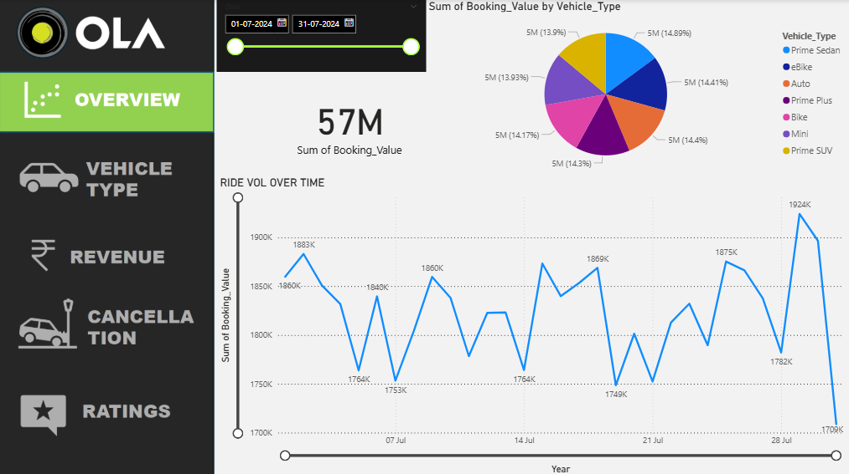

Name: SNEHIL SINGH
Roll No.: 2305896
Course: Power BI (IS30074)
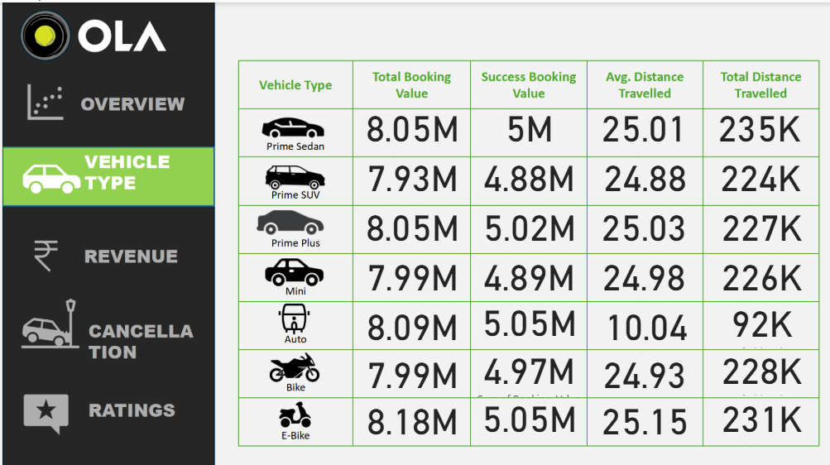

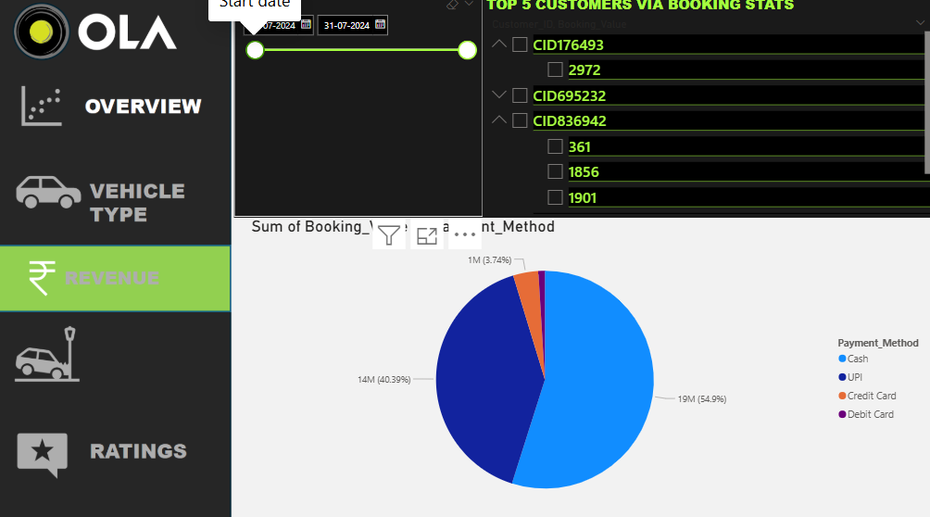

Name: SNEHIL SINGH
Roll No.: 2305896
Course: Power BI (IS30074)
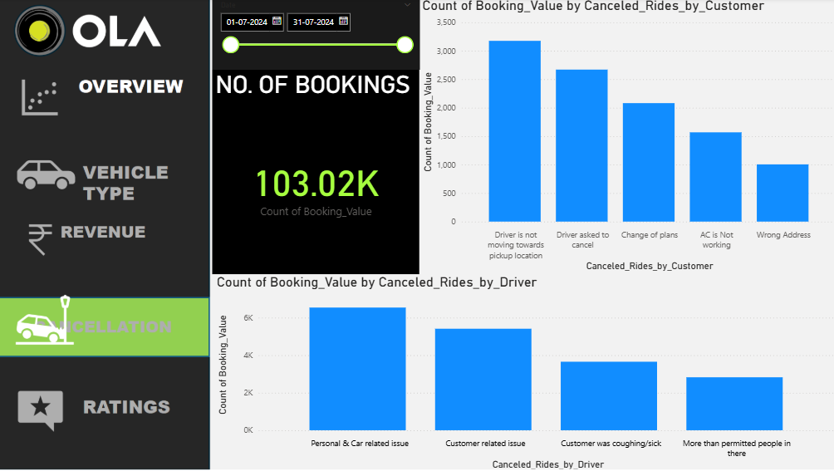
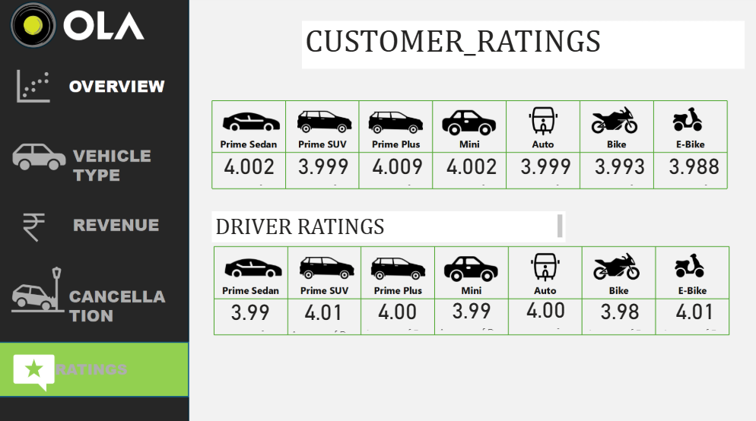

Tech Stack
The following tools and technologies were used:
Name: SNEHIL SINGH
Roll No.: 2305896
Course: Power BI (IS30074)

• Power BI – for dashboard and visualization
Power BI is used to design and develop the interactive dashboard. It helps in creating charts like bar charts, pie charts, line charts, KPI cards, and slicers.
• Power Query – for data transformation
Power Query is used to clean and prepare the dataset. Tasks like handling missing values, changing data types, and formatting columns are performed here.
• Dataset – for input data
The dataset contains Ola ride-related information such as:
- Ride ID
- Date & Time
- Location
- Ride Type
- Distance
- Fare Amount
• DAX – basic calculations
Basic DAX functions are used for:
- Total Revenue
- Average Distance
- Ride Count

Unique Points

This project includes several unique features:

Interactive dashboard with real-time filtering
Name: SNEHIL SINGH
Roll No.: 2305896
Course: Power BI (IS30074)

Clean and user-friendly layout
Multiple visualizations for better insights
Analysis of ride demand patterns
Identification of peak hours and high-demand locations

Future Improvements
- Add real-time data using APIs
- Include customer ratings and feedback analysis
- Implement advanced analytics (forecasting demand)
- Add drill-through and navigation buttons
- Improve UI/UX with advanced Power BI features

Conclusion
This project demonstrates how Power BI can be effectively used to analyze Ola ride data. The dashboard provides valuable insights into ride trends, revenue generation, and operational efficiency, making it easier to understand and make data-driven decisions.

