Snehil Rao

17BEE0282

**Abstract:**

This document shows the progress of my summer project work of making a digital voltmeter and ammeter.

**Keywords:**

TC7107 AtoD converter, IC7660 & 7 Segment Display(7SD)

**Work Progress:**

Since previously I’ve tried to work with IC 3161 and IC 3162 in which one used as BCD to 7SD and later to give the signal to IC 3161 but the working of IC 3162 is quite complex and hard to understand.

So, I come to a point to not to use these IC’s for this project instead I’m using TC7107 AtoD converter to control 4 7SD’s.

This IC takes the voltage as input and process it to be displayed in 4 different 7SD in which last one is after the decimal point.

Moreover its upper range is up to 200 Volts but the accuracy of lower range is to be observed.

But the problem may be faced when working with ammeter circuit since we have to convert the current input to the input accepted by IC that is proportional Voltage. This problem could be solved by trying some more IC like hcf4511b or IC 7660, which I’ve to work on.

Here’s the IC and its pin nomenclature:

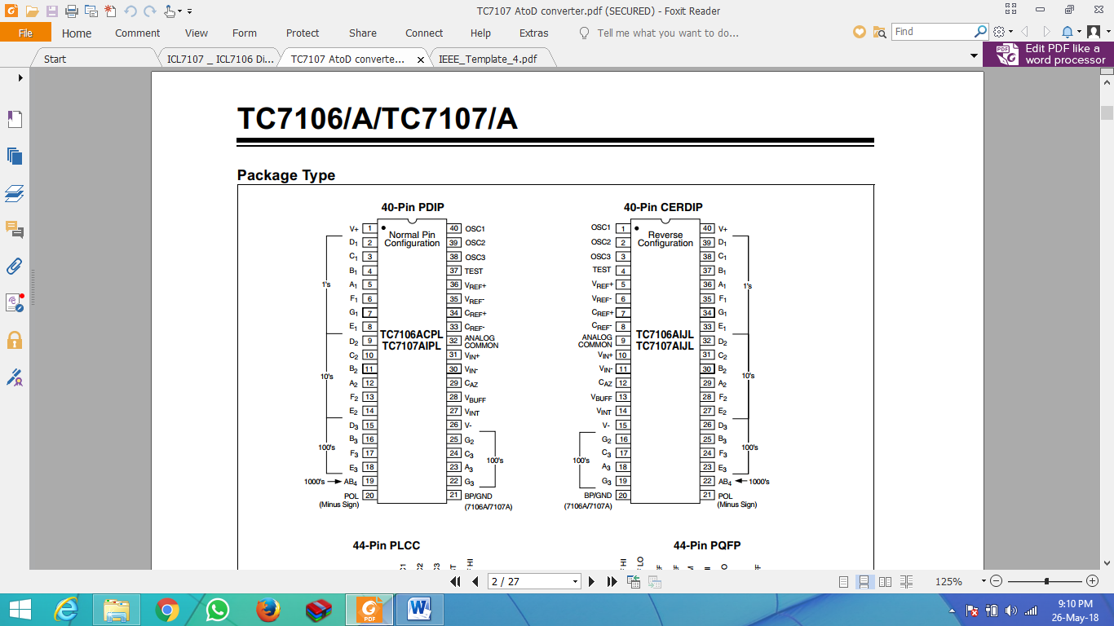

Learning about the pins is yet to be done.