Date: 31-05-2017

### Purpose

Need to merge changes of different branches from multiple remote repositories.

### Getting set up

Below I illustrate following steps in local system:

|  |  |
| --- | --- |
| Repository **A** | Nemo_latest_code |
| Repository **B** | Release |
| **stage** | qa_code_release |

* Clone desire branch of Repository **A** and Checkout the branch
* At different Location Clone desire branch of Repository **B**
* Create a new branch(**stage**) in Repository **B** and clean that branch
* Copy the code from Repository **A** branch to **stage** branch of Repository **B**
* Push the code to Repository **B**
* Merge **stage** branch to target branch of Repository **B**

Below shown are the screenshots to perform this activity:

* First, let’s get the Clone *Nemo_latest_code* repository:

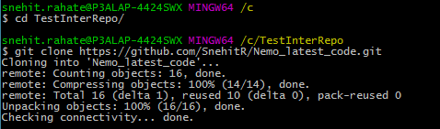

* Check out required branch



* In different Location in local – Clone required branch from *MainRelease* Repository

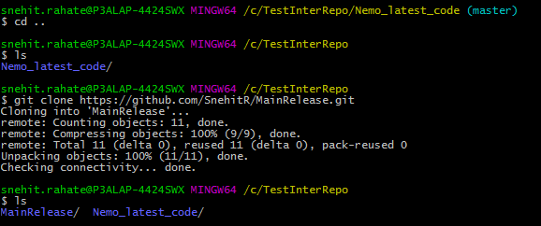

* Create a new branch in *MainRelease* Repository and Clean that branch

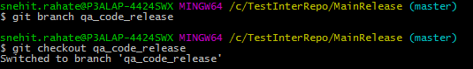

* Checkout to newly created branch



* Open **new GIT bash window** to copy the code from source Repository
* Copy the code from *Nemo_Latest_Code* Repository to newly created branch in *MainRelease* Repository

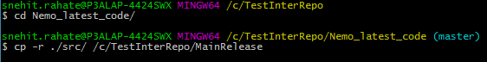

* Code is copied to new branch from Nemo_Latest_Code Repository (branch)



* Now push new branch(code)to remote *MainRelease* Repository in GITHUB

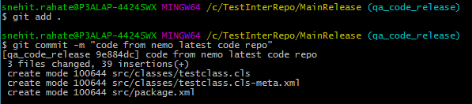

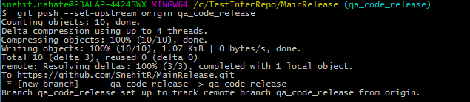

* New branch is added to *MainRelease* repository in Github

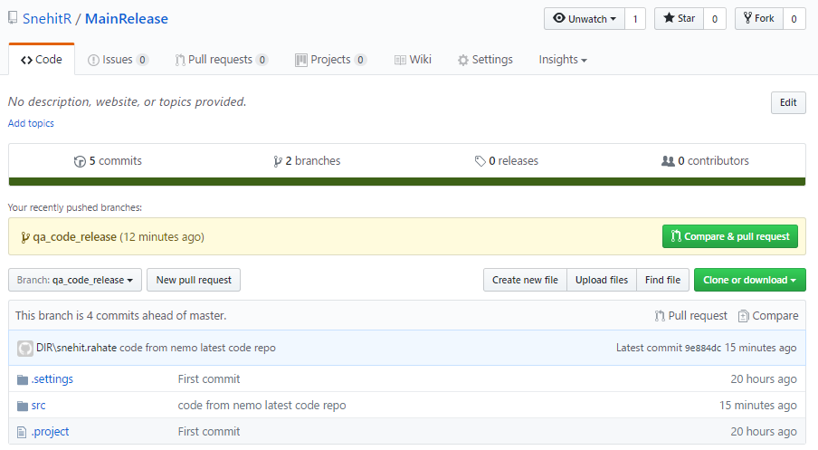

* Now create new pull request to merge the desire branched in single repository.