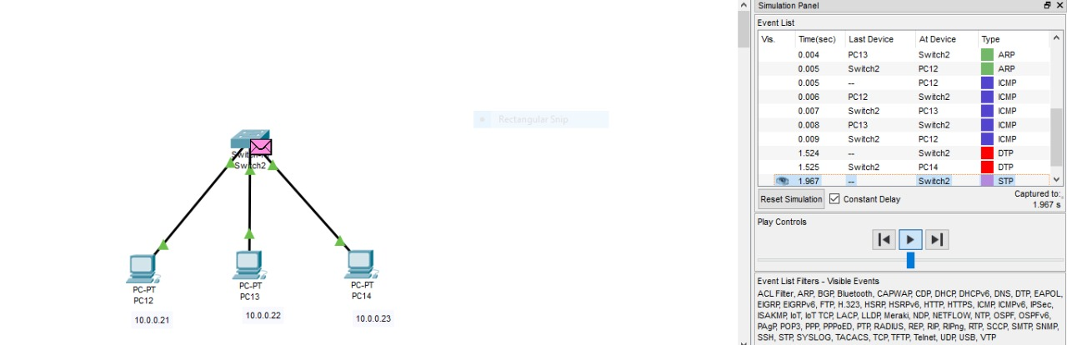

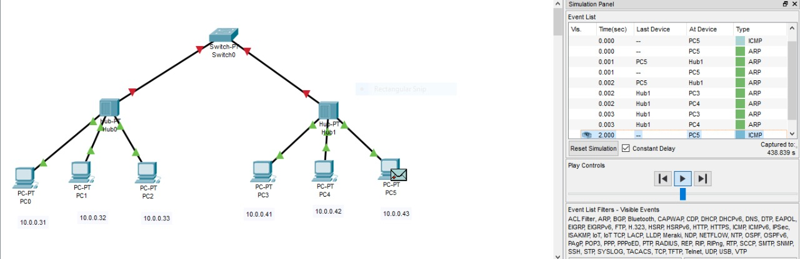

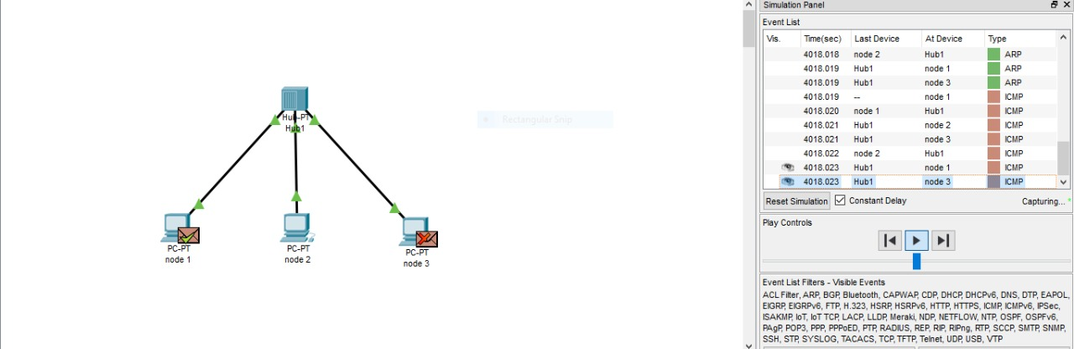

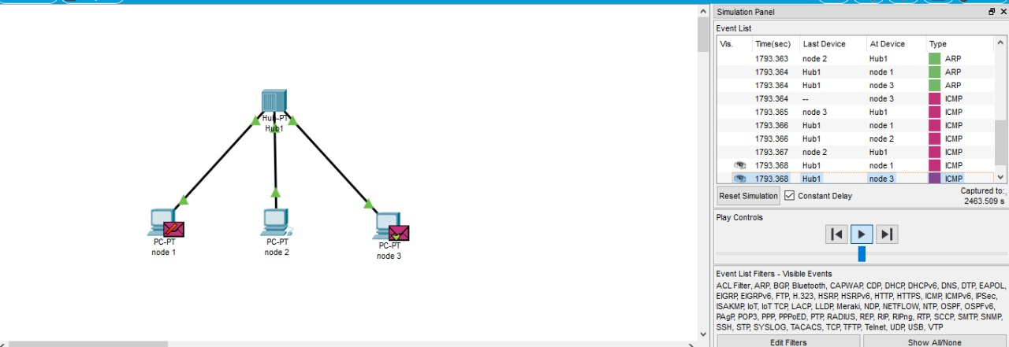

Outcome**: We learnt the difference between the working of a switch and a hub.**

Hub is a networking devices which is used to transmit the signal to each port except one port to respond from which the signal was received. Switch is a network device which is used to enable the connection establishment and connection termination on the basis of need. Switch is operated on Data link layer.