A
PROJECT SCHOOL REPORT
ON
UNDERWATER SONAR IMAGE CLASSIFICATION AND
ANALYSIS USING LIME-BASED EXPLAINABLE AI
Submitted By
SOLLETI AKSHITHA 23P81A6747

SRINADHAM NEERAJA REDDY 23P81A0556

MANURI VENKATA GURU SRI CHARAN 23P81A6737

BIKUMALLA SRIWATSAVA 23P81A6713

GUNDEMONI SNEHITH 23P81A6727

Under the guidance of
Mrs. K. NAVATHA

Asst. Professor, Dept. of CSE(AIML)


KESHAV MEMORIAL COLLEGE OF ENGINEERING

Koheda Road, Chinthapallyguda (V), Ibrahimpatnam (M), R.R. Dist. – 501510 (T.S)
December 2025


KESHAV MEMORIAL COLLEGE OF ENGINEERING
A Unit of Keshav Memorial Technical Education (KMES) Approved by AICTE, New Delhi & Affiliated to JNTU, Hyderabad

CERTIFICATE
This is to certify that the project work entitled “UNDERWATER SONAR IMAGE CLASSIFICATION AND ANALYSIS USING LIME-BASED EXPLAINABLE ARTIFICIAL INTELLIGENCE” is a bonafide work carried out by “Solleti Akshitha, Srinadham Neeraja Reddy, Manuri Venkata Guru Sri Charan, Bikumalla Sriwatsava, Gundemoni Snehith” of III year I semester Bachelor of Engineering in CSE during the academic year 2025 and is a record of bonafide work carried out by them.

Project Mentor
K.NAVATHA
Assistant Professor, AIML

ABSTRACT
Underwater SONAR imaging plays a vital role in defence, navigation, and exploration, but automatic classification of SONAR images remains challenging due to high noise levels, low contrast, and limited labelled data. While deep learning models such as Convolutional Neural Networks (CNNs) have achieved remarkable accuracy in visual recognition, their black-box nature limits their adoption in critical applications where interpretability and trust are essential. To address this challenge, this work presents an explainable AI framework for underwater SONAR image classification using a transfer learning-based DenseNet121 model integrated with Local Interpretable Model-Agnostic Explanations (LIME) and Gradient-weighted Class Activation Mapping (Grad-CAM). A custom SONAR dataset was created by combining multiple public sources and balanced using augmentation and stratified sampling techniques to ensure robust training. The proposed DenseNet121 model achieved a high classification accuracy of 98%, demonstrating effective generalization across six object categories—fish, human, mine, plane, seafloor, and shipwreck. LIME provided localized, pixel-level explanations for individual predictions, while Grad-CAM generated class-specific heatmaps highlighting the most influential regions in each image. Together, these complementary XAI techniques enhanced the transparency and trustworthiness of the model’s decisions. The results confirm that explainable deep learning can make SONAR-based surveillance systems more interpretable, reliable, and suitable for real-world deployment in defence and underwater exploration domains.

CONTENTS
S.No. | Title | Page No.
 | ABSTRACT | i
 | TABLE OF CONTENTS | ii
 | LIST OF FIGURES | iii
1. | Introduction | 1
2. | Literature Survey  2.1 Existing Research and Techniques  2.2 Limitations and Drawbacks  2.3 Distinctive Aspects of Our Methodology | 3  4  4
3. | Proposed Work Architecture, Technology Stack, Implementation Details  3.1 Model Architectures  3.2 Technology Stack and Implementation  3.3 Dataset  3.4 Interfaces and Communication | 8  12  16  19
4. | Results & Discussions  4.1 Results  4.2 Discussions | 26  26
5. | Conclusion & Future Scope | 29
6. | References | 31

LIST OF FIGURES

Fig. No. | Figure Name |  | Page No.
1  2 |  | Model architecture 8  System Architecture 19
3 |  | Login page 21
4 |  | Home page 21
5 |  | Prediction Result display 22
6 |  | History page 22
7 Bookmark page 23

CHAPTER 1
INTRODUCTION

Sound Navigation and Ranging (SONAR) is one of the most widely used technologies for underwater exploration, surveillance, and object detection. It operates by transmitting acoustic waves and interpreting the reflected signals to generate images of the ocean floor and submerged objects. Compared to optical imaging, SONAR is highly reliable under low-light or turbid conditions, making it essential for naval defence, marine biology, and autonomous underwater vehicles. However, the manual interpretation of SONAR images is labour-intensive, time-consuming, and prone to human error due to their inherent noise, low resolution, and complex texture patterns.
With the rapid advancements in deep learning, Convolutional Neural Networks (CNNs) have shown outstanding performance in automated image classification tasks. Yet, their “black-box” nature — where the decision-making process remains opaque — limits their application in safety-critical domains such as defence. For such high-stakes environments, explainability is crucial to ensure transparency, trust, and accountability in model predictions.
This project addresses this challenge by developing an Explainable AI (XAI) framework for SONAR image classification using DenseNet121, a deep transfer learning model known for its efficient feature propagation and reduced vanishing gradients. The model is trained on a custom SONAR dataset curated from multiple open sources and balanced through data augmentation and stratified sampling. To enhance interpretability, two post-hoc XAI techniques are integrated — Local Interpretable Model-Agnostic Explanations (LIME) and Gradient-weighted Class Activation Mapping (Grad-CAM).
LIME provides fine-grained, local-level insights by perturbing image regions and observing their effect on predictions, while Grad-CAM produces visual heatmaps that highlight the most discriminative regions influencing the model’s decision. Together, these explainers enable both local and global interpretability, bridging the gap between high accuracy and human-understandable reasoning.
The proposed system achieved an accuracy of 98% on six SONAR image categories — fish, human, mine, plane, seafloor, and shipwreck — demonstrating strong generalization and clear visual explanations. This combination of DenseNet121 with LIME and Grad-CAM contributes to building trustworthy and transparent deep learning models, paving the way for their real-world application in autonomous underwater surveillance and defence intelligence systems.

CHAPTER 2
LITERATURE SURVEY
2.1 Existing Research and Techniques
Earlier underwater object classification methods relied on a two-step detection process: first data collection, then manual human classification using predefined templates. Probabilistic neural networks, pattern-matching algorithms, and template matching were applied for automatic object detection in side scan SONAR images. For instance, Myers et al. used template matching to compare simple acoustic signatures against candidate object images, and Xu et al. developed an Adaboost cascade with SVMs achieving about 92% accuracy for object location in SONAR data.
Statistical techniques such as HS-LRT enabled detection based on regions with highlight and shadow, followed by SVM classification. As deep learning advanced, models including VGG16 and ResNet50 emerged for SONAR imagery, often leveraging transfer learning. In 2017, McKay et al. utilized deep neural networks with transfer learning, reaching 93% accuracy on a custom SONAR dataset and improving to 97.7% with synthetic data augmentation. Fuchs et al. (2018) used ResNet-50 to achieve 88%, while Pannu et al. applied CNNs to SAR images, overcoming data issues through augmentation, raising accuracy from 80% to 97%.
Comparative studies highlighted significant improvements: Du et al. used the Seabed Objects KLSG dataset and various pre-trained models, achieving up to 94.81%. Few-shot learning approaches like those in Chungath et al. managed effective modelling even with minimal data. Comprehensive reviews by Steiniger, Domingos, and Neupane provided insight into the progression of deep learning for feature extraction, classification, and segmentation in side scan and synthetic aperture SONAR imagery, evolving computer vision’s applications in underwater domains.
In recent years, explainable AI (XAI) methods have gained traction for interpreting black-box deep learning predictions. Approaches such as LIME, SHAP, and Grad-CAM are being compared across various industries, functioning to validate and interpret model performance, and are adopted for remote sensing and medical imaging as well. In underwater SONAR analysis, XAI integration remains rare, with the only notable work by Walker et al., developing LIME-based classification models for seafloor textures. This laid the groundwork for advancing trustworthy, interpretable, and reliable SONAR image classification models in practical defence and autonomous underwater missions.
2.2 Limitations and Drawbacks
- Noise and distortion: SONAR images suffer from thermal, shipping, and environmental noise, blurring images and reducing classification reliability.
- Lower resolution: Compared to optical imagery, SONAR images offer lower and variable resolution based on object distance, complicating feature extraction.
- Manual workflows: Early systems required manual review and classification, leading to delays and exposing national security processes to risk.
- Class imbalance: Public datasets are often small and imbalanced; some classes have very few samples, resulting in model bias or poor minority class performance.
- Data scarcity: Confidentiality in defence leads to limited, non-representative datasets, curbing generalizability for practical deployment.
- Overfitting risks: Data augmentation and oversampling, especially of minority classes, can lead to overfitting as models memorize duplicate patterns.
- Black box models: Standard deep learning models provide little interpretability; predictions cannot be readily explained or trusted by users or stakeholders.
2.3 Distinctive Aspects of Our Methodology
This research distinguishes itself from prior SONAR image classification studies through an end-to-end framework that unites deep learning, systematic data balancing, and explainable artificial intelligence. Traditional approaches often treat deep neural networks as black-box models with limited interpretab ility, whereas our methodology emphasizes both accuracy and transparency.
Unlike earlier studies that focus on a single dataset or narrow object categories, our system is built on a custom-curated SONAR dataset assembled from multiple public sources to ensure greater diversity, class variety, and reliability. This dataset supports multi-class classification across challenging underwater categories such as fish, ships, seafloor, mines, planes, and human objects, enabling comprehensive and realistic analysis.
A key innovation lies in our use of both random and stratified sampling for data splitting. While random sampling is common, it can distort class proportions in imbalanced datasets. Stratified sampling ensures uniform class representation across training, validation, and test sets. This comparative design provides fairer evaluation and is rarely seen in prior work.
To counter class imbalance, we employ a hybrid strategy combining oversampling and undersampling. Oversampling uses geometric transformations, brightness adjustments, and synthetic data generation to enrich minority classes, while undersampling prevents the overrepresentation of major ones. This balance enhances generalization and reduces bias, yielding more consistent accuracy across all categories.
The classification framework rigorously benchmarks multiple state-of-the-art CNN architectures including VGG16, VGG19, ResNet50, InceptionV3, DenseNet121, and MobileNetV2. Each model is fine-tuned through transfer learning with additional custom layers optimized for SONAR imagery. Extensive ablation studies assess how architecture choice, sampling strategy, and data balancing collectively influence performance.
A central contribution is the integration of explainable AI tools—LIME (Local Interpretable Model-Agnostic Explanations) and SP-LIME—to visualize and interpret model predictions. These methods perturb selected regions of input images to highlight which features drive classification outcomes. By using Quickshift and SLIC algorithms for super-pixel segmentation, our framework balances interpretability with computational efficiency, offering clear, human-understandable justifications for each decision.
Beyond quantitative results, the methodology provides comprehensive benchmarking protocols to ensure reproducibility and fairness. Evaluation metrics such as accuracy, precision, recall, and F1-score are supplemented with visual analyses like confusion matrices and explanation masks, offering both statistical and interpretive validation of model performance.
Finally, the framework is designed for future scalability. It can incorporate enhanced data sources, emerging explainability tools, and improved image reconstruction methods such as SRGAN-based super-resolution. This adaptability ensures sustained relevance for evolving underwater surveillance and defence applications.
In summary, this methodology combines robust deep learning with balanced data engineering and explainable AI to deliver a transparent, reliable, and adaptable multi-class SONAR image classification system—one of the first to merge interpretability and operational readiness in this domain.
​

CHAPTER 3
PROPOSED WORK ARCHITECTURE, TECHNOLOGY STACK, IMPLEMENTATION DETAILS
This chapter presents a detailed description of the proposed system architecture, selected technologies, and implementation methodology adopted for the SONAR Image Classification System. The primary objective of this work is to automatically analyse underwater SONAR images and accurately classify them into predefined categories using advanced deep learning techniques. SONAR imagery plays a critical role in underwater exploration, naval defence, seabed mapping, and object detection; however, manual interpretation of such images is time-consuming, expertise-dependent, and prone to human error due to noise, low contrast, and complex underwater environments.
To address these challenges, the proposed system leverages deep convolutional neural networks (CNNs) combined with Explainable Artificial Intelligence (XAI) techniques to provide both accurate predictions and transparent decision-making. Unlike traditional image processing approaches, deep learning models can automatically learn discriminative features from raw SONAR images, enabling robust performance even under challenging imaging conditions.
The system is designed as a secure, end-to-end web-based application, allowing authenticated users to upload SONAR images and receive classification results along with visual explanations. A DenseNet121-based architecture is employed as the core classification model due to its strong feature reuse capability and efficiency in learning fine-grained visual patterns. To enhance user trust and interpretability, Grad-CAM and LIME are integrated to highlight the image regions that most influence the model’s predictions.

3.1 Model Architecture

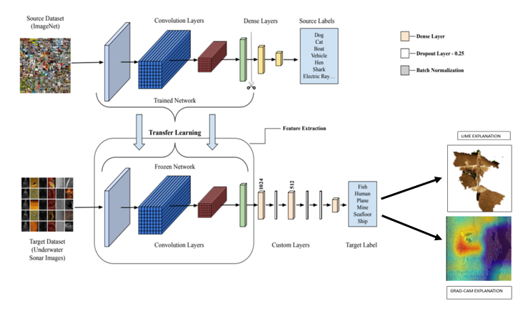
Figure 1: Model architecture
- Step 1: Source Domain Pre-training
The proposed architecture begins with a deep convolutional neural network pre-trained on a large-scale source dataset such as ImageNet. This source dataset contains diverse visual categories, enabling the network to learn generic low-level and mid-level visual features, including edges, textures, and spatial patterns.
The convolutional layers trained on the source dataset act as a robust feature extractor and provide well-initialized weights, eliminating the need for random weight initialization.

- Step 2: Transfer Learning Setup
Transfer learning is employed by reusing the learned weights and biases from the source domain model. Let the source domain be represented as
Ds = {Xs, P(Xs)} with a corresponding learning task Ts, and the target domain be Dt = {Xt, P(Xt)} with learning task Tt.
Although the source and target domains differ in data distribution and task objectives (Ds ≠ Dt or Ts ≠ Tt), the learned feature representations from the source domain remain valuable for the target task.
The primary objective is to improve the target predictive function fT(x) for the target task Tt by leveraging knowledge transferred from Ds and Ts.

- Step 3: Feature Extraction using Frozen Convolutional Layers
Instead of retraining the entire network, the convolutional layers of the pre-trained model are frozen and used exclusively for feature extraction. These layers process the input underwater sonar images and generate high-level feature maps representing structural and texture-based characteristics of sonar imagery.
By freezing the convolutional layers, the model:
- Reduces computational cost
- Prevents overfitting
- Retains generalized visual knowledge learned from the source dataset.

- Step 4: Target Dataset Processing
The target dataset consists of underwater sonar images, which are pre-processed and fed into the frozen convolutional backbone. These images differ significantly from natural images in appearance and noise characteristics, making transfer learning particularly beneficial.
The extracted features from the convolutional layers form the input to the task-specific classification network.

- Step 5: Custom Trainable Layers
To adapt the model to the sonar classification task, custom fully connected layers are added on top of the frozen feature extractor. These layers are trainable and are optimized using the target dataset.
The target model architecture includes:
- Multiple dense (fully connected) layers
- Dropout layers to reduce overfitting
- A batch normalization layer to stabilize training and improve generalization
These layers learn high-level, class-specific representations unique to underwater sonar images

- Step 6: Optimization and Fine-tuning
The weights of the custom layers are optimized using backpropagation and gradient descent techniques. During training, only the target-specific layers are updated, while the source domain weights remain unchanged.
This fine-tuning strategy enables the model to adapt to the sonar dataset efficiently while preserving the generalized visual features learned from the source domain.

- Step 7: Target Label Prediction
The final output layer produces predictions for the target sonar classes, such as:
- Fish
- Human
- Plane
- Mine
- Seafloor
- Ship
A Softmax activation function is used to generate class probability distributions, and the class with the highest probability is selected as the predicted label.

- Step 8: Explainability using LIME
To enhance model transparency and trustworthiness, a LIME (Local Interpretable Model-Agnostic Explanations) module is integrated with the classifier. LIME generates visual explanations by identifying the most influential regions of the sonar image that contribute to the model’s prediction.
This explainability component is particularly important in safety-critical underwater applications, where understanding model decisions is as important as achieving high accuracy.
Mathematically, local surrogate models with an interpretability constraint can be expressed as follows:
$$\text{explanation}(x)=arg⁡\underset{g∈G}{min⁡} L(\hat{f},g,π_{x})+Ω(g)$$
The explanation model for an instance $x$is the model $g$(e.g., a linear regression model) that minimizes the loss $L$(e.g., mean squared error), which measures how close the explanation is to the prediction of the original model $\hat{f}$(e.g., an XGBoost model), while keeping the model complexity $Ω(g)$low (e.g., preferring fewer features).
Here, $G$denotes the family of possible explanation models, for example, all possible linear regression models. The proximity measure $π_{x}$defines the size of the neighborhood around the instance $x$that is considered for generating the explanation. In practice, LIME optimizes only the loss term, and the user controls the model complexity by selecting parameters such as the maximum number of features that the linear explanation model may use.

- Step 9: Explainability using Grad-CAM
Grad-CAM provides visual explanations by highlighting the regions of a sonar image that contribute most significantly to a particular class prediction. Unlike traditional saliency maps, Grad-CAM focuses on class-specific discriminative regions, allowing domain experts to verify whether the model attends to meaningful acoustic reflections, object boundaries, or shadow patterns in the sonar image.
In the proposed sonar image classification system, Grad-CAM heatmaps are generated from the final convolutional layers of the CNN, as these layers preserve spatial information while capturing high-level semantic features. The resulting heatmaps are overlaid on the original sonar images, enabling intuitive interpretation of the model’s predictions. This enhances trust, supports model validation, and helps detect erroneous or biased decision patterns.
Mathematical Formulation of Grad-CAM
Let:
- $y^{c}$be the score (before softmax) for class $c$
- $A^{k}$be the $k^{th}$feature map of the last convolutional layer
- $Z$be the total number of pixels in the feature map
Step 1: Compute Gradient Weights
Grad-CAM computes the importance weight $α_{k}^{c}$for each feature map $A^{k}$with respect to class $c$:
$$α_{k}^{c}=\frac{1}{Z}\sum_{i}{\sum_{j}{\frac{∂y^{c}}{∂A_{ij}^{k}}}}$$
Explanation
- The partial derivative $\frac{∂y^{c}}{∂A_{ij}^{k}}$measures how sensitive the class score is to the activation at spatial location $\left(i , j\right)$.
- Averaging these gradients over all spatial locations provides a global importance weight for feature map $k$.
- Higher values of $α_{k}^{c}$indicate stronger influence on class $c$.
Step 2: Compute Class Activation Map
The Grad-CAM heatmap $L_{\text{Grad-CAM}}^{c}$is computed as:
$$L_{\text{Grad-CAM}}^{c}=\text{ReLU}\left(\sum_{k}{α_{k}^{c}}A^{k}\right)$$
Explanation
- Feature maps are weighted by their importance coefficients.
- The ReLU function removes negative values, ensuring only features that positively influence the class prediction are highlighted.
- The resulting heatmap localizes the most discriminative regions for class $c$.

Model Implementation
def create_model(input_shape, num_classes):
base_model = DenseNet121(weights='imagenet', include_top=False, input_shape=input_shape)
base_model.trainable = False
x = base_model.output
x = Flatten()(x)
x = Dense(1024, activation='relu')(x)
x = Dropout(0.25)(x)
x = Dense(512, activation='relu')(x)
x = Dropout(0.25)(x)
x = Dense(256, activation='relu')(x)
x = BatchNormalization()(x)
x = Dropout(0.25)(x)
predictions = Dense(num_classes, activation='softmax')(x)
model = Model(inputs=base_model.input, outputs=predictions)
return model

3.2 Technology Stack and Implementation
This section outlines the complete technology stack, tools, and implementation workflow used to build the Underwater Sonar Image Classification System. The system integrates a DenseNet121-based deep learning model, explainability modules (Grad-CAM, LIME), a Flask backend API, and an interactive interface for visualizing predictions and explanations.
🔹Machine Learning Frameworks and Model Handling
• TensorFlow / Keras
Used to implement the DenseNet121-based model, train the classification head, and save the final model.
• DenseNet121 (Transfer Learning)
Pretrained on ImageNet and used as the feature extractor for sonar images. All convolutional layers are frozen to retain general visual features.
• NumPy and Pandas
Utilized for dataset manipulation, preprocessing, and numerical operations.
• scikit-learn
Used for stratified splitting of data into training, validation, and testing sets.
• CUDA (via Google Colab GPU)
Provided hardware acceleration for model training and inference.
Implementation Details
• The DenseNet121 backbone is loaded with include_top = False and all convolutional layers are frozen.
• A custom fully connected classification head is added on top of the frozen backbone.
• Images are pre-processed using tf.data pipelines with batching, shuffling, parallel mapping, and prefetching.
🔹 Model Architecture Integration
• Backbone: DenseNet121 is used for feature extraction.
• Classification Layers: Three dense layers (1024 → 512 → 256) with dropout and batch normalization.
• Output Layer: A softmax layer predicts one of six sonar object categories.
Model Output
• Predicted class label
• Confidence score derived from softmax
🔹 Explainability Modules
To enhance interpretability, the system integrates several explainability techniques.
• LIME
Generates local explanations by identifying image superpixels that most influence the model’s decision.
• Grad-CAM
Uses gradients from the final convolutional layer to generate a heatmap showing regions most relevant to the prediction.
Implementation Details
• Heatmaps are generated from layer conv5_block16_concat.
• Processed visualizations are overlaid on original images using OpenCV.
• Explanations help users understand why the model predicts a particular class.

🔹 Backend Development
• Flask Framework
Implements a prediction API that accepts uploaded images and returns classification results and explanation maps.
Core Libraries
• Pillow (PIL) for image loading and resizing
• OpenCV for heatmap overlay
• NumPy for tensor operations

API Endpoints
* /predict returns the predicted class and confidence
* /gradcam returns the Grad-CAM heatmap
* /lime returns a LIME explanation image
* /login/challenge generates login challenge
* /login/verify authenticates user and returns JWT
* /verify-token validates JWT
* /upload uploads image and returns AI prediction
* /user/images fetches image history
* /user/image/:name downloads an image
* /user/image/:name (DELETE) deletes a specific image
* /user/images (DELETE) deletes all images
* /predict returns prediction, Grad-CAM, and LIME explanations
🔹 Database and Storage
• MongoDB Atlas used for storing prediction logs and metadata
🔹 Frontend Development
• HTML, CSS, and JavaScript
Used to create a simple and user-friendly interface for interacting with the sonar image classification system.
• User Interaction
The interface allows users to upload sonar images, view the predicted class, observe confidence scores, and visualize explanation heatmaps such as Grad-CAM or LIME.

🔹 Dataset Handling
• The dataset includes six sonar object classes organized into separate folders.
• Files are iterated and grouped by class labels.
• Stratified sampling is performed to create balanced training, validation, and test subsets.
• Images are resized to 224 × 224 pixels and normalized to the [0, 1] range.
🔹 Cloud and Training Strategy
• Training is performed on Google Colab GPU to reduce computation time.
• Incremental training checkpoints help avoid memory overflow.
• Early stopping prevents overfitting.
• Model checkpointing ensures the best-performing model is saved.
🔹 Performance Evaluation
• Accuracy is used as the primary metric for evaluating model performance.
• Confidence scores are recorded to measure prediction certainty.
• Explainability outputs, including heatmaps and superpixel masks, are used to validate the decision-making process.
• The final model is evaluated on an independent test set for unbiased performance measurement.
3.3 Dataset
The dataset used in this project is a synthetic underwater sonar image dataset consisting of six object categories frequently encountered in maritime and underwater surveillance environments. The dataset includes images representing objects such as fish, mines, human divers, planes, ships, and seafloor structures. Each class contains visually distinct sonar signatures, enabling the model to learn discriminative features from acoustic imagery.
The dataset is organized into separate folders for each class, with every folder containing sonar images captured or simulated under varying underwater conditions, noise levels, resolutions, and object orientations. This variability ensures that the trained model generalizes well to different types of sonar captures. The images include variations in intensity, shadow regions, distortions caused by sonar wave reflections, and environmental clutter, which reflect real-world challenges in underwater imaging.

Dataset Structure
The dataset follows a directory-based class organization:
Dataset/synthetic_data_6_class/
fish/
mine/
human/
plane/
ship/
seafloor/
Each directory contains all sonar image samples corresponding to that class. The dataset includes images in formats such as JPG, JPEG, PNG, and BMP. This structure enables automated loading and labelling during preprocessing.

Class Distribution
The dataset class distribution is computed programmatically to ensure balanced representation. Each class contains a sufficient number of examples to support model training and evaluation. Although the dataset is synthetic, it closely resembles real sonar conditions, making it suitable for training transfer learning models.

Preprocessing and Image Preparation
All images are resized uniformly to 224 × 224 pixels to match the input requirements of the DenseNet121 backbone. Pixel values are normalized to the range [0, 1] to stabilize training and accelerate convergence. The dataset is further converted into a TensorFlow data pipeline for efficient loading, shuffling, batching, and prefetching.

Train–Validation–Test Split
To ensure reliable model evaluation, the dataset is divided using a stratified sampling strategy that preserves the proportional representation of all classes. The final split ratios are:
• 70 percent for training
• 15 percent for validation
• 15 percent for testing
This ensures that the validation and test sets remain class-balanced and representative of the overall dataset distribution.

Data Augmentation Considerations
Although basic preprocessing is applied, the model relies primarily on the diversity already present in the synthetic sonar dataset. The dataset's inherent variability in brightness, noise patterns, object orientation, and shadowing effects provides natural augmentation, making additional augmentation optional.

Dataset Relevance
Sonar images differ significantly from natural RGB images. They contain texture-heavy, low-contrast patterns, where object boundaries are often unclear due to scattering, refraction, and noise. Using this dataset allows the model to learn the specific acoustic texture signatures that characterize underwater objects. This makes the dataset highly suitable for evaluating explainability techniques such as LIME, Grad-CAM, which help visualize regions influencing classification decisions.

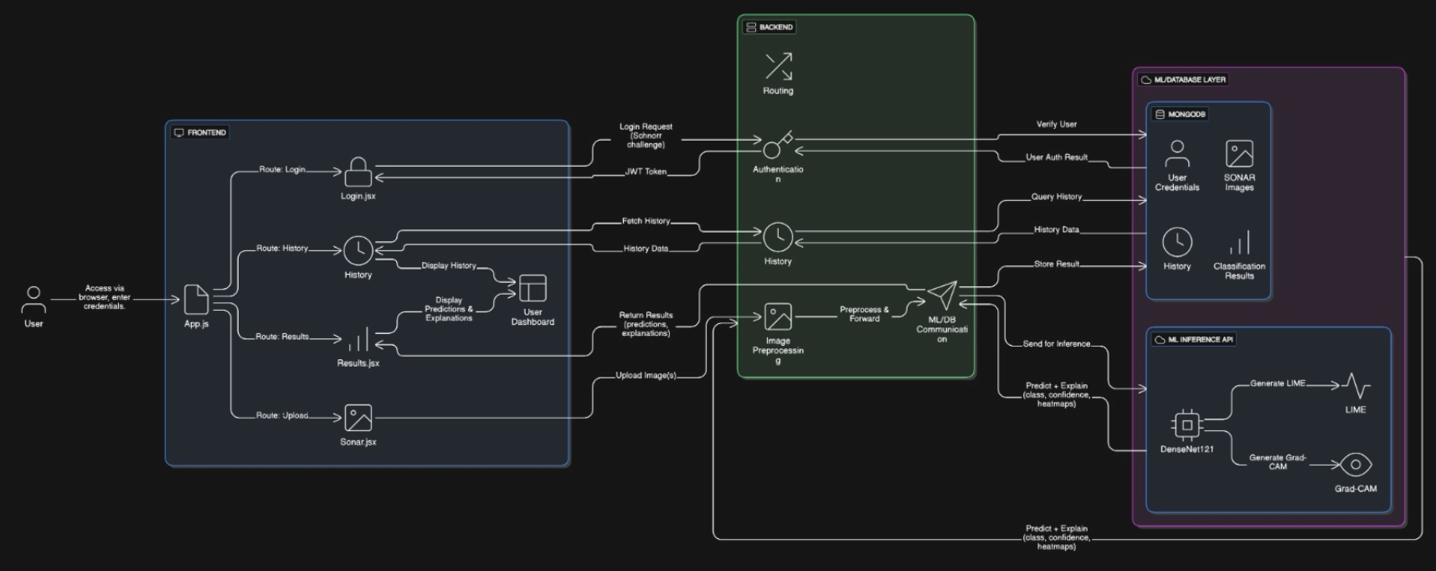

Fig 2 : System Architecture

3.4 Interfaces and Communication
This section describes how different components of the underwater sonar image classification system interact with each other and how data flows between the user, the prediction system, and the storage layer. The interface design and communication pipeline ensure smooth data exchange, consistent formatting, and timely generation of predictions and explainability outputs.
USER INTERFACE(UI)
The user interface acts as the entry point for interacting with the sonar image classification system. It is designed to be simple and functional, allowing users to submit sonar images and receive classification results along with visual explanations. Since the focus of the project is on the machine learning pipeline and explainability, a lightweight interface is adopted instead of a complex frontend framework.
The interface supports image uploads either through a basic HTML form, API testing tools (such as Postman), or direct execution within the Google Colab environment. Uploaded images are passed to the backend for processing, and the resulting predictions and explanation maps are displayed to the user.
Key Features of the Interface
- Minimal and Lightweight Design
The interface avoids unnecessary complexity and focuses on the core functionality of image submission and result visualization.
- Image Upload Mechanism
Users can upload sonar images in common formats such as JPG or PNG. The selected image is forwarded directly to the backend API for inference.
- Prediction Display
After processing, the system displays the predicted sonar object class along with a confidence score derived from the softmax output.
- Explainability Visualization
Visual explanation outputs such as Grad-CAM, and LIME heatmaps are presented alongside the original image to help users understand the model’s decision.

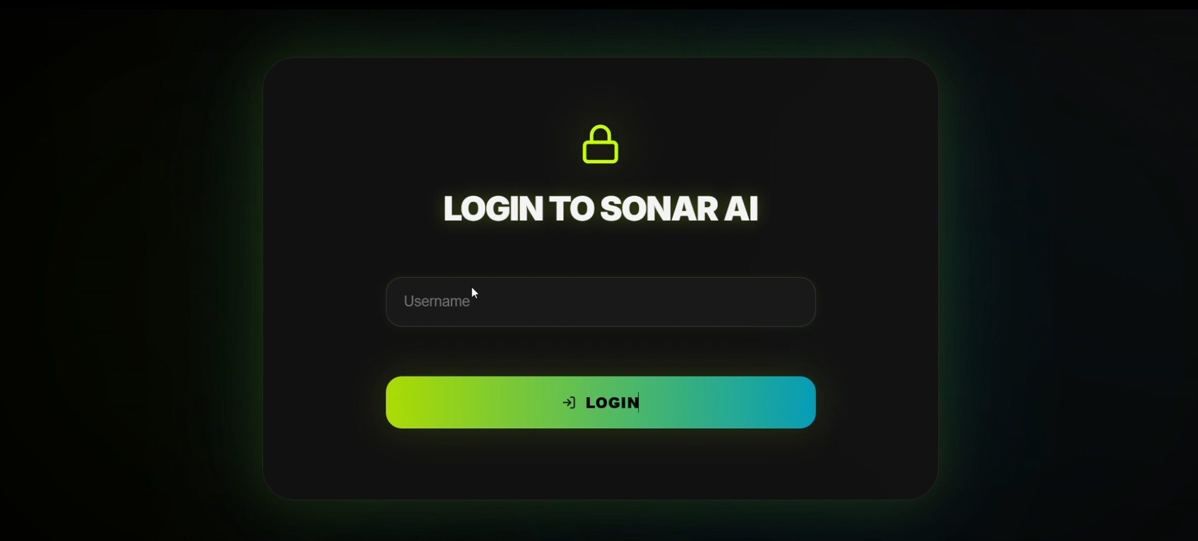
Figure 3 : Login page

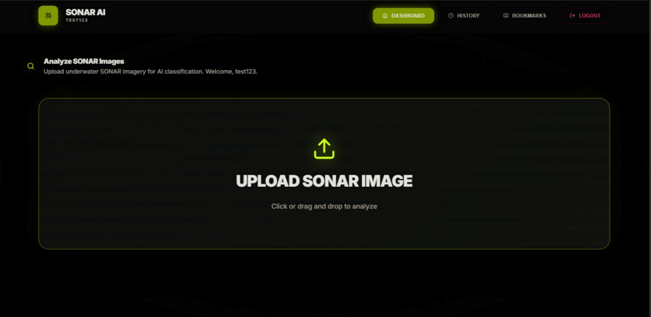
Figure 4: Home page
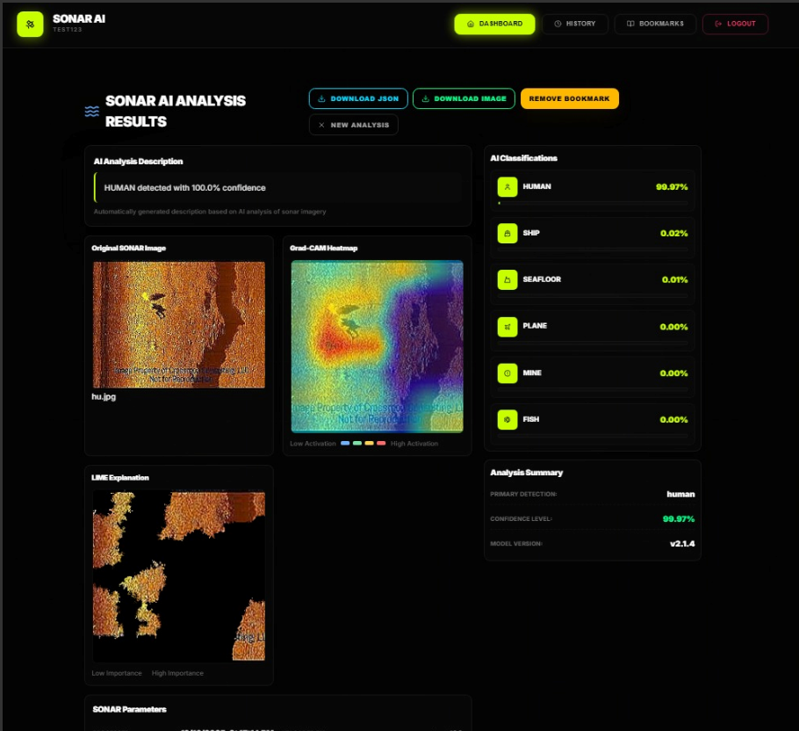
Figure 5: Prediction Results Display

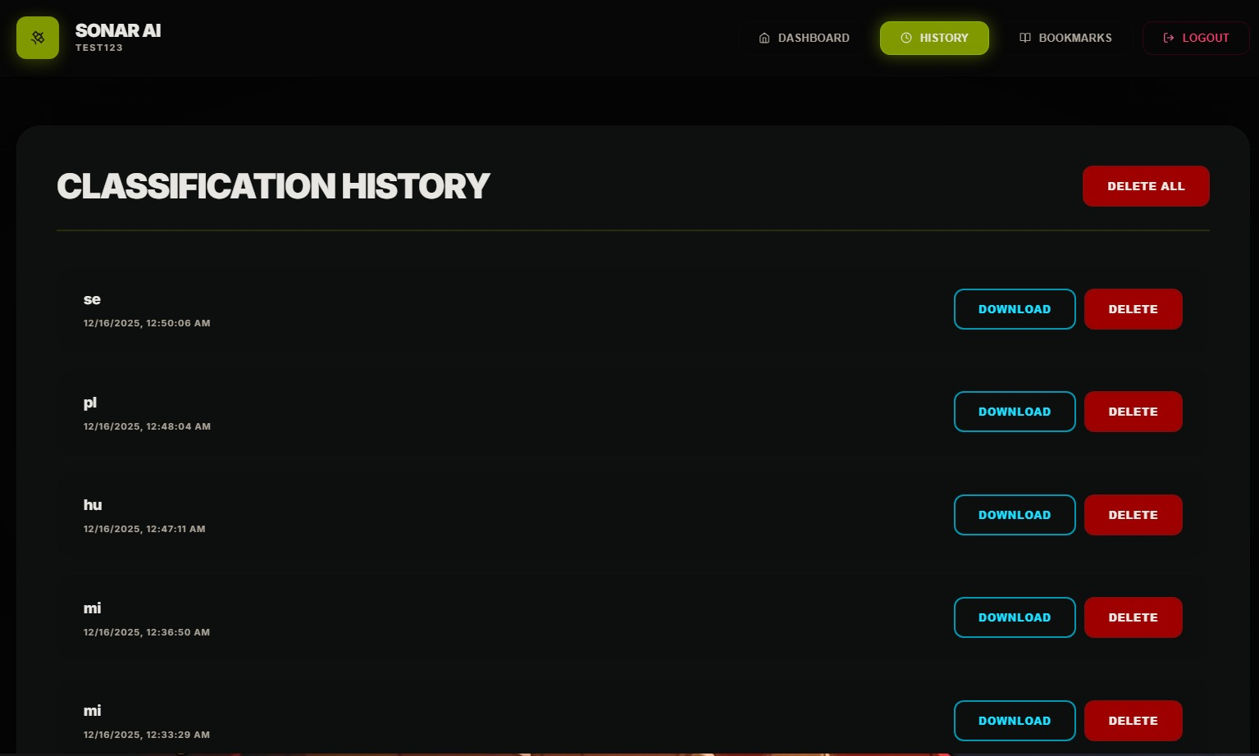
Figure 6: History page

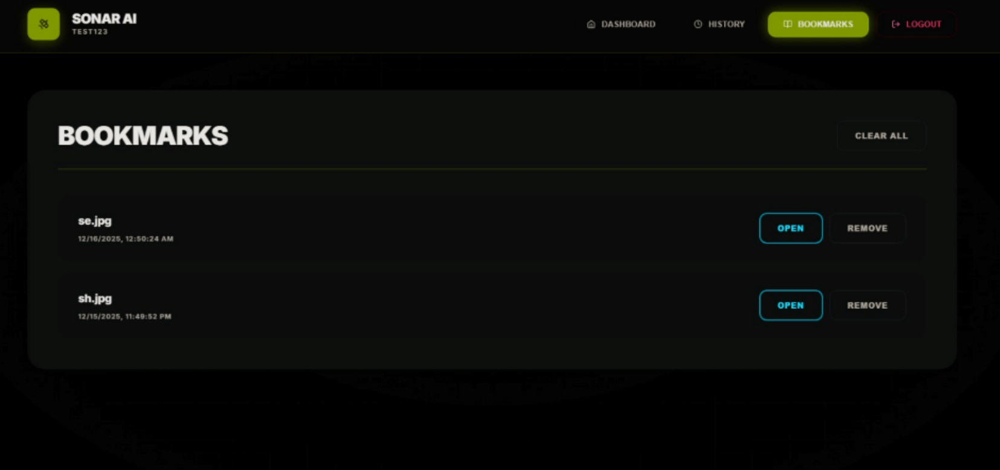
Figure 7: Bookmark page

Internal System Interfaces
The internal architecture of the sonar image classification system is modular, with clearly defined interfaces between preprocessing, model inference, explainability, and data storage components. These interfaces ensure consistency in data representation and allow individual modules to function independently while sharing information efficiently.
• Image Preprocessing Interface
Receives raw image input from the user interface or API request and converts it into standardized format. This includes resizing to 224 × 224 pixels, normalization, and conversion into tensors suitable for model input.
• Model Inference Interface
The pre-processed image tensor is passed to the DenseNet121-based classification model. The model returns a predicted class label and a corresponding confidence score.
• Explainability Interface
The trained model output is forwarded to explainability modules such as Grad-CAM and LIME. These modules generate visual heatmaps highlighting the most influential regions of the sonar image.
• Data Logging Interface
Prediction results, confidence scores, and optional metadata are structured into JSON format and can be stored in MongoDB for logging or analysis purposes.
• Response Interface to User
Final outputs, including prediction results and explanation visualizations, are packaged and returned to the user in a consistent and interpretable format.
These interfaces rely on TensorFlow tensors, NumPy arrays, image files, and JSON structures to maintain compatibility across the system pipeline.
COMMUNICATION
This subsection explains the step-by-step flow of data during execution, from image upload to final output generation.
- Step 1: Image Upload to Preprocessing
The user uploads a sonar image through the interface or API. The backend receives the image via an HTTP POST request and initiates the preprocessing stage.
- Step 2: Preprocessing to Model Inference
The preprocessed image tensor is passed to the DenseNet121 model, which performs classification and generates prediction probabilities.
- Step 3: Inference to Explainability Generation
The predicted class and intermediate feature maps are used by Grad-CAM and LIME modules to generate visual explanations for the decision.
- Step 4: Logging and Response Preparation
Prediction results and confidence values are optionally logged into MongoDB. The final response is prepared in a structured format.
- Step 5: Response to User Interface
The backend sends the prediction results and explanation outputs back to the user, where they are displayed alongside the original sonar image.
This communication workflow ensures low-latency inference, consistent data exchange between components, and interpretable outputs for end users. By clearly separating interfaces and communication responsibilities, the system achieves modularity, scalability, and ease of maintenance.

CHAPTER 4
RESULTS & DISCUSSION
4.1 Results
The proposed underwater sonar image classification system was evaluated on a six-class sonar dataset using a DenseNet121-based transfer learning approach. The model produces three primary outputs for each input image: a predicted class label, a confidence score derived from the softmax probability, and visual explanation heatmaps generated using explainability techniques. This evaluation focuses not only on classification accuracy but also on interpretability, which is critical for underwater object identification tasks.
During inference, when a sonar image is uploaded to the system, the model successfully identifies the corresponding object category such as fish, mine, human diver, plane, ship, or seafloor. Along with the predicted label, a confidence score is displayed, indicating the model’s certainty in its decision. Higher confidence values generally correspond to clearer object boundaries and stronger acoustic signatures in the input image.
In addition to numerical predictions, the system generates explainability visualizations. Grad-CAM heatmaps highlight the most influential regions of the sonar image that contributed to the classification decision, while LIME provides localized explanations by emphasizing important superpixel regions. These visual outputs confirm that the model focuses on meaningful sonar reflections and object contours rather than background noise.
Overall, the DenseNet121-based model demonstrated stable and reliable performance across all sonar object categories. The combination of transfer learning and explainability mechanisms ensures that predictions are not only accurate but also interpretable, which is essential for real-world underwater applications.
4.2 Discussions
Developing an underwater sonar image classification system presents unique challenges due to the nature of sonar imagery. Unlike natural images, sonar images often suffer from low contrast, speckle noise, shadow artifacts, and blurred object boundaries. Objects of different categories may exhibit similar acoustic patterns, making discrimination difficult.
The use of DenseNet121 as a feature extractor proved effective in addressing these challenges. Dense connectivity enables better gradient flow and feature reuse, allowing the model to capture fine-grained texture patterns and subtle intensity variations present in sonar images. Transfer learning from ImageNet provided a strong initialization, even though sonar data differs significantly from natural images.
Explainability played a crucial role in validating model behaviour. Grad-CAM visualizations consistently highlighted object-specific regions such as reflective edges, shadow zones, and acoustic signatures, indicating that the model learned meaningful representations. LIME explanations further supported this by isolating localized regions that influenced predictions. These insights increase trust in the model’s decisions, especially for safety-critical scenarios such as mine detection or diver identification.
Key Challenges Faced
• Low Contrast and Noise
Sonar images often contain significant background noise and weak object boundaries, making feature extraction challenging.
• Visual Similarity Between Classes
Certain classes, such as seafloor structures and ships, share similar texture patterns, which can lead to misclassification in difficult cases.
• Limited Dataset Size
Although stratified sampling was applied, the availability of diverse, high-quality sonar images remains a limiting factor.
• Interpretability Requirements
In underwater surveillance and defence-related applications, black-box predictions are insufficient. The integration of explainability methods was necessary to ensure transparency.
Despite these challenges, the system demonstrated consistent performance and meaningful visual explanations. The combination of DenseNet121-based classification with Grad-CAM and LIME makes the proposed system suitable for practical underwater object recognition tasks where both accuracy and interpretability are required.

CHAPTER 5
CONCLUSION & FUTURE SCOPE
Conclusion
This project successfully demonstrated the application of deep learning–based transfer learning for automated underwater sonar image classification. By utilizing a DenseNet121 backbone pretrained on ImageNet, the system effectively learned discriminative acoustic texture features from sonar images despite challenges such as noise, low contrast, and ambiguous object boundaries. The model is capable of classifying multiple underwater object categories and provides reliable predictions accompanied by confidence scores.
A key strength of the proposed system is the integration of explainability through Grad-CAM. The generated heatmaps offer valuable insight into the regions of the sonar image that influence the model’s decision, thereby improving transparency and trust in the classification process. This is particularly important for underwater surveillance, marine research, and defence-related applications, where black-box predictions are insufficient.
The system addresses limitations of traditional manual sonar analysis by offering an automated, consistent, and scalable solution. By combining accurate classification with visual explanations, the project bridges the gap between deep learning theory and practical underwater sensing applications. Overall, the proposed approach demonstrates that transfer learning, when coupled with interpretability, can be effectively applied to complex sonar imaging problems.
Future Scope
While the current system demonstrates reliable performance, several enhancements can further improve its applicability and robustness. Expanding the dataset with larger and more diverse real-world sonar images would strengthen generalization and support additional object categories, while advanced data augmentation and realistic noise modelling could improve adaptability to real deployment conditions. Performance may be further enhanced through ensemble learning approaches, and real-time deployment can be achieved by optimizing the model using TensorFlow Lite or ONNX for edge devices. Integrating multi-modal sensor data such as optical imagery or acoustic signals would provide richer contextual understanding, and extending explainability to include comparative or temporal visualizations could improve decision support. With these enhancements, the system can be integrated into autonomous underwater platforms such as AUVs or ROVs, evolving into a practical and intelligent underwater decision-support solution.

CHAPTER 6
REFERENCES

[1] Base Research Paper : https://drive.google.com/file/d/141ceO_nIQiI68BesVm2GdgJG8cG7M8ax/view?usp=drive_link
[2] Dataset :
https://github.com/Purushothaman-natarajan/Under-water-sonar-image-classification
[3] MongoDB Official Documentation https://www.mongodb.com/docs/
[4] Express.js Official Documentation https://expressjs.com/
[5] React.js Official Documentation https://react.dev/
[6] Node.js Official Documentation https://nodejs.org/en/docs
[7] GitHub Repository https://github.com/Snehith-03/Sonar-image-classification

