**NITW**

**Computer Science Engineering**

**ONLINE BOOKSTORE MANAGEMENT SYSTEM PROJECT**

By- Snehlata  
 21CSB0B54

**PROBLEM STATEMENT:**

The goal of this project is to design and implement a database for online bookstore management. The database will store information about books, members, reviews, orders, order details and a cart. Additional information may be added.

The database should be able to support the following functionalities:

∙ Store and manage member details and accounts.

∙ Store and retrieve information about books and their reviews.

∙ Allows users to rate and post reviews.

∙ Enable search by subjects and advanced search.

∙ Store and retrieve orders and order details.

∙ Store and retrieve information about books present in the cart.

∙ Purchase books and empty the cart.

∙ Additional functionalities may be added.

The database should be scalable to handle large number of users and a growing amount of data. The database should be designed to ensure data reliability and database consistency. The final solution should be presented in the form of an ER model and a database implementation using a RDBMS such as SQL.

**CONTENTS:**

1) ER model assumptions

2) ER Diagram

3) Primary and Foreign keys representation

4) Functional Dependencies & Normalization

5) Data Dictionary

6) Creation of tables

7) Relational Schema

8) Miscellaneous

**1) ER Model Assumptions**

* A return order must return all items in the order, there are no partial returns.
* Not every book is available online, some books are available in the warehouse and suppliers.
* The books are provided from the warehouse to the supplier.
* The supplier then supplies it to the publisher who automatically publishes it to the online web server.
* The books are then ordered by the customers.
* Every detail about the order is handled by the order_details_table and book_instance table.
* The user can interact with the books via rating, upvotes, downvotes, wishlist, favourite the books and leave comments for every book.
* 1 book is written by one author only.

**2)ER Diagram**

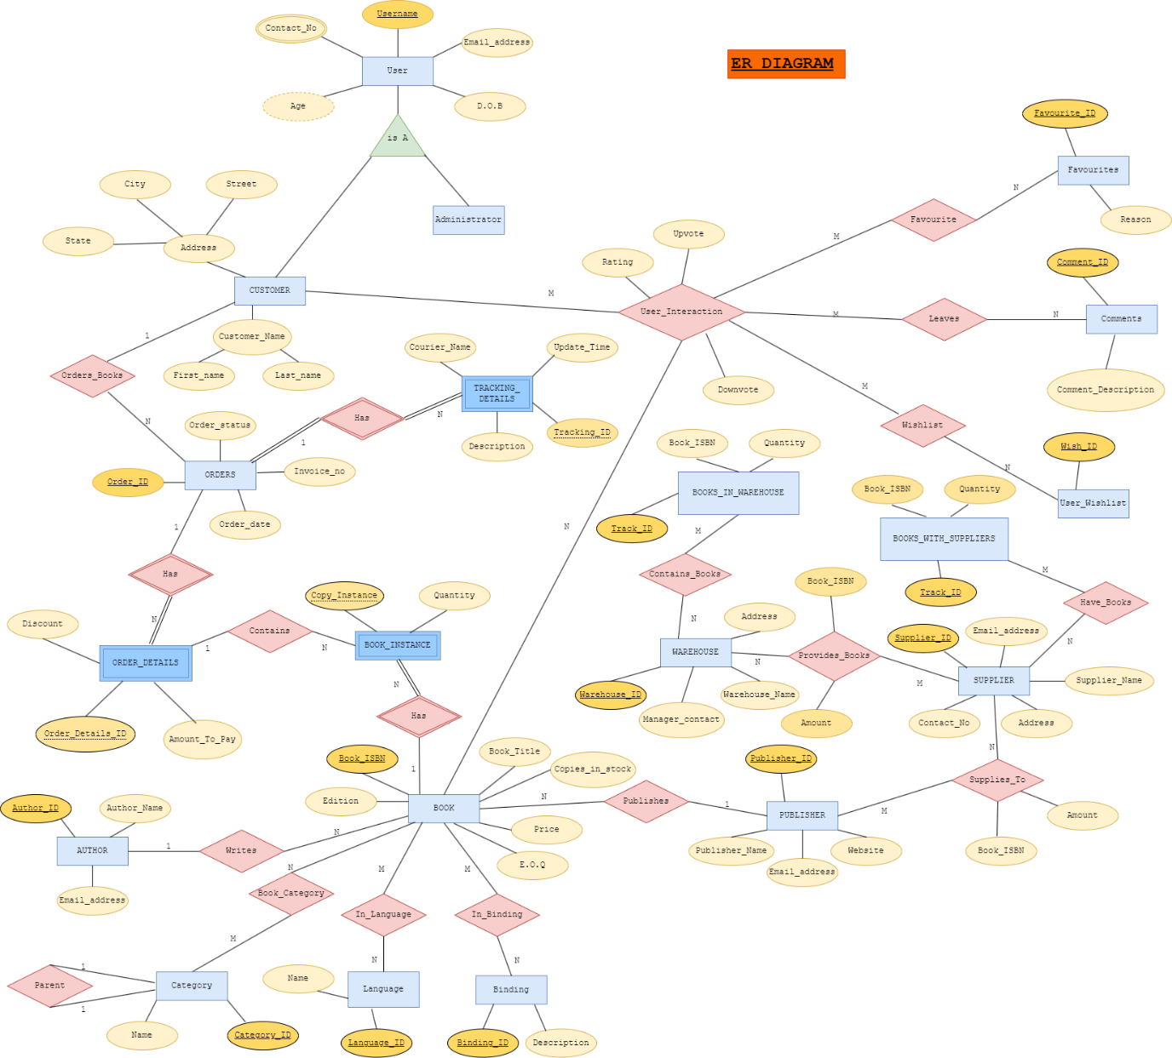

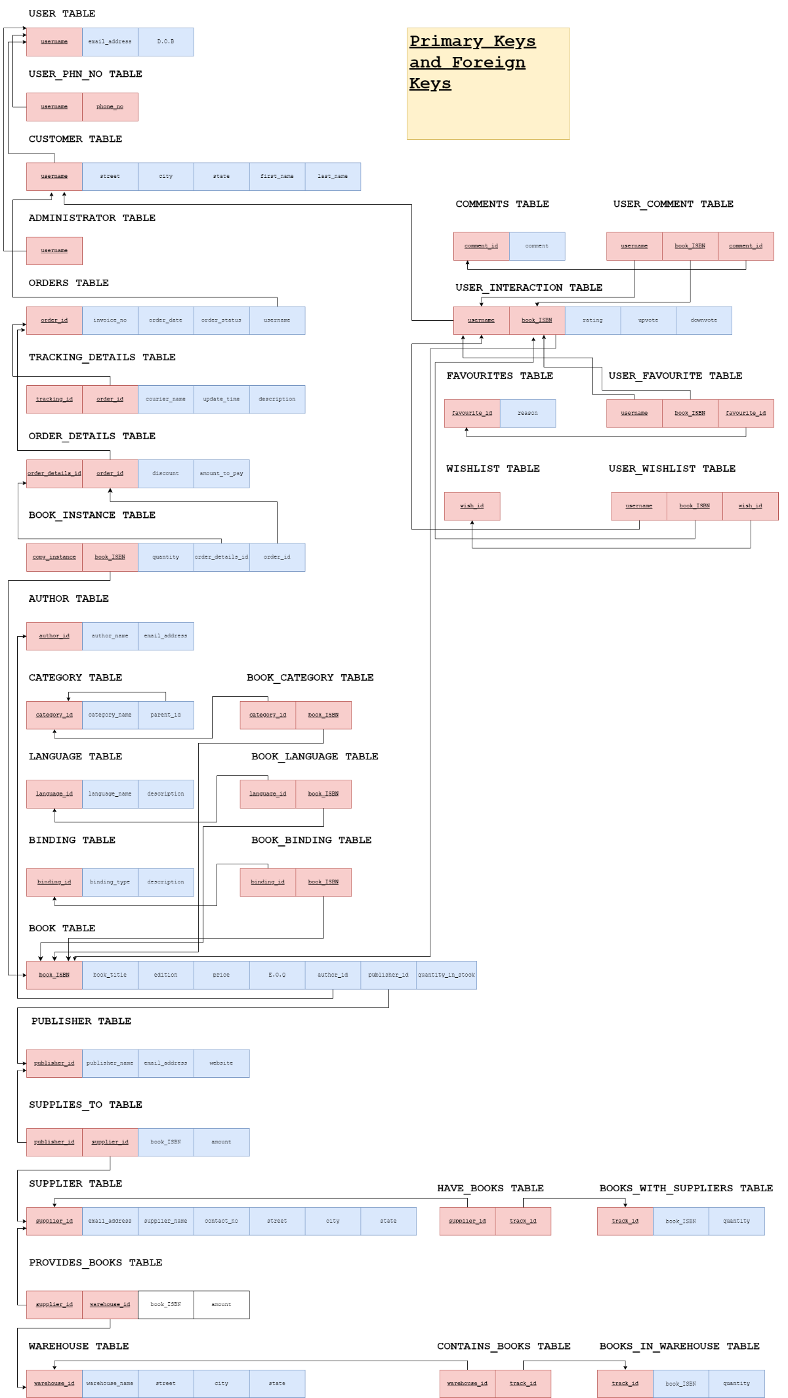

**4)Functional Dependencies and Normalisation**

**USER TABLE**

username -> {email_address, D.O.B, password, description}

email_address -> {username, D.O.B, password, description}

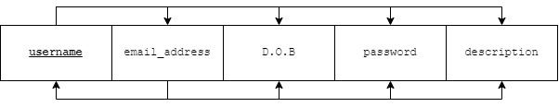

The candidate keys are username, email_address.

Prime attributes = {username, email_address}

Non prime attributes = {D.O.B, password, description}

There are two functional dependencies.

Both satisfy 1NF as all attributes are atomic.

Both also satisfy 2NF as there are no partial dependencies, no non prime attribute is dependent on any proper subset of the candidate keys. (Candidate keys are atomic)

Both also satisfy 3NF as there are no transitive dependencies. Or we can say that for both the functional dependencies, the LHS is a candidate key, hence it is in 3NF.

Both also satisfy BCNF as the LHS of all dependencies are candidate keys.

**USER_PHN_NO TABLE**



Attributes username and phone_no together form a composite key and there are no other attributes.

Hence it is automatically in BCNF. Since all dependencies are trivial.

**CUSTOMER TABLE**

username -> {street, city, state, first_name, last_name}

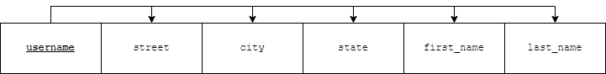

username is a candidate key.

Prime attributes = {username}

Non prime attributes = {street, city, state, first_name, last_name}

There is only one functional dependency.

It satisfies 1NF as all attributes are atomic.

It also satisfies 2NF as there are no partial dependencies, no non prime attribute is dependent on any proper subset of the candidate keys. (Candidate key is atomic)

It also satisfies 3NF as there are no transitive dependencies. Or we can say that for the functional dependency, the LHS is a candidate key, hence it is in 3NF.

It also satisfies BCNF as the LHS of all dependencies are candidate keys.

**ADMINISTRATOR TABLE**



There is only one prime attribute and candidate key username.

It is automatically in BCNF because all dependencies are trivial.

**ORDERS TABLE**

order_id -> {invoice_no, order_date, order_status, username}

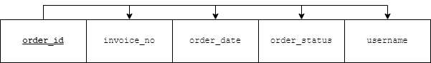

order_id is a candidate key.

Prime attributes = {order_id}

Non prime attributes = {invoice_no, order_date, order_status, username}

There is only one functional dependency.

It satisfies 1NF as all attributes are atomic.

It also satisfies 2NF as there are no partial dependencies, no non prime attribute is dependent on any proper subset of the candidate keys. (Candidate key is atomic)

It also satisfies 3NF as there are no transitive dependencies. Or we can say that for the functional dependency, the LHS is a candidate key, hence it is in 3NF.

It also satisfies BCNF as the LHS of all dependencies are candidate keys.

**TRACKING_DETAILS TABLE**

tracking_id order_id -> {courier_name, update_time, description}

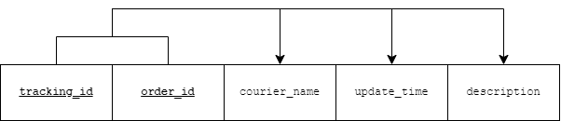

tracking_id order_id is the candidate key.

Prime attributes = {tracking_id, order_id}

Non prime attributes = {courier_name, update_time, description}

There is only one functional dependency.

It satisfies 1NF as all attributes are atomic.

It also satisfies 2NF as there are no partial dependencies, no non prime attribute is dependent on any proper subset of the candidate keys.

It also satisfies 3NF as there are no transitive dependencies. Or we can say that for the functional dependency, the LHS is a candidate key, hence it is in 3NF.

It also satisfies BCNF as the LHS of all dependencies are candidate keys.

**ORDER_DETAILS TABLE**

order_details_id order_id = {discount, amount_to_pay}

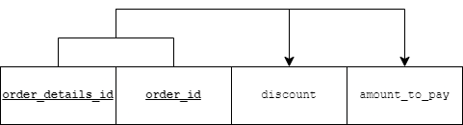

order_details_id order_id is the candidate key.

Prime attributes = {order_details_id, order_id}

Non prime attributes = {discount, amount_to_pay}

There is only one functional dependency.

It satisfies 1NF as all attributes are atomic.

It also satisfies 2NF as there are no partial dependencies, no non prime attribute is dependent on any proper subset of the candidate keys.

It also satisfies 3NF as there are no transitive dependencies. Or we can say that for the functional dependency, the LHS is a candidate key, hence it is in 3NF.

It also satisfies BCNF as the LHS of all dependencies are candidate keys.

**BOOK_INSTANCE TABLE**

copy_instance book_ISBN -> {quantity, order_details_id, order_id}

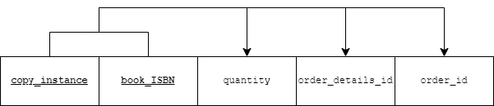

copy_instance book_ISBN is the candidate key.

Prime attributes = {copy_instance, book_ISBN}

Non prime attributes = {quantity, order_details_id, order_id}

There is only one functional dependency.

It satisfies 1NF as all attributes are atomic.

It also satisfies 2NF as there are no partial dependencies, no non prime attribute is dependent on any proper subset of the candidate keys.

It also satisfies 3NF as there are no transitive dependencies. Or we can say that for the functional dependency, the LHS is a candidate key, hence it is in 3NF.

It also satisfies BCNF as the LHS of all dependencies are candidate keys.

**AUTHOR TABLE**

author_id -> {author_name, email_address}

email_address -> {author_id, author_name}

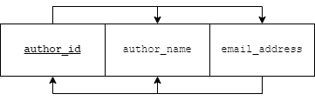

author_id and email_address are the candidate keys.

Prime attributes = {author_id, email_address}

Non prime attributes = {author_name}

There are two functional dependencies.

Both satisfy 1NF as all attributes are atomic.

Both also satisfy 2NF as there are no partial dependencies, no non prime attribute is dependent on any proper subset of the candidate keys. (Candidate keys are atomic)

Both also satisfy 3NF as there are no transitive dependencies. Or we can say that for both the functional dependencies, the LHS is a candidate key, hence it is in 3NF.

Both also satisfy BCNF as the LHS of all dependencies are candidate keys.

**CATEGORY TABLE**

category_id = {category_name, parent_id}

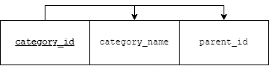

category_id is a candidate key.

Prime attribute = {category_id}

Non prime attribute = {category_name, parent_id}

There is only one functional dependency.

It satisfies 1NF as all attributes are atomic.

It also satisfies 2NF as there are no partial dependencies, no non prime attribute is dependent on any proper subset of the candidate keys.

It also satisfies 3NF as there are no transitive dependencies. Or we can say that for the functional dependency, the LHS is a candidate key, hence it is in 3NF.

It also satisfies BCNF as the LHS of all dependencies are candidate keys.

**BOOK_CATEGORY TABLE**



There are only two prime attributes category_id and book_ISBN.

It is automatically in BCNF because all dependencies are trivial.

**LANGUAGE TABLE**

language_id = {language_name, description}

language_name = {language_id, description}

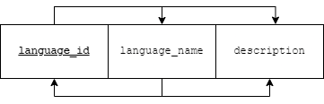

language_id and language_name are candidate keys.

Prime attributes = {language_id, language_name}

Non prime attributes = {description}

There are two functional dependencies.

Both satisfy 1NF as all attributes are atomic.

Both also satisfy 2NF as there are no partial dependencies, no non prime attribute is dependent on any proper subset of the candidate keys. (Candidate keys are atomic)

Both also satisfy 3NF as there are no transitive dependencies. Or we can say that for both the functional dependencies, the LHS is a candidate key, hence it is in 3NF.

Both also satisfy BCNF as the LHS of all dependencies are candidate keys.

**BOOK_LANGUAGE TABLE**



There are only two prime attributes language_id and book_ISBN.

It is automatically in BCNF because all dependencies are trivial.

**BINDING TABLE**

binding_id = {binding _type, description}

binding _type = {binding _id, description}

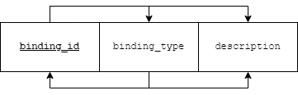

binding _id and binding _type are candidate keys.

Prime attributes = {binding_id, binding _type}

Non prime attributes = {description}

There are two functional dependencies.

Both satisfy 1NF as all attributes are atomic.

Both also satisfy 2NF as there are no partial dependencies, no non prime attribute is dependent on any proper subset of the candidate keys. (Candidate keys are atomic)

Both also satisfy 3NF as there are no transitive dependencies. Or we can say that for both the functional dependencies, the LHS is a candidate key, hence it is in 3NF.

Both also satisfy BCNF as the LHS of all dependencies are candidate keys.

**BOOK_BINDING TABLE**



There are only two prime attributes binding_id and book_ISBN.

It is automatically in BCNF because all dependencies are trivial.

**BOOK TABLE**

book_ISBN -> {book_title, edition, price, E.O.Q, author_id, publisher_id, release_date, page_count, dimension, quantity_in_stock}



book_ISBN is the candidate key.

Prime attributes = {book_ISBN}

Non prime attributes = {book_title, edition, price, E.O.Q, author_id, publisher_id, release_date, page_count, dimension}

There is only one functional dependency.

It satisfies 1NF as all attributes are atomic.

It also satisfies 2NF as there are no partial dependencies, no non prime attribute is dependent on any proper subset of the candidate keys.

It also satisfies 3NF as there are no transitive dependencies. Or we can say that for the functional dependency, the LHS is a candidate key, hence it is in 3NF.

It also satisfies BCNF as the LHS of all dependencies are candidate keys.

**PUBLISHER TABLE**

publisher_id = {publisher_name, email_address, website}

email_address = {publisher_name, publisher_id}

website = {email_address, publisher_name}

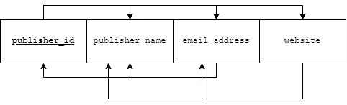

If we check their closures, publisher_id, email_address, website are candidate keys.

All three are prime attributes.

It is automatically in BCNF because all dependencies are trivial.

**SUPPLIES_TO TABLE**

publisher_id supplier_id = {book_ISBN, amount}

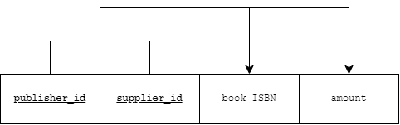

publisher_id supplier_id is the candidate key.

Prime attributes = {publisher_id, supplier_id}

Non prime attributes = {book_ISBN, amount}

There is only one functional dependency.

It satisfies 1NF as all attributes are atomic.

It also satisfies 2NF as there are no partial dependencies, no non prime attribute is dependent on any proper subset of the candidate keys.

It also satisfies 3NF as there are no transitive dependencies. Or we can say that for the functional dependency, the LHS is a candidate key, hence it is in 3NF.

It also satisfies BCNF as the LHS of all dependencies are candidate keys.

**SUPPLIER TABLE**

supplier_id = {email_address, supplier_name, contact_no, street, city, state}

street city state = {supplier_id, email_address, supplier_name, contact_no}

contact_no = {supplier_id}

email_address = {supplier_id}

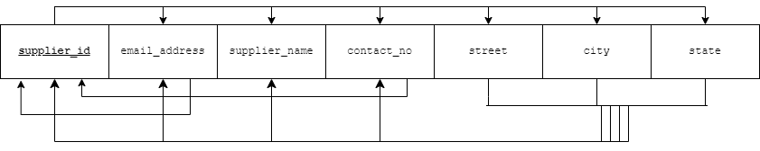

supplier_id, contact_no, email_address and street, city, state are candidate keys.

Prime attributes = {supplier_id, street city state, contact_no, email_address}

Non prime attributes = {supplier_name}

It satisfies 1NF as all attributes are atomic.

It also satisfies 2NF as there are no partial dependencies, no non prime attribute is dependent on any proper subset of the candidate keys.

It also satisfies 3NF as there are no transitive dependencies. Or we can say that for the functional dependency, the LHS is a candidate key, hence it is in 3NF.

It also satisfies BCNF as the LHS of all dependencies are candidate keys.

**PROVIDES_BOOKS TABLE**

supplier_id warehouse_id = {book_ISBN, amount}

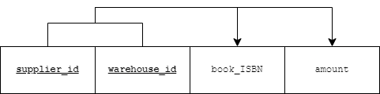

supplier_id warehouse_id is the candidate key.

Prime attributes = {supplier_id, warehouse_id}

Non prime attributes = {book_ISBN, amount}

There is only one functional dependency.

It satisfies 1NF as all attributes are atomic.

It also satisfies 2NF as there are no partial dependencies, no non prime attribute is dependent on any proper subset of the candidate keys.

It also satisfies 3NF as there are no transitive dependencies. Or we can say that for the functional dependency, the LHS is a candidate key, hence it is in 3NF.

It also satisfies BCNF as the LHS of all dependencies are candidate keys.

**WAREHOUSE TABLE**

warehouse_id = {warehouse_name, street, city, state, manager_contact}

street city state = {warehouse_id, warehouse_name}

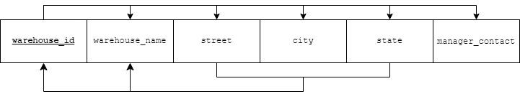

warehouse_id, street city state are the candidate keys.

Prime attributes = {warehouse_id, street, city, state}

Non prime attributes = {warehouse_name}

It satisfies 1NF as all attributes are atomic.

It also satisfies 2NF as there are no partial dependencies, no non prime attribute is dependent on any proper subset of the candidate keys.

It also satisfies 3NF as there are no transitive dependencies. Or we can say that for the functional dependency, the LHS is a candidate key, hence it is in 3NF.

It also satisfies BCNF as the LHS of all dependencies are candidate keys.

**USER_INTERACTION TABLE**

username book_ISBN = {rating, upvote, downvote}

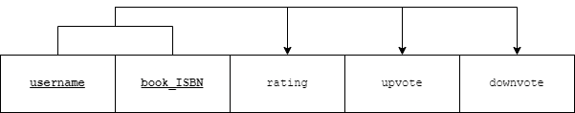

username book_ISBN is the candidate key.

Prime attributes = {username, book_ISBN}

Non prime attributes = {rating, upvote, downvote}

There is only one functional dependency.

It satisfies 1NF as all attributes are atomic.

It also satisfies 2NF as there are no partial dependencies, no non prime attribute is dependent on any proper subset of the candidate keys.

It also satisfies 3NF as there are no transitive dependencies. Or we can say that for the functional dependency, the LHS is a candidate key, hence it is in 3NF.

It also satisfies BCNF as the LHS of all dependencies are candidate keys.

**FAVOURITES TABLE**

favourite_id = {reason}

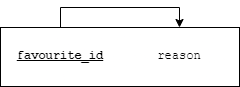

favourite_id is the candidate key.

It is automatically in BCNF as the LHS are all candidate keys.

**USER_FAVOURITE TABLE**



All are prime attributes.

It is automatically in BCNF as all dependencies are trivial.

**COMMENTS TABLE**

comment_id = {comment}

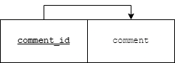

comment_id is the candidate key.

It is automatically in BCNF as the LHS are all candidate keys.

**USER_COMMENT TABLE**



All are prime attributes.

It is automatically in BCNF as all dependencies are trivial.

**WISHLIST_TABLE**



There is only one prime attribute.

It is automatically in BCNF as all dependencies are trivial.

**USER_WISHLIST TABLE**



All are prime attributes.

It is automatically in BCNF as all dependencies are trivial.

**HAVE_BOOKS TABLE**



All are prime attributes.

It is automatically in BCNF as all dependencies are trivial.

**BOOKS_WITH_SUPPLIERS TABLE**

track_id = {book_ISBN, quantity}

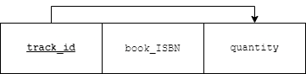

track_id is the candidate key.

It is automatically in BCNF as the LHS are all candidate keys.

**CONTAINS_BOOKS TABLE**



All are prime attributes.

It is automatically in BCNF as all dependencies are trivial.

**BOOKS_IN_WAREHOUSE TABLE**

track_id = {book_ISBN, quantity}

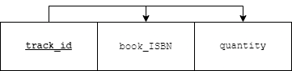

track_id is the candidate key.

It is automatically in BCNF as the LHS are all candidate keys.

**7)Relational Schema**

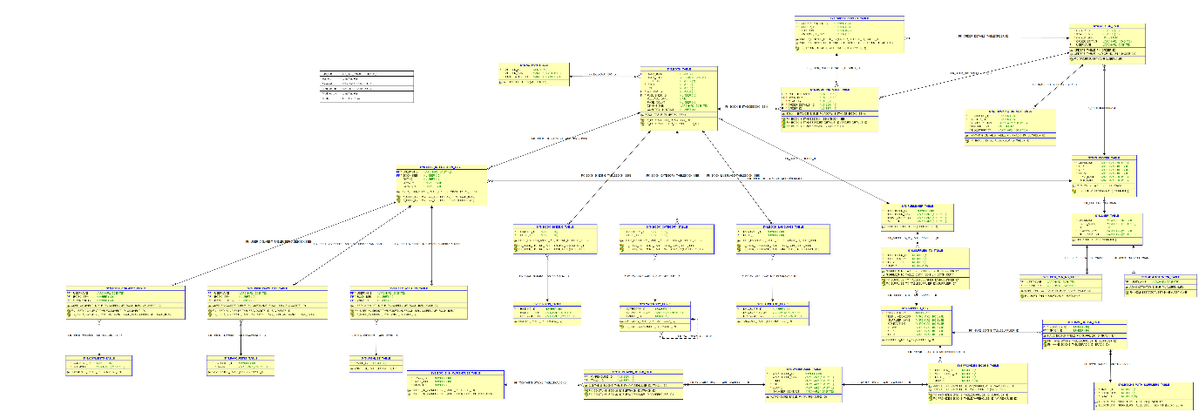

**5)Data Dictionary**

1. **Data Dictionary for USER**

|  |  |  |  |  |
| --- | --- | --- | --- | --- |
| Column Status | Attribute | Data type | Size | Description |
| Not Null  Primary Key | username | VARCHAR2 | 50 | It is a unique way of identifying every user. |
|  | email_address | VARCHAR2 | 100 | Address associated with a user. |
|  | D.O.B | DATE |  | Date of birth of the user. |
| Not Null | password | VARCHAR2 | 20 | Password typed in by the user. |
|  | description | VARCHAR2 | 255 | About section of the user. Can be null. |

1. **Data Dictionary for USER_PHN_NO**

|  |  |  |  |  |
| --- | --- | --- | --- | --- |
| Column Status | Attribute | Data type | Size | Description |
| Not Null  Composite Key  Foreign Key | username | VARCHAR2 | 50 |  |
| Not Null  Composite Key | phone_no | VARCHAR2 | 100 | Phone number associated with the user. |

1. **Data Dictionary for CUSTOMER**

|  |  |  |  |  |
| --- | --- | --- | --- | --- |
| Column Status | Attribute | Data type | Size | Description |
| Not Null  Primary Key  Foreign Key | username | VARCHAR2 | 50 |  |
| Not Null | street | VARCHAR2 | 100 | Address. |
| Not Null | city | VARCHAR2 | 100 | Address. |
| Not Null | state | VARCHAR2 | 100 | Address. |
|  | first_name | VARCHAR2 | 50 | Name of the user. |
|  | last_name | VARCHAR2 | 50 | Name of the user. |

1. **Data Dictionary for ADMINISTRATOR**

|  |  |  |  |  |
| --- | --- | --- | --- | --- |
| Column Status | Attribute | Data type | Size | Description |
| Not Null  Primary Key  Foreign Key | username | VARCHAR2 | 50 |  |

1. **Data Dictionary for ORDERS**

|  |  |  |  |  |
| --- | --- | --- | --- | --- |
| Column Status | Attribute | Data type | Size | Description |
| Not Null  Primary Key | order_id | NUMBER | 10, 0 | Unique ID for each order. |
| Not Null  Unique | invoice_no | NUMBER | 10, 0 | Unique ID between client and the seller. |
| Not Null | order_date | TIMESTAMP |  | Date issued for the order. |
| Not Null | order_status | VARCHAR2 | 100 | Delivered or not. |
| Not Null  Foreign Key | username | VARCHAR2 | 50 |  |

1. **Data Dictionary for TRACKING_DETAILS**

|  |  |  |  |  |
| --- | --- | --- | --- | --- |
| Column Status | Attribute | Data type | Size | Description |
| Not Null  Composite Key | tracking_id | NUMBER | 10, 0 | Unique ID for tracking. |
| Not Null  Composite Key  Foreign Key | order_id | NUMBER | 10, 0 |  |
| Not Null | courier_name | VARCHAR2 | 100 | Name of the deliverer, for contact. |
| Not Null | update_time | TIMESTAMP |  | Time updated. |
| Not Null | description | VARCHAR2 | 100 | Cannot be null. |

1. **Data Dictionary for ORDER_DETAILS**

|  |  |  |  |  |
| --- | --- | --- | --- | --- |
| Column Status | Attribute | Data type | Size | Description |
| Not Null  Composite Key  Unique | order_details_id | NUMBER | 10, 0 | Unique ID for details. |
| Not Null  Composite Key  Foreign Key | order_id | NUMBER | 10, 0 |  |
| Not Null | discount | DECIMAL | 5, 2 | Discount, can be between 0 and 100. |
| Not Null | amount_to_pay | NUMBER | 10, 3 | Amount to be paid |

1. **Data Dictionary for BOOK_INSTANCE**

|  |  |  |  |  |
| --- | --- | --- | --- | --- |
| Column Status | Attribute | Data type | Size | Description |
| Not Null  Composite Key | copy_instance | NUMBER | 10, 0 | Copy instance of the book. |
| Not Null  Composite Key  Foreign Key | book_ISBN | NUMBER | 10, 0 | Unique ID for each book. |
| Not Null | quantity | NUMBER | 5, 0 | Quantity in each order. |
| Not Null  Foreign Key | order_details_id | NUMBER | 10, 0 |  |
| Not Null  Foreign Key | order_id | NUMBER | 10, 0 |  |

1. **Data Dictionary for AUTHOR**

|  |  |  |  |  |
| --- | --- | --- | --- | --- |
| Column Status | Attribute | Data type | Size | Description |
| Not Null  Primary Key | author_id | NUMBER | 10, 0 | Unique ID for each author. |
| Not Null | author_name | VARCHAR2 | 50 | Name of the author. |
| Not Null | email_address | VARCHAR2 | 100 | Email address of the author |

1. **Data Dictionary for CATEGORY**

|  |  |  |  |  |
| --- | --- | --- | --- | --- |
| Column Status | Attribute | Data type | Size | Description |
| Not Null  Primary Key | category_id | NUMBER | 10, 0 | ID of the category. |
| Not Null | category_name | VARCHAR2 | 50 | Name of the category. |
| Foreign Key | parent_id | NUMBER | 10, 0 | Subgenre. |

1. **Data Dictionary for LANGUAGE**

|  |  |  |  |  |
| --- | --- | --- | --- | --- |
| Column Status | Attribute | Data type | Size | Description |
| Not Null  Primary Key | language_id | NUMBER | 10, 0 | ID of the language. |
| Not Null | language_name | VARCHAR2 | 50 | Name of the language. |
|  | description | VARCHAR2 | 255 | Can be NULL. |

1. **Data Dictionary for BINDING**

|  |  |  |  |  |
| --- | --- | --- | --- | --- |
| Column Status | Attribute | Data type | Size | Description |
| Not Null  Primary Key | binding_id | NUMBER | 10, 0 | ID of the binding. |
| Not Null | binding_type | VARCHAR2 | 50 | Name of the binding. |
|  | description | VARCHAR2 | 255 |  |

1. **Data Dictionary for BOOK_CATEGORY**

|  |  |  |  |  |
| --- | --- | --- | --- | --- |
| Column Status | Attribute | Data type | Size | Description |
| Not Null  Composite Key  Foreign Key | category_id | NUMBER | 10, 0 |  |
| Not Null  Composite Key  Foreign Key | book_ISBN | NUMBER | 10, 0 |  |

1. **Data Dictionary for BOOK_LANGUAGE**

|  |  |  |  |  |
| --- | --- | --- | --- | --- |
| Column Status | Attribute | Data type | Size | Description |
| Not Null  Composite Key  Foreign Key | language_id | NUMBER | 10, 0 |  |
| Not Null  Composite Key  Foreign Key | book_ISBN | NUMBER | 10, 0 |  |

1. **Data Dictionary for BOOK_BINDING**

|  |  |  |  |  |
| --- | --- | --- | --- | --- |
| Column Status | Attribute | Data type | Size | Description |
| Not Null  Composite Key  Foreign Key | binding_id | NUMBER | 10, 0 |  |
| Not Null  Composite Key  Foreign Key | book_ISBN | NUMBER | 10, 0 |  |

1. **Data Dictionary for BOOK**

|  |  |  |  |  |
| --- | --- | --- | --- | --- |
| Column Status | Attribute | Data type | Size | Description |
| Not Null  Primary Key | book_ISBN | NUMBER | 10, 0 |  |
|  | book_title | VARCHAR2 | 255 | Title of the book. |
|  | edition | NUMBER | 2, 0 | Edition number. |
| Not Null | price | NUMBER | 7, 3 | Price of the book. |
|  | E.O.Q | NUMBER | 7, 3 | EOQ |
| Not Null  Foreign Key | author_id | NUMBER | 10, 0 |  |
| Not Null  Foreign Key | publisher_id | NUMBER | 10, 0 |  |
|  | release_date | DATE |  |  |
|  | page_count | NUMBER | 4, 0 |  |
|  | dimensions | VARCHAR2 | 50 |  |
| Not Null | quantity_in_stock | NUMBER | 6, 0 |  |

1. **Data Dictionary for PUBLISHER**

|  |  |  |  |  |
| --- | --- | --- | --- | --- |
| Column Status | Attribute | Data type | Size | Description |
| Not Null  Primary Key | publisher_id | NUMBER | 10, 0 | Publisher ID |
| Not Null | publisher_name | VARCHAR2 | 100 |  |
| Not Null | email_address | VARCHAR2 | 100 |  |
| Not Null | website | VARCHAR2 | 100 |  |

1. **Data Dictionary for SUPPLIES_TO**

|  |  |  |  |  |
| --- | --- | --- | --- | --- |
| Column Status | Attribute | Data type | Size | Description |
| Not Null  Composite Key  Foreign Key | publisher_id | NUMBER | 10, 0 |  |
| Not Null  Composite Key  Foreign Key | supplier_id | NUMBER | 10, 0 | Supplier ID. |
| Not Null  Unique | book_ISBN | NUMBER | 10, 0 |  |
| Not Null | amount | NUMBER | 6, 0 |  |

1. **Data Dictionary for SUPPLIER**

|  |  |  |  |  |
| --- | --- | --- | --- | --- |
| Column Status | Attribute | Data type | Size | Description |
| Not Null  Primary Key | supplier_id | NUMBER | 10, 0 |  |
| Not Null | email_address | VARCHAR2 | 100 | Email of the supplier. |
| Not Null | supplier_name | VARCHAR2 | 100 |  |
| Not Null | contact_no | VARCHAR2 | 100 | Contact number. |
| Not Null | street | VARCHAR2 | 100 |  |
| Not Null | city | VARCHAR2 | 100 |  |
| Not Null | state | VARCHAR2 | 100 |  |

1. **Data Dictionary for PROVIDES_BOOKS**

|  |  |  |  |  |
| --- | --- | --- | --- | --- |
| Column Status | Attribute | Data type | Size | Description |
| Not Null  Composite Key  Foreign Key | supplier_id | NUMBER | 10, 0 |  |
| Not Null  Composite Key  Foreign Key | warehouse_id | NUMBER | 10, 0 |  |
| Not Null  Unique | book_ISBN | NUMBER | 10, 0 |  |
| Not Null | amount | NUMBER | 6, 0 | Amount of books. |

1. **Data Dictionary for WAREHOUSE**

|  |  |  |  |  |
| --- | --- | --- | --- | --- |
| Column Status | Attribute | Data type | Size | Description |
| Not Null  Primary Key | warehouse_id | NUMBER | 10, 0 |  |
| Not Null | warehouse_name | VARCHAR2 | 100 |  |
| Not Null | street | VARCHAR2 | 100 |  |
| Not Null | city | VARCHAR2 | 100 |  |
| Not Null | state | VARCHAR2 | 100 |  |
| Not Null | manager_contact | VARCHAR2 | 100 |  |

1. **Data Dictionary for HAVE_BOOKS**

|  |  |  |  |  |
| --- | --- | --- | --- | --- |
| Column Status | Attribute | Data type | Size | Description |
| Not Null  Composite Key  Foreign Key | supplier_id | NUMBER | 10, 0 |  |
| Not Null  Composite Key  Foreign Key | track_id | NUMBER | 10, 0 |  |

1. **Data Dictionary for BOOKS_WITH_SUPPLIERS**

|  |  |  |  |  |
| --- | --- | --- | --- | --- |
| Column Status | Attribute | Data type | Size | Description |
| Not Null  Primary Key | track_id | NUMBER | 10, 0 |  |
| Not Null  Unique | book_ISBN | NUMBER | 10, 0 |  |
| Not Null | quantity | NUMBER | 6, 0 |  |

1. **Data Dictionary for CONTAINS_BOOKS**

|  |  |  |  |  |
| --- | --- | --- | --- | --- |
| Column Status | Attribute | Data type | Size | Description |
| Not Null  Composite Key  Foreign Key | warehouse_id | NUMBER | 10, 0 |  |
| Not Null  Composite Key  Foreign Key | track_id | NUMBER | 10, 0 |  |

1. **Data Dictionary for BOOKS_IN_WAREHOUSE**

|  |  |  |  |  |
| --- | --- | --- | --- | --- |
| Column Status | Attribute | Data type | Size | Description |
| Not Null  Primary Key | track_id | NUMBER | 10, 0 |  |
| Not Null  Unique | book_ISBN | NUMBER | 10, 0 |  |
| Not Null | quantity | NUMBER | 6, 0 |  |

1. **Data Dictionary for USER_INTERACTION**

|  |  |  |  |  |
| --- | --- | --- | --- | --- |
| Column Status | Attribute | Data type | Size | Description |
| Not Null  Composite Key  Foreign Key | username | VARCHAR2 | 50 |  |
| Not Null  Composite Key  Foreign Key | book_ISBN | NUMBER | 10, 0 |  |
|  | rating | NUMBER | 1, 0 |  |
|  | upvote | CHAR | 1 |  |
|  | downvote | CHAR | 1 |  |

1. **Data Dictionary for FAVOURITES**

|  |  |  |  |  |
| --- | --- | --- | --- | --- |
| Column Status | Attribute | Data type | Size | Description |
| Not Null  Primary Key | favourite_id | NUMBER | 10, 0 |  |
|  | reason | VARCHAR2 | 255 |  |

1. **Data Dictionary for USER_FAVOURITE**

|  |  |  |  |  |
| --- | --- | --- | --- | --- |
| Column Status | Attribute | Data type | Size | Description |
| Not Null  Composite Key  Foreign Key | username | VARCHAR2 | 50 |  |
| Not Null  Composite Key  Foreign Key | book_ISBN | NUMBER | 10, 0 |  |
| Not Null  Composite Key  Foreign Key | favourite_id | NUMBER | 10, 0 |  |

1. **Data Dictionary for COMMENTS**

|  |  |  |  |  |
| --- | --- | --- | --- | --- |
| Column Status | Attribute | Data type | Size | Description |
| Not Null  Primary Key | comment_id | NUMBER | 10, 0 |  |
| Not Null | comment | VARCHAR2 | 255 |  |

1. **Data Dictionary for USER_COMMENT**

|  |  |  |  |  |
| --- | --- | --- | --- | --- |
| Column Status | Attribute | Data type | Size | Description |
| Not Null  Composite Key  Foreign Key | username | VARCHAR2 | 50 |  |
| Not Null  Composite Key  Foreign Key | book_ISBN | NUMBER | 10, 0 |  |
| Not Null  Composite Key  Foreign Key | comment_id | NUMBER | 10, 0 |  |

1. **Data Dictionary for WISHLIST**

|  |  |  |  |  |
| --- | --- | --- | --- | --- |
| Column Status | Attribute | Data type | Size | Description |
| Not Null  Primary Key | wish_id | NUMBER | 10, 0 |  |

1. **Data Dictionary for USER_WISHLIST**

|  |  |  |  |  |
| --- | --- | --- | --- | --- |
| Column Status | Attribute | Data type | Size | Description |
| Not Null  Composite Key  Foreign Key | username | VARCHAR2 | 50 |  |
| Not Null  Composite Key  Foreign Key | book_ISBN | NUMBER | 10, 0 |  |
| Not Null  Composite Key  Foreign Key | wish_id | NUMBER | 10, 0 |  |

**6)Creation of tables**

**USER_TABLE**

CREATE TABLE USER_TABLE

(

username VARCHAR2(50) NOT NULL PRIMARY KEY,

email_address VARCHAR2(100),

DOB DATE,

ppassword VARCHAR2(20) NOT NULL,

ddescription VARCHAR2(255)

);

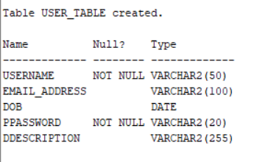

**USER_PHN_NO_TABLE**

CREATE TABLE USER_PHN_NO_TABLE

(

username VARCHAR2(50) NOT NULL,

phone_no VARCHAR2(100) NOT NULL,

PRIMARY KEY(username, phone_no),

CONSTRAINT FK_USER_PHN_NOusername FOREIGN KEY

(username) REFERENCES USER_TABLE (username) ON DELETE CASCADE

);

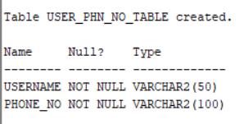

**CUSTOMER_TABLE**

CREATE TABLE CUSTOMER_TABLE

(

username VARCHAR2(50) NOT NULL PRIMARY KEY,

street VARCHAR2(100) NOT NULL,

city VARCHAR2(100) NOT NULL,

sstate VARCHAR2(100) NOT NULL,

first_name VARCHAR2(50),

last_name VARCHAR2(50),

CONSTRAINT FK_CUSTOMERusername FOREIGN KEY

(username) REFERENCES USER_TABLE (username) ON DELETE CASCADE

);

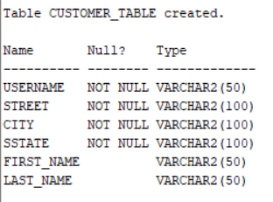

**ADMINISTRATOR_TABLE**

CREATE TABLE ADMINISTRATOR_TABLE

(

username VARCHAR2(50) NOT NULL PRIMARY KEY,

CONSTRAINT FK_ADMINISTRATORusername FOREIGN KEY

(username) REFERENCES USER_TABLE (username) ON DELETE CASCADE

);

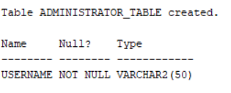

**ORDERS_TABLE**

CREATE TABLE ORDERS_TABLE

(

order_id NUMBER(10, 0) NOT NULL PRIMARY KEY,

invoice_no NUMBER(10, 0) NOT NULL UNIQUE,

order_date TIMESTAMP DEFAULT CURRENT_DATE NOT NULL,

order_status VARCHAR2(100) NOT NULL,

username VARCHAR2(50) NOT NULL,

CONSTRAINT FK_ORDERSusername FOREIGN KEY

(username) REFERENCES CUSTOMER_TABLE (username) ON DELETE CASCADE

);

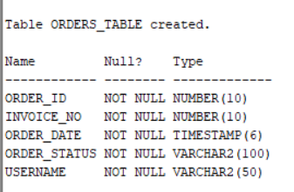

**TRACKING_DETAILS_TABLE**

CREATE TABLE TRACKING_DETAILS_TABLE

(

tracking_id NUMBER(10, 0) NOT NULL,

order_id NUMBER(10, 0) NOT NULL,

courier_name VARCHAR2(100) NOT NULL,

update_time TIMESTAMP DEFAULT CURRENT_DATE NOT NULL,

ddescription VARCHAR2(100) NOT NULL,

PRIMARY KEY(tracking_id, order_id),

CONSTRAINT FK_TRACKING_DETAILSorder_id FOREIGN KEY

(order_id) REFERENCES ORDERS_TABLE (order_id) ON DELETE CASCADE

);

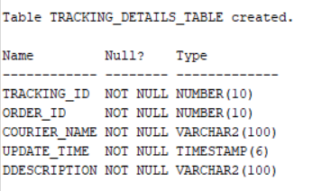

**ORDER_DETAILS_TABLE**

CREATE TABLE ORDER_DETAILS_TABLE

(

order_details_id NUMBER(10, 0) NOT NULL UNIQUE,

order_id NUMBER(10, 0) NOT NULL,

discount DECIMAL(5, 2) DEFAULT 0 CHECK (discount >= 0 AND discount <= 100) NOT NULL,

amount_to_pay NUMBER(10, 3) DEFAULT 0 NOT NULL,

PRIMARY KEY(order_details_id, order_id),

CONSTRAINT FK_ORDER_DETAILS_TABLEorder_id FOREIGN KEY

(order_id) REFERENCES ORDERS_TABLE (order_id) ON DELETE CASCADE

);

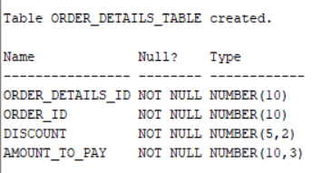

**AUTHOR_TABLE**

CREATE TABLE AUTHOR_TABLE

(

author_id NUMBER(10, 0) NOT NULL PRIMARY KEY,

author_name VARCHAR2(50) NOT NULL,

email_address VARCHAR2(100) NOT NULL

);

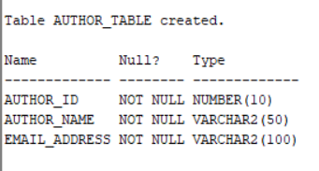

**PUBLISHER_TABLE**

CREATE TABLE PUBLISHER_TABLE

(

publisher_id NUMBER(10, 0) NOT NULL PRIMARY KEY,

publisher_name VARCHAR2(100) NOT NULL,

email_address VARCHAR2(100) NOT NULL,

website VARCHAR2(100) NOT NULL

);

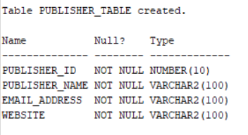

**BOOK_TABLE**

CREATE TABLE BOOK_TABLE

(

book_ISBN NUMBER(10, 0) NOT NULL PRIMARY KEY,

book_title VARCHAR2(255),

eedition NUMBER(2, 0),

price NUMBER(7, 3) NOT NULL,

EOQ NUMBER(7, 3),

author_id NUMBER(10, 0) NOT NULL,

publisher_id NUMBER(10, 0) NOT NULL,

release_date DATE,

page_count NUMBER(4, 0),

dimensions VARCHAR2(50),

quantity_in_stock NUMBER(6, 0) DEFAULT 0 CHECK (quantity_in_stock >= 0) NOT NULL,

CONSTRAINT FK_BOOKauthor_id FOREIGN KEY

(author_id) REFERENCES AUTHOR_TABLE (author_id) ON DELETE CASCADE,

CONSTRAINT FK_BOOKpublisher_id FOREIGN KEY

(publisher_id) REFERENCES PUBLISHER_TABLE (publisher_id) ON DELETE CASCADE

);

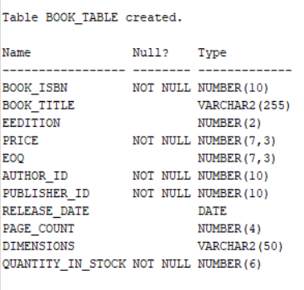

**BOOK_INSTANCE_TABLE**

CREATE TABLE BOOK_INSTANCE_TABLE

(

copy_instance NUMBER(10, 0) NOT NULL,

book_ISBN NUMBER(10, 0) NOT NULL,

quantity NUMBER(5, 0) NOT NULL,

order_details_id NUMBER(10, 0) NOT NULL,

order_id NUMBER(10, 0) NOT NULL,

PRIMARY KEY(copy_instance, book_ISBN),

CONSTRAINT FK_BOOK_INSTANCEbook_ISBN FOREIGN KEY

(book_ISBN) REFERENCES BOOK_TABLE (book_ISBN) ON DELETE CASCADE,

CONSTRAINT FK_BOOK_INSTANCEorder_details_id FOREIGN KEY

(order_details_id) REFERENCES ORDER_DETAILS_TABLE (order_details_id) ON DELETE CASCADE,

CONSTRAINT FK_BOOK_INSTANCEorder_id FOREIGN KEY

(order_id) REFERENCES ORDERS_TABLE (order_id) ON DELETE CASCADE

);

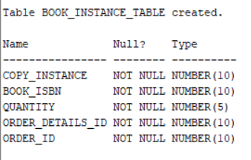

**CATEGORY_TABLE**

CREATE TABLE CATEGORY_TABLE

(

category_id NUMBER(10, 0) NOT NULL PRIMARY KEY,

category_name VARCHAR2(50) NOT NULL,

parent_id NUMBER(10, 0),

CONSTRAINT FK_CATEGORYparent_id FOREIGN KEY

(parent_id) REFERENCES CATEGORY_TABLE (category_id) ON DELETE SET NULL

);

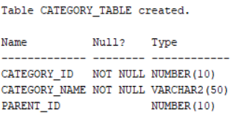

**LANGUAGE_TABLE**

CREATE TABLE LANGUAGE_TABLE

(

language_id NUMBER(10, 0) NOT NULL PRIMARY KEY,

language_name VARCHAR2(50) NOT NULL,

ddescription VARCHAR2(255)

);

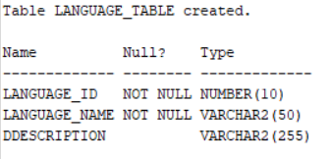

**BINDING_TABLE**

CREATE TABLE BINDING_TABLE

(

binding_id NUMBER(10, 0) NOT NULL PRIMARY KEY,

binding_type VARCHAR2(50) NOT NULL,

ddescription VARCHAR2(255)

);

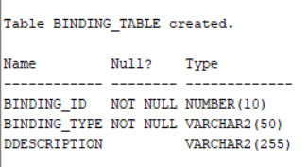

**BOOK_CATEGORY_TABLE**

CREATE TABLE BOOK_CATEGORY_TABLE

(

category_id NUMBER(10, 0) NOT NULL,

book_ISBN NUMBER(10, 0) NOT NULL,

PRIMARY KEY(category_id, book_ISBN),

CONSTRAINT FK_BOOK_CATEGORY_TABLEcategory_id FOREIGN KEY

(category_id) REFERENCES CATEGORY_TABLE (category_id) ON DELETE CASCADE,

CONSTRAINT FK_BOOK_CATEGORY_TABLEbook_ISBN FOREIGN KEY

(book_ISBN) REFERENCES BOOK_TABLE (book_ISBN) ON DELETE CASCADE

);

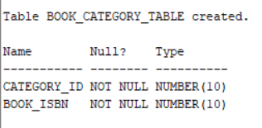

**BOOK_LANGUAGE_TABLE**

CREATE TABLE BOOK_LANGUAGE_TABLE

(

language_id NUMBER(10, 0) NOT NULL,

book_ISBN NUMBER(10, 0) NOT NULL,

PRIMARY KEY(language_id, book_ISBN),

CONSTRAINT FK_BOOK_LANGUAGE_TABLElanguage_id FOREIGN KEY

(language_id) REFERENCES LANGUAGE_TABLE (language_id) ON DELETE CASCADE,

CONSTRAINT FK_BOOK_LANGUAGE_TABLEbook_ISBN FOREIGN KEY

(book_ISBN) REFERENCES BOOK_TABLE (book_ISBN) ON DELETE CASCADE

);

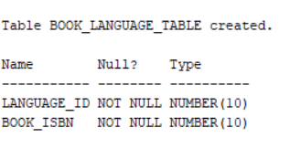

**BOOK_BINDING_TABLE**

CREATE TABLE BOOK_BINDING_TABLE

(

binding_id NUMBER(10, 0) NOT NULL,

book_ISBN NUMBER(10, 0) NOT NULL,

PRIMARY KEY(binding_id, book_ISBN),

CONSTRAINT FK_BOOK_BINDING_TABLEbinding_id FOREIGN KEY

(binding_id) REFERENCES BINDING_TABLE (binding_id) ON DELETE CASCADE,

CONSTRAINT FK_BOOK_BINDING_TABLEbook_ISBN FOREIGN KEY

(book_ISBN) REFERENCES BOOK_TABLE (book_ISBN) ON DELETE CASCADE

);

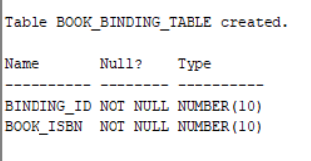

**SUPPLIER_TABLE**

CREATE TABLE SUPPLIER_TABLE

(

supplier_id NUMBER(10, 0) NOT NULL PRIMARY KEY,

email_address VARCHAR2(100) NOT NULL,

supplier_name VARCHAR2(100) NOT NULL,

contact_no VARCHAR2(100) NOT NULL,

street VARCHAR2(100) NOT NULL,

city VARCHAR2(100) NOT NULL,

sstate VARCHAR2(100) NOT NULL

);

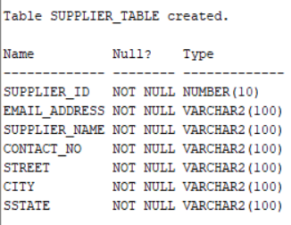

**SUPPLIES_TO_TABLE**

CREATE TABLE SUPPLIES_TO_TABLE

(

publisher_id NUMBER(10, 0) NOT NULL,

supplier_id NUMBER(10, 0) NOT NULL,

book_ISBN NUMBER(10, 0) NOT NULL UNIQUE,

amount NUMBER(6, 0) NOT NULL CHECK (amount >= 0),

PRIMARY KEY(publisher_id, supplier_id),

CONSTRAINT FK_SUPPLIES_TO_TABLEpublisher_id FOREIGN KEY

(publisher_id) REFERENCES PUBLISHER_TABLE (publisher_id) ON DELETE CASCADE,

CONSTRAINT FK_SUPPLIES_TO_TABLEsupplier_id FOREIGN KEY

(supplier_id) REFERENCES SUPPLIER_TABLE (supplier_id) ON DELETE CASCADE

);

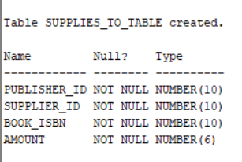

**WAREHOUSE_TABLE**

CREATE TABLE WAREHOUSE_TABLE

(

warehouse_id NUMBER(10, 0) NOT NULL PRIMARY KEY,

warehouse_name VARCHAR2(100) NOT NULL,

street VARCHAR2(100) NOT NULL,

city VARCHAR2(100) NOT NULL,

sstate VARCHAR2(100) NOT NULL,

manager_contact VARCHAR2(100) NOT NULL

);

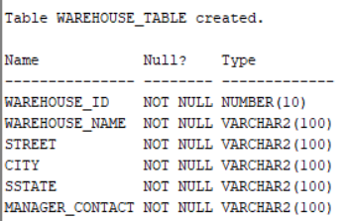

**PROVIDES_BOOKS_TABLE**

CREATE TABLE PROVIDES_BOOKS_TABLE

(

supplier_id NUMBER(10, 0) NOT NULL,

warehouse_id NUMBER(10, 0) NOT NULL,

book_ISBN NUMBER(10, 0) NOT NULL UNIQUE,

amount NUMBER(6, 0) NOT NULL CHECK (amount >= 0),

PRIMARY KEY(supplier_id, warehouse_id),

CONSTRAINT FK_PROVIDES_BOOKS_TABLEsupplier_id FOREIGN KEY

(supplier_id) REFERENCES SUPPLIER_TABLE (supplier_id) ON DELETE CASCADE,

CONSTRAINT FK_PROVIDES_BOOKS_TABLEwarehouse_id FOREIGN KEY

(warehouse_id) REFERENCES WAREHOUSE_TABLE (warehouse_id) ON DELETE CASCADE

);

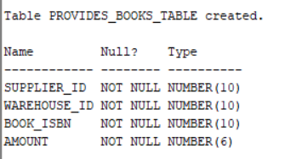

**BOOKS_WITH_SUPPLIERS_TABLE**

CREATE TABLE BOOKS_WITH_SUPPLIERS_TABLE

(

track_id NUMBER(10, 0) NOT NULL PRIMARY KEY,

book_ISBN NUMBER(10, 0) NOT NULL UNIQUE,

quantity NUMBER(6, 0) DEFAULT 0 CHECK (quantity >= 0) NOT NULL

);

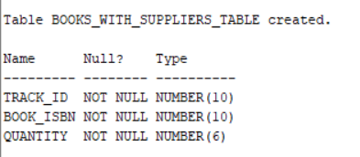

**HAVE_BOOKS_TABLE**

CREATE TABLE HAVE_BOOKS_TABLE

(

supplier_id NUMBER(10, 0) NOT NULL,

track_id NUMBER(10, 0) NOT NULL,

PRIMARY KEY(supplier_id, track_id),

CONSTRAINT FK_HAVE_BOOKS_TABLEsupplier_id FOREIGN KEY

(supplier_id) REFERENCES SUPPLIER_TABLE (supplier_id) ON DELETE CASCADE,

CONSTRAINT FK_HAVE_BOOKS_TABLEtrack_id FOREIGN KEY

(track_id) REFERENCES BOOKS_WITH_SUPPLIERS_TABLE (track_id) ON DELETE CASCADE

);

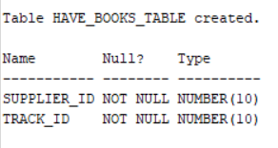

**BOOKS_IN_WAREHOUSE_TABLE**

CREATE TABLE BOOKS_IN_WAREHOUSE_TABLE

(

track_id NUMBER(10, 0) NOT NULL PRIMARY KEY,

book_ISBN NUMBER(10, 0) NOT NULL,

quantity NUMBER(6, 0) DEFAULT 0 CHECK (quantity >= 0) NOT NULL

);

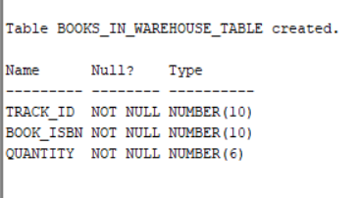

**CONTAINS_BOOKS_TABLE**

CREATE TABLE CONTAINS_BOOKS_TABLE

(

warehouse_id NUMBER(10, 0) NOT NULL,

track_id NUMBER(10, 0) NOT NULL,

PRIMARY KEY(warehouse_id, track_id),

CONSTRAINT FK_CONTAINS_BOOKS_TABLEwarehouse_id FOREIGN KEY

(warehouse_id) REFERENCES WAREHOUSE_TABLE (warehouse_id) ON DELETE CASCADE,

CONSTRAINT FK_CONTAINS_BOOKS_TABLEbook_ISBN FOREIGN KEY

(track_id) REFERENCES BOOKS_IN_WAREHOUSE_TABLE (track_id) ON DELETE CASCADE

);

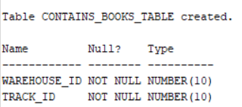

**USER_INTERACTION_TABLE**

CREATE TABLE USER_INTERACTION_TABLE

(

username VARCHAR2(50) NOT NULL,

book_ISBN NUMBER(10, 0) NOT NULL,

rating NUMBER(1, 0),

upvote CHAR(1),

downvote CHAR(1),

PRIMARY KEY(username, book_ISBN),

CONSTRAINT FK_USER_INTERACTION_TABLEusername FOREIGN KEY

(username) REFERENCES CUSTOMER_TABLE (username) ON DELETE CASCADE,

CONSTRAINT FK_USER_INTERACTION_TABLEbook_ISBN FOREIGN KEY

(book_ISBN) REFERENCES BOOK_TABLE (book_ISBN) ON DELETE CASCADE

);

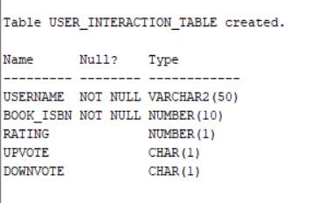

**FAVOURITES_TABLE**

CREATE TABLE FAVOURITES_TABLE

(

favourite_id NUMBER(10, 0) NOT NULL PRIMARY KEY,

reason VARCHAR2(255)

);

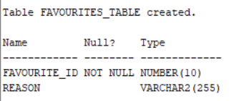

**USER_FAVOURITE_TABLE**

CREATE TABLE USER_FAVOURITE_TABLE

(

username VARCHAR2(50) NOT NULL,

book_ISBN NUMBER(10, 0) NOT NULL,

favourite_id NUMBER(10, 0) NOT NULL,

PRIMARY KEY(username, book_ISBN, favourite_id),

CONSTRAINT FK_USER_FAVOURITE_TABLEusernamebook_ISBN FOREIGN KEY

(username, book_ISBN) REFERENCES USER_INTERACTION_TABLE (username, book_ISBN) ON DELETE CASCADE,

CONSTRAINT FK_USER_FAVOURITE_TABLEfavourite_id FOREIGN KEY

(favourite_id) REFERENCES FAVOURITES_TABLE (favourite_id) ON DELETE CASCADE

);

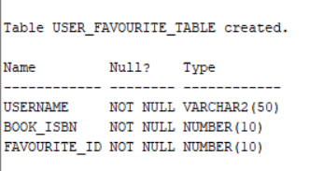

**COMMENTS_TABLE**

CREATE TABLE COMMENTS_TABLE

(

comment_id NUMBER(10, 0) NOT NULL PRIMARY KEY,

ccomment VARCHAR2(255) NOT NULL

);

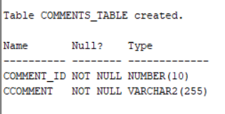

**USER_COMMENT_TABLE**

CREATE TABLE USER_COMMENT_TABLE

(

username VARCHAR2(50) NOT NULL,

book_ISBN NUMBER(10, 0) NOT NULL,

comment_id NUMBER(10, 0) NOT NULL,

PRIMARY KEY(username, book_ISBN, comment_id),

CONSTRAINT FK_USER_COMMENT_TABLEusernamebook_ISBN FOREIGN KEY

(username, book_ISBN) REFERENCES USER_INTERACTION_TABLE (username, book_ISBN) ON DELETE CASCADE,

CONSTRAINT FK_USER_COMMENT_TABLEcomment_id FOREIGN KEY

(comment_id) REFERENCES COMMENTS_TABLE (comment_id) ON DELETE CASCADE

);

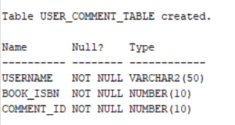

**WISHLIST_TABLE**

CREATE TABLE WISHLIST_TABLE

(

wish_id NUMBER(10, 0) NOT NULL PRIMARY KEY

);

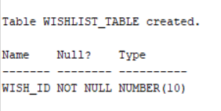

**USER_WISHLIST_TABLE**

CREATE TABLE USER_WISHLIST_TABLE

(

username VARCHAR2(50) NOT NULL,

book_ISBN NUMBER(10, 0) NOT NULL,

wish_id NUMBER(10, 0) NOT NULL,

PRIMARY KEY(username, book_ISBN, wish_id),

CONSTRAINT FK_USER_WISHLIST_TABLEusernamebook_ISBN FOREIGN KEY

(username, book_ISBN) REFERENCES USER_INTERACTION_TABLE (username, book_ISBN) ON DELETE CASCADE,

CONSTRAINT FK_USER_WISHLIST_TABLEwish_id FOREIGN KEY

(wish_id) REFERENCES WISHLIST_TABLE (wish_id) ON DELETE CASCADE

);

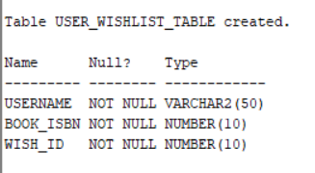

**7)Miscellaneous**

CREATE SEQUENCE SEQ_FOR_INSERTING_IN_HAVE_BOOKS_TABLE

START WITH 10

INCREMENT BY 10 ;

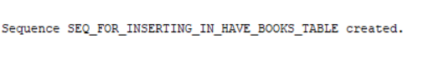

CREATE TABLE LOG_WAREHOUSE_TO_SUPPLIER_TABLE

(

log_user VARCHAR2(50),

log_date DATE,

from_warehouse NUMBER(10, 0),

to_supplier NUMBER(10, 0),

book_sent NUMBER(10, 0),

quantity_sent NUMBER(6, 0)

);



CREATE OR REPLACE TRIGGER TRG_WAREHOUSE_TO_SUPPLIER

FOR INSERT ON PROVIDES_BOOKS_TABLE

COMPOUND TRIGGER

V_track_id NUMBER(10, 0) := &V_track_id ;

V_supplier_id NUMBER(10, 0) := &V_supplier_id ;

AFTER EACH ROW IS

BEGIN

IF (:NEW.amount >= 1000) THEN

RAISE_APPLICATION_ERROR(-20005,'You cannot provide more than 1000 books...');

END IF ;

INSERT INTO BOOKS_WITH_SUPPLIERS_TABLE VALUES(SEQ_FOR_INSERTING_IN_HAVE_BOOKS_TABLE.NEXTVAL, :NEW.book_ISBN, :NEW.amount);

INSERT INTO HAVE_BOOKS_TABLE VALUES(V_supplier_id, SEQ_FOR_INSERTING_IN_HAVE_BOOKS_TABLE.CURRVAL);

UPDATE BOOKS_IN_WAREHOUSE_TABLE

SET quantity = quantity - :NEW.amount

WHERE track_id = V_track_id AND book_ISBN = :NEW.book_ISBN ;

IF (BOOKS_IN_WAREHOUSE_TABLE.quantity = 0) THEN

DELETE FROM BOOKS_IN_WAREHOUSE_TABLE WHERE quantity = 0 ;

END IF ;

INSERT INTO LOG_WAREHOUSE_TO_SUPPLIER_TABLE VALUES(USER, SYSDATE, :NEW.warehouse_id, V_supplier_id, :NEW.amount);

END AFTER EACH ROW ;

AFTER STATEMENT IS

BEGIN

DELETE FROM PROVIDES_BOOKS_TABLE ;

DBMS_OUTPUT.PUT_LINE('Required work has been done successfully!');

END AFTER STATEMENT ;

END ;

CREATE TABLE LOG_SUPPLIER_TO_PUBLISHER_TABLE

(

log_user VARCHAR2(50),

log_date DATE,

from_supplier NUMBER(10, 0),

to_publisher NUMBER(10, 0),

book_sent NUMBER(10, 0),

quantity_sent NUMBER(6, 0)

);

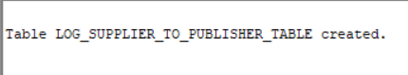

CREATE OR REPLACE FUNCTION FUN_BOOK_EXISTS (search_book_ISBN BOOK_TABLE.book_ISBN%type) RETURN BOOLEAN AS

v_count NUMBER ;

BEGIN

SELECT COUNT(*) INTO v_count FROM BOOK_TABLE WHERE book_ISBN = search_book_ISBN ;

RETURN (v_count > 0) ;

END FUN_BOOK_EXISTS ;

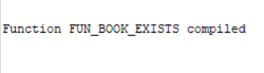

CREATE OR REPLACE TRIGGER TRG_SUPPLIER_TO_PUBLISHER

FOR INSERT ON SUPPLIES_TO_TABLE

COMPOUND TRIGGER

v_book_title VARCHAR2(255) ;

v_edition NUMBER(2, 0) ;

v_price NUMBER(7, 3) ;

v_eoq NUMBER(7, 3) ;

v_author_id NUMBER(10, 0) ;

v_release_date DATE ;

v_page_count NUMBER(4, 0) ;

v_dimensions VARCHAR2(50) ;

BEFORE EACH ROW IS

BEGIN

IF FUN_BOOK_EXISTS(:NEW.book_ISBN) THEN

UPDATE BOOK_TABLE

SET quantity_in_stock = quantity_in_stock + :NEW.amount

WHERE book_ISBN = :NEW.book_ISBN ;

ELSE

v_book_title := &v_book_title ;

v_edition := &v_edition ;

v_price := &v_price ;

v_eoq := &v_eoq ;

v_author_id := &v_author_id ;

v_release_date := &v_release_date ;

v_page_count := &v_page_count ;

v_dimensions := &v_dimensions ;

INSERT INTO BOOK_TABLE VALUES(:NEW.book_ISBN, v_book_title, v_edition, v_price,

v_eoq, v_author_id, :NEW.publisher_id, v_release_date, v_page_count, v_dimensions, :NEW.amount) ;

END IF ;

INSERT INTO LOG_SUPPLIER_TO_PUBLISHER_TABLE VALUES(USER, SYSDATE, :NEW.supplier_id, :NEW.publisher_id, :NEW.book_ISBN, :NEW.amount) ;

END BEFORE EACH ROW ;

AFTER STATEMENT IS

BEGIN

DELETE FROM SUPPLIES_TO_TABLE ;

DBMS_OUTPUT.PUT_LINE('Required work has been done successfully!');

END AFTER STATEMENT ;

END ;