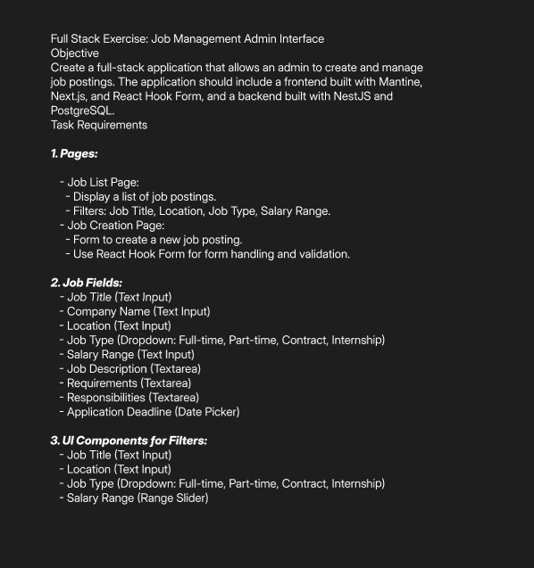

I have completed a full-stack project using React.js for the frontend, Node.js and Express for the backend, and MySQL for the database. In this project, data is posted and saved in the database, and then displayed in the user interface. When the user clicks the **"Create Jobs"** button, a **modal** appears with a form. After filling out the form and clicking the **"Publish"** button, the submitted data is displayed in the UI.This UI is also Responsive.

Here is the screenshots of the project, some fields are hardcoded values.

**Screenshot1:**

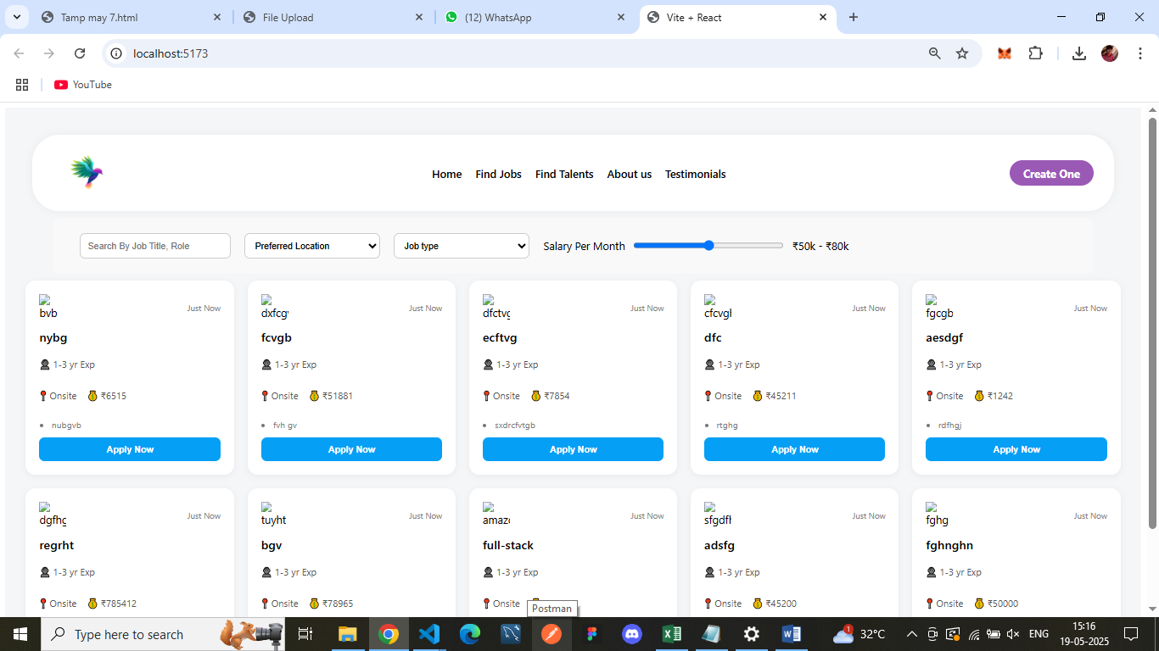

**Screenshot 2:**

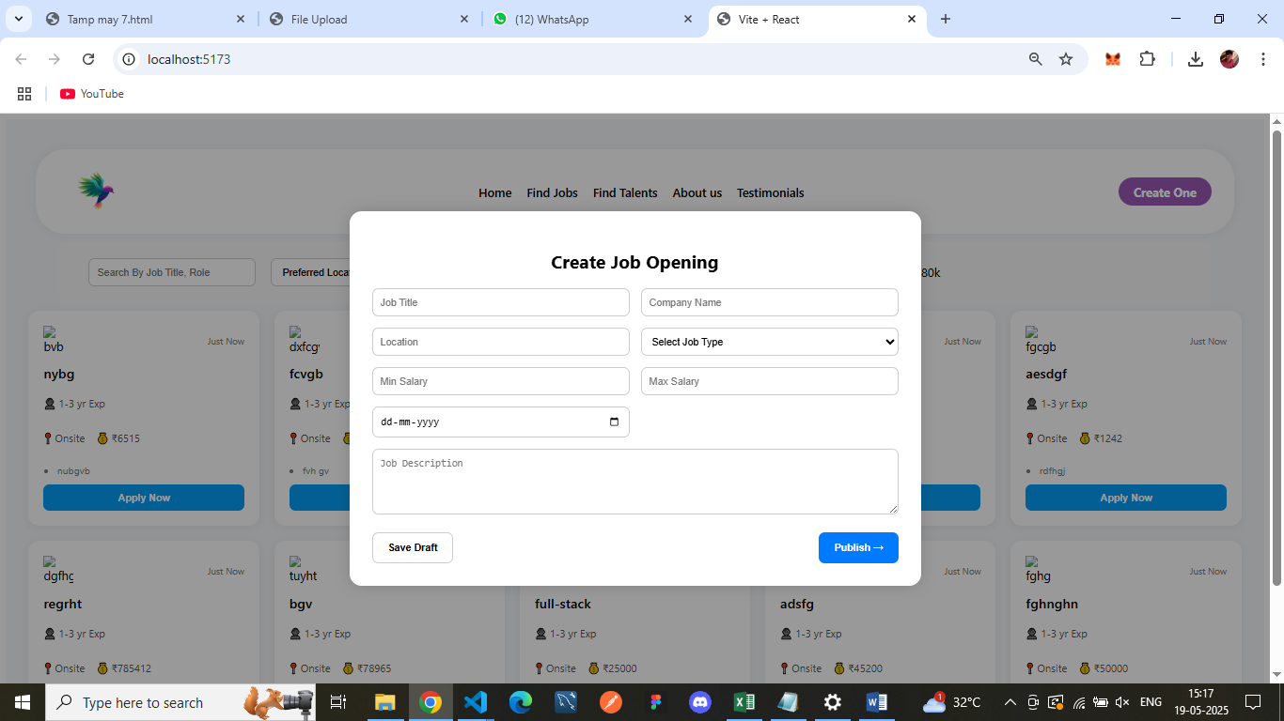

**Screenshot 3:**

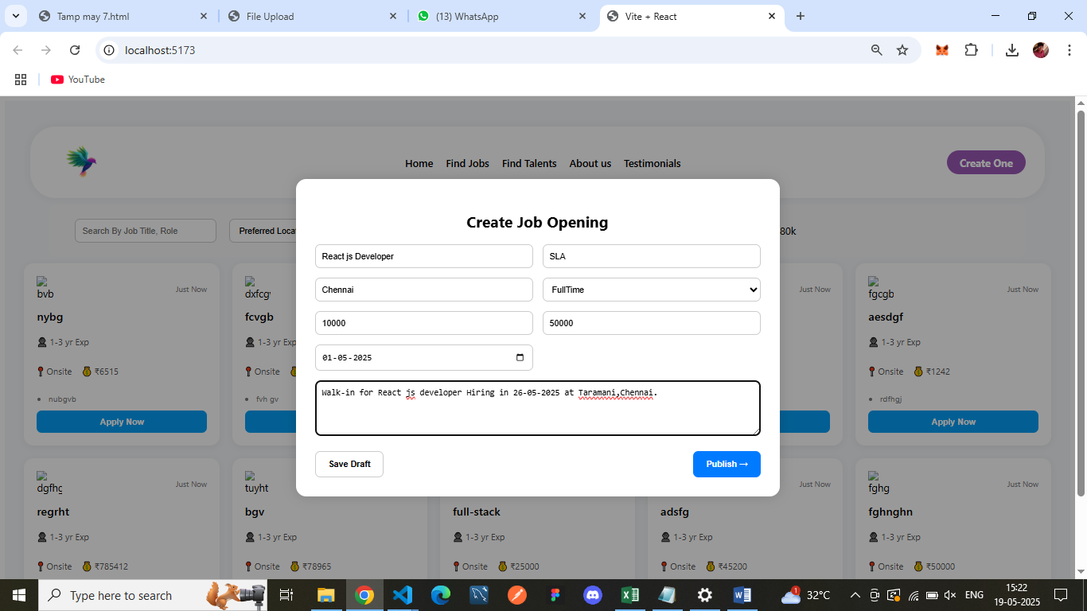

**Screenshot 4:**

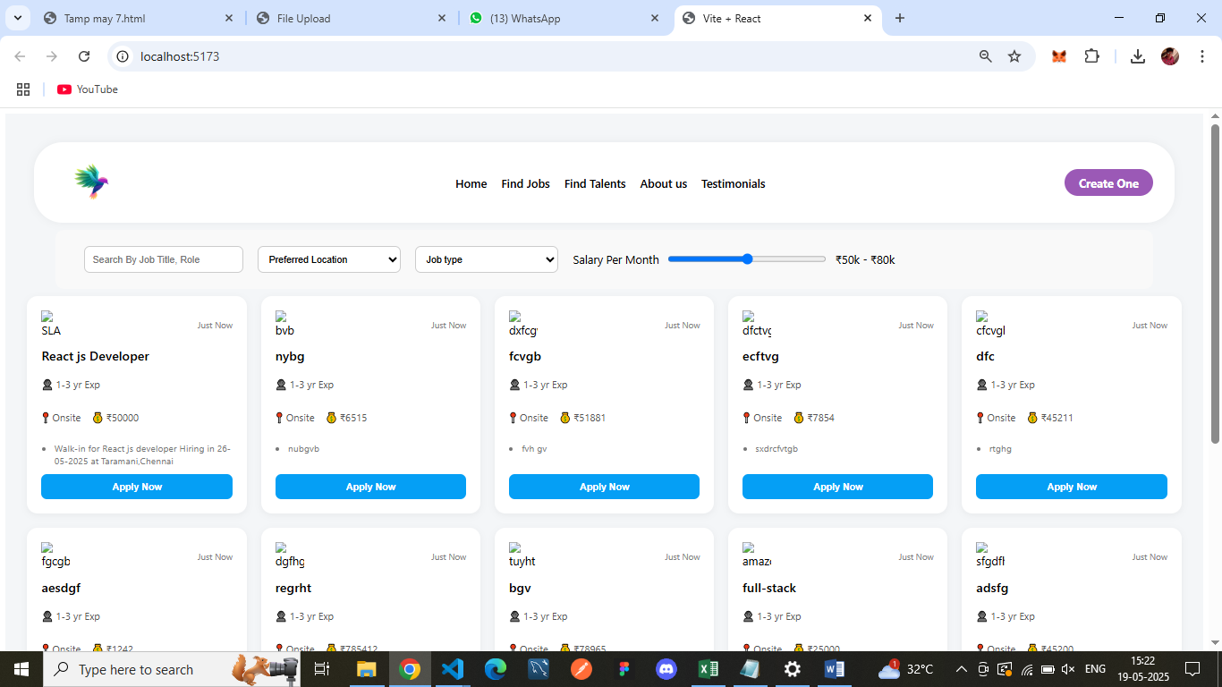

**Screenshot 5:**

