Zachary Snelick

Cloud Class

Project 4

The basic login of my program looked like this: It allows for a user to login or register for an account to enter.

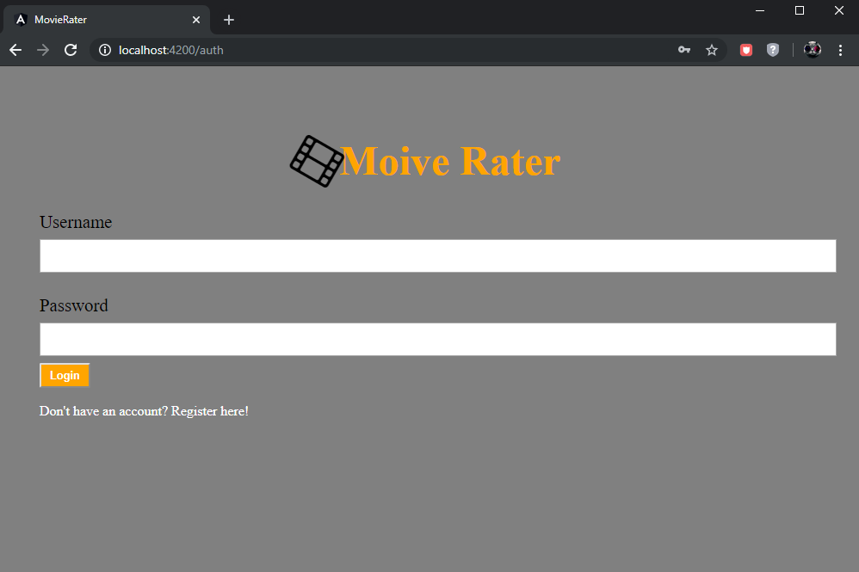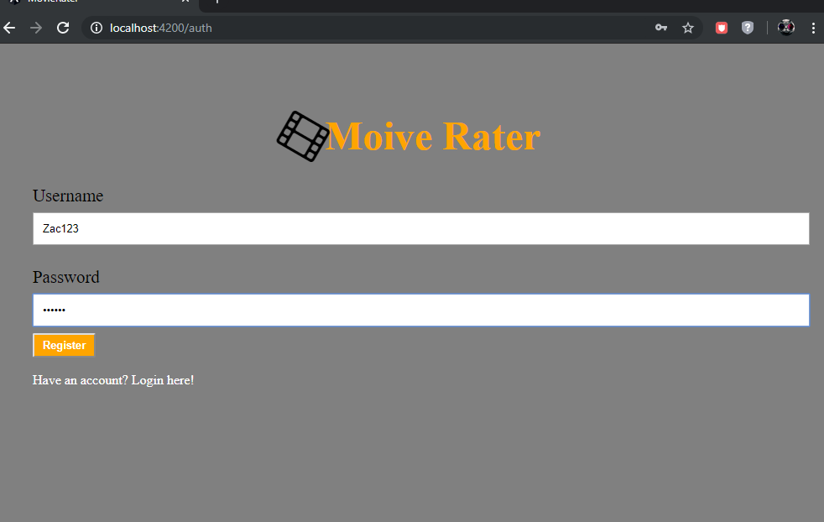

This taught me how tokens are used and saved during someone’s time in an application. It was a difficult process to save the token after a refresh, and it is only deleted on Logout.

There are various functions you can do once you log in, they include being able to delete, edit, and add a movie with a description.

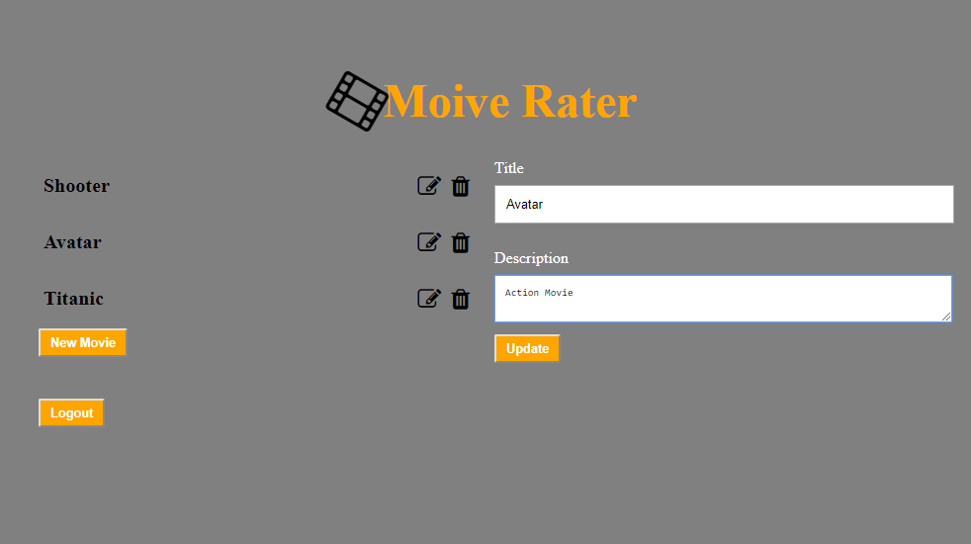This is updating a movie that already exists:

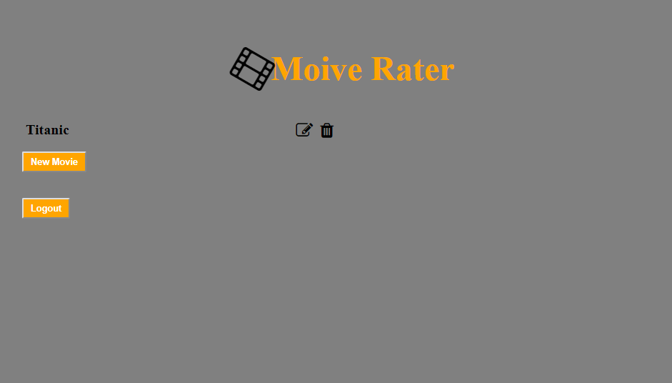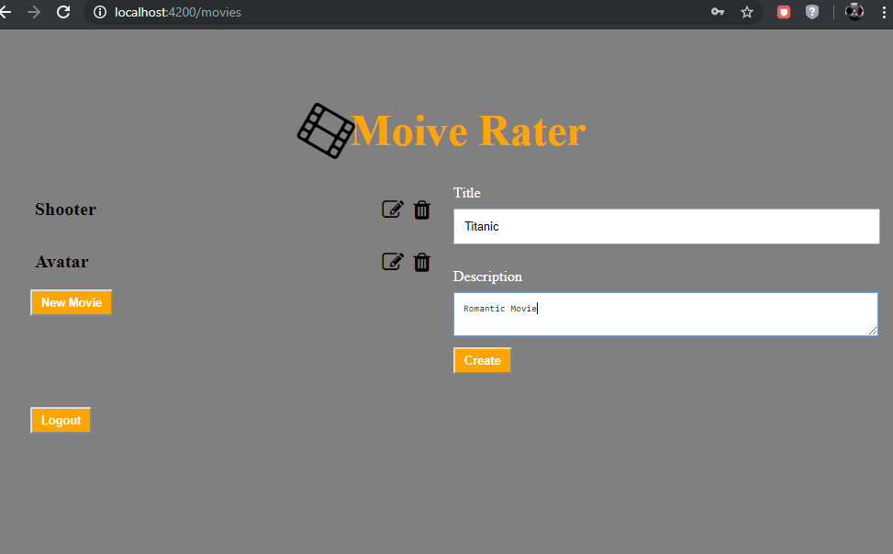This is deleting movies:

This is creating a movie:

Lastly the main part of the program. You can rate the movie, see previous average ratings, and the description of the movie. 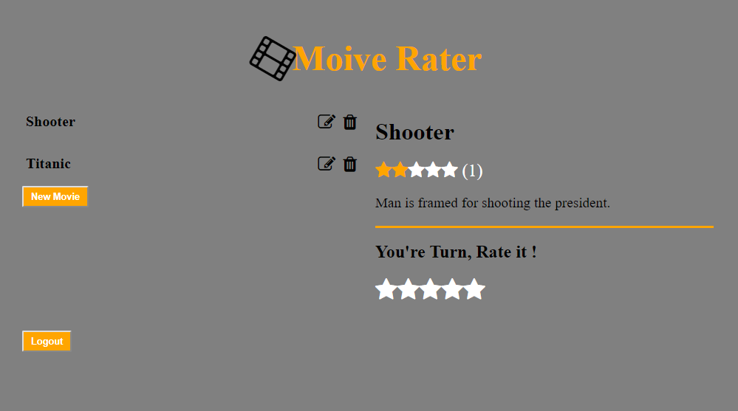

I used Angular 6 web app and python Django 2 RESTfull API to create this application.