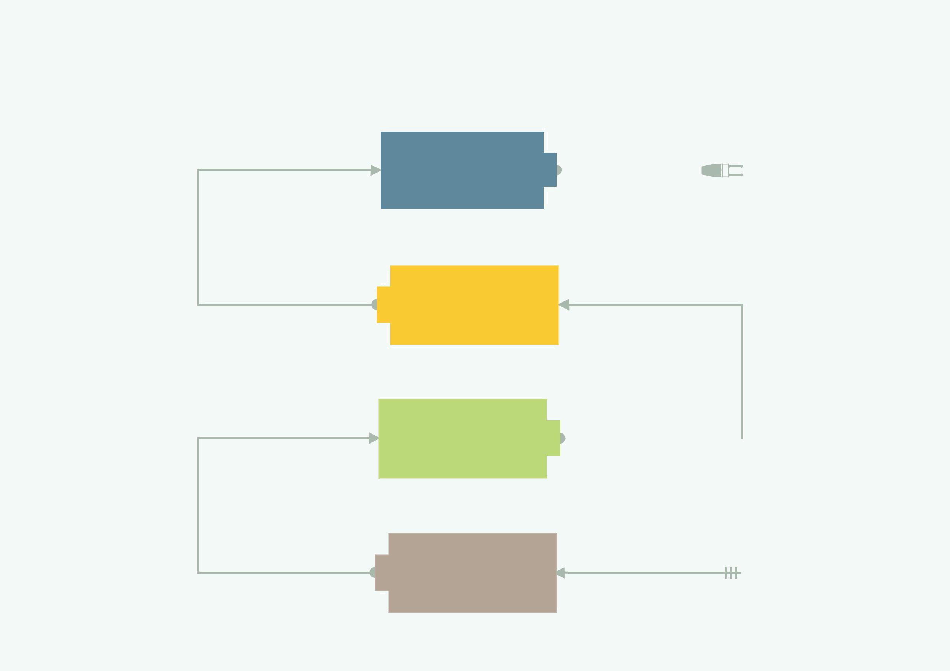
Block Diagram Representation

Entering Values

Entering Values
Entering Values

Sowing

The Bot Drops a bunch of
seeds after a fixed distance
as per the Values entered

BOT Placement

Bot is to be placed on the
leftmost bottom corner
of the farming land

04 |  |  | Leveling
04 |  |  | The Leveling mechanism
 |  |  | Levels the dug soil

03

02 |  | Digging
02 |  | The Digging mechanism
 |  | In the front ensures the soil is well dug before dropping seeds

Entering Values

01
The user enters desired values
as per the Prompts on the LCD screen

