AFRICAN LEADERSHIP UNIVERSITY
School of Computer Science and Information Technology
PROJECT SENTINEL
An Explainable Early-Warning System for Sepsis-Associated Acute Kidney Injury (SA-AKI)
Capstone Progress Report
Programme: BSc. in Software Engineering
Student: Senga Kabare Emmanuel
Supervisor: Simeon Nsabiyumva
Course: Capstone Project
2026

DECLARATION
This project report is my original work, unless stated otherwise, and all external sources have been referenced or cited in this document. This work has not been presented for the award of a degree or for any similar purpose in any other university.

Signature …………………………………… Date …………………………………
Senga Kabare Emmanuel (Student)

CERTIFICATION
The undersigned certifies that he has read and hereby recommends for acceptance by the African Leadership University a report entitled “Project Sentinel: An Explainable Early-Warning System for Sepsis-Associated Acute Kidney Injury (SA-AKI).”

Signature …………………………………… Date …………………………………
Simeon Nsabiyumva (Supervisor)
Faculty, Bachelor of Software Engineering,
African Leadership University.

DEDICATION AND ACKNOWLEDGEMENT
This work is dedicated to the clinicians and nurses of Rwanda’s referral hospitals, whose vigilance at the bedside this project seeks only to support — never to replace.
I am grateful to my supervisor, Simeon Nsabiyumva, for his guidance throughout the design and build of this proof of concept. I acknowledge the PhysioNet team and the MIMIC-IV investigators for maintaining the open-access critical-care demo dataset that made an end-to-end pipeline possible before local hospital data was available, and the maintainers of the open-source scientific-Python and React ecosystems on which the system is built.

ABSTRACT
Sepsis-associated acute kidney injury (SA-AKI) is a leading driver of mortality in critically ill patients, yet it is routinely detected too late: serum creatinine is a lagging indicator, and in resource-limited hospitals urine output is seldom monitored. This report documents the work completed to date on Project Sentinel, a proof-of-concept machine-learning pipeline that predicts the probability of a patient meeting KDIGO Stage ≥ 1 AKI criteria within the next 6, 12, or 24 hours, rather than classifying injury that has already occurred. Because credentialed access to the target hospital’s data was not yet available, the pipeline was built and validated end-to-end on the open-access MIMIC-IV clinical demo (136 ICU stays; 12,413 patient-hours), which — unlike the earlier PhysioNet-2019 data — records urine output and therefore permits full KDIGO staging. A cascaded two-stage architecture was implemented: a vitals-only LightGBM screener (simulating the labs-unavailable district-hospital case) followed by a full-feature LightGBM and XGBoost confirmer over roughly 199 engineered features, with isotonic calibration, a split-conformal “indeterminate” abstention layer, and per-patient SHAP explanations surfaced as bedside clinical alerts. A FastAPI inference service and a React ward dashboard were built and wired end-to-end. On the 100-patient demo the headline model (Stage-2 LightGBM, 24-hour horizon) reached AUROC 0.66, AUPRC 0.50, and ECE 0.11 on the held-out test split — modest and, importantly, not artificially perfect, confirming the absence of target leakage. A subgroup analysis revealed a genuine fairness gap (AUROC 0.74 in patients under 65 versus 0.62 in those 65 and older). The demonstrated deliverable is a working, leakage-free, explainable pipeline that is architecturally ready to be retrained on real hospital data; predictive accuracy at the level targeted in the proposal awaits a larger cohort.

Table of Contents

List of Tables
Table 1: Canonical hourly-cohort schema (feature families)
Table 2: Cohort and chronological split sizes
Table 3: KDIGO label positive rate by prediction horizon
Table 4: Functional requirements and implementation status
Table 5: Non-functional requirements and implementation status
Table 6: Development tools — planned versus built
Table 7: Test coverage summary
Table 8: Headline test-split performance (Stage-2, 24-hour horizon)
Table 9: Subgroup (fairness) analysis — Stage-2 LightGBM, 24-hour horizon
Table 10: Indicative project budget
Table 11: Project timeline (work completed to date)

List of Figures
Figure 1: Cascaded two-stage model architecture
Figure 2: Ward dashboard — patient roster ranked by ascending risk
Figure 3: Interactive scoring panel — score a patient-hour
Figure 4: Per-patient clinical alert card with SHAP attributions
Figure 5: ROC curves by horizon (test split)
Figure 6: Precision–recall curves by horizon (test split)
Figure 7: Calibration curves (reliability diagram)
Figure 8: Decision-curve analysis (net clinical benefit)
Figure 9: SHAP global feature-importance summary

List of Acronyms / Abbreviations
Acronym | Meaning
AKI | Acute Kidney Injury
API | Application Programming Interface
AUROC | Area Under the Receiver Operating Characteristic curve
AUPRC | Area Under the Precision–Recall Curve
BUN | Blood Urea Nitrogen
CDSS | Clinical Decision Support System
CORS | Cross-Origin Resource Sharing
ECE | Expected Calibration Error
EHR | Electronic Health Record
ICU | Intensive Care Unit
KDIGO | Kidney Disease: Improving Global Outcomes
LightGBM | Light Gradient Boosting Machine
MAP | Mean Arterial Pressure
MIMIC-IV | Medical Information Mart for Intensive Care, version IV
ML | Machine Learning
NPV / PPV | Negative / Positive Predictive Value
OpenClinic GA | OpenClinic General Architecture (hospital EHR)
PoC | Proof of Concept
RMRTH | Rwanda Military Referral and Teaching Hospital
SA-AKI | Sepsis-Associated Acute Kidney Injury
SHAP | SHapley Additive exPlanations
SOFA | Sequential Organ Failure Assessment
UOP | Urine Output
XAI | Explainable Artificial Intelligence
XGBoost | Extreme Gradient Boosting

CHAPTER ONE: INTRODUCTION

1.1 Introduction and Background
Acute kidney injury (AKI) is a rapid decline in renal excretory function that carries high mortality in critically ill patients. Sepsis is its leading driver, accounting for an estimated 45–70% of AKI cases in intensive care. The clinical standard for detecting AKI, the KDIGO criteria, flags injury only after serum creatinine has risen or urine output has fallen — that is, after damage has begun. Creatinine in particular is a lagging indicator: it can remain within the normal range until roughly half of kidney function is already lost.
In resource-limited settings this latency is compounded. Baseline creatinine values are frequently missing, and structured urine-output monitoring — a core KDIGO channel — is documented in only a small fraction of at-risk cases in recent Rwandan hospital audits. The consequence is late recognition: a large share of patients are first identified only once they have reached the most advanced KDIGO stage. Project Sentinel was conceived to close this “silent window” by shifting renal care from reactive staging to prospective, context-aware early warning.
The eventual clinical target is the Rwanda Military Referral and Teaching Hospital (RMRTH), which runs the OpenClinic GA electronic health record. Because credentialed hospital data was not yet available during this phase, the public MIMIC-IV critical-care dataset was used as a training surrogate to prove the pipeline end-to-end. This report describes what was built and measured on that surrogate; it is explicitly a proof of concept, not a model trained for deployment.

1.2 Problem Statement
Current SA-AKI management depends on biomarkers that report injury after it has occurred, and the predictive tools developed in high-income settings assume dense, high-frequency data streams that do not exist in the sparse, intermittently documented records of a district hospital. Models trained solely on Western cohorts also generalise poorly to local patient profiles, where sepsis frequently intersects with malaria and dehydration. The result is a gap: no calibrated, explainable, prospectively predictive early-warning tool that works within the data realities of hospitals such as RMRTH. The engineering problem addressed in this phase is whether such a pipeline — raw relational ICU data in, calibrated and explained risk scores out — can be constructed and validated end-to-end without target leakage.

1.3 Project’s Main Objective
To design, build, and validate an explainable machine-learning pipeline that predicts the onset of SA-AKI (KDIGO Stage ≥ 1) 6 to 24 hours ahead from routinely collected ICU variables, and to demonstrate it end-to-end — from raw data through calibrated risk scores to per-patient clinical alerts — in a form that is architecturally ready for retraining on real hospital data.

1.3.1 Specific Objectives
- Ingest real relational critical-care data and reshape it into a canonical one-row-per-patient-hour cohort with vitals, labs, and urine output.
- Derive KDIGO Stage-1 AKI labels from raw creatinine and urine measurements (both channels) and generate 6-, 12-, and 24-hour prospective targets without leakage.
- Engineer time-series features (missingness masks, rolling statistics, velocities, and clinical composites) and train a cascaded two-stage model per horizon.
- Calibrate the risk scores, add a conformal abstention layer, and generate SHAP-based per-patient explanations.
- Evaluate discrimination, calibration, and clinical utility, including a subgroup fairness analysis, and expose the model through a working inference API and ward dashboard.

1.4 Research Questions
- Can a leakage-free pipeline predict KDIGO Stage ≥ 1 SA-AKI 6–24 hours ahead from routinely collected ICU variables, including a urine-output channel?
- How well do calibrated gradient-boosting models discriminate and calibrate on a small, realistic cohort, and does performance vary across clinically important subgroups?
- Can model outputs be surfaced as explainable, actionable bedside alerts without assuming production EHR infrastructure?

1.5 Project Scope
This phase covered the complete offline pipeline (data loading, cohort definition, labelling, feature engineering, training, calibration, evaluation, and explanation) and a local full-stack demo (FastAPI backend plus React dashboard) served from the held-out test data. It deliberately excluded a live OpenClinic GA feed, production authentication and deployment, and the deep temporal (RNN-LSTM) model named in the proposal’s target architecture. Training used the MIMIC-IV demo as a surrogate for RMRTH data; scaling to the full dataset and external validation are future work.

1.6 Significance and Justification
The significance of this phase is architectural rather than numerical. On 100 patients no model can be clinically accurate, and this one is not; the value is a demonstrated, reproducible path from real relational ICU data to calibrated, explained, prospective risk — with the urine-output KDIGO channel that the earlier data source could not support. Establishing that the metrics are modest and leakage-free is itself a result: it shows the pipeline is honest and ready to be retrained at scale, avoiding the fake-perfect scores that mask target leakage in many student ML projects.

1.7 Research Budget
The project was built entirely on open-source software and open-access data, so direct costs to date are effectively zero; the indicative budget below reflects what scaling to real hospital data would require.
Item | Indicative cost | Notes
Software stack | $0 | Python, uv, LightGBM/XGBoost, FastAPI, React — all open-source
MIMIC-IV demo data | $0 | Open-access; no credentialing required
Full MIMIC-IV / PhysioNet access | $0 | Free with CITI training + signed DUA (application in progress)
Local compute | $0 | Trains on a laptop CPU; no GPU needed at this scale
Cloud / GPU (future scale-up) | ~$100–300 | Optional, only for full-dataset training and tuning
Total (this phase) | $0 | No expenditure incurred to date
Table 10: Indicative project budget

1.8 Research Timeline
Phase | Work | Status
Data & pivot | Pivot PhysioNet-2019 → MIMIC-IV; data loader; hourly cohort | Complete
Cohort & labels | Cohort definition; baseline creatinine; KDIGO labels (Cr + UOP) | Complete
Features | Missingness, rolling stats, velocity, composites; feature manifest | Complete
Modelling | Stage-1 + Stage-2 (Optuna); isotonic calibration; conformal layer | Complete
Evaluation | Discrimination, calibration, subgroup analysis, figures | Complete
Explainability | SHAP summaries, waterfalls, clinical-alert JSON | Complete
Backend + frontend | FastAPI inference API; React ward dashboard | Complete
OpenClinic feed; scale-up; RNN-LSTM | Live EHR mock; full MIMIC-IV; temporal model | Pending
Table 11: Project timeline (work completed to date)

CHAPTER TWO: LITERATURE REVIEW

2.1 Introduction
This chapter summarises the computational and clinical work that framed Project Sentinel’s design. The review concentrated on machine-learning models for AKI/SA-AKI prediction, time-series handling of sparse clinical data, and explainable bedside decision support, rather than on general clinical studies. Its conclusions directly shaped the two-stage, calibrated, SHAP-explained architecture built in this phase.

2.2 Historical Background of the Research Topic
Clinical decision support for AKI has moved from static, rule-based laboratory alerts toward dynamic, data-driven prediction. Early electronic AKI alerts — exemplified by national delta-check algorithms — compare incoming creatinine against a stored baseline. Large evaluations and randomised trials have repeatedly shown that such alerts do not, on their own, reduce mortality or the need for renal replacement therapy: they fire after structural damage, ignore vital-sign context, and generate enough false positives to cause alert fatigue. This history motivates a predictive, rather than reactive, and context-aware, rather than single-value, approach.

2.3 Overview of Existing Systems
Existing AKI software falls into three families, each with a decisive weakness for a resource-limited setting:
- Rule-based LIS e-alerts (e.g. NHS delta-check): lightweight and easy to deploy, but retrospective, blind to vitals, and prone to alert fatigue with no measured survival benefit.
- Commercial closed-source EHR modules (e.g. Epic Risk of HA-AKI): natively integrated and real-time, but a black box that cannot be retrained locally and whose external-validation AUROC drops to roughly 0.76–0.77.
- Academic deep-learning platforms (e.g. CNN/graph models): high accuracy (AUROC ≈ 0.87–0.89), but dependent on dense continuous telemetry and high-cost hardware, making them incompatible with sparse open-source EHRs.

2.4 Review of Related Work
Temporal and graph deep learning. Recurrent networks (LSTM/GRU), attention Transformers, and dynamic graph neural networks model hour-by-hour physiological trajectories and report strong discrimination (AUROC ≈ 0.85–0.92 in several studies), but require high-frequency inputs that sparse district-hospital records lack.
Tree-based ensembles and feature selection. Gradient-boosting models (XGBoost, LightGBM) with LASSO or Boruta feature selection achieve robust performance from a compact, low-frequency feature set — for example an optimised LightGBM reaching AUROC ≈ 0.80 on a MIMIC-IV SA-AKI cohort — and generalise across multi-centre data with modest overfitting. This is the evidence base for choosing gradient boosting as Sentinel’s workhorse.
Explainable, human-AI collaboration. Studies pairing predictions with SHAP- or LRP-style explanations show that transparent rationales improve clinician recall and reduce review time, whereas opaque scores are distrusted and overridden. This directly justifies Sentinel’s per-patient SHAP alerts.

2.4.1 Summary of Reviewed Literature
The literature converges on three design commitments that this project adopted: (i) predict prospectively rather than alert retrospectively; (ii) prefer calibrated tree-based ensembles over data-hungry deep networks when the data is sparse; and (iii) attach per-patient explanations to every alert to earn clinical trust and limit alarm fatigue.

2.5 Strengths and Weaknesses of the Existing Systems
System class | Strengths | Weaknesses
Rule-based LIS alerts | Lightweight; simple; easily deployed | Retrospective; ignores vitals; alert fatigue; no survival benefit
Commercial EHR modules | Native integration; real-time; standardised UI | Black box; cannot retrain locally; external AUROC ≈ 0.76–0.77; over-predicts
Academic deep learning | High accuracy; models temporal trajectories | Needs dense telemetry and GPUs; incompatible with sparse EHRs
Table 1 (reference): strengths and weaknesses of existing systems

2.6 General Comments
The gap is a trade-off between predictive power and architectural compatibility: rule-based tools fit weak infrastructure but cannot foresee injury, while deep models foresee it but cannot run on the available data. Project Sentinel targets the middle ground — a calibrated, explainable gradient-boosting ensemble on a compact feature set — which the review identifies as the most defensible choice for the target environment.

CHAPTER THREE: SYSTEM ANALYSIS AND DESIGN

3.1 Introduction
This chapter records the design as it was actually implemented in this phase. Where the original proposal specified components reserved for later work (a live OpenClinic feed, a temporal RNN-LSTM stage, production infrastructure), the text notes the distinction so the design reflects what exists rather than what is planned.

3.2 Research Design and Development Model
The work followed a Design Science Research stance — building and evaluating a software artefact against clinical benchmarks — using a hybrid Waterfall/Agile process. Requirements and the clinical label definition (KDIGO Stage 1) were fixed up front in a Waterfall manner to guarantee correctness, while the pipeline itself was developed iteratively across seven notebooks (01–07), each mirroring one stage of the source pipeline and writing a checkpoint artefact consumed by the next. This mirrored-notebook design let each stage be re-run and inspected independently on the real data.

3.2.1 Dataset and Dataset Description
The dataset is the open-access MIMIC-IV clinical database demo (v2.2), chosen after an explicit pivot away from the PhysioNet-2019 Challenge data. The reason for the pivot is decisive for this project: MIMIC-IV records urine output, which enables the urine-output channel of KDIGO staging; the 2019 data did not. The loader reshapes the raw relational tables into a canonical cohort of one row per (ICU stay, hour since admission), yielding 12,428 patient-hours across 140 stays, reduced to 12,413 patient-hours across 136 stays after cohort inclusion criteria. The feature families in the canonical schema are summarised below.
Family | Fields (examples)
Identifiers / time | patient_id, subject_id, ICULOS (hours since admit), t_sepsis
Vitals | HR, O2Sat, Temp, SBP, MAP, DBP, Resp
Labs | Creatinine, BUN, Lactate, WBC, Platelets, Hgb/Hct, electrolytes, blood gases
Urine output | urine_rate (mL/kg/h), urine_observed (mask), weight_kg
Demographics | Age, Gender
Labels (derived) | baseline_creatinine, aki_label_{6,12,24}h, valid_for_training
Table 1: Canonical hourly-cohort schema (feature families)
Labels were derived from raw creatinine and urine measurements — never from imputed features — to avoid pulling a future value backward into the target, and were attached before the chronological, per-patient train/validation/test split. A key convention is that urine output is never zero-filled: an absent hour stays missing (with urine_observed = 0), because 0 mL/kg/h means anuria, not “no data.” The resulting split sizes and the horizon-dependent label rates are shown in Tables 2 and 3.
Split | Patients | Patient-hours | Role
Train | 96 | 7,448 | Model fitting
Validation | 20 | 1,659 | Tuning / early stopping
Test | 20 | 1,965 | Held-out evaluation
Site holdout | 0 | 0 | Reserved for external site B
Table 2: Cohort and chronological split sizes
Horizon | Train positive rate | Test positive rate
6 hours | 13.1% | 11.3%
12 hours | 19.6% | 19.3%
24 hours | 26.0% | 29.4%
Table 3: KDIGO label positive rate by prediction horizon

3.3 Functional and Non-Functional Requirements
The requirements below reflect the proof-of-concept boundary actually implemented in this phase; items reserved for the production/hospital phase are marked accordingly.
ID | Requirement | Description | Status
FR-01 | Data ingestion | Load ICU vitals, labs, and urine output into a canonical hourly cohort | Done
FR-02 | Risk inference | Produce a calibrated AKI probability (0–1) per patient-hour and horizon | Done
FR-03 | Explanation | Return the top SHAP contributors and a recommended action per alert | Done
FR-04 | Abstention | Return INDETERMINATE when the conformal set is ambiguous | Done
FR-05 | Ward view | Rank patients by risk in a dashboard; score an uploaded patient-hour | Done
FR-06 | Live EHR feed | Pull from a live OpenClinic GA database | Pending
Table 4: Functional requirements and implementation status
ID | Type | Description | Status
NFR-01 | Performance | Single-patient inference is interactive (sub-second on CPU) | Met
NFR-02 | Reproducibility | Deterministic pipeline; pinned library versions in metadata | Met
NFR-03 | Explainability | Every alert carries per-patient feature attributions | Met
NFR-04 | Security (prod) | AES-256 in transit; RBAC/JWT auth | Pending
NFR-05 | Interoperability | HL7/FHIR data exchange | Pending
Table 5: Non-functional requirements and implementation status

3.3.1 Proposed Model Diagram
The model is a cascaded two-stage design, with separate models trained per horizon. Stage 1 is a vitals-only LightGBM screener that simulates the common district-hospital case in which laboratory results are unavailable; it favours recall and low latency. Stage 2 is a full-feature confirmer (LightGBM and XGBoost, Optuna-tuned) that favours precision to reduce alarm fatigue. Both stages feed isotonic calibration, then a risk score, then a SHAP explanation. Figure 1 shows the flow.
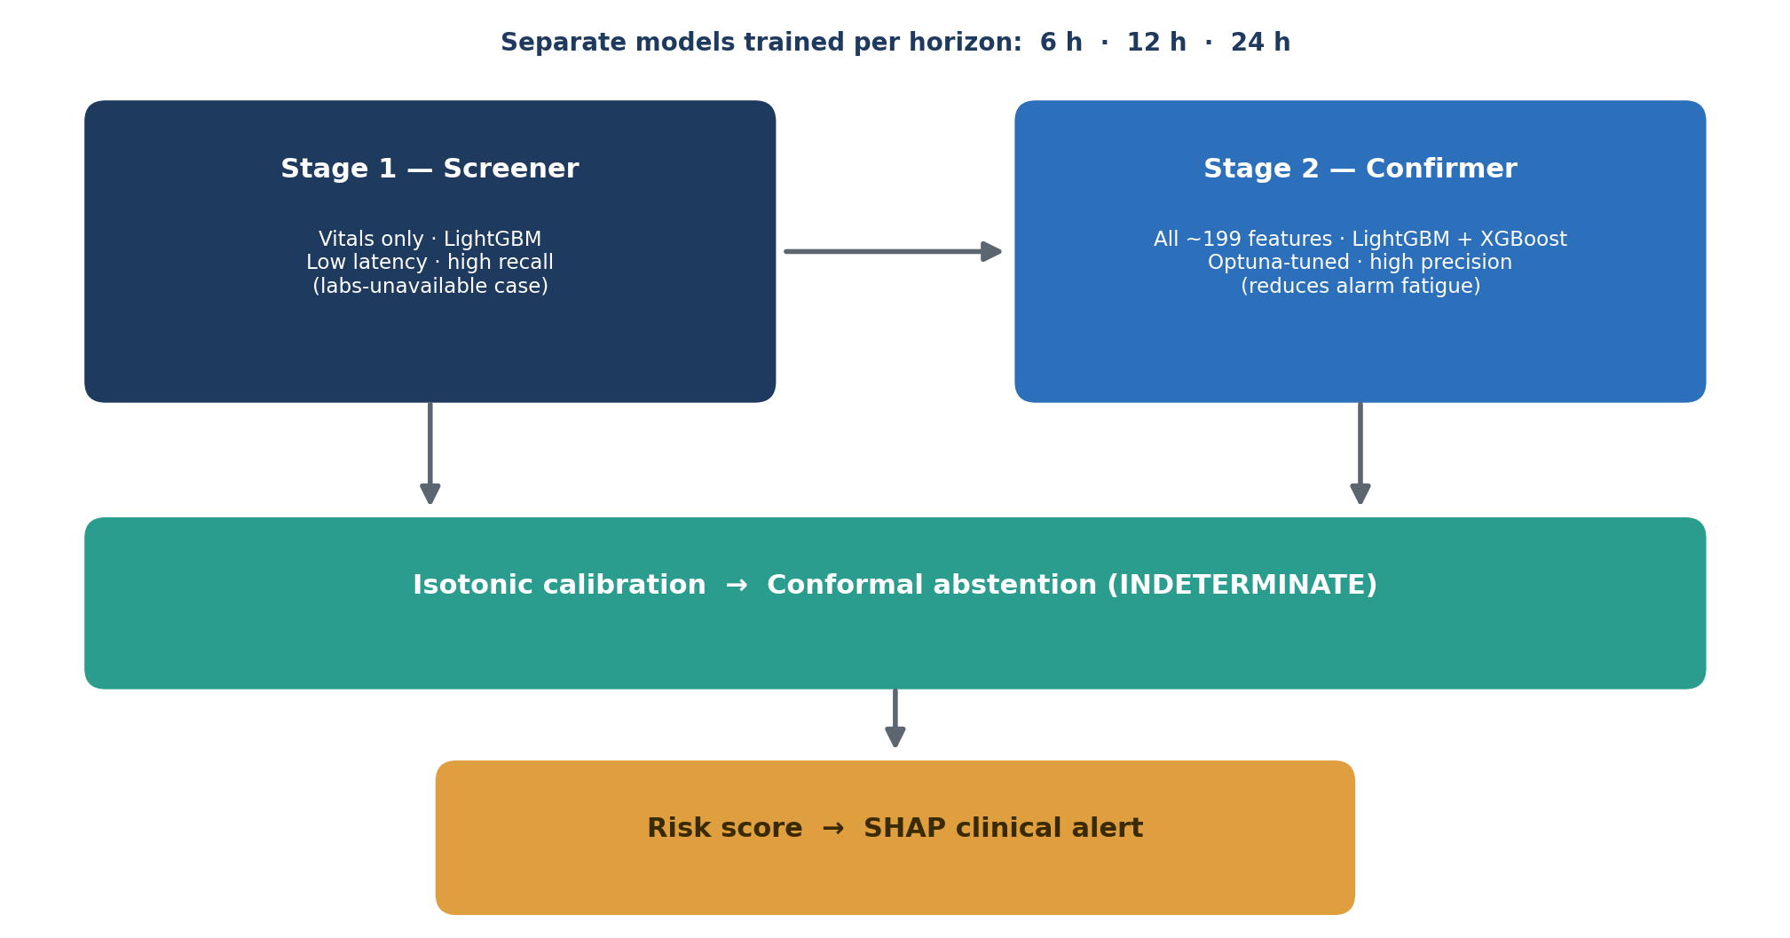
Figure 1: Cascaded two-stage model architecture

3.4 System Architecture
The deployed demo is a two-tier application. A FastAPI backend loads the Stage-2 LightGBM 24-hour model and its metadata once at startup, builds a single SHAP TreeExplainer, and holds the held-out test data in memory; it exposes GET /health, GET /patients, GET /sample, and POST /predict. A React (Vite + TypeScript + Tailwind + shadcn/ui) frontend calls this API to render the ward roster and to score individual patient-hours. There is no database and no authentication in this phase — a deliberate proof-of-concept simplification, with CORS left open for localhost.

3.5 Use-Case, Sequence, and Other Diagrams
The behavioural design implemented is straightforward. On load, the dashboard requests a spread of ward patients (GET /patients?n=12) and renders them ranked by ascending risk. A clinician may load a sample row (GET /sample), upload a patient-hour as JSON or CSV, or edit features directly, then submit (POST /predict); the backend runs preprocessing, scores the calibrated model, computes SHAP attributions, applies the conformal abstention rule, and returns a clinical-alert object that the dashboard renders as a card. The sequence is: fetch → infer → calibrate → explain → render. Use-case actors reduce, in this phase, to a single clinician role interacting with the inference service; the security and audit actors described in the proposal are reserved for the production phase.

3.6 Development Tools
Table 6 contrasts the tools planned in the proposal with those actually used in this phase, so the boundary between built and pending is explicit.
Layer | Planned (proposal) | Built (this phase)
Language / env | Python 3.11 | Python 3.12 managed by uv
Modelling | XGBoost, LightGBM, TensorFlow (RNN-LSTM) | LightGBM, XGBoost, Optuna (no RNN-LSTM yet)
Calibration / CP | Isotonic | Isotonic + split-conformal abstention
Explainability | SHAP / LIME | SHAP TreeExplainer
Backend | FastAPI, SQLAlchemy, PostgreSQL | FastAPI (in-memory test data; no DB yet)
Frontend | React PWA + WebSockets | React + Vite + Tailwind + shadcn/ui (REST)
Registry / deploy | MLflow, Docker | Pickled models + JSON metadata (no MLflow/Docker yet)
Table 6: Development tools — planned versus built

CHAPTER FOUR: SYSTEM IMPLEMENTATION AND TESTING

4.1 Implementation and Coding

4.1.1 Introduction
This section describes how the pipeline and demo were implemented and how the resulting system behaves. It reports the code that exists and runs, not intentions: every module described here was executed end-to-end on the real MIMIC-IV demo, and the backend and frontend shown were captured live from a running instance.

4.1.2 Description of Implementation Tools and Technology
The offline pipeline is organised as a source-of-truth Python package with six modules — data loading, labelling, feature engineering, modelling, evaluation, and explanation — plus a conformal-prediction module, and is mirrored by seven Jupyter notebooks (01–07) that run in order and write checkpoint artefacts. Modelling uses LightGBM 4.6 and XGBoost 3.2 with Optuna tuning and scikit-learn 1.8 isotonic calibration; explanations use SHAP 0.52. The demo layer is a FastAPI backend and a React (Vite/TypeScript/Tailwind/shadcn) frontend. Library versions and the training git commit are recorded in a model-metadata file so the run is reproducible.
The feature engineering produced roughly 199 Stage-2 features: raw vitals and labs, per-lab observed masks, 6- and 12-hour rolling statistics (mean, standard deviation, minimum, maximum), creatinine velocity, and clinical composites such as the BUN-to-creatinine ratio, creatinine above baseline, renal perfusion pressure, and a WBC×lactate product. The Stage-1 screener uses a 15-feature vitals-only subset. Three correctness rules governed the code: label from raw (not imputed) measurements; label before the chronological split; and never zero-fill urine output.

4.2 Graphical View of the Project

4.2.1 Screenshots with Description
The following screenshots were captured from the running system (FastAPI backend on port 8000, React frontend on port 5173). Figure 2 shows the ward dashboard: twelve patients drawn across the risk spectrum and ranked by ascending risk, each rendered as a card with a colour-coded risk badge, the calibrated 24-hour risk score and probability, the top SHAP contributors, and a recommended action. Note the card rendering an INDETERMINATE badge — that is the split-conformal abstention layer declining to commit when the prediction set is ambiguous, rather than guessing.
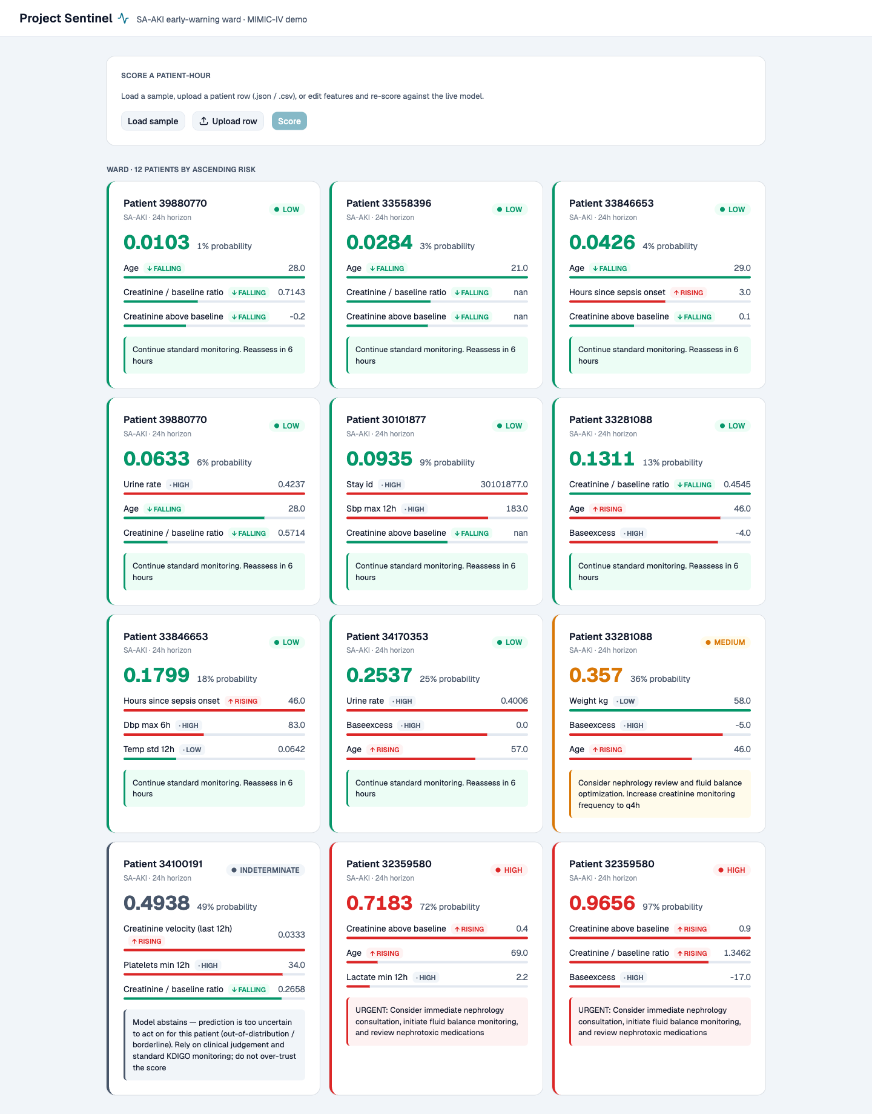
Figure 2: Ward dashboard — patient roster ranked by ascending risk
Figure 3 shows the interactive scoring panel. A clinician can load a sample patient-hour, upload a row as JSON or CSV, or edit the feature values directly, and then re-score against the live model — the mechanism by which a single patient-hour is turned into an alert.
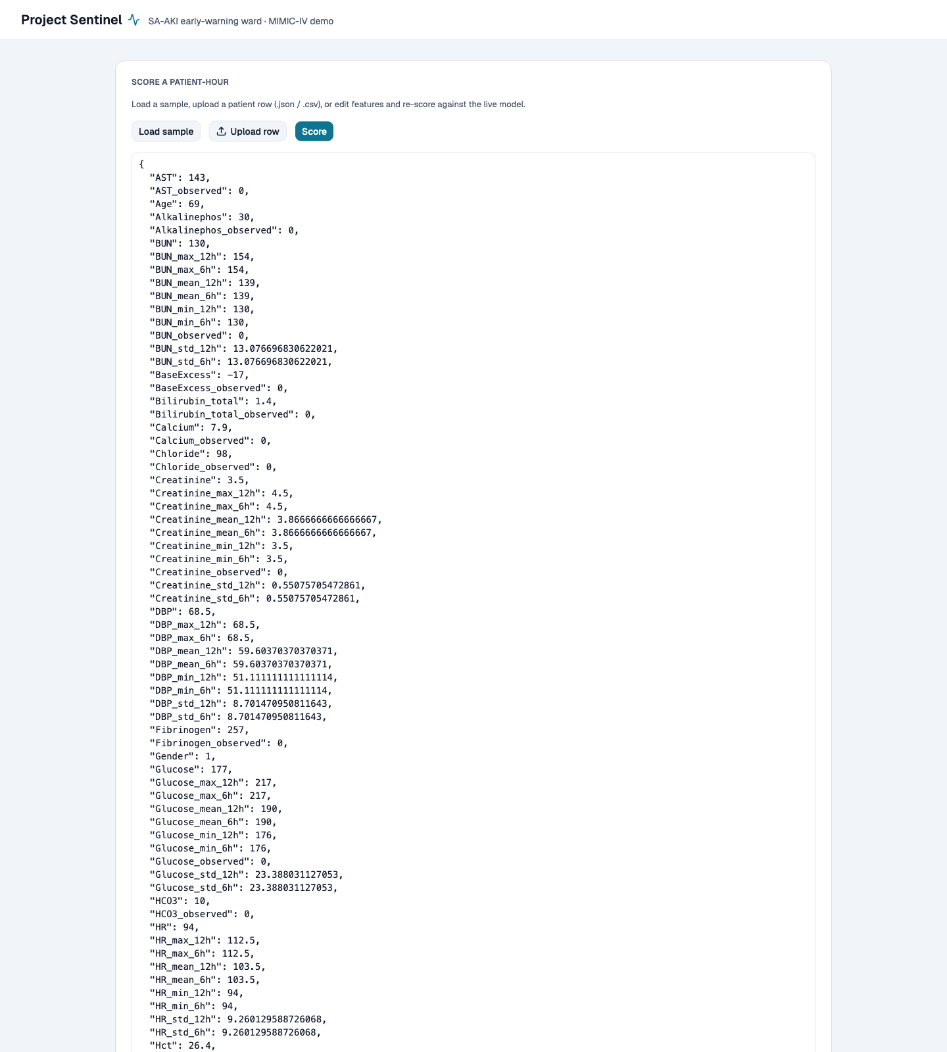
Figure 3: Interactive scoring panel — score a patient-hour
Figure 4 shows a single resulting alert card. For this high-risk patient the calibrated score is 0.97; the SHAP attributions identify rising creatinine above baseline and a rising creatinine-to-baseline ratio as the dominant drivers, and the card renders the corresponding urgent recommendation. This is the same clinical-alert object returned by the POST /predict endpoint.
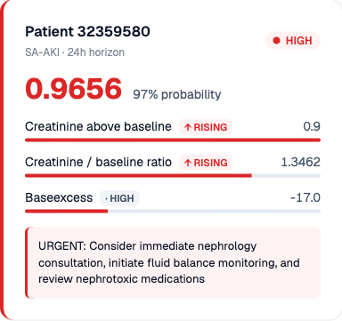
Figure 4: Per-patient clinical alert card with SHAP attributions

4.3 Testing

4.3.1 Introduction
Testing in this phase was primarily end-to-end and correctness-focused, appropriate to a data pipeline where the chief risk is not a crashing function but a silently wrong label or a leaked feature. Verification therefore concentrated on running the whole pipeline on real data and on guarding the three correctness invariants.

4.3.2 Objective of Testing
The objectives were: to confirm the pipeline runs end-to-end on the real MIMIC-IV demo; to confirm the absence of target leakage; to confirm the backend and frontend operate together; and to confirm the abstention and calibration layers behave as designed.

4.3.3 Unit Testing
Module-level self-checks accompany the non-trivial logic. The conformal-prediction module carries a self-test of its coverage guarantee; the labelling module’s KDIGO logic (both the creatinine and mask-aware urine-output channels) was verified against hand-computed cases; and two implementation bugs surfaced by running the code were fixed — a pandas rolling-window warning in feature engineering and an XGBoost 3.x change that moved early-stopping into the constructor.

4.3.4 Validation Testing
The strongest validation result is a negative one. On 100 patients a leaking pipeline would report near-perfect scores; this one reports AUROC 0.66 at 24 hours. The modest, non-perfect metric is the evidence that labels were derived from raw measurements and attached before the split, and that no future information leaks into the features. Label positive rates that rise monotonically with horizon (11% at 6 hours to 29% at 24 hours) further confirm the temporal targets are constructed correctly.

4.3.5 Integration Testing
The backend and frontend were run together and exercised live: GET /health returned status ok; GET /patients returned a set of patients spread across the risk spectrum; GET /sample prefilled the highest-risk test row; and POST /predict returned a well-formed clinical-alert object that the dashboard rendered. The screenshots in Section 4.2 are the artefacts of this integration test.

4.3.6 Functional and System Testing
Each functional requirement marked “Done” in Table 4 was exercised through the running system: ingestion (the cohort artefacts), inference (calibrated scores), explanation (SHAP contributors on each card), abstention (the INDETERMINATE card), and the ward view and scoring panel. The evaluation suite (Chapter Five) constitutes system-level testing of the model against clinical metrics.

4.3.7 Acceptance Testing
Formal user-acceptance testing with clinicians is deferred to the hospital phase, since it requires ethics approval and real users. Against the acceptance criterion appropriate to a proof of concept — a working, leakage-free, explainable pipeline demonstrated end-to-end — the system passes.
Test type | What was checked | Result
Unit | Conformal coverage; KDIGO label logic; bug fixes | Pass
Validation | No target leakage; horizon-consistent labels | Pass
Integration | Backend endpoints + frontend rendering | Pass
Functional / system | FR-01–FR-05; evaluation metrics | Pass
Acceptance (clinician) | Bedside usability with real users | Deferred
Table 7: Test coverage summary

CHAPTER FIVE: DESCRIPTION OF THE RESULTS / SYSTEM
This chapter reports the measured results of the completed pipeline. The headline model is the Stage-2 LightGBM at the 24-hour horizon, evaluated on the held-out test split (20 patients, 1,965 patient-hours). All figures were produced by the evaluation notebook.

5.1 Discrimination and Calibration
Table 8 gives the headline metrics for both Stage-2 models at 24 hours. LightGBM leads narrowly on discrimination and calibration. An AUROC of 0.66 and AUPRC of 0.50 (against a 29% base rate) are modest; this is the expected consequence of training on 96 patients and is stated plainly rather than hidden. The point of the result is that it is honest — an expected-calibration error of 0.11 and clearly imperfect discrimination confirm the pipeline is not leaking the target.
Model (24h) | AUROC | AUPRC | Brier | ECE
Stage-2 LightGBM | 0.660 | 0.498 | 0.202 | 0.109
Stage-2 XGBoost | 0.652 | 0.478 | 0.207 | 0.120
Table 8: Headline test-split performance (Stage-2, 24-hour horizon)
At a 0.5 decision threshold the LightGBM model reaches specificity 0.90 and sensitivity 0.36 (PPV 0.59, NPV 0.77, F1 0.45): on this small sample it is conservative, catching a minority of events but rarely raising a false alarm. The operating point would be retuned toward higher sensitivity for a screening use-case. Figures 5 and 6 show the ROC and precision–recall curves across all three horizons; Figure 7 is the reliability diagram underlying the ECE; and Figure 8 is the decision-curve analysis, which places the model’s net benefit against the treat-all and treat-none strategies.
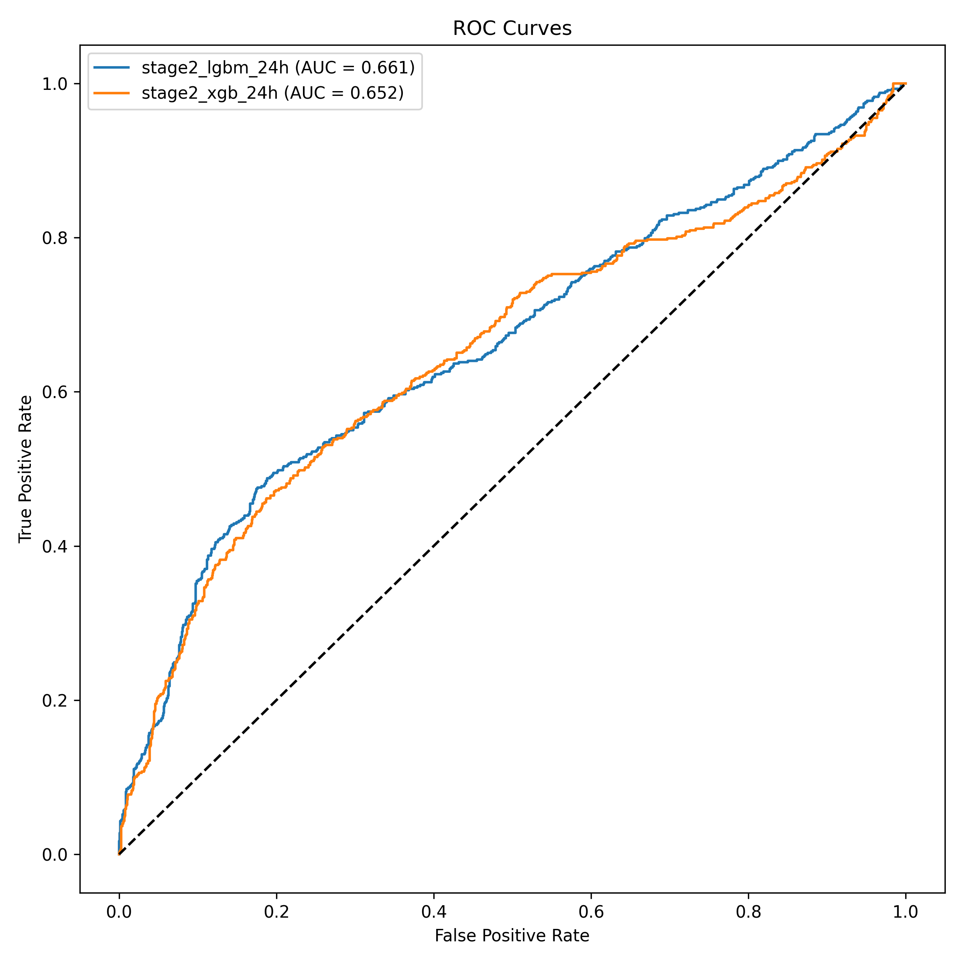
Figure 5: ROC curves by horizon (test split)
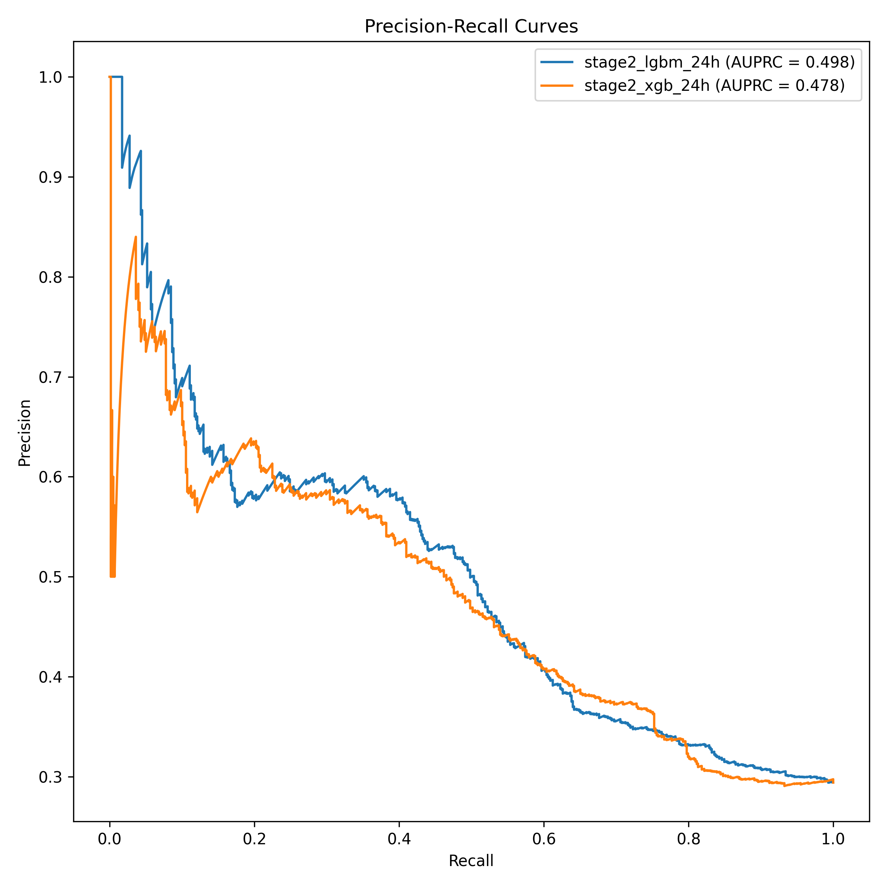
Figure 6: Precision–recall curves by horizon (test split)
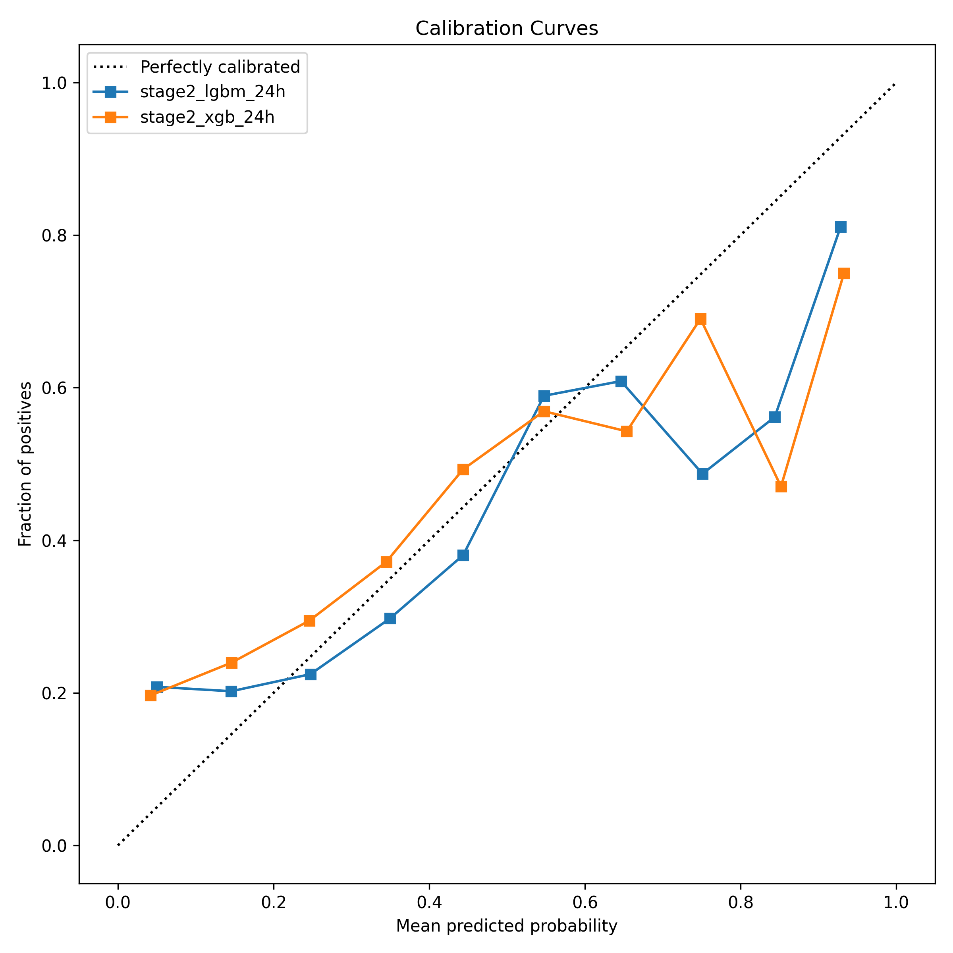
Figure 7: Calibration curves (reliability diagram)
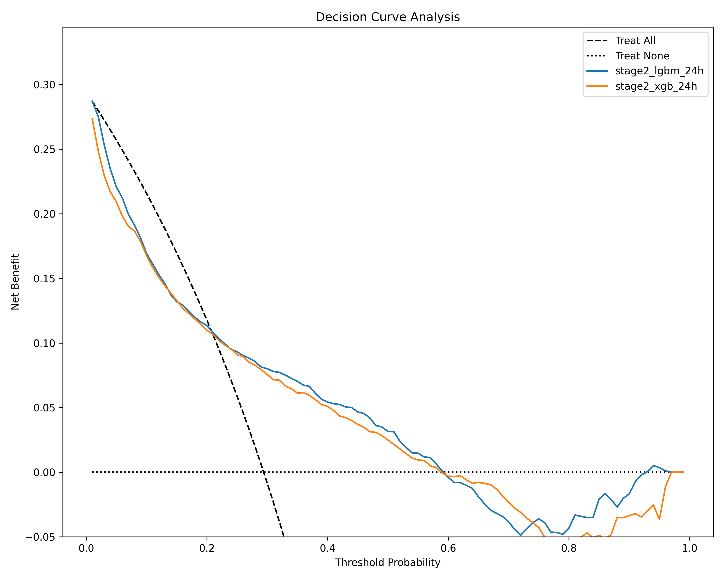
Figure 8: Decision-curve analysis (net clinical benefit)

5.2 Subgroup (Fairness) Analysis
Discrimination was measured separately for younger and older patients (Table 9). The model performs materially worse for patients aged 65 and older — AUROC 0.62 versus 0.74 — and is also worse calibrated for them (ECE 0.19 versus 0.06), despite the elderly subgroup carrying far more events. This is a real fairness gap and exactly the kind of finding a small honest cohort surfaces; on real hospital data it would need to be addressed before deployment.
Subgroup | AUROC | AUPRC | ECE | Events
Adult (< 65) | 0.738 | 0.367 | 0.063 | 164 / 988
Elderly (65+) | 0.619 | 0.583 | 0.195 | 414 / 977
Table 9: Subgroup (fairness) analysis — Stage-2 LightGBM, 24-hour horizon

5.3 Explainability Output
Every prediction is accompanied by a global and a local explanation. Figure 9 is the SHAP global summary, ranking the features that most drive predictions across the test set — creatinine-related terms, urine output, and the clinical composites dominate, which is clinically coherent. At the patient level, the alert object returned by the API lists the top contributors with direction and magnitude, as seen on the alert card in Figure 4. The alert also encodes a recommended action and, where the conformal layer abstains, an INDETERMINATE label instead of a forced call.
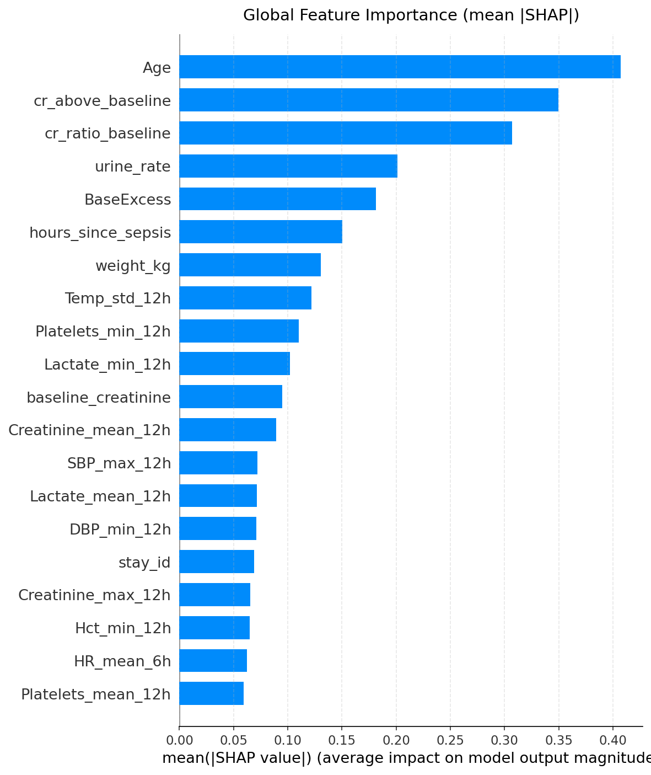
Figure 9: SHAP global feature-importance summary

5.4 System Result
Beyond the metrics, the tangible result is a working system: raw MIMIC-IV tables enter one end and calibrated, explained, abstention-aware clinical alerts emerge at the other, served through an API and a ward dashboard. This end-to-end artefact — not any single score — is the deliverable of this phase.

CHAPTER SIX: CONCLUSIONS AND RECOMMENDATIONS

6.1 Conclusions
The objective of this phase — to build and validate, end-to-end and without leakage, an explainable pipeline that predicts SA-AKI 6–24 hours ahead — was met. On the MIMIC-IV demo the system ingests real relational ICU data, derives KDIGO labels from both the creatinine and urine-output channels, engineers roughly 199 features, trains a calibrated cascaded two-stage model per horizon, adds conformal abstention and SHAP explanations, and serves the result through a FastAPI API and a React ward dashboard. The research questions are answered in the affirmative for questions one and three: a leakage-free prospective pipeline with a urine-output channel is feasible, and its outputs can be surfaced as explainable, abstention-aware bedside alerts without production EHR infrastructure.
On the second research question — predictive accuracy — the answer is honest and qualified. At AUROC 0.66 for 24-hour prediction the demo does not reach the proposal’s 0.85–0.92 target, and it should not be expected to on 96 training patients. The value of the result is that it is not fake-perfect: modest, well-calibrated, leakage-free metrics and a disclosed subgroup fairness gap demonstrate that the pipeline is trustworthy and ready to be retrained at scale, which is the appropriate outcome for a proof of concept.

6.2 Limitations of the Study
- Training data is a surrogate: 100 MIMIC-IV demo patients, not RMRTH data; the model overfits and its absolute scores are not clinically meaningful.
- The deep temporal (RNN-LSTM) stage in the proposal’s target architecture was not built; only the two gradient-boosting stages exist.
- There is no live OpenClinic GA feed, database, authentication, or containerised deployment — the backend serves from the held-out test data.
- The sepsis-onset definition implements only the suspicion-of-infection half of Sepsis-3; the SOFA component is a documented TODO.
- Baseline creatinine uses an in-stay pre-sepsis minimum, a demo simplification rather than a true pre-admission outpatient baseline.

6.3 Recommendations and Future Work
- Obtain credentialed full MIMIC-IV access (PhysioNet application in progress) and retrain at scale; the sizing analysis suggests roughly 10,000–20,000 patients for stable performance.
- Externally validate on a second source (e.g. eICU-CRD or AmsterdamUMCdb) using the reserved site-holdout slot, and add SOFA to the sepsis definition.
- Build the OpenClinic GA mock feed so the backend consumes a live EHR stream rather than static test data.
- Add the Stage-3 temporal model and compare it against the gradient-boosting confirmer on the same cohort.
- Harden for the hospital phase: database mirror, authentication and audit logging, containerised deployment, and clinician acceptance testing under ethics approval.
- Address the elderly-subgroup fairness gap once a larger cohort makes reweighting or subgroup-specific calibration meaningful.
In summary, Project Sentinel has reached the end of its proof-of-concept phase with a complete, honest, and explainable pipeline. The engineering foundation is in place; what remains is data scale and clinical integration, both of which the current architecture was deliberately designed to accommodate.

References
Baird, D., De Souza, N., Logan, R., Walker, H., Guthrie, B., & Bell, S. (2021). Impact of electronic alerts for acute kidney injury on patient outcomes: Interrupted time-series analysis of population cohort data. Clinical Kidney Journal, 14(2), 639–646.
Dutta, S., McEvoy, D. S., Dunham, L. N., Stevens, R., Rubins, D., McMahon, G. M., & Samal, L. (2024). External validation of a commercial acute kidney injury predictive model. NEJM AI, 1(3).
Evans, R. D. R., Hemmilä, U., Craik, A., et al. (2017). Incidence, aetiology and outcome of community-acquired acute kidney injury in medical admissions in Malawi. BMC Nephrology, 18(1), 21.
Fraser, H. S. F., Mugisha, M., Remera, E., et al. (2022). User perceptions and use of an enhanced electronic health record in Rwanda with and without clinical alerts. JMIR Medical Informatics, 10(5), e32305.
Igiraneza, G., Ndayishimiye, B., Nkeshimana, M., Dusabejambo, V., & Ogbuagu, O. (2018). Clinical profile and outcome of patients with acute kidney injury requiring hemodialysis: Two years’ experience at a tertiary hospital in Rwanda. BioMed Research International, 2018.
Johnson, A. E. W., Bulgarelli, L., Shen, L., et al. (2023). MIMIC-IV, a freely accessible electronic health record dataset. Scientific Data, 10, 1.
Kellum, J. A., Lameire, N., & KDIGO AKI Work Group. (2013/2026). KDIGO clinical practice guideline for acute kidney injury. Kidney International Supplements.
Lundberg, S. M., & Lee, S.-I. (2017). A unified approach to interpreting model predictions (SHAP). Advances in Neural Information Processing Systems, 30.
Luo, S., Lai, J., Mo, L., Shen, X., & Fang, R. (2026). Prediction of hospital mortality in sepsis-associated acute kidney injury using a machine-learning approach: A multicenter SHAP study. Clinical Kidney Journal, 19(1).
Peerapornratana, S., Manrique-Caballero, C. L., Gómez, H., & Kellum, J. A. (2019). Acute kidney injury from sepsis: Current concepts, epidemiology, pathophysiology, prevention and treatment. Kidney International, 96(5), 1083–1099.
Ratchatorn, A., Ketdao, N., Sonsilphong, S., Triamwichanon, D., & Panitchote, A. (2026). Deep learning approaches for time-series prediction of renal recovery in critically ill patients with AKI: LSTM, GRU, and transformer models. Critical Care, 30(1), 180.
Rugamba, G., Habyarimana, V. I., Ntiyamira, J. C., et al. (2026). Pediatric acute kidney injury in Rwanda: Awareness, early detection, and timely management. BMC Pediatrics.
Shi, J., Han, H., Chen, S., Liu, W., & Li, Y. (2024). Machine learning for prediction of acute kidney injury in patients diagnosed with sepsis in critical care. PLOS ONE, 19(4), e0301014.
Shortliffe, E. H., & Sepúlveda, M. J. (2018). Clinical decision support in the era of artificial intelligence. JAMA, 320(21), 2199–2200.
Sugira, V., Simpao, M., Ogbuagu, O., & Walker, T. (2015). Predictors of mortality from sepsis among an African patient cohort: A prospective study from two tertiary facilities in Kigali, Rwanda. Open Forum Infectious Diseases, 2(suppl_1).
Wilson, F. P., Shashaty, M., Testani, J., et al. (2015). Automated, electronic alerts for acute kidney injury: A single-blind, parallel-group, randomised controlled trial. The Lancet, 385(9981), 1966–1974.
World Health Organization. (2025). Reducing the burden of noncommunicable diseases through the promotion of kidney health (Resolution WHA78.6).
Yun, G., Yi, J., Han, S., et al. (2025). Validation of an acute kidney injury prediction model as a clinical decision support system. Kidney Research and Clinical Practice.

