- A screenshot of your source code in VS Code.
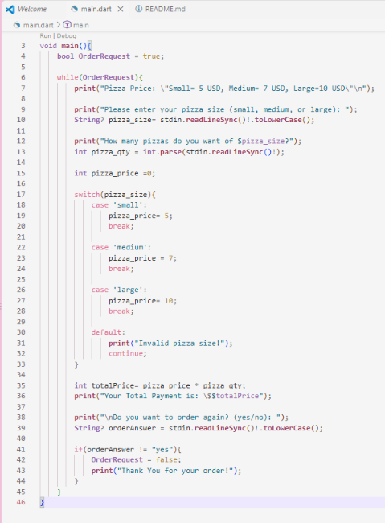

- The URL of your GitHub repository.
https://github.com/Snicco05/TMA3084_-106420-G02.git

