Individual Details
Name: SNG NIC CO
Matric Number: 106420

GitHub Link: https://github.com/Snicco05/TMA3084_G02_LAB03_106420.git
Merged PR Link: https://github.com/Snicco05/TMA3084_G02_LAB03_106420/pull/2

Screenshot Evidence:
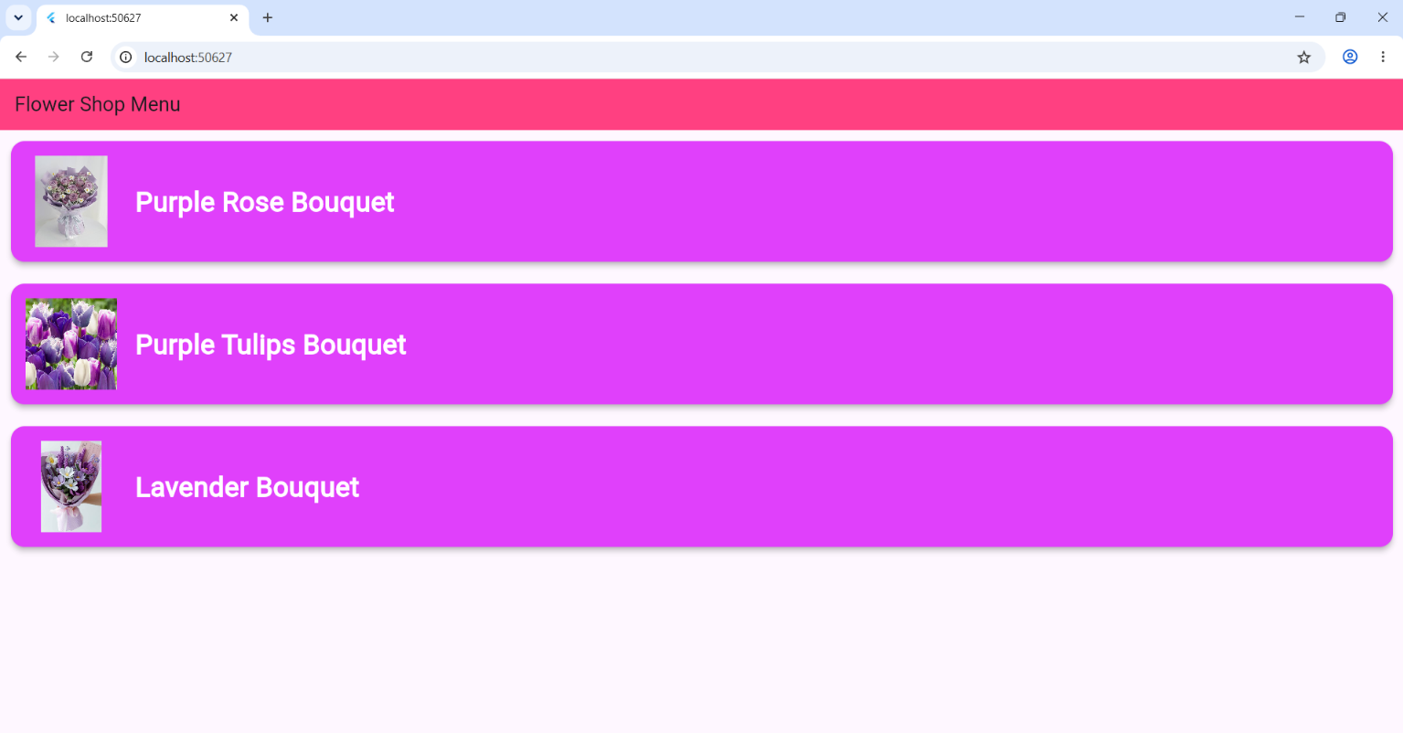
Screenshot 1.0 Running App

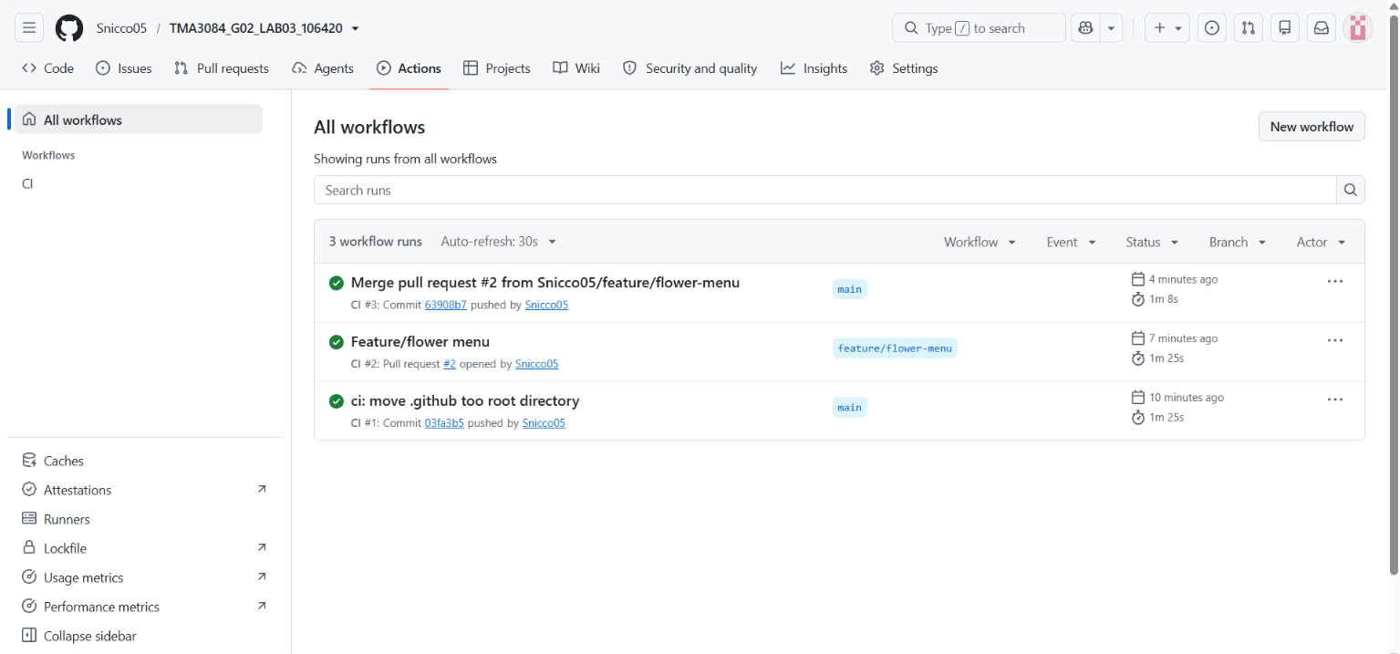
Screenshot 2.0 Github Actions

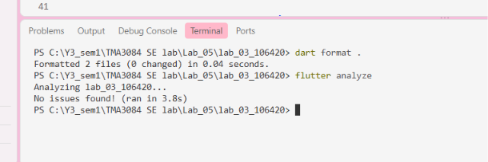
Screenshot 3.0 Terminal run ‘flutter analyze’

