UNIVERSITI MALAYSIA SARAWAK
Faculty of Computer Science and Information Technology
TMA3084 Software Engineering Laboratory | Semester 1, 2026/2027
PROJECT PROPOSAL
(Product Requirements Document)
KerepekHub: Ordering & Customer Feedback Application (KerepekHub)
Group Number / Name | Group 16 - LadyLogics
Lab Group / Demonstrator | Group 2 –Mr. Raynold anak Kabai
Client / Organisation | Nur Asyiqin, Founder, Serooja
Lecturer | Mdm. Nurfauza Jali
GitHub Repository | https://github.com/damiaqistina/KerepekHub
Version / Date | v1.0 (original) – 17/10/2026

Team Members
No. | Name | Matric No. | TSPi Role | Signature
1 | SNG NIC CO | 106420 | Development Manager
2 | AINUR HANUM ABDULLAH TASIP | 103158 | Quality/ Process Manager | 
3 | SITI AISYAH BINTI SABEKI | 106351 | Planning Manager | 
4 | DAMIA QISTINA BINTI FAIZAL | 102504 | Project Manager | 
5 | SABRINA NATASHA BINTI SHUDARSAN | 106199 | Lead Mobile Architect | 

Declaration
By signing above, we certify that this proposal is our own work, that all external sources, libraries, APIs and AI-assisted content are acknowledged, and that we have not engaged in plagiarism or unauthorised collusion (Peraturan Akademik UNIMAS, Etika Akademik). AI tool usage is recorded in LOGAI.

Table of Contents

Abstract 3
1. Introduction 3
1.1 Client Background 3
1.2 Team Background 3
2. Problem Statement. 4
3. Project Objectives & Success Metrics 4
4. Project Perspective 5
4.1 Target Users 5
4.2 System Context and Architecture 6
5. Project Scope 6
5.1 In Scope / Out of Scope 6
5.2 Features and User Stories 7
5.3 AI Feature 9
5.4 Non-Functional Requirements and Constraints 10
5.5 System Environment 11
6. Task Allocation & Team Contribution 11
7. Team Goals 12
8. Expected Results 12
8.1 Working System 12
8.2 Documentation and Artefacts 13
9. Project Planning 13
9.1 Methodology 13
9.2 Submission Schedule 14
9.3 Development Milestones (GitHub) 14
9.4 Risks and Assumptions 15
10. References 15
Appendix A: Client Meeting Evidence 16
Client Elicitation & Scope Validation Interview (Meeting No. 02) 16
Appendix B: Revision History 16

Abstract
KerepekHub is a cross-platform Flutter mobile application designed to digitize business operations for Serooja, a snack micro-business founded by Nur Asyiqin. Currently, Serooja relies on manual WhatsApp ordering and paper notebook stock tracking, causing stockout oversights and delayed order fulfillment. KerepekHub resolves these issues through dual-role capabilities: customers can browse products, place orders, choose self-collection or delivery, and track order progression in real time. Simultaneously, the owner can manage incoming orders, update stock quantities, verify payment status, and view sales performance analytics. Powered by the Google Gemini API, the seller dashboard generates automated sales trend insights, low-stock alerts, and restocking priorities. Developed using Flutter, Supabase, and GitHub Actions CI/CD, KerepekHub establishes a scalable digital foundation for Serooja’s long-term growth.

1. Introduction
KerepekHub: Ordering & Customer Feedback Application is a software engineering project developed by team LadyLogics to digitize business operations for Serooja, a local snack business owned by Nur Asyiqin. The project replaces manual stock logging and unstructured WhatsApp messaging with a dual-role mobile application tailored for both customers and the business owner (LadyLogics, 2026).
Built on Flutter, KerepekHub provides cross-platform flexibility, accessibility, and real-time updates. For tech-literate customers, browsing live product availability sets Serooja apart from local competitors. For the owner, a dedicated app centralizes order processing, enables instantaneous stock updates, and provides sales analytics which eliminates missed orders and repetitive stock inquiries to support sustainable business growth.

1.1 Client Background
Serooja is an independent local snack (kerepek) business founded by Nur Asyiqin, who has operated in the snack trade since age 16. Serooja offers five product variations such as Crunchy Spicy Cheese, Crunchy Nestum Milk, Seaweed Original, Seaweed Spicy Cheese, and seasonal Popia Simpul during Eid al-Fitr which are sold in bottle containers and smaller packets. The primary customer base includes students, working adults, and local families purchasing snacks for personal consumption or gifts (LadyLogics, 2026).

1.2 Team Background
LadyLogics comprises five third-year Software Engineering students experienced in mobile development, cloud databases, and Generative AI integration. The team stands by the motto "Connecting Code to Local Communities."

2. Problem Statement.
Serooja currently manages its business orders manually through WhatsApp messages and notebook. As the business grows and receives more orders, the owner, Nur Asyiqin faces difficulties keeping track of pending and completed orders, updating stock quantities, and ensuring that customers receive the correct products. Based on the client interview, three main problems have been identified.
ID | Current process / problem | Impact on client | Evidence (source)
P1 | Orders are managed manually through WhatsApp messages and notes, making it difficult to track multiple orders at once. | Orders may be missed, forgotten, or recorded with incorrect quantities. The owner also spends more time checking and confirming orders. | The client uses WhatsApp and a notebook to track orders, which may lead to missed orders when handling multiple orders. (Client interview, 6/10/2026)
P2 | Product stock is checked and updated manually using a notebook. | The owner may have difficulty maintaining accurate stock records, and customers may order products that are already out of stock | The client records stock manually and confirmed that customers have sometimes ordered products that were already out of stock. (Client interview, 6/10/2026)
P3 | Customers need to contact the owner to ask about product availability, prices, flavours, and order status. | Customers may experience inconvenience, while the owner spends additional time answering repeated enquiries and checking order updates. | Customers ask about product availability, prices, flavours, and order status, requiring the client to spend additional time responding to enquiries. (Client interview, 6/10/2026)
Table 1: Summary of client problems
To address these problems, the team proposes developing KerepekHub, a Flutter-based mobile application for Serooja that allows customers to browse products and place orders while enabling the owner to manage orders, update stock, and monitor order statuses through a more organised system. The application aims to reduce manual errors, improve ordering convenience, and support the future growth of Serooja.

3. Project Objectives & Success Metrics
No. | Objective | Solves | Success metric (how we measure) | Priority
O1 | To study and analyse the client’s current business processes such as order and stock management, also monitor sales performance. | All | SRS signed off by client by Milestone 2. | High
O2 | To design and develop a Flutter app that allows customers to see product availability, place orders and monitor status. Allow the client as the seller to manage and record orders and sales, update product stock and order status. | P1, P2 | All Must-have FRs pass acceptance tests. | High
O3 | To integrate an AI feature that analyzes sales and stock data for the seller dashboard displaying sales trends and notify about product restocks. | P2 | ≥80% of predefined test scenarios producing accurate stock and sales insights. | High
O4 | To test and evaluate application functionality and receive client confirmation as business requirements have all been fulfilled. | All | ≥50 completed test cases, ≥60% achieved test coverage, UAT sign-off from client. | Medium
Table 2: Project objectives and success metrics

4. Project Perspective

4.1 Target Users
User type | Description | Main needs / goals | Device / tech level
Customer | Individuals who wish to conveniently order items and browse Serooja’s products | Browse products, view prices, place orders and track order status | Android 8.0+ phones
Admin (Client) | Serooja’s owner responsible for managing products and customer orders | Manage orders, update order status, add, update and delete products and monitor customer purchases | Android 8.0+ phones
Table 3: Target users

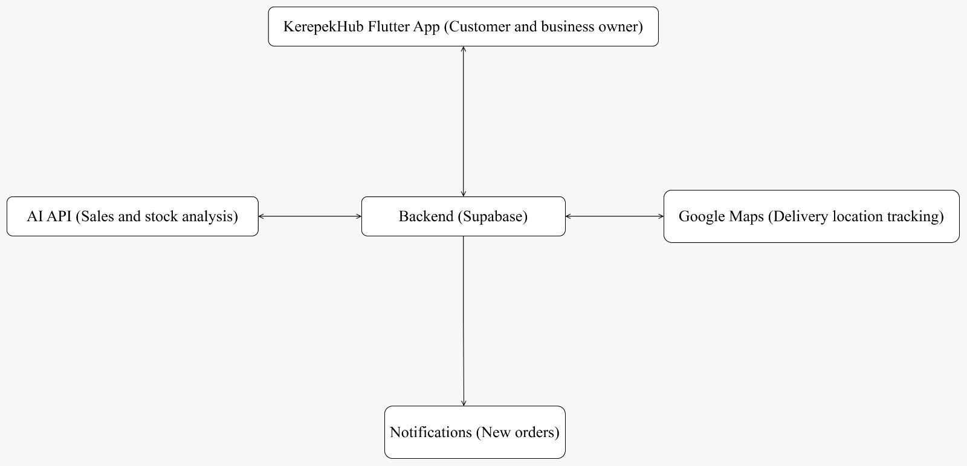
4.2 System Context and Architecture
Figure 1: KerepekHub high-level system architecture
KerepekHub is a new mobile ordering system that replaces the business owner’s manual process of taking orders and recording sales by hand. The Flutter app (Flutter Team, 2026) is used by both customers and the business owner. In this system, the Supabase backend (Supabase, 2026), which manages authentication, product and stock data, orders, order statuses, payment status records, sales records and customer feedback, becomes the only source of communication between the Flutter app and all other services. The backend connects to an AI API that analyses sales and stock data for the owner’s dashboard. It also connects to Google Maps (Google Developers, 2026) to track delivery locations and a notification service to alert the owner of new orders. Payments are made outside of the app, and the owner confirms them in the app. Keeping all external calls behind the backend helps protect API keys and allows individual services to be replaced without changing the app.

5. Project Scope

5.1 In Scope / Out of Scope
In scope (will deliver this semester) | Out of scope (will not deliver)
Customer registration and login | Integration with third-party courier services
Product browsing and viewing product details, flavours, sizes, and prices | Multi-vendor marketplace support
Order placement through the mobile application | Integration with bank payment gateway
Order management for business owner | AI voice assistant/chatbot
Order status tracking (pending, preparing, out for deliver, delivered) | Accounting and tax management system
Delivery location tracking using Google Maps | Advanced route optimization
Product stock management and availability updates | iOS specific optimization
Customer order history viewing | Advanced marketing campaign
Manual payment receipt submission and payment verification | Offline application usage
Order cancellation for unpaid orders after a specific period | Automatic payment processing
Notification for new orders | Warehouse inventory management
Sales record and sales summary viewing | Loyalty and reward programmes
Customer feedback and rating submission | Third party logistics management
AI-based sales and stock analysis dashboard | Predictive demand forecasting with external databases
Table 4: Scope boundary
The scope of KerepekHub is to focuses on some additional features like ordering and business management processes by providing a mobile application for customers and the business owner. Features unrelated to the client’s identified problems or exceed the project timeframe are considered outside the scope of this semester’s development.

5.2 Features and User Stories
FR-ID | Module | User story (As a … I want … so that …) | Priority
FR-01 | User Management | As a customer, I want to register an account so that I can place and manage my orders securely. | Must
FR-02 | User Management | As a customer, I want to log in to my account so that I can access my order history. | Must
FR-03 | Product Catalog | As a customer, I want to browse available products, flavours, sizes, and prices so that I can choose products easily. | Must
FR-04 | Product Catalog | As a customer, I want to search products so that I can quickly find specific items. | Should
FR-05 | Ordering & Cart | As a customer, I want to add products to a cart so that I can order multiple products at once. | Must
FR-06 | Ordering & Cart | As a customer, I want to place an order through the application so that I do not need to order manually through WhatsApp. | Must
FR-07 | Delivery Management | As a customer, I want to choose either self collection or deliver to the door step so that I can receive my order according to my preference. | Must
FR-08 | Order Tracking | As a customer, I want to check my order status so that I know whether my order is preparing/delivering/ready for collection/completed. | Must
FR-09 | Order History | As a customer, I want to view my previous orders so that I can reorder products easily. | Should
FR-10 | Order Management | As a business owner, I want to view incoming orders so that I can process them efficiently. | Must
FR-11 | Order Management | As a business owner, I want to update order status so that customers can track their orders. | Must
FR-12 | Stock Management | As a business owner, I want to manage product stock levels so that inventory remains accurate. | Must
FR-13 | Product Management | As a business owner, I want to add, edit, or remove products so that product information remains up to date. | Must
FR-14 | Payment Management | As a business owner, I want to review uploaded payment receipts and verify payment status so that customer orders can be processed accurately. | Should
FR-15 | Customer Management | As a business owner, I want to view customer information and order history so that I can manage customer records efficiently. | Should
FR-16 | Sales Reporting & Analytics | As the business owner, I want to view sales summaries and reports so that I can monitor business performance. | Must
FR-17 | Notification System | As the business owner, I want to receive notifications when a new order is placed so that I do not miss customer orders. | Should
FR-18 | Maps Tracking | As a customer, I want to view the delivery location on a map so that I can collect my order on the right place. | Should
FR-19 | Maps Tracking | As a customer, I want to view the seller’s real time location on Google Maps so that I can estimate delivery distance and arrival time. | Could
FR-20 | Customer Feedback | As a customer, I want to submit feedback and ratings for my completed orders so that I can share my experience with business owner. | Should
FR-AI-01 | AI Sales Insight | As a business owner, I want AI-generated sales and stock insights so that I can identify best selling products and required stock replenishment. | Must
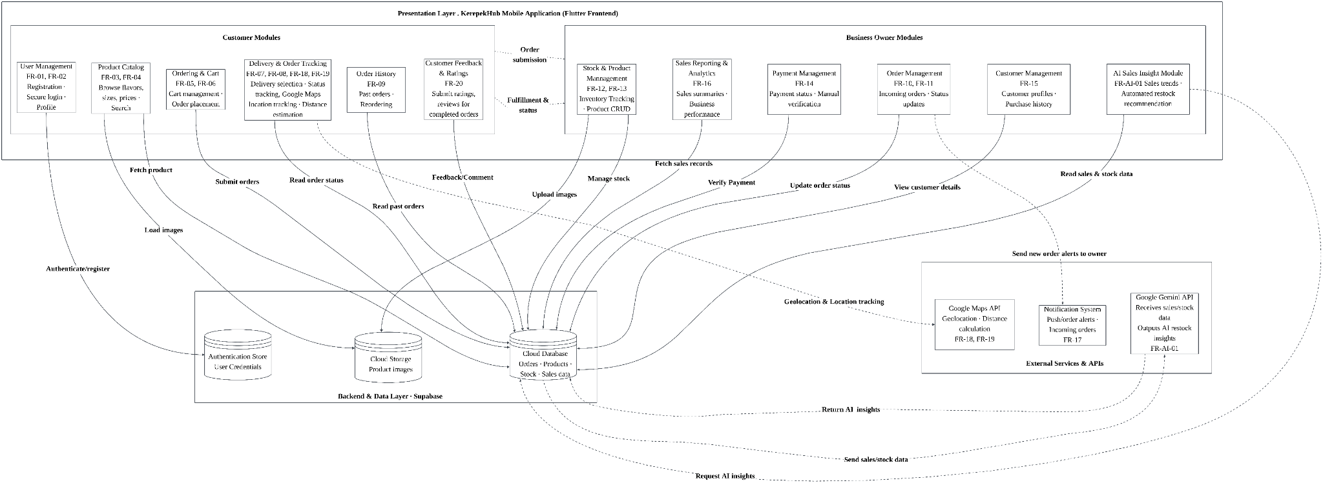
Table 5: Features and user stories
Figure 2: KerepekHub System modules diagram
Figure 2 illustrates the proposed KerepekHub system modules and their interactions with the Supabase backend, Google Maps API, Notification system and google Gemini AI service (Google Cloud, 2026).

5.3 AI Feature
The proposed AI feature helps the business owner make better inventory and sales decision by analysing sales records, order history and product stock data. Instead of displaying raw sales data, the AI generates actionable insights such as identifying best selling products, highlighting low stock items, and suggesting restocking priorities. This feature directly solved P2, where stock levels are currently monitored manually, helping improve inventory management efficiency and business decision making.
Item | Description
AI capability | Sales trend analysis, inventory recommendation and business insight generation
User value | Solves P2 (manual stock management) for the business owner by identifying sales patterns and recommending stock replenishment actions
Input → Output | Sales records, order history, stock levels → Best selling products, sales trends, low-stock alerts, restock recommendations
AI service / API | Google Gemini API
Constraints | - Cost Constraint: Subject to Gemini free-tier API limits  - Security Constraint: Gemini API key will be stored securely using environment variables and excluded from GitHub repository  - Privacy Constraint: No sensitive banking information will be sent to the AI service  - Fallback Constraint: Basic sales reports remain available if the AI service is unavailable
Table 6: AI feature summary

5.4 Non-Functional Requirements and Constraints
NFR-ID | Category | Requirement / constraint | Target
NFR-01 | Performance | The application shall display main screens efficiently. | Main screens load within 5 seconds on a mid-range Android device.
NFR-02 | Usability | Customers shall be able to browse products and place orders easily without training. | At least 80% of users successfully complete an order during user testing.
NFR-03 | Security | User accounts shall be protected through secure authentication. | Supabase Authentication is required before accessing account features.
NFR-04 | Reliability | Order, Customer and stock records shall remain available and recoverable. | system maintains at least 99% data availability through Supabase services.
NFR-05 | Compatibility | The application shall support commonly used Android devices. | Compatible with Android 8.0 (API 26) and above.
NFR-06 | Security & Privacy | Gemini API credentials shall be protected and customer data shall not be exposed. | API keys stored outside source code, no secrets committed to GitHub repository.
Table 7: Non-functional requirements and constraints

5.5 System Environment
Layer | Technology / tool | Justification
Mobile app | Flutter (Dart 3), Material 3 | Course requirement, cross-platform mobile application development and modern UI support
State management | Provider | Lightweight, easy to learn and suitable for managing application state in a small-to-medium sized project
Backend / database | Supabase (Authentication, Database, Storage) | Secure authentication, cloud database services, file storage and real time data synchronization for orders, stock records, customer details and feedback management
Maps Service | Google Maps API | Supports delivery location tracking and location visualisation for customers
AI service | Google Gemini API | Generates business insights based on sales and stock data to support inventory and sales management decisions
Version control & CI | GitHub, GitHub Actions | Support collaborative development, version control, and automated build verification
Target devices | Android 8.0+ phones | Compatible with commonly used Android devices among the target users.
Table 8: System environment

6. Task Allocation & Team Contribution
Member | TSPi role | Owned features (FR-IDs) | Other responsibilities / contribution
DAMIA QISTINA BINTI  FAIZAL | Software Project Manager | FR-01  FR-02  FR-03  FR-04 | Coordinates milestone planning, GitHub repository controls, client communication, weekly WEEK status reports, and risk escalation
SNG NIC CO | Development Manager/ Backend / AI Integration Specialist | FR-17  FR-18  FR-19  FR-20  FR-AI-01 | API integration, Google Gemini Generative AI connection, error/fallback handling, and LOGAI evidence
SITI AISYAH BINTI SABEKI | Lead Systems Analyst/ Requirements Engineer | FR-09  FR-10  FR-11  FR-12 | Leads requirements elicitation with Serooja (client), authors SRS, manages requirement IDs and traceability, and defines acceptance criteria
AINUR HANUM  ABDULLAH TASIP | Quality Assurance & CI/CD Engineer | FR-13  FR-14  FR-15  FR-16 | Leads test planning/automation, GitHub Actions CI/CD workflow execution, defect tracking (LOGD), test execution logging (LOGTEST), and coverage reports.
SABRINA NATASHA BINTI  SHUDARSAN | Lead Mobile Architect | FR-05  FR-06  FR-07  FR-08 | Leads UI/UX prototyping, Flutter state-management architecture, navigation structure, Dart modularity, and SDD drafting.
Table 9: Task allocation and contribution

7. Team Goals
No. | Team goal | Measure
G1 | Develop a quality mobile application that meets the client’s requirements. | All Must-have FRs pass acceptance tests, and all identified defects are recorded and tracked.
G2 | Completed project tasks according to the planned schedule. | Review project progress during weekly meetings and complete all major milestones by their deadlines.
G3 | Ensure effective teamwork through clear role allocation and fair contribution among all team members. | Each member completes ≥1 assigned task per sprint and updates their task status on the project board.
G4 | Continuously improve the team’s development process and product quality. | Conduct a postmortem at each milestone, review defects and progress data, and document at least one improvement action for the next cycle.
Table 10: Team goals

8. Expected Results

8.1 Working System
From the client’s side as the seller, KerepekHub is primarily used to manage and record orders received, verify payments made through external payment gateways, update order status, and record sales to monitor business performance. The customers on the other hand get to see product availability through stock management by the client, place their orders, complete payments through an external payment gateway, track order status, and leave feedback. The application will also include an AI feature that analyzes sales and stock data for the seller dashboard to display sales trends and notify about product restocks. KerepekHub will be considered ready for release once all of the key features are implemented and the overall project successfully meets the agreed business requirements with a client UAT sign-off.

8.2 Documentation and Artefacts
Deliverable | Submitted with
Project Proposal (original) | Proposal Submission (Week 4)
Revised Proposal and Software Requirements Specification (SRS) | Initial Report (Week 9)
Runnable prototype (4–5 screens), tagged release | Demo 1 (Week 9)
Software Design Specification (SDS), test plan and results (LOGTEST), user manual, maintenance plan, client acceptance form | Final Report (Week 13)
Release APK, demo video (5–10 min), presentation slides | Final Demo 2 (Week 14)
GitHub repository and complete project file | e-Archive (Week 15)
TSPi forms (LOGT, LOGD, LOGAI, SCHEDULE, SUMP, SUMQ, SUMS, SUMTASK, WEEK, PEER) and meeting minutes | Ongoing; compiled in Final Report
Table 11: Deliverables

9. Project Planning

9.1 Methodology
KerepekHub is built using Scrum with 2-weeks sprints. Scrum works well for the customer since the owner is a small firm, and once the owner sees the app functioning, requirements like product descriptions, order statuses, and dashboard requirements are likely to change. At the end of every sprint, the team demonstrates the current version of the application to the business owner and collects feedback to guide future enhancements. The team follows TSPi roles, with the Project Manager coordinating team activities, the development manager handles backend development and AI integration, the Lead Systems gathers and analyses client requirements, the Quality Assurance ensures software quality through testing and automated workflows and the Lead Mobile Architect oversees the mobile application's architecture and design. Each feature is recorded as a GitHub issue and implemented in a dedicated branch. A teammate then reviews the changes through a pull request. Automated tests are run before the code is merged, ensuring that only code that passes the tests is integrated into the main branch.

9.2 Submission Schedule
Phase | Deliverable | Week | Due
Phase 1: Planning & Development | Proposal Submission | 4 | 17 Oct 2026
 | Proposal Presentation | 5 | 19 – 23 Oct 2026
 | Initial Report | 9 | 16 Nov 2026
 | Demo 1 | 9 | 16 – 20 Nov 2026
Phase 2: Finalisation & Closure | Final Report | 13 | 24 Dec 2026
 | Final Demo 2 | 14 | 28 – 31 Dec 2026
 | e-Archive | 15 | Before 10 Jan 2027
Table 12: Submission schedule

9.3 Development Milestones (GitHub)
Milestone | Week | Key output | Status
M1 – Scope & Requirements | 4 – 5 | GitHub repo, issue board, CI file; proposal and initial SRS in /docs | Completed
M2 – Design & Prototype | 9 | SDS draft, 4–5 screen prototype, green CI, v0.2.0 tag | Pending
M3 – Product & Verification | 13 | ≥50 tests, ≥60% coverage, AI feature working | Pending
M4 – Final Release & Acceptance | 15 | Release APK v1.0.0, client sign-off, e-Archive | Pending
Table 13: Development milestones
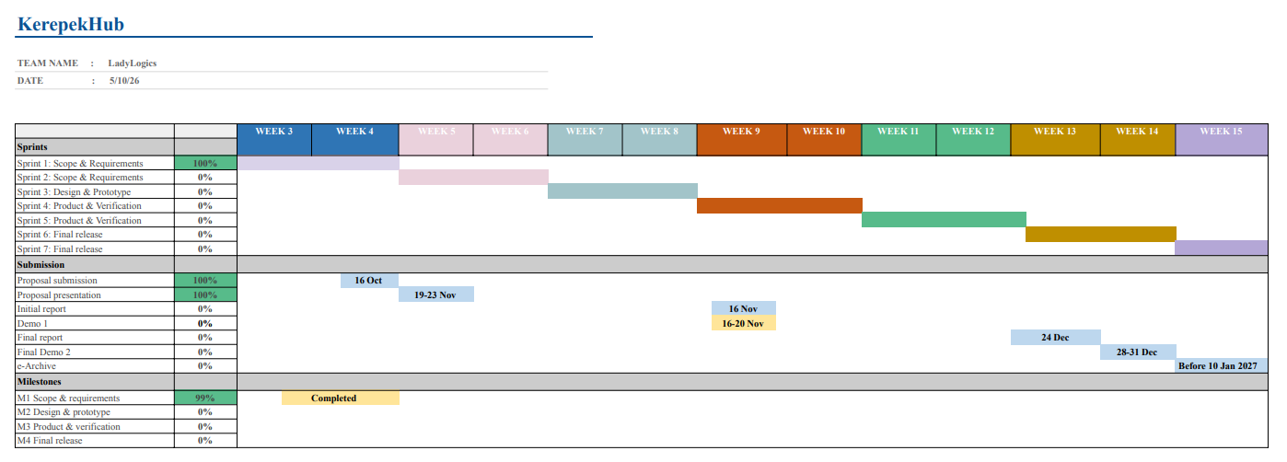
Figure 3: Gantt chart

9.4 Risks and Assumptions
ID | Risk / assumption | Likelihood | Impact | Mitigation
R1 | Client unavailable for meetings | Medium | High | Agree fixed fortnightly slot at the sprint review by using a Whatsapp voice or video call as a fallback
R2 | AI API cost limits so the sales and stock analysis stops working | Medium | High | Send only summarised sales and stock data rather than the raw records
R3 | The team is still learning Flutter which slows development | Medium | High | Assign work by strength and keep notes on solutions in Github
Table 14: Risks and assumptions

10. References
Flutter Team. (2026). Flutter documentation: Build apps for any screen (v3.13+) [Software SDK]. Google Developers. https://flutter.dev/
Google Cloud. (2026). Google Gemini API documentation: Generative AI for developers [API service]. Google AI for Developers. https://ai.google.dev/
Google Developers. (2026). Google Maps Platform: Maps SDK for Android [Software SDK]. Google Cloud Platform. https://developers.google.com/maps
LadyLogics. (2026, October 6). Meeting Minutes No. 02: Client requirements elicitation and scope validation with Serooja [Unpublished meeting minutes]. Faculty of Computer Science and Information Technology, Universiti Malaysia Sarawak. https://bit.ly/4imzvTL
Supabase. (2026). Supabase documentation: The open source Firebase alternative [Cloud database service]. Supabase Docs. https://supabase.com/

Appendix A: Client Meeting Evidence

Client Elicitation & Scope Validation Interview (Meeting No. 02)
Date: 06 October 2026
Attendees:
- Nur Asyiqin (Client)
- Ainur Hanum Abdullah Tasip
- Siti Aisyah binti Sabeki
- Sng Nic Co
- Damia Qistina binti Faizal
- Sabrina Natasha binti Shudarsan

Key Decisions:
- Agreed to implement real-time order status tracking (Pending, Preparing, Ready, Completed) so customers can view order progress independently.
- Agreed to add an automated incoming order notification module for the owner.
- Approved delivery method selection (self-collection vs. doorstep delivery) during checkout.

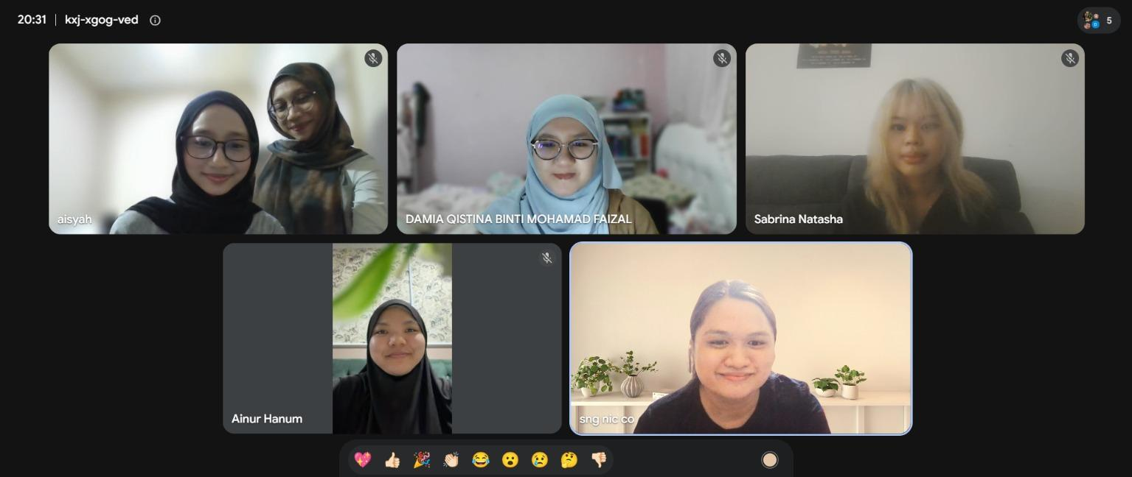
Figure A1: Client Meeting

Appendix B: Revision History
Version | Date | Changes (e.g. after proposal presentation feedback) | By
1.0 | 17/10/26 | Original submission
1.1

