JS code example No 1.

* This part of code assigns functions on clicking the button;
* A class of the element is removed;
* A class of the element is added;
* Element`s background image changed directly in JavaScript;
* Audio sound added;
* Event listener “animationend” used to stop the sprite sheet animation at the particular time;
* Timeout set for the next function;

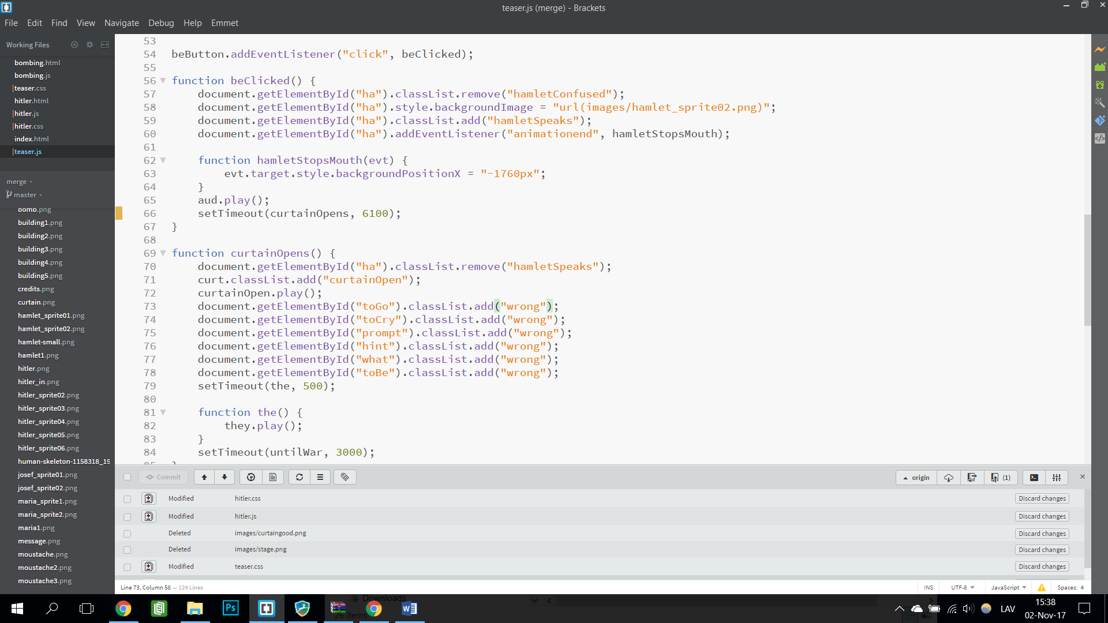

JS code example No 2.

* Audio sound paused;
* Audio sound added;
* Created text element with JavaScript;
* Added class to fade the text element;
* Added another HTML document.

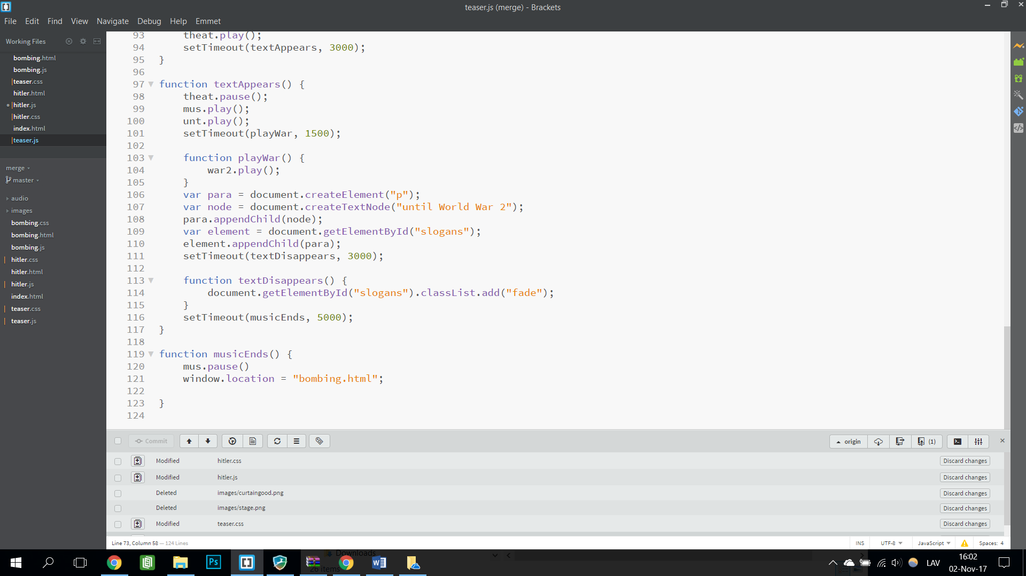

JS code example No 3.

* Event listener “load” added to set initial bombing scene;
* Event listener “transitionend” added to activate the next action when the plane transition ends;
* Event listener “click” added to activate bombing action;

