Foundations of Data Science (CS F320)
Assignment 1

PART A – SEQUENTIAL LEARNING

For every 20 steps the curve changes as following

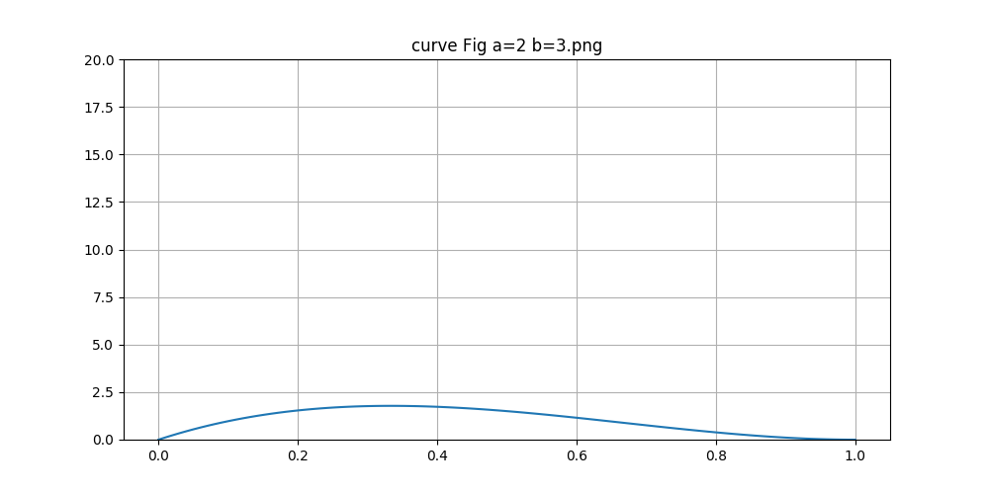

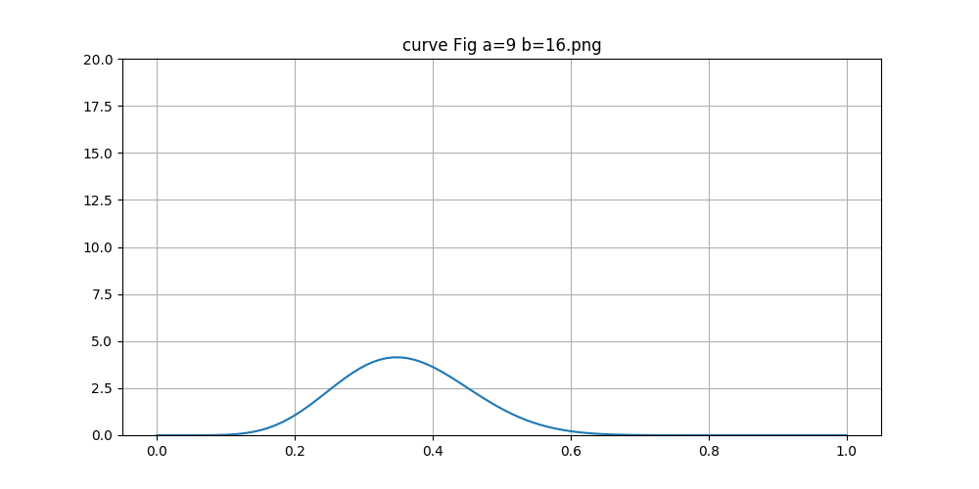

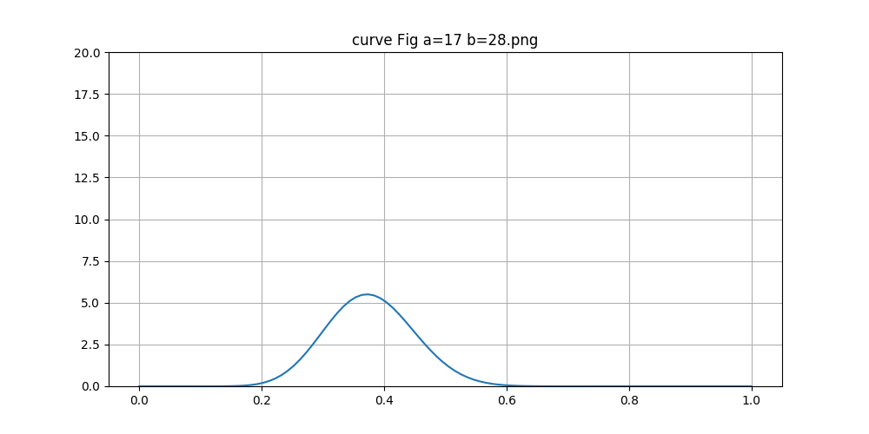
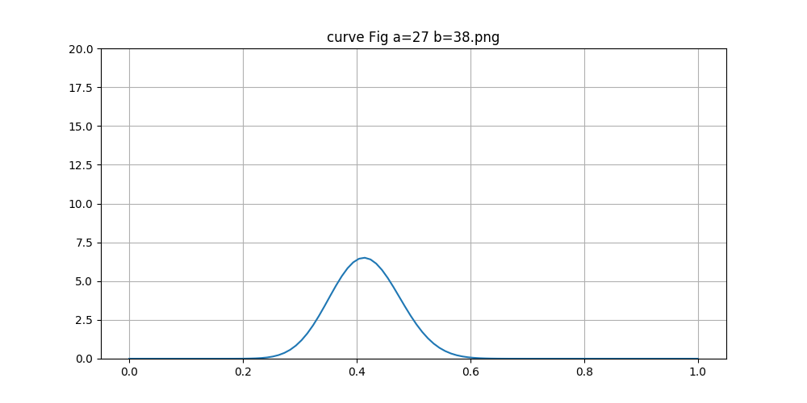

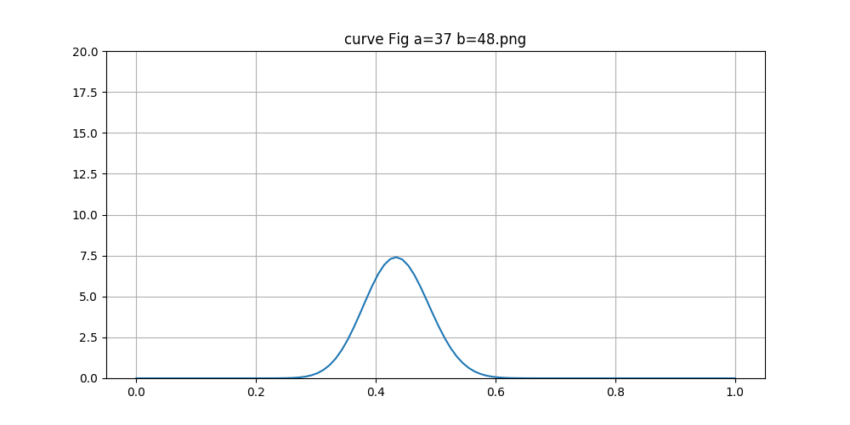

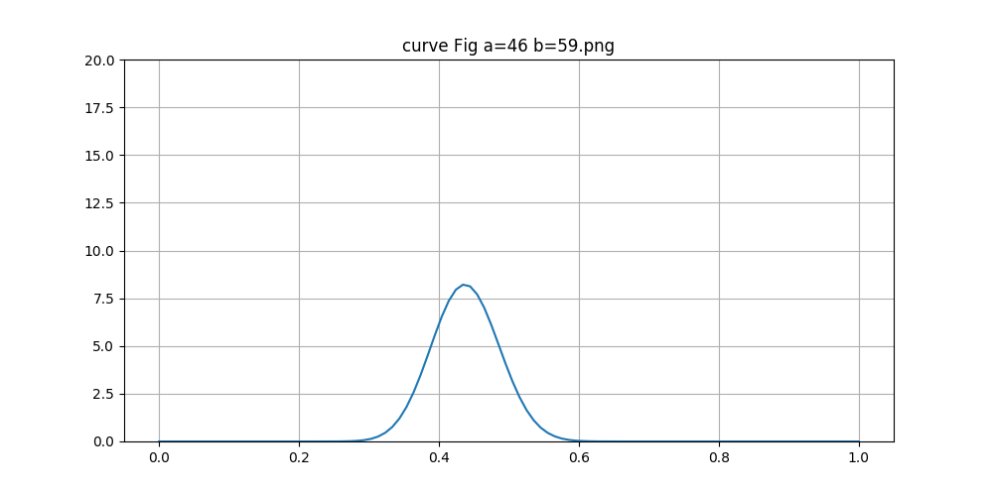

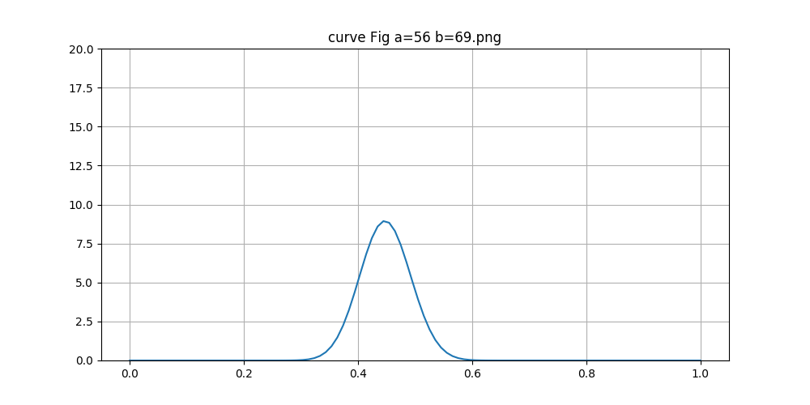

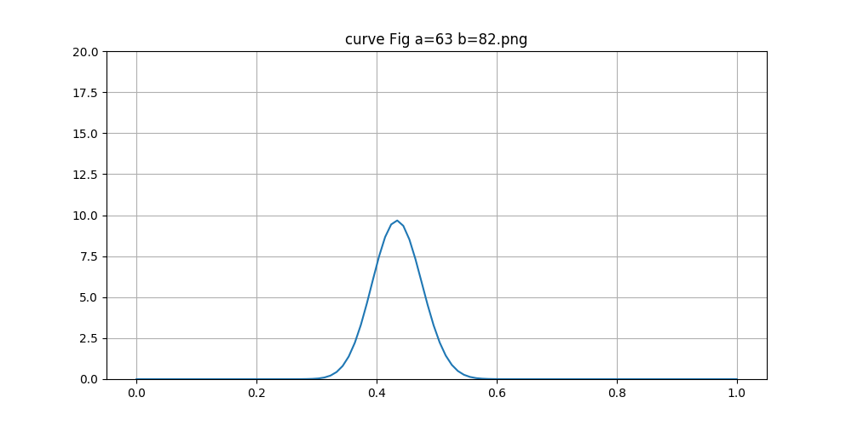
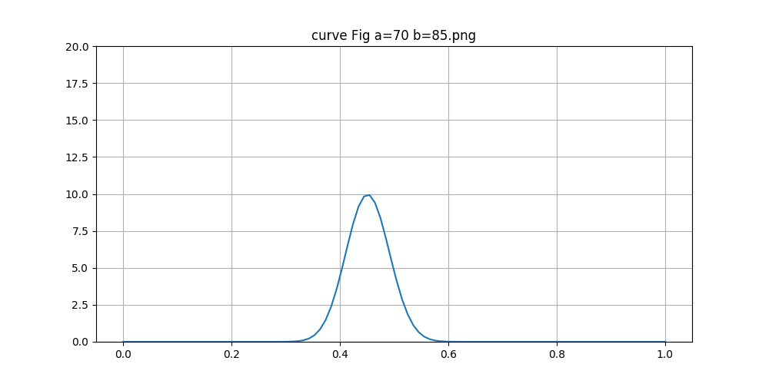
overall gif is
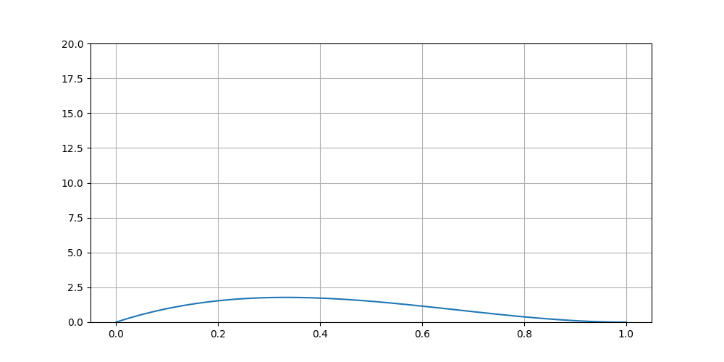

PART B – ALL AT ONCE.
PART C – ANALYSIS

From the rabbit’s point of view men directly approaches to 0.5,where as from tortoise point of view the may not be initially 0.5 but as we increase the observations the mean finally approaches to
a value close to 0.5.Ultimately they both will end up at the same result.

We restrict the number of points to 150 because gamma function value number for 150 itself is very large to store. For observations greater than 150 python cannot store it’s gamma value.so we restrict it to 150.

Team members :
SAI SUNDAR NITIN CHADALAVADA - 2015A7PS0122H
AAYUSH BARATHWAL - 2015A7PS0136H
SNIGDHA GRANDHI - 2015A8PS0495H

