Foundations of data science
Assignment 4

Team members :
SAI SUNDAR NITIN CHADALAVADA - 2015A7PS0122H
AAYUSH BARATHWAL - 2015A7PS0136H
SNIGDHA GRANDHI – 2015A8PS0495H

Xaxis : Time frame
Yaxis : Prediction error
Blue cross : PM25
Red cross : PM10
k = 5

PART- A

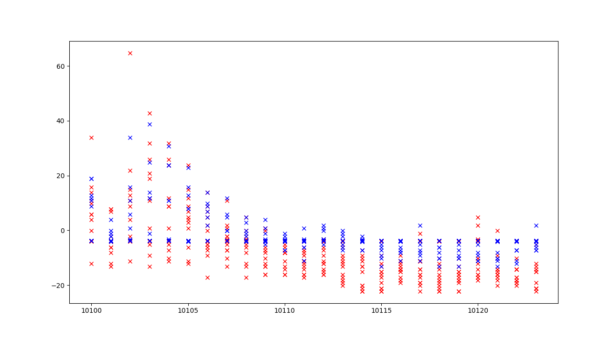

PART-B

ROLLING WINDOW
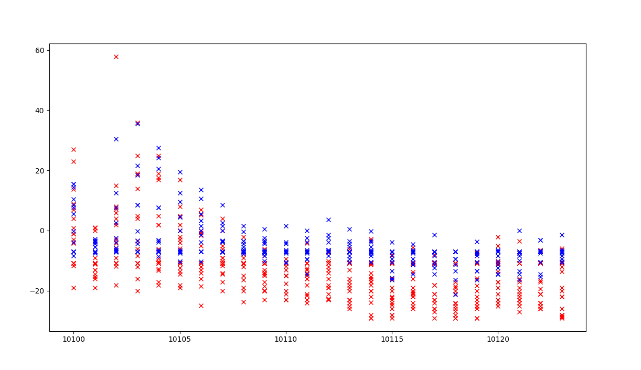
PART C
(NORMALISED)

RECURSIVE WINDOW

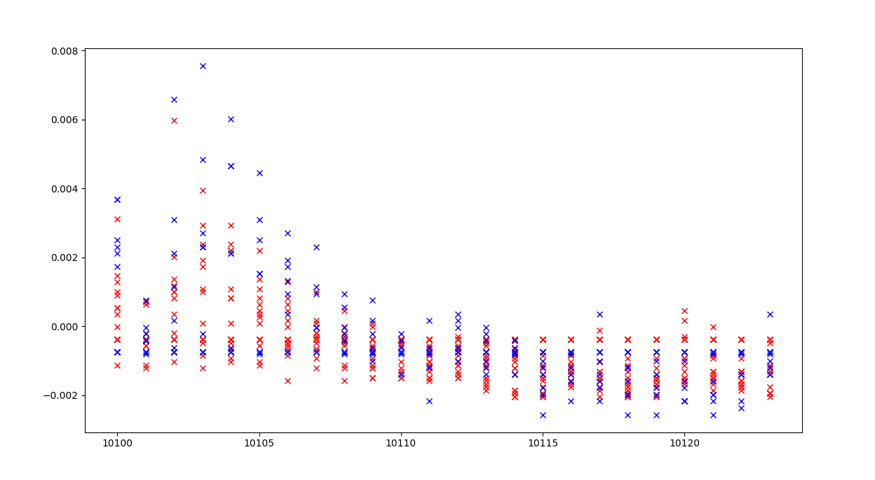

ROLLING WINDOW
