Foundations of Data Science (CS F320)
Assignment 2

PART – A : CIRCLE APPROXIMATION

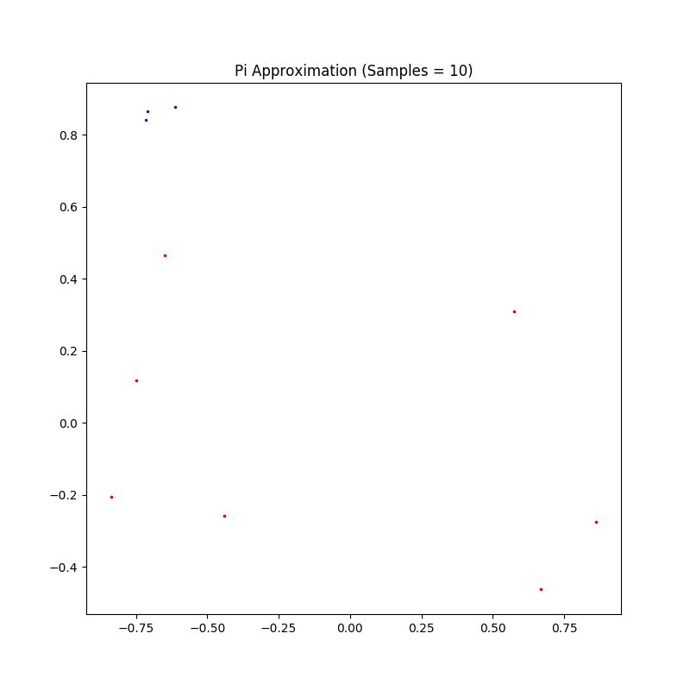
at n= 10 ,pi = 2.0

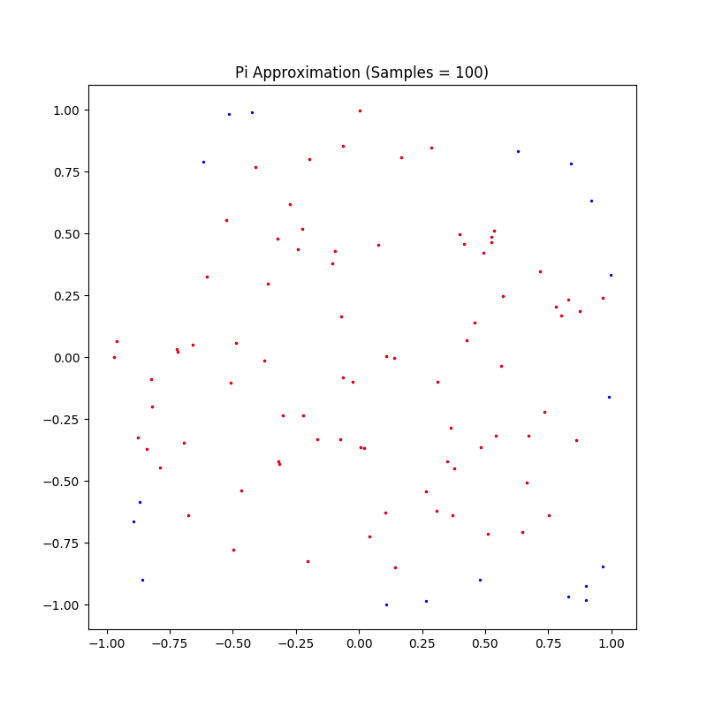
At n = 100 , pi = 2.96
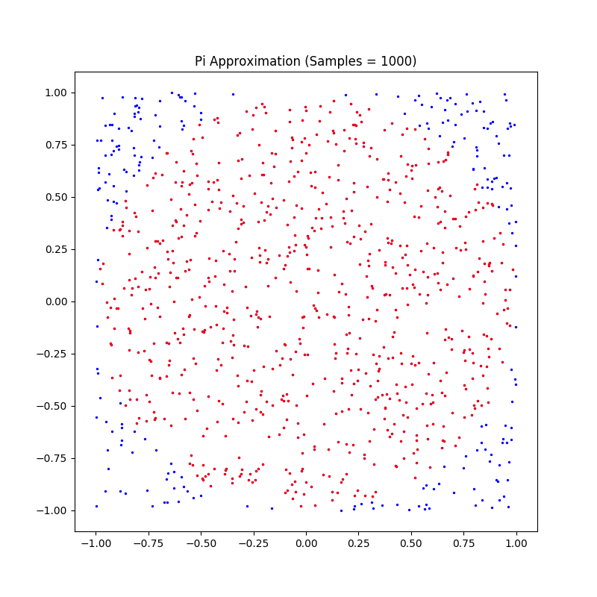

At n= 1000 ,pi = 3.124

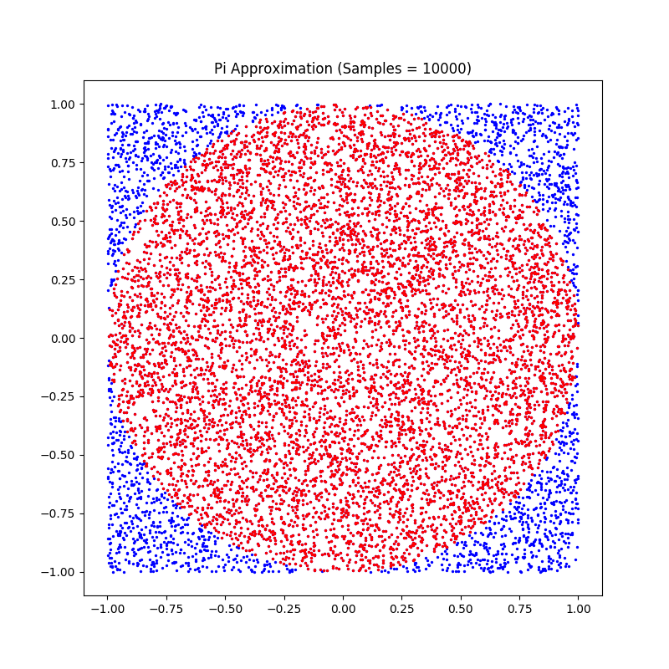

pi for 10000 points is
3.1688

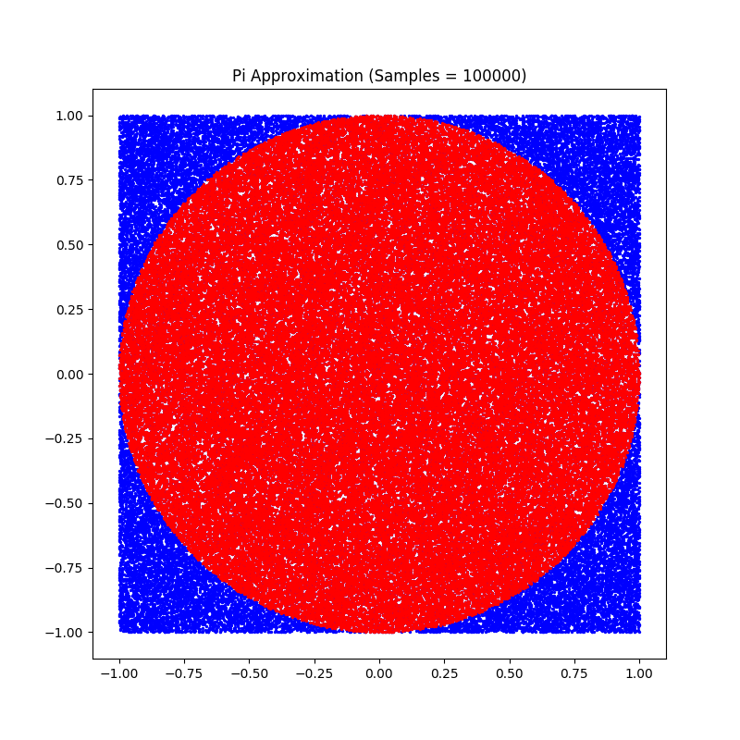

pi for 100000 points is
3.1465600000000005

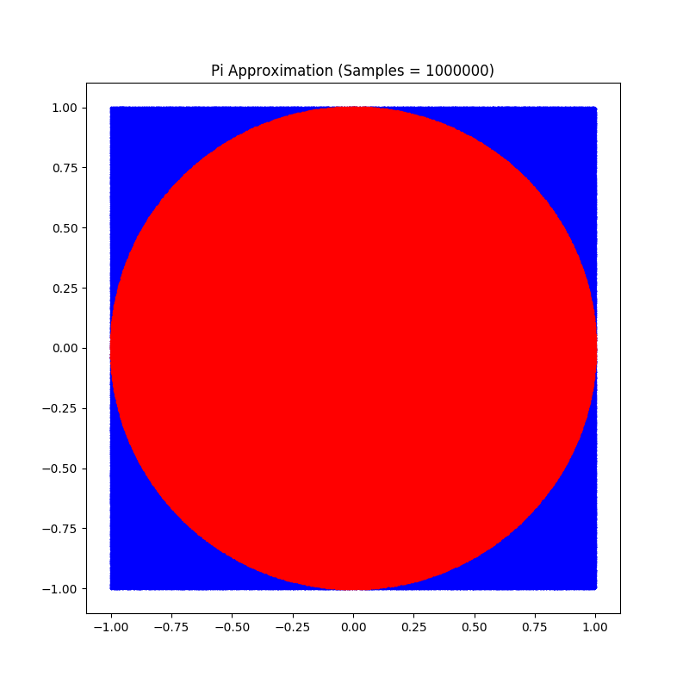

pi for 1000000 points is
3.1408039999999997

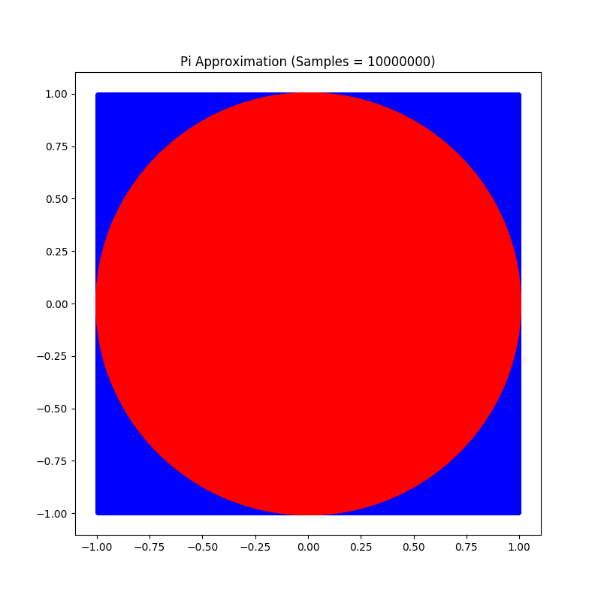
pi for 10000000 points is
3.1420483999999997

PART B : SPHERICAL APPROXIMATION

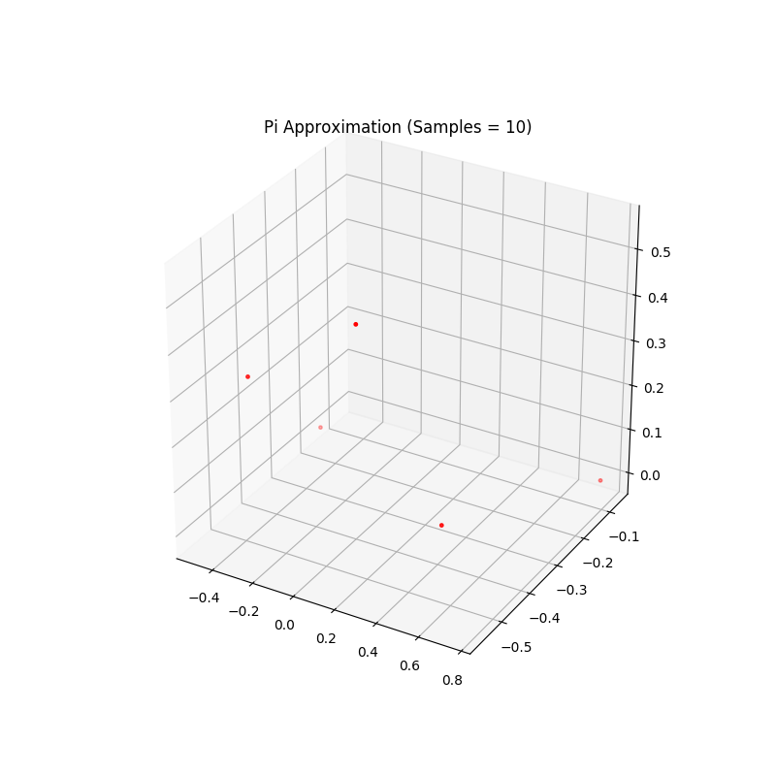

pi for 10 points is
2.4

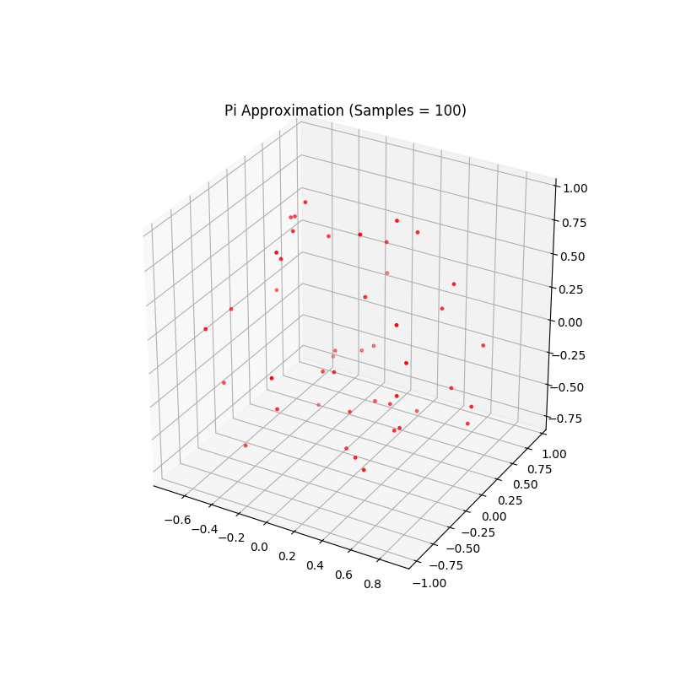
pi for 100 points is
3.36

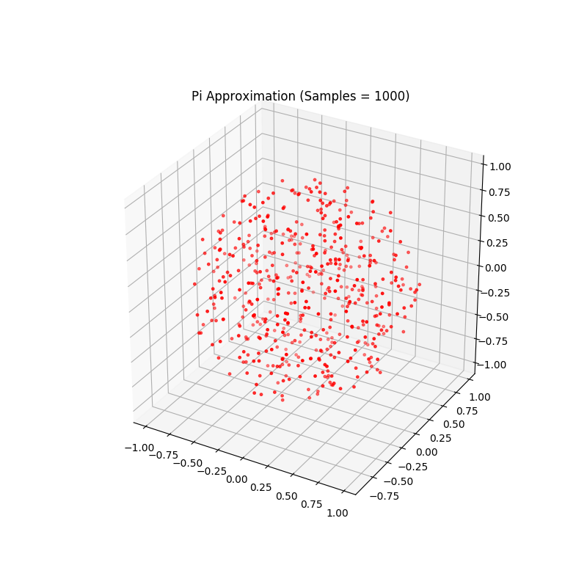

pi for 1000 points is
3.114

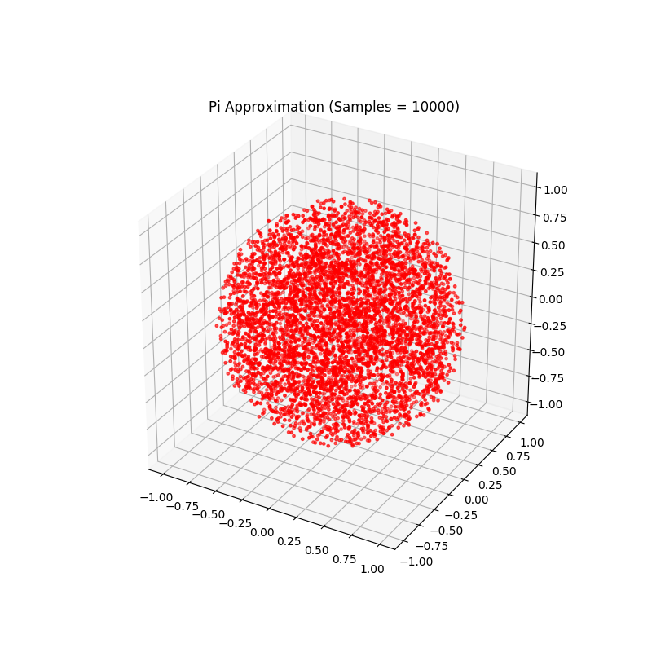
pi for 10000 points is
3.1607999999999996

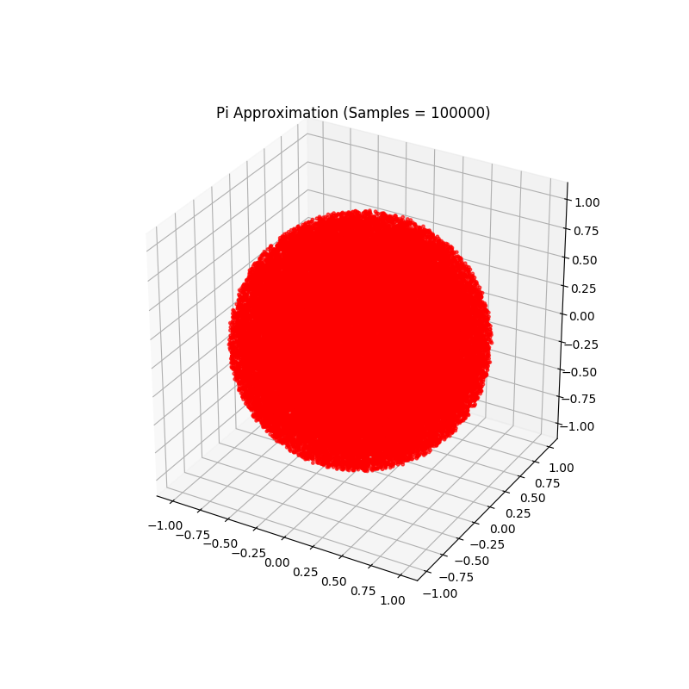
pi for 100000 points is
3.14406

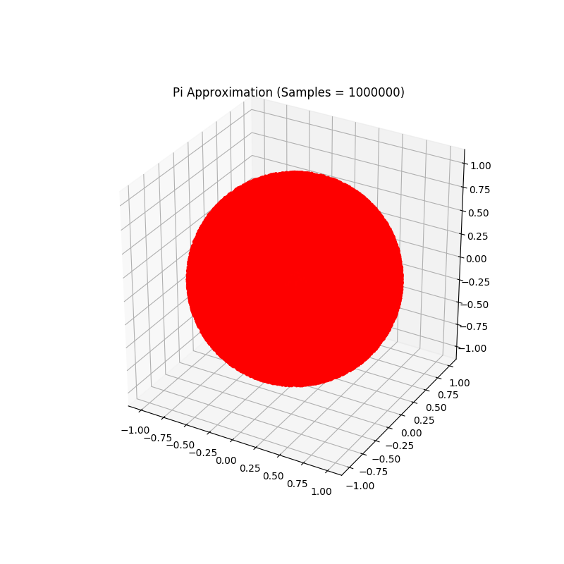

pi for 1000000 points is
3.138516

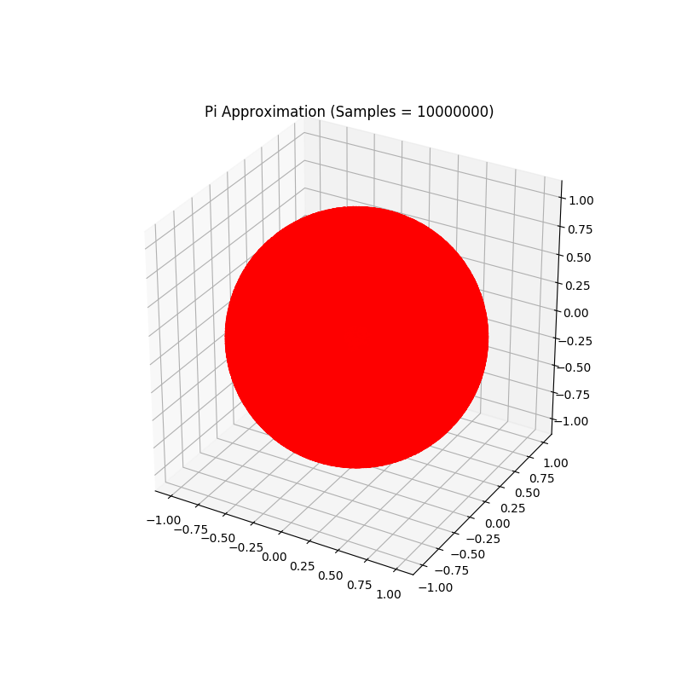
pi for 10000000 points is
3.143313

PART C – ANALYSIS

In both the parts as we kept on increasing the number of points the value of pi approached to it’s value i.e. close to 22/7(which is pi) . But at the same time difference between successive pi values decreased . In case of spherical analysis the value of pi approaches to it’s original value solwer than in circle since the points are more clustered in circle rather than in a sphere.

Team members :
SAI SUNDAR NITIN CHADALAVADA - 2015A7PS0122H
AAYUSH BARATHWAL - 2015A7PS0136H
SNIGDHA GRANDHI - 2015A8PS0495H

