A PRELIMINARY PROJECT REPORT

ON

**WINDOWS PHONE APPLICATION FOR SECURE FILE STORAGE**

**SPONSERED BY**

**VAULTIZE**

**(**<http://www.vaultize.com/index.html>**)**

BY

Lavina Kavediya (B80204294)

Roocha Kharche (B80204256)

DEPARTMENT OF COMPUTER ENGINEERING

CUMMINS COLLEGE OF ENGINEERING FOR WOMEN

KARVENAGAR, PUNE – 411052

2013-2014

**CERTIFICATE**

**This is to certify that the following students**

1. **Lavina Kavediya (B80204294)**
2. **Roocha Kharche (B80204256)**

**Have completed the preliminary work for the project entitled**

**Windows phone application for secure file storage.**

**Satisfactorily for partial fulfilment of the requirements for the Bachelor’s Degree in Computer Engineering of Pune University during the academic year.**

**2013-2014[Semester I]**

**Mr.Ashutosh Muchrikar Mr.Praneeth Siva**

**Internal Guide External Guide**

**Ms.S.S.Deshpande Dr.MadhuriKhambete**

**Head of Computer Department Principal**

**Cummins College of Engineering Cummins College of Engineering**

**ACKNOWLEDGEMENT**

We take this opportunity to express our sincere deference and gratitude to Prof. Mr. Ashutosh Muchrikar and Technical Specialist Mr. Praneeth Siva (Vaultize, Pune) for their constant guidance and motivation provided to us during the course of this work. It was immense pleasure to work under their guidance and supervision.

We also take this opportunity to place on record our thanks and acknowledgement for help and suggestions received from the members of the Faculty of Computer Engineering without whom this report would have not been possible.

We would also express our immense gratitude to Prof. Ms. Shilpa Deshpande, H.O.D, for her continuous support and guidance extended to us.

**Team members:**

Lavina Kavediya

( B80204294)

Roocha Kharche

(B80204256)

**ABSTRACT**

Vaultize gives enterprises a unified platform for File Sharing/Sync (just like popular consumer services), Endpoint Backup and Encryption, and Anywhere Anytime Access to data on corporate file servers, even beyond firewalls — everything with complete enterprise control and visibility. Vaultize is the first enterprise-grade platform to bring together these features through various deployment options including public-cloud, private-cloud and appliance.

We are building this Vaultize app on the windows platform (for windows phone, win8, RT) for the ease of accessing the synced docs anywhere by the clients for their use.

The app admin can also control the data and not only access it. All the controls are in the hands of the admin. Giving an illustration of this, if the admin wants he can block the copying and emailing of the data files synced in the app or only portable document forms (pdfs) can be accessed and not the videos.

The purpose of this Windows application is to allow –Anytime anywhere access of data without being in that particular firewall. It works on the strategy of BYOD (Bring your own device).

**INDEX**

**Table of Contents Page No.**

**Chapter 1**: Introduction

* 1. Problem Definition
  2. Literature Survey

1.2.1 Background of the Project

1.2.2 Domain of study

1.2.3 Motivation of the project

1.2.4 Survey of existing system

1.2.4.1 App Features

1.2.5 Limitations of the existing system

1.2.6 Glossary of the Domain

**Chapter 2**: Software Requirement Specifications (SRS)

2.1. Introduction

* + 1. Purpose of the document
    2. Scope of the Development Project
  1. General Description
     1. User Personas and Characteristics
     2. Product Perspective
     3. Overview of Functional Requirements

2.2.3.1 Overview of functions performed

2.2.3.2 Deployment

* + 1. Overview of Non-functional Requirements

2.2.4.1 Performance Requirements

2.2.4.2 Safety Requirements

2.2.4.3 Security Requirements

2.2.4.4 Software Quality Attributes

* + 1. Operating Environments
    2. General Constraints, Assumptions

2.2.6.1 Limitations

2.2.6.2 Assumptions

* 1. Specific Requirements
     1. Detailed Description of Functional Requirements

2.3.1.1 Template for describing functional requirements

* + 1. Performance Requirements……………..
    2. Quality Attributes……………………………………………...

**Chapter 3**: High Level Design (HLD)

* 1. Block diagram……………………………………………………………
  2. Use Case Diagram………..........................................................................
  3. Activity Diagram…………………………………………………………
  4. State Transition Diagram…………………………………………………
  5. Package Diagram…………………………………………………………
  6. Sequence Diagram………………………………………………………..
  7. Component Diagram……………………………………………………...
  8. Class diagram.............................................................................................

**Chapter 4**:Technology used……………………………………………………….

4.1 Market shares for the windows Phone………………………………………

4.2 Bring Your Own Device……………………………………………………..

4.3 Why Windows phone app?…………………………………………………..

4.4 Anytime anywhere access……………………………………………………

4.5 Microsoft Visual Studio……………………………………………………

4.6 Windows SDK 7……………………………………………………………..

4.7 C#..................................................................................................................

4.8 SQLite………………………………………………………………………

4.9 R-sync Algorithm…………………………………………………………….

4.10 Picsel editor……………………………………………………………….

**APPENDIX A:** Project plan………………………………………………………..

**APPENDIX B:** Glossary…………………………………………………………...

References…………………………………………………………………………...

**CHAPTER 1**

**Introduction**

Vaultize gives enterprises a unified platform for File Sharing/Sync (just like popular consumer services), Endpoint Backup and Encryption, and Anywhere Anytime Access to data on corporate file servers, even beyond firewalls — everything with complete enterprise control and visibility. Vaultize is the first enterprise-grade platform to bring together these features through various deployment options including public-cloud, private-cloud and appliance.

We are building this Vaultize app on the windows platform (for windows phone, win8) for the ease of accessing the synced docs anywhere by the clients for their use.

The app admin can also control the data and not only access it. All the controls are in the hands of the admin. Giving an illustration of this, if the admin wants he can block the copying and emailing of the data files synced in the app or only portable document forms (pdfs) can be accessed and not the videos.

The purpose of this Windows application is to allow –Anytime anywhere access of data without being in that particular firewall. It works on the strategy of BYOD (Bring your own device).

**1.1 Problem statement**

To develop a Windows phone application (desktop and phone) used for secure file storage, file sharing, file syncing and file editing.

**1.2 Literature Survey**

**1.2.1 Background**

We are making a Vaultize application on Windows platform for accessing the synced documents anywhere by the clients. The main idea behind this application is to allow File Sharing/Sync (just like popular consumer services), Endpoint Backup and Encryption, and Anywhere Anytime Access to data on corporate file servers, even beyond firewalls.

Vaultize enterprise platform was basically built to relieve the pains of enterprises with respect to security, data loss and compliance risks that arise from use of consumer file sharing, increasing workforce mobility and the growing trend towards BYOD (Bring-Your-Own-Device).

Unstructured data in corporate has grown exponentially in the last few years. More and more of this data is moving out of corporate networks because of proliferation of endpoints (previously laptops and now smart phones/tablets) through workforce mobility. Corporate IT is facing multi-fold challenges: data on these endpoints is rarely under their control and it’s hardly protected through automated backup and on-disk encryption — making it susceptible to data loss and leakage.

Lately, cloud-based file sharing/sync services have revolutionized the way people access and share information — impacting corporate IT. People are freely using these services even for their official work, and hence sensitive corporate data is now residing in third-party cloud without the knowledge and control of IT — posing significant data loss, security and compliance risks.

Vaultize came to the rescue of enterprises by giving them a unified platform for File Sharing/Sync (just like popular consumer services), Endpoint Backup and Encryption, and Anywhere Anytime Access to data on corporate file servers, even beyond firewalls — everything with complete enterprise control and visibility. Vaultize is the first enterprise-grade platform to bring together these features through various deployment options including public-cloud, private-cloud, on-premise and appliance.

**1.2.2 Domain of study**

The study for the project has been done in the domains of Cloud. It focuses mainly on certain terms like End point Encryption, De-duplication, Wiping and editing the synched documents.

Cloud computing is a type of computing that relies on sharing computing resourcesrather than having local servers or personal [devices](http://www.webopedia.com/TERM/D/device.html) to handle [applications](http://www.webopedia.com/TERM/A/application.html). In cloud computing, the word [cloud](http://www.webopedia.com/TERM/c/cloud.html) is used as a metaphor for *"* the Internet*,"* so the phrase cloud computing means "a type of Internet-based computing," where different services -- such as servers, storage and applications -- are delivered to an organization's computers and devices through the Internet.

Endpoint Encryption is necessary to protect business critical and sensitive data from unauthorized access following device loss or theft. Vaultize Endpoint Encryption encrypts business-critical files and folders on endpoints so that data does not leak when the endpoint or the storage (e.g. hard disk) is lost or stolen. Endpoint Encryption is completely transparent to users and applications and they can continue working as usual. Endpoint Encryption fits naturally with Vaultize’s File-Sharing and Endpoint Backup features to complete the next-generation data protection vision. Vaultize’s fully-integrated solution not only reduces the overheads of managing different solutions from different vendors, but also brings better protection and control of unstructured data within the organization.

In [computing](http://en.wikipedia.org/wiki/Computing), data de-duplication is a specialized [data compression](http://en.wikipedia.org/wiki/Data_compression) technique for eliminating duplicate copies of repeating data.. The technique is used to improve storage utilization and can also be applied to network data transfers to reduce the number of bytes that must be sent. In the de-duplication process, unique chunks of data, or byte patterns, are identified and stored during a process of analysis. As the analysis continues, other chunks are compared to the stored copy and whenever a match occurs, the redundant chunk is replaced with a small reference that points to the stored chunk. Given that the same byte pattern may occur dozens, hundreds, or even thousands of times (the match frequency is dependent on the chunk size), the amount of data that must be stored or transferred can be greatly reduced.

As enterprises start to leverage the increasing consumerization of mobile devices and adopt BYOD strategy to maximize corporate profitability, enterprise IT is facing multiple challenges with the ownership and protection of corporate information assets. Vaultize’s Enterprise Wiping helps IT reduce the risk of data loss by remotely wiping the data when a device (laptop/Smartphone/tablet) is lost or an employee leaves the organization. The wiping is forensically-sound and compliant with US-DoD standards to help prevent any forensic recovery. The legal and financial risks for compromised data make data wiping technology a serious consideration for any organization whose employees carry sensitive data on their devices. For enterprise IT, the responsibility of data loss prevention comes with accountability as well. It is important that IT remotely wipes only the work data, leaving the personal data intact.

The files that are synced on the Vaultize platform are fetched if required to edit and then again an updated version is synced back to Vaultize without using extra storage space. (Using same file chunks)

**1.2.3 Motivation of project**

The idea behind this application is to allow Anytime anywhere access of data without being in that particular firewall.

The increasingly mobile and remote workforce is driving many enterprises to support enterprise mobility as part of their overall corporate strategy.

This application brings secure mobility to enterprises. It lets users access, sync and share data using any Windows Smartphone and tablet – even beyond firewalls, without VPN. All of this, with complete IT control and visibility. Even while doing so, Enterprise IT keeps the data within its control with security and compliance practices.

In absence of easy access to corporate data from across the firewall, employees generously use consumer-grade file sharing/sync services to access corporate data while roaming. This way sensitive corporate information leaks into third-party clouds without the knowledge and control of IT - posing significant security, data loss and compliance risks to enterprises. The application’s Anytime Anywhere access is built for enterprises and is much ahead of industry alternatives in terms of security, control and visibility**.**

**1.2.4 Survey of existing portal**

Vaultize , an enterprise backup, sharing and mobility solution launched its Android app. With this new version, an enterprise or business user will get anywhere and anytime access to the files backed up from her laptop/desktop or shared with her by other users (using Group Sync). At the same time, the enterprise IT team can also rest assured as they would be able to monitor and control which users get to use the app, just like they do with any other Vaultize feature.

“Consumer offerings like iCloud and Dropbox are posing significant data loss threats to businesses and enterprises. Today, important and sensitive corporate information is sitting in these clouds where the businesses and enterprises have no control. Since businesses look at Vaultize as a more secure and safer replacement for such solutions, it is our constant Endeavour to provide solutions through our mobility apps that satisfy both business and end-user needs”, said Ankur Panchbudhe – CTO and Co-founder of Vaultize.

Vaultize is the first backup solution in the world to do both encryption and de-duplication together at source. While all cloud-based backup solutions perform encryption at the server, Vaultize encrypts data at source before it leaves the device – making it the most secure backup and sharing solution in the world. In addition to backup and sync between user devices, Vaultize’s Group Sync feature provides Dropbox-like file sharing and synchronization across users with enterprise-grade security, control and centralized administration.

Vaultize offers flexible deployment options. Customers can choose from Vaultize’s public cloud (hosted in Rack space), virtual private cloud (hosted with any cloud provider of customer’s choice) or ‘Cloud-in-a-box’ appliance. Cloud-in-a-box is industry’s first purpose-built backup and sharing appliance with a combination of enterprise-grade hardware and Vaultize cloud software. The launched Android App works with all deployment options and is available FREE for download from Google Play store. Vaultize already provides similar app for iOS.

The Android application can sync, view and access the documents from the phone itself. There are few screenshots of the Android application given below:

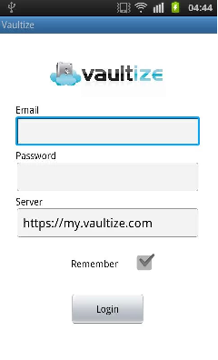

**Fig 1.1-previous portal app image 1**

This image shows the login page of the android application on all android smart phones. This contains the login details of the employee.

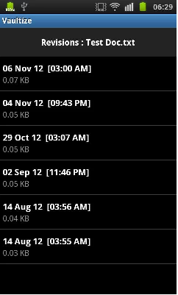

**Fig 1.2- Image 2 of previous portal**

This image shows the previously synced documents on the app and when were they last revised.

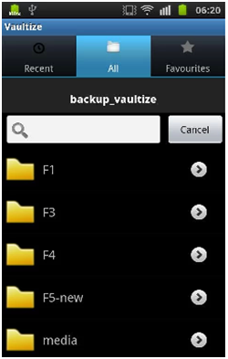

**Fig 1.3- Image 3 of previous portal**

All the folders synced are shown here in fig 1.3.

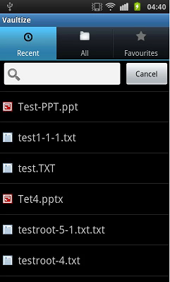

**Fig 1.4- Image 4 of the previous portal**

This image shows the most recently synced documents.

**1.2.4.1 App Features:**

1**. Seamless sharing**: View or download files shared with you by others through Vaultize group sync or sync - no setup required in the app!

2. **Recent files:** Quickly view or download the files you worked on recently (on any of your laptops or desktops)

**3. Browse:** Browse through all your files organized neatly into devices, folders and even versions!

**4. Search:** Search through your files and folders (including the shared ones)  
**5. Stay up-to-date:** Information about your devices, files and sharing is automatically updated from the cloud - no effort required from you.

**6. Intelligent caching:** The app caches all your downloads and smartly refreshes them when they change in the cloud.

**1.2.5 Limitation of existing Portal**

1. The app exists on only android and IOS operating systems.

2. Editing not implemented on Android.

3. No Google documents back-up.

**1.2.6 Glossary of the Domain**

1. BYOD- Bring your own device helps employees be more productive, increases employee convenience and makes the company look like a flexible and attractive employee. Employees can bring their own devices to the workplace.
2. IT- Information Technology

3. UD-DoD- United States Department Of Defence

4. VPN- Virtual Private Network

5. CTO- Chief Technology Officer

**CHAPTER 2: SOFTWARE REQUIREMENT SPECIFICATIONS (SRS)**

### 2.1 Introduction

Vaultize gives enterprises a unified platform for File Sharing/Sync (just like popular consumer services), Endpoint Backup and Encryption, and Anywhere Anytime Access to data on corporate file servers, even beyond firewalls — everything with complete enterprise control and visibility. Vaultize is the first enterprise-grade platform to bring together these features through various deployment options including public-cloud, private-cloud and appliance.

We are building this Vaultize app on the windows platform (for windows phone, win8 desktop) for the ease of accessing the synced docs anywhere by the clients for their use.

The app admin can also control the data and not only access it. All the controls are in the hands of the admin. Giving an illustration of this, if the admin wants he can block the copying and emailing of the data files synced in the app or only portable document forms (pdfs) can be accessed and not the videos.

The purpose of this Windows application is to allow –Anytime anywhere access of data without being in that particular firewall. It works on the strategy of BYOD (Bring your own device).

#### 2.1.1 Purpose of this Document

This document gives the functional and software requirements, and the other valid detailing of the app. This document also explains assumptions and limitations, other aspects of this app.

**2.1.2 Scope of the Development Project**

1. A windows application to access Vaultize data from anywhere.
2. The app integrated with a 3rd party viewer and editor (Picsel editor) for editing the synced documents and putting them back on the Vaultize server.
3. REST API to talk to the Vaultize server.
4. De-duplication and encryption
5. Works on all cloud platforms- public, private and also within appliance (cloud in a box).
6. Integration of the app on the windows platform (win8 and phone).

### 2.2 General Description

### 2.2.1 User Personas and Characteristics

**1. Vaultize end user**: The user of the app can sign into his account. Being a registered user for his/her device with his/her company he can sync the work related documents on the cloud with ease, using his device. The client can even fetch the synced document and edit it using a third party editor (Picsel editor) and can store it back.

**2. Admin**: Primary work to have a backup of all the data. The admin only can wipe or delete the data after a particular period of time if required. Admin can also restrict the access of data. The other users of the company cannot delete the data. He had a record of all the company files synced. Admin can create groups with a set of users and delegate control to a group admin.

Giving an illustration, as fencing is provided to a particular area to avoid others to enter similarly here admin can restrict groups and other controls.

**2.2.2 Product Perspective**

1. Picsel editor to edit the document

2. Encryption (end point) for security of data.

3. De-duplication

4. Cache (enhancing performance)

5. Secure communication

6. No data loss (reliable) (sanity of data should be protected)

7. Authentication

#### 2.2.3 Overview of Functional Requirements

#### 2.2.3.1 Overview of functions performed:

1. Sign up (file browser)
2. Sign in
3. View
4. Edit
5. Sync files
6. Download and upload are asynchronous.

**2.2.3.2 Deployment**:

Deployment would be done on windows phone and windows desktop platforms.

**2.2.4 Overview of Non-functional Requirements**

2.2.4.1 Performance Requirements:

This System no specific requirement for good performance.

## 2.2.4.2 Safety Requirements:

To safely use of this system, the covering image should be large size seleted by end user, because of that may be loss of source data.

## 2.2.4.3 Security Requirements:

For using this system end user can enter username and password to login form in case of wrong information. account will be blocked if attempt is greater than 3 times. Using this system user can generate no. of shares according to demand, and send in different ways, at the receiver side receiver can retrieval data from shares when if these overlap to each other in proper position then receiver can get the correct data.

## 2.2.4.4 Software Quality Attributes:

1. Portability :-This System is Platform independent i.e. It can be operate on any environment.

2 Optimality :- This System require less time to perform its operation, it uses simple algorithm, hence it optimize the system time as well as cost of storage.

3. Adaptability :-:user can generate no. of shares as well as Selecting Covering image as his choice.

4. Availability :- This system is available for authorized used only.

5. Reliability :- This system is reliable its provides various feature to retrieve the data correctly very efficient manner.

6. Robustness :- This system is robustness, because it has not failure case to interrupt the execution of system, It is not depend on specific h/w.

**2.2.5 Operating Environment:**

* Windows phone 8.

The deployment of the application can be shown as:

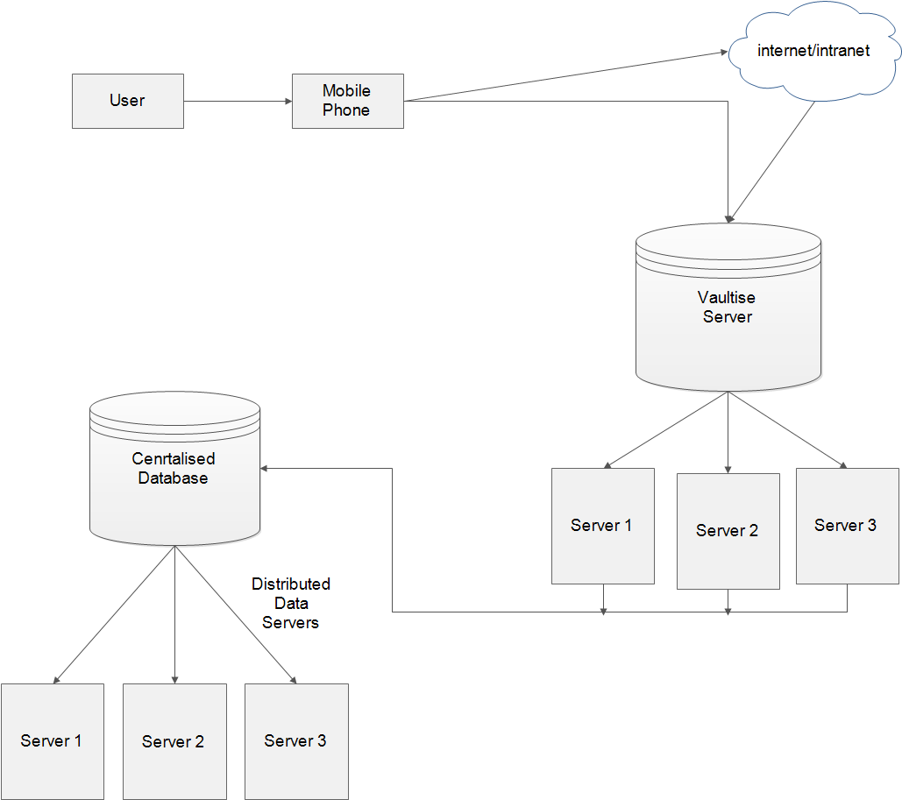

Fig

#### 2.2.6 General Constraints, Assumptions, Dependencies, Guidelines

**2.2.6.1 Limitations:**

1. File size on mobile is limited to 100-200 MBs (accessing from Vaultize server).

2. No filter used for checking whether the file is personal or enterprises file that is being synced.

**2.2.6.2 Assumptions:**

1. Only Wi-Fi or high speed network connectivity is used on the device.

2. User cannot delete the file once synced on the cloud.

3. Wiping can be done only by the admin or super admin.

### 2.3. Specific Requirements

#### 2.3.1 Detailed Description of Functional Requirements

**Function specific diagram:**

1. Access
2. Edit (Picsel editor)
3. **ACCESS:**

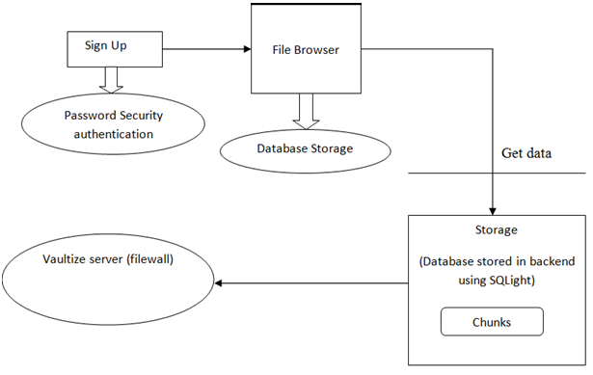

**fig**

1. **EDIT (PICSEL EDITOR):**

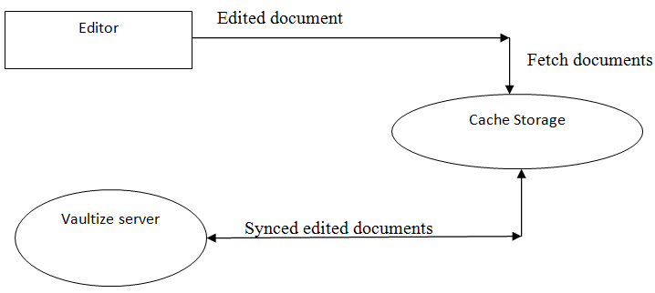

fig

#### 2.3.1.1 Template for describing functional requirements

**TEMPLATE FOR SIGN UP:**

|  |  |
| --- | --- |
| **Function** | Sign up |
| **Precondition** | Member of the company (registered member) |
| **Steps** | Enter detail information  Contact details and other required details. |
| **post condition** | Set up of profile  Access to all services |
| **Alternative flows** | User name already exists,  Fake details or incorrect details filled. |

**TEMPLATE FOR SIGN IN:**

|  |  |
| --- | --- |
| Function | Sign in |
| **Precondition** | Member of the company (registered member) Sign up already done (registered) |
| Steps | Enter detail information Contact details etc during sign up. |
| post condition | Set up of profile  Access to all services Can sync documents |
| Alternative flows | User name already exists Syncing the same document again. |

**TEMPLATE FOR VIEW DOCUMENTS:**

|  |  |
| --- | --- |
| **Function** | View documents |
| **Precondition** | Member of the company (registered member)  Sign in your account. |
| **Steps** | Select document  View document |
| **post condition** | Documents viewed |
| **Alternative flows** | Document already is opened. |

**TEMPLATE FOR DOCUMENT SYNCING**

|  |  |
| --- | --- |
| **Function** | Sync documents |
| **Precondition** | Network accessibility  No personal documents to sync |
| **Steps** | Check member's validity  Sync document.  Check if a company document. |
| **post condition** | Do not allow to delete. |
| **Alternative flows** | Extra-large files  Personal files synced. |

**TEMPLATE FOR EDIT SYNCED DOCUMENTS:**

|  |  |
| --- | --- |
| **Function** | Edit (Synced documents) |
| **Precondition** | Network accessibility  Document availability |
| **Steps** | Check member's validity  Check Synced document.  Edit document |
| **post condition** | Do not allow to delete  Sync the documents back |
| **Alternative flows** | Extra-large files  No personal files for syncing |

#### 2.3.2 Performance Requirements

* Wi-Fi network availability
* Good network speed.
* Rendering of files should be very fast
* Cache should be effective
* Encryption and decryption speed should be high.

#### 2.3.3 Quality Attributes

**Security**: The security is the main aspect of Vaultize app. All the data that flows through the app should be encrypted. Admin adherence

**Availability:** 24x7 availability as you can carry your device anywhere and access. Data should be available where ever we have network connection.

**Reliability:** The appshould gracefully handle huge amount of data. It should not crash in between while performing some task. No data loss should be experienced.

**Maintainability:** Maintains all the synced, edited and re-synced documents with

minimum space using de-duplication of data.

**Performance**: App should not get stuck (multithreading) in between and should perform well. For good speed efficiency cache is used.

**CHAPTER 3: HIGH LEVEL DESIGN**

3.1 Block Diagram

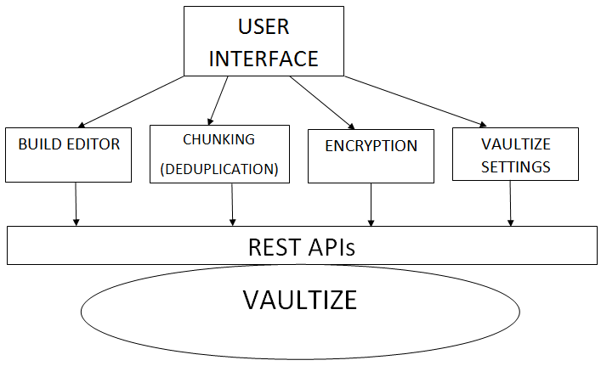

fig 3.1 Block diagram

**ACCESS:**



fig 3.2 Access block diagram

**EDIT (PICSEL EDITOR):**



fig 3.2 Edit block diagram

3.2 Use case diagram for Admin



fig 3.4 Use case for admin

Use case diagram for USER (sharing data):



fig 3.5 Use case for user(employee)

3.3 Activity diagram

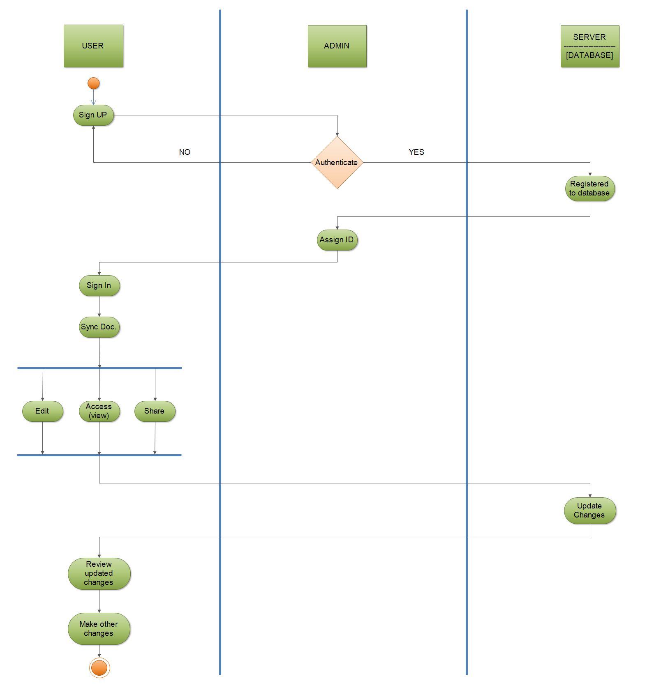

fig 3.6 Activity diagram

ACTIVITY DIAGRAM FOR EDIT FUNCTION:

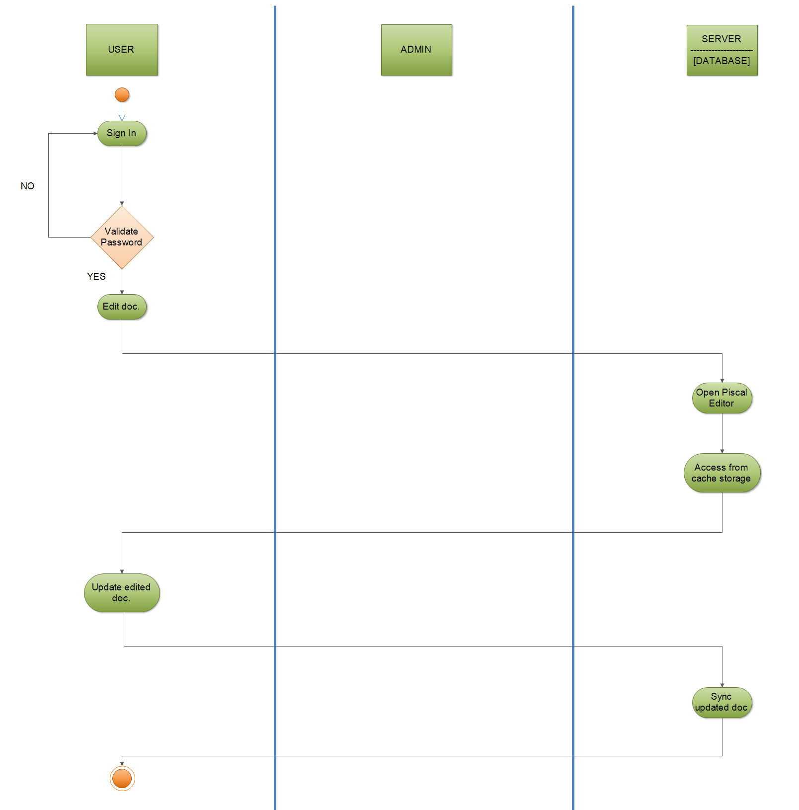

fig 3.7 Activity diagram for edit function

3.4 State transition diagram

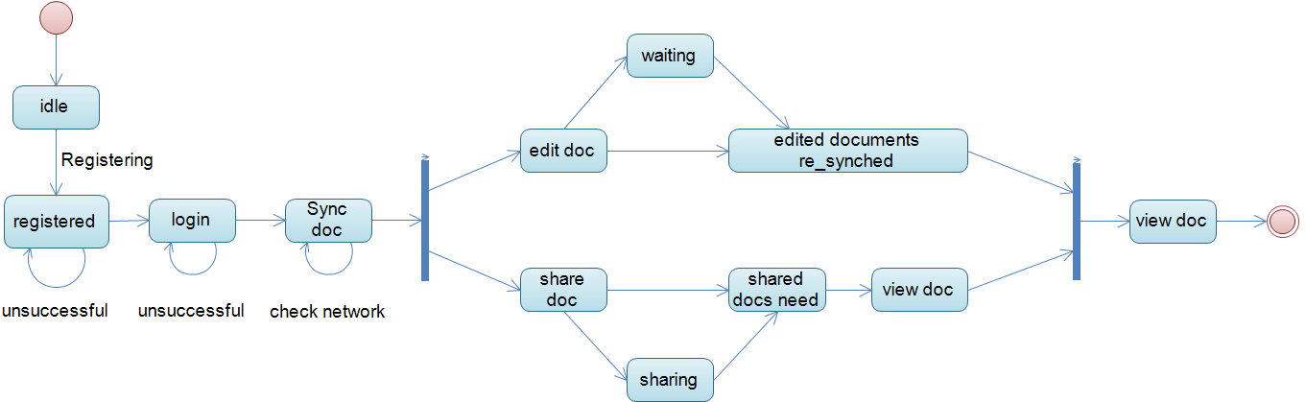

fig 3.8 State transition diagram

3.5 Package diagram

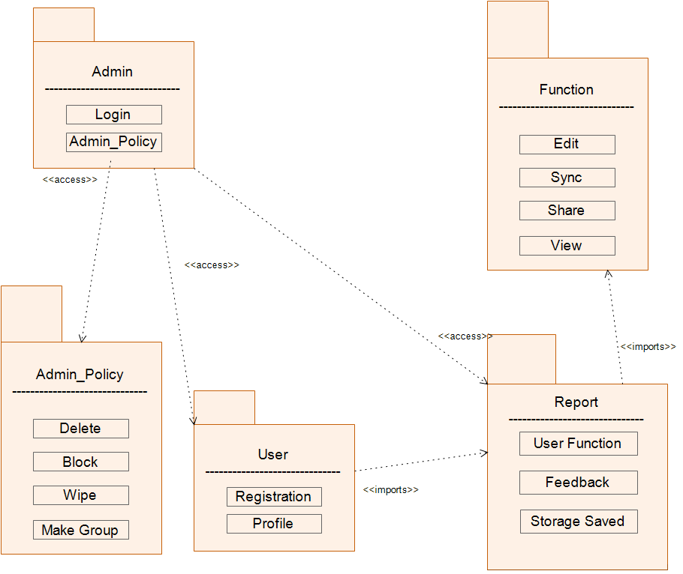

fig 3.9 Package diagram

3.6 Sequence diagram

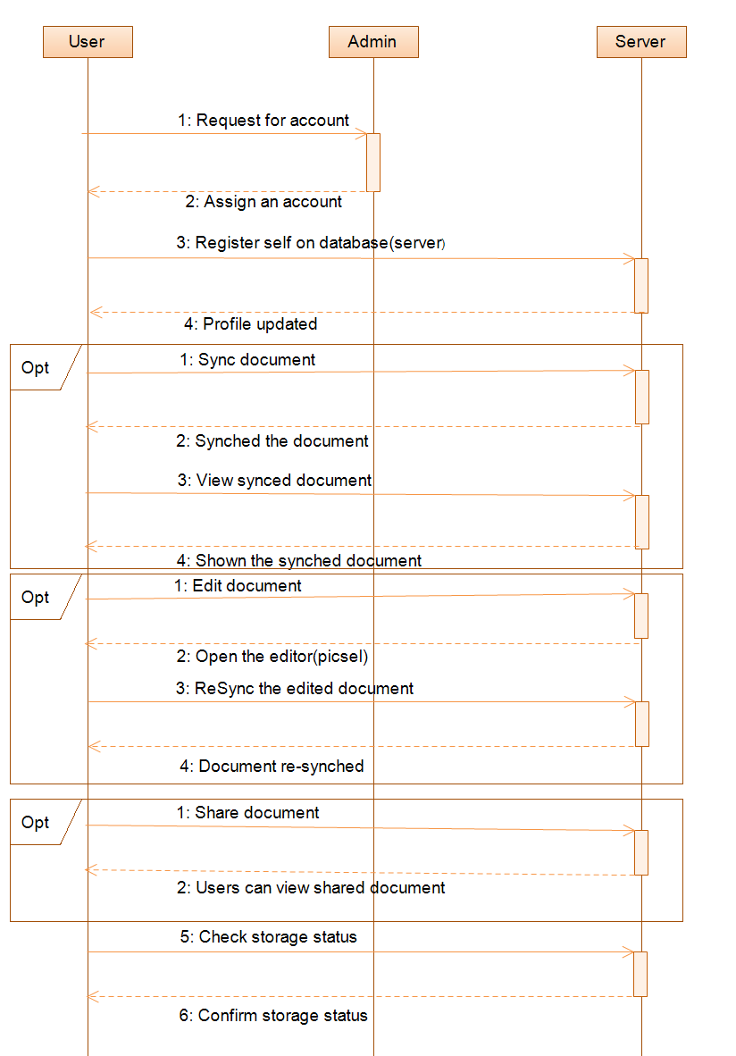

fig 3.10 Sequence diagram

3.7 Component diagram

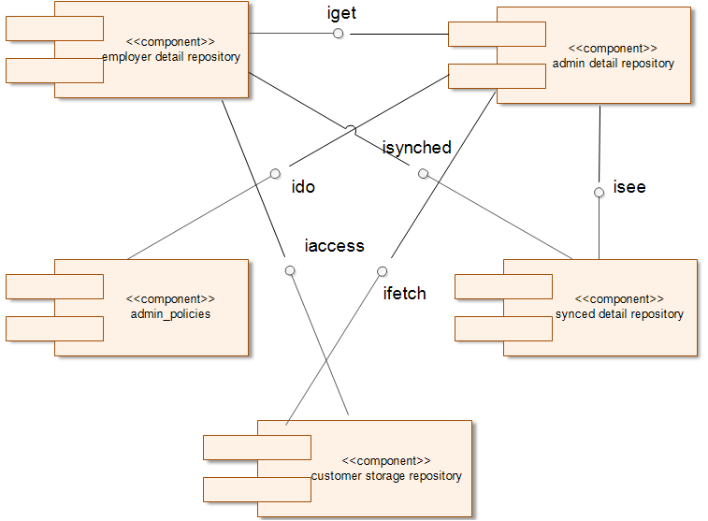

fig 3.11 Component diagram

3.8 Class diagram

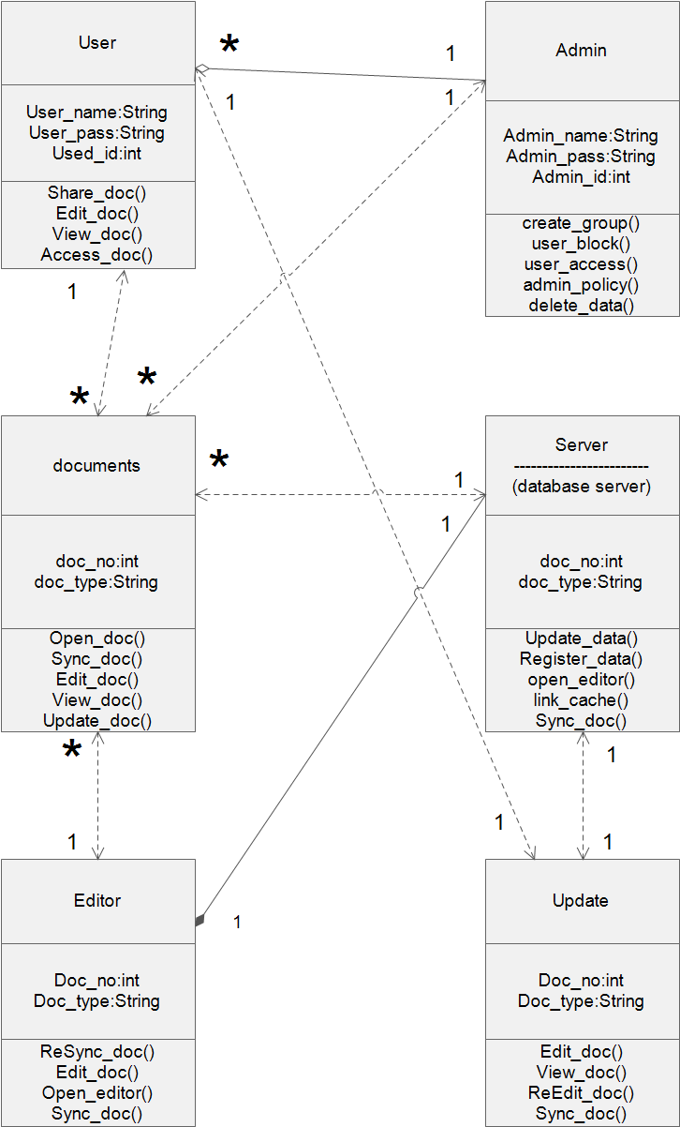fig 3.12 Class diagram

**CHAPTER 4: TECHNOLOGY**

**LOOKING AT THE BUSINESS ASPECTS:**

**4.1 Market shares for windows phone**

**Windows Phone** posted the largest year-over-year growth worldwide of any of the leading operating systems, a result primarily driven by the support of Nokia. By itself, Nokia accounted for 93.2% of all the Windows Phone-powered smart phones shipped during the quarter, marking a new milestone in the company's short history on the Microsoft platform. Participation from other vendors, meanwhile, still seemed a mixed bag with more vendors participating from a year ago, but volumes still far behind Nokia's own. IDC published its third-quarter 2013 [smart phone market share and sales estimates](http://www.idc.com/getdoc.jsp?containerId=prUS24442013).

Microsoft's Windows Phone platform also made notable market share gains in the quarter; Microsoft increased its global Windows Phone share by 80 percent, up to 3.6 percent of the total market in Q3 2013 from 2.0 percent of the market in Q3 2012, IDC says. Windows Phone shipments also more than doubled year over year, with 9.5 million devices shipped in Q3 2013, or a 156 percent increase over the 3.7 million devices it shipped in Q3 2012

These Windows Phone numbers are particularly impressive, even though the OS still has a relatively small percentage of the overall market. Nokia is fueling the charge; 93.2 percent of all the Windows Phone smart phones shipped during Q3 2013 were Nokia devices, according to IDC. The increase could bode well for the future of a platform that has not seen any significant market share gains during the past couple of years.

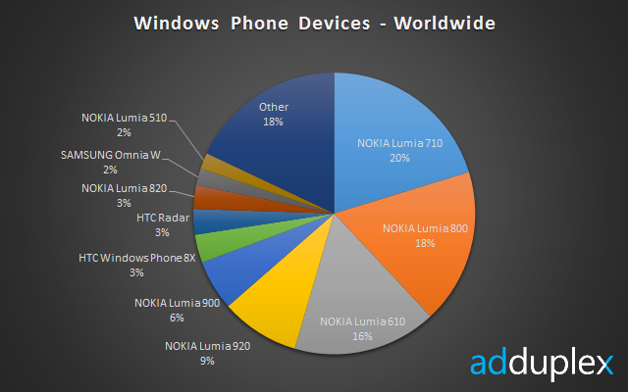

fig 4.1 windows phone devices - worldwide

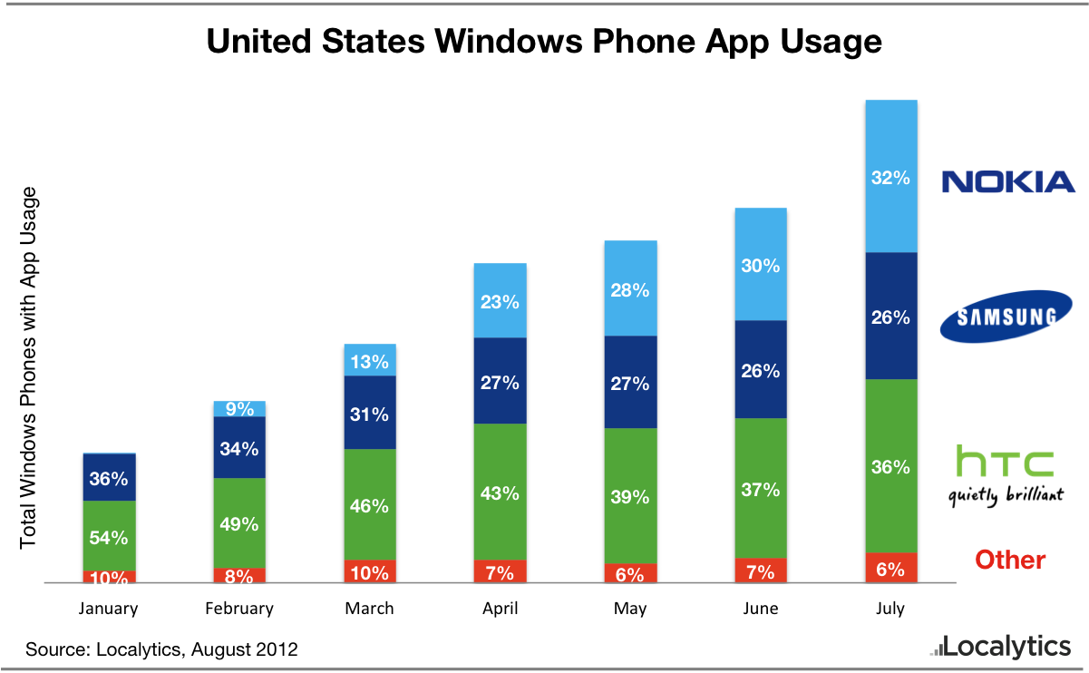

**fig**

Shows increase in the market for windows phone in market.

**4.2 BYOD**

Bring your own device (BYOD) (also called bring your own technology (BYOT), bring your own phone (BYOP), and bring your own PC (BYOPC)) refers to the policy of permitting employees to bring personally owned mobile devices (laptops, tablets, and smart phones) to their workplace, and to use those devices to access privileged company information and applications

There are four basic options, which allow:

* Unlimited access for personal devices.
* Access only to non-sensitive systems and data.
* Access, but with IT control over personal devices, apps and stored data.
* Access, but prevent local storage of data on personal devices.

## BYOD Security

Today, employees expect to use personal smart phones and mobile devices at work, making BYOD security a concern for IT teams. Many corporations that allow employees to use their own mobile devices at work implement a BYOD security policy that clearly outlines the company's position and governance policy to help IT better manage these devices and ensure [network security](http://www.webopedia.com/TERM/N/network_security.html) is not compromised by employees using their own devices at work.

BYOD security can be addressed by having IT provide detailed security requirements for each type of personal device that is used in the workplace and connected to the corporate network. For example, IT may require devices to be configured with passwords, prohibit specific types of applications from being installed on the device or require all data on the device to be encrypted. Other BYOD security policy initiatives may include limiting activities that employees are allowed to perform on these devices at work (e.g. email usage is limited to corporate email accounts only) and periodic IT audits to ensure the device is in compliance with the company's BYOD security policy.

## BYOD VoIP Subscription

Another common use of the phrase BYOD can be found in the [VoIP](http://www.webopedia.com/TERM/V/VoIP.html) (Voice over Internet Protocol) industry, and used to describe a specific type of [VoIP](http://www.webopedia.com/TERM/V/VoIP.html) subscription or plan. Subscribers who have their own VoIP [device](http://www.webopedia.com/TERM/D/device.html) (a [SIP](http://www.webopedia.com/TERM/S/SIP.html) (Session initiation Protocol)-capable device) when signing up for a VoIP service will usually be able to take advantage of a cheaper subscription plan when they use BYOD – however not all [VoIP service providers](http://www.webopedia.com/TERM/V/voip_service_provider.html) will offer special rate plans for subscribers with their own equipment. If the BYOD subscription is unavailable through a VoIP provider you will need to use the provider's equipment instead of your own.

### Benefits of bring your own device:

**Increased productivity and innovation:** Employees are more comfortable with a personal device and become expert using it — making them more productive. Personal devices tend to be more cutting-edge, so the enterprise benefits from the latest features. Also users upgrade to the latest hardware more frequently.

**Employee satisfaction:**

Your people use the devices they have chosen and invested in — rather than what was selected by IT. Allowing employees to use personal devices also helps them avoid carrying multiple devices.

**Cost savings:** BYOD programs sometimes save budget by shifting costs to the user, with employees paying for mobile devices and data services. However, this often results in little to no savings, so do not base your decision primarily on anticipated savings.

**4.3 WHY WINDOWS PHONE APP:**

As a developer, I would want to publish my application in the windows store for the following reasons:

* Market opportunity
* Designed for discovery
* Flexible business models
* Uber-transparency

Windows operating system is available in over 100 languages and over 200 markets.  But people don’t truly grasp what a huge market opportunity this is .Compare the market sizes (data is from Dec 2012):

* Windows 7: 500M devices
* Android phones:234M devices
* Android tablets:13M devices
* iPhone:112M devices
* iPad:40M devices
* Mac:30M devices

There are over 500 million machines running Windows 7 today (and note that this number is JUST Windows 7…if we included all of the Windows XP and other Windows machines still out there, the number is easily over a billion).  Any machine running Windows 7 will be able to run Windows 8, in terms of hardware requirements.  So there is a huge potential market here.  If you add up all of the Android devices, iPhones, iPads, and Mac computers, that total number is still far less than the number of machines running just Windows 7!

From a sheer business perspective, crunching the numbers, it’s smart to think about writing an application for Windows 8.

**Designed for Discovery**

The Windows team has done a lot of work to ensure that applications in the Windows Store can be easily found.

* They’ve done work around search engine optimization, so the name of your app in a search engine should return its listing page in the Windows Store.
* The Windows Store will appear as a tile in the Start Menu of every Windows 8 user.
* Within the Windows Store, there are a lot of ways to surface great apps, such as the Spotlight section where great apps are highlighted, recommendations for you based on your past downloads, browsing and filtering capabilities (based on categories, price, and ratings), a “new releases” section where you can see newly-launched apps, a section where you can see the top downloaded apps, and of course search.
* We can add [two lines of mark-up](http://blogs.msdn.com/b/ie/archive/2011/10/20/connect-your-web-site-to-your-windows-8-app.aspx) to your website, and any end user running the Metro version of Internet Explorer 10 will see an app button within the browser that promotes your app.  The app button on a Windows 8 PC takes you to the app listing in the Store (if the app is not installed) or directly launches the app (if it’s installed).  You can see the app button in the below picture on the bottom left (the button between the back button and the URL)

### Flexible business models

Next, there is a lot of flexibility in business models.  You can make free apps or paid apps that cost money.  You can enable trials, which can be time-based (example: expire after 30 days) or feature-based (example: you can play the first 10 levels of my game for free and then you buy the app to unlock the rest of the levels once you’re hooked).  You can have in-app purchases, which can be done through Microsoft or a third party.  ([In-app purchases](http://msdn.microsoft.com/en-us/library/windows/apps/hh694067.aspx) are a way for users to buy additional products or features from within your application.)  You can have advertising support in your app, which can also be [Microsoft advertising](http://www.windowsadvertising.com/) or third-party.

### Uber-transparency

### It details the amazing analytics that are provided for your published app in the Windows Store.  One example is the App Summary page, which shows download trends, ratings breakdown, and quality overview for your application.

### http://blogs.msdn.com/cfs-filesystemfile.ashx/__key/communityserver-blogs-components-weblogfiles/00-00-01-49-52-metablogapi/3716.App_5F00_Summary_5F00_2DB424CD.jpg

### fig 4.2

Secondly, there is mega-transparency in the application submission process.  When a developer submits an application to the Windows Store, at any time, you can log into your developer dashboard and see what the steps of the process are, how long each step usually takes, and exactly where your app is in the process.

Third, there is a tool called the Windows App Certification Kit (or WACK) that allows you to take a step out of the feedback loop.  Instead of submitting to the Windows Store and waiting to find out if you passed or not, you can run the WACK locally before you submit your app and test for major issues.

Finally, documentation has been published with all of the Windows Store policies

**4.4 Anytime anywhere access**

The increasingly mobile and remote workforce is driving many enterprises to support enterprise mobility as part of their overall corporate strategy.

Vaultize brings secure mobility to enterprises. It lets users access, sync and share data using any iOS/Android smart phone and tablet – even beyond firewalls, without VPN. All of this, with complete IT control and visibility. Even while doing so, Enterprise IT keeps the data within its control with security and compliance practices.

In absence of easy access to corporate data from across the firewall, employees generously use consumer-grade file sharing/sync services to access corporate data while roaming. This way sensitive corporate information leaks into third-party clouds without the knowledge and control of IT - posing significant security, data loss and compliance risks to enterprises. Vaultize’s Anytime Anywhere access is built for enterprises and is much ahead of industry alternatives in terms of security, control and visibility.

**4.5 Microsoft Visual studio**

Microsoft Visual Studio is an [integrated development environment](http://en.wikipedia.org/wiki/Integrated_development_environment) (IDE) from [Microsoft](http://en.wikipedia.org/wiki/Microsoft). It is used to develop [console](http://en.wikipedia.org/wiki/Console_application) and [graphical user interface](http://en.wikipedia.org/wiki/Graphical_user_interface) [applications](http://en.wikipedia.org/wiki/Application_software) along with [Windows Forms](http://en.wikipedia.org/wiki/Windows_Forms) or [WPF](http://en.wikipedia.org/wiki/Windows_Presentation_Foundation) applications, [web sites](http://en.wikipedia.org/wiki/Web_site), [web applications](http://en.wikipedia.org/wiki/Web_application), and  [web services](http://en.wikipedia.org/wiki/Web_service) in both [native code](http://en.wikipedia.org/wiki/Native_code) together with [managed code](http://en.wikipedia.org/wiki/Managed_code) for all platforms supported by Microsoft, [Windows Mobile](http://en.wikipedia.org/wiki/Windows_Mobile), [Windows CE](http://en.wikipedia.org/wiki/Windows_CE), [.NET Framework](http://en.wikipedia.org/wiki/.NET_Framework), [.NET Compact Framework](http://en.wikipedia.org/wiki/.NET_Compact_Framework) and [Microsoft Silverlight](http://en.wikipedia.org/wiki/Microsoft_Silverlight).

Visual Studio includes a [code editor](http://en.wikipedia.org/wiki/Code_editor) supporting [IntelliSense](http://en.wikipedia.org/wiki/IntelliSense) as well as [code refactoring](http://en.wikipedia.org/wiki/Code_refactoring). The integrated debugger works both as a source-level debugger and a machine-level debugger. Other built-in tools include a forms designer for building [GUI](http://en.wikipedia.org/wiki/GUI) applications, [web designer](http://en.wikipedia.org/wiki/Web_designer), [class](http://en.wikipedia.org/wiki/Class_(computing)) designer, and [database schema](http://en.wikipedia.org/wiki/Database_schema) designer. It accepts plug-ins that enhance the functionality at almost every level—including adding support for [source-control](http://en.wikipedia.org/wiki/Source_control) systems (like Subversion and [Visual SourceSafe](http://en.wikipedia.org/wiki/Visual_SourceSafe)) and adding new toolsets like editors and visual designers for [domain-specific languages](http://en.wikipedia.org/wiki/Domain-specific_language) or toolsets for other aspects of the [software development lifecycle](http://en.wikipedia.org/wiki/Software_development_lifecycle) (like the [Team Foundation Server](http://en.wikipedia.org/wiki/Team_Foundation_Server) client: Team Explorer).

Visual Studio supports different [programming languages](http://en.wikipedia.org/wiki/Programming_language) by means of language services, which allow the code editor and debugger to support (to varying degrees) nearly any programming language, provided a language-specific service exists. Built-in languages include [C](http://en.wikipedia.org/wiki/C_(programming_language))/[C++](http://en.wikipedia.org/wiki/C%2B%2B)(via [Visual C++](http://en.wikipedia.org/wiki/Visual_C%2B%2B)), [VB.NET](http://en.wikipedia.org/wiki/VB.NET) (via [Visual Basic .NET](http://en.wikipedia.org/wiki/Visual_Basic_.NET)), [C#](http://en.wikipedia.org/wiki/C_Sharp_(programming_language)) (via [Visual C#](http://en.wikipedia.org/wiki/Visual_C_Sharp)), and [F#](http://en.wikipedia.org/wiki/F_Sharp_(programming_language)) (as of Visual Studio 2010).Support for other languages such as [M](http://en.wikipedia.org/wiki/M_(programming_language)), [Python](http://en.wikipedia.org/wiki/IronPython), and [Ruby](http://en.wikipedia.org/wiki/IronRuby) among others is available via language services installed separately. It also supports [XML](http://en.wikipedia.org/wiki/XML)/[XSLT](http://en.wikipedia.org/wiki/XSLT), [HTML](http://en.wikipedia.org/wiki/HTML)/[XHTML](http://en.wikipedia.org/wiki/XHTML), [JavaScript](http://en.wikipedia.org/wiki/JavaScript) and [CSS](http://en.wikipedia.org/wiki/Cascading_Style_Sheets). Individual language-specific versions of Visual Studio also exist which provide more limited language services to the user: Microsoft Visual Basic, Visual J#, Visual C#, and Visual C++.

**Visual Studio 2012**

Final build of Visual Studio 2012 was announced on August 1, 2012 and the official launch event was held on September 12, 2012

Unlike prior versions, Visual Studio 2012 can't record and play back [macros](http://en.wikipedia.org/wiki/Visual_Basic_for_Applications) and the macro editor is gone.

A major new feature is support for [WinRT](http://en.wikipedia.org/wiki/WinRT" \o "WinRT) and [C++/CX](http://en.wikipedia.org/wiki/C%2B%2B/CX) (Component Extensions). Support for [C++ AMP](http://en.wikipedia.org/wiki/C%2B%2B_AMP) ([GPGPU](http://en.wikipedia.org/wiki/GPGPU) programming) is also included.

On 16 September 2011 a complete 'Developer Preview' of Visual Studio 11 was published on Microsoft's website. Visual Studio 11 Developer Preview requires Windows 7, Windows Server 2008 R2, Windows 8, or later operating systems.. Versions

of [Microsoft Foundation Class Library](http://en.wikipedia.org/wiki/Microsoft_Foundation_Class_Library) (MFC) and C runtime (CRT) included with this release cannot produce software that is compatible with Windows XP or Windows Server 2003 except by using native multi-targeting and foregoing the newest libraries, compilers, and headers. However, on June 15, 2012, a blog post on the VC++ Team blog announced that based on customer feedback, Microsoft would re-introduce native support for Windows XP targets (though not for XP as a development platform) in a version of Visual C++ to be released later in the fall of 2012. "Visual Studio 2012 Update 1" (Visual Studio 2012.1) was released in November 2012. This update added support for Windows XP targets and also added other new tools and features (e.g. improved diagnostics and testing support for Windows Store apps).

**4.6 Windows SDK 7**

Microsoft Windows SDK for Windows 7 and .NET Framework 4 is a development tool that includes a set of tools for creating applications that run on Windows. The tool can be used by developers with [Visual Studio](http://www.softpedia.com/get/Programming/Coding-languages-Compilers/Microsoft-Visual-Studio.shtml) or [Visual Studio Express](http://www.softpedia.com/get/Programming/Coding-languages-Compilers/Visual-Studio-Express-Editions.shtml).

The package includes tools, compilers, headers, libraries and a large number of code samples that intend to make your job easier. The examples also intend to demonstrate the functionality of the components for the programmers that are not that experienced.   
 You can adapt the development kit to your working environment by using the web installer in order to carefully select the components that you want to use. If you do not want to be dependent of the Internet connection, you can download the entire disc and deploy the tools to the computer of your choice. Either way, this version of the development kit intends to reduce the installation package while providing better features. This is achieved by providing a flexible installation procedure and by integrating it with Visual Studio in order to avoid installing the same tools twice.  
 The SDK is designed to help you create applications by using the native or the managed programming model. In this sense, it provides you with an extensive documentation and offers you the possibility to access other online resources.   
You can choose the documentation that you want to view offline in order to have access to it even when you are not connected to the Internet.

The Windows SDK is an essential tool for the developers that create applications for the Windows platform.

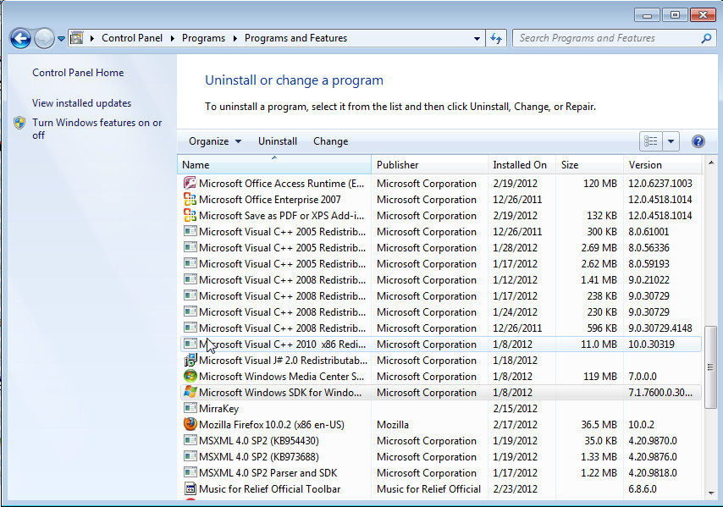

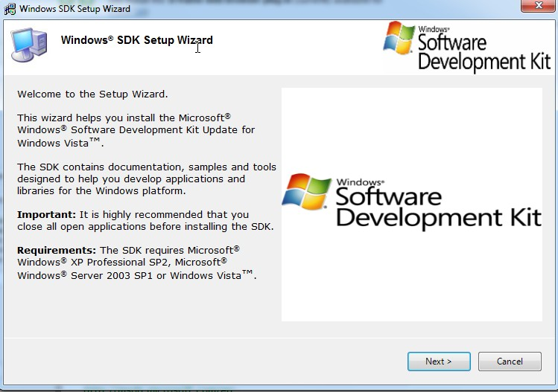

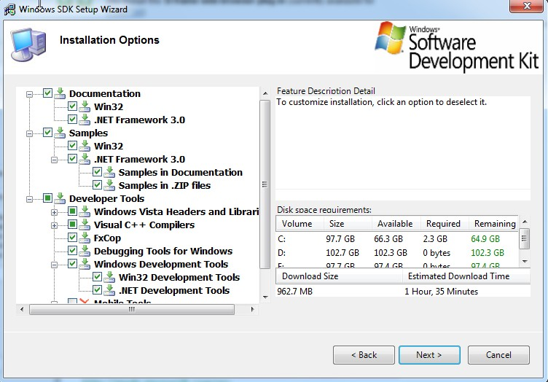

fig 4.4 Screenshot of windows sdk

**4.7 Introduction to C#:**

C# (pronounced C Sharp) is new technology that is much powerful and easy to learn. It consists of thousands of prebuilt classes and interfaces that lets programmer to write powerful code in very less time.

* **Key Features of C#:**

1. **Simple:** It simplifies C++ by eliminating some operator such as ->, :: and pointers.
2. **Consistent:**  It supports a unified type system which eliminates the problem of varying ranges of integer types. All types are treated as object and developers can extend the type system simply and easily.
3. **Modern:** It supports, Automatic garbage collection, modern approach to debugging, rich intrinsic model for error handling, decimal data type for financial application and robust security model.
4. **Object-Orient:** It supports all the three tenets of object-oriented system, namely Encapsulation, Inheritance and Polymorphism.
5. **Type-Safe:** Type safety promotes robust programs, C# incorporates a number of type-safe measures **:-**
   * 1. All dynamically allocated object and arrays are initialized to zero.
     2. Use of any uninitialized variables produces an error message by the compiler.
     3. Accesses to array are range checked and warned if it goes out-of-bounds.
     4. C# does not permit unsafe casts and enforces overflow checking in arithmetic’s operation.
     5. Reference parameters that are passed are type-safe.
     6. C# supports automatic garbage collection.
6. **Version able:** Making new versions of software modules work with the existing  applications is known as versioning with the help of new and override keywords, With this support, a programmer can guarantee that his new class library will maintain binary compatibility with the existing client application.
7. **Flexible:** Although C# does not support pointers we may declare certain classes and methods as ‘unsafe’ and then use pointers to manipulate them. These codes are not being type-safe.
8. **Inter-Operability:** C# provides support for using COM objects, no matter what language was used to author them. C# also supports a special feature that enables a program to call out any native API.

* **Reasons to Use C#:**

1. **C# is better than Java (in that):**
2. Everything that can be written in Java can be written in C# just as easily or easier, but the reverse is not true. Many features such as lambda expression is impossible (or very hard in Java), and C# also has syntactic sugar that makes things a lot easier, such as extension method, automatic properties.
3. There are a few things that C# does that Java doesn't: value types (Java has primitives, but no user-defined value types), generics support value types (Java can only use the wrapper classes of primitives in generics), reified generics (actually different code for different generic arguments, especially important with value types), partial classes.
4. C# does provide features that Java lacks, e.g. direct support for certain programming idioms like properties, functional programming style, and so on.
5. It supports both reference-type (class) and value-type (struct) user-defined types, which, if you know what you are doing, can yield significant performance benefits.
6. C# is a very good language if:
   1. You want to do general purpose object oriented development. It's a classic, statically typed OOP language.
   2. C# as a language is nicer than Java in various ways (better syntax for properties, value types, reified generics etc.).
7. **C# is better than C++ (in that):**
8. It allows you to treat class-methods' signatures as free functions (i.e. ignoring the statically typed this pointer argument), and hence create more dynamic and flexible relationships between classes They can just assign a void() method of any class to any other void() delegate.
9. It has a huge standard library with useful stuff that's well-implemented and easy to use.
10. It allows for both managed and native code blocks.
11. Assembly versioning easily remedy DLL hell problems.
12. You can set classes, methods and fields to be assembly-internal (which means they are accessible from anywhere within the DLL they're declared in, but not from other assemblies).
13. It does away with header files, which translates to great simplicity.
14. C# has a higher level of abstraction than C++, which is an advantage when development time is more important that program speed.

**4.8 SQLite**

SQLite is a [relational database management system](http://en.wikipedia.org/wiki/Relational_database_management_system) contained in a small (~350 [KB](http://en.wikipedia.org/wiki/Kilobyte)) C Programming [library](http://en.wikipedia.org/wiki/Library_(computer_science)). In contrast to other database management systems, SQLite is not a separate process that is accessed from the client application, but an integral part of it.

SQLite is [ACID](http://en.wikipedia.org/wiki/Atomicity,_consistency,_isolation,_durability)-compliant and implements most of the [SQL](http://en.wikipedia.org/wiki/SQL) standard, using a dynamically and weakly typed SQL [syntax](http://en.wikipedia.org/wiki/Syntax) that does not guarantee the [domain integrity](http://en.wikipedia.org/wiki/Integrity_constraints). SQLite is a popular choice as [embedded database](http://en.wikipedia.org/wiki/Embedded_database) for local/client storage in [application software](http://en.wikipedia.org/wiki/Application_software) such as [web browsers](http://en.wikipedia.org/wiki/Web_browser). It is arguably the most widely deployed [database engine](http://en.wikipedia.org/wiki/Database_engine), as it is used today by several widespread browsers, [operating systems](http://en.wikipedia.org/wiki/Operating_system), and embedded, among others.[.](http://en.wikipedia.org/wiki/SQLite#cite_note-5) SQLite has many [bindings](http://en.wikipedia.org/wiki/Language_binding) to programming languages. The [source code](http://en.wikipedia.org/wiki/Source_code) for SQLite is in the [public domain](http://en.wikipedia.org/wiki/Public_domain).

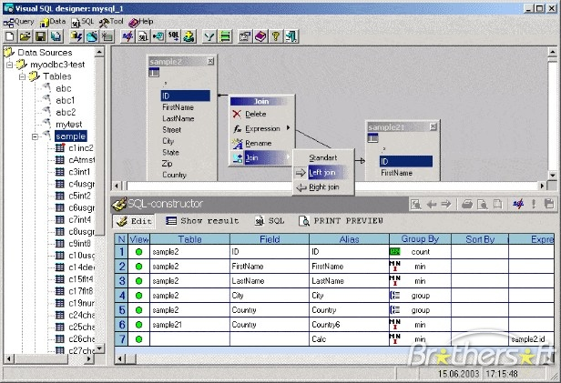

fig 4.5 Screenshot of SQLite

**4.9 R-sync algorithm for encryption**

R-sync is a [utility software](http://en.wikipedia.org/wiki/Utility_software) and [network protocol](http://en.wikipedia.org/wiki/Network_protocol) for [Unix-like](http://en.wikipedia.org/wiki/Unix-like) systems (with [ports](http://en.wikipedia.org/wiki/Porting) to [Microsoft Windows](http://en.wikipedia.org/wiki/Microsoft_Windows) and [Apple Macintosh](http://en.wikipedia.org/wiki/Apple_Macintosh)) that [synchronizes files](http://en.wikipedia.org/wiki/File_synchronization) and [directories](http://en.wikipedia.org/wiki/Directory_(file_systems)) from one location to another while minimizing [data](http://en.wikipedia.org/wiki/Data) transfer by using [delta encoding](http://en.wikipedia.org/wiki/Delta_encoding) when appropriate. R-sync is a file transfer program for Unix systems. R-sync uses the 'r-sync algorithm' which provides a very fast method for bringing remote files into sync.". A feature of r-sync not found in most similar programs/protocols is that the [mirroring](http://en.wikipedia.org/wiki/Mirror_(computing)) takes place with only one transmission in each direction, eliminating the message latency overhead inherent in transmitting a large number of small messages. R-sync can copy or display directory contents and copy files, optionally using [compression](http://en.wikipedia.org/wiki/Data_compression) and [recursion](http://en.wikipedia.org/wiki/Recursion).

R-sync listens on the default [TCP](http://en.wikipedia.org/wiki/Transmission_Control_Protocol) [port](http://en.wikipedia.org/wiki/TCP_and_UDP_port), 873, serving files in the native r-sync protocol. You can also implicitly start it through a remote [shell](http://en.wikipedia.org/wiki/Shell_(computing)) such as [RSH](http://en.wikipedia.org/wiki/Remote_Shell) or [SSH](http://en.wikipedia.org/wiki/Secure_Shell) Of course in both cases you need an r-sync client executable installed on the local machine; in the latter case the client executable, that gets started by you implicitly on the remote machine, acts as a server. Released under the [GNU General Public License version 3](http://en.wikipedia.org/wiki/GNU_General_Public_License#Version_3), r-sync is [free software](http://en.wikipedia.org/wiki/Free_software), and is widely used.

**4.10 PICSEL EDITOR**

Picsel is a trademark used by a [software company](http://en.wikipedia.org/wiki/Software_company) that develops products for [handheld devices](http://en.wikipedia.org/wiki/Handheld_devices) such as [mobile phones](http://en.wikipedia.org/wiki/Mobile_phone) and tablets. Picsel produces Picsel Smart Office, and other [Office suite](http://en.wikipedia.org/wiki/Office_suite) software for [viewing](http://en.wikipedia.org/wiki/File_viewer) and editing documents on mobile devices. It has also developed other software such as[web browsers](http://en.wikipedia.org/wiki/Microbrowser) and [user interface](http://en.wikipedia.org/wiki/User_interface) development tools, although these other software products have only had very limited commercial success.

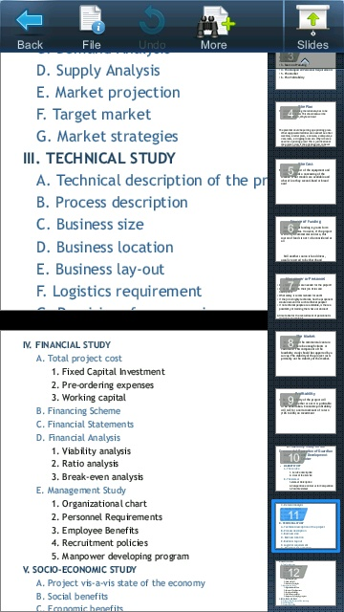

fig 4.6 Screenshot of picsel editor

**APPENDIX A: PROJECT PLAN**

|  |  |  |  |  |
| --- | --- | --- | --- | --- |
| **Sr. No** | **Task/Activity** | **Month/ Period** | **Expected deliverables** | **Work done/ Target achieved** |
| 1. | App Designing | 1 week | Software/ app design | Designing part of the application should be completed |
| 2. | Client-side functional implementation like sync, etc | 2-3 weeks | Functionalities implemented | Basic app functionalities ready. |
| 3. | Client-Side app edit functionality implementation | 2-3 weeks | Editor integrated | Implemented editing |
| 4. | Encryption | 3-4 weeks | Endpoint encryption | Encryption enabled for security |
| 5. | Database connectivity (SQLite) | 2-3 weeks | SQLite connectivity | Database repository functioning |
| 6. | Other implementations like caching, etc | 2-3 weeks | Cache implemented, other app detailing | Application model implemented |

**APPENDIX B: GLOSSARY**

**REFERENCES**

**Web references and documents**

* **http://d2jqdmsj5bf82f.cloudfront.net/docs/Vaultize%20Cloud-in-a-box%20-%20Brochure%2021082012.pdf**
* **http://d2jqdmsj5bf82f.cloudfront.net/docs/Vaultize%20Sharing%20Sync%20Backup%20and%20Mobility%20%20Brochure%2022022013.pdf**
* **http://d2jqdmsj5bf82f.cloudfront.net/docs/Vaultize%20Google%20Apps%20Backup%20-%20Brochure%2021082012.pdf**
* **http://tech.vaultize.com/**
* **http://punetech.com/interview-with-vaultize-pune-based-enterprise-file-sync-and-storage-service/**
* **http://www.vaultize.com/index.html**