Task 1: Federated Healthcare Problem Formulation

1.0 Literature Review Matrix
Author (s) | Year | Methodology | Key Findings | Limitations
Triastcyn & Faltings | 2019 | Bayesian Differential Privacy (BDP) in Federated Learning | Tighter privacy guarantees via distribution-adaptive noise; improved accuracy; fewer communication rounds | Not healthcare-specific; assumes known data distribution; no large-scale validation
Aledhari et al. | 2020 | Survey of FL architectures, protocols and applications | FL enables decentralized training without raw-data sharing; scalable collaborative learning | Generalized; no domain-specific healthcare experiments
Ouadrhiri & Abdelhadi | 2022 | Survey of Differential Privacy in Deep/Federated Learning | DP mitigates membership-inference and model-inversion attacks | Significant privacy-accuracy trade-off; high computational overhead
Sohan & Basalamah | 2023 | PRISMA-based review of FL in medical imaging (17 papers) | ~90% diagnostic accuracy while preserving privacy | Limited to imaging domain; small sample of studies
Rauniyar et al. | 2023 | Survey: taxonomy/trends of FL in medical applications | Secure distributed disease prediction; strong IoMT integration | No experimental validation; conceptual only
Bashir et al. | 2023 | Survey of FL in Healthcare Metaverse environments | Real-time monitoring and secure metaverse data sharing | Conceptual; no real-world deployment
Taha et al. | 2023 | Data-centric survey of FL in healthcare | Identifies non-IID data, communication overhead, resource constraints | No proposed solution; challenges-only focus
Annan et al. | 2025 | Review of genomic privacy & AI security mechanisms | FL + DP + cryptography prevent re-identification/inference attacks | Security-focused; no FL model implementation
Alghamdi et al. | 2025 | FIXAIH: Explainable AI (XAI) framework | Improves interpretability and clinician trust | No FL integration; no experimental healthcare model
Khowaja et al. | 2026 | Agentic FL with Differential Privacy + Multi-Agent RL | 94% accuracy in disease prediction with strong privacy and attack robustness | Partially synthetic data; high computational complexity
Table 1. Literature matrix of reviewed studies on federated learning, differential privacy, and healthcare AI

1.2 Literature review
Recent advances in artificial intelligence and distributed computing have shaped the development of privacy-preserving healthcare systems. Federated Learning has emerged as a promising approach that enables collaborative model training across institutions without requiring the sharing of sensitive patient data. Early work by Triastcyn and Faltings (2019) introduced Bayesian Differential Privacy, adapting injected noise to the underlying data distribution to improve the privacy-accuracy balance, though not specifically for clinical settings. Aledhari et al. (2020) provided a broad architectural overview of FL, establishing terminology and protocols later applied to healthcare, while Ouadrhiri and Abdelhadi (2022) examined how differential privacy mitigates membership-inference and model-inversion attacks at the cost of reduced accuracy.
Healthcare-specific applications followed: Sohan and Basalamah (2023) reviewed FL for medical imaging and reported diagnostic accuracy near 90% while preserving privacy, though restricted to imaging tasks. Rauniyar et al. (2023) mapped FL's role in distributed disease prediction and IoMT integration, and Bashir et al. (2023) extended this to healthcare-metaverse environments, though both studies remained largely conceptual. Taha et al. (2023) took a data-centric view, cataloguing non-IID data, communication overhead, and resource constraints as recurring implementation barriers.
More recent work has turned toward security and interpretability. Annan et al. (2025) combined FL with cryptographic techniques to protect genomic data from re-identification, and Alghamdi et al. (2025) proposed the FIXAIH explainable-AI framework to build clinician trust, though without FL integration. Khowaja et al. (2026) most closely anticipates the direction of this project, combining differential privacy with multi-agent reinforcement learning to reach 94% accuracy on multimodal EHR and imaging data while resisting poisoning and inference attacks — albeit using partially synthetic data and at high computational cost.
Taken together, the literature confirms that federated learning is a viable route to privacy-preserving, collaborative disease prediction, but that privacy-accuracy trade-offs, communication overhead, heterogeneous data, and limited real-world validation remain open problems — directly motivating the system proposed in this report.

1.3 Research Gaps
- Data heterogeneity (non-IID data): medical data varies significantly across hospitals and devices, limiting model generalization.
- Privacy-accuracy trade-off: stronger differential privacy guarantees introduce noise that reduces predictive accuracy.
- Communication overhead: frequent exchange of model updates increases bandwidth usage and limits large-scale deployment.
- Incomplete attack resistance: limited comprehensive protection against data poisoning, model inversion, and membership inference.
- Limited real-world validation: many studies rely on simulated or synthetic datasets rather than clinical deployments.
- Low interpretability: most FL models lack explainability, reducing clinician trust and adoption.
- Lack of systematic comparison: algorithms, privacy mechanisms, robust aggregation and communication-saving techniques are rarely evaluated together under identical, statistically tested conditions.

2.0 Federated Healthcare Architecture
The system architecture defined during problem formulation designates a fixed set of healthcare institutions as federated clients, each retaining a local model trained exclusively on its own patient data. Rather than transmitting raw records, each client sends only model updates (parameters or gradients) to a central federated server, which performs secure aggregation — using FedAvg, FedProx, or SCAFFOLD — to produce an updated global model. The global model is then broadcast back to all clients for the next training round. This client-server structure, illustrated below, underlies every subsequent design decision in this report, including the technology choices discussed right below the diagram.
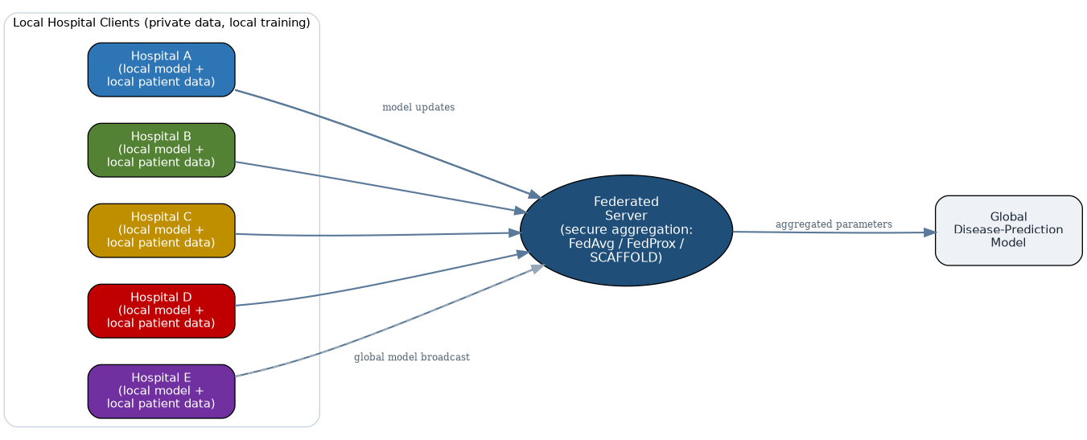
The architecture incorporates several key design principles grounded in federated-learning literature. First, data locality is enforced: raw patient records remain at each hospital and are never transmitted to the central server, addressing privacy concerns identified by Rauniyar et al. (2023) and Taha et al. (2023). Second, secure aggregation is used as a complementary security layer so that the server does not see individual hospital updates, while differential privacy is used to limit information leakage from model updates. Third, the system is designed for heterogeneous data: hospitals operate under different patient demographics, equipment, and EHR systems, so the federated server must tolerate non-IID data using specialized aggregation algorithms like FedProx. The server maintains no patient-level data itself, only the global model parameters, aggregated evaluation metrics, and metadata logs. This design choice aligns with regulatory-compliance requirements outlined in the market study, where data minimization and transparency are priorities. The architecture supports monitoring and diagnostics through logging data that tracks convergence, identifies stragglers, and flags potential data-poisoning attacks, consistent with security requirements identified by Annan et al. (2025).
Figure 1. Federated healthcare architecture: local hospital clients, federated server, and global disease-prediction model.

2.1 Selected Disease-Prediction Problem
Building on the candidate disease-prediction applications identified during problem formulation, the team has selected chronic disease risk prediction — specifically cardiovascular disease — from structured electronic health record (EHR) data as the primary application. This problem was chosen because it relies on tabular clinical features (e.g., age, blood pressure, glucose levels, cholesterol) that are consistently available across institutions, is well represented in the reviewed literature, and is naturally suited to simulating multiple non-IID hospital clients using publicly available, institution-segmented datasets.
Cardiovascular disease and diabetes represent significant global health burdens and are well-suited to predictive modeling. Risk prediction for these conditions relies on a stable set of tabular features: demographic information (age, gender, family history), vital signs (blood pressure, heart rate), and laboratory results (glucose, cholesterol). These features are routinely collected across most healthcare institutions and are relatively standardized, making them ideal for federated learning across heterogeneous hospitals.
The choice to focus on tabular EHR data offers several practical advantages. First, tabular models train quickly on edge devices with limited computational resources. Second, the models integrate seamlessly with differential-privacy noise injection using tools like Opacus and TensorFlow Privacy. Third, tabular predictions are easier to interpret and explain to clinicians, addressing the interpretability gap identified in recent literature.

2.2 Initial Research Gap
Problem formulation surfaced an initial gap centered on the difficulty of achieving accurate disease prediction while preserving patient privacy across institutions with heterogeneous data. The research-gap discussion in Section 1.3 elaborates this into seven specific gaps: data heterogeneity, the privacy-accuracy trade-off, communication overhead, incomplete adversarial-attack resistance, limited real-world clinical validation, low model interpretability, and the lack of a systematic joint comparison of techniques.

2.3 Research Questions
- RQ1: To what extent can differential privacy be integrated into a federated learning pipeline for disease prediction without significantly degrading predictive accuracy?
- RQ2: How does data heterogeneity (non-IID distribution) across simulated hospital clients affect the convergence and accuracy of federated disease-prediction models?
- RQ3: Which federated aggregation algorithm — FedAvg, FedProx, or SCAFFOLD — offers the best trade-off between accuracy, communication overhead, and robustness to heterogeneous data for this task?
- RQ4: Can model interpretability be improved without compromising privacy guarantees or aggregation efficiency?
- RQ5: Do normalised averaging (FedNova) and adaptive server optimisers (FedAdam, FedYogi, FedAdagrad) improve convergence speed and accuracy over FedAvg, FedProx and SCAFFOLD on non-IID hospital data?
- RQ6: How do DP-SGD, local differential privacy, secure aggregation, homomorphic encryption and the hybrid DP + secure aggregation compare in privacy budget (epsilon), utility loss, communication cost and training time?
- RQ7: How resilient are robust aggregation rules (Krum, Multi-Krum, Trimmed Mean, Median) and federated adversarial training to poisoned or Byzantine clients, and how much communication can FedPAQ, quantisation and sparsification save without significant accuracy loss?

2.4 Candidate Datasets
The following publicly available datasets were identified as candidates for simulating multi-institution federated training and evaluation.
Dataset | Domain / Type | Relevance to Federated Simulation
Heart Disease UCI (Cleveland, Hungary, Switzerland, VA Long Beach subsets) | Tabular clinical records; cardiovascular disease | Four naturally separate institutional subsets directly support simulating distinct, non-IID hospital clients
Pima Indians Diabetes Dataset | Tabular clinical records; diabetes | Compact, widely used benchmark for local client training and quick prototyping
MIMIC-III / MIMIC-IV | ICU electronic health records (structured + notes) | Large-scale, realistic EHR data for later-stage validation at greater scale and complexity
Chronic Kidney Disease dataset (UCI) | Tabular clinical records; kidney disease | Additional disease-prediction task to test generalizability of the federated pipeline
Table 2. Candidate datasets for federated disease-prediction experiments.

2.5 Initial Selection of ML Models and FL Algorithms
For local model training, three candidate machine learning models have been shortlisted: logistic regression, as an interpretable baseline; random forest, for improved accuracy on tabular clinical data; and a feed-forward neural network (multilayer perceptron), for compatibility with gradient-based federated aggregation and differential-privacy noise injection. For federated coordination, three aggregation algorithms have been shortlisted: FedAvg, as the standard baseline; FedProx, which adds a proximal term to better tolerate heterogeneous (non-IID) client data; and SCAFFOLD, which uses control variates to reduce client drift under heterogeneity.
The experiment design will compare logistic regression and the feed-forward neural network across the three aggregation algorithms. Random forest will be retained as a centralized non-federated baseline because standard random-forest training does not map directly onto gradient-based FedAvg, FedProx, and SCAFFOLD aggregation.
Extension following the suggested study areas. The shortlist of federated algorithms is extended with FedNova, FedAdam, FedYogi and FedAdagrad, and the privacy and security options with local differential privacy, secure aggregation, homomorphic encryption, robust aggregation (Krum, Multi-Krum, Trimmed Mean, Median), federated adversarial training, and communication-efficient methods (FedPAQ, quantisation, sparsification). The resulting comparative framework, metrics and statistical protocol are defined in Sections 2.8 to 2.11, and the implementation is given in Section 2.12 and Appendix A.
2.6 Detailed Algorithm Implementation Strategies
Federated Averaging (FedAvg)
FedAvg is the foundational algorithm that enables federated learning. In each communication round t, the federated server maintains a global model with parameters w_t. The algorithm operates as follows:
(1) Server Initialization: The server initializes a global model w_0 (e.g., logistic regression weights) with random or zero values.
(2) Client Selection and Local Training: In round t, the server selects a subset of K clients (hospitals). Each selected client k:
- Receives the current global model w_t
- Performs local training on its private data D_k for E epochs using stochastic gradient descent (SGD)
- Computes local updates: w_k,t = w_t - η∇F_k(w_t), where η is the learning rate and ∇F_k is the gradient of the loss function on client k's data
- Returns only the updated weights w_k,t to the server (not the raw data D_k)
(3) Server Aggregation: The server aggregates the local updates using weighted averaging:
w_{t+1} = Σ_k (n_k / n) * w_k,t
where n_k is the number of samples at client k and n is the total number of samples across all clients.
(4) Convergence Check: The server evaluates the global model on a validation dataset (pooled from all clients or held separately) to track convergence and privacy budget consumption.
(5) Rounds Continue: Steps 2-4 repeat until convergence or a maximum number of rounds is reached.
FedAvg's key advantage is simplicity: it requires minimal communication (only model parameters, not data) and works with any gradient-based model including logistic regression and neural networks. However, FedAvg can be affected by substantial non-IID data. When client data distributions differ significantly, model updates may diverge, causing slower convergence or accuracy degradation.
Federated Proximal (FedProx)
FedProx addresses FedAvg's limitation by adding a proximal term to each client's local objective function. Instead of minimizing only the local loss, each client k minimizes:
F_k(w) + (μ/2)||w - w_t||²
where μ is a regularization hyperparameter and ||w - w_t||² is the squared Euclidean distance between the client's updated model and the global model.
Key differences from FedAvg:
(1) Local Objective Modification: The proximal term penalizes large deviations from the global model, encouraging local models to remain close to the global model even when local data distributions differ.
(2) Heterogeneity Tolerance: By constraining w_k,t to stay near w_t, FedProx reduces client drift — the tendency for heterogeneous clients to learn divergent models. This is especially important in healthcare where different hospitals may have different patient demographics, disease prevalence, and EHR systems.
(3) Convergence Properties: FedProx has proven convergence guarantees for non-IID data under convex and non-convex loss functions, making it theoretically sound for real-world healthcare scenarios.
(4) Implementation: For logistic regression, the proximal term is simply added to the cross-entropy loss:
L_k(w) = CrossEntropy(w) + (μ/2)||w - w_t||²
For neural networks, the term is added to the final loss layer.
FedProx's trade-off is that the proximal term introduces an additional hyperparameter μ that must be tuned. Too small and heterogeneity is not addressed; too large and convergence is slow.
SCAFFOLD (Stochastic Controlled Averaging for Federated Learning)
SCAFFOLD is more advanced, using control variates to explicitly estimate and correct for client drift. The algorithm maintains two sets of parameters at each client and the server:
(1) Model Parameters: w_t (server) and w_k,t (client k) — same as FedAvg/FedProx
(2) Control Variates: c_t (server) and c_k,t (client k) — new parameters that track cumulative drift
Algorithm steps:
(1) Initialization: c_0 = 0 (both server and clients)
(2) In each round t, client k:
- Receives w_t and c_t from the server
- Computes the drift-adjusted gradient: ∇_adj = ∇F_k(w_t) - c_k,t + c_t
- Performs local SGD updates: w_k,t = w_t - η * ∇_adj
- Computes the new control variate: c_k,t = c_k,t - (1/E) * (∇F_k(w_k,t) - ∇F_k(w_t))
(3) Server aggregates:
- w_{t+1} = Σ_k (n_k/n) * w_k,t
- c_{t+1} = Σ_k (n_k/n) * c_k,t
(4) Key insight: The control variate c_k,t estimates the difference between client k's local gradient and the global gradient. By subtracting c_k,t and adding the global c_t, SCAFFOLD reorients each client's optimization direction toward the global objective, not the local objective.
SCAFFOLD Advantages:
- Convergence rate faster than FedAvg/FedProx on non-IID data (proven theoretically)
- Works with non-convex loss functions (important for neural networks)
- Automatically adapts to data heterogeneity without requiring manual tuning of a proximal term
SCAFFOLD Disadvantages:
- Requires communication of both model parameters and control variates (roughly 2x communication overhead vs. FedAvg)
- More complex to implement, increasing computational cost per client
- Control variates add memory overhead at each client
Integration with Logistic Regression
For the proposed system using logistic regression as the primary model, here's how each algorithm would be deployed:
Logistic Regression Model: Each client k maintains a logistic regression classifier:
y_pred = sigmoid(w^T * x + b)
where w is the weight vector, b is the bias, x is the feature vector, and sigmoid is the logistic sigmoid function.
Loss Function: Binary cross-entropy (for binary classification like cardiovascular disease presence/absence):
L(w) = -[y*log(y_pred) + (1-y)*log(1-y_pred)]
Algorithm Application:
1. FedAvg with Logistic Regression: Each client trains its logistic regression weights locally using SGD, then the server averages these weights. This is the simplest and fastest approach but may underperform if hospitals have different disease prevalence.
2. FedProx with Logistic Regression: Each client adds the proximal term to its cross-entropy loss, preventing weight drift. This is recommended when we know hospitals have significantly different patient populations.
3. SCAFFOLD with Logistic Regression: Each client maintains control variates alongside its logistic regression weights. This is the most robust approach, automatically adapting to whatever heterogeneity exists in the data.
For the federated disease-prediction system, we recommend:
- Start with FedAvg as the baseline for simplicity and speed
- Use FedProx if initial FedAvg experiments show performance degradation due to non-IID data
- Deploy SCAFFOLD if FedProx still shows convergence issues and if communication bandwidth permits
2.7 Practical Implementation Considerations for Hospital Deployment
When deploying the proposed federated learning system across multiple hospitals, several practical considerations must be addressed:
Data Preprocessing and Standardization
Different hospitals often use different EHR systems, equipment, and coding standards. Before federated training can begin, each hospital must preprocess its data locally to match a standardized schema. For the logistic regression model predicting cardiovascular disease, standardization includes:
(1) Feature Normalization: Blood pressure, glucose, and cholesterol measurements are normalized using z-score normalization (subtract mean, divide by standard deviation) computed on each hospital's local data. This prevents hospitals with different measurement scales from biasing the global model.
(2) Missing Data Imputation: Different hospitals may have different rates of missing laboratory results. Each hospital imputes missing values locally using mean imputation (for numerical features) or mode imputation (for categorical features), consistent with clinical ML best practices.
(3) Feature Encoding: Categorical features like smoking status or gender are one-hot encoded locally, ensuring consistent encoding across all hospitals.
(4) Label Definition: The target variable (presence/absence of cardiovascular disease) must be defined consistently. This requires coordination across hospitals to agree on a unified clinical definition, e.g., "any documented history of myocardial infarction, angina, or coronary artery disease."
Computational and Network Constraints
Healthcare institutions often operate with limited computational resources and network bandwidth. The federated system must be designed to accommodate these constraints:
(1) Model Size: Logistic regression is lightweight (typically 10-100 parameters for a disease-prediction model), making it suitable for low-bandwidth settings. In contrast, large neural networks with millions of parameters would be infeasible for many hospitals. This is another advantage of logistic regression over deeper models in real-world healthcare deployment.
(2) Communication Frequency: Not all hospitals can train simultaneously. The federated server must tolerate stragglers — hospitals that take longer to complete each training round due to computational constraints or network issues. The federated server must tolerate stragglers—hospitals that take longer to complete each training round because of computational constraints or network issues. Client availability and variable local work should therefore be incorporated into the experimental design.
(3) Batch Size: Each hospital must choose a local batch size for SGD training. Larger batch sizes reduce variance but require more memory; smaller batches save memory but introduce more noise. The choice depends on the hospital's available computational resources.
Privacy Budget Management and Differential Privacy Integration
The federated system must enforce privacy budgets to ensure that cumulative model updates do not leak sensitive information through gradient inversion attacks. This involves:
(1) Local DP-SGD: Each hospital can apply differential privacy to its local training using DP-SGD (Differentially Private Stochastic Gradient Descent), which clips gradients and adds Gaussian noise before sending updates to the server. This requires the Opacus library (for PyTorch) or TensorFlow Privacy.
(2) Privacy Budget (Epsilon): Each hospital allocates a total privacy budget ε (epsilon) representing the maximum allowable privacy loss. As rounds progress, the budget is consumed. When ε is depleted, the hospital must stop participating in federated training to preserve privacy.
(3) Delta Parameter: In addition to ε, practitioners specify δ (delta), the probability of differential privacy violation. Typical values are δ = 10^-6, meaning a 1-in-a-million chance that privacy is violated.
(4) Server-Side Privacy: Even if hospitals don't use local DP-SGD, the server can apply privacy amplification by subsampling (training on a random subset of clients each round) or secure aggregation (using cryptographic techniques so the server never sees individual hospital updates, only aggregated results).
Model Validation and Evaluation
In federated learning, validation is more complex than in centralized ML:
(1) Holdout Test Sets: Each hospital should maintain a local holdout test set (not used in training) to evaluate local model performance and detect data drift or model degradation.
(2) Global Validation: The server can maintain a small pooled validation set (with explicit consent from participating hospitals) to track global model performance without requiring data sharing.
(3) Metrics: For disease prediction (binary classification), standard metrics include:
- Accuracy: fraction of correct predictions
- Precision: true positives / (true positives + false positives)
- Recall: true positives / (true positives + false negatives)
- AUROC (Area Under Receiver Operating Characteristic Curve): measure of how well the model discriminates between diseased and healthy patients
- AUPRC (Area Under Precision-Recall Curve): especially important when disease prevalence is low
(4) Fairness and Bias Auditing: Federated systems must audit the global model for bias — e.g., does cardiovascular disease prediction accuracy vary across demographic groups (age, gender, race)? Disparity in model accuracy can undermine clinical trust and fairness.
→ Solution: Each hospital applies DP-SGD locally before sending updates, while secure aggregation can additionally prevent the server from observing individual updates. We will measure the accuracy vs. privacy trade-off across selected privacy budgets (for example, ε = 1, 5, and 10).

2.8 Extended Study of Techniques (Instructor-Suggested Study Areas)
Following the guidance provided after Task 1, the study design is extended from a three-algorithm comparison (FedAvg, FedProx, SCAFFOLD) combined with differential privacy into a systematic comparison across four technique groups: (i) federated learning algorithms, (ii) privacy-preserving techniques, (iii) security-oriented techniques, and (iv) communication-efficient techniques. Figure 2 summarises the techniques covered in each group and the evaluation metrics applied to all of them. Every technique listed here is implemented in the accompanying Python code (Section 2.12 and Appendix A) so that the comparison can be reproduced on the heart-disease data.
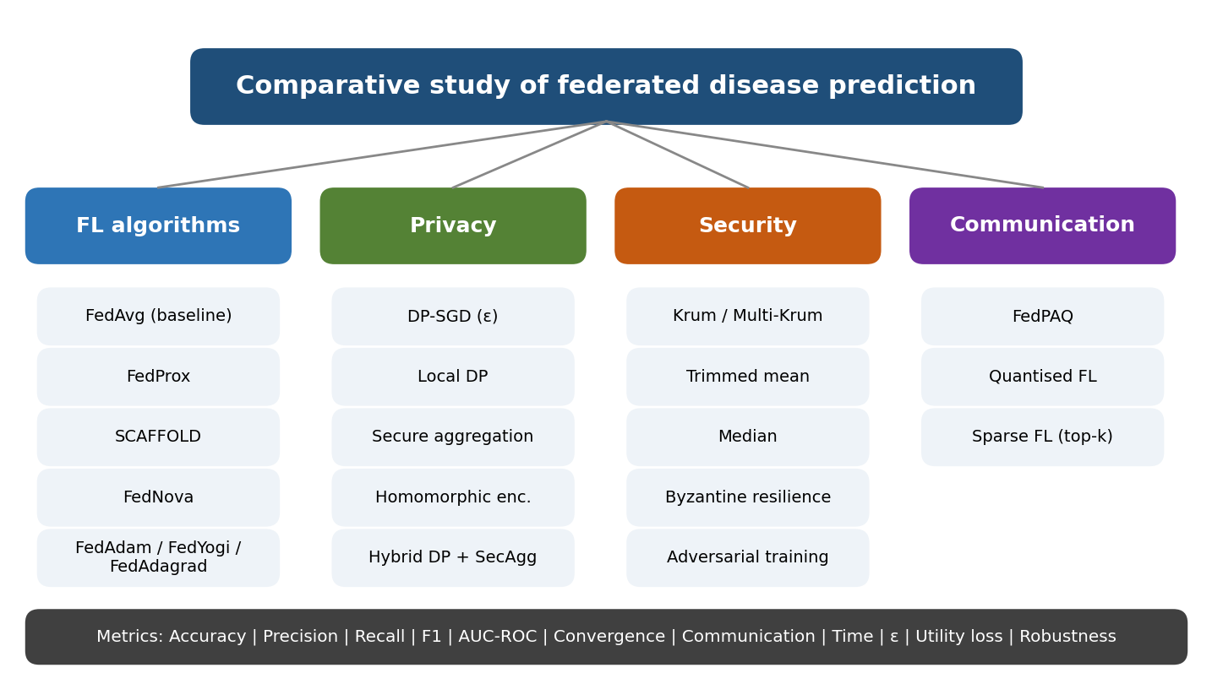
Figure 2. Taxonomy of the techniques compared in the extended study and the shared evaluation metrics.

2.8.1 Federated Learning Algorithms
Section 2.6 described FedAvg, FedProx and SCAFFOLD. Two further families are added. FedNova addresses objective inconsistency: when hospitals perform different numbers of local steps τ_k (because their datasets differ in size, or because slower hospitals complete fewer epochs), plain FedAvg implicitly minimises a surrogate objective that is biased towards the clients that did more work. FedNova divides each client update by its number of local steps, d_k = (w_k − w_t) / τ_k, averages the normalised updates and rescales by the effective step count: w_(t+1) = w_t + τ_eff · Σ_k p_k d_k, with τ_eff = Σ_k p_k τ_k and p_k = n_k / n.
Adaptive federated optimisation (FedAdam, FedYogi, FedAdagrad) treats the averaged client update Δ_t = Σ_k p_k (w_k − w_t) as a pseudo-gradient and feeds it to an adaptive server-side optimiser: m_t = β1 · m_(t−1) + (1 − β1) · Δ_t, and w_(t+1) = w_t + η · m_t / (√v_t + τ). The three methods differ only in the second-moment update: FedAdagrad uses v_t = v_(t−1) + Δ_t²; FedAdam uses v_t = β2 · v_(t−1) + (1 − β2) · Δ_t²; FedYogi uses v_t = v_(t−1) − (1 − β2) · Δ_t² · sign(v_(t−1) − Δ_t²). Clients run ordinary local SGD, so no extra client-side computation or communication is needed.
In the implementation, SCAFFOLD uses the control-variate update of Option II in the original SCAFFOLD paper, c_k+ = c_k − c + (w_t − w_k) / (τ · η), which replaces the simplified gradient-difference expression written in Section 2.6; the server update of the global control variate is c ← c + (|S|/N) · mean(Δc_k).
Technique | Core idea | Problem addressed | Cost / limitation | Role in this study
FedAvg | Weighted average of locally trained models | Baseline collaborative training | Drifts under non-IID data | Reference baseline
FedProx | Proximal term (μ/2)||w − w_t||² in local loss | Client drift, heterogeneity | Extra hyper-parameter μ | Convergence stability vs FedAvg
SCAFFOLD | Control variates correct local gradients | Strong non-IID drift | 2x communication and client memory | Highly non-IID comparison
FedNova | Normalises updates by local step count | Objective inconsistency from unequal local work | Needs step counts; small server overhead | Tested with 1-4 random local epochs
FedAdam / FedYogi / FedAdagrad | Adaptive server optimiser on averaged update | Slow or unstable convergence | Extra server state and tuning (η, τ) | Faster convergence candidates
Table 3. Federated learning algorithms included in the extended study.

2.8.2 Privacy-Preserving Techniques
Five privacy mechanisms are compared. They protect against different threats, so they are complementary rather than interchangeable.
- Differential Privacy with DP-SGD. Each hospital clips every per-example gradient to norm C and adds Gaussian noise N(0, (σC)²) to the summed gradient before the update. The privacy budget is tracked with a Rényi-DP accountant for the sub-sampled Gaussian mechanism and converted to (ε, δ)-DP at δ = 10⁻⁶; the reported ε is the worst case over hospitals. The noise multiplier σ is calibrated automatically to hit a target ε (1, 5 or 10).
- Local Differential Privacy (LDP). The hospital clips its whole model update to norm C and adds Gaussian noise itself before transmission, so even the server is not trusted. Because every update is perturbed in every round and no sub-sampling amplification applies, the same ε requires more noise than DP-SGD and a larger utility loss is expected.
- Secure Aggregation. Each pair of hospitals shares a seed; one adds and the other subtracts a pseudo-random mask on fixed-point-encoded updates (modulo 2³²). The server only sees masked vectors, yet the masks cancel exactly in the sum, so accuracy is unchanged while individual updates stay hidden. The overhead is 32-bit integer vectors plus pairwise key material.
- Homomorphic Encryption (HE). Updates are encrypted with the additively homomorphic Paillier scheme; the server adds ciphertexts without decrypting and only the key holder opens the sum. Protection is strong, but a ciphertext is 2 x key-length bits per parameter (256 bytes at 1024 bits versus 4 bytes for a float) and encryption is orders of magnitude slower.
- Hybrid DP + Secure Aggregation. Secure aggregation hides individual updates from the server, while DP-SGD bounds what the released aggregate (the global model) can reveal about any patient. Together they give layered protection, which is the configuration most often proposed for practical deployments.
Technique | Protects against | Where noise / crypto is applied | Main trade-off
DP-SGD | Membership inference, model inversion on the model | Per-example gradients at each hospital | Accuracy falls as epsilon decreases
Local DP | Untrusted or curious server | Whole update, at the client | Largest utility loss for the same epsilon
Secure aggregation | Curious server seeing single updates | Pairwise masks on updates | Extra communication; no bound on leakage from the aggregate
Homomorphic encryption | Curious server and network eavesdroppers | Encrypted updates | Very high computation and ciphertext size
DP + SecAgg | Both of the above | Both layers | Sum of both overheads
Table 4. Privacy-preserving techniques, threat models and trade-offs.

2.8.3 Security-Oriented Techniques
Federated learning is exposed to poisoned or malicious clients, because the server cannot inspect local data. Four robust aggregation rules replace the plain average: Krum selects the single update whose summed squared distance to its K − f − 2 nearest neighbours is smallest (requires K ≥ 2f + 3); Multi-Krum averages the K − f best-scoring updates; Trimmed Mean discards the largest and smallest fraction β of values in every coordinate before averaging; and Median takes the coordinate-wise median. For Byzantine-resilience testing, three attacks are simulated: label flipping (data poisoning), sign flipping scaled by a factor of 3 (model poisoning), and random Gaussian updates. The evaluation uses 12 clients (each hospital split into three shards) of which 3 are malicious.
Federated adversarial training augments every local mini-batch with FGSM adversarial examples (x + ε · sign of the input gradient, which for logistic regression is available in closed form). Robustness is measured as accuracy on FGSM-perturbed test records. An important design observation is that robust aggregation needs access to individual updates, which secure aggregation and HE deliberately hide; the code therefore refuses to combine them, and this tension is itself a finding to be discussed in the paper.
Technique | Mechanism | Assumption / limitation
Krum | Select the most central update | Needs K ≥ 2f + 3; discards honest information
Multi-Krum | Average the K − f best Krum scores | Same assumption; less variance than Krum
Trimmed Mean | Coordinate-wise trimming, then mean | Needs β ≥ fraction of attackers
Median | Coordinate-wise median | Statistically less efficient on honest data
Byzantine-resilient FL | Evaluate rules under label-flip, sign-flip and Gaussian attacks | Attack strength is simulated
Federated adversarial training | Train on FGSM-perturbed samples | FGSM is a single-step, tabular-data approximation
Table 5. Security-oriented techniques included in the study.

2.8.4 Communication-Efficient Techniques
FedPAQ combines periodic averaging (several local epochs between communications), partial client participation (50% of hospitals per round) and quantised uploads. Quantised FL compresses each update with unbiased stochastic uniform quantisation to 8, 4 or 2 bits per value. Sparse FL transmits only the top-k largest-magnitude coordinates (10% or 30%) and keeps the discarded remainder in a local error-feedback memory so that no information is permanently lost. Communication cost is accounted in both directions (compressed upload plus full-precision broadcast of the global model, and twice that for SCAFFOLD). Because the logistic-regression model has only 23 parameters, absolute savings are small; the techniques become important when the same pipeline is applied to the multilayer-perceptron model of Section 2.5.
Technique | Mechanism | Expected effect
FedPAQ | Periodic averaging + partial participation + quantisation | Far fewer and smaller messages; slightly noisier convergence
Quantised FL | b-bit stochastic quantisation of updates | About 4x-16x smaller uploads with little accuracy loss
Sparse FL | Top-k coordinates with error feedback | Uploads shrink to k x 8 bytes; convergence may slow at small k
Table 6. Communication-efficient techniques included in the study.

2.9 Recommended Comparative Framework
The main experiment compares the eight configurations below on identical data splits. The first four isolate the effect of the aggregation algorithm; the last four add privacy layers on top of FedAvg or FedProx, so that every privacy cost can be attributed to a specific mechanism. The DP rows are additionally repeated for ε = 1, 5 and 10 to plot the privacy-utility curve. The remaining techniques of Section 2.8 (FedNova, FedYogi, FedAdagrad, Local DP, HE, robust aggregation, adversarial training and the communication-efficient methods) are evaluated in four supporting experiments.
# | Configuration | Aggregation | Privacy layer | Question answered
1 | FedAvg | Weighted average | None | Reference baseline
2 | FedProx | Proximal local objective | None | Is training more stable on non-IID hospitals? (RQ2, RQ3)
3 | SCAFFOLD | Control variates | None | Does drift correction justify 2x communication?
4 | FedAdam | Adaptive server optimiser | None | Does adaptive optimisation converge faster? (RQ5)
5 | FedAvg + DP | Weighted average | DP-SGD | What does DP cost on the baseline? (RQ1)
6 | FedProx + DP | Proximal local objective | DP-SGD | Does FedProx tolerate DP noise better?
7 | FedProx + SecAgg | Proximal local objective | Secure aggregation | Cost of hiding individual updates (RQ6)
8 | FedProx + DP + SecAgg | Proximal local objective | DP-SGD + secure aggregation | Cost and benefit of layered protection (RQ6)
Table 7. Recommended comparative framework (eight configurations).

2.10 Evaluation Metrics
All methods are evaluated on the pooled held-out test records of all hospitals (20% of each hospital, never used for training) with the metrics below, computed in metrics.py and server.py.
Metric | Definition | Purpose
Accuracy, Precision, Recall, F1-Score | Standard confusion-matrix metrics at threshold 0.5 | Predictive quality; recall matters most for screening
AUC-ROC | Probability a diseased patient is ranked above a healthy one (Mann-Whitney U) | Threshold-independent discrimination
Convergence rate | Rounds until global test loss is within 3% of the centralised logistic-regression loss (R + 1 = never reached) | Speed and stability of each algorithm (RQ2, RQ3, RQ5)
Communication cost | Total kilobytes sent in both directions over all rounds | Bandwidth burden (Section 2.7)
Training time | Wall-clock seconds of the simulated federated run | Computational overhead of privacy and security layers
Privacy budget (ε) | (ε, δ)-DP at δ = 10⁻⁶ from the Rényi-DP accountant, worst case over hospitals | Quantifies privacy protection (RQ1)
Utility loss (%) | 100 x (F1 of non-private counterpart - F1 of private method) / F1 of non-private counterpart | Privacy-utility trade-off
Robustness against client poisoning | F1 under attack as a percentage of clean F1 (label flipping at one hospital; robust-aggregation study uses 3 of 12 clients) | Security evaluation (RQ7)
Adversarial accuracy | Accuracy on FGSM-perturbed test records | Effect of federated adversarial training
Table 8. Evaluation metrics used in the comparative study.

2.11 Proposed Research Contribution and Statistical Validation
A stronger contribution than evaluating only FedAvg, FedProx and differential privacy is a systematic study titled "Comparative Analysis of FedAvg, FedProx, SCAFFOLD and FedAdam with Differential Privacy and Secure Aggregation for Privacy-Preserving Federated Learning". It would provide:
- Algorithm comparison: convergence and accuracy of four aggregation strategies on naturally non-IID hospitals.
- Privacy comparison: DP-SGD, Local DP, secure aggregation, HE and their hybrid, with measured ε.
- Security comparison: robust aggregation rules and adversarial training under three attack types.
- Privacy-utility trade-off analysis: utility loss against ε, communication and training time.
- Statistical significance testing: every comparison repeated over multiple random seeds.
Statistical protocol: each configuration is run with 10 different random seeds (different train/test splits, shuffling and initial noise). Differences from the baseline are tested with the paired Wilcoxon signed-rank test (primary) and the paired t-test (secondary), and p-values are adjusted with the Holm-Bonferroni correction because many configurations are compared. With fewer than six seeds the Wilcoxon test cannot reach p < 0.05, so at least six, and preferably ten, seeds are required. Results are reported as mean +/- standard deviation.

2.12 Implementation and Experimental Protocol
The complete simulation framework is written in Python (NumPy, SciPy, scikit-learn, Matplotlib and the optional python-paillier package) and is listed in Appendix A. The modules and their roles are summarised below.
File | Purpose
config.py | FLConfig dataclass describing one complete experiment
data.py | UCI loader, synthetic fallback, local pre-processing (imputation, z-score, one-hot), client construction
model.py | Logistic regression: loss, gradient, per-example gradients, FGSM
client.py | Local training with FedProx, SCAFFOLD, DP-SGD and adversarial-training options
server.py | Federated loop for FedAvg, FedProx, SCAFFOLD, FedNova, FedAdam/Yogi/Adagrad, FedPAQ; communication accounting
privacy.py | DP-SGD step, Local DP, Rényi-DP accountant, sigma calibration
secure.py | Pairwise-masking secure aggregation and Paillier HE aggregation
robust.py | Krum, Multi-Krum, Trimmed Mean, Median; poisoning attacks
compress.py | Stochastic quantisation and top-k sparsification with error feedback
metrics.py | Accuracy, precision, recall, F1, AUC-ROC, convergence rate, utility loss
experiments.py | Five experiment families, centralised baselines, significance testing
plots.py, run_all.py, tests.py | Figures, command-line driver, unit tests
Table 9. Structure of the implementation.
How to run. Install the requirements (pip install -r requirements.txt), place the four files processed.cleveland.data, processed.hungarian.data, processed.switzerland.data and processed.va.data from the UCI Heart Disease repository in a folder named data (they are downloaded automatically when internet access is available), then run python tests.py followed by python run_all.py --seeds 10. Results are written as CSV files and PNG figures to the results folder. The option --skip-he omits the slow Paillier experiment.
Verification status and limitations.
- The framework was executed end to end and passed its unit tests (exactness of secure aggregation, Paillier additivity, accountant calibration, behaviour of robust rules, compression). Because the UCI files could not be downloaded in the development environment, this run used the built-in synthetic non-IID hospital generator. The full 10-seed results of that run are reported in Section 2.13 for illustration only; they do not represent real clinical data, and the final results must be produced by re-running the notebook (or run_all.py) on the UCI files.
- Secure aggregation is simulated: the pairwise masking and exact cancellation are real, but Diffie-Hellman key agreement and dropout recovery by secret sharing are not implemented.
- The Rényi-DP accountant uses integer orders and treats shuffled mini-batches as Poisson sampling, which is the usual approximation; ε values should be read as accountant estimates, not audited guarantees.
- Paillier experiments use 1024-bit keys for speed; a real deployment requires at least 2048 bits.
- The code implements logistic regression, the primary model of Section 2.5. The multilayer perceptron would be added with PyTorch and Opacus; random forest is provided only as a centralised baseline, as stated in Section 2.5.

2.13 Experimental Results and Insights
This section reports the complete 10-seed run (seeds 0-9, 40 communication rounds, 2 local epochs, FedProx mu = 0.1, delta = 10^-6) of the five experiment families described in Sections 2.8-2.9. All numbers are mean ± standard deviation over the 10 seeds on the pooled 20% hold-out test set. Every table is generated directly from the CSV files written by the notebook (results folder).
Important - data used. The four UCI Heart Disease files could not be downloaded in the environment where this run was executed, so the figures below come from the built-in synthetic non-IID hospital generator (five hospitals with 300, 290, 120, 200 and 250 patients, different covariate shift, label skew, concept drift and missing-data rates). They show how the framework behaves and which conclusions are robust, but they are not clinical results and must not be quoted as such. The notebook has to be re-run on the UCI files and Tables 13-17 replaced with the new output before final submission.
For reference, a centralised logistic regression trained on the pooled synthetic data reaches AUC-ROC 0.808 and test loss 0.532; this loss defines the convergence target (within 3%). A convergence value of 41 means the target was never reached within 40 rounds.

2.13.1 Federated learning algorithms (Experiment 1)
Algorithm | F1 | AUC-ROC | Rounds to converge | Comm. (KB) | Wilcoxon p vs FedAvg (F1)
FedAvg | 0.762 ± 0.024 | 0.809 ± 0.020 | 7.1 ± 3.0 | 35.9 | -
FedProx | 0.762 ± 0.022 | 0.809 ± 0.020 | 7.8 ± 3.5 | 35.9 | 0.81
SCAFFOLD | 0.758 ± 0.020 | 0.808 ± 0.020 | 6.7 ± 2.4 | 71.9 | 0.43
FedNova | 0.766 ± 0.021 | 0.810 ± 0.020 | 6.4 ± 2.5 | 35.9 | 0.36
FedAdam | 0.760 ± 0.022 | 0.806 ± 0.020 | 6.8 ± 2.3 | 35.9 | 0.49
FedYogi | 0.759 ± 0.020 | 0.806 ± 0.020 | 6.8 ± 2.3 | 35.9 | 0.43
FedAdagrad | 0.768 ± 0.028 | 0.796 ± 0.016 | 39.5 ± 3.2 | 35.9 | 0.38
Table 13. Federated learning algorithms on non-IID hospitals (Experiment 1). No comparison survives Holm correction (all adjusted p = 1.00).
All seven algorithms end up within 0.014 AUC and 0.010 F1 of each other, which is less than one standard deviation across seeds (about 0.02). None differs significantly from FedAvg: the smallest raw Wilcoxon p-value is 0.36 and every Holm-adjusted p-value is 1.00. The visible ordering in convergence speed (FedNova 6.4 rounds, SCAFFOLD 6.7, FedAdam/FedYogi 6.8, FedAvg 7.1, FedProx 7.8) is also inside the seed-to-seed spread of 2-3.5 rounds. The one real outlier is FedAdagrad, whose accumulated second moment shrinks the effective step size: it reaches the loss target only at round 39.5 on average and has the lowest AUC (0.796), with high recall (0.809) but the lowest precision (0.733).
Insight: with a 23-parameter, convex logistic-regression model and only mild heterogeneity, client drift is small, so the extra machinery of SCAFFOLD, FedNova and the adaptive optimisers does not pay for itself. SCAFFOLD in particular doubles the traffic (71.9 KB versus 35.9 KB) without a measurable accuracy gain. FedAvg or FedProx is the sensible default; the advanced methods should be re-tested on the real, more heterogeneous UCI hospitals.
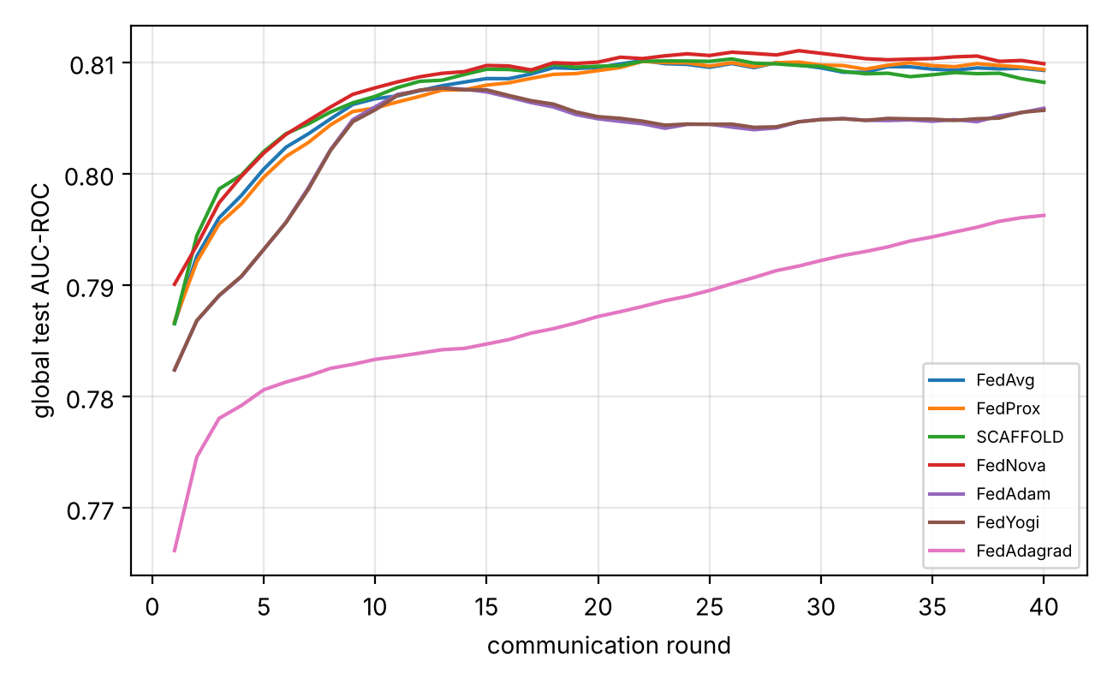
Figure 6. Global test AUC-ROC per communication round for the seven algorithms (mean of 10 seeds).

2.13.2 Privacy-preserving techniques (Experiment 2)
Technique | ε | F1 | AUC-ROC | Utility loss (%) | Comm. (KB) | Time (s)
FedProx (no privacy) | - | 0.767 ± 0.021 | 0.810 ± 0.019 | - | 35.9 | 0.071
DP-SGD eps=1 | 1 | 0.694 ± 0.044 | 0.692 ± 0.060 | 9.6 | 35.9 | 0.234
DP-SGD eps=5 | 5 | 0.764 ± 0.019 | 0.796 ± 0.021 | 0.5 | 35.9 | 0.240
DP-SGD eps=10 | 10 | 0.769 ± 0.013 | 0.802 ± 0.020 | -0.2 | 35.9 | 0.239
Local DP eps=5 | 5 | 0.614 ± 0.090 | 0.611 ± 0.078 | 20.0 | 35.9 | 0.072
Local DP eps=10 | 10 | 0.646 ± 0.078 | 0.650 ± 0.069 | 15.8 | 35.9 | 0.073
Secure aggregation | - | 0.767 ± 0.021 | 0.810 ± 0.019 | 0.0 | 60.9 | 0.100
DP-SGD eps=5 + SecAgg | 5 | 0.764 ± 0.019 | 0.796 ± 0.021 | 0.5 | 60.9 | 0.265
Homomorphic enc. (Paillier) | - | 0.770 ± 0.017 | 0.804 ± 0.019 | -0.3 | 292.0 | 16.239
Table 14. Privacy-preserving techniques on FedProx (Experiment 2). Utility loss is measured on F1 against the non-private run. The Paillier run uses 10 rounds instead of 40, so its totals understate the per-round cost.
DP-SGD: the privacy-utility curve is flat from epsilon = 10 down to 5 and then drops sharply. At epsilon = 10 there is no F1 loss and AUC falls by 0.008; at epsilon = 5 F1 loses 0.4% and AUC 0.014; at epsilon = 1 F1 loses 9.5% and AUC falls from 0.810 to 0.692. Epsilon = 5 therefore looks like the practical operating point. DP noise also slows convergence: with DP the loss target is reached only after 31-35 rounds on average (never at epsilon = 1), even though final F1 is close to the non-private run.
Local DP versus DP-SGD: for the same budget local DP is far more costly because every update is perturbed in every round with no sub-sampling amplification. At epsilon = 5 local DP reaches F1 0.614 and AUC 0.611 against 0.764 and 0.796 for DP-SGD, and even at epsilon = 10 it only reaches F1 0.646. Local DP is only justified when the server itself is untrusted.
Secure aggregation is exact: its accuracy is identical to the non-private run (F1 0.767, AUC 0.810), at the price of about 70% more traffic (60.9 versus 35.9 KB) and about 40% more time. Layering DP-SGD (epsilon = 5) on top of secure aggregation gives exactly the same accuracy as DP-SGD alone, so the two protections compose without interfering. Homomorphic encryption (Paillier, 1024-bit) matches the plain accuracy (F1 0.770, AUC 0.804) but is the most expensive option: per round it needs about 32 times the bandwidth (29.2 versus 0.9 KB) and roughly 900 times the compute (1.6 s versus 1.8 ms), which makes it impractical beyond very small models.
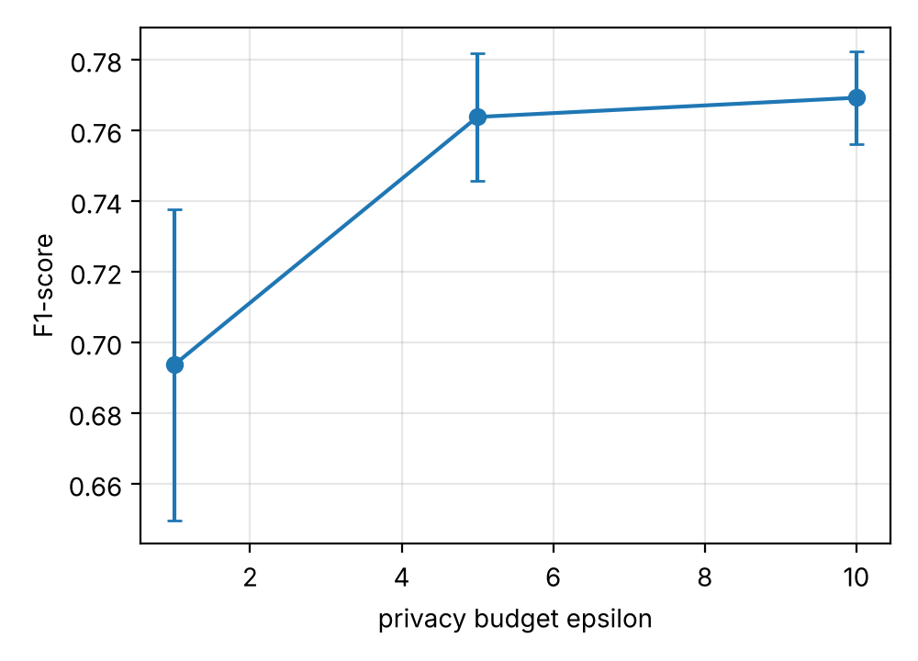
Figure 7. Privacy-utility curve of DP-SGD: F1 against epsilon (mean ± std over 10 seeds).

2.13.3 Security: robust aggregation and adversarial training (Experiment 3)
Aggregation rule | F1: no attack | F1: label flip | F1: sign flip | F1: Gaussian | Accuracy under FGSM (ε = 0.3)
FedAvg (mean) | 0.774 | 0.636 | 0.000 | 0.754 | 0.195
Krum | 0.735 | 0.643 | 0.695 | 0.699 | 0.212
Multi-Krum | 0.778 | 0.646 | 0.737 | 0.732 | 0.229
Trimmed mean (β = 0.25) | 0.765 | 0.631 | 0.603 | 0.731 | 0.209
Median | 0.760 | 0.635 | 0.631 | 0.712 | 0.197
FedAvg + adversarial training | 0.739 | 0.124 | 0.000 | 0.705 | 0.454
Table 15. Mean F1 under attack with 12 clients, 3 malicious (Experiment 3), and accuracy on FGSM-perturbed test records.
Model poisoning (sign flip, scaled by 3): plain averaging collapses completely (F1 0.000, AUC 0.427, i.e. worse than random: the model is turned upside down). Multi-Krum is the clear winner (F1 0.737, AUC 0.809, essentially unaffected). Krum (0.695), median (0.631) and trimmed mean (0.603) hold up less well in F1, but their AUC stays near 0.80, so the ranking of patients is intact and the F1 loss comes from a shifted decision threshold. Random Gaussian updates are harmless to plain averaging (F1 0.754 versus 0.774 clean) because the noise averages out.
Data poisoning (label flip) is not solved by any rule: every aggregator, robust or not, falls to F1 0.63-0.65 from 0.74-0.78, while AUC stays near 0.77-0.80. Flipped-label clients produce updates that look statistically ordinary, so distance- and rank-based filters cannot single them out; the damage mainly shifts the intercept and hence the recall-precision balance. Krum also has a cost without attackers (F1 0.735, AUC 0.764 versus 0.774 and 0.808 for averaging) because it keeps a single update and discards the others, whereas Multi-Krum is almost free (F1 0.778).
Federated adversarial training raises accuracy on FGSM-perturbed records from 0.195 to 0.454 (2.3 times), but costs 3.5 points of clean F1 (0.774 to 0.739) and 0.06 AUC. In this setup it is also fragile under poisoning (F1 0.124 under label flip and 0.000 under sign flip), so it should not be combined with plain averaging when malicious clients are possible.
Design tension: robust aggregation needs to see individual updates, which secure aggregation and homomorphic encryption deliberately hide, and the code therefore refuses to combine them. A deployment must choose between protecting updates from the server and protecting the model from poisoned updates, or add a different mechanism (for example norm-bounding or secure computation of the robust statistic).

2.13.4 Communication-efficient techniques (Experiment 4)
Method | F1 | AUC-ROC | Total comm. (KB) | Saving vs float32 (%)
FedAvg (float32) | 0.778 ± 0.018 | 0.809 ± 0.019 | 35.9 | -
FedPAQ (E=4, 8-bit, 50% clients) | 0.762 ± 0.041 | 0.808 ± 0.022 | 2.4 | 93
Quantised 8-bit | 0.778 ± 0.018 | 0.809 ± 0.019 | 24.0 | 33
Quantised 4-bit | 0.777 ± 0.018 | 0.809 ± 0.018 | 21.9 | 39
Quantised 2-bit | 0.776 ± 0.017 | 0.809 ± 0.018 | 20.7 | 42
Top-k 30% + error feedback | 0.775 ± 0.018 | 0.810 ± 0.018 | 28.9 | 20
Top-k 10% + error feedback | 0.772 ± 0.013 | 0.808 ± 0.020 | 21.1 | 41
Table 16. Communication-efficient techniques (Experiment 4). Traffic counts compressed uploads plus the full-precision broadcast.
Quantisation to 8, 4 or 2 bits leaves accuracy untouched (F1 0.776-0.778, AUC 0.809 for all, identical to float32) and cuts total traffic by 33%, 39% and 42%. Top-k sparsification with error feedback saves 20% (30% of coordinates) and 41% (10%) with at most 0.006 F1 loss. The savings look modest because the downlink broadcast stays at full precision and the model has only 23 parameters, so the fixed header and index overhead matters; for the multilayer perceptron the same techniques would save far more. FedPAQ saves 93% (2.4 versus 35.9 KB) at F1 0.762 ± 0.041 and the same AUC (0.808), but most of that saving comes from fewer rounds and half of the clients per round, not from quantisation; its F1 variance across seeds is more than double that of FedAvg (0.041 versus 0.018).

2.13.5 Recommended comparative framework (Experiment 5)
Configuration | F1 | AUC-ROC | Rounds to converge | Comm. (KB) | ε | Utility loss (%) | F1 kept under poisoning (%)
FedAvg | 0.765 ± 0.022 | 0.810 ± 0.019 | 8.4 | 35.9 | - | 0.0 | 85
FedProx | 0.767 ± 0.021 | 0.810 ± 0.019 | 9.0 | 35.9 | - | 0.0 | 85
SCAFFOLD | 0.755 ± 0.020 | 0.809 ± 0.020 | 8.2 | 71.9 | - | 0.0 | 90
FedAdam | 0.760 ± 0.023 | 0.807 ± 0.019 | 6.7 | 35.9 | - | 0.0 | 85
FedAvg + DP | 0.764 ± 0.019 | 0.797 ± 0.021 | 35.3 | 35.9 | 5 | 0.1 | 79
FedProx + DP | 0.764 ± 0.019 | 0.796 ± 0.021 | 35.3 | 35.9 | 5 | 0.4 | 79
FedProx + SecAgg | 0.767 ± 0.021 | 0.810 ± 0.019 | 9.0 | 60.9 | - | 0.0 | 85
FedProx + DP + SecAgg | 0.764 ± 0.019 | 0.796 ± 0.021 | 35.3 | 60.9 | 5 | 0.4 | 79
Table 17. The eight configurations of Table 7 (Experiment 5). Poisoning = label flipping at one hospital.
Accuracy is practically indistinguishable across all eight configurations (F1 0.755-0.767). The only comparisons that reach significance in the tests run in this study appear here, in AUC against FedProx: the three DP configurations lose about 0.013 AUC (Holm-adjusted p = 0.014 for FedAvg + DP and 0.023 for the other two); secure aggregation alone has an identical AUC to FedProx. Utility loss at epsilon = 5 stays below 0.5% in F1. SCAFFOLD retains the most F1 when one hospital flips its labels (90% versus about 85% for FedAvg/FedProx), although this advantage is not significant and costs double the traffic; DP configurations retain slightly less (about 79%), suggesting that noise makes a poisoned update harder to compensate for. FedAdam converges fastest (6.7 rounds) but not significantly so.
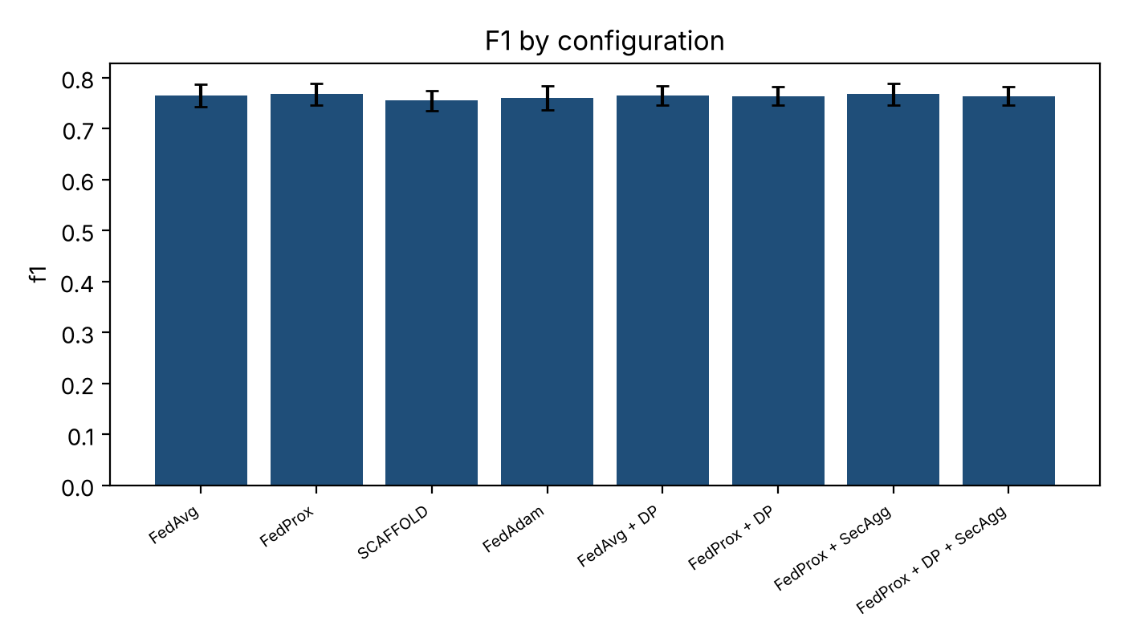
Figure 8. Mean F1 (± std) of the eight framework configurations over 10 seeds.

2.13.6 Answers to the research questions
- RQ1. DP-SGD at epsilon = 5-10 costs 0-0.4% F1 and 0.008-0.014 AUC, with the AUC loss at epsilon = 5 statistically significant but small; epsilon = 1 is too expensive (9.5% F1). Local DP is much worse at equal epsilon.
- RQ2. With the mild heterogeneity of the synthetic hospitals, non-IID data had little visible effect on convergence or accuracy. This question cannot be answered convincingly until the real UCI hospitals, which are far more heterogeneous, are used.
- RQ3. No aggregation algorithm is significantly better than FedAvg. FedAvg or FedProx is the best accuracy-per-byte choice; SCAFFOLD doubles communication for no significant gain.
- RQ4. Not evaluated by these experiments; logistic-regression coefficients are inherently interpretable, but no interpretability metric was measured.
- RQ5. FedNova, FedAdam and FedYogi converge 0.3-0.7 rounds earlier than FedAvg, which is within noise; FedAdagrad is worse. No improvement in accuracy.
- RQ6. Secure aggregation is free in accuracy (+70% traffic, +40% time); DP-SGD costs little accuracy at epsilon >= 5 but 3.4 times the training time; local DP has the largest utility loss; Paillier HE is exact but about 32 times the bandwidth and 900 times the compute per round; DP + SecAgg combines both protections without extra accuracy loss.
- RQ7. Multi-Krum resists model poisoning best and costs nothing without attackers, while no rule defends against label flipping. FedPAQ saves 93% of traffic, quantisation 33-42% and top-k 20-41%, with 0.016 F1 loss for FedPAQ and no more than 0.006 for the others.

2.13.7 Practical recommendation and limitations
On this evidence the most defensible configuration for a hospital consortium is FedProx (or FedAvg) with DP-SGD at epsilon of about 5 and secure aggregation: accuracy within 0.5% F1 of the non-private model, the server never sees an individual update, and only about 70% extra traffic. If malicious hospitals are a realistic threat, Multi-Krum should be used instead of secure aggregation, accepting that individual updates become visible to the server.
Limitations: (i) all numbers are from synthetic data and must be regenerated on the UCI hospitals; (ii) 10 seeds and many comparisons mean that only large effects reach significance after Holm correction; (iii) secure aggregation is simulated and epsilon values are accountant estimates (Section 2.12); (iv) the Paillier run uses 1024-bit keys and 10 rounds; (v) only the logistic-regression model was run, so the communication savings of Experiment 4 are understated relative to the MLP.

2.14 References for the Extended Study
- McMahan, H. B., et al. (2017). Communication-efficient learning of deep networks from decentralized data. AISTATS.
- Li, T., et al. (2020). Federated optimization in heterogeneous networks (FedProx). MLSys.
- Karimireddy, S. P., et al. (2020). SCAFFOLD: Stochastic controlled averaging for federated learning. ICML.
- Wang, J., et al. (2020). Tackling the objective inconsistency problem in heterogeneous federated optimization (FedNova). NeurIPS.
- Reddi, S., et al. (2021). Adaptive federated optimization (FedAdam, FedYogi, FedAdagrad). ICLR.
- Abadi, M., et al. (2016). Deep learning with differential privacy. ACM CCS.
- Mironov, I., Talwar, K., & Zhang, L. (2019). Rényi differential privacy of the sampled Gaussian mechanism. arXiv:1908.10530.
- Bonawitz, K., et al. (2017). Practical secure aggregation for privacy-preserving machine learning. ACM CCS.
- Paillier, P. (1999). Public-key cryptosystems based on composite degree residuosity classes. EUROCRYPT.
- Blanchard, P., et al. (2017). Machine learning with adversaries: Byzantine tolerant gradient descent (Krum). NeurIPS.
- Yin, D., et al. (2018). Byzantine-robust distributed learning: Towards optimal statistical rates (trimmed mean, median). ICML.
- Reisizadeh, A., et al. (2020). FedPAQ: A communication-efficient federated learning method with periodic averaging and quantization. AISTATS.

3. Technical Feasibility and Technical Stack
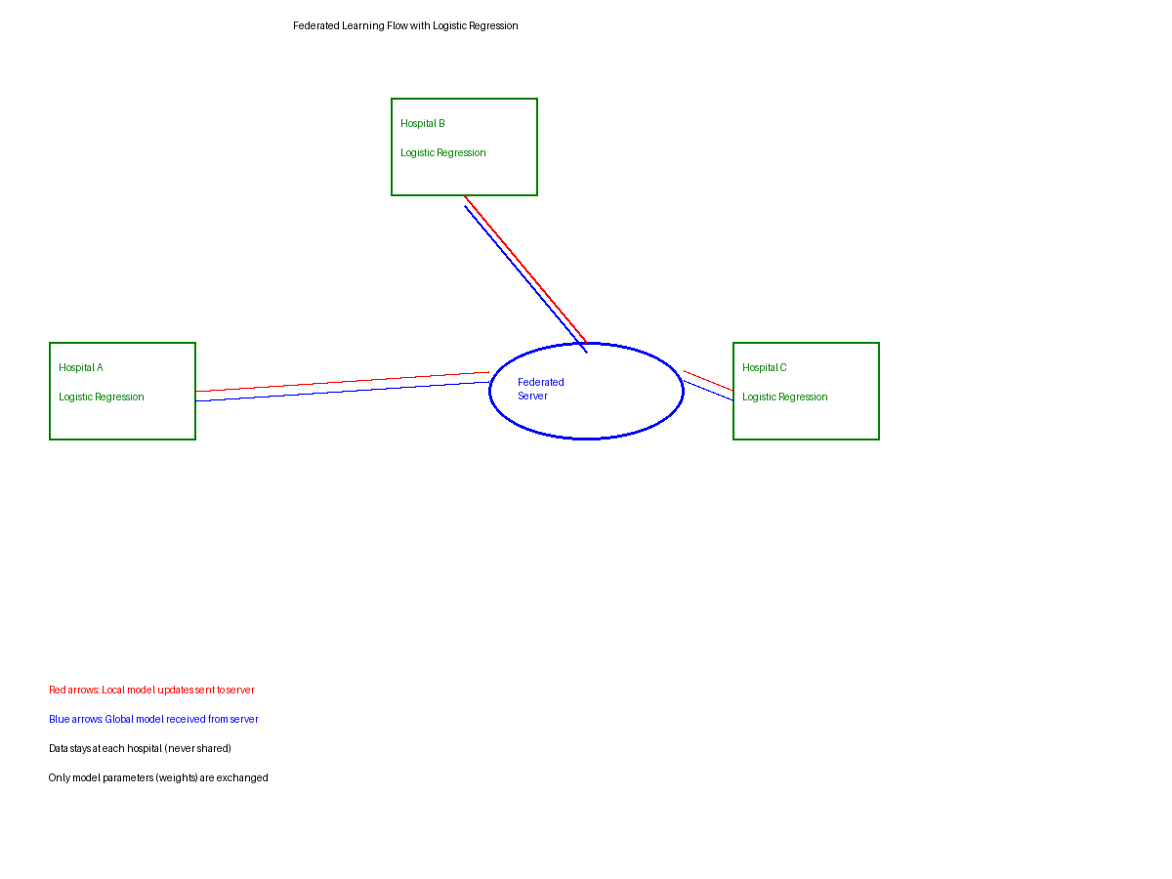

3.1 Purpose
To identify and justify the technologies required to implement the proposed privacy-preserving federated disease-prediction system, building on the architecture (Hospitals A–E → Federated Server → Global Model) established during problem formulation.

3.2 Technical Stack
Component | Technology | Purpose | Justification
Programming language | Python 3.x | Core implementation language for models and FL logic | Dominant ecosystem for ML/FL research; extensive library support
Deep learning framework | PyTorch (or TensorFlow) | Build and train local/global disease-prediction models | Flexible, widely used in FL research; strong community and tutorials
Federated learning framework | Flower (or NVIDIA FLARE) | Orchestrate client-server FL rounds, aggregation (FedAvg/FedProx) | Framework-agnostic, lightweight, simulates multi-hospital clients easily
Privacy layer | Opacus / TensorFlow Privacy | Inject differential privacy noise during local training | Mature, well-documented DP libraries integrating directly with PyTorch/TensorFlow
Database | MongoDB | Store metadata, experiment logs, non-sensitive structured records | Schema flexibility suits heterogeneous multi-institution data formats
Containerization | Docker | Package server and client nodes for reproducible deployment | Ensures consistent environments across simulated hospital nodes
Orchestration (optional) | Kubernetes | Scale client/server simulation for larger experiments | Supports scaling to many simulated institutions
Visualization/Dashboard | Streamlit / Flask + React | Monitor training rounds, accuracy, and privacy budget | Rapid prototyping of a lightweight monitoring interface
Version control & CI | Git / GitHub | Track code changes and collaboration | Standard practice for reproducible research
Numerical and statistical libraries | NumPy, SciPy, scikit-learn, Matplotlib | Simulated FL algorithms, metrics, Wilcoxon / t-tests, centralised baselines, plots | Lightweight, reproducible and fast enough to repeat each experiment over 10 seeds
Secure computation | Pairwise-masking secure aggregation (custom); python-paillier / TenSEAL | Secure aggregation and homomorphic-encryption experiments | Allows privacy overhead to be measured without a full cryptographic deployment
Table 10. Proposed technical stack with purpose and justification for each component.

3.3 Expected Outcome
A well-justified and feasible technical stack capable of supporting local model training at each simulated hospital node, secure federated aggregation, differential-privacy noise injection, and monitoring of accuracy and privacy budget throughout training rounds.

4. Mind Map Development

4.1 Purpose
To visually organize the problem, proposed solution, and system components, connecting the problem statement, modules, inputs/outputs, technologies, and stakeholders into a single structured overview.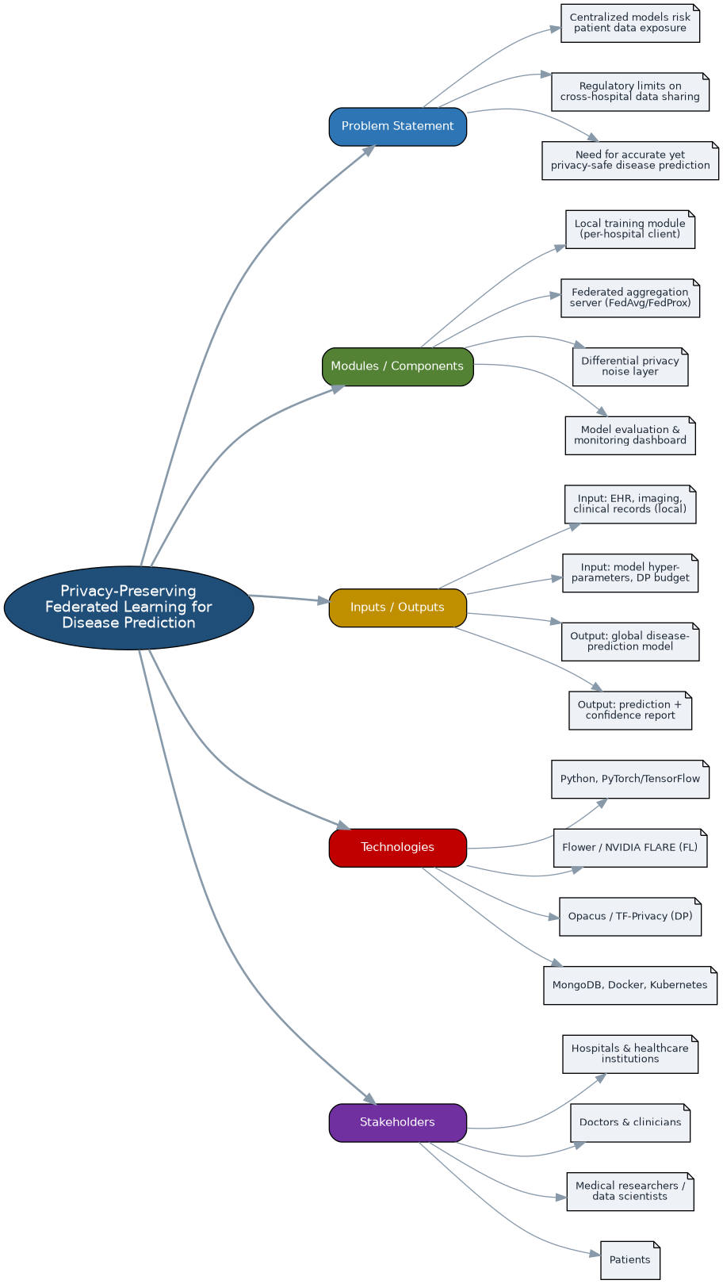
Figure 3. Mind map of the privacy-preserving federated disease-prediction system, organized around the problem statement, modules/components, inputs/outputs, technologies, and stakeholders.
A clear and structured visual representation of the system that can be used as supporting evidence and as a communication tool for stakeholders unfamiliar with the technical details of federated learning.

5. Market Study

5.1 Market Analysis

Existing Systems / Products
Current healthcare systems primarily rely on centralized machine learning architectures, where patient data from multiple hospitals is collected and stored on a central server for analysis and disease prediction. These include cloud-based healthcare analytics platforms, AI-driven diagnostic tools, and medical imaging analysis systems. While such systems can achieve high accuracy due to access to large datasets, they pose significant risks to patient privacy and data security, and strict data-protection regulations restrict cross-institution data sharing.

Target Users
The proposed system serves multiple stakeholders: hospitals and healthcare institutions that wish to collaboratively train predictive models without sharing sensitive data; doctors and clinicians who benefit from improved diagnostic accuracy; medical researchers and data scientists who gain access to diverse data patterns while preserving privacy; and patients, who benefit indirectly through earlier diagnosis and improved care quality.

Competitor Solutions
Existing solutions fall broadly into centralized machine learning systems and emerging federated learning-based approaches. Centralized systems aggregate data in one location, improving performance but compromising privacy. Federated systems instead train locally and share only model updates, improving privacy at the cost of communication overhead, data heterogeneity, and system complexity — challenges this project's system is designed to address.

5.2 SWOT Analysis
Category | Description
Strengths | Keeps patient data local, sharing only model updates; combines multiple institutions' data diversity to raise accuracy; scalable to large hospital networks and IoT medical devices; layered security mechanisms.
Weaknesses | High computational complexity from distributed training and privacy mechanisms; communication overhead from frequent model-update exchange; requires robust infrastructure and technical expertise; struggles with non-IID data.
Opportunities | Rising demand for privacy-preserving healthcare driven by regulation; integration with wearables/IoT for real-time prediction; cross-institution and government collaboration; advances in AI/distributed computing improve efficiency.
Threats | Cyberattacks such as data poisoning and model inversion; regulatory/compliance variation across regions; competition from centralized AI healthcare incumbents; network/infrastructure limitations in some regions.
Table 11. SWOT analysis of the proposed privacy-preserving federated disease-prediction system.

5.3 Comparative Analysis of Solutions
The proposed system is positioned relative to three representative solutions spanning commercial and research-oriented offerings.
Feature | Google Health AI | NVIDIA FLARE | IBM Watson Health | Proposed System
Architecture | Primarily centralized cloud AI | Federated learning framework (research/enterprise) | Centralized cloud analytics | Federated learning + differential privacy
Data locality | Data typically aggregated in cloud | Data stays on-site; only updates shared | Data aggregated centrally | Data stays on-site; only updates shared
Privacy technique | Standard access controls/encryption | Supports DP add-ons via SDK | Encryption, access controls | Adaptive/Bayesian differential privacy
Target domain focus | General health AI products | General-purpose FL research toolkit | Clinical decision support | Disease prediction across multiple hospitals
Explainability | Limited public tooling | Not a core focus | Some clinical reasoning support | Planned XAI layer for clinician trust
Deployment maturity | Commercial, widely deployed | Research/enterprise pilots | Commercial (reduced scope after 2022) | Prototype / academic research stage
Table 12. Comparative analysis of the proposed system against existing healthcare AI / FL solutions.

5.4 Market Analysis Report
The healthcare industry is undergoing significant transformation driven by the integration of artificial intelligence and data-driven technologies. Across the reviewed literature, there is a clear shift from centralized machine learning toward decentralized frameworks such as Federated Learning, motivated primarily by strict privacy regulation and the sensitivity of medical data. FL enables collaborative model training without sharing raw data, while privacy-preserving techniques such as differential privacy and cryptographic methods address risks such as model inversion and membership inference.
A parallel trend is the growing demand for explainable and interpretable AI. Clinicians remain reluctant to adopt opaque AI systems, and explainable-AI frameworks aim to bridge this trust gap while supporting regulatory compliance. Emerging technologies such as IoT, edge computing, and healthcare-metaverse applications are further expanding the scope of use cases — including disease prediction, medical imaging, and remote patient monitoring — with some federated models already achieving strong accuracy in research settings. Despite this momentum, data heterogeneity, communication cost, interoperability, and the privacy-performance trade-off remain the central barriers to wider adoption.

5.5 Problem-Solution Gap Identification
A recurring issue across the literature is the trade-off between data privacy and model performance: differential privacy provides strong protection but reduces accuracy through added noise, and while Bayesian differential privacy improves this balance, no solution yet achieves both high privacy and high accuracy simultaneously. Interpretability presents a related gap, as existing explainable-AI frameworks are not yet standardized for clinical workflow integration.
Data fragmentation and interoperability form a second gap: healthcare data is distributed across institutions in inconsistent formats, and while FL avoids centralizing raw data, it does not resolve standardization or system-compatibility issues. FL systems also remain vulnerable to gradient leakage and model-poisoning attacks that current encryption and secure-aggregation techniques only partially mitigate. High communication and computational costs remain a further limitation, and most solutions remain at the experimental stage with limited real-world clinical validation — leaving a gap between theoretical advances and practical healthcare deployment that this project's proposed system is intended to narrow.

6.0 Conclusion
This report consolidates the literature review, market study, technical feasibility analysis, and mind map required for the current phase into a single, coherent research paper, while remaining consistent with the problem formulation established in the earlier project phase. The literature confirms federated learning as a viable, privacy-preserving approach to collaborative disease prediction, but highlights persistent gaps in the privacy-accuracy trade-off, communication efficiency, security, and interpretability. The market study positions the proposed system relative to existing centralized and federated offerings, and the technical stack and mind map translate these findings into a feasible implementation plan. These outputs collectively set the foundation for the system design and experimentation planned in subsequent phases of the project.
Following the suggested study areas, the report has been extended with a systematic comparative framework (Sections 2.8 to 2.11) covering federated algorithms (FedAvg, FedProx, SCAFFOLD, FedNova, FedAdam, FedYogi, FedAdagrad), privacy mechanisms (DP-SGD, local DP, secure aggregation, homomorphic encryption and their hybrid), robust and adversarially trained aggregation, and communication-efficient methods. A complete, tested Python implementation is provided (Section 2.12 and Appendix A), with an evaluation protocol based on repeated runs and paired significance tests. The next phase is to run this framework on the UCI hospital data and report the privacy-utility and security trade-offs.
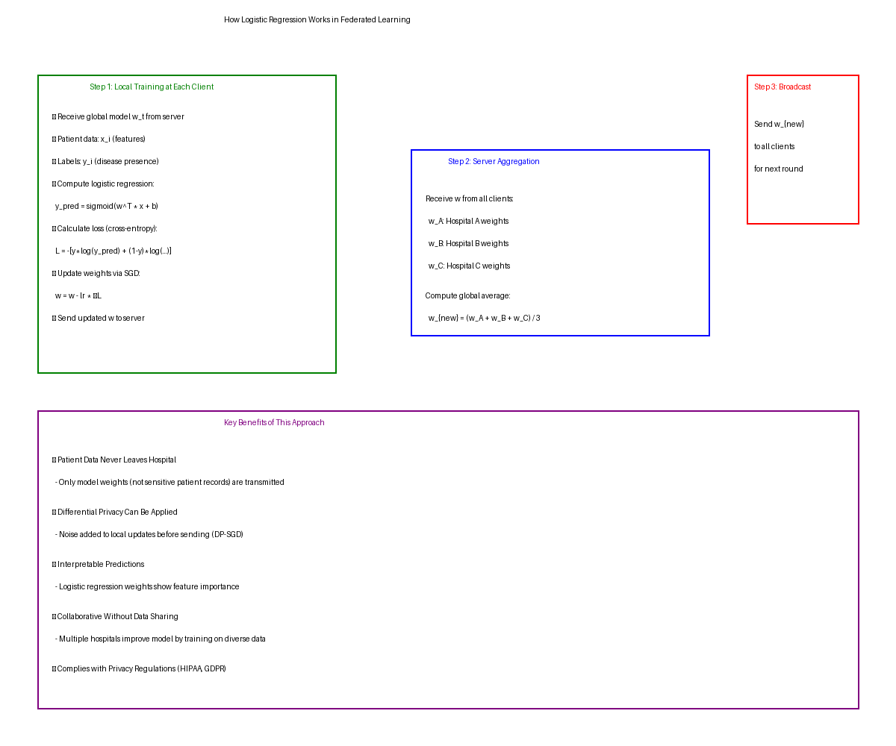
Figure 4. Step-by-step flow of logistic regression training in federated setting with privacy guarantees.
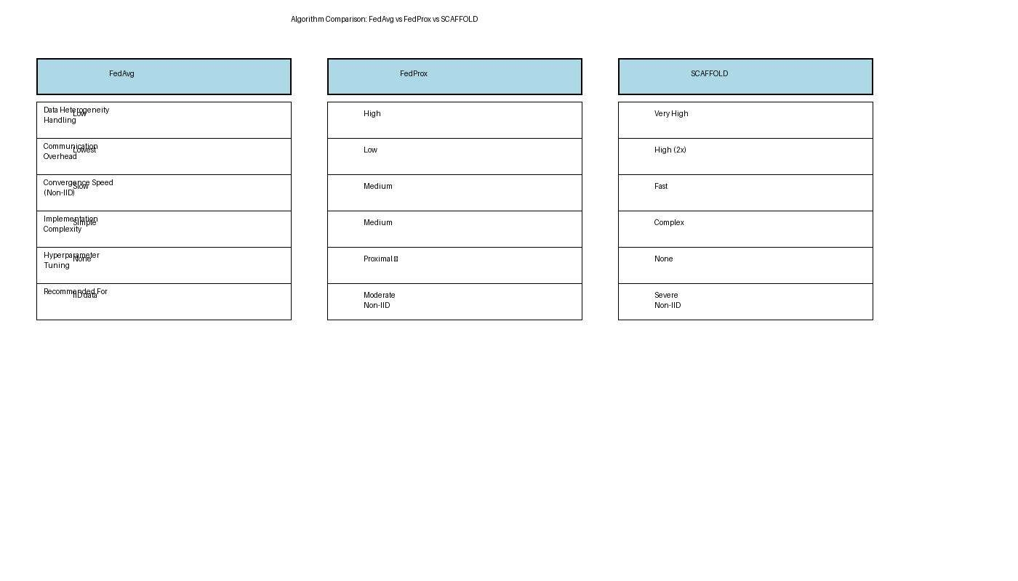
Figure 5. Comparison of FedAvg, FedProx, and SCAFFOLD algorithms.

Appendix A: Source Code
The code below is the complete implementation described in Section 2.12. The same files are supplied separately in the folder federated_code so that they can be executed directly. Requirements: numpy, scipy, pandas, scikit-learn, matplotlib and phe (optional, only for the homomorphic-encryption experiment).

A.1 config.py -- Experiment configuration
"""config.py -- one dataclass that describes a complete federated experiment."""
from dataclasses import dataclass
from typing import Optional, Tuple

@dataclass
class FLConfig:
name: str = "FedAvg"
# ---- federated optimisation -------------------------------------------
algo: str = "fedavg" # fedavg|fedprox|scaffold|fednova|fedadam|fedyogi|
# fedadagrad|fedpaq
rounds: int = 40
local_epochs: int = 2
het_epochs: Optional[Tuple[int, int]] = None # random epochs per client/round
batch_size: int = 32
lr: float = 0.1 # client learning rate
l2: float = 1e-3 # L2 regularisation of the logistic model
mu: float = 0.1 # FedProx proximal coefficient
server_lr: float = 1.0 # server step size (adaptive methods: ~0.05-0.1)
beta1: float = 0.9
beta2: float = 0.99
tau: float = 1e-3 # adaptivity constant of FedAdam/Yogi/Adagrad
participation: float = 1.0 # fraction of clients sampled per round
# ---- privacy -----------------------------------------------------------
dp: Optional[str] = None # None | "dpsgd" (example-level) | "ldp"
clip: float = 1.0 # clipping norm C
noise_multiplier: Optional[float] = None
target_eps: Optional[float] = None # sigma is calibrated to hit this epsilon
delta: float = 1e-6
secagg: bool = False # pairwise-masking secure aggregation
he: bool = False # Paillier homomorphic-encryption aggregation
he_key_bits: int = 1024 # use >= 2048 in a real deployment
# ---- security ----------------------------------------------------------
aggregator: str = "mean" # mean|krum|multikrum|trimmed|median
n_byzantine: int = 0 # f assumed by Krum / Multi-Krum
trim_beta: float = 0.2 # fraction trimmed on each side
malicious_ids: Tuple[int, ...] = ()
attack: Optional[str] = None # label_flip | sign_flip | gaussian
attack_scale: float = 3.0
adv_eps: float = 0.0 # FGSM epsilon for federated adversarial training
eval_adv_eps: float = 0.3 # FGSM epsilon used when testing robustness
# ---- communication -----------------------------------------------------
compression: Optional[str] = None # None | "quant" | "topk"
quant_bits: int = 8
topk_frac: float = 0.1
seed: int = 0

A.2 data.py -- Data loading and local pre-processing
"""data.py -- hospital data loading, local pre-processing and client construction.

Real data : the four UCI Heart Disease sites (Cleveland, Hungarian, Switzerland,
VA Long Beach) = four naturally non-IID hospitals.
Fallback : a synthetic multi-hospital generator in the same 14-column format,
used only when the UCI files are not available (e.g. no internet).
All pre-processing statistics are computed LOCALLY at each hospital (Sec. 2.7).
"""
import os
import urllib.request
from dataclasses import dataclass
from typing import List

import numpy as np
import pandas as pd

UCI_URL = ("https://archive.ics.uci.edu/ml/machine-learning-databases/"
"heart-disease/processed.{}.data")
HOSPITALS = ["cleveland", "hungarian", "switzerland", "va"]
COLUMNS = ["age", "sex", "cp", "trestbps", "chol", "fbs", "restecg", "thalach",
"exang", "oldpeak", "slope", "ca", "thal", "num"]
NUMERIC = ["age", "trestbps", "chol", "thalach", "oldpeak", "ca"]
BINARY = ["sex", "fbs", "exang"]
CATEGORICAL = {"cp": [1, 2, 3, 4], "restecg": [0, 1, 2],
"slope": [1, 2, 3], "thal": [3, 6, 7]}

def load_uci_heart(data_dir="data", download=True):
"""Return {hospital: DataFrame} or None if the files cannot be obtained."""
os.makedirs(data_dir, exist_ok=True)
raw = {}
for h in HOSPITALS:
path = os.path.join(data_dir, f"processed.{h}.data")
if not os.path.exists(path):
if not download:
return None
try:
urllib.request.urlretrieve(UCI_URL.format(h), path)
except Exception as exc: # no internet, etc.
print(f"[data] could not download '{h}': {exc}")
return None
raw[h] = pd.read_csv(path, header=None, names=COLUMNS, na_values="?")
return raw

def make_synthetic_hospitals(n_hospitals=5, sizes=(300, 290, 120, 200, 250), seed=0):
"""Non-IID synthetic hospitals: covariate shift, label skew, concept drift
and different missing-data rates."""
rng = np.random.default_rng(seed)
base_w = dict(age=.35, sex=.5, cp4=1.0, bp=.25, chol=.2, hr=-.5, exang=.8,
oldpeak=.5, ca=.6, thal7=.8)
out = {}
for h in range(n_hospitals):
n = sizes[h]
w = {k: v * rng.uniform(0.85, 1.15) for k, v in base_w.items()} # drift
age = rng.normal(54 + rng.normal(0, 4), 9, n).clip(28, 77)
sex = rng.binomial(1, np.clip(0.68 + rng.normal(0, .12), .3, .95), n)
cp = rng.choice([1, 2, 3, 4], n, p=rng.dirichlet([2, 3, 4, 6]))
bp = rng.normal(131 + rng.normal(0, 6), 17, n).clip(90, 200)
chol = rng.normal(246 + rng.normal(0, 25), 52, n).clip(120, 560)
fbs = rng.binomial(1, .15, n)
restecg = rng.choice([0, 1, 2], n, p=[.5, .02, .48])
hr = rng.normal(150 + rng.normal(0, 8) - .5 * (age - 54), 22, n).clip(70, 205)
exang = rng.binomial(1, .33, n)
oldpeak = np.abs(rng.normal(1.0, 1.1, n)).round(1)
slope = rng.choice([1, 2, 3], n, p=[.45, .45, .10])
ca = rng.choice([0, 1, 2, 3], n, p=[.6, .2, .12, .08]).astype(float)
thal = rng.choice([3, 6, 7], n, p=[.55, .06, .39])
risk = 1.6 * (rng.normal(-1.9, .7) + w["age"] * (age - 54) / 9 + w["sex"] * sex
+ w["cp4"] * (cp == 4) + w["bp"] * (bp - 131) / 17
+ w["chol"] * (chol - 246) / 52 + w["hr"] * (hr - 150) / 22
+ w["exang"] * exang + w["oldpeak"] * oldpeak + w["ca"] * ca
+ w["thal7"] * (thal == 7))
y = rng.binomial(1, 1 / (1 + np.exp(-risk)))
df = pd.DataFrame(dict(age=age, sex=sex, cp=cp, trestbps=bp, chol=chol,
fbs=fbs, restecg=restecg, thalach=hr, exang=exang,
oldpeak=oldpeak, slope=slope, ca=ca, thal=thal,
num=y * rng.integers(1, 5, n)))
for col in ("ca", "thal", "slope"): # missing data
df.loc[rng.random(n) < rng.uniform(0, .6), col] = np.nan
out[f"hospital_{chr(65 + h)}"] = df
return out

def clean_raw(df):
df = df.copy()
for col in ("chol", "trestbps"): # 0 means "not recorded"
df.loc[df[col] == 0, col] = np.nan
df["target"] = (df["num"] > 0).astype(int) # presence of heart disease
return df

class LocalPreprocessor:
"""Mean/mode imputation, z-scoring and one-hot encoding -- fitted locally."""

def fit(self, df):
self.mean = {c: df[c].mean() for c in NUMERIC}
self.std = {c: (df[c].std(ddof=0) if df[c].notna().any() else 1.0)
for c in NUMERIC}
self.mode = {c: (df[c].mode().iloc[0] if df[c].notna().any() else 0)
for c in BINARY + list(CATEGORICAL)}
return self

def transform(self, df):
cols = []
for c in NUMERIC:
m, s = self.mean[c], self.std[c]
if np.isnan(m): # column absent at this site
cols.append(np.zeros(len(df)))
continue
s = 1.0 if (np.isnan(s) or s < 1e-9) else s
cols.append((df[c].fillna(m).to_numpy(float) - m) / s)
for c in BINARY:
cols.append(df[c].fillna(self.mode[c]).to_numpy(float))
for c, cats in CATEGORICAL.items():
v = df[c].fillna(self.mode[c]).to_numpy()
cols.extend((v == k).astype(float) for k in cats)
return np.column_stack(cols)

@dataclass
class FederatedData:
clients: List[dict] # each: name, hospital, X (with bias column), y
X_test: np.ndarray # pooled test set (for global evaluation)
y_test: np.ndarray
dim: int

def build_federated_data(raw, seed=0, test_frac=0.2, shards=1):
"""Split every hospital into train/test, pre-process locally and (optionally)
cut each hospital into `shards` smaller clients (used by security tests)."""
rng = np.random.default_rng(seed)
clients, Xte, yte = [], [], []
for hosp, df in raw.items():
df = clean_raw(df).reset_index(drop=True)
idx = rng.permutation(len(df))
n_te = max(1, int(round(test_frac * len(df))))
te, tr = idx[:n_te], idx[n_te:]
pre = LocalPreprocessor().fit(df.iloc[tr])
add_bias = lambda X: np.hstack([X, np.ones((len(X), 1))])
X_tr = add_bias(pre.transform(df.iloc[tr]))
y_tr = df["target"].to_numpy(float)[tr]
Xte.append(add_bias(pre.transform(df.iloc[te])))
yte.append(df["target"].to_numpy(float)[te])
for s, part in enumerate(np.array_split(rng.permutation(len(tr)), shards)):
name = hosp if shards == 1 else f"{hosp}-{s}"
clients.append({"name": name, "hospital": hosp,
"X": X_tr[part], "y": y_tr[part]})
X_test, y_test = np.vstack(Xte), np.concatenate(yte)
return FederatedData(clients, X_test, y_test, X_test.shape[1])

A.3 model.py -- Logistic regression model
"""model.py -- logistic regression (binary cross-entropy) in pure NumPy.

The bias is the last column of X (added once in data.py), so a model is just a
weight vector w of length d + 1.
"""
import numpy as np

def sigmoid(z):
return 0.5 * (1.0 + np.tanh(0.5 * z)) # numerically stable

def predict_proba(w, X):
return sigmoid(X @ w)

def loss(w, X, y, l2=0.0):
p = np.clip(predict_proba(w, X), 1e-12, 1 - 1e-12)
bce = -np.mean(y * np.log(p) + (1 - y) * np.log(1 - p))
return bce + 0.5 * l2 * np.sum(w[:-1] ** 2)

def gradient(w, X, y, l2=0.0):
g = X.T @ (predict_proba(w, X) - y) / len(y)
reg = l2 * w
reg[-1] = 0.0 # do not regularise the bias
return g + reg

def per_sample_gradients(w, X, y):
"""Row i is the gradient of the loss of example i (needed by DP-SGD)."""
return (predict_proba(w, X) - y)[:, None] * X

def fgsm(w, X, y, eps):
"""Fast-gradient-sign adversarial examples for logistic regression."""
g = (predict_proba(w, X) - y)[:, None] * w[None, :] # d loss / d x
g[:, -1] = 0.0 # keep the bias column
return X + eps * np.sign(g)

A.4 privacy.py -- Differential privacy and accountant
"""privacy.py -- differential privacy: DP-SGD, local DP and an RDP accountant."""
import math

import numpy as np
from scipy.special import logsumexp

ORDERS = list(range(2, 129)) # integer Renyi orders

# ---------------------------------------------------------------------------
# Mechanisms
# ---------------------------------------------------------------------------
def dp_sgd_gradient(per_sample_grads, clip, sigma, rng):
"""DP-SGD step: clip every example gradient to norm C, sum, add N(0,(sigma*C)^2)."""
norms = np.linalg.norm(per_sample_grads, axis=1, keepdims=True)
clipped = per_sample_grads * np.minimum(1.0, clip / (norms + 1e-12))
noisy_sum = clipped.sum(axis=0) + rng.normal(0.0, sigma * clip,
per_sample_grads.shape[1])
return noisy_sum / len(per_sample_grads)

def ldp_perturb(update, clip, sigma, rng):
"""Local DP: the CLIENT clips its model update and adds Gaussian noise
before anything leaves the hospital (the server is not trusted)."""
norm = np.linalg.norm(update)
update = update * min(1.0, clip / (norm + 1e-12))
return update + rng.normal(0.0, sigma * clip, update.shape)

# ---------------------------------------------------------------------------
# Renyi-DP accountant for the (sub)sampled Gaussian mechanism
# ---------------------------------------------------------------------------
def rdp_sampled_gaussian(q, sigma, alpha):
"""RDP of one step at integer order alpha (Mironov et al., 2019)."""
if q <= 0:
return 0.0
if q >= 1:
return alpha / (2.0 * sigma ** 2)
k = np.arange(alpha + 1)
log_binom = (math.lgamma(alpha + 1) - np.array([math.lgamma(i + 1) for i in k])
- np.array([math.lgamma(alpha - i + 1) for i in k]))
terms = (log_binom + (alpha - k) * math.log1p(-q) + k * math.log(q)
+ (k * k - k) / (2.0 * sigma ** 2))
return float(logsumexp(terms)) / (alpha - 1)

def epsilon(q, sigma, steps, delta):
"""(epsilon, delta)-DP guarantee after `steps` compositions."""
best = float("inf")
for a in ORDERS:
eps = steps * rdp_sampled_gaussian(q, sigma, a) + math.log(1 / delta) / (a - 1)
best = min(best, eps)
return best

def calibrate_sigma(target_eps, delta, q, steps, lo=0.3, hi=500.0):
"""Smallest noise multiplier whose epsilon does not exceed target_eps."""
for _ in range(40):
mid = math.sqrt(lo * hi)
if epsilon(q, mid, steps, delta) > target_eps:
lo = mid
else:
hi = mid
return hi

A.5 secure.py -- Secure aggregation and homomorphic encryption
"""secure.py -- secure aggregation (pairwise masking) and Paillier HE aggregation."""
import numpy as np

class SecureAggregator:
"""Simplified Bonawitz-style secure aggregation.

Every pair of clients (i, j) shares a seed; client i ADDS the pseudo-random
mask PRG(s_ij) if i < j and SUBTRACTS it if i > j, working modulo 2^32 on
fixed-point integers. The server sees only masked vectors, yet the masks
cancel exactly in the sum. (Dropout recovery via secret sharing and the
Diffie-Hellman key agreement are not simulated.)
"""

def __init__(self, dim, scale_bits=16, mod_bits=32, seed=0):
self.dim, self.S, self.M, self.seed = dim, 2 ** scale_bits, 2 ** mod_bits, seed

def _mask(self, i, j, rnd):
rng = np.random.default_rng([self.seed, rnd, min(i, j), max(i, j)])
return rng.integers(0, self.M, self.dim, dtype=np.int64)

def mask(self, i, vec, participants, rnd):
"""Client side: fixed-point encode + add/subtract the pairwise masks."""
x = np.round(vec * self.S).astype(np.int64) % self.M
for j in participants:
if j == i:
continue
m = self._mask(i, j, rnd)
x = (x + m) % self.M if i < j else (x - m) % self.M
return x

def aggregate(self, masked):
"""Server side: sum modulo M and decode back to floats."""
s = np.sum(masked, axis=0) % self.M
s = np.where(s >= self.M // 2, s - self.M, s)
return s.astype(float) / self.S

class PaillierAggregator:
"""Additively homomorphic aggregation with python-paillier (`pip install phe`).

Clients encrypt their (already weighted) update coordinate by coordinate; the
server adds ciphertexts without decrypting; only the key holder opens the SUM.
"""

def __init__(self, key_bits=1024):
from phe import paillier
self.pub, self.priv = paillier.generate_paillier_keypair(n_length=key_bits)
self.ct_bytes = 2 * key_bits // 8 # one ciphertext, in bytes

def encrypt(self, vec):
return [self.pub.encrypt(float(x)) for x in vec]

@staticmethod
def add(enc_list):
total = enc_list[0]
for enc in enc_list[1:]:
total = [a + b for a, b in zip(total, enc)]
return total

def decrypt(self, enc):
return np.array([self.priv.decrypt(c) for c in enc])

A.6 robust.py -- Robust aggregation and attacks
"""robust.py -- Byzantine-robust aggregation rules and poisoning attacks."""
import numpy as np

def _pairwise_sq_dists(U):
G = U @ U.T
sq = np.diag(G)
return np.maximum(sq[:, None] + sq[None, :] - 2 * G, 0.0)

def krum_scores(U, f):
"""Score_i = sum of squared distances to the K - f - 2 closest other updates."""
K = len(U)
m = max(1, K - f - 2)
D = _pairwise_sq_dists(U)
return np.array([np.sort(np.delete(D[i], i))[:m].sum() for i in range(K)])

def krum(U, f):
return U[int(np.argmin(krum_scores(U, f)))]

def multi_krum(U, f, m=None):
m = m or max(1, len(U) - f)
return U[np.argsort(krum_scores(U, f))[:m]].mean(axis=0)

def trimmed_mean(U, beta):
K = len(U)
t = int(np.floor(beta * K))
if 2 * t >= K:
return np.median(U, axis=0)
return np.sort(U, axis=0)[t:K - t].mean(axis=0)

def coordinate_median(U):
return np.median(U, axis=0)

def robust_aggregate(name, U, f=0, beta=0.2):
if name == "krum":
return krum(U, f)
if name == "multikrum":
return multi_krum(U, f)
if name == "trimmed":
return trimmed_mean(U, beta)
if name == "median":
return coordinate_median(U)
raise ValueError(f"unknown aggregator '{name}'")

# ---------------------------------------------------------------------------
# Attacks (a malicious client is a Byzantine participant)
# ---------------------------------------------------------------------------
def apply_attack(kind, delta, rng, scale=3.0):
if kind == "sign_flip": # push the model the wrong way
return -scale * delta
if kind == "gaussian": # send random noise
return rng.normal(0.0, scale * (np.std(delta) + 1e-3), delta.shape)
return delta

def poison_labels(client):
"""Label-flipping data-poisoning attack: returns a poisoned copy."""
poisoned = dict(client)
poisoned["y"] = 1.0 - client["y"]
return poisoned

A.7 compress.py -- Communication compression
"""compress.py -- communication-efficient update compression.

* quant : unbiased stochastic uniform quantisation to `bits` bits per value
* topk : top-k sparsification with error feedback (residual memory)
Every call returns (compressed_vector, bytes_on_the_wire).
"""
import numpy as np

class Compressor:
def __init__(self, kind=None, bits=8, k_frac=0.1, dim=0, seed=0):
self.kind, self.bits, self.k_frac = kind, bits, k_frac
self.residual = np.zeros(dim)
self.rng = np.random.default_rng(seed)

def __call__(self, v):
d = len(v)
if self.kind is None:
return v, 4 * d # float32 per value
if self.kind == "quant":
levels = 2 ** self.bits - 1
lo, hi = float(v.min()), float(v.max())
nbytes = int(np.ceil(d * self.bits / 8)) + 8 # + (lo, hi) header
if hi - lo < 1e-12:
return v, nbytes
x = (v - lo) / (hi - lo) * levels
low = np.floor(x)
q = low + (self.rng.random(d) < (x - low)) # stochastic rounding
return lo + q * (hi - lo) / levels, nbytes
if self.kind == "topk":
u = v + self.residual # error feedback
k = max(1, int(round(self.k_frac * d)))
idx = np.argpartition(np.abs(u), -k)[-k:]
out = np.zeros(d)
out[idx] = u[idx]
self.residual = u - out
return out, k * 8 # value + index
raise ValueError(f"unknown compression '{self.kind}'")

A.8 client.py -- Local training
"""client.py -- local training at one hospital (all client-side variants)."""
import numpy as np

from model import gradient, per_sample_gradients, fgsm
from privacy import dp_sgd_gradient

def local_train(w_global, client, cfg, rng, epochs, sigma=0.0,
c_glob=None, c_loc=None):
"""Mini-batch SGD starting from the global model.

FedProx : adds mu * (w - w_global) to the gradient (proximal term).
SCAFFOLD : adds the drift correction (c_glob - c_loc) to the gradient.
DP-SGD : per-example clipping + Gaussian noise (cfg.dp == "dpsgd").
Adv.train: half of every batch is replaced by FGSM examples (cfg.adv_eps > 0).
Returns the new weights and the number of local steps tau.
"""
X, y = client["X"], client["y"]
n = len(y)
B = min(cfg.batch_size, n)
w = w_global.copy()
tau = 0
for _ in range(epochs):
perm = rng.permutation(n)
for s in range(0, n, B):
idx = perm[s:s + B]
Xb, yb = X[idx], y[idx]
if cfg.adv_eps > 0:
Xb = np.vstack([Xb, fgsm(w, Xb, yb, cfg.adv_eps)])
yb = np.concatenate([yb, yb])
if cfg.dp == "dpsgd":
g = dp_sgd_gradient(per_sample_gradients(w, Xb, yb),
cfg.clip, sigma, rng)
reg = cfg.l2 * w
reg[-1] = 0.0
g = g + reg
else:
g = gradient(w, Xb, yb, cfg.l2)
if cfg.algo == "fedprox":
g = g + cfg.mu * (w - w_global)
elif cfg.algo == "scaffold":
g = g - c_loc + c_glob
w -= cfg.lr * g
tau += 1
return w, tau

A.9 server.py -- Federated server loop
"""server.py -- the federated training loop for every algorithm in the study."""
import math
import time

import numpy as np

from client import local_train
from compress import Compressor
from metrics import evaluate, classification_metrics
from model import fgsm, predict_proba
from privacy import calibrate_sigma, epsilon, ldp_perturb
from robust import robust_aggregate, apply_attack, poison_labels
from secure import SecureAggregator, PaillierAggregator

ADAPTIVE = ("fedadam", "fedyogi", "fedadagrad")

def _steps(n, cfg):
B = min(cfg.batch_size, n)
return cfg.rounds * cfg.local_epochs * math.ceil(n / B), B / n

def resolve_sigma(cfg, clients):
"""Noise multiplier: given directly or calibrated to cfg.target_eps."""
if cfg.dp is None:
return 0.0
if cfg.noise_multiplier is not None:
return cfg.noise_multiplier
if cfg.target_eps is None:
raise ValueError("set noise_multiplier or target_eps when dp is enabled")
if cfg.dp == "ldp":
return calibrate_sigma(cfg.target_eps, cfg.delta, 1.0, cfg.rounds)
sig = []
for c in clients:
steps, q = _steps(len(c["y"]), cfg)
sig.append(calibrate_sigma(cfg.target_eps, cfg.delta, q, steps))
return max(sig) # worst-case hospital

def epsilon_spent(cfg, clients, sigma):
if cfg.dp is None:
return float("nan") # no formal guarantee
if cfg.dp == "ldp":
return epsilon(1.0, sigma, cfg.rounds, cfg.delta)
eps = []
for c in clients:
steps, q = _steps(len(c["y"]), cfg)
eps.append(epsilon(q, sigma, steps, cfg.delta))
return max(eps)

def _aggregate(vectors, weights, part, rnd, cfg, secagg, he):
"""Combine client vectors. Returns (aggregate, uplink_bytes_per_client)."""
d = vectors.shape[1]
if cfg.aggregator != "mean":
return robust_aggregate(cfg.aggregator, vectors, cfg.n_byzantine,
cfg.trim_beta), 4 * d
if secagg is not None:
masked = [secagg.mask(int(k), weights[i] * vectors[i], part, rnd)
for i, k in enumerate(part)]
return secagg.aggregate(masked), 4 * d + 32 * (len(part) - 1)
if he is not None:
enc = [he.encrypt(weights[i] * vectors[i]) for i in range(len(part))]
return he.decrypt(he.add(enc)), he.ct_bytes * d
return weights @ vectors, 4 * d

def run_federated(fd, cfg):
if cfg.aggregator != "mean" and (cfg.secagg or cfg.he):
raise ValueError("robust aggregation needs individual updates, which "
"secure aggregation / HE deliberately hide")
rng = np.random.default_rng(cfg.seed)
clients = list(fd.clients)
if cfg.attack == "label_flip":
clients = [poison_labels(c) if i in cfg.malicious_ids else c
for i, c in enumerate(clients)]
K, d = len(clients), fd.dim
sizes = np.array([len(c["y"]) for c in clients], float)
sigma = resolve_sigma(cfg, clients)

w = np.zeros(d)
c_glob, c_loc = np.zeros(d), [np.zeros(d) for _ in range(K)]
m, v = np.zeros(d), np.full(d, cfg.tau ** 2)
comps = [Compressor(cfg.compression, cfg.quant_bits, cfg.topk_frac, d,
cfg.seed + k) for k in range(K)]
secagg = SecureAggregator(d, seed=cfg.seed) if cfg.secagg else None
he = PaillierAggregator(cfg.he_key_bits) if cfg.he else None

history, comm, t0 = [], 0, time.perf_counter()
for r in range(1, cfg.rounds + 1):
part = (np.arange(K) if cfg.participation >= 1 else
np.sort(rng.choice(K, max(1, round(cfg.participation * K)),
replace=False)))
p = sizes[part] / sizes[part].sum()
deltas, taus, dcs, up = [], [], [], 4 * d
for k in part:
ep = (cfg.local_epochs if cfg.het_epochs is None else
int(rng.integers(cfg.het_epochs[0], cfg.het_epochs[1] + 1)))
wk, tau = local_train(w, clients[k], cfg, rng, ep, sigma, c_glob, c_loc[k])
delta = wk - w
if cfg.algo == "scaffold": # control-variate option II
c_new = c_loc[k] - c_glob + (w - wk) / (tau * cfg.lr)
dcs.append(c_new - c_loc[k])
c_loc[k] = c_new
if k in cfg.malicious_ids and cfg.attack in ("sign_flip", "gaussian"):
delta = apply_attack(cfg.attack, delta, rng, cfg.attack_scale)
if cfg.dp == "ldp":
delta = ldp_perturb(delta, cfg.clip, sigma, rng)
delta, up = comps[k](delta) # compression (optional)
deltas.append(delta)
taus.append(tau)
U, taus = np.stack(deltas), np.array(taus, float)
if cfg.algo == "fednova": # normalise by local steps
U = U / taus[:, None]
agg, up_agg = _aggregate(U, p, part, r, cfg, secagg, he)
if cfg.compression is None: # else: compressed size
up = up_agg

if cfg.algo == "fednova":
w = w + cfg.server_lr * float(p @ taus) * agg
elif cfg.algo in ADAPTIVE:
m = cfg.beta1 * m + (1 - cfg.beta1) * agg
g2 = agg ** 2
if cfg.algo == "fedadagrad":
v = v + g2
elif cfg.algo == "fedyogi":
v = v - (1 - cfg.beta2) * g2 * np.sign(v - g2)
else:
v = cfg.beta2 * v + (1 - cfg.beta2) * g2
w = w + cfg.server_lr * m / (np.sqrt(v) + cfg.tau)
else: # fedavg / fedprox / fedpaq / scaffold
w = w + cfg.server_lr * agg
if cfg.algo == "scaffold":
uni = np.full(len(part), 1.0 / len(part))
agg_c, _ = _aggregate(np.stack(dcs), uni, part, r, cfg, secagg, he)
c_glob = c_glob + (len(part) / K) * agg_c

factor = 2 if cfg.algo == "scaffold" else 1 # SCAFFOLD ships c as well
comm += len(part) * (factor * up + factor * 4 * d)
h = evaluate(w, fd.X_test, fd.y_test, cfg.l2)
h.update(round=r, comm_bytes=comm, time=time.perf_counter() - t0)
history.append(h)

final = dict(history[-1])
adv = fgsm(w, fd.X_test, fd.y_test, cfg.eval_adv_eps)
final["adv_accuracy"] = classification_metrics(
fd.y_test, predict_proba(w, adv))["accuracy"]
final.update(epsilon=epsilon_spent(cfg, clients, sigma), sigma=sigma,
comm_kb=comm / 1024.0, time_s=time.perf_counter() - t0)
return {"history": history, "final": final, "w": w}

A.10 metrics.py -- Evaluation metrics
"""metrics.py -- evaluation metrics requested in the comparative framework."""
import numpy as np
from scipy.stats import rankdata

from model import predict_proba, loss

def auc_roc(y, score):
"""AUC-ROC through the Mann-Whitney U statistic (ties handled by mid-ranks)."""
n_pos, n_neg = int(np.sum(y == 1)), int(np.sum(y == 0))
if n_pos == 0 or n_neg == 0:
return float("nan")
ranks = rankdata(score)
return (ranks[y == 1].sum() - n_pos * (n_pos + 1) / 2) / (n_pos * n_neg)

def classification_metrics(y, proba, threshold=0.5):
yhat = (proba >= threshold).astype(int)
tp = int(np.sum((yhat == 1) & (y == 1)))
fp = int(np.sum((yhat == 1) & (y == 0)))
fn = int(np.sum((yhat == 0) & (y == 1)))
tn = int(np.sum((yhat == 0) & (y == 0)))
precision = tp / (tp + fp) if tp + fp else 0.0
recall = tp / (tp + fn) if tp + fn else 0.0
f1 = 2 * precision * recall / (precision + recall) if precision + recall else 0.0
return {"accuracy": (tp + tn) / len(y), "precision": precision,
"recall": recall, "f1": f1, "auc": auc_roc(y, proba)}

def evaluate(w, X, y, l2=0.0):
out = classification_metrics(y, predict_proba(w, X))
out["loss"] = loss(w, X, y, l2)
return out

def rounds_to_target(history, key, target, lower_is_better=True):
"""Convergence rate: first round whose `key` is at least as good as `target`
(rounds + 1 if the target is never reached)."""
for h in history:
if (h[key] <= target) if lower_is_better else (h[key] >= target):
return h["round"]
return len(history) + 1

def utility_loss(baseline_value, value):
"""Relative utility loss in percent with respect to a non-private baseline."""
return 100.0 * (baseline_value - value) / max(baseline_value, 1e-12)

A.11 experiments.py -- Experiment families and significance tests
"""experiments.py -- the five experiment families of the comparative study."""
from dataclasses import replace

import numpy as np
import pandas as pd
from scipy.stats import wilcoxon, ttest_rel
from sklearn.ensemble import RandomForestClassifier

from client import local_train
from config import FLConfig
from data import (build_federated_data, load_uci_heart, make_synthetic_hospitals)
from metrics import classification_metrics, evaluate, rounds_to_target, utility_loss
from server import run_federated

METRICS = ["accuracy", "precision", "recall", "f1", "auc"]

def load_raw(data_dir="data", synthetic=False):
if not synthetic:
raw = load_uci_heart(data_dir)
if raw is not None:
return raw, "UCI Heart Disease (4 hospitals)"
return make_synthetic_hospitals(), "SYNTHETIC multi-hospital data (fallback)"

def centralised_baselines(fd, seed):
"""Pooled (non-federated) logistic regression and random forest (Sec. 2.5)."""
X = np.vstack([c["X"] for c in fd.clients])
y = np.concatenate([c["y"] for c in fd.clients])
cfg = FLConfig(local_epochs=200, lr=0.1)
w, _ = local_train(np.zeros(fd.dim), {"X": X, "y": y}, cfg,
np.random.default_rng(seed), 200)
lr = evaluate(w, fd.X_test, fd.y_test, cfg.l2)
rf = RandomForestClassifier(200, random_state=seed).fit(X[:, :-1], y)
rf_m = classification_metrics(fd.y_test, rf.predict_proba(fd.X_test[:, :-1])[:, 1])
return lr, rf_m

def run_many(raw, configs, seeds, shards=1):
"""Run every config on every seed. Returns (summary DataFrame, histories)."""
rows, hist = [], {}
for seed in seeds:
fd = build_federated_data(raw, seed=seed, shards=shards)
ref, _ = centralised_baselines(fd, seed)
target = 1.03 * ref["loss"] # converged = within 3 % of centralised loss
for name, cfg in configs.items():
res = run_federated(fd, replace(cfg, name=name, seed=seed))
f = res["final"]
rows.append({"name": name, "seed": seed,
**{k: f[k] for k in METRICS},
"adv_accuracy": f["adv_accuracy"],
"conv_rounds": rounds_to_target(res["history"], "loss", target),
"comm_kb": f["comm_kb"], "time_s": f["time_s"],
"epsilon": f["epsilon"], "central_auc": ref["auc"],
"central_loss": ref["loss"]})
hist[(name, seed)] = res["history"]
return pd.DataFrame(rows), hist

def summarise(df, cols=None):
cols = cols or METRICS + ["conv_rounds", "comm_kb", "time_s", "epsilon"]
g = df.groupby("name", sort=False)[cols]
return g.mean().round(4).astype(str) + " ± " + g.std().round(4).astype(str)

def significance(df, baseline, metric="f1"):
"""Paired Wilcoxon + paired t-test against `baseline` with Holm correction."""
piv = df.pivot(index="seed", columns="name", values=metric)
out = []
for name in piv.columns:
if name == baseline:
continue
diff = piv[name] - piv[baseline]
p_w = 1.0 if np.allclose(diff, 0) else wilcoxon(piv[name], piv[baseline]).pvalue
p_t = 1.0 if np.allclose(diff, 0) else ttest_rel(piv[name], piv[baseline]).pvalue
out.append({"method": name, "mean_diff": diff.mean(), "p_wilcoxon": p_w,
"p_ttest": p_t})
res = pd.DataFrame(out).sort_values("p_wilcoxon").reset_index(drop=True)
m = len(res)
holm = np.maximum.accumulate((m - np.arange(m)) * res["p_wilcoxon"].to_numpy())
res["p_holm"] = np.minimum(holm, 1.0)
res["significant@0.05"] = res["p_holm"] < 0.05
return res

# ---------------------------------------------------------------------------
# Experiment 1 -- federated learning algorithms
# ---------------------------------------------------------------------------
def exp_algorithms(raw, seeds, rounds=40):
base = FLConfig(rounds=rounds, het_epochs=(1, 4)) # stragglers do less work
adapt = dict(server_lr=0.05)
cfgs = {"FedAvg": replace(base, algo="fedavg"),
"FedProx": replace(base, algo="fedprox", mu=0.1),
"SCAFFOLD": replace(base, algo="scaffold"),
"FedNova": replace(base, algo="fednova"),
"FedAdam": replace(base, algo="fedadam", **adapt),
"FedYogi": replace(base, algo="fedyogi", **adapt),
"FedAdagrad": replace(base, algo="fedadagrad", **adapt)}
return run_many(raw, cfgs, seeds)

# ---------------------------------------------------------------------------
# Experiment 2 -- privacy-preserving techniques (base algorithm: FedProx)
# ---------------------------------------------------------------------------
def exp_privacy(raw, seeds, rounds=40, with_he=True):
base = FLConfig(algo="fedprox", rounds=rounds)
cfgs = {"FedProx (no privacy)": base}
for eps in (1, 5, 10):
cfgs[f"DP-SGD eps={eps}"] = replace(base, dp="dpsgd", target_eps=eps)
for eps in (5, 10):
cfgs[f"Local DP eps={eps}"] = replace(base, dp="ldp", target_eps=eps, clip=0.5)
cfgs["Secure aggregation"] = replace(base, secagg=True)
cfgs["DP-SGD eps=5 + SecAgg"] = replace(base, dp="dpsgd", target_eps=5, secagg=True)
if with_he:
cfgs["Homomorphic enc. (Paillier)"] = replace(base, he=True, rounds=min(rounds, 10))
return run_many(raw, cfgs, seeds)

# ---------------------------------------------------------------------------
# Experiment 3 -- security (12 clients, 3 of them malicious)
# ---------------------------------------------------------------------------
def exp_security(raw, seeds, rounds=40):
base = FLConfig(algo="fedavg", rounds=rounds, malicious_ids=(0, 1, 2),
n_byzantine=3, trim_beta=0.25)
rows, hist = [], {}
for attack in (None, "label_flip", "sign_flip", "gaussian"):
for agg in ("mean", "krum", "multikrum", "trimmed", "median"):
for adv in (0.0, 0.2):
if adv and agg != "mean":
continue
label = f"{attack or 'no attack'} | {agg}" + (" + adv.training" if adv else "")
cfg = replace(base, attack=attack, aggregator=agg, adv_eps=adv)
df, h = run_many(raw, {label: cfg}, seeds, shards=3)
df["attack"] = attack or "none"
df["aggregator"] = agg + (" + AT" if adv else "")
rows.append(df)
hist.update(h)
return pd.concat(rows, ignore_index=True), hist

# ---------------------------------------------------------------------------
# Experiment 4 -- communication-efficient techniques
# ---------------------------------------------------------------------------
def exp_communication(raw, seeds, rounds=40):
base = FLConfig(algo="fedavg", rounds=rounds, local_epochs=1)
cfgs = {"FedAvg (float32)": base,
"FedPAQ (E=4, 8-bit, 50% clients)": replace(
base, algo="fedpaq", rounds=rounds // 4, local_epochs=4,
compression="quant", quant_bits=8, participation=0.5)}
for b in (8, 4, 2):
cfgs[f"Quantised {b}-bit"] = replace(base, compression="quant", quant_bits=b)
for k in (0.3, 0.1):
cfgs[f"Top-k {int(k * 100)}% + error feedback"] = replace(
base, compression="topk", topk_frac=k)
return run_many(raw, cfgs, seeds)

# ---------------------------------------------------------------------------
# Experiment 5 -- recommended comparative framework (8 configurations)
# ---------------------------------------------------------------------------
BASELINE_OF = {"FedAvg + DP": "FedAvg", "FedProx + DP": "FedProx",
"FedProx + SecAgg": "FedProx", "FedProx + DP + SecAgg": "FedProx"}

def framework_configs(rounds=40, eps=5):
b = FLConfig(rounds=rounds)
dp = dict(dp="dpsgd", target_eps=eps)
return {"FedAvg": replace(b, algo="fedavg"),
"FedProx": replace(b, algo="fedprox"),
"SCAFFOLD": replace(b, algo="scaffold"),
"FedAdam": replace(b, algo="fedadam", server_lr=0.05),
"FedAvg + DP": replace(b, algo="fedavg", **dp),
"FedProx + DP": replace(b, algo="fedprox", **dp),
"FedProx + SecAgg": replace(b, algo="fedprox", secagg=True),
"FedProx + DP + SecAgg": replace(b, algo="fedprox", secagg=True, **dp)}

def exp_framework(raw, seeds, rounds=40, eps=5):
cfgs = framework_configs(rounds, eps)
clean, hist = run_many(raw, cfgs, seeds)
# poisoning robustness: hospital 0 flips its labels (data poisoning)
pois_cfgs = {k: replace(v, attack="label_flip", malicious_ids=(0,))
for k, v in cfgs.items()}
pois, _ = run_many(raw, pois_cfgs, seeds)
f1 = clean.set_index(["name", "seed"])["f1"]
clean["utility_loss_%"] = [
utility_loss(f1[(BASELINE_OF[n], s)], f) if n in BASELINE_OF else 0.0
for n, s, f in zip(clean.name, clean.seed, clean.f1)]
pois_f1 = pois.set_index(["name", "seed"])["f1"]
clean["f1_under_poisoning"] = [pois_f1[(n, s)] for n, s in zip(clean.name, clean.seed)]
clean["poison_retention_%"] = 100 * clean["f1_under_poisoning"] / clean["f1"]
return clean, hist

A.12 plots.py -- Figures
"""plots.py -- figures used in the report."""
import matplotlib
matplotlib.use("Agg")
import matplotlib.pyplot as plt
import numpy as np

def plot_convergence(hist, names, key, path, ylabel=None):
plt.figure(figsize=(6.5, 4))
for n in names:
runs = [[h[key] for h in v] for (nm, _), v in hist.items() if nm == n]
if runs:
plt.plot(np.arange(1, len(runs[0]) + 1), np.mean(runs, axis=0), label=n)
plt.xlabel("communication round")
plt.ylabel(ylabel or key)
plt.grid(alpha=.3)
plt.legend(fontsize=7)
plt.tight_layout()
plt.savefig(path, dpi=200)
plt.close()

def plot_bars(df, metric, path, title=""):
g = df.groupby("name", sort=False)[metric]
plt.figure(figsize=(7, 4))
plt.bar(range(len(g.mean())), g.mean(), yerr=g.std(), capsize=3, color="#1F4E79")
plt.xticks(range(len(g.mean())), g.mean().index, rotation=35, ha="right", fontsize=7)
plt.ylabel(metric)
plt.title(title)
plt.tight_layout()
plt.savefig(path, dpi=200)
plt.close()

def plot_privacy_utility(df, path):
d = df[df.name.str.startswith("DP-SGD eps=")].copy()
d["eps"] = d.name.str.extract(r"eps=(\d+)").astype(float)
g = d.groupby("eps")["f1"]
plt.figure(figsize=(5, 3.6))
plt.errorbar(g.mean().index, g.mean(), yerr=g.std(), marker="o", capsize=3)
plt.xlabel("privacy budget epsilon")
plt.ylabel("F1-score")
plt.grid(alpha=.3)
plt.tight_layout()
plt.savefig(path, dpi=200)
plt.close()

A.13 run_all.py -- Command-line driver
"""run_all.py -- run the whole study: python run_all.py --seeds 10

Results (CSV + PNG) are written to ./results. If the UCI files are not found in
./data and cannot be downloaded, the synthetic fallback is used (and announced).
"""
import argparse
import os

import pandas as pd

import experiments as ex
import plots

pd.set_option("display.width", 200, "display.max_columns", 30)

def main():
ap = argparse.ArgumentParser()
ap.add_argument("--data-dir", default="data")
ap.add_argument("--out", default="results")
ap.add_argument("--seeds", type=int, default=10)
ap.add_argument("--rounds", type=int, default=40)
ap.add_argument("--synthetic", action="store_true")
ap.add_argument("--skip-he", action="store_true", help="skip slow Paillier run")
ap.add_argument("--only", nargs="*", default=["algorithms", "privacy", "security",
"communication", "framework"])
a = ap.parse_args()
os.makedirs(a.out, exist_ok=True)
seeds = list(range(a.seeds))
raw, desc = ex.load_raw(a.data_dir, a.synthetic)
print(f"\n=== DATA: {desc} ===")

def save(name, df, hist=None, conv_names=None):
df.to_csv(f"{a.out}/{name}.csv", index=False)
print(f"\n--- {name} ---")
print(ex.summarise(df))
if hist and conv_names:
plots.plot_convergence(hist, conv_names, "auc", f"{a.out}/{name}_auc.png",
"global test AUC-ROC")

if "algorithms" in a.only:
df, h = ex.exp_algorithms(raw, seeds, a.rounds)
save("exp1_algorithms", df, h, list(df.name.unique()))
print(ex.significance(df, "FedAvg"))
if "privacy" in a.only:
df, h = ex.exp_privacy(raw, seeds, a.rounds, with_he=not a.skip_he)
save("exp2_privacy", df)
plots.plot_privacy_utility(df, f"{a.out}/exp2_privacy_utility.png")
if "security" in a.only:
df, h = ex.exp_security(raw, seeds, a.rounds)
df.to_csv(f"{a.out}/exp3_security.csv", index=False)
print("\n--- exp3_security (mean F1) ---")
print(df.pivot_table(index="aggregator", columns="attack", values="f1").round(3))
print("\n--- adversarial accuracy under FGSM ---")
print(df[df.attack == "none"].groupby("aggregator")["adv_accuracy"].mean().round(3))
if "communication" in a.only:
df, h = ex.exp_communication(raw, seeds, a.rounds)
save("exp4_communication", df, h, list(df.name.unique()))
if "framework" in a.only:
df, h = ex.exp_framework(raw, seeds, a.rounds)
cols = ex.METRICS + ["conv_rounds", "comm_kb", "time_s", "epsilon",
"utility_loss_%", "poison_retention_%"]
save("exp5_framework", df, h, list(df.name.unique()))
print(df.groupby("name", sort=False)[cols].mean().round(3))
print("\nSignificance vs FedAvg (F1):")
print(ex.significance(df, "FedAvg", "f1"))
print("\nSignificance vs FedProx (AUC):")
print(ex.significance(df, "FedProx", "auc"))
plots.plot_bars(df, "f1", f"{a.out}/exp5_f1.png", "F1 by configuration")

if __name__ == "__main__":
main()

A.14 tests.py -- Unit tests
"""tests.py -- quick correctness checks: python tests.py"""
import numpy as np

from privacy import calibrate_sigma, epsilon
from robust import krum, multi_krum, trimmed_mean, coordinate_median
from secure import SecureAggregator, PaillierAggregator
from compress import Compressor

def test_secure_aggregation_is_exact():
rng = np.random.default_rng(0)
V = rng.normal(size=(5, 23))
sa = SecureAggregator(23, seed=1)
masked = [sa.mask(i, V[i], range(5), 3) for i in range(5)]
assert np.abs(masked[0] / sa.S).max() > 100 # individual update hidden
assert np.allclose(sa.aggregate(masked), V.sum(0), atol=1e-3)

def test_paillier_sum():
he = PaillierAggregator(512)
a, b = np.array([0.5, -1.25]), np.array([2.0, 0.75])
out = he.decrypt(he.add([he.encrypt(a), he.encrypt(b)]))
assert np.allclose(out, a + b, atol=1e-6)

def test_accountant_calibration():
s = calibrate_sigma(5.0, 1e-6, 0.1, 500)
assert 4.5 < epsilon(0.1, s, 500, 1e-6) <= 5.0

def test_robust_rules_ignore_outliers():
U = np.vstack([np.ones((8, 4)) + np.random.default_rng(0).normal(0, .01, (8, 4)),
-50 * np.ones((2, 4))])
for agg in (krum(U, 2), multi_krum(U, 2), trimmed_mean(U, .2), coordinate_median(U)):
assert np.allclose(agg, 1.0, atol=0.1)

def test_compression():
v = np.random.default_rng(0).normal(size=1000)
q, nb = Compressor("quant", 8, dim=1000)(v)
assert np.abs(q - v).max() < 0.05 and nb < 4000
s, nb = Compressor("topk", k_frac=0.1, dim=1000)(v)
assert np.count_nonzero(s) == 100

if __name__ == "__main__":
for name, fn in list(globals().items()):
if name.startswith("test_"):
fn()
print("PASS", name)

