**REVIEW AND ANALYSIS OF THE STUDY OF**

**“LONG-TERM TOXICITY OF A ROUNDUP HERBICIDE AND A ROUNDUP-TOLERANT GENETICALLY MODIFIED MAIZE”**

Research work submitted to CHRIST (Deemed to be University)

Bachelor of Science

in

COMPUTER SCIENCE, MATHEMATICS, STATISTICS

by

Aishwarya Anandan   
Niharika Hari  
Snigdha Jamwal

Under the Supervision of

Dr. Sahana Prasad

Associate Professor



DEPARTMENT OF STATISTICS

CHRIST (Deemed to be University)

BANGALORE

September 2019

DECLARATION

We declare that the research work entitled “REVIEW AND ANALYSIS OF THE STUDY OF “LONG-TERM TOXICITY OF A ROUNDUP HERBICIDE AND A ROUNDUP-TOLERANT GENETICALLY MODIFIED MAIZE”” is a record of original research work undertaken by us under the supervision of Dr. Sahana Prasad, Associate Professor, Department of Statistics, CHRIST (Deemed to be University), Bangalore and has not formed the basis for the award of any degree, diploma, associateship, fellowship etc.

Place: Bangalore Signature of candidates

Date:

Aishwarya Anandan (1740222)

Niharika Hari (1740231)   
   
Snigdha Jamwal (1740265)

**CERTIFICATE**

This is to certify that the research work submitted by Aishwarya Anandan (1740222), Niharika Hari (1740231) and Snigdha Jamwal (1740265) entitled “REVIEW AND ANALYSIS OF THE STUDY OF “LONG-TERM TOXICITY OF A ROUNDUP HERBICIDE AND A ROUNDUP-TOLERANT GENETICALLY MODIFIED MAIZE”” is a record of original research work carried out during the academic year 2018 – 2019 under my supervision.

Place: Bangalore Signature of the Supervisor

Date:

*Review and analysis of the* *study of*

*“Long-term toxicity of a Roundup herbicide and a Roundup-tolerant genetically modified maize”*

Aishwarya Anandan   
*Department of Statistics  
CHRIST (Deemed to be University)*Bangalore, India

Niharika Hari  
*Department of Statistics  
CHRIST (Deemed to be University)*Bangalore, India

Snigdha Jamwal  
*Department of Statistics  
CHRIST (Deemed to be University)*Bangalore, India

*Abstract*— **One of the most controversial topics in the advancement of the science of agriculture and genetics is the concept of genetic mutation, or GMO (Genetically Modified Organisms). This paper reviews and suggests improvements of the controversial republished paper *“Long-term toxicity of a Roundup herbicide and a Roundup-tolerant genetically modified maize”* by a French molecular biologist, Gilles-Eric Séralini which was a 720 day follow up study to Monsanto's 90 days study.  The paper concluded that the genetically modified NK603 maize and herbicide Roundup, manufactured by Monsanto and other similar agricultural edible GMOs and complete pesticide formulations must be evaluated thoroughly in long-term studies to measure their potential toxic effects.**

**This paper shall shed light over the controversy and the limitations and differences between both studies, the one original 90 days study conducted by Monsanto and the follow up 720 days study conducted by Gilles-Eric Séralini. Then the paper reviews the criticisms faced by the follow up study to see if they had any merit and suggests remedial methods if necessary.**

Keywords—GMO (Genetically Modified Organisms), Monsanto, NK603 Maize, herbicide Roundup

# Introduction

A GMO (genetically modified organism) is any organism whose [genetic](https://en.wikipedia.org/wiki/Gene) material has been altered using [genetic engineering techniques](https://en.wikipedia.org/wiki/Genetic_engineering_techniques). The exact definition of a genetically modified organism and what constitutes [genetic engineering](https://en.wikipedia.org/wiki/Genetic_engineering) is unclear. The common definition though, is an organism altered in a way that "does not occur naturally by mating and/or natural [recombination](https://en.wikipedia.org/wiki/Recombination_(biology))". A wide variety of organisms have been genetically modified, from animals to plants and microorganisms. Genes have been transferred [within the same species](https://en.wikipedia.org/wiki/Cisgenesis), across [species](https://en.wikipedia.org/wiki/Species) (creating transgenic organisms) and even across [kingdoms](https://en.wikipedia.org/wiki/Kingdom_(biology)). New genes can be introduced, or [endogenous genes](https://en.wikipedia.org/wiki/Endogenous) can be enhanced, altered or [knocked out](https://en.wikipedia.org/wiki/Gene_knockout).

One such company that introduced genes into plants was the Monsanto Company, an American agrochemical and [agricultural biotechnology corporation](https://en.wikipedia.org/wiki/Agricultural_biotechnology) founded in 1901 and headquartered in [Creve Coeur, Missouri](https://en.wikipedia.org/wiki/Creve_Coeur,_Missouri). Monsanto developed [Roundup](https://en.wikipedia.org/wiki/Roundup_(herbicide)), a [glyphosate](https://en.wikipedia.org/wiki/Glyphosate)-based [herbicide](https://en.wikipedia.org/wiki/Herbicide), in the 1970s, and became a major producer of [genetically engineered](https://en.wikipedia.org/wiki/Genetic_engineering) crops.

The GRACE (GMO Risk Assessment and Communication of Evidence) study conducted two 90-day feeding trials on rats using the different varieties of maize genetically modified to resist insect pests and tolerate glyphosate. Genetically modified NK603 maize, manufactured by Monsanto has a property that makes it insensitive to Roundup, which means that Roundup can be sprayed on this maize to kill all weeds without being harmful to the maize itself. This study concluded that the respective genetically modified food and herbicide were, in fact, harmless.

However, a few years down the line and after much controversy over the safety of these crops, Gilles-Eric Séralini, a French molecular biologist at the [University of Caen](https://en.wikipedia.org/wiki/University_of_Caen), and his colleagues conducted a 720 days study based on similar parameters as that of the Monsanto study. The paper written by Gilles-Eric Séralini based on this study was first published in November 2012 in Food and Chemical Toxicology and will therefore be referred to as the Seralini paper. It reported an increase in tumors among rats fed genetically modified corn and herbicide, RoundUp created by company, Monsanto. It was immediately embraced by anti-GMO activists, and continues to be often cited as evidence that GMO foods are unhealthy. It was also immediately skewered by skeptics and more objective scientists as a fatally flawed study. Scientists and regulatory agencies subsequently concluded that the study's design was flawed and its findings unsubstantiated and the paper was retracted the paper in November, 2013. Séralini supporters criticized the retraction of the study, concluding the response was a product of industry-driven campaign and regard this as a concerning example of industry interference in the scientific process. An amended version of the paper was republished in June, 2014 which renewed the controversy surrounding it.

This paper objectively tests whether the criticisms of the Séralini’s method of administration of the experiment have any merit and gives a further analysis on the data provided to the public on the health statistics of rats under experiment and the number of deaths or tumours for male and female rats separately.

## Significance

There are several advantages of growing GM (Genetically Modified) crops, such as crops with increased nutrition, disease and drought-resistant plants that require fewer environmental resources (such as water and fertilizer), less use of pesticides, increased supply of food with reduced cost and longer shelf life and faster growing plants and animals.

No matter the number of advantages of GM crops, when one interferes with the general of organisms, there is bound to be the most hitting concern, about the safety of going to such measures. Besides the scientific advantages, there are monetary gains for companies the practice genetic engineering which must also be taken into consideration. The inherent tension between the scientific process and commercial interests of product developers necessitates implementation of safeguards that protect the scientific processes such as genetic engineering. This means setting up regulations and tests that each modified crop must pass in order to be released to the market. This is where the importance of this paper comes is – to validate the accuracy of the current GMO studies in general and the Seralini paper specifically.

## Objectives

* A comprehensive study of the drawbacks of the experiment.
* To estimate the sample size that must have been taken to receive accurate and unbiased results.
* Presentation of number of deaths and tumors in various groups of rats through time-series graphs.

# METHODOLOGY

## Methods used in the Seralini Experiment

Gilles-Eric Séralini and his team wanted to investigate whether the continuous consumption of a certain genetically modified maize variety and/or the herbicide Roundup was damaging to health. [1] To answer this question, they set up a two-year long feeding experiment with rats. Two years is the average lifespan of a rat.

Seralini fed the rats the following test diets:

* A diet that partially comprised genetically modified NK603 maize in which he tested three different proportions: 11%, 22% and 33% genetically modified maize. The remaining 89, 78 and 67% of the diet comprised standard, commercially available laboratory rat food made by the firm Safe.
* A diet that, similar to the first diet, comprised in part genetically modified NK603 maize, but which had been sprayed in the field with the herbicide Roundup. Once again he tested three different proportions: 11%, 22% and 33% genetically modified maize. Whether there were any traces of Roundup on the maize that was fed to the rats, and, if so, how much, is not known because it was not measured.
* A diet that contained no genetically modified maize, but in which the rats had free access to drinking water that contained three different concentrations of the herbicide Roundup at 10-8%, 0,09% or 0,5% Roundup. NB: There is a significant difference in concentration from the 1st to the 2nd sample (a difference of a factor 107).
* A diet that contained non-genetically modified maize which had a genetic background that largely resembled NK603 maize. Thirty-three percent of this diet consisted of this maize and the remaining 67% comprised commercially available laboratory rat food.

# STATISTICAL ANALYSIS

Secondary raw data pertaining to the Seralini paper was taken which was made publicly available after its republication. The following analysis was performed on the data.

## Sample Size Estimation

One of the major drawbacks of the Seralini paper that has been mentioned time and again is that the sample size of rats taken was too small from which to derive an accurate result. Seralini started with 200 randomly chosen young Sprague-Dawley rats, 100 males and 100 females which were divided into groups of 10. It know that regardless of any specific treatment, 60% of the females and 50% of the males will spontaneously develop tumours. [3] Thus, among the females six in each group will develop tumours spontaneously and among the males this will be five. It is not known beforehand, however, which of these animals will develop tumours spontaneously. The chances that the groups of 10 made among the females will have the one instance two and in the other instance nine animals will spontaneously develop tumours, or four and eight instead of six, are extremely good. Only once you have increased the size of the groups significantly will the chances that you have divided the animals incorrectly drop considerably. This is the second fundamental flaw in the research design used in the Seralini paper. They used far too few animals per treated group.

In an attempt to estimate the sample size of rats that would have been required in each group to obtain valuable and reliable results, the following procedure was followed using R programming language and the corresponding output received.

### Method used

The method used to calculate required sample size is using a Two-sample power t-test calculation.

The above test is used to perform power analysis for comparing means, and using the result to calculate the required sample size for the results of the experiment to be valid and reliable.

The effect size is generally calculated by taking the difference between the two groups (e.g., the mean of treatment group minus the mean of the control group) and dividing it by the standard deviation of one of the groups. [5] For example, in an evaluation with a treatment group and control group, effect size is the difference in means between the two groups divided by the standard deviation of the control group. This value needs to be available before conducting the experiment, and hence is obtained through values estimated from previous experiments carried out on the same.

### Results

By applying various commonly used values of effect size, level of significance and power for the test, the following set of values corresponding to each combination was obtained as depicted in TABLE I as follows:

TABLE I

|  |  |  |  |  |
| --- | --- | --- | --- | --- |
| **S No.** | Effect Size | Significance Level | Power | Sample Size |
| 1 | 0.2 | 0.05 | 0.9 | 526.3332 |
| 2 | 0.5 | 0.05 | 0.9 | 85.03128 |
| 3 | 0.8 | 0.05 | 0.9 | 33.82555 |
| 4 | 0.2 | 0.05 | 0.8 | 393.4057 |
| 5 | 0.5 | 0.05 | 0.8 | 63.76561 |
| 6 | 0.8 | 0.05 | 0.8 | 25.52458 |
| 7 | 0.2 | 0.01 | 0.9 | 585.6093 |
| 8 | 0.5 | 0.01 | 0.9 | 95.10364 |
| 9 | 0.8 | 0.01 | 0.9 | 38.18831 |
| 10 | 0.2 | 0.01 | 0.8 | 745.63 |
| 11 | 0.5 | 0.01 | 0.8 | 120.7055 |
| 12 | 0.8 | 0.01 | 0.8 | 48.1861 |

### Conclusion

In TABLE I, the sample sizes required at various values of effect size, level of significance and power are shown. It can be seen that the minimum sample size required would be 26 units per group corresponding to effect size 0.8, level of significance 0.05 and power 0.8.

Now, for the experiment conducted by Seralini, the size of each group in the sample was 10. However, as concluded above, for the results to be accurate and reliable, the desired number of rats in each group should have been a minimum of 26, that is, the overall sample should have contained a total of 520 rats consisting of 260 males and 260 females, assuming the effect size to be 0.8.

## Visualization of Data

### Number of female rats with tumors over time

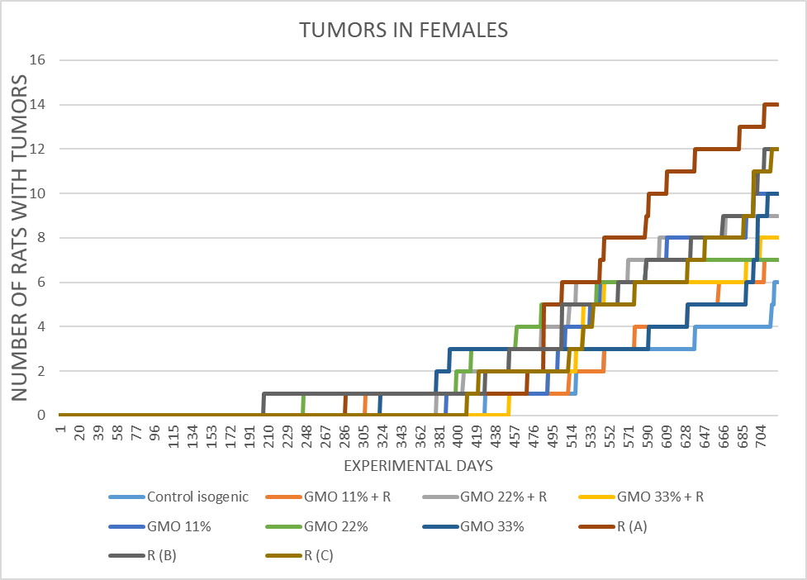

Fig. 1. *Number of tumours in females over time*

In Fig. 1, it was found that in females, the earliest tumours were found in R(B), followed by GMO 22% and R(A) groups, and the most tumours were present in R(A), followed by R(B) and R(C) respectively.

### Number of male rats with tumors over time

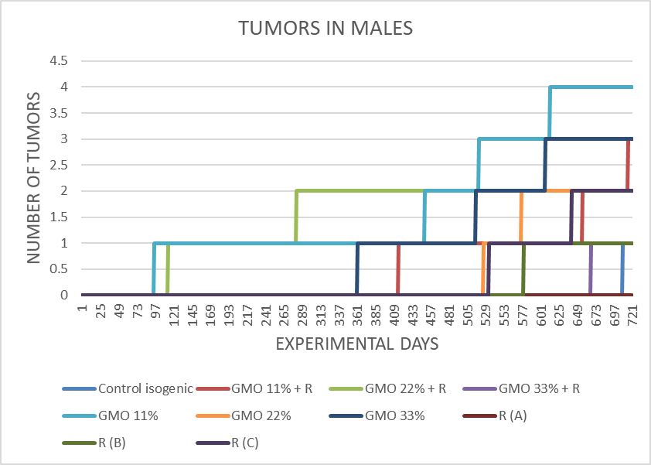

Fig. 2. *Number of tumours in males over time*

In Fig 2, it was found that in males the earliest tumours were found in GMO 11%, followed by R(B) and GMO 33% groups, and the most tumours were present in GMO 11%, followed by GMO 33% and R(A) respectively.

### 

### Number of deaths in female rats over time

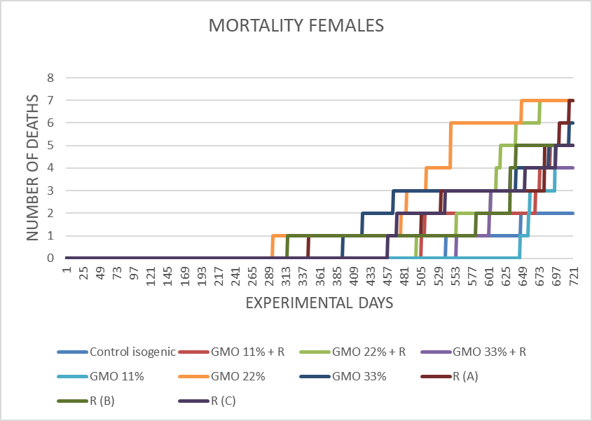

Fig. 3. *Number of deaths in females over time*

In Fig 3, it was found that in females the earliest deaths were found in GMO 22%, followed by R(B) and R(A) groups, and the most deaths were present in GMO 22%, followed by GMO 22% + R and R(A) respectively.

### Number of deaths in males over time

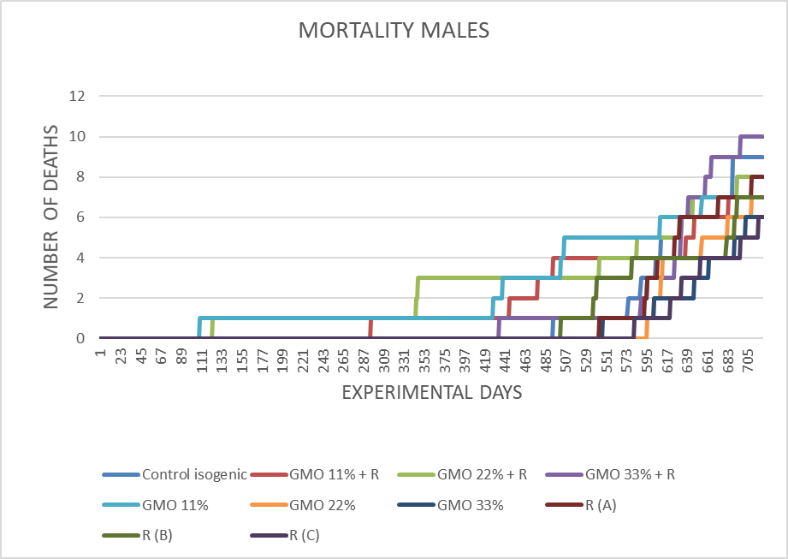

Fig. 4. *Number of deaths in males over time*

In Fig 4, it was found that in males the earliest deaths were found in GMO 11%, followed by GMO 22% + R and GMO 11% + R groups, and the most deaths were present in GMO 33% + R, followed by Control Isogenic and GMO 22% + R respectively.

### Number of deaths in males and females combined over time

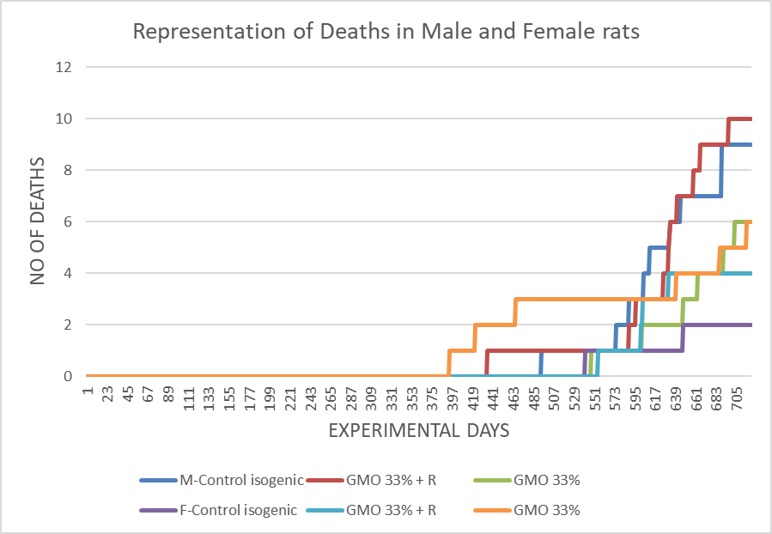

Fig. 5. *Number of deaths in males and females combined, over time*

In Fig 5, it was found that when combining males and females, the earliest deaths were found in GMO 33%, followed by GMO 33% + R and M – Control isogenic groups, and the most deaths were present in GMO 33% + R, followed by M – Control isogenic and GMO 33% respectively.

### Number of tumors of various types in the GMO, R and GMO+R groups repestively

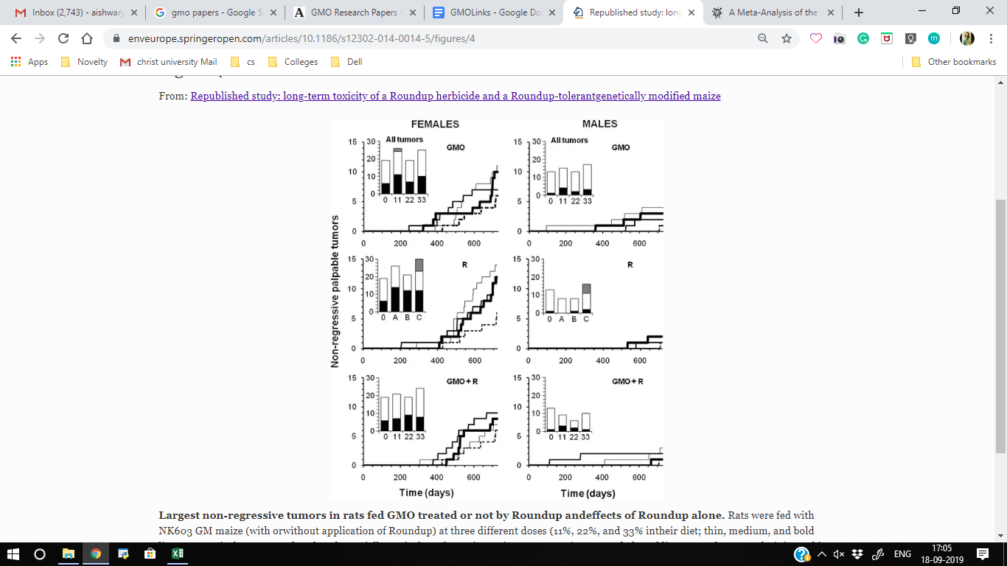 Fig. 6. *Number of tumours of various types in the GMO, R and GMO+R groups respectively*

In Fig. 6. the three different doses of GMO are denoted by the thin, medium and bold lines respectively compared to the substantially equivalent closest isogenic non-GM maize (control group) represented by the dotted line. Roundup was administered in drinking water at three increasing doses - environmental (A), MRL in some agricultural GMOs (B) and half of minimal agricultural levels (C), denoted by the thin, medium and bold lines respectively. Summary of all tumours are shown in the bar histograms: black, non-regressive large tumours; white, small internal tumours; grey, metastases. [3]

# CONCLUSION

## Sample Size Estimation

As is evident through the results obtained by the two-sample power t-test calculation, the size of each group in the experiment, as 10 was too small. For the results to be accurate and reliable, the desired number of rats in each group should have been a minimum of 26, that is, the overall sample should have contained a total of 520 rats consisting of 260 males and 260 females, assuming the effect size to be 0.8

## Graphical representation of deaths and tumors in various groups over time

It can be noticed from the line charts plotted for number of deaths and tumours in male and female rats, that the number of deaths and tumours were seen to be higher in those groups that were fed genetically modified maize with and without RoundUp herbicide, as compared to the Control Isogen group.

However, this interpretation is not reliable because of the flaw mentioned earlier in the research model, that is, the small sample size.

## Drawbacks

* The effect size value used for calculation of the required sample size is meant to be selected by experiments and research that has been carried out in the past. The effect value was chosen to be 0.8, however there must be more research done as to whether or not it is the value most suited for this particular topic of research.
* The experiment, even after increasing the sample size, continues encountering the same problem of lack of enough control groups for the accurate comparison of number of deaths and tumours in the different groups of rats.

## Further Improvement and Research

* The most suited value of effect size must be further investigated and the studies conducted thereafter should have a sample size of at least 26 rats per group present in the study
* Once a suitable sample size is selected, the experiment can be assigned a research model using methods that ensure the validity of the study.

# REFERENCES

1. VIB (2012), “A scientific analysis of the rat study conducted by Gilles-Eric Séralini” et al, in press.
2. Meyer H, Hilbeck A, “Rat feeding studies with genetically modified maize—a comparative evaluation of applied methods and risk assessment standards.” in Environ Sci Europe 25:33, 2013, in press.
3. Gilles-Eric Seralini, Emilie Clair, Robin Mesnage, Steve Gress, “Long term toxicity of a Roundup herbicide and a Roundup-tolerant genetically modified maize,” retracted.
4. John Fagan, Terje Traavik, Thomas Bohn, “The Seralini affair: degeneration of Science to Re-Science?”, Environmental Science Europe 27, Article number: 19, 2015, in press.
5. Séralini GE, Cellier D, Spiroux de Vendômois J. “New analysis of a rat feeding study with a genetically modified maize reveals signs of hepatorenal toxicity”, Arch Environ Contam Toxicol. 2007;52:596–602, in press.